WEEK 1 PROJECT PLAN
Data Science Project Planning & Strategy Design
Hypothetical Customer Churn Prediction Project using Python

Prepared for | Week 1 Data Science Planning Task
Role | Data Science Project Planner
Technology | Python-based Data Science Stack
Planned effort | 33 hours

Purpose: establish a complete, measurable, and implementation-ready strategy before technical execution begins.

1. Executive Summary
This document presents a complete plan for a hypothetical customer churn prediction project. The business problem is to identify customers who are at elevated risk of discontinuing a service so that the organization can prioritize retention actions. The project is intentionally designed without a dataset because the Week 1 objective is strategic planning, not model implementation.
The planned approach follows a standard data science lifecycle: problem definition, data acquisition and validation, data cleaning, exploratory analysis, feature engineering, model development, evaluation, interpretation, and business recommendation. The strategy emphasizes reproducibility, leakage prevention, explainability, and business-aligned metrics.

2. Project Background & Motivation

2.1 Hypothetical Problem
A subscription-based company is experiencing customer attrition. Management currently knows the number of customers who leave, but does not have a systematic predictive process to identify customers who are likely to churn before the event occurs. The proposed data science project will use historical customer, usage, billing, service, and interaction information to build a model that estimates churn risk.

2.2 Motivation
- Retention activity can be prioritized toward customers with higher predicted risk.
- Historical data can reveal behavioral patterns associated with churn.
- A predictive workflow can support proactive customer-service and marketing decisions.
- A documented Python pipeline can make the analysis repeatable and easier to improve.
- The project creates a measurable bridge between business questions and analytical outputs.

2.3 Business Question
Which customer characteristics and behaviors are associated with churn, and can historical data be used to predict which customers are at elevated risk of leaving within a defined future period?

3. Project Objectives & Scope

3.1 Specific Objectives
- Define the target variable and prediction horizon for churn.
- Design a reliable data collection and validation plan.
- Identify missing values, duplicates, inconsistent categories, and abnormal records.
- Explore relationships between customer behavior and churn.
- Engineer features that are available before the prediction point.
- Develop baseline and candidate classification models.
- Evaluate models using metrics aligned with the cost of false positives and false negatives.
- Explain the main drivers of predictions and translate findings into business actions.
- Document assumptions, limitations, risks, and a repeatable implementation workflow.

3.2 In Scope
- Customer profile, subscription, usage, billing, support, and historical interaction data.
- Binary churn classification for a defined prediction window.
- Data quality assessment and preprocessing strategy.
- Exploratory data analysis and feature engineering.
- Baseline and machine-learning classification models.
- Model validation, error analysis, explainability, and business recommendations.

3.3 Out of Scope
- Real-time production deployment or API development.
- Automated marketing campaign execution.
- Collection of new customer data through surveys during Week 1.
- Financial forecasting unrelated to churn.
- Use of sensitive personal attributes unless explicitly justified, legally permitted, and governed.
- Guaranteeing that the model will prevent churn; the model only provides risk estimates.

4. Methodology & Strategy
The project will use an iterative CRISP-DM-inspired workflow adapted for a Python implementation. Each stage has an explicit output and quality check so that problems discovered later can be traced back to their source.
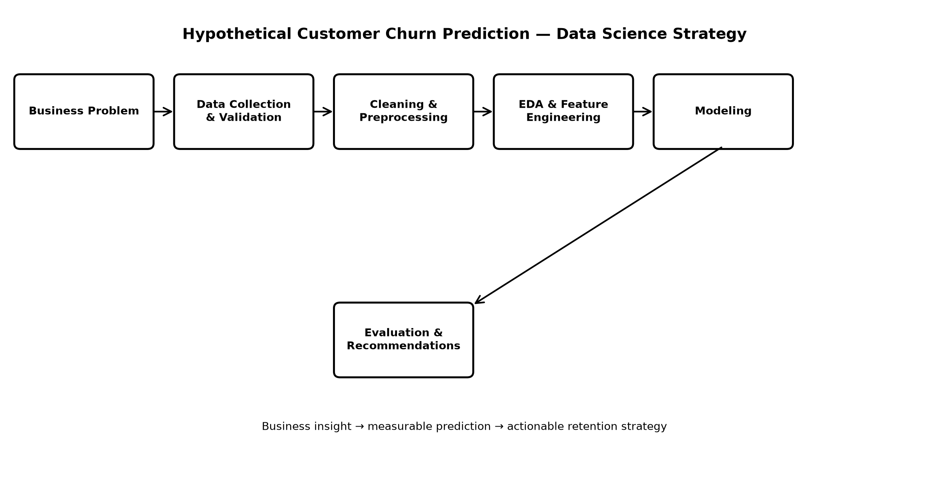
Figure 1. Planned end-to-end data science workflow.

4.1 Problem Definition
Define churn, prediction horizon, decision owner, cost of errors, success metrics, and assumptions.
Expected output: Project charter; KPI definitions; target-variable specification.

4.2 Data Collection & Validation
Identify data sources such as CRM, billing, product usage, support tickets, and subscription history. Define joins, keys, refresh frequency, and data-quality checks.
Expected output: Data dictionary; source-to-feature mapping; validation checklist.

4.3 Data Cleaning & Preprocessing
Handle missing values, duplicates, inconsistent categories, impossible values, outliers, and data types. Separate training and test data before learning transformations where appropriate.
Expected output: Clean analytical dataset specification; preprocessing pipeline design.

4.4 Exploratory Data Analysis
Examine churn rate, distributions, segment behavior, time patterns, correlations, and potential leakage. Use grouped analysis and visualizations.
Expected output: EDA notebook plan; insight list; candidate features.

4.5 Feature Engineering
Create interpretable features such as tenure, recent usage change, support-contact frequency, payment behavior, and service-plan indicators.
Expected output: Feature catalogue with definitions and availability timing.

4.6 Modeling
Start with a simple baseline such as logistic regression, then compare tree-based models such as Random Forest or Gradient Boosting. Use reproducible pipelines.
Expected output: Candidate model results; cross-validation design.

4.7 Evaluation
Use precision, recall, F1, ROC-AUC and PR-AUC as appropriate, plus confusion-matrix analysis. Choose thresholds based on business costs rather than accuracy alone.
Expected output: Evaluation report; error analysis; threshold strategy.

4.8 Interpretation & Recommendation
Explain influential features, identify actionable customer segments, and document limitations. Recommendations should be traceable to evidence.
Expected output: Business recommendation brief; limitations and next-step plan.

5. Data Strategy
Potential source | Example fields | Purpose | Key quality checks
CRM / Customer master | Customer ID, segment, region, tenure | Customer profile | Unique IDs, valid categories
Subscription system | Plan, start date, renewal date, status | Lifecycle context | Date consistency, status rules
Product usage | Logins, sessions, usage volume | Behavioral signals | Missing periods, extreme values
Billing / payments | Amount, payment method, failed payments | Payment behavior | Currency, duplicates, date alignment
Support system | Tickets, issue types, resolution time | Service experience | Duplicate tickets, timestamps
A central data dictionary should define each field, business meaning, datatype, allowed values, source, update frequency, and whether the feature is available before the prediction point. This is important for preventing target leakage.

6. Analytical & Modeling Strategy

6.1 Baseline
The first benchmark will be a simple rule or logistic-regression baseline. The purpose is to establish a reference point and avoid adopting a complex model without demonstrating measurable improvement.

6.2 Candidate Models
- Logistic Regression — interpretable baseline and probability output.
- Decision Tree — easy-to-explain nonlinear relationships.
- Random Forest — robust tree ensemble for nonlinear interactions.
- Gradient Boosting — candidate for improved predictive performance if justified by validation.

6.3 Validation Design
- Use a train/validation/test structure or cross-validation as appropriate.
- Use stratification for imbalanced binary outcomes where random splitting is valid.
- Use time-based splitting if the project represents future churn prediction and historical time order matters.
- Fit preprocessing steps only on training data within a reproducible pipeline.
- Check explicitly for leakage from post-churn or post-prediction information.

6.4 Evaluation Metrics
Metric | Why it matters | Interpretation
Precision | Controls unnecessary retention outreach | Of customers predicted high-risk, how many actually churn?
Recall | Captures more true churners | Of customers who churn, how many were identified?
F1-score | Balances precision and recall | Useful when both error types matter.
ROC-AUC | Measures ranking ability across thresholds | How well does the model separate classes overall?
PR-AUC | Useful when churn is relatively rare | Focuses on precision-recall behavior.
Confusion matrix | Shows error counts by class | Makes operational trade-offs visible.

7. Tools & Technology Stack
Tool / Library | Planned use
Python | Primary language for data analysis and modeling.
Jupyter Notebook / JupyterLab | Exploration, experiments, documentation, and visual analysis.
Pandas | Data loading, transformation, aggregation, and tabular analysis.
NumPy | Numerical operations and array-based calculations.
Matplotlib | Core charts and controlled visualizations.
Seaborn | Statistical visualization and exploratory plots.
Scikit-learn | Preprocessing, pipelines, models, cross-validation, and metrics.
SciPy | Statistical and numerical utilities where required.
Git / GitHub | Version control and collaboration.
CSV / SQL / Excel sources | Potential input formats depending on the hypothetical environment.

8. Timeline & 33-Hour Work Allocation
The Week 1 plan allocates 33 hours across eight work packages. The schedule is intentionally weighted toward problem framing, data quality, methodology, and documentation so the later technical implementation has a clear foundation.
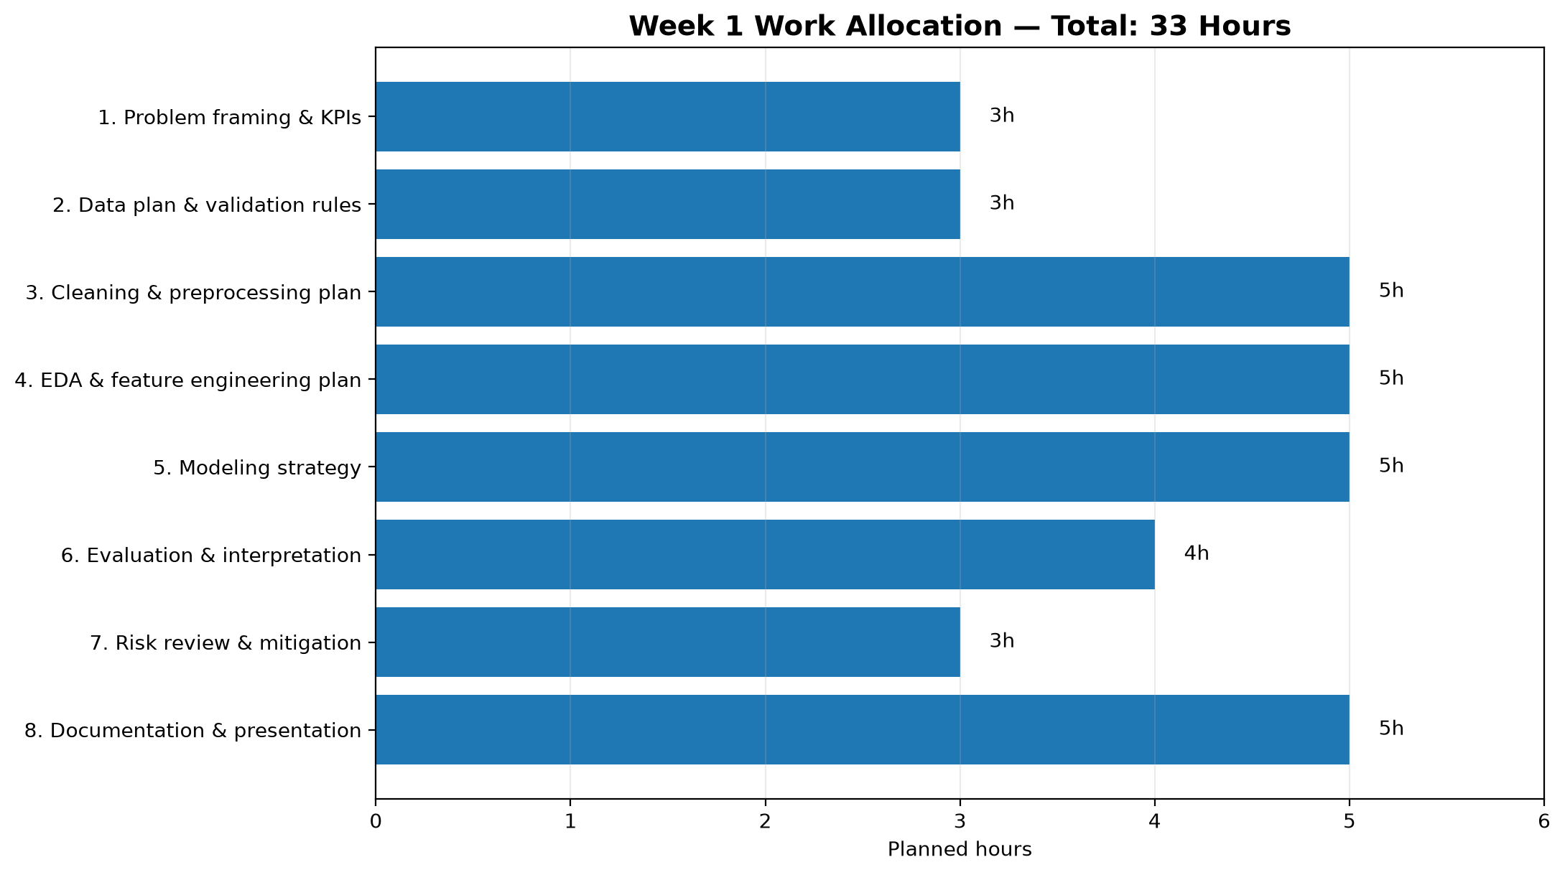
Figure 2. Planned 33-hour allocation.
Work package | Hours | Main deliverable
Problem framing & KPIs | 3 | Problem statement, target, success criteria
Data plan & validation rules | 3 | Source map and data-quality checklist
Cleaning & preprocessing plan | 5 | Preprocessing strategy and leakage controls
EDA & feature engineering plan | 5 | EDA questions and feature catalogue
Modeling strategy | 5 | Baseline, candidate models, validation design
Evaluation & interpretation | 4 | Metric and threshold strategy
Risk review & mitigation | 3 | Risk register and controls
Documentation & presentation | 5 | Final project plan and diagrams
Total | 33 | Week 1 completed project plan

9. Expected Outcomes
- A clearly defined churn prediction problem with measurable success criteria.
- A documented data architecture and data-quality strategy.
- A repeatable Python workflow covering preprocessing through evaluation.
- A set of candidate features linked to business meaning.
- A baseline and model-comparison framework ready for implementation.
- An evaluation strategy that considers operational costs rather than relying only on accuracy.
- Actionable customer segments or risk signals that can be investigated by business teams.
- A documented list of assumptions, limitations, risks, and next steps.

10. Anticipated Challenges & Mitigation
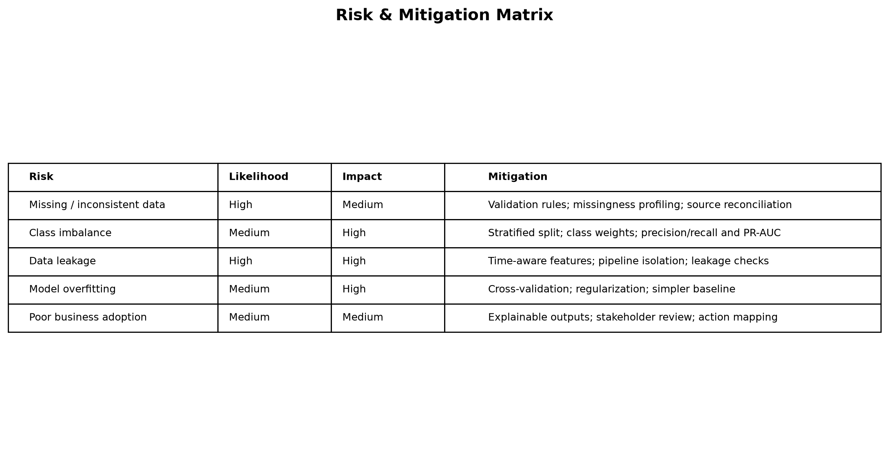
Figure 3. Risk and mitigation overview.
The main strategic risks are data quality, class imbalance, target leakage, overfitting, and weak business adoption. The mitigation approach is to introduce validation gates at each stage, use reproducible pipelines, evaluate multiple metrics, and involve stakeholders in defining the prediction horizon and acceptable error trade-offs.

11. Quality, Governance & Reproducibility
- Keep a data dictionary and version-controlled project documentation.
- Use fixed random seeds where reproducibility is appropriate.
- Record preprocessing, feature definitions, model parameters, and evaluation results.
- Separate exploratory analysis from final evaluation to reduce accidental overfitting.
- Avoid using information that would not be available at prediction time.
- Protect customer information and use only data necessary for the analytical objective.
- Document limitations and uncertainty rather than presenting predictions as guarantees.

12. Week 1 Deliverables Checklist
Deliverable | Status / definition
Project background | Hypothetical churn problem and motivation documented
Objectives & scope | Specific objectives, in-scope and out-of-scope items defined
Methodology | Collection, cleaning, EDA, feature engineering, modeling and evaluation strategy
Strategic flowchart | End-to-end workflow diagram inserted
Timeline | 33-hour allocation and chart inserted
Tools | Python libraries and supporting tools identified
Expected outcomes | Business and technical outcomes defined
Challenges & mitigation | Risk matrix and mitigation controls documented

13. Conclusion & Next Steps
The proposed Week 1 plan converts a broad business problem into a structured data science workflow. The most important principle is to establish the target, prediction timing, data quality rules, and evaluation criteria before model training. This reduces avoidable rework and provides a defensible foundation for the technical implementation in subsequent weeks.
Recommended next steps for Week 2:
- Obtain or create the approved dataset and data dictionary.
- Perform initial data profiling and quality checks.
- Implement the preprocessing pipeline in Python.
- Begin exploratory data analysis and feature engineering.
- Establish the baseline model and evaluation metrics.

