WEEK 2 PROJECT PLAN
Exploratory Data Analysis (EDA) & Visualization Framework Design
A reusable Python framework for systematic data exploration

Item | Details
Prepared for | Week 2 Data Science Task
Focus | EDA, visualization, data quality and reporting
Tools | Python, Pandas, NumPy, Matplotlib, Seaborn, Plotly
Planned effort | 35 hours

1. Introduction to Exploratory Data Analysis
Exploratory Data Analysis (EDA) is the systematic process of examining a dataset before statistical modeling or machine learning. It combines numerical summaries, data-quality checks, visualizations, and domain questions to understand the structure, quality, distributions, relationships, and unusual observations within data.
EDA is essential because model quality depends strongly on data quality and feature behavior. A well-designed EDA process can reveal missing values, duplicates, inconsistent categories, skewed distributions, outliers, class imbalance, unexpected relationships, and potential data leakage. Because Week 2 does not provide a dataset, this report defines a dataset-independent framework that can be adapted to numerical, categorical, temporal, and mixed datasets.

1.1 EDA Objectives
- Understand dataset dimensions, schema, data types and variable meanings.
- Assess completeness, consistency, uniqueness and validity.
- Summarize individual variables and identify unusual distributions.
- Investigate relationships between variables and target outcomes.
- Define evidence-based missing-value and outlier strategies.
- Create clear visualizations that reveal patterns without misleading presentation.
- Generate hypotheses for later statistical or machine-learning analysis.
- Document findings, assumptions, transformations and decisions reproducibly.

2. Potential Data Types & Data Structure
The first analytical step is to identify variable types because the appropriate summaries and visualizations depend on the data type.
Data type | Examples | Exploration methods
Continuous numerical | Age, revenue, temperature | Mean/median, quantiles, histogram, KDE, box plot
Discrete numerical | Visits, tickets, units | Frequency, bar chart, histogram
Nominal categorical | City, product type | Counts, proportions, bar chart
Ordinal categorical | Low/Medium/High | Ordered frequencies, grouped analysis
Binary | Churn yes/no, pass/fail | Class balance, count plot
Datetime | Order date, login time | Time trends, seasonality, rolling statistics
Text | Reviews, comments | Length, missingness, NLP if required
Identifier | Customer ID, transaction ID | Uniqueness, duplicates, join integrity

2.1 Initial Structural Audit
- Load the dataset with an appropriate pandas reader or database connector.
- Inspect dimensions, samples, column names, types and non-null counts.
- Identify candidate target and identifier columns.
- Create a data dictionary with meaning, datatype, source and allowed values.
- Check duplicate rows and duplicate identifiers.
- Validate date parsing and relationships between tables.

3. EDA Process & Exploration Workflow
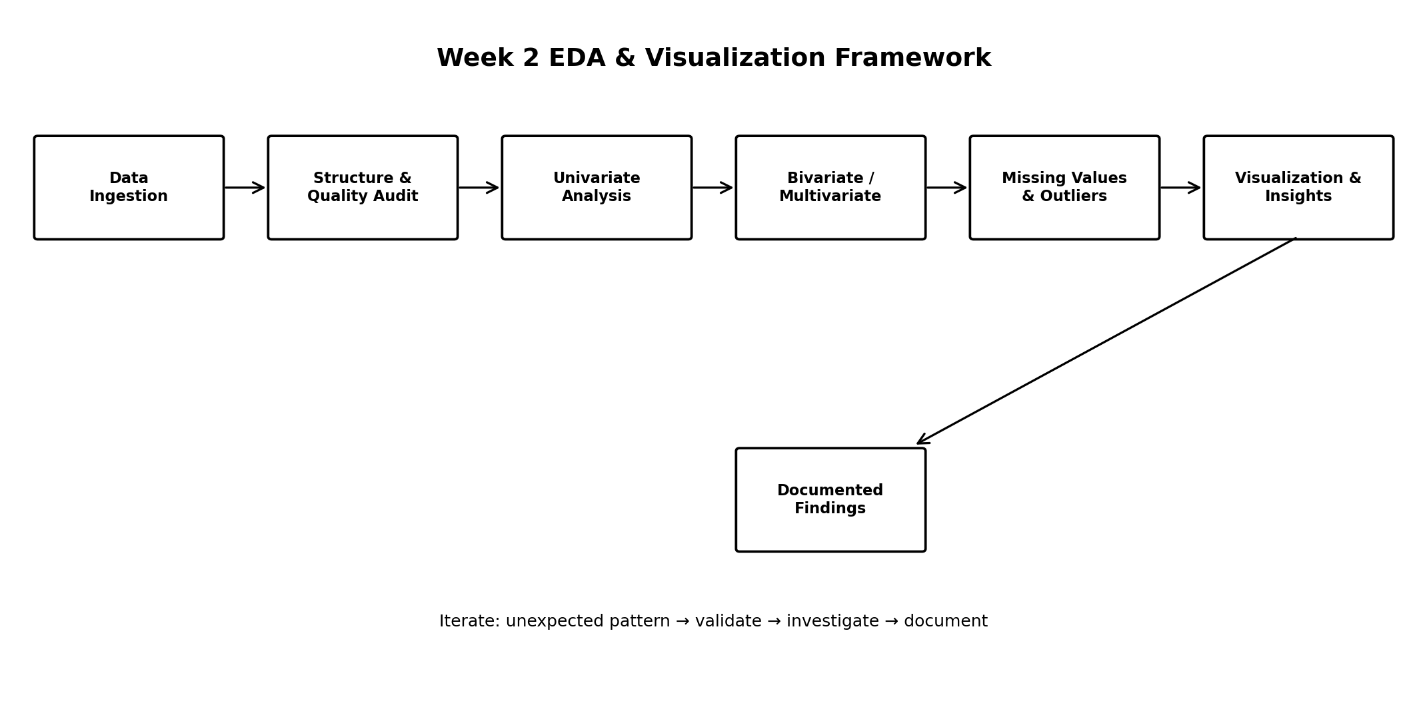
Figure 1. Proposed end-to-end EDA workflow.

3.1 Univariate Analysis
Univariate analysis studies one variable at a time. Numerical analysis examines central tendency, dispersion, quantiles, skewness and potential outliers. Categorical analysis examines frequency, proportions, cardinality and rare categories.
- Numerical summaries: count, mean, median, standard deviation, minimum, maximum and quartiles.
- Histograms and KDE plots for distribution shape.
- Box plots for spread and potential outliers.
- Categorical frequency tables and percentage distributions.
- Datetime summaries by day, week, month or quarter.

3.2 Bivariate Analysis
Bivariate analysis examines relationships between two variables. The technique should match their types.
Combination | Techniques | Visualizations
Numeric + Numeric | Correlation, trend, covariance | Scatter, regression-oriented plot, hexbin
Categorical + Numeric | Group mean/median, quantiles | Box, violin, strip plot
Categorical + Categorical | Cross-tabulation, proportions | Grouped/stacked bar, heatmap
Datetime + Numeric | Aggregation and rolling summaries | Line, area chart

3.3 Multivariate Analysis
- Correlation matrix for relationships and redundant numerical variables.
- Pair plots for a selected manageable subset.
- Faceted/grouped charts across meaningful segments.
- Heatmaps for matrix-style relationships.
- PCA or other dimensionality reduction only when justified.
- Multivariate inspection of target outcomes to identify combinations of relevant factors.

4. Missing Data & Outlier Framework

4.1 Missing Data
Missing values should not automatically be replaced. Treatment should depend on why values are missing, the amount of missingness, variable type, and analytical purpose.
Step | Approach
Profile | Calculate missing counts and percentages by column and segment.
Diagnose | Determine whether missingness appears random, systematic or process-related.
Decide | Retain, impute, add missing-indicator, or exclude when justified.
Numerical | Consider median or model-based imputation without leakage.
Categorical | Consider an explicit Unknown category when appropriate.
Document | Record method, assumptions and impact.

4.2 Outliers
Outliers may be genuine rare events, measurement errors, data-entry errors or meaningful business cases. Therefore, outlier detection is an investigation step rather than an automatic deletion rule.
- Use IQR-based flags such as Q1 − 1.5×IQR and Q3 + 1.5×IQR.
- Use Z-scores or robust methods when distribution assumptions are suitable.
- Validate extreme values against domain rules.
- Possible treatments include correction, capping, transformation, robust modeling or retention.
- Document every treatment and compare results before and after where material.

5. Visualization Strategy
Visualization will be driven by analytical questions rather than by producing a large number of charts. Every chart should have a clear purpose, informative title, labeled axes, readable units and a concise interpretation.
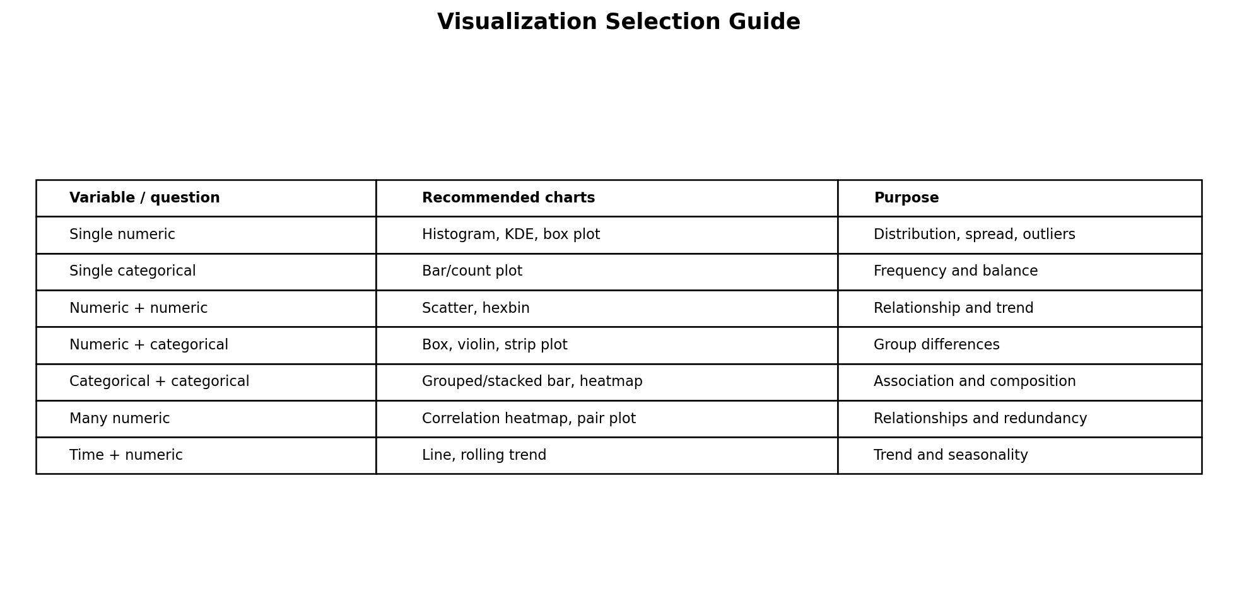
Figure 2. Visualization selection guide.
Plot | Primary use | Example question
Histogram | Distribution | Is revenue skewed?
KDE | Smoothed distribution | Do groups have different distributions?
Box plot | Spread/outliers by group | Which segment has higher variation?
Violin plot | Distribution shape by category | How do full distributions differ?
Bar/count plot | Category frequency | Which category is most common?
Scatter plot | Numeric relationship | Does usage increase with revenue?
Line chart | Time trend | How does a metric change over time?
Heatmap | Matrix relationships | Which variables are correlated?
Pair plot | Selected multivariate relationships | Are there visible clusters?
Stacked bar | Composition | How does outcome composition differ by segment?

5.1 Visualization Principles
- Use the simplest chart that answers the question.
- Label axes and units clearly.
- Use consistent scales for comparisons.
- Avoid truncated axes when they exaggerate differences.
- Show denominators or sample sizes for proportions when useful.
- Use color purposefully and include legends.
- Keep categories readable and ordered meaningfully.
- Use interactive dashboards only when interaction supports a clear analytical need.

6. Python Tools & Libraries
Tool / Library | Contribution
Pandas | Loading, cleaning, grouping, aggregation, reshaping and tabular summaries.
NumPy | Numerical operations, arrays and mathematical transformations.
Matplotlib | Foundational plotting with detailed figure and axis control.
Seaborn | Statistical visualizations, categorical plots and correlation heatmaps.
Plotly | Interactive charts and exploratory dashboards.
SciPy | Statistical and numerical utilities when required.
Jupyter / JupyterLab | Interactive code, narrative documentation and charts.
Git / GitHub | Version control and reproducibility.

6.1 Typical Python Workflow
A practical implementation would use Pandas for structured data operations, NumPy for numerical calculations, Seaborn and Matplotlib for static visualizations, and Plotly for interactive exploration where useful. Scikit-learn can be introduced later for preprocessing and modeling, while Week 2 remains focused on understanding and validating the data.

7. Reporting & Documentation Framework
The EDA output should be documented so another analyst can reproduce the analysis and understand why each decision was made.
Report section | Content
Executive summary | Dataset context, major quality findings, important patterns and next steps.
Dataset overview | Source, dimensions, variables, target, period and limitations.
Data quality | Missingness, duplicates, invalid values, inconsistent categories and treatments.
Univariate findings | Important distributions, category balance and unusual observations.
Relationship analysis | Key bivariate/multivariate patterns with supporting charts.
Visualization gallery | Selected charts with captions and interpretations.
Feature observations | Candidate variables, transformations, redundancy and leakage concerns.
Analytical insights | Evidence-backed observations and hypotheses for validation.
Limitations | Sampling, measurement, missingness and representativeness constraints.
Next steps | Statistical tests, feature engineering, modeling or additional data needs.

7.1 Chart Documentation Template
- Chart title: exactly what is being shown.
- Question: the analytical question addressed.
- Data scope: population, period and filters.
- Interpretation: observable pattern without unsupported causal claims.
- Next step: validation or further analysis required.

8. EDA Quality & Reproducibility Checklist
- Document dataset source, period and population.
- Check row counts and unique IDs before and after transformations.
- Validate data types and dates.
- Profile missingness before treatment.
- Check duplicates and inconsistent categories.
- Inspect distributions and outliers using numerical and visual methods.
- Check potential target leakage.
- Use reproducible code and retain notebooks/scripts.
- Record assumptions and decisions.
- Review charts for misleading scales, unclear labels and unsupported interpretations.

9. 35-Hour Week 2 Timeline
The planned workload is 35 hours, within the requested 30–35 hour range. The schedule balances analytical design with documentation so the resulting framework can be converted into a practical Python notebook when a dataset becomes available.
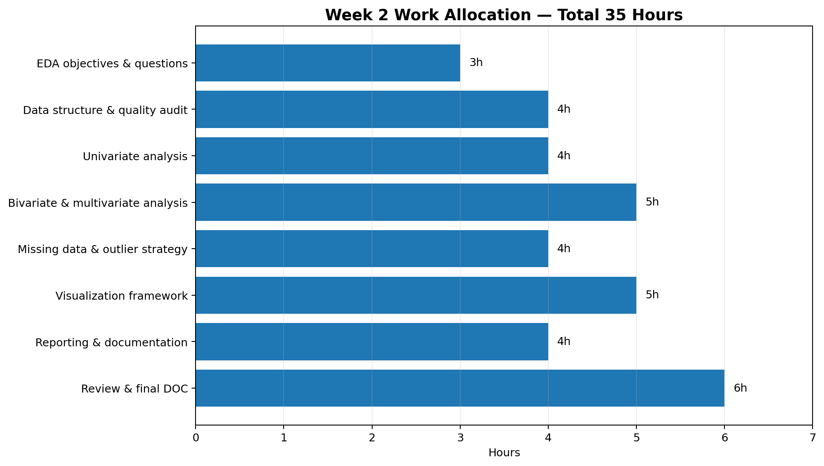
Figure 3. Week 2 planned work allocation.
Work package | Hours | Output
EDA objectives & questions | 3 | Analytical question catalogue
Data structure & quality audit | 4 | Schema and quality-check framework
Univariate analysis | 4 | Numeric/categorical exploration framework
Bivariate & multivariate analysis | 5 | Relationship-analysis framework
Missing data & outlier strategy | 4 | Treatment decision framework
Visualization framework | 5 | Chart selection and design standards
Reporting & documentation | 4 | EDA report template
Review & final DOC | 6 | Final Week 2 submission
Total | 35 | Completed EDA framework

10. Expected Outcomes
- A reusable EDA workflow applicable to multiple dataset types.
- A structured method for detecting data-quality issues before modeling.
- A clear method for choosing visualizations based on variable type and analytical question.
- A documented missing-value and outlier framework.
- A consistent standard for chart quality and interpretation.
- A 35-hour execution plan for Week 2.
- A strong foundation for feature engineering, statistical testing and machine learning.

11. Anticipated Challenges & Mitigation
Challenge | Effect | Mitigation
Very large datasets | Slow computation/plots | Sample for visualization, aggregate intelligently and optimize dtypes.
High-cardinality categories | Unreadable charts | Use top-N views and group rare categories.
Severe missingness | Biased summaries | Profile by segment and document limitations.
Extreme outliers | Distorted statistics/scales | Investigate domain validity and use robust summaries.
Correlation misinterpretation | False causal conclusions | Treat EDA relationships as associations and validate later.
Too many charts | Low clarity | Select charts based on analytical questions.
Data leakage | Overly optimistic later models | Flag variables known only after outcome/prediction time.

12. Conclusion
This Week 2 framework provides a systematic approach to understanding data before statistical modeling or machine learning. It combines structural inspection, data-quality assessment, univariate, bivariate and multivariate analysis with purposeful visualization. The framework remains adaptable because the exact charts, transformations and statistical methods can change according to the dataset, business question, variable types and analytical objective.
When a dataset becomes available, the next step will be to convert this framework into a reproducible Python notebook that records every transformation, chart, observation and decision. This will make the analysis transparent and provide a strong foundation for feature engineering and model development in subsequent weeks.

