PROJECT IN AUTOMATA AND LANGUAGE THEORY

GENDER NEUTRAL LANGUAGE RECOGNIZER

Submitted by:
Mark Jeshmer B. Jaromahum
Feny Ann V. Cervantes
Jules J. Tuyogon
Jotham Aaron Puracan
BSCS 3A

Submitted to:

ALMA MAE B. AUXTERO
Instructor
Date submitted: November 5, 2026

1 Project overview
The Gender Neutral Language Recognizer is a web application that reads a plain-text (.txt) document, finds predefined gender-specific words and phrases such as “chairman”, “fireman” and “mankind”, and suggests a gender-neutral alternative for each. Its purpose is to help writers review their text for inclusive language. Main features: file selection, whole-word and case-insensitive recognition using a regular expression, a results table showing each detected term with its number of occurrences and suggested alternative, highlighting of the detected terms in the document text, and clear messages for empty files, unsupported formats and documents with no detected terms. Suggestions are for review only; nothing is replaced automatically.

2 Tools and recognition approach
Language and tools: HTML, CSS and JavaScript, running in any modern web browser (no installation or libraries). The code was written in Visual Studio Code. Recognition approach: regular expressions.
- The recognizer is one regular expression built from the term list by the function buildRecognizer():
(?<![A-Za-z0-9_])(chairman|policeman|fireman|…|he\s+or\s+she|…)(?![A-Za-z0-9_]) flags: g, i
How the pattern works:
- Alternation ( | ): all 23 predefined terms are joined into one group, so a single pass over the text finds any of them. Terms are sorted longest-first so a longer phrase is always tried before a shorter one.
- Ignore capitalization: the i flag makes “Chairman”, “chairman” and “CHAIRMAN” all match.
- Whole words only: (?<![A-Za-z0-9_]) and (?![A-Za-z0-9_]) are lookbehind and lookahead assertions that require the match not to touch another letter, digit or underscore. This is why “he” inside “the” is never detected.
- Phrases: spaces inside multi-word terms become \s+, so “he or she” still matches across extra spaces or a line break. Special characters such as the hyphen in “man-made” are escaped.
- All occurrences: the g flag finds every match, and each match is converted to lowercase to count it under its dictionary entry.
Predefined gender-specific terms and suggested alternatives (23):
Term | Suggested alternative | Term | Suggested alternative
chairman | chairperson | layman | layperson
policeman | police officer | foreman | supervisor
fireman | firefighter | headmaster | head teacher
stewardess | flight attendant | waitress | server
mankind | humankind | manpower | workforce
businessman | businessperson | man-made | artificial
salesman | salesperson | man hours | work hours
mailman | mail carrier | ladies and gentlemen | everyone
congressman | member of Congress | boys and girls | children
spokesman | spokesperson | he or she | they
workman | worker | his or her | their
craftsman | artisan

3 Application screenshots
Figures 1–3 are screenshots of the running application.
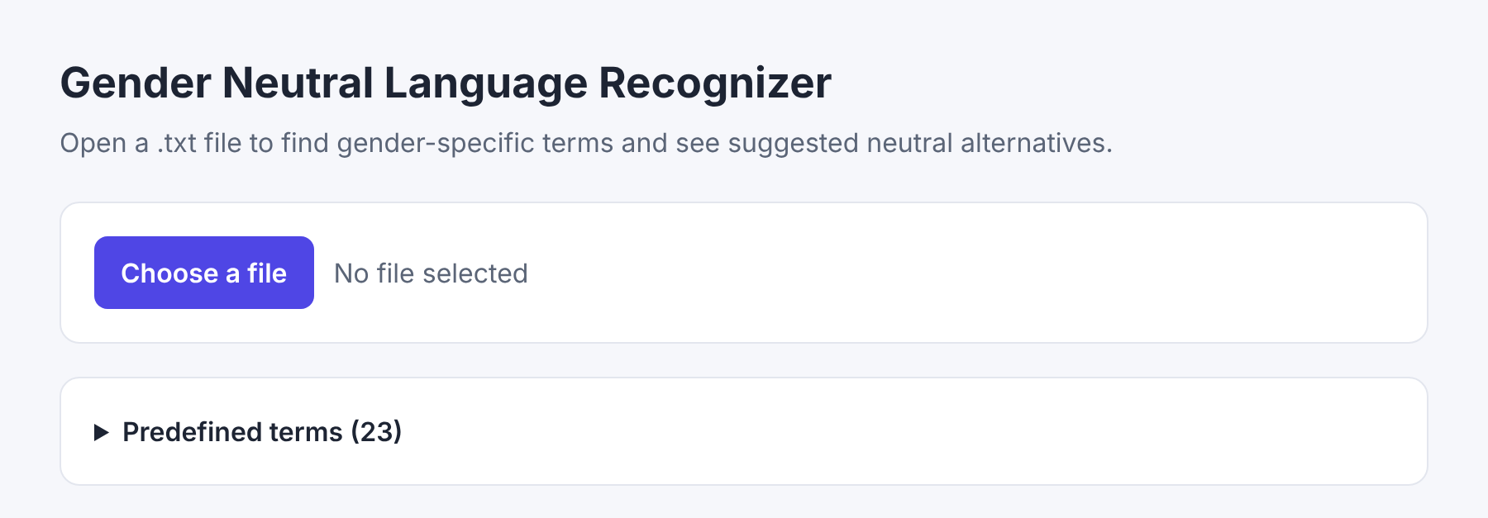
Figure 1. Start screen with the Choose a file button and the list of predefined terms.
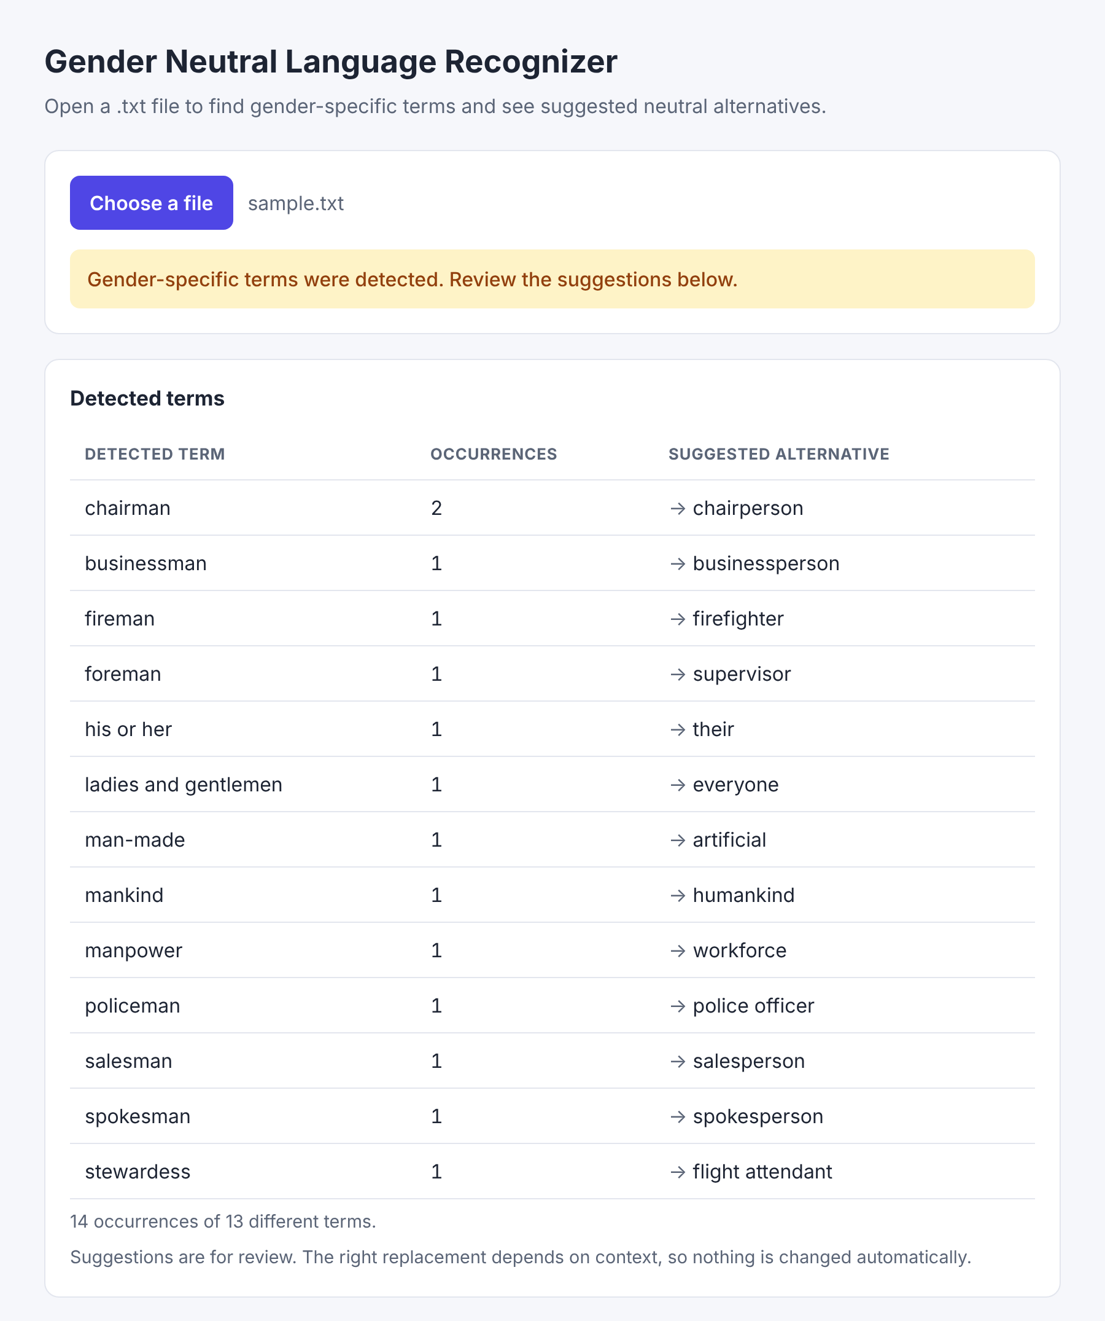
Figure 2. sample.txt selected: detected terms with occurrence counts and suggested alternatives, and the document text with the terms highlighted.
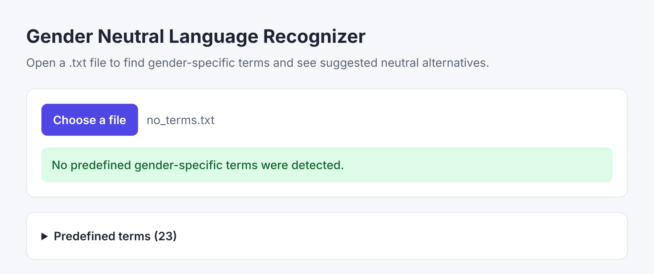
Figure 3. A document with no listed terms (it contains “the”, “them” and “whole”): the “No predefined gender-specific terms were detected.” message is shown.
Source code (public GitHub repository): https://github.com/mrxtorm/gender-neutral-language-recognizer

4 Testing
Each situation was run in the application using the files in the tests folder (and sample.txt). The actual results below are the application’s real output.
# | Test situation (file) | Expected result | Actual result | Result
1 | Document containing listed terms (sample.txt) | Listed terms are detected with counts and suggested alternatives. | 13 different terms found, 14 occurrences in total (e.g. chairman 2 → chairperson; fireman 1 → firefighter; his or her 1 → their). Matches highlighted. | Pass
2 | Same term more than once, different capitalization (tests/repeated.txt) | “Chairman”, “chairman” and “CHAIRMAN” are counted together; same for “fireman”. | chairman 3, fireman 2, policeman 1 (6 occurrences of 3 terms). | Pass
3 | No listed terms, includes “the” (tests/no_terms.txt) | Message “No predefined gender-specific terms were detected.”; “he” in “the” is not detected. | Message “No predefined gender-specific terms were detected.” was displayed; no results table. | Pass
4 | Empty .txt file (tests/empty.txt) | Clear message that the file is empty. | “The file is empty. Please choose a file that contains text.” | Pass
5 | Unsupported format (tests/unsupported.pdf) | Clear message that the format is not supported. | “Unsupported file format. Please choose a .txt file.” | Pass

5 Conclusion
We completed a working recognizer that loads a .txt file, finds 23 predefined gender-specific terms regardless of capitalization and only as whole words, and displays the occurrences and suggested alternatives in a results table, with clear messages for empty files, unsupported formats and documents with no matches. All five required tests passed. We learned how to turn a word list into a single regular expression and how lookarounds, flags and escaping control exactly what is matched. Known limitations: only the predefined terms are recognized (no plural or other word forms such as “chairmen”), only .txt files are supported (.docx and .pdf are not), terms inside longer hyphenated words may still be matched because the hyphen counts as a boundary, and suggestions must be chosen by the writer because the right replacement depends on context.

6 Sources and contributions
References and tools: Mozilla Developer Network (MDN) documentation on JavaScript regular expressions, lookbehind/lookahead assertions and the FileReader API; Visual Studio Code. No external libraries or borrowed code were used. AI assistance: Claude (Anthropic) was used to generate the initial application code, the sample and test files, and the draft of this document; the group reviewed it and ran the tests.
Member contributions:
- Mark Jeshmer B. Jaromahum: Wrote the regular expression and the term-matching logic; led the application coding.
- Feny Ann V. Cervantes: Designed the results table and the on-screen messages; prepared the application screenshots.
- Jules J. Tuyogon: Prepared the sample and test files and ran the five required tests; recorded the results.
- Jotham Aaron Puracan: Compiled the list of terms and alternatives; wrote the README and the project document; set up the GitHub repository.

