Campus Lost & Found — Project Documentation
Oct 18, 2026 · @MarkStorm

Preliminary Pages

Title Page
CAMPUS LOST AND FOUND: A MOBILE APPLICATION FOR REPORTING, MATCHING, AND CLAIMING LOST ITEMS AT BISU CANDIJAY CAMPUS
A Capstone Project Presented to the Faculty of the Computer Science Department, Bohol Island State University – Candijay Campus, Candijay, Bohol
In Partial Fulfillment of the Requirements for the Degree Bachelor of Science in Computer Science
by
Mark Jeshmer B. Jaromahum
Feny Ann V. Cervantes
Jules J. Tuyogon
Jotham Aaron Puracan
October 2026

Approval Sheet
This capstone project entitled "Campus Lost and Found: A Mobile Application for Reporting, Matching, and Claiming Lost Items at BISU Candijay Campus", prepared and submitted by Mark Jeshmer B. Jaromahum, Feny Ann V. Cervantes, Jules J. Tuyogon and Jotham Aaron Puracan, in partial fulfillment of the requirements for the degree Bachelor of Science in Computer Science, has been examined and is recommended for acceptance and approval.
Name | Role | Signature / Date
Jhoel Kennenth Gulle | Adviser
 | Panel Member
 | Panel Member
 | Panel Chairperson
Accepted and approved in partial fulfillment of the requirements for the degree Bachelor of Science in Computer Science.

Abstract
Lost personal belongings are a daily problem on a school campus, and owners and finders usually have no direct way to reach each other. This project developed Campus Lost & Found, an Android application for Bohol Island State University – Candijay Campus, built with Flutter and Google Firebase. Users report lost or found items with up to five photos, search and filter posts, and receive suggestions of possible matches produced by a keyword-based matching method with synonym handling and category weighting. An owner claims a found item by answering a private verification question set by the finder, who then approves or rejects the claim inside a private conversation. The app also provides in-app notifications, optional feedback after a return, and an offline-first local database that keeps reports, claims and messages while the phone has no connection and syncs them when it reconnects. Only users with a verified email who have accepted the Terms of Service can access data, and Firestore Security Rules enforce this on the server. The project followed an Agile, iterative development approach. All 21 automated tests of the local database and user interface passed. The results show that a single mobile platform with verification-based claiming can give the campus an organized and safer way to return lost items.
Keywords: lost and found, mobile application, Flutter, Firebase, item matching, offline-first

List of Tables
No. | Title
1 | Comparison of Existing Systems
2 | Functional Requirements
3 | Non-Functional Requirements
4 | Use-Case Descriptions
5 | Firestore Data Dictionary
6 | Hardware and Software Requirements
7 | Development Tools and Technologies
8 | System Modules
9 | Synonym Groups Used by the Matcher
10 | Automated Test Results
11 | Functional Test Cases
12 | Security Measures

List of Figures
No. | Title
1 | Conceptual Framework (Input–Process–Output)
2 | Agile Development Cycle
3 | System Architecture
4 | Use-Case Diagram
5 | Context Diagram (DFD Level 0)
6 | Logical Entity-Relationship Diagram
7 | Claim and Return Flow

Chapter 1 — Introduction

1.1 Background of the Study
Losing personal belongings is a common problem in schools. Students and employees move between classrooms, laboratories, the library, the canteen and the gymnasium every day, and small items such as phones, wallets, ID cards, keys and books are easily left behind. When an item is lost, the owner and the person who finds it usually have no direct way to contact each other.
On many campuses, lost and found items are handled informally: by word of mouth, by posts in social-media groups, or by surrendering the item to a guard or an office. These channels are scattered. A post is quickly buried in a busy feed, a logbook can only be checked in person, and there is no reliable way to prove that a claimant is the real owner before the item is handed over.
Since almost every student carries a smartphone, a dedicated mobile application can give the campus one organized place to report lost and found items. This project developed Campus Lost & Found, an Android application for Bohol Island State University (BISU) – Candijay Campus, built with Flutter and Google Firebase. Users post lost or found items with photos, receive suggestions of possible matches, claim found items by answering a private verification question set by the finder, and talk inside the app until the item is returned. The app also works on a weak connection: reports, claims and messages are saved on the phone first and sent when the connection returns.

1.2 Statement of the Problem
General problem: How can a mobile application help the BISU Candijay Campus community report, match, verify and return lost and found items more efficiently and securely?
Specific problems:
- How can lost and found items be reported and viewed in one central place accessible from a mobile phone?
- How can the system help users find possible matches between lost items and found items?
- How can a finder confirm that a claimant is the real owner before returning an item?
- How can owners and finders communicate privately and receive timely updates about their reports and claims?
- How can the application stay usable when the internet connection is unstable?
- How can user accounts and personal data be protected from unauthorized access?

1.3 Objectives of the Project
General objective: To develop Campus Lost & Found, an Android mobile application that helps the BISU Candijay Campus community report, match, verify and return lost and found items.
Specific objectives:
- To develop a reporting module where users post lost or found items with item name, category, location, date, description and up to five photos.
- To provide a searchable and filterable feed of lost and found items.
- To implement a keyword-based matching method that suggests possible matches between lost and found reports.
- To implement a claim process where the claimant answers a finder-defined verification question and the finder approves or rejects the claim.
- To provide private one-to-one messaging and in-app notifications for claims and possible matches.
- To support offline use by saving reports, claims and messages locally and syncing them automatically when the device reconnects.
- To secure the system through email verification, Terms of Service acceptance and server-side Firestore Security Rules.

1.4 Scope and Limitations
Scope. The project is an Android application for the students and employees of BISU Candijay Campus. It covers:
- Accounts: registration with full name, email and password; required email verification; login, password reset and logout; quick sign-in for accounts previously used on the device (no passwords saved).
- Terms of Service: users must accept the Terms (version 1.0) before entering the app, and each acceptance is recorded.
- Reporting: Lost or Found posts with name, one of six categories (Electronics, Wallet, ID, Keys, Books, Others), one of seven locations (Library, Classroom, Laboratory, Cafeteria, Gymnasium, Main Building, Other), date, description and up to five photos. Found posts require at least one photo and a verification question.
- Matching: possible matches are shown before posting and on demand from My Posts; owners of similar Lost items are notified when a matching Found item is posted.
- Browsing: search by name, category or location; filter by type and category.
- Claiming: one claim per user per Found item; the finder approves or rejects; a rejected claim can be resent. On approval, the item, claim and conversation are deleted and a minimal return record is kept.
- Messaging and notifications: private chat per post with unread counts; in-app notifications for claim events, possible matches and synced offline reports.
- Post-return feedback: an optional 1–5 rating and short recommendation from each party.
- Offline support: reports, deletions, claims, messages and read-status changes made offline are synced automatically.
Limitations.
- The app is built for Android only; iOS and web are not configured.
- There is one user type. There is no administrator account or campus-office dashboard.
- Notifications appear inside the app only; push notifications are not implemented.
- Matching compares item names using English keywords and a fixed synonym list, with a bonus for the same category. It does not compare photos, descriptions, locations or dates.
- Editing a post and the profile settings (edit profile, change password) are not yet available.
- Reporting inappropriate posts and moderation are described in the Terms of Service and modeled in the security rules, but have no app screen yet.
- Starting a new conversation needs an internet connection.
- The app helps users find each other; it does not handle the physical hand-over of items.
- A formal usability or performance evaluation with campus users was not conducted in this study.

1.5 Significance of the Project
- Students and employees who lose items get one place to report losses and are notified automatically when a similar found item is posted.
- Finders get a simple way to post found items and to confirm ownership through a private question before returning them.
- The campus administration gets a model for a more organized lost-and-found process that can complement the existing manual handling of items.
- Future researchers can use this project as a reference for offline-first mobile apps, client-side matching and data protection with Firebase Security Rules.
- The researchers gained practical experience in mobile development, cloud databases, security rules and software testing.

1.6 Definition of Terms
Term | Definition (as used in this project)
Access Gate | The part of the app that admits a signed-in user only after the email is verified and the current Terms are accepted.
Claim | A request to recover a Found item, containing the claimant's answer to the verification question. Its status is Pending, Approved or Rejected.
Claimant | The user who submits a claim for a Found item.
Cloud Firestore | Google Firebase's cloud NoSQL database, where the app stores shared data as documents in collections.
Cloudinary | A cloud image-hosting service where item photos are uploaded.
Completed Return | A minimal record saved when a finder approves a claim, used to allow post-return feedback.
Drift | A Dart library for an SQLite database on the phone; used for offline storage.
Finder | The user who posted a Found item; sets the verification question and decides on claims.
Firestore Security Rules | Server-side rules that decide which user may read or write each document.
Flutter | Google's framework for building mobile apps from one Dart codebase.
Item Matching | Finding possible pairs between Lost and Found reports by comparing keywords in item names, with a bonus for the same category.
Offline-first | A design where the app reads and writes a local database first and syncs with the cloud when a connection is available.
Sync | Sending locally saved changes to the cloud and receiving the latest cloud data.
Verification Question | A question written by the finder that only the real owner should be able to answer.

Chapter 2 — Review of Related Literature and Systems

2.1 Related Literature
Local-first and offline-first software. Kleppmann et al. (2019) argue that cloud apps centralize data on servers and stop working without a connection. They propose "local-first" software, in which the main copy of the data lives on the user's device, the app works offline, and changes sync across devices later. Campus Lost & Found follows this idea: every report, claim and message is written to a local SQLite database first and synced to Cloud Firestore when the phone is online, so the app stays usable on a weak campus connection.
Text similarity for matching. Manning et al. (2008) describe the Jaccard coefficient as a basic measure of overlap between two sets of words: the size of their intersection divided by the size of their union. The app's matching method uses this measure on the keywords of two item names, after removing stop words and replacing synonyms, to rank possible matches between lost and found reports.
Data privacy. The Data Privacy Act of 2012 (Republic Act No. 10173) requires that personal information be collected for a declared purpose, processed with consent, and protected by reasonable security measures. This guided the app's design: users accept a Terms of Service and User Agreement before use, claim answers and chats are visible only to the two users involved, and the item, claim and conversation are deleted once an item is returned.

2.2 Related Studies
UTHM Losthub (Rahim & Arbain, 2026) is an Android app for lost and found items at Universiti Tun Hussein Onn Malaysia, built with Android Studio and Firebase. Users log in with their institutional email, report and search items, filter them and message each other directly. Functional and user acceptance testing reported high user satisfaction; the authors note the lack of password recovery and some performance issues as limitations.
SearchiT (Itaagi, 2023) is a Flutter mobile app with a MySQL database developed at Makerere University using the prototyping methodology. Users view, upload and search lost and found items and submit claims by email or phone call. A survey of students showed a preference for a mobile app over a web app, and most respondents in user acceptance testing were satisfied.
Web-based System for Matching Losers and Finders (Oyedeji et al., 2021), published in the Mindanao Journal of Science and Technology, matches reported items against the opposite category using the Knuth-Morris-Pratt string-matching algorithm. It includes an admin dashboard to manage items and users. In testing it matched 4 of 5 real item pairs (80%), and 10 student evaluators rated functionality highest (77%) and clarity lowest (64%).
FindIt (Ngu, 2025), from Universiti Malaysia Sarawak, is a mobile and web application that uses image matching to pair lost and found items automatically, with real-time notifications and a web interface for administrators to manage claims. It followed the Waterfall model, and the author reports improved recovery efficiency and user satisfaction in testing.
Smart Lost and Found Android Application (Saleh, 2020), from MSA University, uses a pre-trained convolutional neural network to classify photos of items into categories, with an admin web panel to manage posts and users.

2.3 Comparison of Existing Systems
Table 1. Comparison of Existing Systems (✔ present, ✘ absent, — not reported in the source)
Feature | UTHM Losthub | SearchiT | Oyedeji et al. | FindIt | Campus Lost & Found
Platform | Android | Mobile (Flutter) | Web | Mobile + web | Android (Flutter)
Report lost and found items | ✔ | ✔ | ✔ | ✔ | ✔
Search and filter | ✔ | ✔ | — | — | ✔
Automatic match suggestions | — | ✘ | ✔ (KMP text) | ✔ (image) | ✔ (keyword + synonyms)
Ownership verification before return | — | ✘ | — | ✔ (admin) | ✔ (finder's private question)
In-app messaging | ✔ | ✘ (email/phone) | ✘ | — | ✔
Notifications | — | — | — | ✔ | ✔ (in-app)
Works offline | — | — | ✘ | — | ✔
Verified accounts | ✔ (institutional email) | — | — | — | ✔ (email verification + Terms)
Admin tools | — | — | ✔ | ✔ | ✘

2.4 Synthesis
The reviewed studies agree that a central, mobile-accessible platform makes lost-and-found handling easier than scattered informal channels, and that students prefer a mobile app (Itaagi, 2023; Rahim & Arbain, 2026). Most systems share the same core: reporting, searching and some form of contact between owner and finder. Some add automatic matching, by text (Oyedeji et al., 2021) or by image (Ngu, 2025; Saleh, 2020). Claiming is usually handled outside the app (by email or phone) or by an administrator. None of the reviewed sources reports offline use.

2.5 Research Gap
Campus Lost & Found addresses these gaps:
- Peer-to-peer ownership verification. The finder writes a private verification question; only the finder and claimant see the answer, and the finder decides without needing an administrator.
- Matching before posting. Possible matches are shown before a report is submitted, and owners of similar Lost items are notified when a Found item is posted.
- Privacy after return. Claims and conversations are private and are deleted once the item is returned.
- Offline-first design. Users can report, claim and message on an unstable connection.

2.6 Conceptual Framework
The project uses the Input–Process–Output (IPO) model. The inputs are the data users enter, the process is how the app handles them, and the outputs are what users get back.
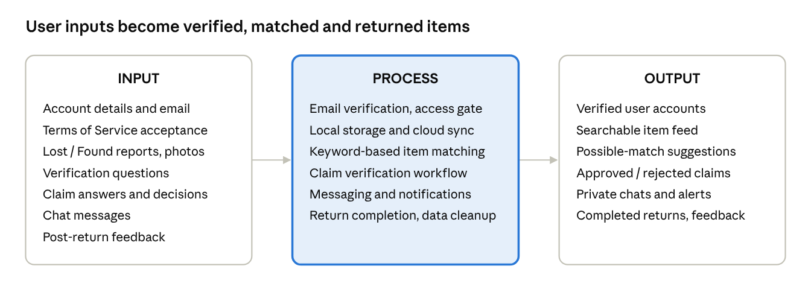
Figure 1. Conceptual Framework (IPO)
The inputs are processed by the app's six core processes to produce verified accounts, a searchable feed, match suggestions, claim decisions and completed returns.

Chapter 3 — Methodology and System Design

3.1 Software Development Methodology
The project followed an Agile, iterative and incremental approach. Features were built in short cycles; each cycle was planned, built, tested on a device and reviewed, and the next cycle added features or fixed problems found in the previous one. This suited a small team whose requirements grew as the app was tried out.
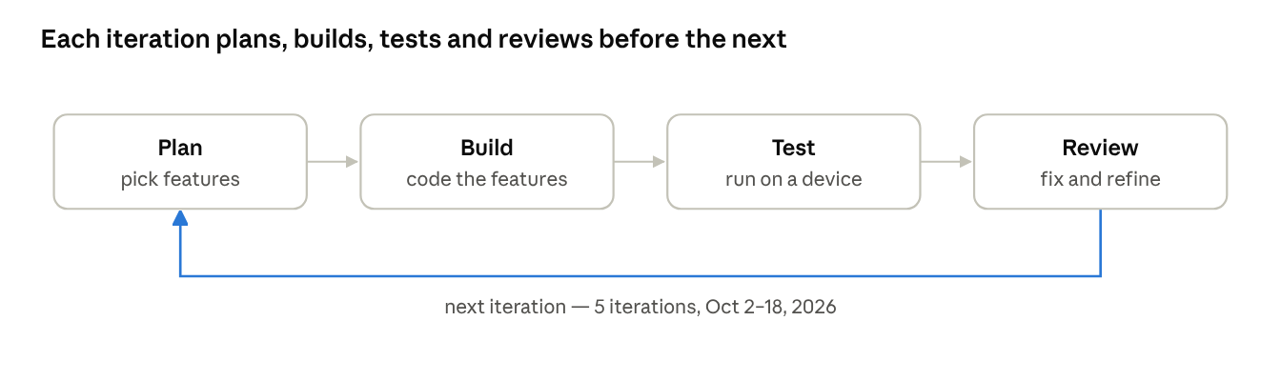
Figure 2. Agile Development Cycle
Iteration | Dates (2026) | Work done
1 — Core app | Oct 2 – Oct 4 | Project set-up, authentication, reporting, home feed, claims, messaging, offline database, Firestore rules
2 — Matching | Oct 4 | Name and category matching on submit, Check Matches in My Posts, match notifications, resend button for rejected claims
3 — Interface | Oct 5 – Oct 13 | User-interface improvements across screens
4 — Trust and safety | Oct 14 – Oct 17 | Email verification, Terms of Service agreement, multiple photos, Lost posts without photos, notification badge, mark as read, post-return feedback
5 — Refinement | Oct 18 | UI refinements, shared feedback widgets, theme updates, automated testing

3.2 Requirements-Gathering Methods
The requirements were defined by the researchers based on their own experience of how lost items are handled on campus, an analysis of the problem, and a review of the related systems in Chapter 2.

3.3 System Requirements
Table 2. Functional Requirements
ID | The system shall…
FR-01 | let a user register with full name, email and password.
FR-02 | send an email-verification link and block access until the email is verified.
FR-03 | let a user log in, log out and request a password-reset email.
FR-04 | require acceptance of the current Terms of Service and record it.
FR-05 | let a user report a Lost or Found item with name, category, location, date, description and up to 5 photos.
FR-06 | require at least one photo and a verification question for Found reports.
FR-07 | show possible matches of the opposite type before a report is submitted and on demand.
FR-08 | display other users' posts with search and filters.
FR-09 | let a user submit one claim per Found item by answering the verification question.
FR-10 | let the finder approve or reject a claim, and let the claimant resend a rejected claim.
FR-11 | record a completed return and delete the item, claim and conversation when a claim is approved.
FR-12 | provide private one-to-one messaging per post with unread counts.
FR-13 | create in-app notifications for claim events and possible matches.
FR-14 | let a user view, filter and delete their own posts.
FR-15 | let both parties of a return give an optional 1–5 rating and recommendation.
FR-16 | save reports, claims, messages and read-status changes made offline and sync them when online.
Table 3. Non-Functional Requirements
Category | Requirement
Security | Only verified users who accepted the Terms can read or write data; users can change only data they own.
Privacy | Claim answers and chats are visible only to the two users involved and are deleted after a return; no passwords are stored on the device.
Availability | The app stays usable without an internet connection.
Reliability | Offline actions are never lost or duplicated during sync.
Usability | Forms show clear errors next to fields; screens follow Material Design.
Portability | Runs on Android smartphones.

3.4 System Architecture
The app uses a layered, offline-first architecture with no custom backend server. The phone talks directly to Firebase and Cloudinary, and Firestore Security Rules enforce access on the server.
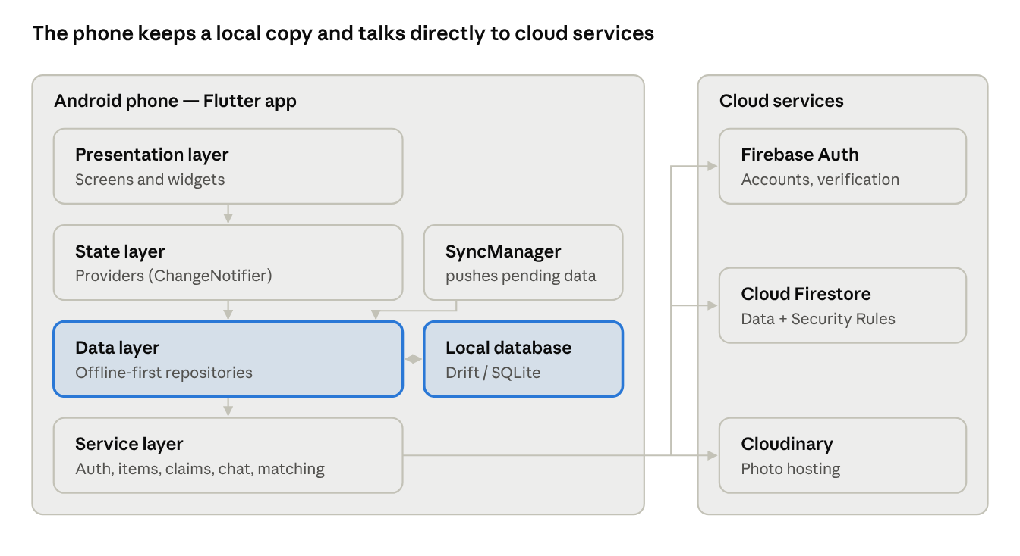
Figure 3. System Architecture
Screens read from the local database through the providers and repositories, so they load even offline; the SyncManager pushes pending changes, and the service layer talks to Firebase and Cloudinary.

3.5 Use-Case Diagram
The app has one human actor, the User, who acts as a Finder when they posted a Found item and as a Claimant when they claim someone else's Found item. There is no administrator.
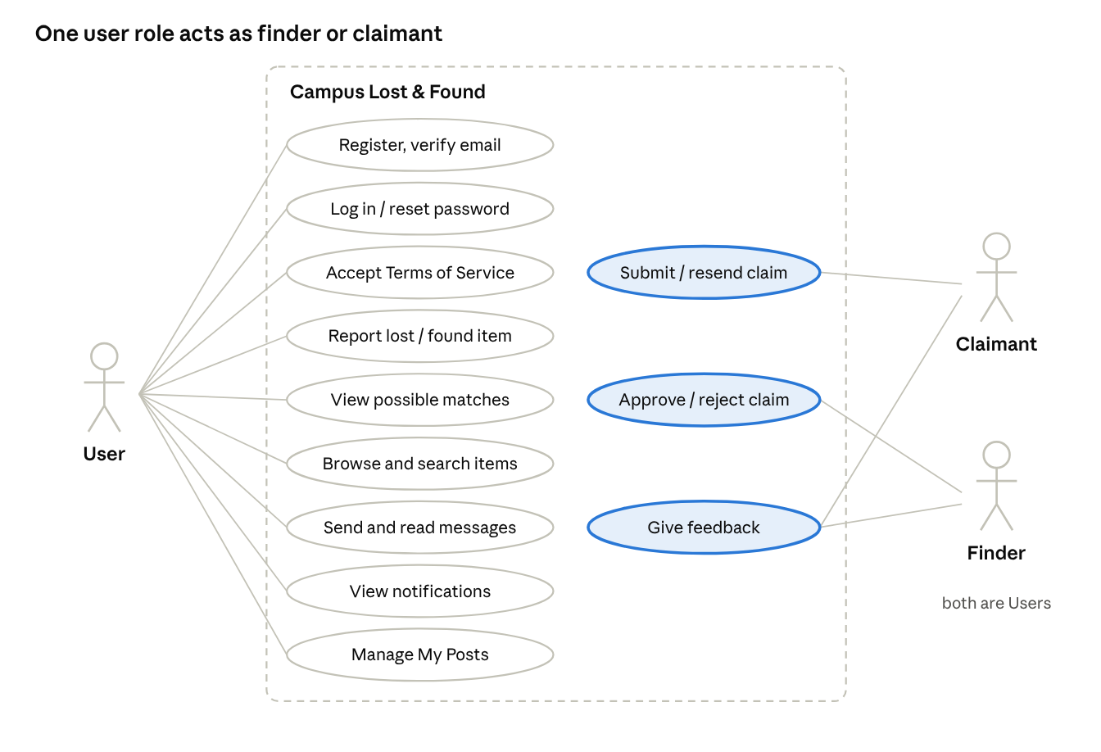
Figure 4. Use-Case Diagram
Table 4. Use-Case Descriptions
Use case | Actor | Main flow | Result
Register and verify | User | Enter name, email, password → open link in email → tap "I've Verified My Email" | Verified account
Accept Terms | User | Read Terms → tap I Accept | User can enter the app
Report item | User | Fill in the form → review possible matches → post | Item visible to others
Submit claim | Claimant | Answer verification question → submit | Pending claim; finder notified
Approve / reject claim | Finder | Read answer in conversation → Accept Claim or Reject | Return recorded, or claimant may resend
Give feedback | Finder, Claimant | Rate 1–5 and add a recommendation | One feedback per user per return

3.6 Data-Flow Diagram
At the context level, the user sends registration data, reports, photos, claims, messages and feedback to the system and receives the item feed, matches, claim status, messages and notifications. The system exchanges credentials and verification requests with Firebase Authentication, stores shared data in Cloud Firestore, and uploads photos to Cloudinary, which returns image URLs.
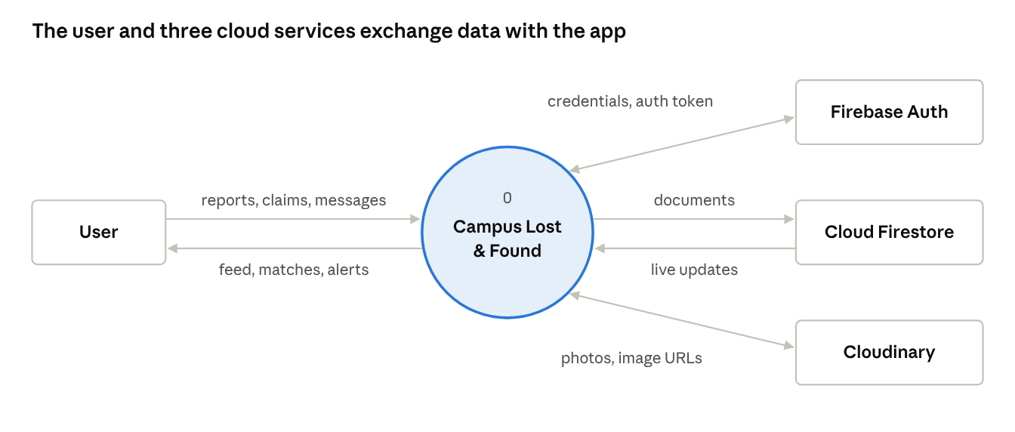
Figure 5. Context Diagram (DFD Level 0)

3.7 Entity-Relationship Diagram
Cloud Firestore is a NoSQL document database, so the diagram below is a logical ERD: relationships are ID fields stored inside documents.
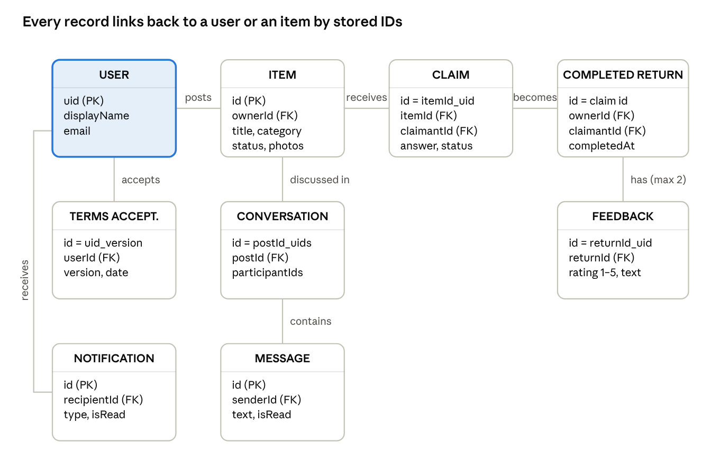
Figure 6. Logical Entity-Relationship Diagram
All relationships are one-to-many except claim → completed return (one-to-one) and completed return → feedback (at most two). Users also submit claims (claimantId) and take part in conversations (participantIds).

3.8 Database Design
Table 5. Firestore Data Dictionary
Collection | Document ID | Main fields
items | UUID v4 (made on the phone) | title, description, category, location, date, status (Lost/Found), imageUrls (0–5), username, ownerId, verificationQuestion, createdAt
claims | itemId_claimantId | itemId, itemTitle, claimantId, claimantName, ownerId, answer, additionalDetails, status (Pending/Approved/Rejected), createdAt
conversations | postId_uidA_uidB | postId, itemName, itemType, participantIds (2), participantNames, lastMessage, lastMessageTime, unreadCounts
conversations/messages | UUID v4 | senderId, senderName, text (1–2000 chars), timestamp, isRead
notifications | auto ID | recipientId, type, title, message, relatedItemId, relatedClaimId, isRead, createdAt
termsAcceptances | uid_version | userId, email, version, acceptedAt
completedReturns | same as claim ID | itemId, itemTitle, ownerId, claimantId, completedAt
feedback | returnId_uid | returnId, authorId, role, otherUserId, rating (1–5), recommendation (≤500), createdAt
The phone keeps a local Drift (SQLite) copy of items, claims, conversations, messages and notifications. Each local table adds sync columns such as synced, pendingCreate, pendingUpdate and pendingDelete.

3.9 Activity and Sequence Diagrams
The claim-to-return flow below shows how a claim moves between the claimant and the finder.
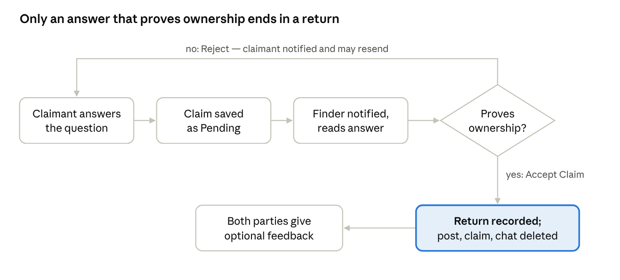
Figure 7. Claim and Return Flow
The item's public status never changes while a claim is pending, so other users cannot see that someone has claimed it.

3.10 User-Interface Design
The app uses Flutter Material components with one custom theme. After the Splash screen and the Access Gate (Login → Verify Email → Terms), the main screens are reached from a bottom navigation bar with five tabs: Home, Messages, My Posts, Notifications and Profile. The Notifications tab shows an unread badge. The report form is divided into numbered steps and scrolls to the first error.

3.11 Hardware and Software Requirements
Table 6. Hardware and Software Requirements
Item | Requirement
End-user device | Android smartphone (Android 7.0 or later recommended) with camera or gallery and internet access for syncing
Development computer | Windows 10/11 PC, 8 GB RAM or more, able to run Android Studio and an emulator
Operating system for development | Windows 11
Framework and language | Flutter SDK, Dart SDK 3.12 or later
IDE | Android Studio
Cloud services | Firebase Authentication, Cloud Firestore, Cloudinary
Testing tools | flutter_test; Node.js, Java and Firebase CLI for security-rules tests

3.12 Development Tools and Technologies
Table 7. Development Tools and Technologies
Tool / Library | Role in the app
Flutter / Dart | Cross-platform UI framework and language
provider | State management
firebase_auth | Accounts, email verification, password reset
cloud_firestore | Cloud database, real-time listeners, transactions
Firestore Security Rules | Server-side access control
Cloudinary (via http) | Photo upload and hosting
image_picker, cached_network_image | Picking photos; caching downloaded photos
drift, sqlite3 | Local database for offline-first storage
connectivity_plus | Detecting online/offline changes
shared_preferences | Remembered accounts and cached Terms acceptance
uuid | Generating document IDs on the phone
Git | Version control

Chapter 4 — System Development, Results, and Discussion

4.1 System Implementation
The app was built in Flutter for Android and connected to a Firebase project using the FlutterFire configuration. Firebase Authentication uses the Email/Password method and also sends verification and password-reset emails. Cloud Firestore stores the shared collections, with Security Rules and composite indexes deployed through the Firebase CLI. Photos are uploaded to Cloudinary over HTTPS and the returned secure URL is saved in the item document. At start-up the app initializes Firebase, creates the local Drift database, the connectivity service, the repositories and the SyncManager, and registers them with Provider.

4.2 Description of System Modules
Table 8. System Modules
Module | Description
Authentication and Access Gate | Registration, email verification (with forced token refresh), login, password reset, remembered accounts. The gate routes users to Verify Email, then Terms, then the main app.
Terms of Service | Version 1.0, nine sections. Accepting creates a termsAcceptances record; declining signs the user out.
Item Reporting | Step-by-step form; the report is saved locally first with a UUID, then photos are uploaded and the document is written to Firestore.
Item Matching | Runs before posting, from My Posts (Check Matches), and when a Found item is posted (notifies owners of similar Lost items in the same category).
Home Feed and Search | Other users' posts, newest first; text search, Lost/Found filter, category cards; item details with a full-screen photo viewer.
Claims and Verification | One claim per user per Found item. The finder sees the answer in a private claim panel inside the conversation and taps Accept Claim or Reject.
Messaging | One conversation per post per pair of users; messages are sent in a Firestore transaction that also updates the preview and unread count.
Notifications | In-app notifications for claim received, approved and rejected, possible matches, and offline reports that finished posting; mark one or all as read.
My Posts | The user's own posts with filters, delete (with confirmation) and Check Matches.
Post-Return Feedback | Celebration animation followed by an optional 1–5 rating and recommendation from each party.
Offline Sync | Pending changes are pushed at sign-in, when the connection returns, and every 30 seconds while work remains.

4.3 User-Interface Presentation
The main screens of the app are: Splash, Login, Register, Verify Email, Terms of Service, Home, Report Item, Possible Matches, Item Details, Claim Item, Messages, Conversation with Claim Panel, Notifications, My Posts, Feedback Sheet and Profile. Screenshots of each screen are placed in Appendix C.

4.4 Database Implementation
All protected collections use one rule helper, hasAccess(), which requires a signed-in user with a verified email and a termsAcceptances record for the current version. Any path not listed in the rules is denied by default.
Collection | Who can read | Who can write
items | Any user with access | Owner only
claims | Claimant and finder | Claimant creates; finder changes status only; delete only when Approved
conversations, messages | The two participants | Participants; message text 1–2000 characters; only the recipient marks as read
notifications | Recipient | Allowed types only; recipient marks as read
termsAcceptances, completedReturns, feedback | Owner / participants | Create-only (cannot be edited or deleted)
Deterministic document IDs (such as itemId_claimantId for claims and returnId_uid for feedback) prevent duplicate claims, chats and feedback. Items and messages use UUIDs generated on the phone, so syncing never creates duplicates.

4.5 Algorithms and Important Code
Item-matching algorithm. Given a report (name, category, type) and a list of candidate items:
- Keep only candidates of the opposite type (Lost ↔ Found), excluding the user's own posts.
- Extract keywords from each name: lowercase, remove symbols, drop stop words and colors, drop numbers, remove plural endings, and replace synonyms with one common word (Table 9).
- Require at least one shared keyword.
- Apply the accessory guard: both names must have the same accessory words, so "phone" does not match "phone charger".
- Compute the name score: 1.00 for identical names, 0.95 for the same keyword set, 0.85 when one set contains the other, otherwise the Jaccard index (minimum 0.40).
- Final score = 0.7 × name score + 0.3 if the categories match. Sort by score and return the top results.
\text{score} = 0.7 \cdot \text{nameScore} + 0.3 \cdot [\text{sameCategory}], \qquad J(A,B) = \frac{|A \cap B|}{|A \cup B|}
Table 9. Synonym Groups
Common keyword | Treated as the same
phone | mobile, cellphone, cell, smartphone, telephone, iphone, android
tablet | ipad, tab
laptop | macbook
earphone | earbud, headphone, headset, airpod
wallet | purse, billfold
key | keychain, keyring
bag | backpack, handbag, knapsack
bottle | tumbler, flask
glasses | eyeglasses, spectacles
Example: a Lost "Black Mobile Phone" and a Found "iPhone 13", both Electronics, share the keyword set {phone}, so the score is 0.7 × 0.95 + 0.3 = 0.965. A Lost "Phone" and a Found "Phone Charger" are not matched because of the accessory guard.
Offline queue and conflict handling. Every write goes to the local database first with a pending flag, then the app tries to push it immediately. When server data arrives, a local row with a pending change is kept, so local edits are never overwritten before upload. Messages are written with a transaction that first checks whether the message ID already exists.
Return completion. When the finder approves: (1) the claimant is notified, (2) the claim is set to Approved, (3) a completedReturns record is written, and (4) the messages, conversation, item and claim are deleted in batches.

4.6 System Testing
Two kinds of testing were used: automated tests run with flutter test (unit tests of the offline database and a widget test), and functional testing of each feature on an Android device by the researchers.

4.7 Test Cases and Results
Table 10. Automated Test Results (flutter test, October 18, 2026)
Test group | Tests | Passed
Local database: items (create, update, delete, pending queries) | 5 | 5
Local database: cross-account visibility | 2 | 2
Local database: server sync and conflict handling | 4 | 4
Local database: messages (no duplicates, pending kept) | 3 | 3
Local database: claims | 2 | 2
Local database: read status | 2 | 2
Local database: logout cache clearing | 2 | 2
Widget: celebration animation | 1 | 1
Total | 21 | 21
Table 11. Functional Test Cases
TC | Test | Expected result | Result
01 | Register with mismatched passwords | "Passwords do not match."
02 | Try to enter the app before verifying the email | Verify Email screen is shown
03 | Decline the Terms of Service | User is signed out
04 | Log in with a wrong password | "Invalid email or password."
05 | Submit a Found report with no photo | Photo error shown; form scrolls to it
06 | Submit a Lost report with no photo | Post is created
07 | Add a 6th photo | "You can add up to 5 photos."
08 | Report Lost "Mobile Phone" while Found "iPhone 13" exists | Shown in Possible Matches
09 | Search "wallet" and filter by Found | List filtered correctly
10 | Claim a Found item | "Request Submitted"; finder gets a notification and message
11 | Claim the same item twice while pending | "You already submitted a claim for this item."
12 | Finder rejects the claim | Claimant notified; Resend Claim available
13 | Finder accepts the claim | Confetti and feedback form; item, chat and claim removed
14 | Send a message | Appears for both; unread count increases
15 | Report an item in airplane mode, then reconnect | Post shown as pending, then synced; "Report Posted" notification
16 | Log out of account A and log in as B on the same phone | B cannot see A's chats or notifications

4.8 Security and Data-Privacy Measures
Table 12. Security Measures
Measure | Where enforced
Email verification required | Firebase Auth token + hasAccess() rule
Terms of Service acceptance recorded | Create-only termsAcceptances + hasAccess()
Only the owner can change or delete a post | items rules
Claim answers visible only to claimant and finder | claims rules
Chats private to two participants; messages cannot be edited | conversations and messages rules
Audit records cannot be changed | Create-only completedReturns and feedback
Deny by default | Catch-all rule denies every other path
Data minimization after return | Item, claim, chat and messages deleted on approval
No passwords on the device | Remembered accounts store only name, email and photo
Encrypted transport | All Firebase and Cloudinary traffic uses HTTPS

4.9 Discussion of Findings
All seven specific objectives were implemented. Users can report items with photos, browse and search them, receive keyword-based match suggestions, claim items through a private verification question, chat, and receive notifications, while the offline-first database keeps the app usable without a connection. All 21 automated tests passed, confirming that offline changes are queued, conflicts favor unsynced local edits, and messages are never duplicated.
A key problem during development was Firestore permission errors when starting new chats and claims. It was solved with deterministic document IDs, which also enforce one claim per user per item. The main limitations are that matching uses item names only, notifications are in-app only, and some business logic (match notifications and return cleanup) runs on the phone rather than on a server.

Chapter 5 — Summary, Conclusions, and Recommendations

5.1 Summary of the Project
This project developed Campus Lost & Found, an Android application for BISU Candijay Campus that helps users report, match, verify and return lost and found items. It was built with Flutter and Dart, using Firebase Authentication for accounts, Cloud Firestore for shared data, Cloudinary for photos and a local Drift (SQLite) database for offline use, following an Agile, iterative approach. The finished app provides verified registration with a recorded Terms of Service agreement, Lost and Found reporting with up to five photos, keyword-based match suggestions, a private claim workflow with a finder-defined verification question, one-to-one messaging, in-app notifications, post-return feedback, and automatic offline synchronization. All 21 automated tests passed.

5.2 Conclusions
- The reporting module collects the essential details of lost and found items, including photos, in one central place.
- The searchable and filterable feed lets users find relevant posts by name, category, location and type.
- The keyword-based matching method, with synonyms, an accessory guard and category weighting, suggests relevant opposite-type reports, although its accuracy is limited because it compares item names only.
- The verification-question workflow gives finders a structured way to confirm ownership before returning an item, and the Security Rules keep claim answers private.
- Private messaging and in-app notifications keep claimants and finders informed throughout a claim.
- The offline-first design keeps reports, claims and messages when there is no connection and syncs them later, as confirmed by the automated database tests.
- Email verification, Terms acceptance and ownership-based Security Rules limit data access to authorized users.

5.3 Recommendations
- Move notification creation and return cleanup to the server (Firebase Cloud Functions) to prevent spoofed notifications and incomplete cleanups.
- Delete photos from Cloudinary when a post is deleted or returned, and use signed uploads.
- Add pagination to the Home feed so the app stays fast as posts grow.
- Conduct a formal usability evaluation (for example ISO/IEC 25010 or the System Usability Scale) with students and employees of BISU Candijay Campus.
- Coordinate with the campus office that handles surrendered items so the app can complement the existing process.

5.4 Proposed Future Enhancements
Enhancement | Basis in the current app
Edit an existing post | Menu option exists but is not yet implemented
Profile management and in-app password change | Profile options show "coming soon"
Reporting inappropriate posts, warnings and temporary bans | Already modeled in the Security Rules and the Terms
Administrator or campus-office dashboard | No admin role yet
Push notifications, including new-message alerts | Notifications are in-app only
Smarter matching using description, location, date, photos and Filipino terms | Matching uses English item names only
iOS version | Only Android is configured

References
Books and laws
- Data Privacy Act of 2012, Republic Act No. 10173 (2012). National Privacy Commission. https://privacy.gov.ph/data-privacy-act/
- Manning, C. D., Raghavan, P., & Schütze, H. (2008). Introduction to information retrieval. Cambridge University Press.
Journal articles and studies
- Itaagi, B., Jr. (2023). A mobile application for finding lost items (SearchiT) [Undergraduate project, Makerere University]. Makerere University Dissertations
- Kleppmann, M., Wiggins, A., van Hardenberg, P., & McGranaghan, M. (2019). Local-first software: You own your data, in spite of the cloud. In Proceedings of the 2019 ACM SIGPLAN International Symposium on New Ideas, New Paradigms, and Reflections on Programming and Software (Onward! '19). ACM. https://doi.org/10.1145/3359591.3359737
- Ngu, K. C. (2025). FindIt: Simplifying campus item recovery with AI-driven lost and found app [Undergraduate project, Universiti Malaysia Sarawak]. UNIMAS ScholarHub
- Oyedeji, A. O., Folorunsho, O., Abolade, O. R., & Eigbiremonlen, N. I. (2021). Development of a web-based system for matching losers and finders of personal items. Mindanao Journal of Science and Technology, 19(1), 293–306. Article PDF
- Rahim, R., & Arbain, S. H. (2026). UTHM Losthub: Mobile application for lost and found items in UTHM. Applied Information Technology and Computer Science, 7(1), 879–896. Article page
- Saleh, Y. N. (2020). Smart lost and found Android application for university using machine learning [Graduation project, MSA University]. MSA Repository
Technical documentation
- Cloudinary. (n.d.). Upload API reference. Retrieved October 18, 2026, from https://cloudinary.com/documentation/image_upload_api_reference
- Google. (n.d.). Cloud Firestore. Firebase. Retrieved October 18, 2026, from https://firebase.google.com/docs/firestore
- Google. (n.d.). Firebase Authentication. Firebase. Retrieved October 18, 2026, from https://firebase.google.com/docs/auth
- Google. (n.d.). Flutter documentation. Retrieved October 18, 2026, from https://docs.flutter.dev
- Binder, S. (n.d.). Drift documentation. Retrieved October 18, 2026, from https://drift.simonbinder.eu

Appendices

Appendix A — User Manual
- Register. On Login, tap Register. Enter Full Name, University Email, Password and Confirm Password, then tap Create Account.
- Verify your email. Open the link sent to your inbox, return to the app and tap "I've Verified My Email".
- Accept the Terms. Read the Terms of Service and tap I Accept.
- Report an item. On Home, tap the report button, choose Lost or Found, add photos (required for Found), fill in name, category, location, date and description. For Found items, write a verification question only the owner can answer. Review any possible matches, then post.
- Find items. Use the search bar, the Lost/Found filter and the category cards. Tap a post to see details and photos.
- Claim a found item. Open the Found post, tap Claim, answer the verification question and add details. Follow the conversation in Messages. If rejected, tap Resend Claim with better details.
- Handle a claim (finder). Open the "Claim Request Received" notification, read the answer in the claim panel, and tap Accept Claim or Reject. After accepting, arrange the hand-over in person.
- Give feedback. After a return, rate the experience from 1 to 5 stars and add an optional recommendation.
- Log out. Profile → Log Out.

Appendix B — Installation Guide
End user: copy the APK to the Android phone, allow installation from this source when asked, then open the APK and tap Install.
Developer setup:
- Install the Flutter SDK, Android Studio, Git, Node.js, Java (JDK) and the Firebase CLI.
- Run flutter pub get.
- Create a Firebase project, enable Email/Password authentication and Cloud Firestore, and connect the Android app with flutterfire configure.
- Deploy rules and indexes: firebase deploy --only firestore:rules,firestore:indexes.
- Create an unsigned Cloudinary upload preset and set the cloud name and preset in cloudinary_service.dart.
- Run with flutter run, or build with flutter build apk --release.
- Run the tests with flutter test.

Appendix C — Screenshots
Insert screenshots of: Login, Register, Verify Email, Terms of Service, Home, Report Item, Possible Matches, Item Details, Claim Item, Messages, Conversation with Claim Panel, Notifications, My Posts, Feedback Sheet and Profile.

Appendix D — Sample Source Code
Matching score (item_matching_service.dart)
// The item names must share at least one keyword.
final shared = draftTokens.intersection(candidateTokens);
if (shared.isEmpty) continue;
// Accessory guard: "phone" must not match "phone charger".
final draftAccessories = draftTokens.intersection(_accessoryWords);
final candidateAccessories = candidateTokens.intersection(_accessoryWords);
if (draftAccessories.length != candidateAccessories.length ||
!draftAccessories.containsAll(candidateAccessories)) {
continue;
}
final sameCategory = draftCategory.isNotEmpty &&
_normalize(candidate.category) == draftCategory;
final nameScore = _nameSimilarity(
draftName, _normalize(candidate.title), draftTokens, candidateTokens);
// Name is the main signal; same category is a bonus.
final score = (0.7 * nameScore) + (sameCategory ? 0.3 : 0.0);
Access gate in the Security Rules (firestore.rules)
function isVerified() {
return request.auth != null
&& request.auth.token.email_verified == true;
}
function hasAcceptedTerms() {
return exists(/databases/$(database)/documents/termsAcceptances/$(
request.auth.uid + '_' + requiredTermsVersion()));
}
function hasAccess() {
return isVerified() && hasAcceptedTerms();
}
Sync pass (sync_manager.dart)
Future<void> syncNow() async {
if (_isSyncing) return;
final uid = _currentUserId;
if (uid == null) return;
_isSyncing = true;
try {
if (!await connectivity.checkNow()) return;
await itemRepository.pushPending(uid);
await claimRepository.pushPending(uid);
await chatRepository.pushPending(uid);
await notificationRepository.pushPending(uid);
} finally {
_isSyncing = false;
await _scheduleRetryIfNeeded();
}
}

Appendix E — Researchers' Profiles
Name | Program | Role
Mark Jeshmer B. Jaromahum | BS Computer Science
Feny Ann V. Cervantes | BS Computer Science
Jules J. Tuyogon | BS Computer Science
Jotham Aaron Puracan | BS Computer Science

