## Part 3 – Trump Tweets classifier

### General

In this part we were requested to create a supervised classifier that classifies Trump twitter tweets. The dataset contains tweets from two sources (iphone, Android) and the hypothesis is that the tweet original distribution is different between the sources.

### Classifier 1 –Bert + custom FC classifier on tweet text only

This classifier passes the tweets text in a bert model, passes the last hidden state through mean pooling to reduce one dimension, then uses an FC layer for classification. The model does not use any other data beside the text itself. Train / Validation performance can be seen below.

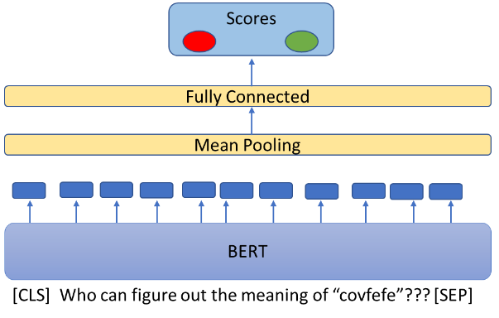

**Train / Validation performance:**

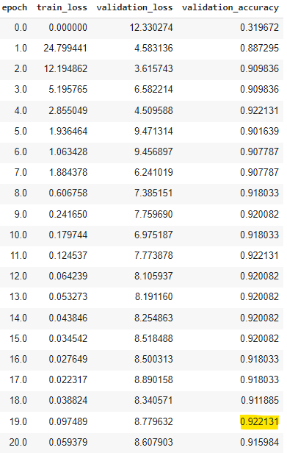 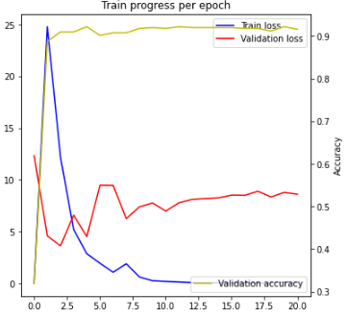

### Classifier 2 – Classification using the tweet text + hand crafted features. using Bert + FC layers

This is a more complex classifier, which gets both the tweets text and a list of hand-crafted attributes. The texts are passed in a BERT model, then mean pooling, and then an FC layer that keeps the same dimensions as the input, producing output (a). In parallel, hand featured attributes are passed through an FC layer, producing output (b).

Both inputs (a) and (b) are then concatenated and the concat vector is passed through a 2-layered MLP to produce the class predictions. side is the same as Classifier1, but the passes the tweets text in a BERT model, passes the last hidden state through mean pooling to reduce one dimension, then uses an FC layer for classification.

Hand-crafted Attributes:

* “Dumb retweet” – retweeted another tweet using copy/paste
* Percent capital letters in the tweet
* Contains URL - Boolean
* Number of hashtags in tweet
* Date/Time attributes: hour, minute, day, month, year, weekday

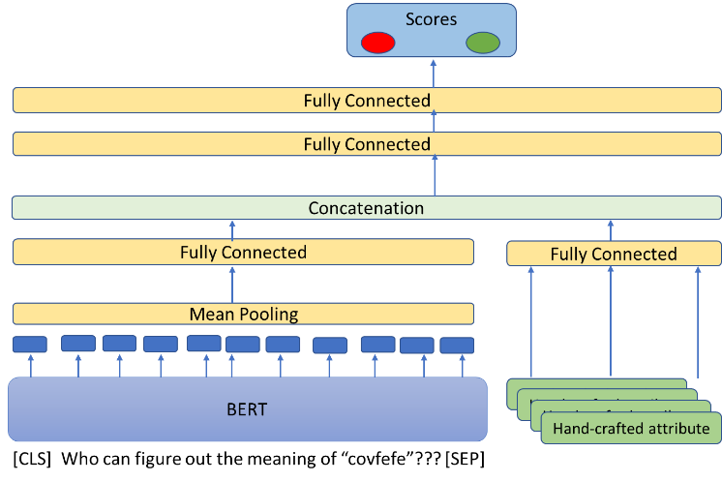

### Model selection for test

We decided to run on the test set with model Classifier2, trained on the entire dataset for 12 epochs.

**Train / Validation performance:**

