Name: Maryam Tahir
Registration no: SP23-BCS-068
Course Title: Data Science
Credit Hours: 03
Submitted To: Sir Fakhar Mustafa

Q1: Significance of data science in decision-making
Healthcare:
Data science enables predictive models (e.g., risk of readmission, disease progression). Hospitals use patient history + labs to prioritize care and reduce costs — e.g., predicting sepsis early so clinicians intervene sooner.
Finance:
Fraud detection (anomaly detection on transactions), credit scoring (predict default risk using past behaviour), and algorithmic trading (models that act on real-time signals) — these reduce losses and automate decisions.
Manufacturing / Supply chain:
Predictive maintenance (use sensor data to schedule repairs before failure), inventory optimization (reduce stockouts/overstock).
Overall:
Data science converts raw data into actionable insight (predictions, segmentation, optimization) that improves speed, quality, and cost-effectiveness of decisions.

2. Typical steps in the data science process & why each matter
Data collection:
Gather relevant raw data (databases, sensors, APIs). Why: if data is missing or biased, downstream analysis will be wrong.

Data cleaning / preprocessing:
Handle missing values, outliers, inconsistent formats, type conversions. Why: garbage in → garbage out; cleaning ensures model correctness and stability.
Data exploration / EDA (exploratory data analysis):
Summary statistics, visualizations, correlation checks. Why: reveals distributions, relationships, and informs feature engineering and modelling choices.
Feature engineering:
Create or transform variables (scaling, encoding, aggregations). Why: better features often improve model accuracy more than complex models.
Modelling:
Choose and train models (regression, tree-based, etc.). Why: produces predictions / inferences used for decisions.
Evaluation & validation:
Use metrics, cross-validation, confusion matrix, etc. Why: ensures model generalizes and avoids overfitting.
Deployment & monitoring:
Put model into production and monitor performance (drift). Why: ensures continued utility and catches degradation over time.

Q2 — Vectors & Lists
Emp_ID | Name | Age | Dept | Salary | Gender | Experience
E1 X 34 HR 50000 Male 5
E2 Y 29 IT 60000 Female 3
E3 Z 40 Finance 70000 Male 10
E4 X 30 Marketing 80000 Female 4
E5 Y 35 HR 50000 Male 2
E6 Z 27 IT 65000 Female 7
E7 X 41 Finance 45000 Male 9
E8 Y 30 Marketing 60000 Female 6.
i. Extract Salary column as a vector & average salary
Salaries: 50000, 60000, 70000, 80000, 50000, 65000, 45000, 60000.
Sum = 480,000. Number of employees = 8.
Average salary = 480000 / 8 = 60,000.
ii. Ages vector; minimum and maximum ages
Ages vector: 34, 29, 40, 30, 35, 27, 41, 30.
Minimum age = 27.
Maximum age = 41.
iii. Create a list for a single employee and display each element
Example list for employee E3 (Name Z, Dept Finance, Age 40, Salary 70000):

#create a list for employee E3
emp_E3 <- list (Name = "Z", Dept = "Finance", Age = 40, Salary = 70000)
#display each element
emp_E3$Name emp_E3$Dept emp_E3$Age emp_E3$Salary
#or print all
print(emp_E3)

iv. Why lists are advantageous over vectors when storing multiple types
- Vectors in R are homogeneous (all elements must be same type: numeric, character, etc.).
- Lists are heterogeneous and can store multiple types (strings, numbers, other lists, data frames).
- Thus, lists are appropriate for storing complex records (an employee with name (character), age (numeric), salary (numeric), and nested structures) without coercion.
v. R code to calculate mean, standard deviation, and correlation

#Create the dataset in R
emp <- data.frame( Emp_ID = c("E1","E2","E3","E4","E5","E6","E7","E8"), Name = c("X","Y","Z","X","Y","Z","X","Y"), Age = c(34,29,40,30,35,27,41,30), Dept = c("HR","IT","Finance","Marketing","HR","IT","Finance","Marketing"), Salary = c(50000,60000,70000,80000,50000,65000,45000,60000), Gender = c("Male","Female","Male","Female","Male","Female","Male","Female"), Experience = c(5,3,10,4,2,7,9,6) )
#mean and sd of Salary
mean_salary <- mean(emp$Salary) # 60000 sd_salary <- sd(emp$Salary)
#mean and sd of Age
mean_age <- mean(emp$Age) sd_age <- sd(emp$Age)
#correlation examples:
#correlation between Salary and Experience
cor_salary_exp <- cor(emp$Salary, emp$Experience)
#correlation between Salary and Age
cor_salary_age <- cor(emp$Salary, emp$Age)
#print results
mean_salary; sd_salary mean_age; sd_age cor_salary_exp; cor_salary_age
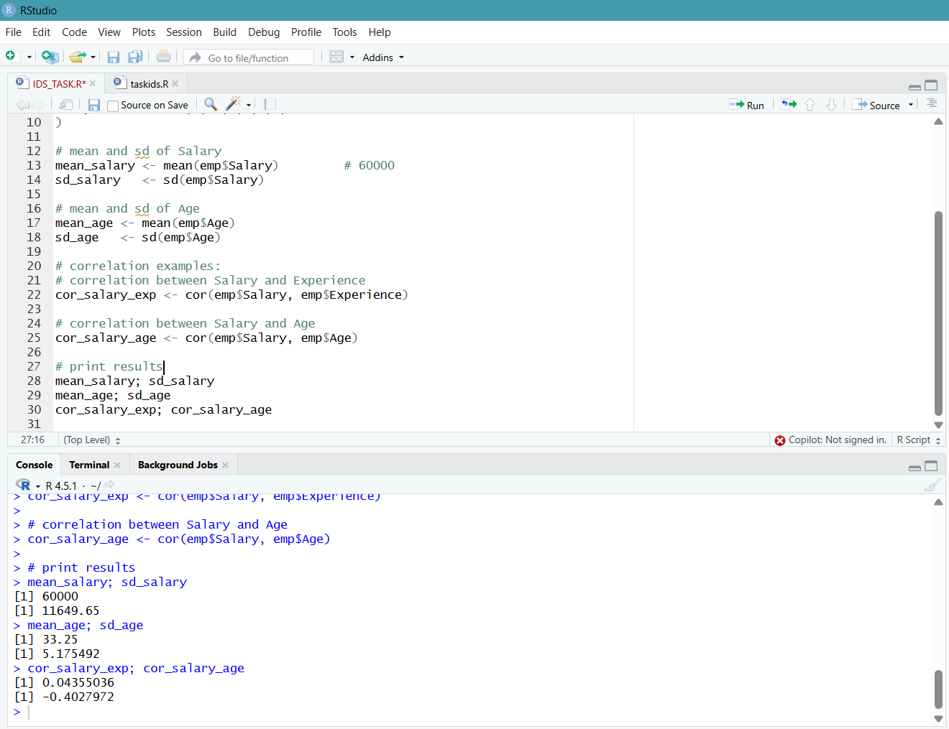
Q3 — Data visualization with mtcars
i. Scatter plot: horsepower (hp) vs miles per gallon (mpg) with trend line
# Install ggplot2 if not already installed
# install.packages("ggplot2")
library(ggplot2)
data(mtcars) # load mtcars
# mtcars: has columns mpg, cyl, hp, wt, etc.

i. Scatter plot: horsepower (hp) vs miles per gallon (mpg) with trend line
ggplot(mtcars, aes(x = hp, y = mpg)) +
geom_point() +
geom_smooth(method = "lm", se = TRUE) + # linear trend line with confidence band
labs (title = "Relationship between Horsepower and Miles per Gallon",
x = "Horsepower (hp)",
y = "Miles per Gallon (mpg)") +
theme minimal ()
Explanation:
geom_point() plots each car as a point.
geom_smooth(method = "lm") fits and draws a linear regression line; se = TRUE shows the confidence band.
Typically, hp and mpg are negatively correlated: as horsepower increases, mpg tends to decrease (cars with more power often consume more fuel). The trend line quantifies that relation.
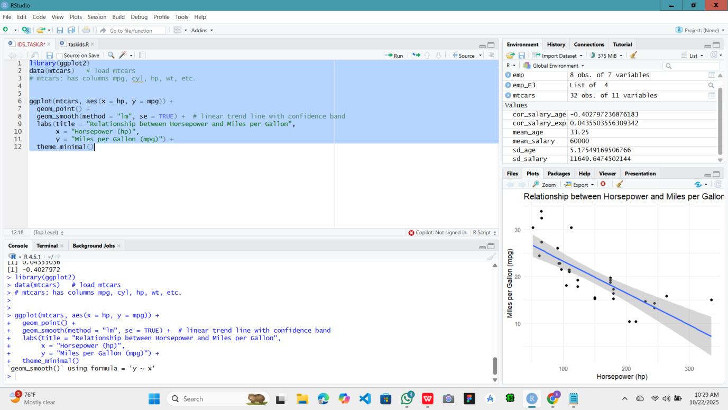
ii. Box plot:
compare mpg distribution across cylinders (cyl)
# Make cyl a factor so boxplot groups by cylinder count categories
mtcars$cyl_f <- factor(mtcars$cyl, levels = sort(unique(mtcars$cyl)))
ggplot(mtcars, aes(x = cyl_f, y = mpg)) +
geom_boxplot() +
labs(title = "Distribution of MPG by Number of Cylinders",
x = "Number of Cylinders",
y = "Miles per Gallon (mpg)") +
theme_minimal()
Explanation:
Turning cyl into a factor ensures discrete categories (4, 6, 8 cylinders).
The boxplot shows median mpg, interquartile range, and outliers per cylinder group. Usually, 4-cylinder cars have higher mpg than 6- and 8-cylinder cars; the plot makes these differences clear.
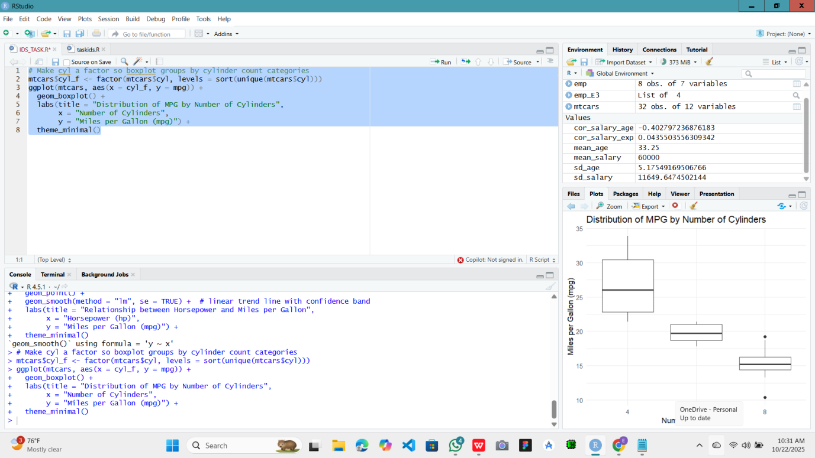
ii. Histogram:
distribution of car weights (wt) with chosen bins
# mtcars$wt is in 1000s of lbs (thousands of lbs)
ggplot(mtcars, aes(x = wt)) +
geom_histogram(bins = 8, boundary = 0) + # adjust bins as desired
labs(title = "Distribution of Car Weights (wt) in mtcars",
x = "Weight (1000 lbs)",
y = "Count") +
theme_minimal()
Explanation & tips:
bins = 8 provides a reasonable balance between detail and smoothing; you can change to bins = 6 or bins = 12 to see broader or finer detail.
wt is weight in units of 1000 lbs (so wt = 3 means 3000 lbs). The histogram reveals whether weights cluster around a central value or are spread out, and whether there are multiple modes (clusters).
