**1**

**a)Single-Linkage**

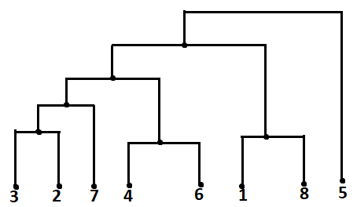

**b)Complete-Linkage**



