Meryem AKDENİZ

2018280004

**1**

**a)Single-Linkage**

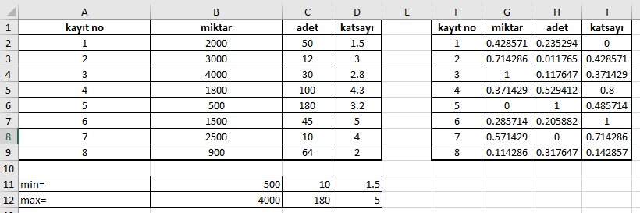

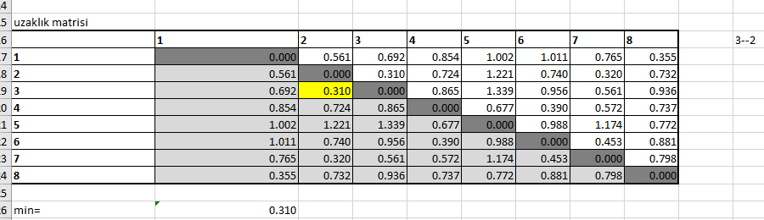

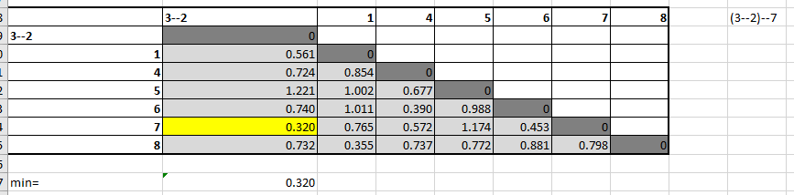

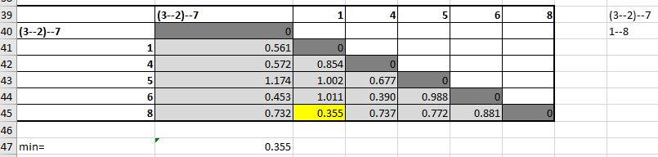

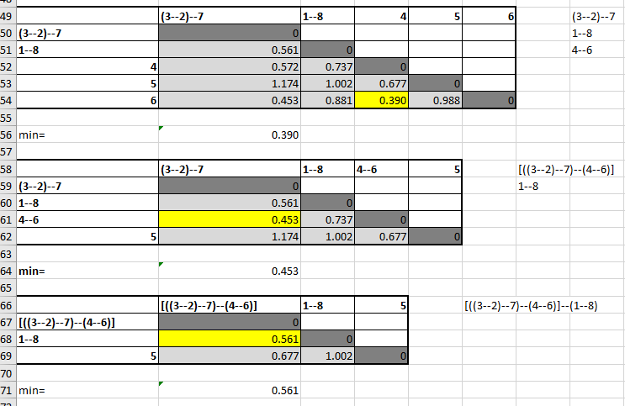

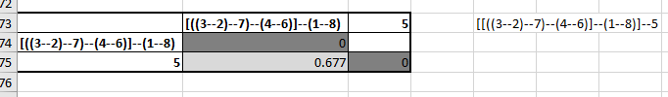

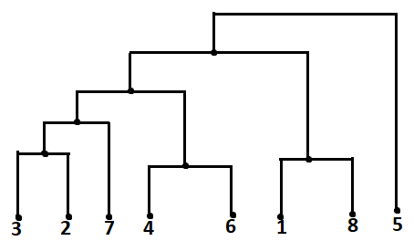

**b)Complete-Linkage**



