university of westminster

5BUIS019W Business Analytics Coursework (2024/25)

Salma Chahed

20-04-2025

**Student Name: Maryam Abbasi**

**Student ID: w2001181**

Contents

**Part A: Forecasting** 2

**Question 1** 2

**Question 2** 4

**Question 3** 4

**Question 4** 5

**Part B: Simulation** 5

**Scenario 1 Analysis** 5

**Scenario 2 Analysis** 5

# **Part A: Forecasting**

## **Question 1**

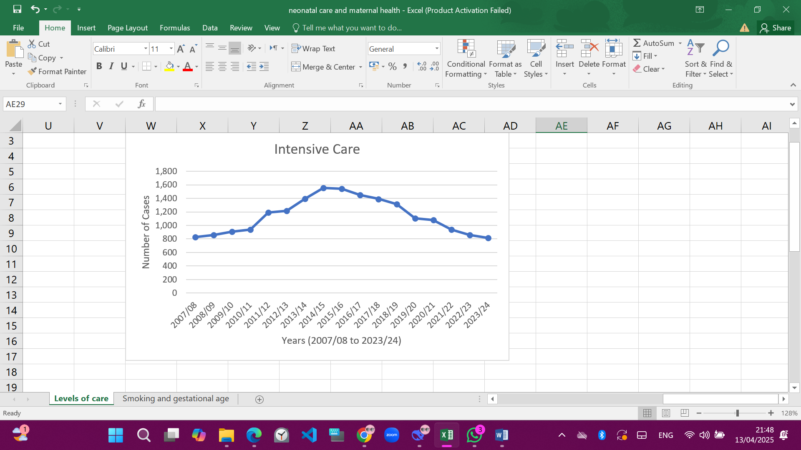

**Graph 1: Intensive Care**

The Intensive Care time series displays a distinctive inverted U-shape, indicative of a non-monotonic trend. From 2007/08 to 2014/15, there is a consistent upward trajectory in admissions, reaching a peak of approximately 1,600 cases. This is followed by a marked decline through 2023/24, where admissions return to near-baseline levels. The trend may reflect evolving clinical practices, healthcare policy changes, or advancements in early interventions. The absence of seasonality is expected in annual data, and the noise appears minimal, with year-to-year variability not overshadowing the overall pattern.



**Graph 2: High Dependency**

The High Dependency care series demonstrates a **steady upward trend** over the 17-year span. From 581 cases in 2007/08, the number rises consistently, culminating in a peak of 1,328 cases in 2023/24. This sustained growth suggests an increasing reliance on intermediate neonatal care, which may reflect changing clinical guidelines, improved neonatal survival, or shifts in categorization practices. The time series does not exhibit seasonal patterns, which is expected from annual data, and the noise level is minimal, indicating a robust trend.



**Graph 3: Special Care**

Special Care cases have steadily **declined** over the 17-year period from 2007/08 to 2023/24. Starting at 4,755 cases, the number drops consistently year after year, reaching a low of 2,340 cases in the final year. This strong downward trend suggests a **reduced reliance on basic-level neonatal care**. There is no noticeable seasonality, and yearly fluctuations are relatively small, making this a very clean, trend-driven series.

## **Question 2**

**Comparison of Forecasting Methods**

Three forecasting techniques were applied to predict Special Care admissions: Naïve Forecast, 4-Period Moving Average, and Exponential Smoothing.

The Naïve method resulted in a MAPE of approximately 11.10%, indicating moderate forecasting accuracy by simply carrying forward the previous value.

The 4-Period Moving Average achieved a very similar MAPE of approximately 11.12%, offering slight smoothing over short-term fluctuations but no significant improvement compared to the Naïve method.

In contrast, Exponential Smoothing, using an optimized smoothing constant (α) and achieving a MAPE of approximately 16.70%, did not outperform the simpler methods in this case.

Given the relatively lower MAPE values, the Naïve and Moving Average methods are recommended for short-term forecasting of Special Care admissions in this dataset, as they provided more reliable accuracy compared to Exponential Smoothing.

Table 1

|  |  |
| --- | --- |
| **Forecasting Method** | **Mean Absolute Percentage Error (MAPE)** |
| Naïve Forecast | 11.10% |
| 4-Period Moving Average | 11.12% |
| Exponential Smoothing | 16.70% |

Table 1 summarizes the Mean Absolute Percentage Error (MAPE) for each forecasting method applied. The Naïve Forecast and 4-Period Moving Average showed similar and lower error rates compared to Exponential Smoothing.

## **Question 3**

Based on the evaluation of forecasting methods, the Naïve Forecast was selected as the most appropriate approach for predicting Special Care admissions.

It achieved the lowest Mean Absolute Percentage Error (MAPE) of approximately 11.10%, indicating higher forecasting accuracy compared to the 4-Period Moving Average and Exponential Smoothing methods.

Using the Naïve method, the forecasted number of Special Care admissions for the year 2024/25 is 2340 neonates, based on the observed value from 2023/24.

## **Question 4**



A simple linear regression analysis was conducted to explore the relationship between maternal smoking during pregnancy and the proportion of preterm births.

The resulting regression equation was:

Preterm Births (%) = 0.6683 × Smoking During Pregnancy (%) − 9.6002

Preterm Births (%) = 0.6683 × Smoking During Pregnancy (%) − 9.6002

The R-squared value of 0.8734 indicates a powerful positive relationship between smoking during pregnancy and the incidence of preterm births.

This suggests that higher rates of maternal smoking are strongly associated with an increased proportion of babies born before 37 weeks of gestation.

These findings align with established medical research that identifies smoking as a significant risk factor for premature birth.

# **Part B: Simulation**

## **Scenario 1 Analysis**

The average total time spent in the Emergency Department under Scenario 1 (1 nurse and 1 doctor) was 34 minutes. The simulation suggests that limited staffing can lead to longer patient waiting times, especially as patient flow increases. Delays were observed particularly in triage and doctor consultations due to resource bottlenecks. This highlights the potential need for additional staffing to reduce patient total time in ED and improve service delivery.

## **Scenario 2 Analysis**

Two simulation scenarios were compared to evaluate patient flow through the Emergency Department (ED).

In Scenario 1 (1 nurse, 1 doctor), the average total time spent in the ED was 34 minutes, with noticeable delays due to limited triage and doctor availability.

In Scenario 2 (2 nurses, 1 doctor), the average total time in the ED improved to 30 minutes, demonstrating that increasing the number of triage nurses significantly reduced waiting times for triage, although bottlenecks still occurred at the doctor stage.

Overall, the simulation indicates that while adding a second triage nurse improves initial patient flow and reduces time spent waiting for triage, overall ED performance is still constrained by the availability of only one doctor. Further improvements could be achieved by addressing doctor availability alongside triage capacity. Overall, the simulation highlights the importance of strategic staffing decisions to optimize patient flow and reduce delays within emergency care services.