START-TO-FINISH SETUP
DaVinci 200 to ASTAR Middleware
Follow the screens in this order.
1  ToolCommander | 2  Host Interface ON | 3  Port 5000 LISTENING | 4  ASTAR connected | 5  Online Local

DAVINCI CONTROL PC | ASTAR MIDDLEWARE PC
ToolCommander  Host Interface = Server  TCP/IP Port = 5000 | production.yaml  hsms_mode = active  host = DaVinci IPv4

If all three GEM State fields look gray
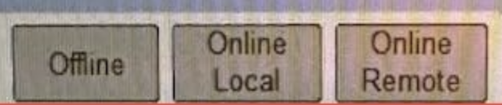
Your current GEM State strip.
MEANING: This is not a documented GEM state. Do not call it Offline.
ACTION: Open Components > Host Interface (Global) > Operation.
READ: FabLink Connection, HSMS State, Communications State, and Control State.
EXPECTED: A normal top strip has one colored field: red, yellow, or green.
A gray ToolCommander header monitor labeled Disabled is a separate indicator. It means host communication is disabled or not installed.

Step 1 - Start the DaVinci
LOCATION: DaVinci cabinet and control screen.
ACTION: If ToolCommander is already visible, do not power-cycle. Go to Step 2.
EXPECTED: ToolCommander is open.
IF WRONG: If the machine is fully off, use the cold-start actions below.
COLD START 1: Turn the Main Power Switch clockwise.
COLD START 2: Wait about 30 seconds.
COLD START 3: Press Main Switch (I).
COLD START 4: Wait for Windows and ToolCommander.
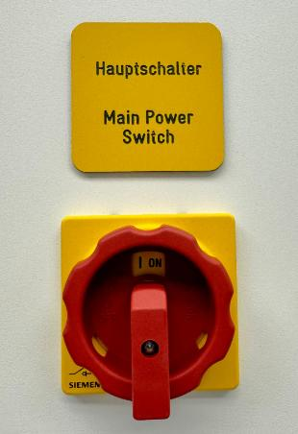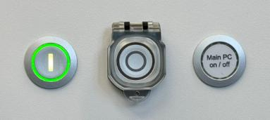
Cold start: Main Power Switch ON, then Main Switch (I). Source: Maintenance Manual, p. 18.
Do not press Init Machine for this setup
Initialization can move hardware. It does not open TCP port 5000.

Step 2 - Log in
LOCATION: ToolCommander > bottom-right User Options... > Log On.
ACTION: Enter an authorized user name and password. The account needs Change Parameters and Control Fab Hostinterface.
EXPECTED: You can save Parameters and operate Offline or Online Local.
IF WRONG: Ask the tool administrator for the missing right.
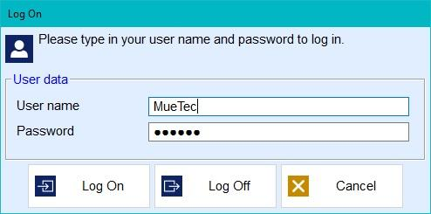
Log On dialog. Source: Maintenance Manual, p. 16.
Rights required
Change Parameters = edit and save. Control Fab Hostinterface = change Offline, Online Local, or Online Remote.

Step 3 - Open Host Interface (Global)
LOCATION: ToolCommander bottom menu.
ACTION: Press Components. Select Host Interface. Select module Global. Press Operation.
EXPECTED: The window title is Host Interface (Global).
IF WRONG: If Host Interface is absent, stop. Ask the tool administrator to confirm it is installed.
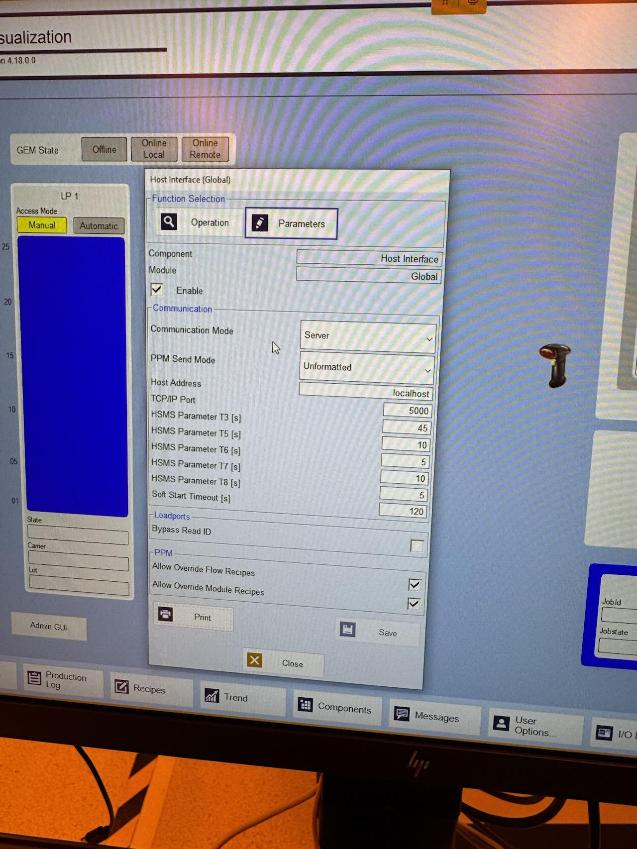
Current screen: Components is on the bottom menu. Host Interface (Global) is open.
The top GEM State strip is only a summary. Use the Operation fields for diagnosis.

Step 4 - Check the Operation screen
LOCATION: Components > Host Interface (Global) > Operation.
ACTION: Check Operation Mode. It must not be Disabled. Use Production for normal service.
EXPECTED: Production is selected. FabLink Connection is available.
IF WRONG: If Disabled is selected, stop. Ask an authorized tool engineer to select the approved active mode.
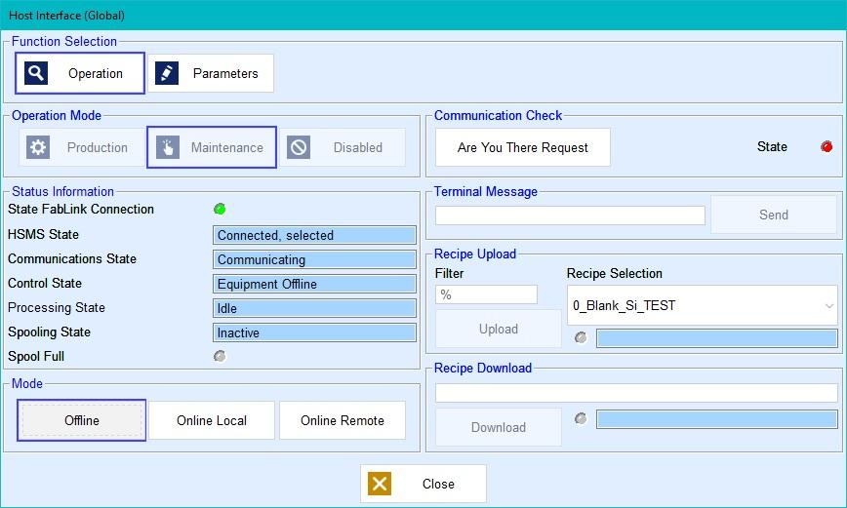
Field locations on Operation. Source: Maintenance Manual, p. 16.
Do not copy Maintenance from this manual image
The image is a maintenance example. Normal service uses Production. Do not select Online Remote.

Step 5 - Turn on and save the Host Interface
LOCATION: Components > Host Interface (Global) > Parameters.
ACTION: Check Enable. Select Server. Set TCP/IP Port to 5000. Leave Host Address unchanged. Keep 45/10/5/10/5 and Soft Start 120. Press Save.
EXPECTED: Save becomes gray. After close and reopen, Enable, Server, and 5000 remain.
IF WRONG: If values revert, log in with Change Parameters and save again.

Use these connection values. Press Save, then reopen and verify.
LEAVE ALONE: PPM Send Mode, Loadports, recipe override boxes, and other fields.
SERVER MODE: Host Address is unused. Do not enter the middleware address there.

Step 6 - Check port 5000 and find the DaVinci IPv4
LOCATION: DaVinci control PC > Windows Start > type PowerShell > open Windows PowerShell.
ACTION: Run the listener command. Then run ipconfig.
EXPECTED: Port 5000 shows Listen. Record the Ethernet IPv4 used by the middleware network.
IF WRONG: If no listener appears, return to Steps 4 and 5. Do not continue to ASTAR.
Get-NetTCPConnection -State Listen -LocalPort 5000
netstat -ano | findstr ":5000"
ipconfig
Result | Action
0.0.0.0:5000 or DaVinci-IPv4:5000 | Continue.
127.0.0.1:5000 only | Stop. Remote middleware cannot reach it.
No result | Recheck Enable, Save, Server, port 5000, and Operation Mode.

Do not use 127.0.0.1 or localhost as the ASTAR host unless ASTAR runs on the DaVinci PC.

Step 7 - Set the ASTAR machine entry
LOCATION: ASTAR middleware PC > Windows Start > type PowerShell > open PowerShell.
ACTION: Open production.yaml in Notepad. Find endpoint_id TOOL_02. Set the DaVinci IPv4. Save the file.
EXPECTED: TOOL_02 uses port 5000, device ID 0, active mode, and enabled true.
IF WRONG: If the file is elsewhere, use the production.yaml used by the installed service.
notepad C:\SECSGEM_EAP\app\config\production.yaml
- endpoint_id: "TOOL_02"
host: "192.168.254.13" # replace if Step 6 found another IPv4
port: 5000
secs_device_id: 0
hsms_mode: "active"
enabled: true
request_online: false
DO NOT USE: localhost or 127.0.0.1 for host on a separate middleware PC.
SAVE: File > Save. Close Notepad.

Step 8 - Test the network connection
LOCATION: ASTAR middleware PC > PowerShell.
ACTION: Stop the installed ASTAR service if it is running. Validate the file. Test TCP from ASTAR to the DaVinci.
EXPECTED: Validation is valid. TcpTestSucceeded is True. test-machine prints tcp-ok.
IF WRONG: Refused: fix the DaVinci listener or port. Timeout: fix the IPv4, route, VLAN, ACL, or firewall.
Get-Service AstarSecsGemEapMiddleware
Stop-Service AstarSecsGemEapMiddleware # run only if the service exists
cd C:\SECSGEM_EAP\app
python -m eap_middleware validate-config --config config\production.yaml
Test-NetConnection 192.168.254.13 -Port 5000
python -m eap_middleware test-machine --config config\production.yaml --endpoint-id TOOL_02
Stop here unless both TCP tests pass
tcp-ok checks the socket only. Continue to the live ASTAR check below.

Step 9 - Start ASTAR and watch Operation
LOCATION: ASTAR middleware PC PowerShell and DaVinci Host Interface Operation screen.
ACTION: Run ASTAR in the foreground. Keep the PowerShell window open. Watch the four Operation fields.
EXPECTED: ASTAR prints [TOOL_02] Communication established. DaVinci shows FabLink green, HSMS Connected, selected, and Communications Communicating.
IF WRONG: If HSMS does not select, stop other host software and restart ASTAR. If Communications does not reach Communicating, read the ASTAR error and restart once.
python -m eap_middleware run-service --config config\production.yaml
Operation field | Required result
FabLink Connection | Green
HSMS State | Connected, selected
Communications State | Communicating
Control State | Equipment Offline is acceptable before Step 10

Step 10 - Select Online Local
LOCATION: DaVinci > Components > Host Interface (Global) > Operation > Mode.
ACTION: Keep ASTAR running. Press Online Local once. Do not press Online Remote.
EXPECTED: Control State becomes Online Local. The top Online Local field becomes yellow.
IF WRONG: If it stays Offline or all gray, confirm ASTAR still shows Communication established. Then repeat Step 9.
Offline | Online Local | Online Remote
COLOR KEY ONLY. On the machine, one field is colored. The other two are gray.
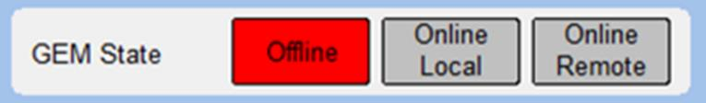
Example: Offline is red. For this setup, expect Online Local yellow. Source: User Manual, p. 28.
Restart ASTAR once after Online Local
Press Ctrl+C in the foreground ASTAR window. Run the Step 9 command again. This reruns status and event setup while the tool is Online Local.

Step 11 - Confirm the final state
LOCATION: DaVinci Operation screen and ASTAR PowerShell or service log.
ACTION: Check every line below.
EXPECTED: Every line passes.
IF WRONG: Use the fault table. Fix the first failed line only.
- DaVinci Parameters: Enable checked, Server, port 5000, values saved.
- DaVinci Operation Mode: not Disabled.
- DaVinci FabLink Connection: green.
- DaVinci HSMS State: Connected, selected.
- DaVinci Communications State: Communicating.
- DaVinci Control State: Online Local.
- Top GEM State: Online Local yellow.
- ASTAR: [TOOL_02] Communication established.

If one line fails
First failed result | Exact next action
All three top fields gray | Ignore the strip. Read the four Operation fields.
Saved values revert | Log in with Change Parameters. Set again. Press Save.
Operation Mode is Disabled | Authorized tool engineer selects Production.
FabLink is not green | Recheck Enable, Save, and Operation Mode. Stop before ASTAR.
No local port 5000 listener | Recheck Server and port 5000. Inspect ToolCommander Messages.
Remote TCP is refused | Start the listener or correct the port/firewall rule.
Remote TCP times out | Correct the IPv4, route, VLAN, ACL, or firewall.
TCP passes; HSMS not selected | Stop another host. Confirm DaVinci Server and ASTAR active. Restart ASTAR.
Selected; not Communicating | Restart ASTAR once. Read the first ASTAR protocol error.
Communicating; still Offline | Press Online Local while ASTAR is running.
S9F1 after connection | Match ASTAR secs_device_id to HostConnection.ini [Connection]. Default is 0.

