Openshift Kubernetes Distribution (OKD)
OKD Cluster Handbook: Design, Deployment, Operations & Troubleshooting
Document Generated: 31-01-2026

Document Revision History
Editor | Date | Description
Mirza Nehal | 31-01-2026 | Initial creation with Architecture , Cluster Limitation, Costing, Installation

Table of Contents
Document Revision History 2
Table of Contents 2
1. Introduction to OKD 3
2. Architecture 3
2.1 Custom operating system 4
2.3 Glossary of common terms for OKD architecture 4
3. OKD Cluster Limitation: 8
3.1 OKD tested cluster maximums for major releases 8
3.1.1 On Cloud: 8
3.1.2 On Prem: 8
Maximum Tested Cluster Scale (4.x) 8
4. OKD installation 9
4.1 Supported platforms for OKD clusters 10
4.2 Installation process details 12
4.3 Minimum Node for OKD Cluster 13
4.4 Minimum Resource Specification per Machine 13
4.5 User-provisioned cluster on bare metal Pre-Steps (HomeLab) 14
4.5.1 Systems Specification: 14
4.5.2 Pre-Requistes: 14
4.5.3 Network Architecture Diagram: 15
4.6 User-provisioned cluster on bare metal Steps (HomeLab) 16
4.6.1 DNS Setup: 16
4.6.2 DHCP Server Setup: 17
4.6.3 HAProxy Setup: 17
4.6.4 DNS Setup: 17
4.6.5 DNS Setup: 17
4.6.6 DNS Setup: 17
4.6.7 DNS Setup: 17
4.6.8 DNS Setup: 17
5. OKD Troubleshooting 17

Introduction to OKD
OKD is a platform for developing and running containerized applications. It is designed to allow applications and the data centers that support them to expand from just a few machines and applications to thousands of machines that serve millions of clients.

With its foundation in Kubernetes, OKD incorporates the same technology that serves as the engine for massive telecommunications, streaming video, gaming, banking, and other applications. Its implementation in open Red Hat technologies lets you extend your containerized applications beyond a single cloud to on-premise and multi-cloud environments.

Architecture
OKD is a cloud-based Kubernetes container platform. The foundation of OKD is based on Kubernetes and therefore shares the same technology. To learn more about OKD and Kubernetes, see product architecture.

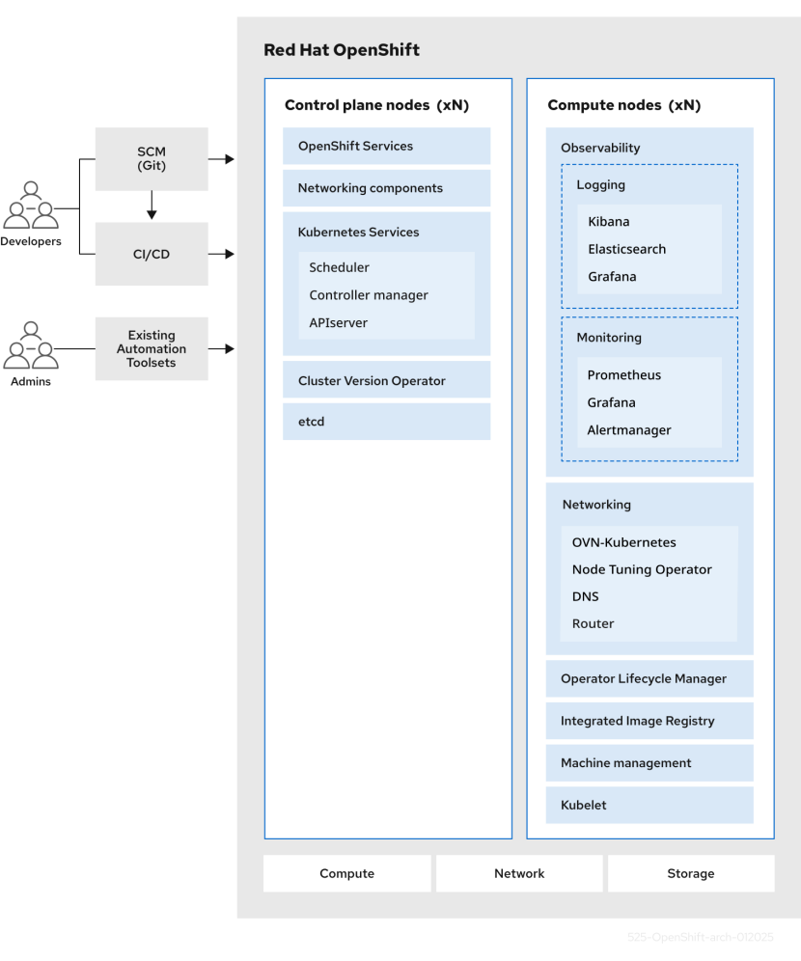

2.1 Custom operating system
OKD uses Fedora CoreOS (FCOS), a container-oriented operating system that is specifically designed for running containerized applications from OKD and works with new tools to provide fast installation, Operator-based management, and simplified upgrades.
FCOS includes:
- Ignition, which OKD uses as a firstboot system configuration for initially bringing up and configuring machines.
- CRI-O, a Kubernetes native container runtime implementation that integrates closely with the operating system to deliver an efficient and optimized Kubernetes experience. CRI-O provides facilities for running, stopping, and restarting containers. It fully replaces the Docker Container Engine, which was used in OKD 3.
- Kubelet, the primary node agent for Kubernetes that is responsible for launching and monitoring containers.
In OKD 4, you must use FCOS for all control plane machines, but you can use Red Hat Enterprise Linux (RHEL) as the operating system for compute machines, which are also known as worker machines. If you choose to use RHEL workers, you must perform more system maintenance than if you use FCOS for all of the cluster machines.

2.3 Glossary of common terms for OKD architecture
This glossary defines common terms that are used in the architecture content.
access policies
A set of roles that dictate how users, applications, and entities within a cluster interact with one another. An access policy increases cluster security.
admission plugins
Admission plugins enforce security policies, resource limitations, or configuration requirements.
authentication
To control access to an OKD cluster, a cluster administrator can configure user authentication to ensure only approved users access the cluster. To interact with an OKD cluster, you must authenticate with the OKD API. You can authenticate by providing an OAuth access token or an X.509 client certificate in your requests to the OKD API.
bootstrap
A temporary machine that runs minimal Kubernetes and deploys the OKD control plane.
certificate signing requests (CSRs)
A resource requests a denoted signer to sign a certificate. This request might get approved or denied.
Cluster Version Operator (CVO)
An Operator that checks with the OKD Update Service to see the valid updates and update paths based on current component versions and information in the graph.
compute nodes
Nodes that are responsible for executing workloads for cluster users. Compute nodes are also known as worker nodes.
configuration drift
A situation where the configuration on a node does not match what the machine config specifies.
containers
Lightweight and executable images that consist of software and all of its dependencies. Because containers virtualize the operating system, you can run containers anywhere, such as data centers, public or private clouds, and local hosts.
container orchestration engine
Software that automates the deployment, management, scaling, and networking of containers.
container workloads
Applications that are packaged and deployed in containers.
control groups (cgroups)
Partitions sets of processes into groups to manage and limit the resources processes consume.
control plane
A container orchestration layer that exposes the API and interfaces to define, deploy, and manage the life cycle of containers. Control planes are also known as control plane machines.
CRI-O
A Kubernetes native container runtime implementation that integrates with the operating system to deliver an efficient Kubernetes experience.
deployment
A Kubernetes resource object that maintains the life cycle of an application.
Dockerfile
A text file that contains the user commands to perform on a terminal to assemble the image.
hosted control planes
A OKD feature that enables hosting a control plane on the OKD cluster from its data plane and workers. This model performs the following actions:
- Optimize infrastructure costs required for the control planes.
- Improve the cluster creation time.
- Enable hosting the control plane using the Kubernetes native high level primitives. For example, deployments and stateful sets.
- Allow a strong network segmentation between the control plane and workloads.
hybrid cloud deployments
Deployments that deliver a consistent platform across bare metal, virtual, private, and public cloud environments. This offers speed, agility, and portability.
Ignition
A utility that FCOS uses to manipulate disks during initial configuration. It completes common disk tasks, including partitioning disks, formatting partitions, writing files, and configuring users.
installer-provisioned infrastructure
The installation program deploys and configures the infrastructure that the cluster runs on.
kubelet
A primary node agent that runs on each node in the cluster to ensure that containers are running in a pod.
kubernetes manifest
Specifications of a Kubernetes API object in a JSON or YAML format. A configuration file can include deployments, config maps, secrets, daemon sets.
Machine Config Daemon (MCD)
A daemon that regularly checks the nodes for configuration drift.
Machine Config Operator (MCO)
An Operator that applies the new configuration to your cluster machines.
machine config pools (MCP)
A group of machines, such as control plane components or user workloads, that are based on the resources that they handle.
metadata
Additional information about cluster deployment artifacts.
microservices
An approach to writing software. Applications can be separated into the smallest components, independent from each other by using microservices.
mirror registry
A registry that holds the mirror of OKD images.
monolithic applications
Applications that are self-contained, built, and packaged as a single piece.
namespaces
A namespace isolates specific system resources that are visible to all processes. Inside a namespace, only processes that are members of that namespace can see those resources.
networking
Network information of OKD cluster.
node
A worker machine in the OKD cluster. A node is either a virtual machine (VM) or a physical machine.
OpenShift CLI (oc)
A command-line tool to run OKD commands on the terminal.
OpenShift Dedicated
A managed Fedora OKD offering on Amazon Web Services (AWS) and Google Cloud. OpenShift Dedicated focuses on building and scaling applications.
OpenShift Update Service (OSUS)
For clusters with internet access, Fedora provides over-the-air updates by using an OpenShift update service as a hosted service located behind public APIs.
OpenShift image registry
A registry provided by OKD to manage images.
Operator
The preferred method of packaging, deploying, and managing a Kubernetes application in an OKD cluster. An Operator takes human operational knowledge and encodes it into software that is packaged and shared with customers.
OperatorHub
A platform that contains various OKD Operators to install.
Operator Lifecycle Manager (OLM)
OLM helps you to install, update, and manage the lifecycle of Kubernetes native applications. OLM is an open source toolkit designed to manage Operators in an effective, automated, and scalable way.
OSTree
An upgrade system for Linux-based operating systems that performs atomic upgrades of complete file system trees. OSTree tracks meaningful changes to the file system tree using an addressable object store, and is designed to complement existing package management systems.
over-the-air (OTA) updates
The OKD Update Service (OSUS) provides over-the-air updates to OKD, including Fedora CoreOS (FCOS).
pod
One or more containers with shared resources, such as volume and IP addresses, running in your OKD cluster. A pod is the smallest compute unit defined, deployed, and managed.
private registry
OKD can use any server implementing the container image registry API as a source of the image which allows the developers to push and pull their private container images.
public registry
OKD can use any server implementing the container image registry API as a source of the image which allows the developers to push and pull their public container images.
Fedora OKD Cluster Manager
A managed service where you can install, modify, operate, and upgrade your OKD clusters.
Fedora Quay Container Registry
A Quay.io container registry that serves most of the container images and Operators to OKD clusters.
replication controllers
An asset that indicates how many pod replicas are required to run at a time.
role-based access control (RBAC)
A key security control to ensure that cluster users and workloads have only access to resources required to execute their roles.
route
Routes expose a service to allow for network access to pods from users and applications outside the OKD instance.
scaling
The increasing or decreasing of resource capacity.
service
A service exposes a running application on a set of pods.
Source-to-Image (S2I) image
An image created based on the programming language of the application source code in OKD to deploy applications.
storage
OKD supports many types of storage, both for on-premise and cloud providers. You can manage container storage for persistent and non-persistent data in an OKD cluster.
Telemetry
A component to collect information such as size, health, and status of OKD.
template
A template describes a set of objects that can be parameterized and processed to produce a list of objects for creation by OKD.
user-provisioned infrastructure
You can install OKD on the infrastructure that you provide. You can use the installation program to generate the assets required to provision the cluster infrastructure, create the cluster infrastructure, and then deploy the cluster to the infrastructure that you provided.
web console
A user interface (UI) to manage OKD.
worker node
Nodes that are responsible for executing workloads for cluster users. Worker nodes are also known as compute nodes.

OKD Cluster Limitation:

3.1 OKD tested cluster maximums for major releases

3.1.1 On Cloud:
to do cost estimation and resource calculation required for cloud regarding OCP, we have caclulator to estimate
https://access.redhat.com/labs/ocplimitscalculator/

3.1.2 On Prem:

Maximum Tested Cluster Scale (4.x)
Resource Type | Maximum Tested Value | Notes / Conditions
Number of Nodes | 2,000 | Tested cluster size
Number of Pods | 150,000 | Total across cluster
Pods per Node | 2,500 | Upper tested scheduling density
Namespaces | 10,000 | Logical isolation units
Builds | 10,000 | S2I strategy with default pod RAM 512 Mi
Pods per Namespace | 25,000 | High multi-tenant workload
Routes (2 default routers) | 9,000 | Ingress capacity
Secrets | 80,000 | Includes service + application secrets
ConfigMaps | 90,000 | Application configuration objects
Services | 10,000 | Cluster-wide services
Services per Namespace | 5,000 | Per tenant/app space
Backends per Service | 5,000 | Large-scale load balancing
Deployments per Namespace | 2,000 | Application rollout objects
BuildConfigs | 12,000 | OpenShift build definitions
Custom Resource Definitions (CRDs) | 1,024 | API extensions limit

Pause pods were deployed to stress the control plane components of OKD at 2000 node scale. The ability to scale to similar numbers will vary depending upon specific deployment and workload parameters.

The pod count displayed here is the number of test pods. The actual number of pods depends on the application’s memory, CPU, and storage requirements.

This was tested on a cluster with 31 servers: 3 control planes, 2 infrastructure nodes, and 26 worker nodes. If you need 2,500 user pods, you need both a hostPrefix of 20, which allocates a network large enough for each node to contain more than 2000 pods, and a custom kubelet config with maxPods set to 2500. For more information, see Running 2500 pods per node on OCP 4.13.

When there are a large number of active projects, etcd might suffer from poor performance if the keyspace grows excessively large and exceeds the space quota. Periodic maintenance of etcd, including defragmentation, is highly recommended to free etcd storage.

There are several control loops in the system that must iterate over all objects in a given namespace as a reaction to some changes in state. Having a large number of objects of a given type in a single namespace can make those loops expensive and slow down processing given state changes. The limit assumes that the system has enough CPU, memory, and disk to satisfy the application requirements.

Each service port and each service back-end has a corresponding entry in iptables. The number of back-ends of a given service impact the size of the Endpoints objects, which impacts the size of data that is being sent all over the system.

Tested on a cluster with 29 servers: 3 control planes, 2 infrastructure nodes, and 24 worker nodes. The cluster had 500 namespaces. OKD has a limit of 1,024 total custom resource definitions (CRD), including those installed by OKD, products integrating with OKD and user-created CRDs. If there are more than 1,024 CRDs created, then there is a possibility that oc command requests might be throttled.

Read more at https://docs.okd.io/latest/scalability_and_performance/planning-your-environment-according-to-object-maximums.html#planning-your-environment-according-to-object-maximums

OKD installation
The OKD installation program offers four methods for deploying a cluster which are detailed in the following list:
- Interactive: You can deploy a cluster with the web-based Assisted Installer. This is an ideal approach for clusters with networks connected to the internet. The Assisted Installer is the easiest way to install OKD, it provides smart defaults, and it performs pre-flight validations before installing the cluster. It also provides a RESTful API for automation and advanced configuration scenarios.
- Local Agent-based: You can deploy a cluster locally with the Agent-based Installer for disconnected environments or restricted networks. It provides many of the benefits of the Assisted Installer, but you must download and configure the Agent-based Installer first. Configuration is done with a command-line interface. This approach is ideal for disconnected environments.
  - Additionally, you can deploy a cluster without an external registry, using self-contained installation media that also provides a simplified user interface similar to the Assisted Installer during on-premise installations. For more information, see "Installing a cluster without an external registry".
- Automated: You can deploy a cluster on installer-provisioned infrastructure. The installation program uses each cluster host’s baseboard management controller (BMC) for provisioning. You can deploy clusters in connected or disconnected environments.
- Full control: You can deploy a cluster on infrastructure that you prepare and maintain, which provides maximum customizability. You can deploy clusters in connected or disconnected environments.
  - Each method deploys a cluster with the following characteristics:
  - Highly available infrastructure with no single points of failure, which is available by default.
  - Administrators can control what updates are applied and when.

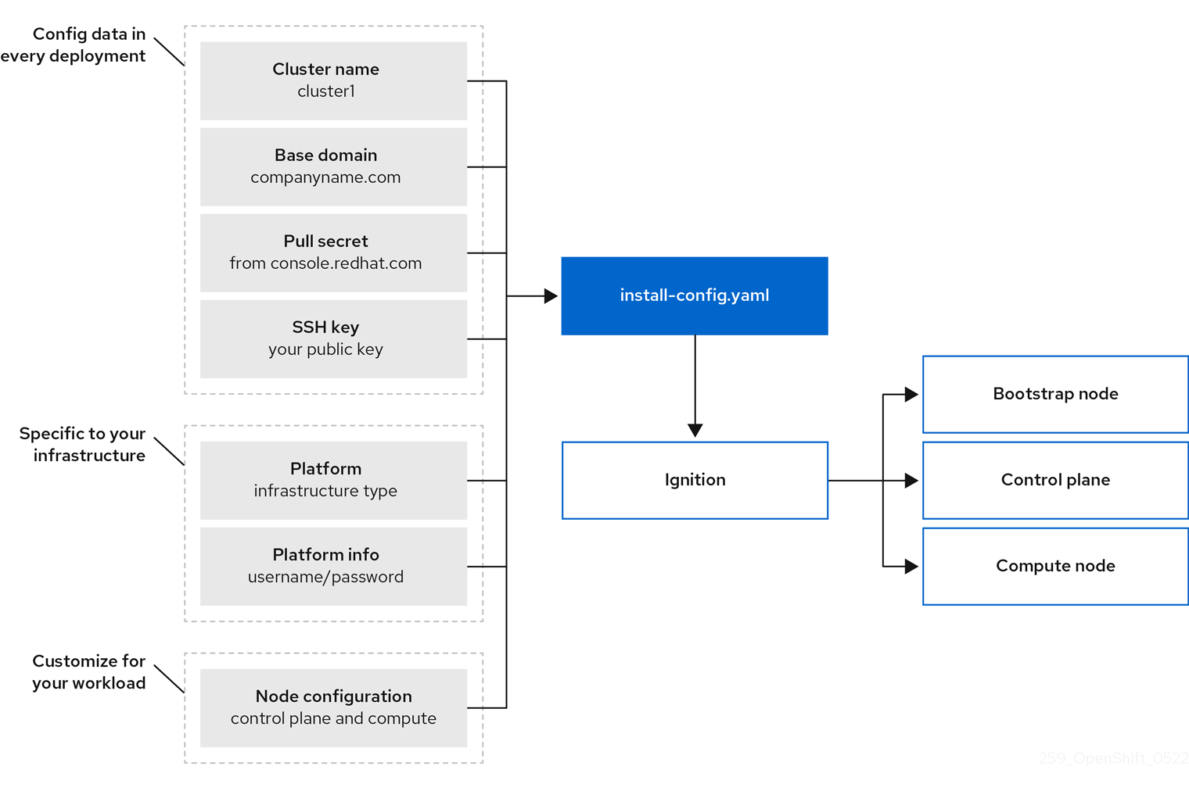

4.1 Supported platforms for OKD clusters
read more at https://docs.okd.io/latest/architecture/architecture-installation.html#supported-platforms-for-openshift-clusters_architecture-installation
Platform | Installer-provisioned infrastructure | User-provisioned infrastructure | Agent-based Installer | Assisted Installer
Amazon Web Services (AWS) | ❌ | ✅ | ❌ | ✅
Bare metal | ❌ | ✅ | ✅ | ✅
External | ❌ | ✅ | ❌ | ✅
Google Cloud | ❌ | ✅ | ❌ | ✅
IBM Cloud® Classic | ❌ | ✅ | ❌ | ❌
IBM Cloud® Virtual Private Cloud (VPC) | ❌ | ✅ | ❌ | ❌
IBM Power® | ❌ | ✅ | ✅ | ❌
IBM Z® / IBM® LinuxONE | ❌ | ✅ | ✅ | ❌
Microsoft Azure | ❌ | ✅ | ❌ | ❌
Microsoft Azure Stack Hub | ❌ | ✅ | ❌ | ❌
None (existing infrastructure) | ❌ | ✅ | ❌ | ❌
Nutanix | ❌ | ✅ | ❌ | ❌
Oracle Cloud Infrastructure (OCI) | ❌ | ✅ | ❌ | ❌
OpenStack | ❌ | ✅ | ❌ | ❌
VMware vSphere | ❌ | ✅ | ✅ | ✅

- For installer-provisioned infrastructure: All machines, including the computer that you run the installation process on, must have direct internet access to pull images for platform containers and provide telemetry data to Red Hat.

- For user-provisioned infrastructure: Depending on the supported cases for the platform, you can perform installations on user-provisioned infrastructure so that you can run machines with full internet access, place your cluster behind a proxy, or perform a disconnected installation.
In a disconnected installation, you can download the images that are required to install a cluster, place them in a mirror registry, and use that data to install your cluster. While you require internet access to pull images for platform containers, with a disconnected installation on vSphere or bare-metal infrastructure, your cluster machines do not require direct internet access.
- For OpenStack: The latest OKD release supports both the latest OpenStack long-life release and intermediate release. For complete OpenStack release compatibility, see the OKD on OpenStack support matrix.

Except for the Assisted Installer, when you install an OKD cluster, you must download the installation program from https://github.com/openshift/okd/releases.

4.2 Installation process details
Bootstrapping a cluster involves the following steps:
- The bootstrap machine boots and starts hosting the remote resources required for the control plane machines to boot. If you provision the infrastructure, this step requires manual intervention.
- The bootstrap machine starts a single-node etcd cluster and a temporary Kubernetes control plane.
- The control plane machines fetch the remote resources from the bootstrap machine and finish booting. If you provision the infrastructure, this step requires manual intervention.
- The temporary control plane schedules the production control plane to the production control plane machines.
- The Cluster Version Operator (CVO) comes online and installs the etcd Operator. The etcd Operator scales up etcd on all control plane nodes.
- The temporary control plane shuts down and passes control to the production control plane.
- The bootstrap machine injects OKD components into the production control plane.
- The installation program shuts down the bootstrap machine. If you provision the infrastructure, this step requires manual intervention.
- The control plane sets up the compute nodes.
- The control plane installs additional services in the form of a set of Operators.
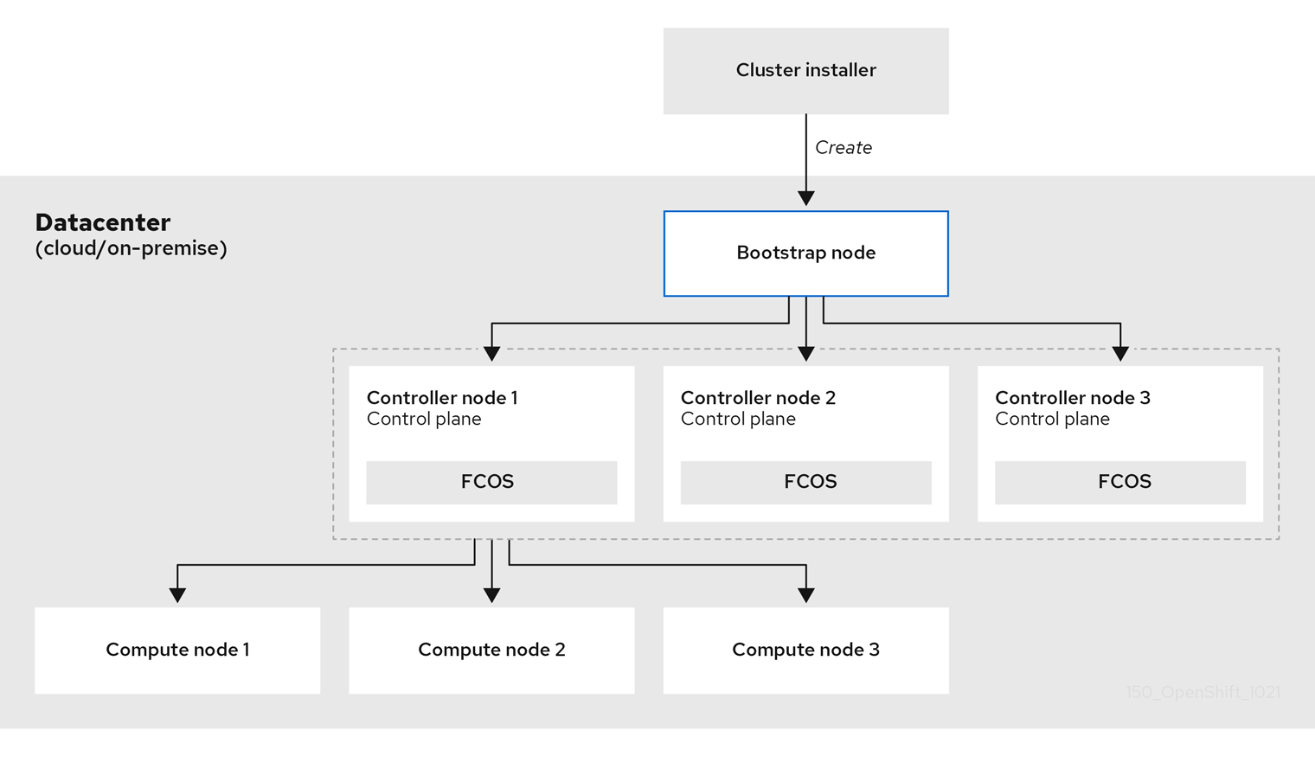

Read more about update at https://docs.okd.io/latest/architecture/architecture-installation.html#update-service-about_architecture-installation

4.3 Minimum Node for OKD Cluster
The bootstrap and control plane machines must use Fedora CoreOS (FCOS) as the operating system. However, the compute machines can choose between Fedora CoreOS (FCOS), Fedora 8.6 and later.

Hosts | Description
One temporary bootstrap machine | The cluster requires a bootstrap machine to initialize and deploy the OKD cluster on the control plane nodes. This machine is only needed during installation and can be safely removed after the cluster is fully operational.
Three control plane machines | These machines run the core Kubernetes and OKD services, including API server, scheduler, controller manager, and etcd, forming the cluster’s control plane and managing overall cluster state.
At least two compute (worker) machines | Worker machines run application workloads, pods, and services requested by OKD users. They provide the compute capacity and scale horizontally based on workload demand.

4.4 Minimum Resource Specification per Machine
Machine | Operating System | CPU (vCPU) | RAM | Storage | IOPS
Bootstrap | FCOS (Fedora CoreOS) | 4 | 16 GB | 100 GB | 300
Control Plane | FCOS (Fedora CoreOS) | 4 | 16 GB | 100 GB | 300
Compute (Worker) | FCOS (Fedora CoreOS) | 2 | 8 GB | 100 GB | 300

- One CPU is equivalent to one physical core when simultaneous multithreading (SMT), or Hyper-Threading, is not enabled. When enabled, use the following formula to calculate the corresponding ratio: (threads per core × cores) × sockets = CPUs.

- OKD and Kubernetes are sensitive to disk performance, and faster storage is recommended, particularly for etcd on the control plane nodes which require a 10 ms p99 fsync duration. Note that on many cloud platforms, storage size and IOPS scale together, so you might need to over-allocate storage volume to obtain sufficient performance

- As with all user-provisioned installations, if you choose to use Fedora compute machines in your cluster, you take responsibility for all operating system life cycle management and maintenance, including performing system updates, applying patches, and completing all other required tasks. Use of Fedora 7 compute machines is deprecated and has been removed in OKD 4.10 and later.

read more at https://docs.okd.io/latest/installing/installing_bare_metal/upi/installing-bare-metal.html#installing-bare-metal

4.5 User-provisioned cluster on bare metal Pre-Steps (HomeLab)

4.5.1 Systems Specification:
Sr# | Name | Machine Model | Purpose | Architecture | *vCPU | **Memory | ***Storage (SSD/NVME)
1 | Intel NUC | NUC7i5BNH | Service | Intel i5-7260 CPU @ 2.20GHz | 4vcpu | 8GB DDR4 | 250GB
2 | JPYXKM | DAD600 / DLL600D | Bootstrap | Intel N100 CPU @ 3.4GHz | 4vcpu | 12GB DDR5 | 512GB
3 | GMKtec NucBox | K9 Mini | Control Plane | Intel Ultra 125H @ 4.50 GHz | 18vcpu | 32GB DDR5 | 250GB+1TB
4 | HP EliteDesk | 705 G4 35W (396) | Control Plane | ryzen 5 pro 2400ge @ 3.2 GHz | 8vcpu | 32GB DDR4 | 250GB
5 | HP EliteDesk | 705 G4 36W (215) | Control Plane | ryzen 5 pro 2400ge @ 3.2 GHz | 8vcpu | 32GB DDR5 | 250GB
6 | GMKtec NucBox | K8 Plus Mini | Worker Node | AMD Ryzen™ 7 8845HS @ 5.1Ghz | 16vcpu | 96GB DDR5 | 128gb +1 TB
7 | GMKtec NucBox | K12 Mini | Worker Node | AMD Ryzen™ 7 H 255 @ 3.8 GHz | 16vcpu | 32GB DDR5 | 128gb +1 TB

*For CPU, use following command:
lscpu
** For Memory, use following command:
free -h
***For Storage, use following command:
lsblk
****To calculateIOPS, use following command:
sudo mkdir -p /var/tmp/fio
sudo fio --name=etcd-okd-test \ --directory=/var/tmp/fio \ --rw=randwrite \ --bs=4k \ --iodepth=1 \ --numjobs=1 \ --size=5G \ --runtime=60 \ --time_based \ --direct=1 \ --ioengine=libaio \ --fsync=1 \ --group_reporting

4.5.2 Pre-Requistes:
Sr# | Name | Machine Model | Purpose | Linux | IP Address | Hostname
1 | Intel NUC | NUC7i5BNH | Service | Omarchy Linux | 192.168.8.206 / 10.0.0.1
2 | JPYXKM | DAD600 / DLL600D | Bootstrap | Fedora Core | 10.0.0.145
3 | GMKtec NucBox | K9 Mini | Control Plane | Fedora Core | 10.0.0.150
4 | HP EliteDesk | 705 G4 35W (396) | Control Plane | Fedora Core | 10.0.0.151
5 | HP EliteDesk | 705 G4 36W (215) | Control Plane | Fedora Core | 10.0.0.152
6 | GMKtec NucBox | K8 Plus Mini | Worker Node | Fedora Core | 10.0.0.155
7 | GMKtec NucBox | K12 Mini | Worker Node | Fedora Core | 10.0.0.160

4.5.3 Network Architecture Diagram:
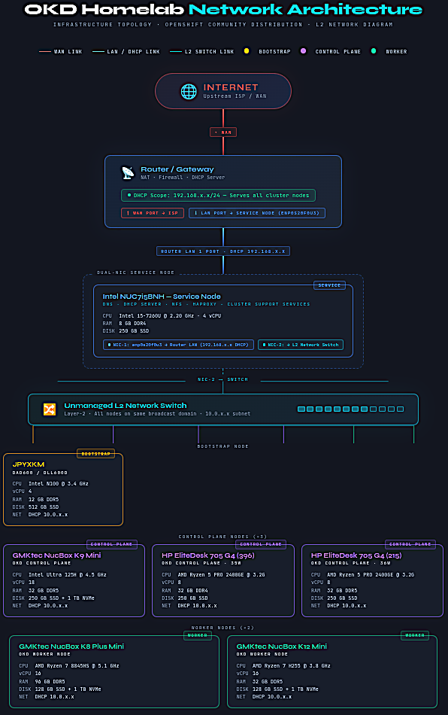
Preview more at https://mrzjordan16.github.io/OKD-BareMetal-UPI/

4.6 User-provisioned cluster on bare metal Steps (HomeLab)

4.6.1

4.6.2 DNS Setup:
1) Install DNS on service machine (Arch Linux)
sudo pacman -S bind -y

- Take backup of main DNS configuration file

cp /etc/named.conf /etc/named.conf-original!

- make modification of ip and copy the file named.conf
cd <repository-location>
cd scripts/arch-linux-service/named.conf /etc/named.conf
sudo chown root:named /etc/named.conf
sudo chmod 640 /etc/named.conf

- Check for Syntax Error
named-checkconf

- Create the required directory for logs with appropriate permission and ownership

mkdir /var/named/log/
chown named:named /var/named/log/
chmod 700 /var/named/log/

restorecon -RFv /var/named/log/ #Only used for Rhel/Fedora/Rocky/Alma

- Define Forward Zone
change Ip address in okd.ms1.lan.zone file and then copy it to /var/named/
cp scripts/arch-linux-service/okd.ms1.lan.zone /var/named/

- Define Reverse Zone
cp scripts/arch-linux-service/11.168.192.in-addr.arpa.zone /var/named/

- Set Permission
chown root:named /var/named/okd.ms1.lan.zone
chown root:named /var/named/11.168.192.in-addr.arpa.zone

chmod 640 /var/named/okd.ms1.lan.zone
chmod 640 /var/named/11.168.192.in-addr.arpa.zone

Run named-checkzone file for any errors.

named-checkzone okd.ms1.lan /var/named/okd.ms1.lan.zone
named-checkzone 11.168.192.in-addr.arpa /var/named/11.168.192.in-addr.arpa.zone

- Start Service
Start and enable the service persistently

systemctl enable --now named
systemctl status named.service

- Check DNS Resolution
dig +short @localhost A ns1.okd.ms1.lan
dig +short @localhost A api.okd.ms1.lan
dig @localhost A api.okd.ms1.lan
dig +short @localhost -x 192.168.8.10

- Firewall
sudo ufw status
sudo ufw allow dns

firewall-cmd --permanent --add-service=dns
firewall-cmd --reload
firewall-cmd --list-all

4.6.2 DHCP Server Setup:
As Diagram show, i am using my router DHCP Server but if someone is interested,
read more at https://www.linuxsysadmins.com/configuring-haproxy-lb-for-okd-ha-cluster/

4.6.3 HAProxy Setup:
1) Install HAProxy on service machine (Arch Linux)
sudo pacman -S haproxy -y

- make modification of ip and copy the file named.conf
cd <repository-location>
cd scripts/arch-linux-service/haproxy.cfg /etc/haproxy/
sudo chown root:named /etc/haproxy/haproxy.cfg
sudo chmod 640 /etc/haproxy/haproxy.cfg

4.6.4 DNS Setup:

4.6.5 DNS Setup:

4.6.6 DNS Setup:

4.6.7 DNS Setup:

4.6.8 DNS Setup:

OKD Troubleshooting
- Problem- #1 :
  - invalid managed-keys-directory /var/named/dynamic: file not found
- Reference:

- Solution:
  - sudo mkdir -p /var/named/dynamic
  - sudo chown -R named:named /var/named
  - sudo chmod 750 /var/named /var/named/dynamic
  - sudo systemctl restart named
  - sudo systemctl status named --no-pager

- Problem- #2 :
  - parsing [/etc/haproxy/haproxy.cfg:25] : 'option httplog' not usable with proxy 'api-server-6443' (needs 'mode http'). Falling back to 'option tcplog'.
  - [/etc/haproxy/haproxy.cfg:49] : 'server api-server-6443/bootstrap' : unable to set SSL cipher list to 'PROFILE=SYSTEM'.
  - parsing [/etc/haproxy/haproxy.cfg:25] : 'option httplog' not usable with proxy 'machine-config-server-22623' (needs 'mode http'). Falling back to 'option tcplog'.
- Reference:

- Solution:

- Problem- #3 :

- Reference:

- Solution:

- Problem- #4:

- Reference:

- Solution:

