Economic Evaluation and Budget Impact Analysis of Increased Peritoneal Dialysis Uptake Compared with Haemodialysis in Singapore

Table 1. Assessment scope
Item | Specification
Technology / pathway change | Increased peritoneal dialysis (PD) uptake among medically suitable new dialysis patients
Comparator | Current practice, represented as a more haemodialysis (HD)-dominant pathway
Population | Adults with kidney failure in Singapore who are medically suitable for either HD or PD
Perspective | Singapore healthcare system perspective, direct healthcare costs only
Model structure | Five-year cohort Markov model with annual cycles and a five-year budget impact analysis
Status | Portfolio health economic model using public cost proxies, literature evidence and documented assumptions

Executive summary
This report evaluates the five-year cost-utility and budget impact of increasing peritoneal dialysis (PD) uptake among medically suitable patients with kidney failure in Singapore, compared with current practice. The assessment uses a Singapore healthcare system perspective and includes direct healthcare costs, health-state utilities and annual transition probabilities. The model population is limited to patients assumed to be suitable for both haemodialysis (HD) and PD, because modality choice depends on clinical, social and practical suitability.
The base-case model estimated lower five-year costs and a small quality-adjusted life-year (QALY) gain with increased PD uptake. Five-year cost per eligible patient decreased from S$137,176 under current practice to S$131,191 under increased PD uptake. The incremental cost was -S$5,985.70 per eligible patient and incremental QALYs increased by 0.0105. Life-years were unchanged because equal mortality was assumed for HD and PD in the base case.
The five-year budget impact analysis estimated cost savings across all PD adoption scenarios. The base adoption scenario generated estimated cumulative savings of S$15.89 million compared with current practice, while the low and high adoption scenarios generated estimated savings of S$12.36 million and S$32.74 million respectively. Negative budget impact values represent lower expenditure compared with current practice, not additional spending.
The conclusion is primarily driven by the annual cost difference between HD and PD. The base-case annual HD cost was S$37,800, while the blended annual PD cost was S$18,840. These values were derived from Singapore-facing public cost information and a blended PD costing approach using CAPD and APD cost ranges and modality mix assumptions.^{7,8,9}
The findings support cautious expansion of PD pathways among suitable patients, with continued attention to patient selection, home support, technique failure, infection prevention, modality switching and local outcome monitoring. The model should not be interpreted as evidence that PD is clinically superior to HD for all patients. It provides a structured estimate of economic value and budget impact under documented assumptions.

Background

Kidney failure and dialysis burden
Kidney failure requires long-term kidney replacement therapy through dialysis or transplantation. In Singapore, dialysis creates a substantial recurrent health-system burden because treatment is ongoing, resource intensive and often required for many years. The National Kidney Foundation reports more than 9,000 dialysis patients in Singapore, approximately six new kidney failure patients each day, and around S$300 million in annual dialysis treatment spending.⁵
For the model, the incident population was estimated as 2,190 new kidney failure patients per year, derived from six new patients per day over 365 days. A 60% PD-suitable share was applied to define an eligible cohort of 1,314 patients per year. This suitability assumption was applied because PD expansion is only relevant for patients who can safely and practically receive home-based dialysis.^{5,6}
HD and PD differ in setting, resource requirements and patient workload. HD is usually centre-based and depends on dialysis facility capacity, staffing and repeated attendance. PD is home-based and may reduce pressure on centre-based capacity, but requires patient education, home suitability, infection prevention and responsive clinical support. The decision problem is therefore not a universal replacement of HD by PD, but the expected value of increasing PD uptake among suitable patients.

HD versus PD decision context
The assessment compares increased PD uptake with current practice for medically suitable new dialysis patients. The current practice scenario was anchored at 19% PD uptake and 81% HD uptake among new dialysis patients, while the base increased-uptake scenario moved towards 30% PD uptake. These values reflect Singapore policy statements on increasing PD uptake among new dialysis patients.⁶
The comparison is relevant to health technology assessment because dialysis modality choice affects clinical outcomes, quality of life, resource use, budget impact, implementation feasibility and equity. WHO describes HTA as a systematic and transparent process that considers clinical effectiveness, safety, economic implications, and wider organisational, ethical and social dimensions of health technologies.²

Objective
The objective is to estimate the five-year cost-utility and budget impact of increasing PD uptake among medically suitable patients with kidney failure in Singapore, compared with current practice. Outcomes include total cost, life-years, QALYs, incremental cost, incremental QALYs, dominance or ICER interpretation, annual budget impact and cumulative five-year budget impact.
The secondary objective is to assess uncertainty around the base-case result through one-way sensitivity analysis, technical scenario analysis and threshold analysis. The assessment is restricted to dialysis modality mix and does not model the full kidney replacement therapy pathway, including transplantation.

Methods

Evaluation design
A model-based cost-utility analysis was conducted using a cohort Markov model with annual cycles over a five-year horizon. Cost-utility analysis was selected because the model compares both costs and QALYs between current practice and increased PD uptake. Economic evaluation uses incremental comparison of costs and consequences between alternatives, and QALYs allow mortality and morbidity consequences to be combined into a common health outcome.¹
A five-year budget impact analysis was conducted alongside the economic model. The budget impact analysis compared the current intervention mix with alternative PD adoption scenarios and estimated annual and cumulative incremental costs. Local medical technology evaluation guidance describes budget impact analysis as a comparison between current and new scenarios over a typical five-year horizon, using the eligible population, intervention mix, resource use and costs.³

Population
The model population comprised medically suitable adults with kidney failure in Singapore who were eligible for either HD or PD. The annual eligible cohort was 1,314 patients, derived from 2,190 incident kidney failure patients per year and a 60% PD-suitable share.^{5,6}

Intervention and comparator
The intervention was increased PD uptake among medically suitable new dialysis patients. The comparator was current practice. Current practice was fixed at 19% PD uptake and 81% HD uptake. The base adoption scenario increased PD uptake from 22% in 2026 to 30% in 2030; the low adoption scenario increased PD uptake from 21% to 27%; and the high adoption scenario increased PD uptake from 25% to 40%.⁶
In the budget impact analysis, current practice generated approximately 250 new PD starts and 1,064 new HD starts per year among the eligible cohort. Under the base adoption scenario, PD starts increased from approximately 289 in 2026 to 394 in 2030, while HD starts decreased from approximately 1,025 to 920 over the same period.⁶

Perspective, time horizon and discounting
The analysis adopted a Singapore healthcare system perspective and included direct healthcare costs only. Costs were reported in Singapore dollars. The five-year time horizon was aligned with the budget impact horizon and was sufficient for a first model of modality uptake, switching and short-to-medium-term dialysis costs.
The undiscounted base case was supplemented by technical scenario analyses using a 3% annual discount rate for costs and QALYs. A 3% rate was selected because local medical technology evaluation guidance specifies annual discounting of costs and health outcomes at 3%, with alternative scenarios used to test sensitivity to modelling assumptions.³

Model structure
The Markov model included four health states: HD, PD, switched PD to HD, and death. Patients entered the model according to the assigned modality mix. During each annual cycle, patients could remain in their current state, switch from HD to PD, switch from PD to HD, or die. Death was modelled as an absorbing state.
The switched PD-to-HD state represented technique failure or modality switching after initial PD. Kidney transplantation, peritonitis, hospitalisation, vascular access complications and separate continuous ambulatory peritoneal dialysis (CAPD) and automated peritoneal dialysis (APD) states were not modelled explicitly. These omissions were treated as structural limitations.

Transition probabilities
The base case assigned an annual death probability of 0.12 to both HD and PD. Equal mortality was used to avoid attributing survival differences to modality in a simplified model, because observational comparisons can be affected by selection and case-mix differences. Singapore outcome evidence was used as the clinical context for mortality uncertainty.¹⁰
The annual probability of switching from PD to HD was set at 0.15, reflecting technique failure or modality change. The annual probability of switching from HD to PD was set at 0.01, reflecting the focus on initial uptake rather than large-scale switching among existing HD patients. These parameters were classified as uncertainty drivers and varied in sensitivity analysis.^{6,9,10}

Cost inputs
The model included annual costs for HD, PD, switched PD-to-HD care and death. Annual HD cost was S$37,800, with a range of S$33,600 to S$42,000. This was derived from a monthly HD cost range of S$2,800 to S$3,500.⁷
The annual blended PD cost was S$18,840, with a range of S$16,800 to S$20,700. CAPD was costed at S$1,100 to S$1,300 per month and APD at S$1,600 to S$1,800 per month, excluding electricity. The blended PD cost used APD and CAPD shares from Singapore kidney replacement therapy economics evidence.^{8,9}
The switched PD-to-HD state was assigned the HD annual cost of S$37,800. No ongoing dialysis cost was assigned after death. Public patient-facing cost information was treated as a cost proxy rather than a complete provider-cost estimate.

Utilities and QALYs
QALYs were estimated by multiplying time spent in each health state by its utility weight. The base-case utility weights were 0.58 for HD, 0.62 for PD, 0.56 for switched PD to HD, and 0.00 for death. The HD and switched-state utilities were informed by chronic kidney disease utility evidence, while the PD utility was informed by Singapore PD health-related quality-of-life evidence.^{11,13}
The utility difference between HD and PD was deliberately small. Utility values were treated as uncertain because Singapore-specific modality utility data were not available for all model states. Utility parameters were varied in one-way sensitivity analysis.
Table 2. Key model inputs and source basis
Input | Base value | Notes | Source
Eligible patients per year | 1,314 | Derived from 2,190 incident patients/year and 60% PD suitability | 5,6
Current PD uptake | 19% | Current practice uptake among new dialysis patients | 6
Target PD uptake | 30% | Base adoption target by 2030 in modelled scenario | 6
Annual HD cost | S$37,800 | Derived from S$2,800 to S$3,500/month | 7
Annual blended PD cost | S$18,840 | CAPD/APD cost ranges weighted by PD modality mix | 8,9
HD and PD annual death probability | 0.12 | Equal mortality base-case assumption, informed by Singapore outcome evidence | 10
PD-to-HD annual switch probability | 0.15 | Technique failure or modality switch assumption | 9
HD utility / PD utility | 0.58 / 0.62 | Literature-derived utility inputs | 11,13

Budget impact analysis
The budget impact analysis covered 2026 to 2030. It applied the eligible annual cohort to current practice and three increased PD adoption scenarios. Annual and cumulative incremental costs were calculated by comparing each increased uptake scenario with current practice. Negative values indicate savings relative to current practice.

Uncertainty analysis
Uncertainty was assessed using one-way sensitivity analysis, technical scenario analysis and threshold analysis. One-way sensitivity analysis varied key costs, utilities and transition probabilities across their low and high values. Technical scenarios tested 3% discounting and half-cycle correction. Threshold analysis estimated the annual PD cost at which increased PD uptake would no longer remain cost-saving.^{1,3}

Results

Base-case economic evaluation
In the base case, increased PD uptake reduced five-year cost per eligible patient from S$137,176 to S$131,191. Life-years were unchanged at 3.9356 in both strategies. QALYs increased from 2.3031 under current practice to 2.3135 under increased PD uptake.
Table 3. Base-case economic results per eligible patient
Strategy | Five-year cost | Life-years | QALYs | Final alive | Final dead
Current practice | S$137,176.31 | 3.9356 | 2.3031 | 0.5277 | 0.4723
Increased PD uptake | S$131,190.61 | 3.9356 | 2.3135 | 0.5277 | 0.4723

The incremental analysis showed a saving of S$5,985.70 per eligible patient and a QALY gain of 0.0105. Increased PD uptake was therefore dominant in the base case, meaning lower cost and higher QALYs compared with current practice. The result does not indicate a survival advantage, because mortality was assumed to be equal for HD and PD.
Table 4. Incremental economic results
Incremental cost | Incremental QALYs | Incremental life-years | Interpretation
S$-5,985.70 | 0.0105 | 0.0000 | Dominant: lower cost and higher QALYs

Budget impact results
The budget impact analysis estimated savings across all adoption scenarios. The low adoption scenario generated cumulative five-year savings of S$12.36 million, the base adoption scenario generated savings of S$15.89 million, and the high adoption scenario generated savings of S$32.74 million.
Table 5. Budget impact summary
Scenario | Five-year cumulative budget impact | Five-year incremental QALYs | Year 5 incremental cost
Low PD adoption | S$-12,364,066.72 | 23.96 | S$-4,521,082.62
Base PD adoption | S$-15,890,210.78 | 30.78 | S$-5,913,747.31
High PD adoption | S$-32,737,986.58 | 63.30 | S$-11,799,259.71

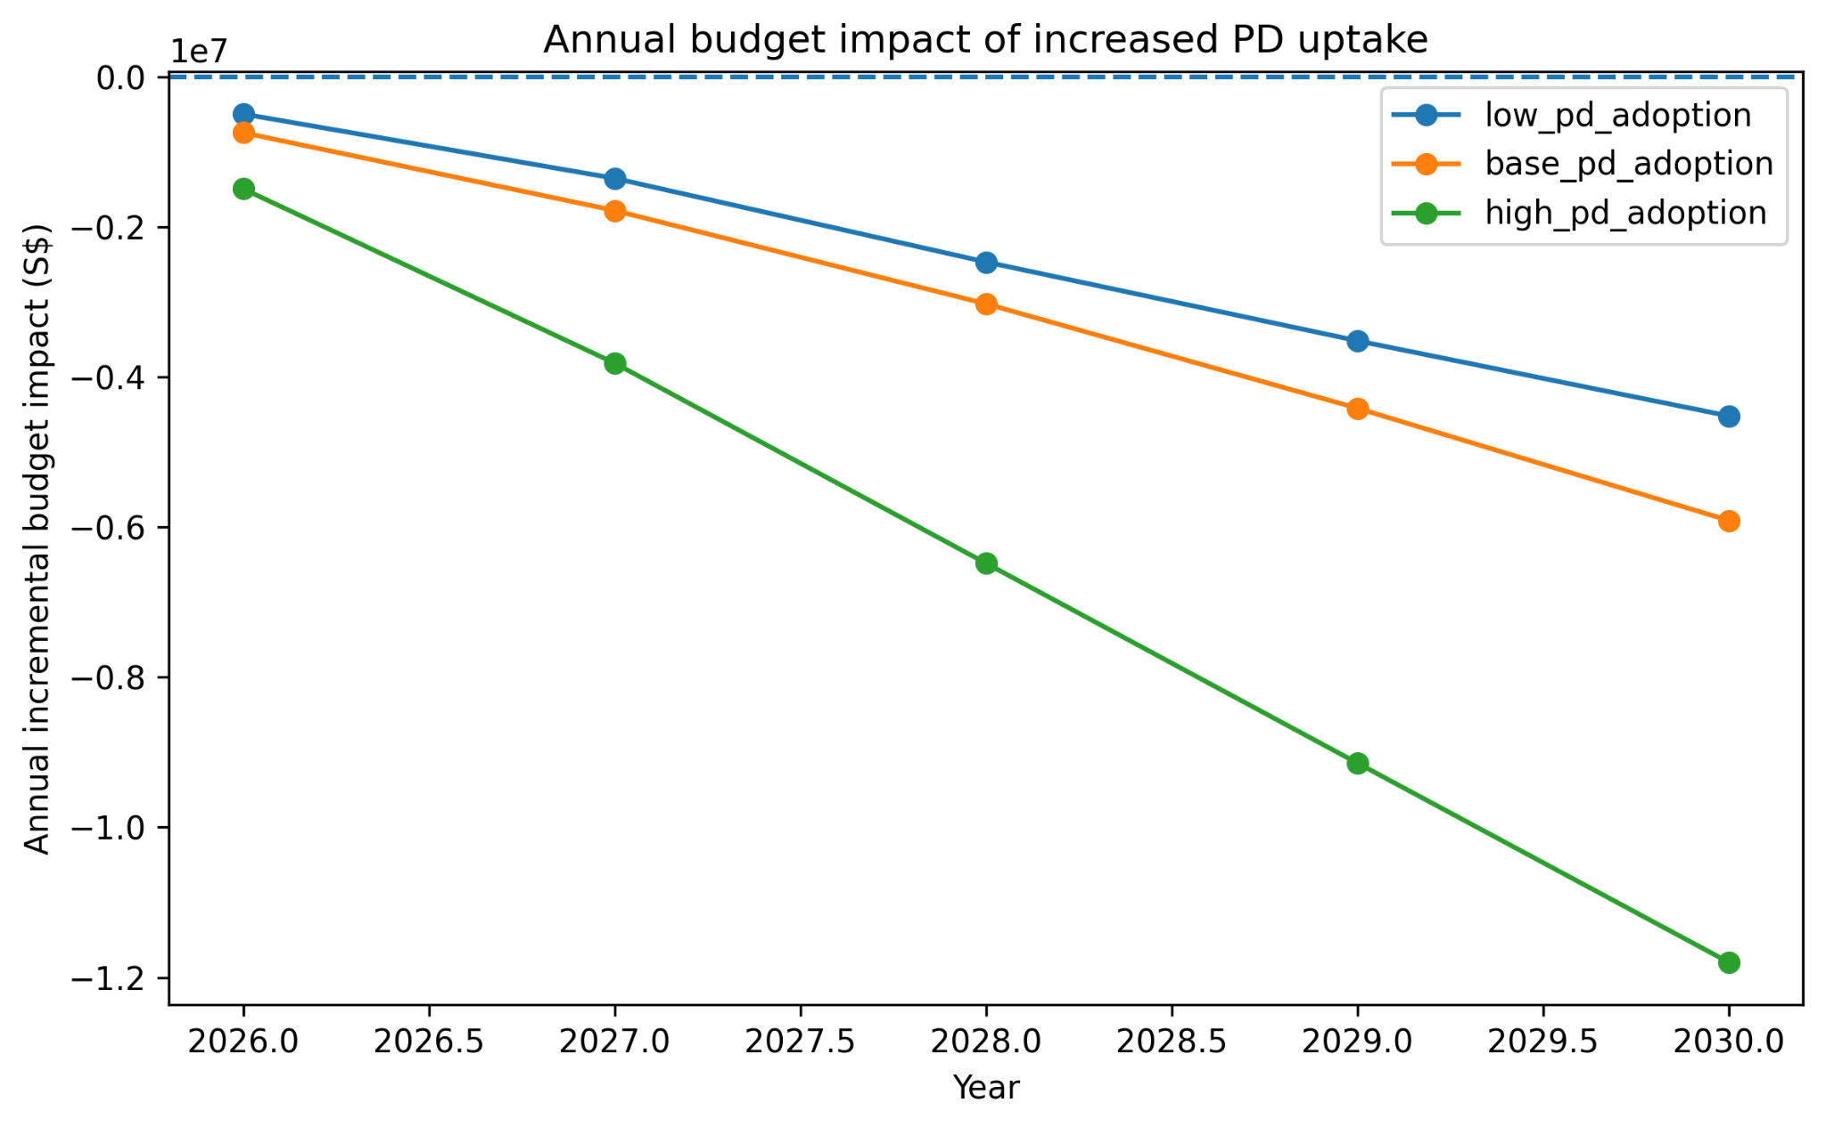
Figure 1. Annual budget impact of increased PD uptake, 2026 to 2030. Negative values indicate estimated savings compared with current practice.
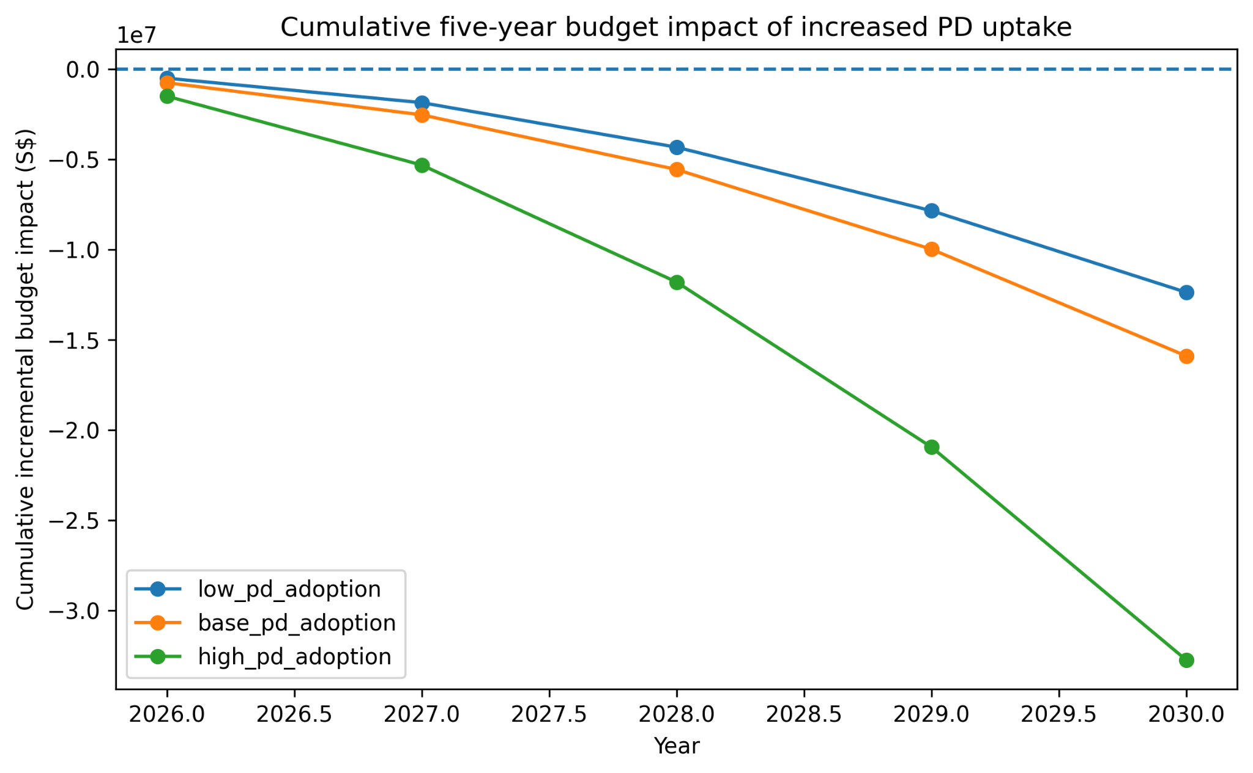
Figure 2. Cumulative five-year budget impact of increased PD uptake. Negative values indicate cumulative estimated savings compared with current practice.
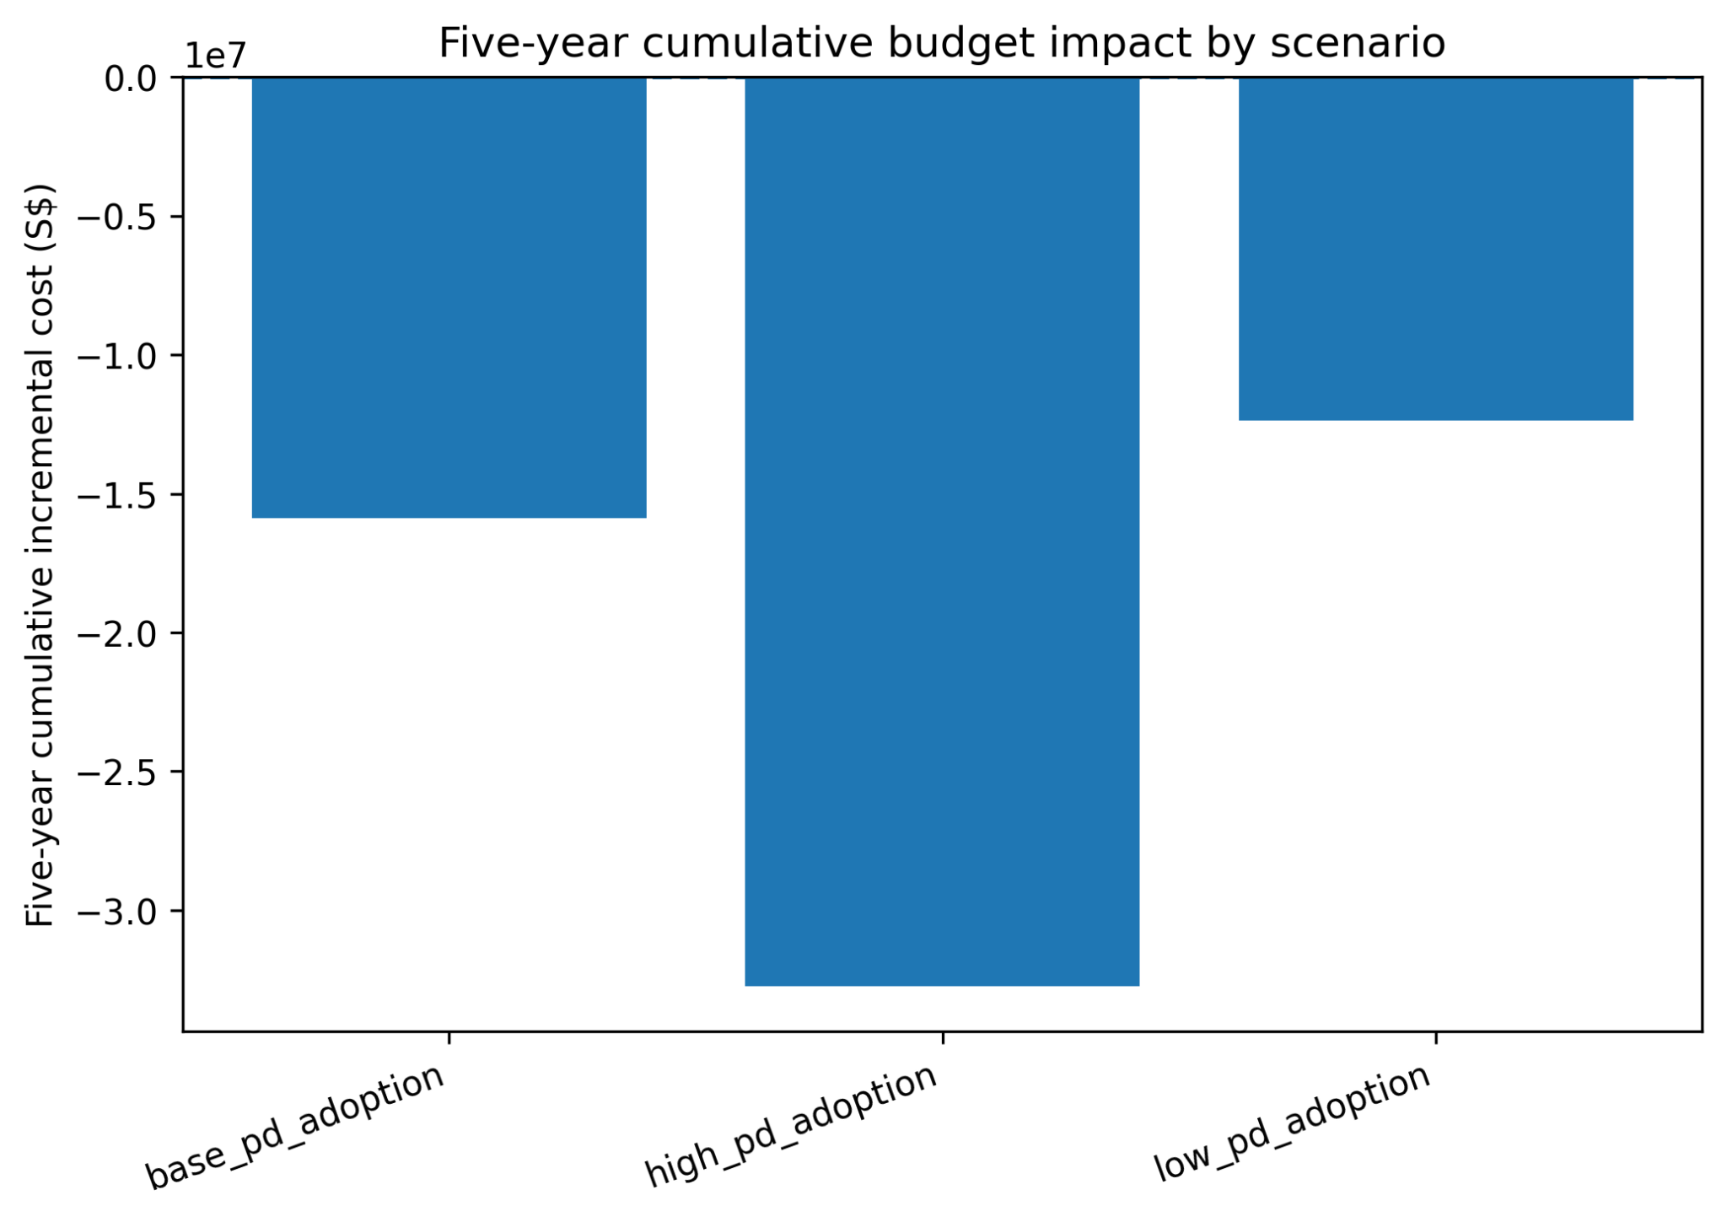
Figure 3. Five-year cumulative budget impact by PD adoption scenario. Negative values indicate estimated savings compared with current practice.

Technical scenario analysis
The base-case conclusion remained directionally stable after technical model adjustments. With 3% discounting and no half-cycle correction, the estimated saving was S$5,753.39 and the incremental QALY gain was 0.0101. With both 3% discounting and half-cycle correction, the estimated saving was S$4,938.41 and the incremental QALY gain was 0.0081.
Table 6. Technical scenario results
Technical scenario | Incremental cost | Incremental QALYs | Interpretation
No discount, no half-cycle correction | S$-5,985.70 | 0.0105 | Dominant: lower cost and higher QALYs
3% discount, no half-cycle correction | S$-5,753.39 | 0.0101 | Dominant: lower cost and higher QALYs
No discount, with half-cycle correction | S$-5,137.40 | 0.0083 | Dominant: lower cost and higher QALYs
3% discount, with half-cycle correction | S$-4,938.41 | 0.0081 | Dominant: lower cost and higher QALYs

Sensitivity and threshold analysis
The one-way sensitivity analysis showed that incremental cost was most sensitive to annual HD death probability, annual HD cost, annual PD-to-HD switch probability, annual PD death probability, annual PD cost, annual switched PD-to-HD cost and annual HD-to-PD switch probability. These drivers reflect the duration of dialysis exposure, the probability of remaining in lower- or higher-cost states, and the cost difference between HD and PD.
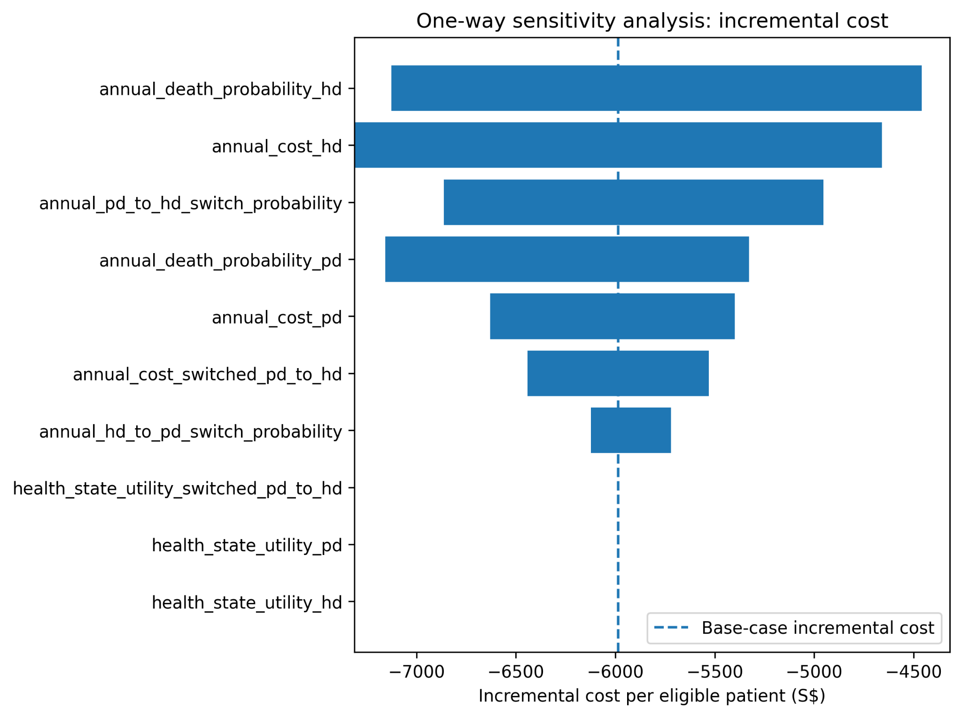
Figure 4. One-way sensitivity analysis for incremental cost. The bars show how the estimated cost saving changes when individual parameters are varied across tested ranges.
QALY results were more sensitive to utility and mortality assumptions than to cost inputs. Some sensitivity scenarios produced lower costs but fewer QALYs, particularly when HD utility was higher, PD utility was lower, or PD mortality was higher. These scenarios were interpreted as cost-saving with a potential health trade-off, not as cost per QALY gained.
The threshold analysis estimated an approximate break-even annual PD cost of S$38,000. This is close to the modelled annual HD cost of S$37,800 and above the base-case annual blended PD cost of S$18,840. The cost-saving conclusion therefore depends on PD remaining materially less costly than HD.^{7,8,9}
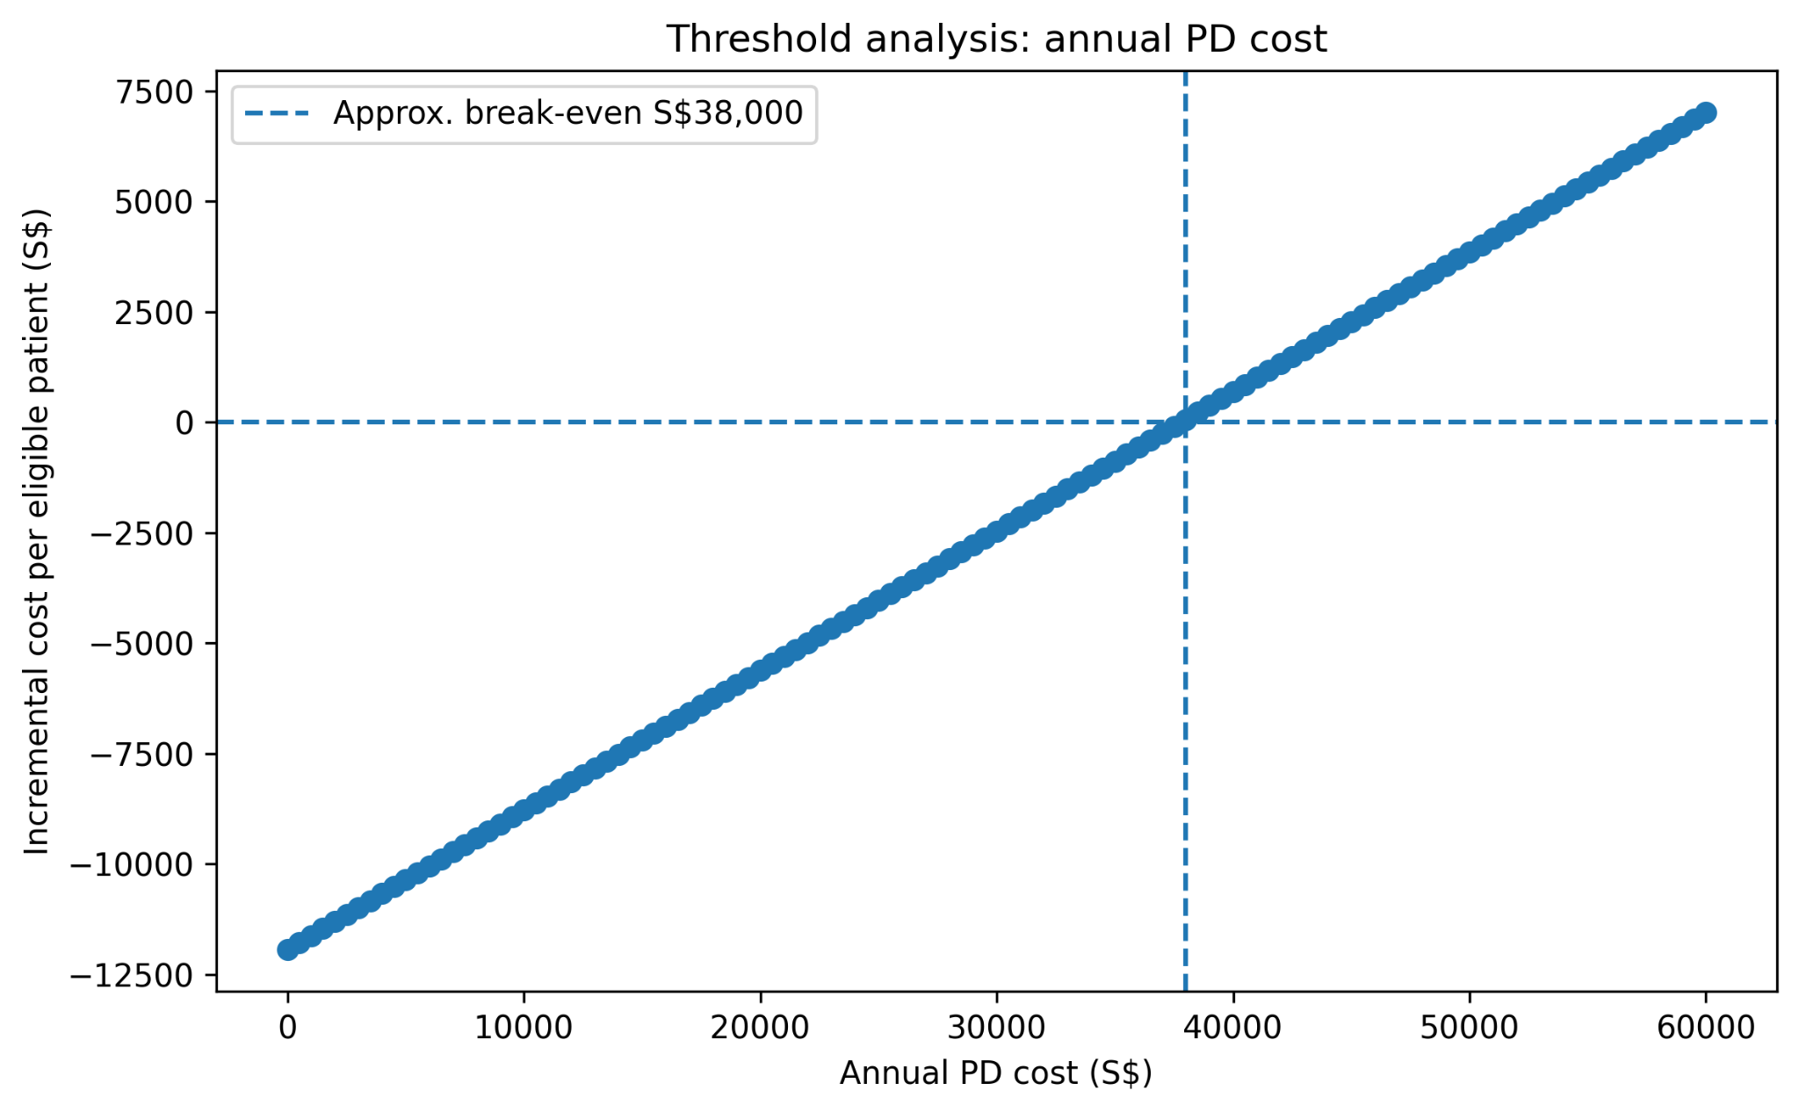
Figure 5. Threshold analysis for annual PD cost. The approximate break-even point is where increased PD uptake no longer remains cost-saving compared with current practice.

Discussion

Singapore interpretation
The model suggests that increased PD uptake among suitable patients may reduce dialysis-related expenditure in Singapore while maintaining broadly similar health outcomes. The economic result is mainly explained by the lower annual cost assigned to PD relative to HD. The QALY gain is small and should be interpreted cautiously because survival was unchanged in the base case.
The findings are relevant to system affordability and service capacity. HD requires repeated centre-based treatment and ongoing facility capacity, while PD shifts part of treatment to the home setting. PD expansion may therefore reduce pressure on centre-based services, but only if patients are appropriately selected and supported. The economic result should not be read as automatic cash release, because safe PD expansion may require investment in education, training, home assessment, infection prevention and follow-up.
The results do not support universal replacement of HD by PD. HD remains necessary for patients who are unsuitable for PD, prefer centre-based care, experience PD technique failure or require modality switching. A stronger policy interpretation is that PD pathways should be strengthened for suitable patients while maintaining adequate HD capacity.

Implementation and feasibility
Implementation feasibility depends on patient selection, pre-dialysis education, home suitability, caregiver availability, patient confidence, catheter care, supply logistics and rapid access to clinical advice. These implementation factors directly affect PD technique survival and switching back to HD.
The annual PD-to-HD switch probability was an important uncertainty driver. If switching is higher than assumed, the economic advantage of increased PD uptake may be reduced because more patients move into the higher-cost HD pathway. If switching is lower through stronger PD support, the strategy may become more favourable. Local monitoring of technique failure, peritonitis, hospitalisation and switching is therefore central to future reassessment.^{9,10}

Equity and policy implications
PD expansion may improve system efficiency, but equity risks should be considered. Successful home-based dialysis may depend on housing conditions, storage space, health literacy, manual ability, caregiver support and confidence in self-management. Patients with stronger home and social support may be better positioned to use PD safely, while patients with fewer resources may remain dependent on centre-based HD.
Policy implementation should therefore focus on appropriate PD uptake, not maximum PD uptake. Practical actions include earlier modality counselling, shared decision-making, home assessment, patient and caregiver training, infection prevention, monitoring of technique failure and clear pathways for switching to HD. Better local data on provider costs, patient-reported quality of life, PD technique survival and complications would strengthen future evaluation.

Limitations

Cost data limitations
The main limitation is the use of public cost proxies rather than complete provider-cost, claims or patient-level expenditure data. Annual HD cost was based on a patient-facing cost range, and PD cost was derived from CAPD and APD public cost ranges and a blended PD modality mix.^{7,8,9}
The model does not include patient transport, caregiver time, productivity loss, home storage requirements or informal care burden. These costs may be relevant because HD and PD distribute costs differently between providers, patients and households. A societal perspective would be needed to capture these wider costs.

Transition probability limitations
Transition probabilities were simplified. Equal HD and PD mortality was used in the base case, and PD-to-HD switching was represented using a single annual probability. The model does not distinguish early and late technique failure, planned and unplanned switching, temporary HD use, age or comorbidity subgroups, or differences in peritonitis risk.^{9,10}

Utility limitations
Utility values were literature-derived and assumption-based. The base-case QALY difference was small, and sensitivity analysis showed that some utility and mortality assumptions could shift the result to lower cost but fewer QALYs. The assessment therefore places greater confidence on the direction of cost savings than on the magnitude or direction of QALY gain.^{11,13}

Structural limitations
The model excluded kidney transplantation, explicit peritonitis events, hospitalisation, cardiovascular events, vascular access complications and separate CAPD and APD states. CAPD refers to continuous ambulatory peritoneal dialysis, where exchanges are usually performed manually during the day. APD refers to automated peritoneal dialysis, where a cycler machine performs exchanges, usually overnight. The base model combined both into a blended PD state, which simplified the model but reduced modality-specific detail.
Budget impact scenarios should be interpreted as scenarios rather than forecasts. The model estimates what may occur if uptake changes according to the specified trajectories, but it does not prove that those trajectories can be achieved without implementation costs or service barriers.

Conclusion
In this model, increasing PD uptake among medically suitable patients with kidney failure in Singapore was associated with lower five-year costs and a small QALY gain compared with current practice. The base case estimated a saving of S$5,985.70 per eligible patient and a QALY gain of 0.0105. The base adoption scenario generated estimated cumulative savings of S$15.89 million over five years.
The findings are strongest for cost savings and less certain for health gain. The model does not show a survival advantage, and the QALY gain is sensitive to utility and mortality assumptions. The cost-saving conclusion depends mainly on PD remaining materially less costly than HD and on a proportion of suitable patients being able to start and remain on PD safely.
The assessment supports cautious expansion of PD pathways for clinically suitable and adequately supported patients. Implementation should prioritise patient selection, early education, home support, infection prevention, monitoring of technique failure and clear switching pathways. Further evaluation should use local provider-cost data, registry-calibrated transition probabilities and patient-reported quality-of-life data.

Appendix: reproducibility
The analysis was organised into raw data, processed data, modelling notebooks and final outputs. The source inventory documents the origin of each input, while the processed data dictionary defines variables used in the model. Input quality flags identify whether parameters were directly sourced, derived or assumption-heavy. The validation summary records data completeness and consistency checks. This structure supports review and future updating if stronger local data become available.^{2,3}
Table 7. Reproducibility files
Appendix item | File/source | Purpose
Data source inventory | data_processed/source_inventory.csv | Source traceability
Processed data dictionary | data_processed/processed_data_dictionary.csv | Variable definitions
Input quality flags | data_processed/input_quality_flags.csv | Input strength and uncertainty
Validation summary | data_processed/data_validation_summary.csv | Data and calculation checks
Transition matrix | data_processed/transition_matrix_base_case.csv | Health-state transition probabilities
Final model outputs | outputs/final_for_report/ | Tables and figures used in the report
Notebooks | 01_process_hd_pd_clinical_cost_data.ipynb; 02_hd_pd_hta_model_FINAL_USED_FOR_REPORT.ipynb | Reproducible data processing and modelling

References
- Drummond, M.F., Sculpher, M.J., Claxton, K., Stoddart, G.L. and Torrance, G.W. (2015) Methods for the Economic Evaluation of Health Care Programmes. 4th edn. Oxford: Oxford University Press.
- World Health Organization (2025) Health Technology Assessment of Medical Devices. 2nd edn. Geneva: World Health Organization.
- Agency for Care Effectiveness (2025) Medical Technologies Evaluation Methods and Process Guide. Version 4.0. Singapore: Ministry of Health.
- Guinness, L. and Wiseman, V. (eds.) (2011) Introduction to Health Economics. 2nd edn. Maidenhead: Open University Press.
- National Kidney Foundation Singapore (n.d.) Key Statistics. Available at: https://nkfs.org/about-us/key-statistics/
- Ministry of Health Singapore (2022) Key causes of recent increase in number of patients requiring kidney dialysis. Available at: https://www.moh.gov.sg/newsroom/key-causes-of-recent-increase-in-number-of-patients-requiring-kidney-dialysis/
- Duke-NUS Lien Centre for Palliative Care (2026) myKIDNEY: Comparing treatment options. Available at: https://www.duke-nus.edu.sg/lcpc/mykidney/treatment-options/comparing-treatment-options
- HealthHub Singapore (2026) Peritoneal Dialysis. Available at: https://www.healthhub.sg/health-conditions/what-is-peritoneal-dialysis
- Khan, B.A. et al. (2022) Health economics of kidney replacement therapy in Singapore: Taking stock and looking ahead. Annals Academy of Medicine Singapore. Available at: https://annals.edu.sg/health-economics-of-kidney-replacement-therapy-in-singapore-taking-stock-and-looking-ahead/
- Khoo, C.Y. et al. (2022) Death and cardiovascular outcomes in end-stage renal failure patients on different modalities of dialysis. Annals Academy of Medicine Singapore. Available at: https://annals.edu.sg/death-and-cardiovascular-outcomes-in-end-stage-renal-failure-patients-on-different-modalities-of-dialysis/
- Cooper, J.T. et al. (2020) Health-related quality of life utility weights for economic evaluation through different stages of chronic kidney disease: a systematic review. Available at: https://pmc.ncbi.nlm.nih.gov/articles/PMC7507735/
- Yang, F., Lau, T. and Luo, N. (2016) Cost-effectiveness of haemodialysis and peritoneal dialysis for patients with end-stage renal disease in Singapore. Nephrology. Available at: https://pubmed.ncbi.nlm.nih.gov/26566750/
- Yang, F. et al. (2018) Health-related quality of life in patients treated with continuous ambulatory peritoneal dialysis and automated peritoneal dialysis in Singapore. Applied Health Economics and Health Policy. Available at: https://link.springer.com/article/10.1007/s41669-017-0046-z

