Primary Cancer Inpatient Utilisation and Cost Variation Using SPARCS 2024 Administrative Discharge Data

Table 1. Report scope
Item | Specification
Dataset | NY SPARCS 2024 hospital inpatient discharge extract; 50,000 cleaned admissions
Study population | Primary cancer inpatient admissions identified using CCSR diagnosis groupings; analysis cohort n=1,218
Analysis type | Retrospective cost and utilisation analysis using administrative discharge data
Main outcomes | Total inpatient cost, high-cost admission status and length of stay; total charges retained as a descriptive financial measure
Reported models | Gamma GLM with log link for total costs; logistic GLM for high-cost admission status; Negative Binomial GLM for length of stay
Model checks | LOS model adequacy and cost prediction checks; sensitivity evidence retained in appendix

Executive summary
This report examines inpatient utilisation and cost variation among primary cancer admissions identified from a cleaned SPARCS 2024 hospital discharge extract. SPARCS is a New York State de-identified hospital discharge dataset containing discharge-level information on patient characteristics, diagnoses, procedures, services and charges.¹ The cleaned extract contained 50,000 inpatient records. The main analysis cohort comprised 1,218 admissions classified as primary cancer admissions using International Classification of Diseases, Tenth Revision, Clinical Modification (ICD-10-CM) and Clinical Classifications Software Refined (CCSR) diagnosis groupings.² Descriptive comparisons used the wider cleaned extract where relevant, while adjusted modelling was restricted to the primary cancer cohort.
Primary cancer admissions represented 2.44% of the cleaned extract. Median length of stay (LOS) was 4.0 days and mean LOS was 7.39 days. Median total inpatient cost was $27,049 and mean total inpatient cost was $41,849, indicating that cost was concentrated in a higher-cost upper tail. High-cost admission status was defined as admissions above the upper quartile of total inpatient cost, equivalent to $47,065, and included 25.0% of the primary cancer cohort. Emergency admission type accounted for 40.3% of admissions, adults aged 70 years or above accounted for 39.7%, and haematologic cancers accounted for 12.7%.
The reported adjusted analysis used three main models. A Gamma generalised linear model (GLM) with log link was used for total inpatient cost, a logistic GLM was used for high-cost admission status, and a Negative Binomial GLM was used for LOS. Model adequacy checks supported this structure and are retained as supporting evidence rather than as headline findings.⁸,⁹,¹¹
Severity score and haematologic cancer were the most consistent markers of higher inpatient resource use. In the Gamma cost model, each one-level increase in severity score was associated with a cost ratio of 1.65, while haematologic cancer was associated with a cost ratio of 1.68. In the high-cost logistic model, severity score was associated with higher odds of high-cost admission, with an odds ratio (OR) of 3.79, while haematologic cancer was also associated with higher odds, with an OR of 2.92. In the Negative Binomial LOS model, severity score was associated with longer expected stay, with an incidence rate ratio (IRR) of 1.89, while haematologic cancer was associated with an IRR of 1.68.
The findings should be interpreted as adjusted associations from admission-level administrative data, not as causal estimates. The report does not compare alternative interventions, estimate an incremental cost-effectiveness ratio, or measure quality-adjusted life years (QALYs). It is a retrospective cost and utilisation analysis of inpatient oncology resource use. Its main use is to identify where cost and LOS are concentrated and to support severity-adjusted monitoring in hospital planning, financial review and data-quality improvement.³

1. Background and report scope
Primary cancer inpatient admissions create a measurable hospital resource burden through their use of beds, diagnostics, procedures, medicines, specialist staff and discharge planning capacity. These resources are finite, and capacity used for one group of admissions cannot be used elsewhere in the system.³⁴ Cost and length of stay are therefore useful service-planning measures because they show how inpatient oncology activity translates into hospital resource use.
This report focuses on inpatient cost and length of stay, not cancer incidence, survival or treatment effectiveness. The analysis uses administrative hospital discharge data to describe how primary cancer admissions appear within an inpatient dataset and to identify admission-level characteristics associated with higher total cost, high-cost admission status and longer stay. Administrative discharge data are suitable for analysing service use and financial patterns, but they do not provide the clinical detail available in cancer registry data, clinical audit datasets or longitudinal patient-level records.
Cost and utilisation are analysed together because they describe different dimensions of inpatient resource use. Length of stay reflects the duration of bed occupancy and inpatient care, while total inpatient cost provides a financial estimate of resources used during the admission. Total charges are retained as a descriptive financial measure, but total cost is used as the main economic outcome because charges do not directly represent resource consumption. This distinction is important for hospital planning, where admission volume alone may understate the effect of case mix, severity and resource intensity.
The analysis is scoped as a retrospective cost and utilisation study, not a full economic evaluation. Full economic evaluation requires comparison of alternative courses of action in terms of both costs and consequences.³ This report does not compare interventions, estimate incremental cost-effectiveness or measure quality-adjusted life years. It describes inpatient oncology cost and utilisation patterns and estimates adjusted associations between selected admission-level characteristics and resource-use outcomes.

2. Research questions and analytical outputs
The objective of this report was to quantify inpatient utilisation and cost variation among primary cancer admissions in the SPARCS 2024 inpatient discharge extract, and to identify admission-level characteristics associated with higher total inpatient cost, high-cost admission status and longer length of stay.
Table 2. Research questions and analytical outputs
Research question | Analytical output
RQ1. What is the inpatient cost and utilisation profile of primary cancer admissions? | Cohort profile, cost and LOS summaries, diagnosis group, severity, admission type and payer tables
RQ2. Which admission-level factors are associated with total inpatient cost? | Gamma GLM with log link for total inpatient cost
RQ3. Which admission-level factors are associated with high-cost admission status? | Logistic GLM for high-cost admission indicator
RQ4. Which admission-level factors are associated with length of stay? | Negative Binomial GLM for length of stay
RQ5. What do the findings imply for service planning and health economics interpretation? | Discussion, service planning implications and limitations

3. Methods

3.1 Data source and study design
The analysis used a 50,000-record extract of the NY SPARCS 2024 hospital inpatient discharge dataset. The official SPARCS de-identified inpatient discharge dataset contains discharge-level detail for public-use analysis of hospital activity.¹ The unit of analysis was the hospital admission, not the individual patient. Repeat admissions by the same person could not be treated as longitudinal patient histories unless a stable patient identifier was available.
The study design was retrospective, observational and secondary-data based. No intervention was assigned and no causal contrast was estimated. The report therefore describes patterns and adjusted associations in inpatient resource use rather than estimating treatment effectiveness or clinical outcomes.

3.2 Cohort construction
The raw extract contained 50,000 inpatient records and 33 columns. After cleaning and validation, the analysis dataset retained 50,000 rows and 49 cleaned or derived variables. Primary cancer admissions were identified using cleaned CCSR diagnosis descriptions and cancer-related classification flags. The primary cancer cohort contained 1,218 admissions, with 25 unique primary cancer CCSR codes in the data.
The broader cancer-related cohort contained 1,377 admissions. The report focuses on the narrower primary cancer cohort because it provides a clearer case definition for cost and LOS modelling. Keyword-matched records that did not meet the cancer cohort definition were excluded from the adjusted modelling cohort. The model input retained all 1,218 primary cancer admissions.
Table 3. Data readiness and cohort construction
Item | Value
Raw SPARCS extract rows | 50,000
Raw SPARCS extract columns | 33
Cleaned analysis rows | 50,000
Cleaned analysis columns | 49
Primary cancer admissions | 1,218
Broader cancer-related admissions | 1,377
Model input rows | 1,218
Unique primary cancer CCSR codes | 25
Invalid LOS rows | 0
Missing or invalid total charges rows | 0
Missing or invalid total costs rows | 0
Analysis dataset status | final_analysis_ready

3.3 Outcomes and covariates
The main economic outcome was total inpatient cost. Total charges were retained for descriptive comparison but were not treated as the main economic outcome. Length of stay was measured in inpatient days. High-cost admission status was derived using the 75th percentile of total inpatient cost, with admissions above $47,064.56 classified as high-cost. Long-stay status was derived using the 75th percentile of LOS, with admissions above 8 days classified as long-stay. The 75th percentile was used as an internal upper-quartile threshold to identify the higher-resource tail of this dataset as a distributional threshold for service monitoring, not a clinical threshold or external benchmark.⁷
The adjusted models used a deliberately limited covariate set: APR severity score, emergency admission type, older adult aged 70 years or above, and haematologic cancer. This kept the models interpretable, reduced the risk of unstable estimates in a cohort of 1,218 admissions, and focused the analysis on variables that were consistently available, clinically plausible and directly relevant to the report questions. Severity score was treated as an ordinal measure from minor to extreme severity. Haematologic cancer included leukaemia, lymphoma and myeloma diagnosis groups.
Table 4. Main model covariates
Variable | Definition / role | Value in cohort
Severity score | Ordinal APR severity score, Minor=1 to Extreme=4 | Mean 2.33
Emergency admission | Emergency admission type indicator | 40.3%
Older adult 70+ | Age group 70 years or older | 39.7%
Haematologic cancer | Leukaemia, lymphoma or myeloma diagnosis group | 12.7%

Table 4 is a covariate summary table. It shows which adjustment variables entered the reported models, how each variable was defined, and how common the variable was in the primary cancer cohort. It is not a results table by itself; it documents the model inputs used to interpret adjusted associations.

3.4 Descriptive and modelling strategy
Descriptive analysis summarised cohort composition, LOS, total charges, total costs, cost per inpatient day, emergency admission patterns, long-stay admissions and high-cost admissions. Medians were emphasised because the project figures and summary tables showed right-skewed distributions for both cost and LOS, with mean values higher than median values. Means were retained to show the influence of the upper tail on average resource use.
The modelling approach followed the scale and distribution of each outcome. Total inpatient cost was positive and right-skewed, so a Gamma GLM with a log link was used to estimate multiplicative differences in expected cost. High-cost admission status was binary, so a logistic GLM was used. LOS was a non-negative count-like outcome; a Poisson diagnostic benchmark showed overdispersion, supporting use of a Negative Binomial GLM as the reported LOS model.⁸,⁹ ,¹⁰ ,¹¹
Sensitivity checks were retained separately to assess model adequacy and directional stability. They were not treated as equivalent headline models and are not used as final findings.

4. Results

4.1 Cohort profile and primary cancer comparison
The primary cancer cohort contained 1,218 admissions, representing 2.44% of the cleaned 50,000-record inpatient extract. The non-cancer comparison group contained 48,259 admissions and should not be interpreted as the full complement of the primary cancer cohort as the project classification also identified broader cancer-related-only records and excluded keyword-matched non-cancer records.
Compared with the non-cancer comparison group, primary cancer admissions had higher median LOS and higher median total costs. Median LOS was 4.0 days among primary cancer admissions compared with 3.0 days among non-cancer admissions. Median total inpatient cost was $27,049 for primary cancer admissions compared with $13,885 for non-cancer admissions.
Table 5. Primary cancer and non-cancer comparison
Group | Admissions | Median LOS | Mean LOS | Median total cost | Median total charges | Emergency admission
Non-cancer | 48,259 | 3.0 | 5.71 | $13,885 | $46,535 | 66.7%
Primary cancer | 1,218 | 4.0 | 7.39 | $27,049 | $91,355 | 40.3%

Figure 1. Median total costs among primary cancer and non-cancer admissions
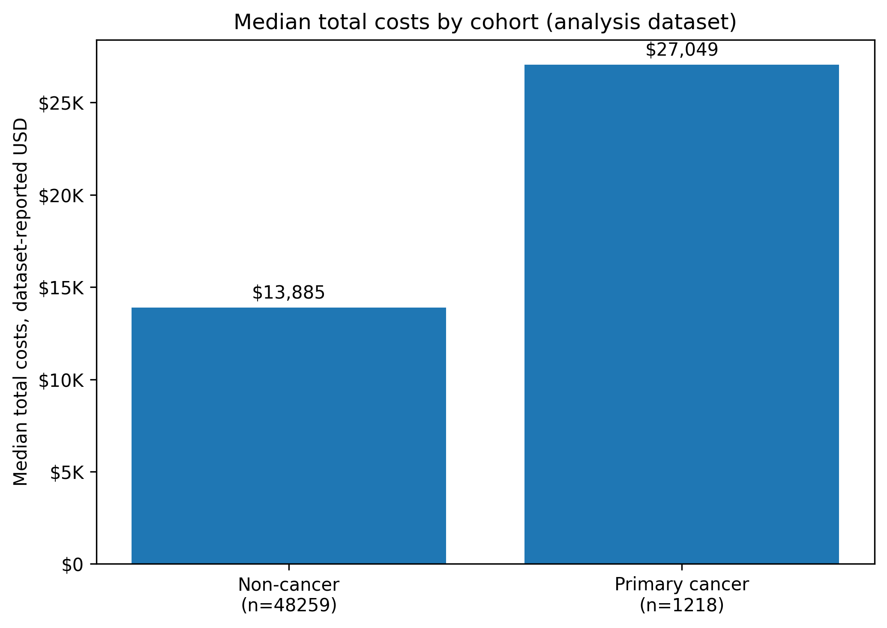
Figure 2. Median length of stay among primary cancer and non-cancer admissions
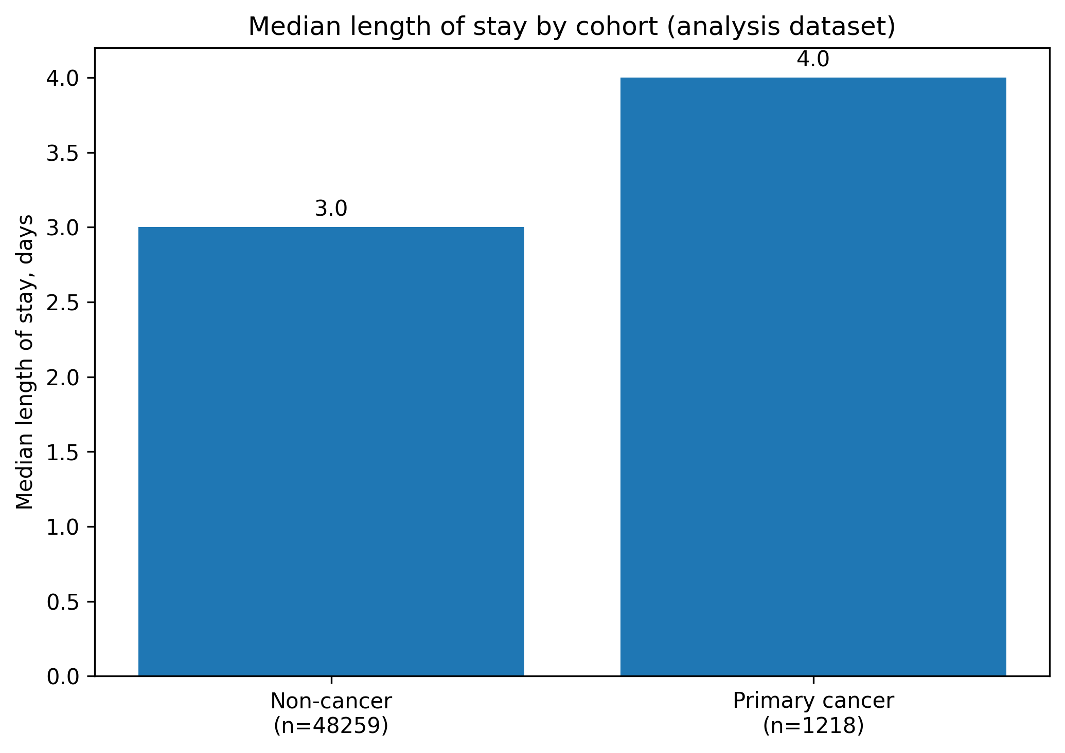
Figure 3. Top primary cancer diagnosis groups in the analysis cohort
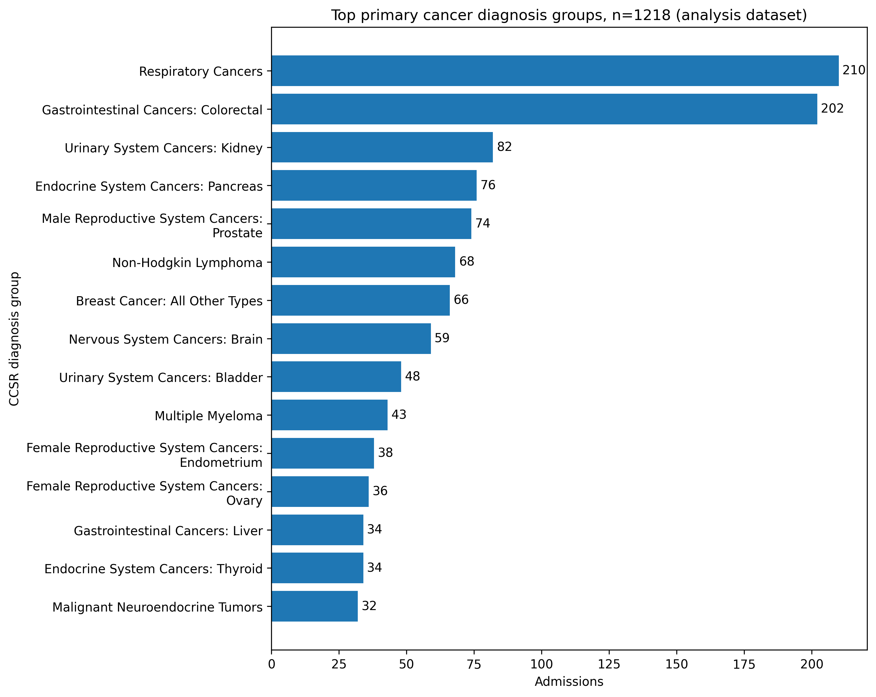

4.2 Overall primary cancer utilisation and cost summary
Within the primary cancer cohort, median total cost was $27,049 and mean total cost was $41,849. The higher mean compared with the median indicates concentration in a higher-cost upper tail. The same pattern appeared for charges, where the median was $91,355 and the mean was $145,212. Median cost per inpatient day was $6,882. Emergency department use was recorded in 37.8% of primary cancer admissions, while emergency admission type accounted for 40.3%.
The long-stay and high-cost indicators were based on the upper quartile of the primary cancer cohort. The long-stay definition classified admissions above, not at or above, the 75th percentile of eight days. The resulting long-stay share was 24.0% rather than exactly 25.0%. High-cost admissions numbered 305 and accounted for 25.0% of the cohort.
Table 6. Overall primary cancer utilisation and cost summary
Metric | Value
Admissions | 1,218
Median LOS | 4.0 days
Mean LOS | 7.39 days
75th percentile LOS | 8.0 days
Median total charges | $91,355
Mean total charges | $145,212
Median total costs | $27,049
Mean total costs | $41,849
Median cost per inpatient day | $6,882
Emergency department admissions | 37.8%
Emergency admission type | 40.3%
Long-stay admissions | 24.0%
High-cost admissions | 25.0%

4.3 Variation by severity, admission type, diagnosis group and payer
Severity showed the clearest descriptive gradient. Median total cost increased from $19,978 for minor severity admissions to $70,573 for extreme severity admissions. Median LOS increased from 1.0 day in the minor group to 14.0 days in the extreme group. The proportion of high-cost admissions also increased from 4.3% in the minor group to 66.4% in the extreme group.
Table 7. Utilisation and cost by severity group
Severity | Admissions | Median LOS | Mean LOS | Median cost | Mean cost | High-cost | Long-stay
Minor | 233 | 1.0 | 2.43 | $19,978 | $22,694 | 4.3% | 3.0%
Moderate | 464 | 3.0 | 4.86 | $25,621 | $30,732 | 14.2% | 11.6%
Major | 405 | 6.0 | 9.82 | $33,675 | $47,624 | 37.5% | 36.3%
Extreme | 116 | 14.0 | 18.99 | $70,573 | $104,635 | 66.4% | 72.4%

Figure 4. Median total costs by APR severity group
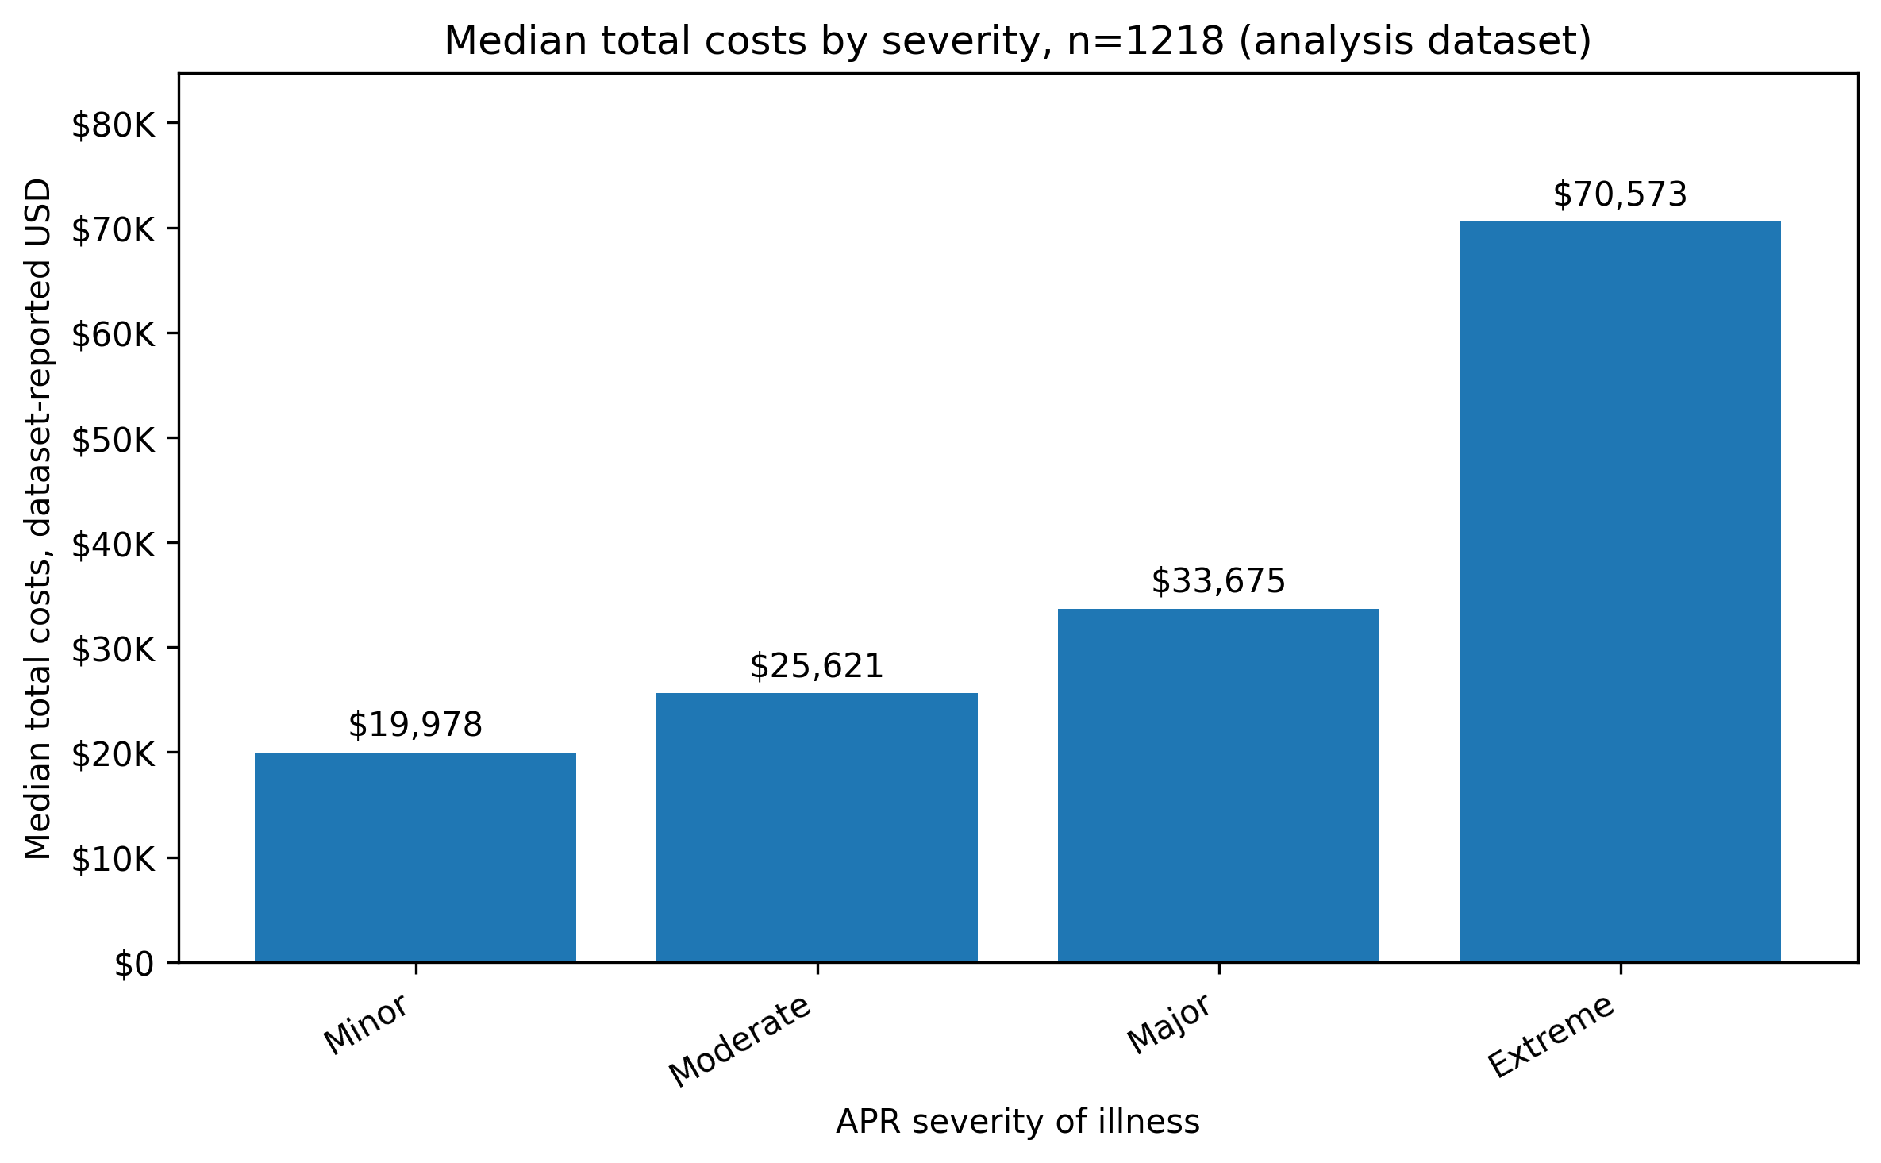
Figure 5. Median length of stay by APR severity group
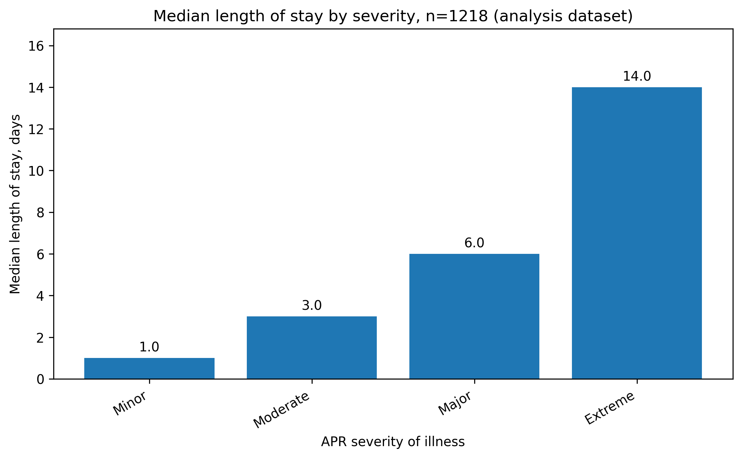
.
Admission type showed a different pattern. Emergency admissions had longer LOS than elective admissions, with median LOS of 6.0 days compared with 3.0 days. Median total cost was similar across elective and emergency admissions, at $27,898 and $27,704 respectively. This suggests that emergency admission status alone did not capture the same resource-use gradient as severity.
Diagnosis group variation was substantial. Respiratory cancers and colorectal cancers were the largest groups, accounting for 210 and 202 admissions respectively. Among diagnosis groups with at least 20 admissions, acute myeloid leukaemia had the highest median total cost ($76,435) and median LOS (18.0 days). Multiple myeloma also had high median cost ($55,323) and median LOS (11.0 days).
Table 8. Selected diagnosis group utilisation and cost results
Diagnosis group | Admissions | Median LOS | Median total cost | High-cost | Emergency admission
RESPIRATORY CANCERS | 210 | 3.0 | $28,198 | 20.5% | 34.8%
GASTROINTESTINAL CANCERS - COLORECTAL | 202 | 5.0 | $28,559 | 25.2% | 38.1%
URINARY SYSTEM CANCERS - KIDNEY | 82 | 2.0 | $21,840 | 6.1% | 9.8%
ENDOCRINE SYSTEM CANCERS - PANCREAS | 76 | 6.0 | $28,709 | 26.3% | 50.0%
MALE REPRODUCTIVE SYSTEM CANCERS - PROSTATE | 74 | 1.0 | $20,317 | 9.5% | 27.0%
NON-HODGKIN LYMPHOMA | 68 | 7.0 | $33,018 | 38.2% | 69.1%
BREAST CANCER - ALL OTHER TYPES | 66 | 2.0 | $21,911 | 13.6% | 31.8%
NERVOUS SYSTEM CANCERS - BRAIN | 59 | 4.0 | $39,379 | 37.3% | 55.9%
URINARY SYSTEM CANCERS - BLADDER | 48 | 4.0 | $27,100 | 25.0% | 45.8%
MULTIPLE MYELOMA | 43 | 11.0 | $55,323 | 55.8% | 72.1%
FEMALE REPRODUCTIVE SYSTEM CANCERS - ENDOMETRIUM | 38 | 2.0 | $18,657 | 5.3% | 36.8%
FEMALE REPRODUCTIVE SYSTEM CANCERS - OVARY | 36 | 3.0 | $25,533 | 13.9% | 33.3%

.
Figure 6. Median total costs by diagnosis group, limited to groups with n>=20
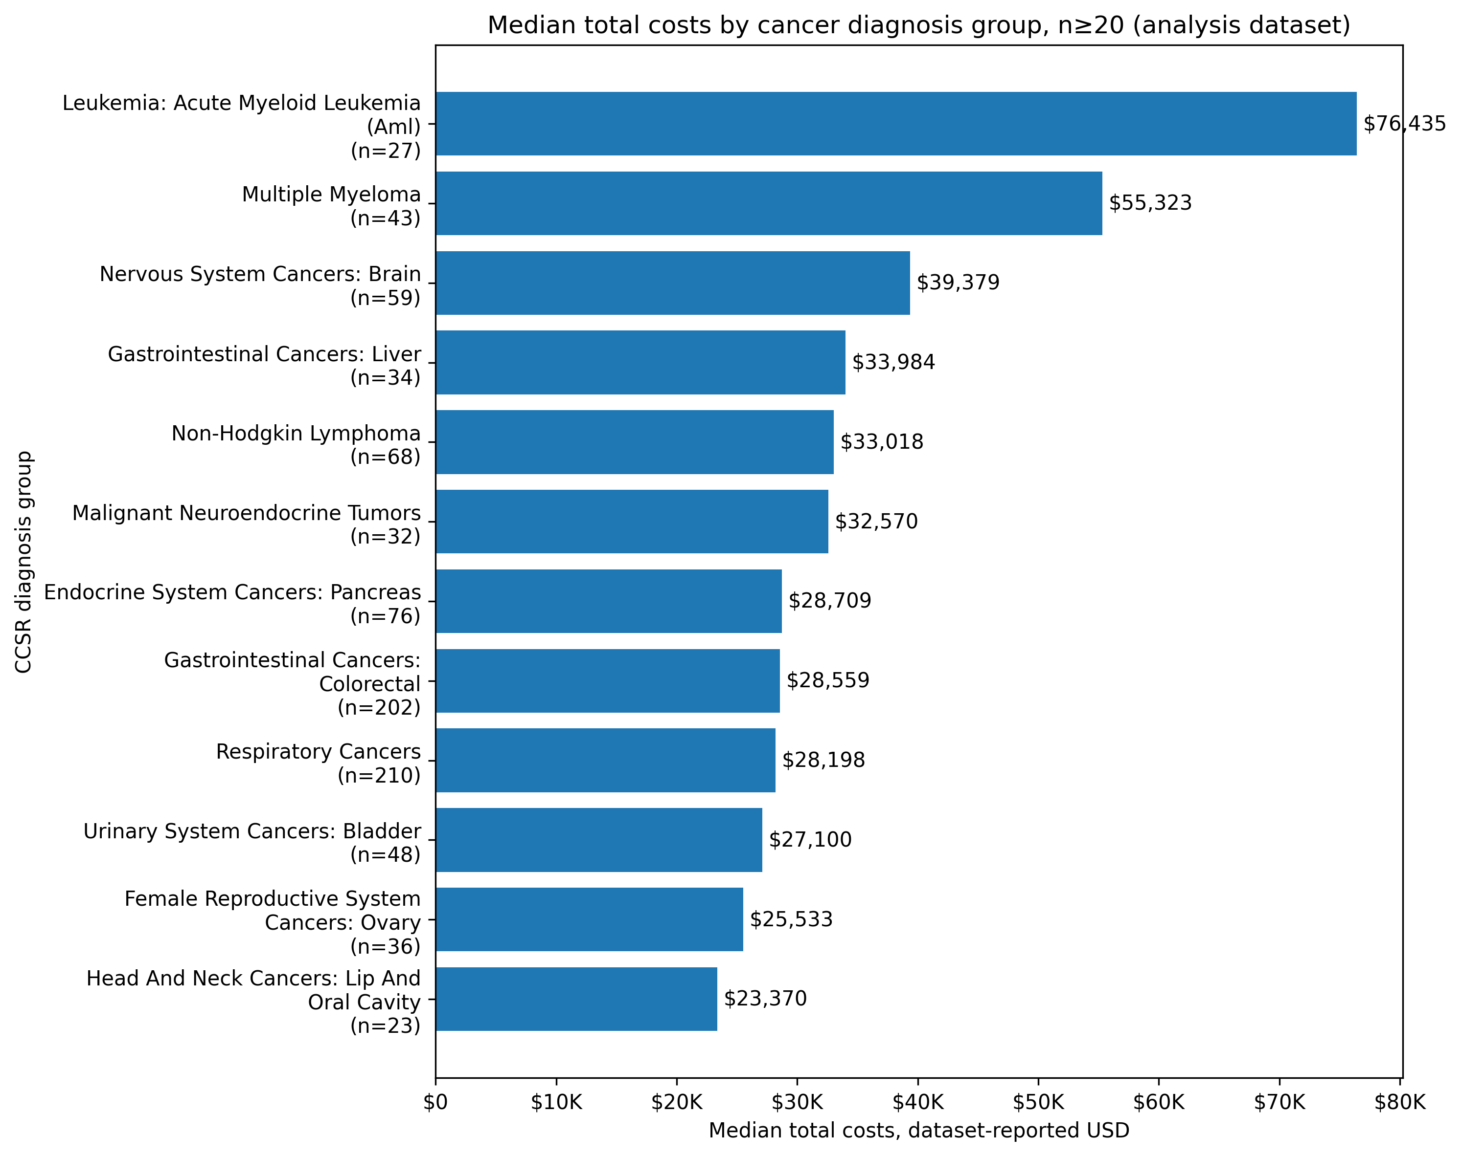
Figure 7. Median length of stay by diagnosis group, limited to groups with n>=20
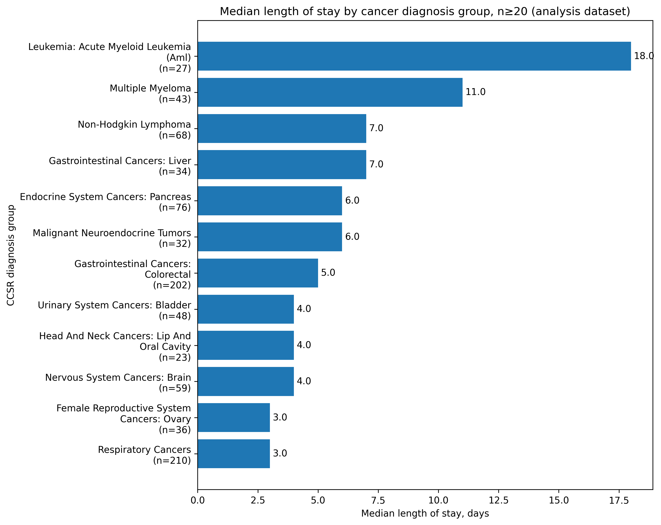
Payer group differences were observed descriptively. Medicare was the largest payer group, accounting for 602 admissions. Medicaid accounted for 206 admissions and had the highest median total cost among payer groups with at least 20 admissions ($33,757), as well as a higher long-stay share (32.0%) and high-cost share (35.9%) than Medicare, private insurance and Blue Cross/Blue Shield. These patterns should not be interpreted as payer effects because payer type may proxy age, socioeconomic context, eligibility rules, severity mix and admission pathway.

4.4 Adjusted model results
The adjusted model results are presented as ratios. A ratio above 1.00 indicates a higher expected outcome relative to the reference or per one-level increase in the predictor, while a ratio below 1.00 indicates a lower expected outcome. Cost ratios describe multiplicative differences in expected total inpatient cost. Odds ratios describe the odds of admission into the high-cost group, not the absolute probability. Incidence rate ratios describe multiplicative differences in expected LOS. The 95% confidence interval indicates the range of values compatible with the model estimate, while the p-value provides a statistical test of whether the estimated association differs from no association under the model.
Across the reported models, severity score and haematologic cancer were the most consistent resource-use signals. Emergency admission type had a mixed profile: it was associated with longer LOS in descriptive analysis, but did not show an independent positive association with higher cost or longer LOS after adjustment for severity and cancer group.
Table 9. Reported adjusted model effects
Model | Term | Effect estimate with 95% CI | p-value
Gamma GLM, total inpatient cost | Severity score | 1.65 (1.56 to 1.75) | <0.001
Gamma GLM, total inpatient cost | Emergency admission | 0.74 (0.66 to 0.83) | <0.001
Gamma GLM, total inpatient cost | Age 70 or older | 0.88 (0.80 to 0.96) | 0.005
Gamma GLM, total inpatient cost | Haematologic cancer | 1.68 (1.38 to 2.04) | <0.001
Logistic GLM, high-cost admission | Severity score | 3.79 (3.06 to 4.69) | <0.001
Logistic GLM, high-cost admission | Emergency admission | 0.61 (0.43 to 0.85) | 0.004
Logistic GLM, high-cost admission | Haematologic cancer | 2.92 (1.94 to 4.39) | <0.001
Negative Binomial GLM, length of stay | Severity score | 1.89 (1.74 to 2.06) | <0.001
Negative Binomial GLM, length of stay | Emergency admission | 1.01 (0.87 to 1.16) | 0.939
Negative Binomial GLM, length of stay | Age 70 or older | 1.13 (0.98 to 1.31) | 0.103
Negative Binomial GLM, length of stay | Haematologic cancer | 1.68 (1.40 to 2.02) | <0.001

Gamma GLM cost model
In the Gamma cost model, severity score and haematologic cancer were associated with higher expected total inpatient cost. Each one-level increase in severity score was associated with a 65.2% higher expected cost (cost ratio 1.65, 95% CI 1.56 to 1.75). Haematologic cancer was associated with a 68.0% higher expected cost (cost ratio 1.68, 95% CI 1.38 to 2.04).
Emergency admission was associated with lower adjusted expected cost (cost ratio 0.74, 95% CI 0.66 to 0.83), and age 70 years or above was also associated with lower adjusted expected cost (cost ratio 0.88, 95% CI 0.80 to 0.96). This should be interpreted as an adjusted association within the selected model rather than evidence that emergency admissions are low burden overall. A plausible interpretation is that some planned or non-emergency oncology admissions may involve high-cost procedures or treatments, while emergency admission status overlaps with severity and diagnosis group in ways that administrative data cannot fully separate.

Figure 8. Gamma GLM cost model cost ratios
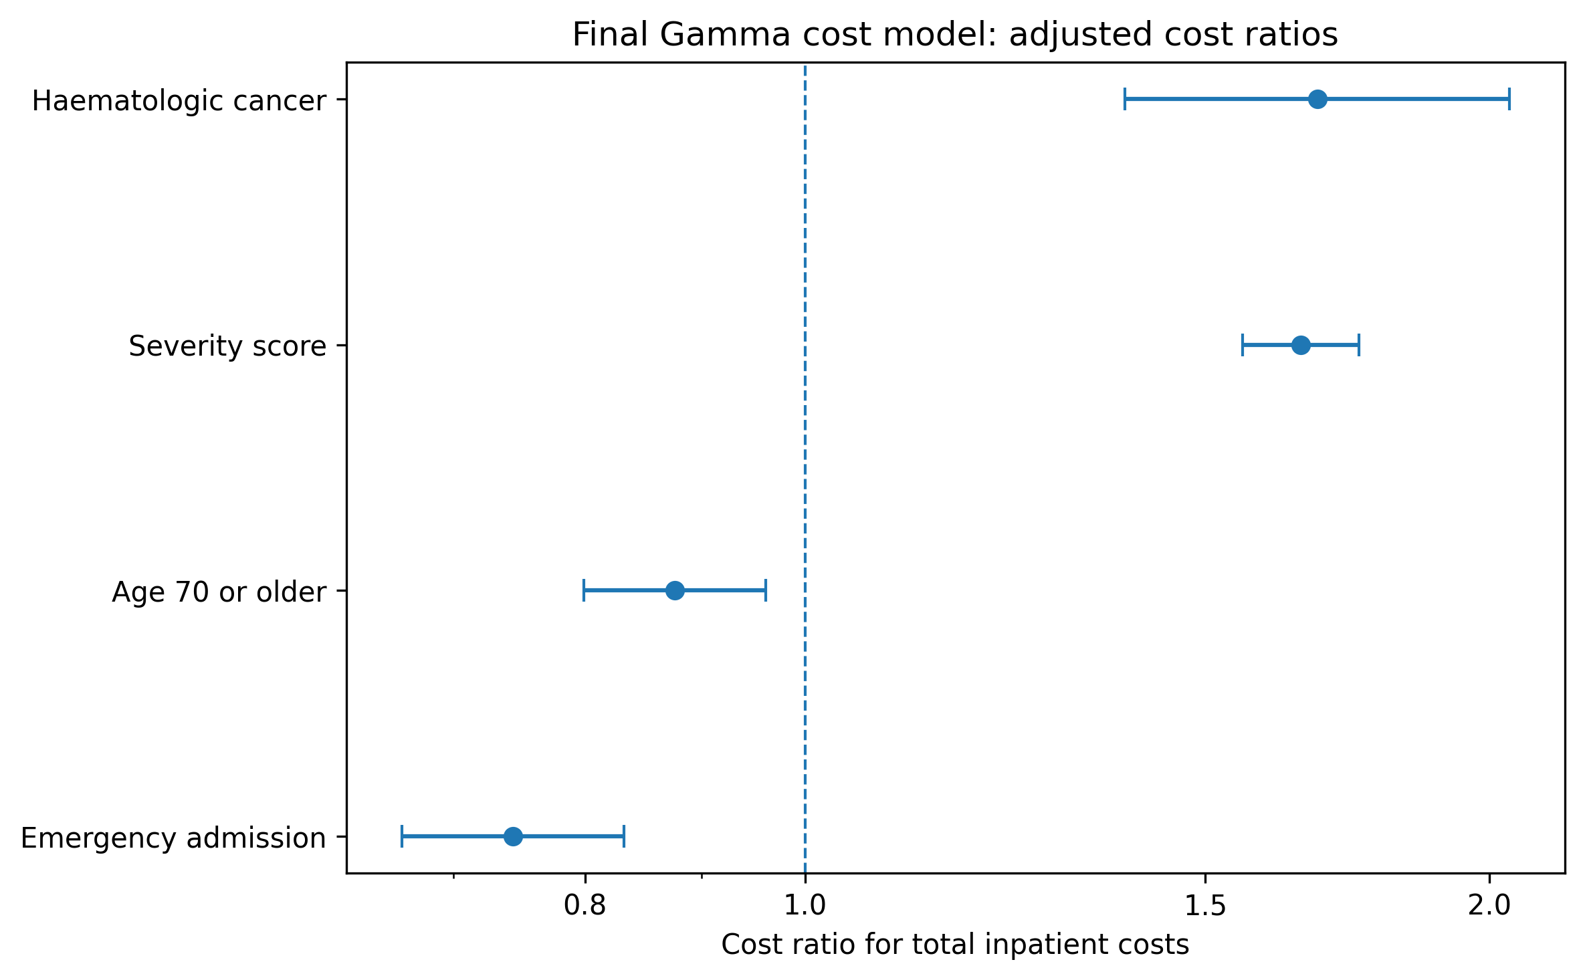

High-cost logistic model
The high-cost logistic model identified factors associated with admission into the upper quartile of total inpatient cost. Severity score had the strongest association, with each one-level increase associated with higher odds of high-cost admission (OR 3.79, 95% CI 3.06 to 4.69). Haematologic cancer was also associated with higher odds of high-cost admission (OR 2.92, 95% CI 1.94 to 4.39).
Emergency admission was associated with lower adjusted odds of high-cost admission (OR 0.61, 95% CI 0.43 to 0.85). In operational terms, emergency admission type did not identify the upper cost tail as strongly as severity and haematologic cancer after adjustment. The result should be interpreted within the limits of the available covariates and admission-level design.

Figure 9. High-cost logistic model odds ratios
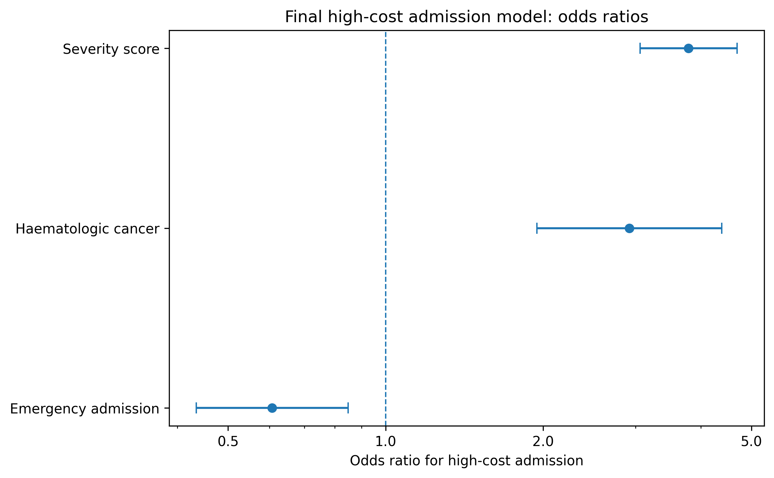

Negative Binomial LOS model
The Negative Binomial LOS model showed that severity score and haematologic cancer were also associated with longer length of stay. Each one-level increase in severity score was associated with a higher expected LOS (IRR 1.89, 95% CI 1.74 to 2.06). Haematologic cancer was associated with longer expected LOS (IRR 1.68, 95% CI 1.40 to 2.02).
Emergency admission was not associated with LOS after adjustment (IRR 1.01, 95% CI 0.87 to 1.16), and age 70 years or above was not clearly associated with LOS at conventional thresholds (IRR 1.13, 95% CI 0.98 to 1.31). The adjusted LOS model therefore identifies severity and haematologic cancer as more stable markers of inpatient utilisation than emergency admission type alone.

Figure 10. Negative Binomial LOS model incidence rate ratios

5. Discussion
The analysis shows that inpatient oncology resource use in the SPARCS 2024 extract was concentrated in a relatively small but high-resource cohort. Primary cancer admissions represented 2.44% of the cleaned extract, but had higher median LOS and higher median total cost than the non-cancer comparison group. The resource-use profile reflected not only admission count, but also greater cost intensity, longer stays and a distinct upper cost tail within the primary cancer cohort.
Severity was the most consistent finding. It showed a clear descriptive gradient across median cost, median LOS, long-stay percentage and high-cost percentage, and remained strongly associated with cost, high-cost status and LOS in adjusted models. For service planning, this means that crude counts of cancer admissions are insufficient. Monitoring should account for case mix and severity, otherwise comparisons across admission pathways or diagnosis groups may understate resource intensity.
Haematologic cancer was the second consistent signal. Although haematologic cancers represented 12.7% of the model cohort, they were associated with higher expected cost, higher odds of high-cost admission and longer LOS. The diagnosis-level results were aligned with this pattern: acute myeloid leukaemia and multiple myeloma had some of the highest median costs and longest median stays among groups with adequate sample size. This supports separate monitoring of haematologic malignancy admissions rather than treating oncology admissions as a homogeneous group.
Emergency admission type requires cautious interpretation. Descriptively, emergency admissions had longer median LOS than elective admissions. In the adjusted models, however, emergency admission was not associated with longer LOS and was associated with lower expected cost and lower odds of high-cost admission. This pattern suggests that emergency status should be considered alongside severity and diagnosis group rather than used as a standalone cost-risk marker. It may also reflect residual confounding, coding differences, and the possibility that some planned oncology admissions involve high-cost treatment episodes.
The report does not identify which clinical services should be expanded, reduced or redesigned. Its contribution is narrower and more operational: it provides a structured view of where inpatient cost and LOS are concentrated and which admission groups may require more detailed review. This can support hospital finance teams, oncology service planners, coding teams and data analysts by making resource-use patterns more visible and reproducible.³,⁴ ,⁵

6. Service planning and analytics implications
Oncology inpatient dashboards should include severity-adjusted cost and LOS measures, not only crude admission counts. Severity was consistently associated with cost, high-cost status and LOS, so unadjusted reporting may distort comparisons across diagnosis groups or admission pathways. Haematologic cancer admissions should be monitored as a distinct resource-use group. The finding does not imply inappropriate care; it indicates that haematologic malignancy admissions had longer stays, higher expected costs and higher high-cost risk in this extract. High-cost admissions should be monitored as a separate outcome rather than inferred from mean cost alone. The model diagnostic showed that the Gamma model was closer to the median than the mean, suggesting that the highest-cost tail contains information that average cost modelling may not fully capture. Emergency admission should be interpreted with severity and diagnosis group. Emergency admissions had longer unadjusted LOS, but emergency status was not an independent positive marker of high cost in the adjusted models. Operational reporting should therefore avoid treating emergency status as the sole explanation for high oncology cost variation. Data quality and coding transparency are part of the value of the analysis. The report was only possible because the extract was cleaned, cancer cohort definitions were documented and evidence tables were exported. Future iterations should strengthen the data dictionary, document all derived variables and maintain a reproducible evidence pack for review. Policy translation should also consider actors, context and implementation. Evidence does not automatically change practice; it must be interpreted by the organisations and teams responsible for finance, coding, clinical service planning and data infrastructure.¹² The immediate value of this report is therefore a reproducible evidence base for targeted service review rather than a policy mandate.

7. Limitations
The analysis has several limitations. The dataset describes inpatient discharges, not patient pathways, and it cannot reliably distinguish one patient with multiple admissions from multiple patients with single admissions. The results therefore apply to admissions, not individual cancer patients. The analysis used administrative diagnosis groupings rather than detailed oncology clinical information. Tumour stage, treatment intent, chemotherapy or radiotherapy details, disease progression, genomic markers, performance status and treatment line were not available in the report-facing dataset. Severity score partly captures illness burden, but it is not a substitute for oncology clinical staging.Cost was limited to inpatient cost fields in SPARCS. The analysis does not include outpatient oncology costs, physician professional fees outside the inpatient record, patient out-of-pocket costs, caregiver time, travel cost, productivity loss, post-discharge costs or end-of-life community care costs. The report therefore reflects inpatient resource use only. Additionally, charges and costs should not be conflated. Total charges were described because they are available in the dataset and relevant to hospital billing patterns, but total cost was used as the main economic outcome. Charges may exceed or differ from resource cost and should not be interpreted as the true economic cost of care.Adjusted model results are associations, not causal effects. Emergency admission, age group, severity and haematologic cancer may be associated with unmeasured clinical and operational factors. Residual confounding is likely because administrative discharge data cannot fully capture clinical complexity. This report is not a full economic evaluation. It does not compare alternative interventions, estimate ICERs, measure QALYs or assess cost-effectiveness. A cost and utilisation analysis can inform planning, but it cannot determine whether one clinical pathway offers better value than another.³ The extract contains 50,000 inpatient records rather than the full SPARCS population. The results should therefore be treated as an analysis of the selected extract, not as a complete New York State oncology hospitalisation estimate. The use of New York administrative data also limits direct transferability to other health systems without local costing, coding and service-context checks.

8. Conclusion
This retrospective cost and utilisation analysis identified 1,218 primary cancer admissions from a cleaned SPARCS 2024 inpatient extract. Primary cancer admissions had higher median LOS and higher median total cost than the non-cancer comparison group, and cost outcomes were strongly skewed. Severity score and haematologic cancer were the most consistent adjusted markers of higher resource use across the Gamma cost, high-cost logistic and Negative Binomial LOS models. Emergency admission type had a more mixed interpretation and should not be treated as a simple independent cost driver. The findings support severity-adjusted oncology cost and utilisation monitoring, separate attention to high-cost admissions and clearer reproducible reporting of administrative oncology data.

Appendix A. Reproducibility and evidence pack
The analysis was organised into raw data, processed datasets, modelling notebooks, final tables, final figures and report assets. The evidence pack recorded that main-report tables and figures were present, deprecated figures were excluded, model effects were exported and the master summary table was available.
Table A1. Core reproducibility files
Appendix item | File/source | Purpose
Validation summary | outputs/final_tables/01_notebook_02_validation_summary.csv | Raw and cleaned row counts, missingness and validation checks
Cohort size assessment | outputs/final_tables/02_notebook_02_cohort_size_assessment.csv | Primary cancer cohort and readiness status
Primary vs non-cancer summary | outputs/final_tables/04_notebook_03_primary_vs_non_cancer_summary.csv | Comparison statistics used in Results section
Overall utilisation and cost summary | outputs/final_tables/06_notebook_04_overall_utilisation_cost_summary.csv | Headline descriptive statistics for the primary cancer cohort
Diagnosis and payer summaries | outputs/final_tables/07-08_notebook_04_*.csv | Diagnosis-group and payer-group results
Model comparison summary | outputs/final_tables/10_notebook_05_model_comparison_summary.csv | Role of each model and sensitivity checks
Reported model tables | outputs/final_tables/11-13_notebook_05_*_model_results_report_facing.csv | Adjusted model effects used in Table 9
Diagnostics tables | outputs/final_tables/15-16_notebook_05_*.csv | LOS overdispersion and cost prediction checks
Figure shortlist | outputs/report_assets/final_report_figure_shortlist.csv | Main-report figure list and purposes
Evidence manifest | outputs/report_assets/final_evidence_manifest.json | Evidence pack structure and traceability
Notebooks | notebooks/02, 03, 04, 05 and 06 | Data cleaning, cohort profiling, descriptive analysis, modelling and evidence export

Appendix B. Model adequacy and sensitivity checks
Model adequacy checks are reported as supporting evidence rather than as final findings. The reported LOS findings are based on the Negative Binomial model; the Poisson specification was used only as a diagnostic benchmark. The benchmark produced a Pearson dispersion ratio of 10.22, indicating overdispersion and supporting the Negative Binomial LOS model. The cost prediction check showed that the Gamma model captured central tendency more closely than the upper cost tail: predicted median total cost was $28,101 compared with the observed median of $27,049, while predicted mean total cost was $30,534 compared with the observed mean of $41,849.
Table B1. Model adequacy and sensitivity summary
Diagnostic / check | Result | Interpretation
LOS overdispersion diagnostic | Pearson dispersion ratio 10.22 | Supports use of the Negative Binomial model for reported LOS findings; Poisson output is not used as a final finding
Observed vs predicted median cost | $27,049 vs $28,101 | Predicted median close to observed median
Observed vs predicted mean cost | $41,849 vs $30,534 | Upper cost tail not fully reproduced by the continuous cost model
Log-linear OLS cost model | Directionally consistent with Gamma cost model | Retained as sensitivity evidence, not as the primary cost result

Appendix C. Fact-check summary
Reported numeric details were checked against the exported project files before revision. No headline numerical contradictions were found in the main statistics or adjusted model estimates. Two presentation issues were corrected: the non-cancer comparison group was clarified as a defined comparison group rather than the full complement of primary cancer admissions, and figure placement/order was revised so figures appear in the relevant Results and model sections.
Table C1. Selected fact-check outcomes
Area checked | Result | Status
Cohort size | Primary cancer n=1,218; cleaned extract n=50,000 | Confirmed
Non-cancer comparison | Non-cancer n=48,259; not full complement of primary cancer | Wording corrected
Primary cancer cost/LOS | Median cost $27,049; mean cost $41,849; median LOS 4.0; mean LOS 7.39 | Confirmed
Severity gradient | Minor median cost $19,978; extreme median cost $70,573 | Confirmed
High-cost threshold | >$47,064.56, rounded to >$47,065 | Confirmed
Gamma cost model | Severity CR 1.65; haematologic cancer CR 1.68 | Confirmed
High-cost logistic model | Severity OR 3.79; haematologic cancer OR 2.92 | Confirmed
Negative Binomial LOS model | Severity IRR 1.89; haematologic cancer IRR 1.68 | Confirmed
Model diagnostics | LOS overdispersion diagnostic 10.22; observed/predicted median cost $27,049 vs $28,101 | Confirmed

References
1. New York State Department of Health. Hospital Inpatient Discharges (SPARCS De-Identified): 2024. Health Data NY. Accessed 18 May 2026.
2. Agency for Healthcare Research and Quality. Clinical Classifications Software Refined (CCSR) for ICD-10-CM Diagnoses, v2024.1. Healthcare Cost and Utilization Project. Rockville, MD: AHRQ; 2023.
3. Drummond MF, Sculpher MJ, Claxton K, Stoddart GL, Torrance GW. Methods for the Economic Evaluation of Health Care Programmes. 4th ed. Oxford: Oxford University Press; 2015.
4. Guinness L, Wiseman V, editors. Introduction to Health Economics. 2nd ed. Maidenhead: Open University Press; 2011.
5. Bowling A. Research Methods in Health: Investigating Health and Health Services. 5th ed. Maidenhead: Open University Press; 2023.
6. Krentel A, McKee M, editors. Issues in Public Health: Challenges for the 21st Century. 3rd ed. Maidenhead: Open University Press; 2022.
7. Kirkwood BR, Sterne JAC. Essentials of Medical Statistics. 2nd ed. Malden, MA: Blackwell Science; 2003.
8. Deb P, Norton EC, Manning WG. Health Econometrics Using Stata. College Station, TX: Stata Press; 2017.
9. Manning WG, Mullahy J. Estimating log models: to transform or not to transform? Journal of Health Economics. 2001;20(4):461-494.
10. Fox J. Applied Regression Analysis and Generalized Linear Models. 3rd ed. Thousand Oaks, CA: SAGE; 2016.
11. Cameron AC, Trivedi PK. Regression Analysis of Count Data. 2nd ed. Cambridge: Cambridge University Press; 2013.
12. Buse K, Mays N, Walt G. Making Health Policy. 2nd ed. Maidenhead: Open University Press; 2012.

