ckanext-spatial - Geo related plugins for CKAN

Introduce

This extension contains plugins that add geospatial capabilities to CKAN.

The extension adds a spatial field to the default CKAN dataset schema, using [PostGIS](http://postgis.org/) as the backend. This allows to perform spatial queries and display the dataset extent on the frontend. It also provides harvesters to import geospatial metadata into CKAN from other sources, as well as commands to support the CSW standard. Finally, it also includes plugins to preview spatial formats such as [GeoJSON](http://geojson.org/).

Ckanext-spatial URL: <http://docs.ckan.org/projects/ckanext-spatial/en/latest/index.html>

GeoJSON URL: <http://geojson.org/>

Functions

1. Spatial Search

The spatial extension allows to index datasets with spatial information so they can be filtered via spatial query.

1.1 Spatial Search Widget

The extension provides a snippet to add a map widget to the search form, which allows filtering results by an area of interest.

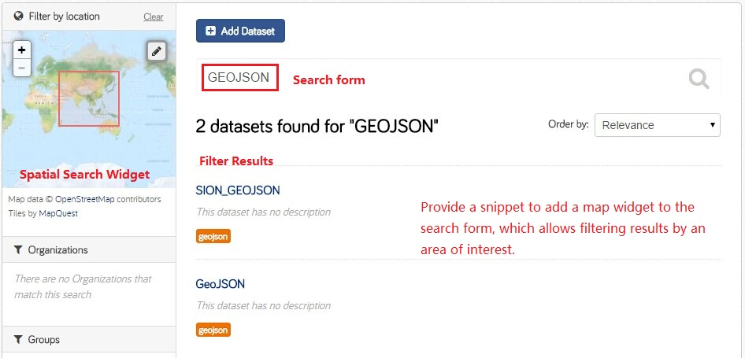

1.2 Dataset Extent Map

Using the snippets provided, if datasets contain a spatial extra like the one described in the previous section, a map will be shown on the dataset details page.

There are snippets already created to load the map on the left sidebar or in the main body of the dataset details page, but these can be easily modified to suit your project needs.

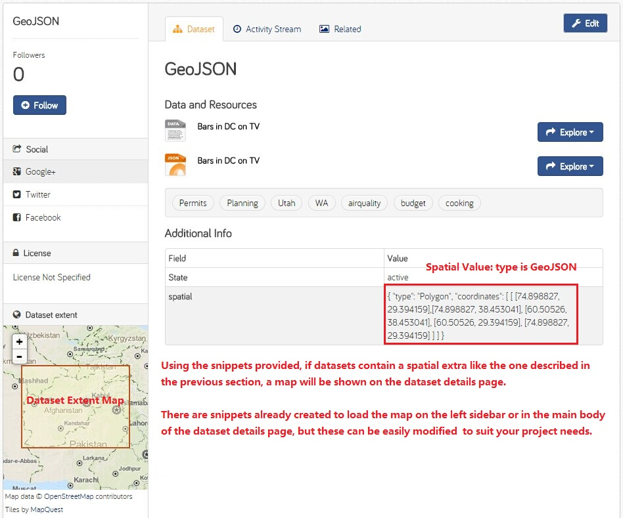

1. Previews for Spatial Formats

The extension includes some plugins that implement the IResourcePreview interface, allowing to preview spatial resource files. They are based in popular Javascript mapping libraries and should be really easy to extend and adapt to your own needs.

2.1 GeoJSON Preview

The GeoJSON previewer is based on Leaflet. It will render GeoJSON files on a map and add a popup showing the features properties, for those resources that have a format of geojson or gjson.

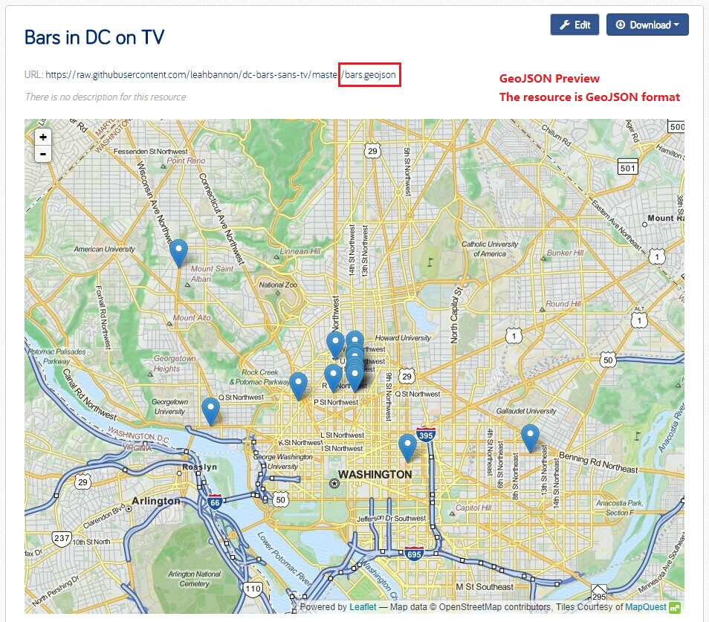

2.1 WMS Preview

The WMS previewer is based on OpenLayers. When the plugin is enabled, if datasets contain a resource that has wms format, the resource page will load a simple map viewer that will attemapt to load the remote service layers, based on the GetCapabilites response. In order for the proxy to get correct response, the URL of the resource must be a full GetCapabilites request, not just the main WMS service endpoint.

<http://vmap0.tiles.osgeo.org/wms/vmap0?SERVICE=WMS&REQUEST=GetCapabilities&VERSION=1.1.1>

1. CSW support
2. Spatial Harvesters