Contents

Designs 2

Wireframes 2

This is my wireframe for my about page: 2

2

This is my wireframe for my portfolio: 3

3

This is my wireframe form my contact page: 3

3

This is my wireframe for my useful links: 4

Sketches: 4

Sketch homepage: 4

Sketches about: 6

Sketches portfolio: 7

Sketches contact: 8

Prototypes 9

Style tile: 9

Evidence of how I have used Modules of Good Practice 9

Page Load Speed 9

Visual appeal 10

Navigation 10

Progression of website over 12 weeks 11

Week 1-4 11

11

Week 4-8 14

Week 8-12 15

## Designs

Before starting my portfolio, I went through some people’s portfolio for some references and ideas. Taking some references from other’s website, it made me easier to make my portfolio. One of the websites which I took as reference is

* <http://joel.sh/>

## Wireframes

### This is my wireframe for my homepage:

Navigation bar

Body

Footer

### This is my wireframe for my about page:

Heading

Navigation bar

Right bar

Image

Footer

### This is my wireframe for my portfolio:

### 

Heading

Description section

Picture with transform property

Navigation bar

### : This is the wireframe for my contact page:

### 

Heading

# 

Navigation bar

Contact form

### 

Footer

### This is my wireframe for my useful links:

Sketches:

### Sketch homepage:

I want my homepage to be a simple one .My homepage shall have a navigation bar on the very top for useful links as well was a picture of me. The body part contains a little bit of information about me. It does not have very much property but it has a combination of descent and gradient colors. I will have a footer where I can write the copyright part. The header and footer for all the pages will be same. A rough sketch of my homepage is shown below:

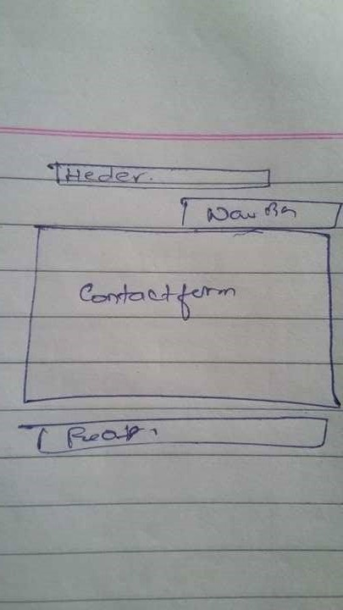

## Sketches about:

In about, I have mentioned a brief biography about me in few paragraphs. There is a heading. The header, footer and navigation bar are same as the homepage. A picture of me is placed on the left. A rough sketch of about is given below:

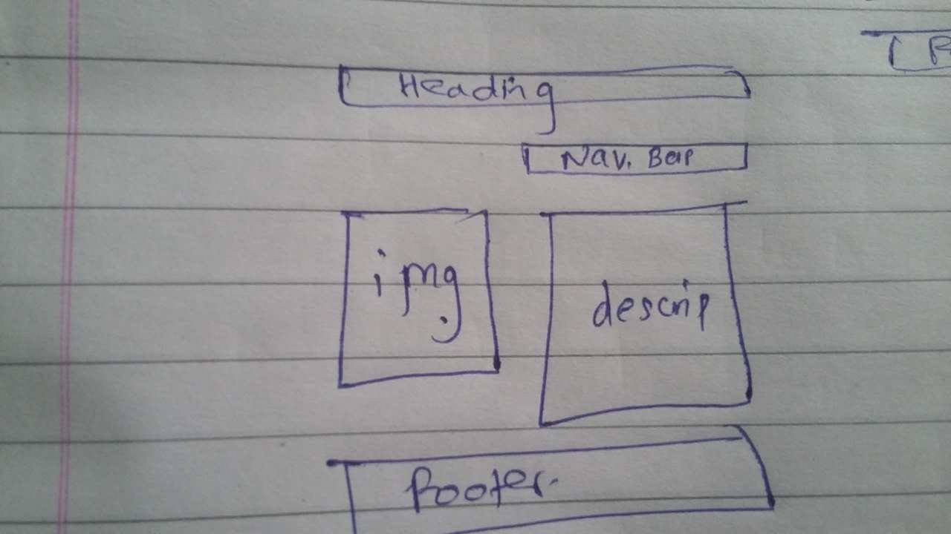

## Sketches portfolio:

In sketch portfolio, there is the same a heading mentioning my curriculum vitae. The navigation bar gives the useful links. I have made two columns for a photo of me with transform property on the left. On the right, a description of my portfolio is given with my qualification.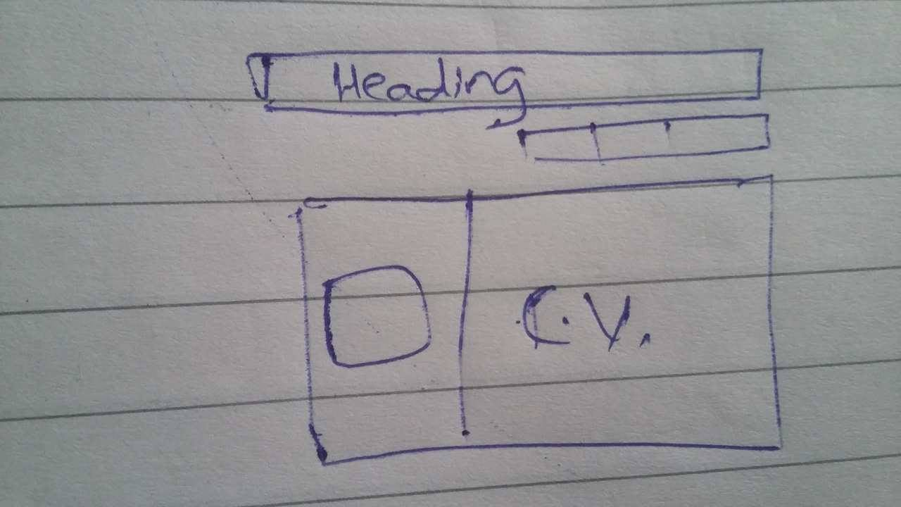

In this sketch, the useful links is mentioned in the navigation bar serially. The sketch has navigation bar on top, body on section part and footer in the end. A rough sketch is given below:

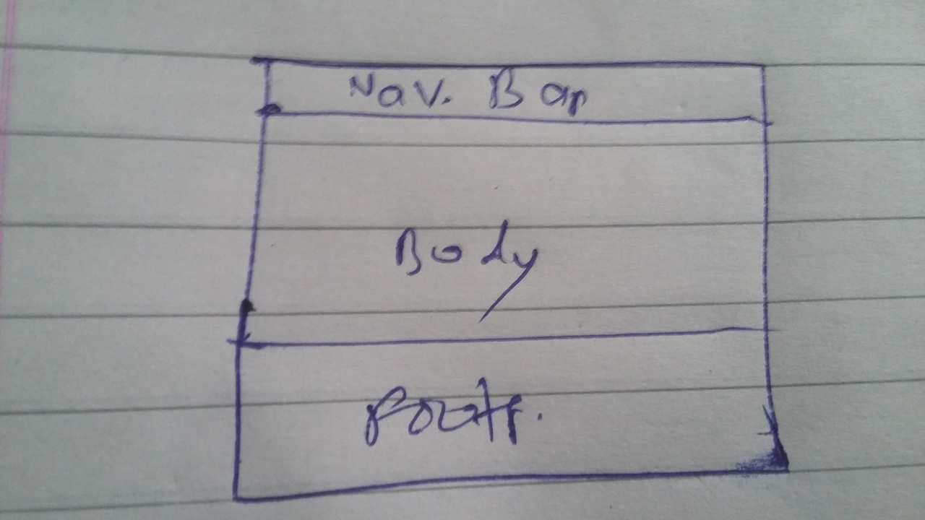

## Sketches contact:

The sketches contact contains a header part. It also has a navigation part with the useful links. The contact form contains information about the contact form. The footer is at the end with the description of the copyright.



# Prototypes

## Style tile:

Portfolio

Buttons

Contact

About me

Possible color

Slategrey, stelblue,silver

Navigation bar

Images I have created

This is one of my favorite icons. It is a clear and neat prototype where we can find navigation bar on the very top-right.

There is no mixing of sections in the body part and is very clearly differentiated. It is not so complicated. It is very easy and clear to understand.

# Evidence of how I have used Modules of Good Practice

## Page Load Speed

Speed is one of the most important thing on internet after the internet access. For effective activities on internet, loading of website and speed of internet plays a very vital role. I have tested my website on Pingdom.com and the result are given below. Out of 93% of the tested sites, my website loads in 766ms according to the test you see below.

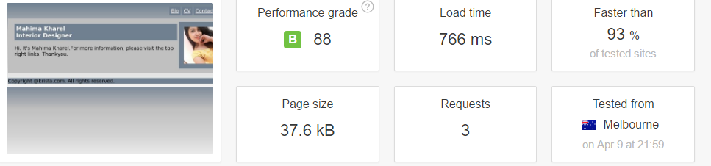

# Visual appeal

After having some look at other people’s portfolio and website, I came to know that rather than overrated colors, a design with simple and descent colors would look good and genuine one. So, without adding any more unappealing colors, I decided to make my website an ambiguous and simple one. I too showed the design of my website to my friends and had a positive response so finally I made this website a simple one.

# Navigation

We all know that one of the most important models of good practices is the navigation system. The system shall be easy and clear to understand. There should not be mixing of unwanted buttons. Navigation system is one of the basic part of the website. So it should go according to the flow without any unwanted interruptions. People should be easily move the system back and forth without any complication which can be a plus point to the website.

## Progression of website over 12 weeks

### Week 1-4

### 

This is my progress within a month. I just made a simple homepage which is easy to understand. I made a horizontal list for the useful links in the navigation bar on the top-right. On the body part, a section is created, in which a very short message is given. To the right, we have a picture of myself in which class aside image is given. On the bottom, we have footer part, where copyright for the page is provided with a slight mix of gradient too.

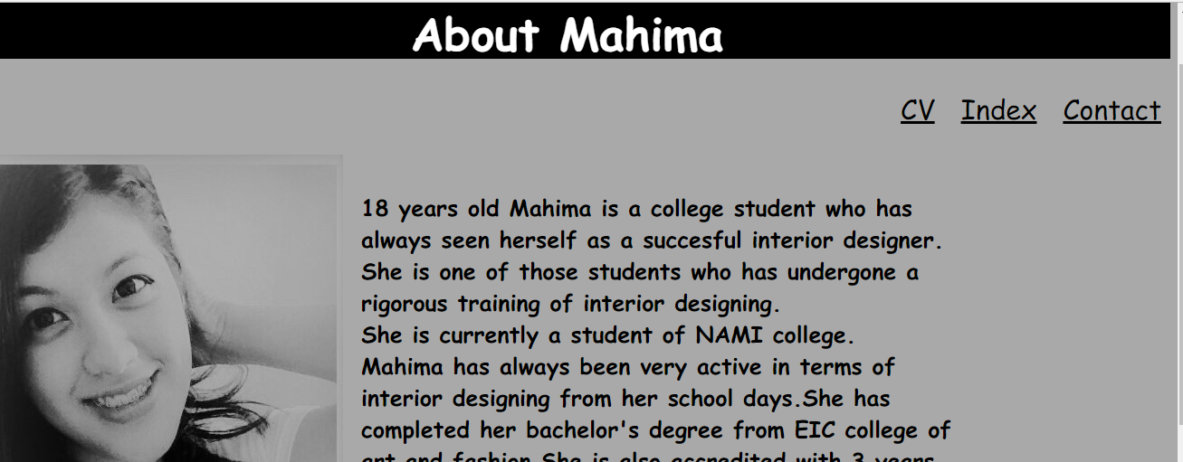

Also, the biography part was completed within a month. I have given a heading with black background and white color. The body part has darkgrey color with resemblance to the picture on the left. On the top, we have the navigation part for different useful links.

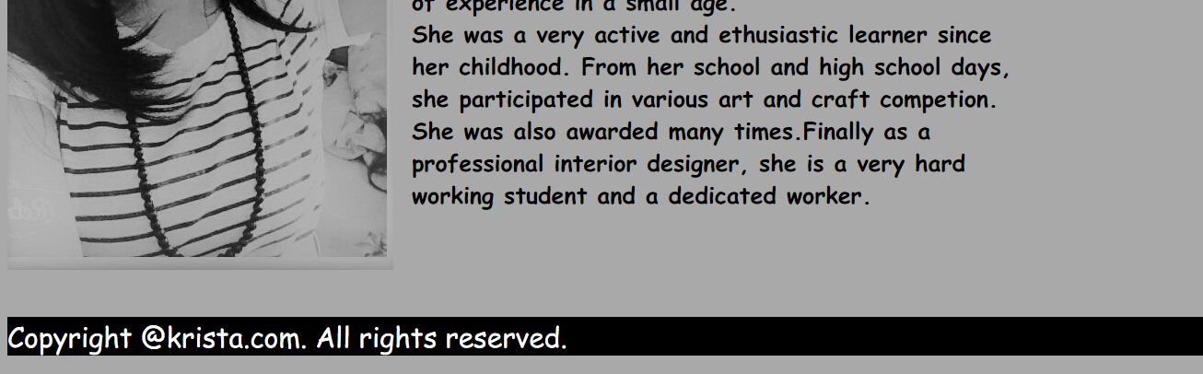

On the footer part, we have given the copyright part with black background and white color. On the right, I have given a brief description of myself in it.

## Week 4-8

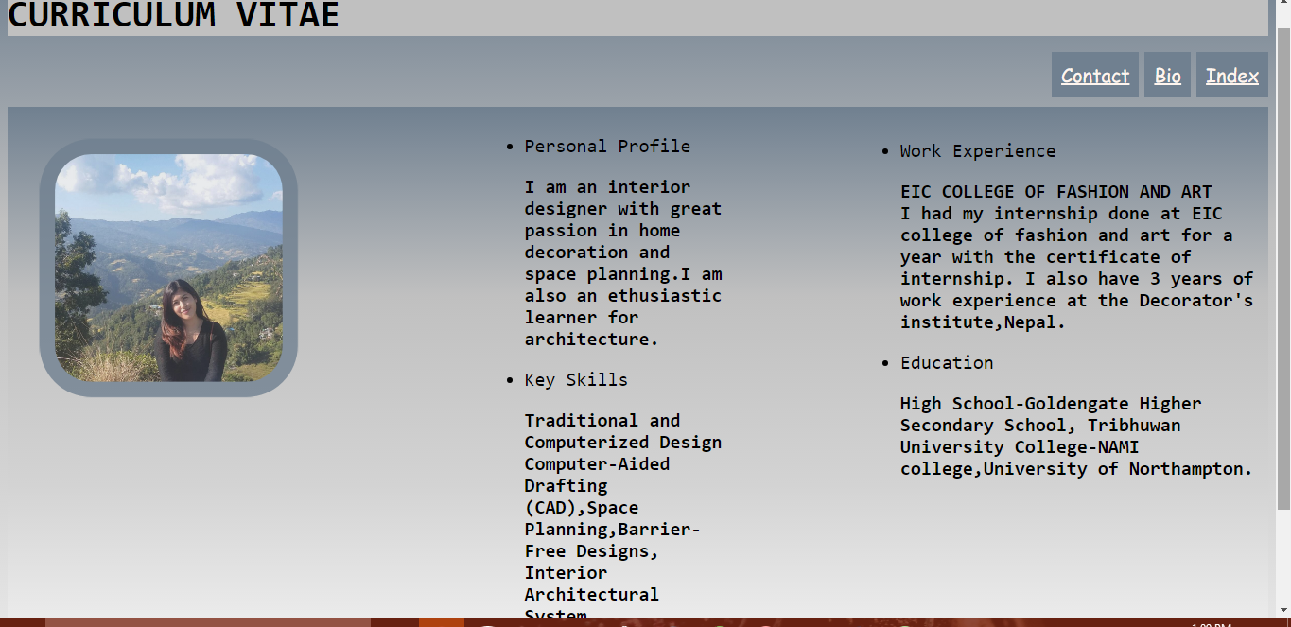

During my 4th week, I made my portfolio page. It was one of the most time consuming phase for me since I have put more property in this part with comparison to other. In this part, I have mentioned my portfolio including my qualification education and work experience. We have the same common navigation bar at ta top right with useful links. At the very top, there is heading with different font. On the left part of body section, there is a photo with transform property. The footer is also a common one.

### Week 8-12

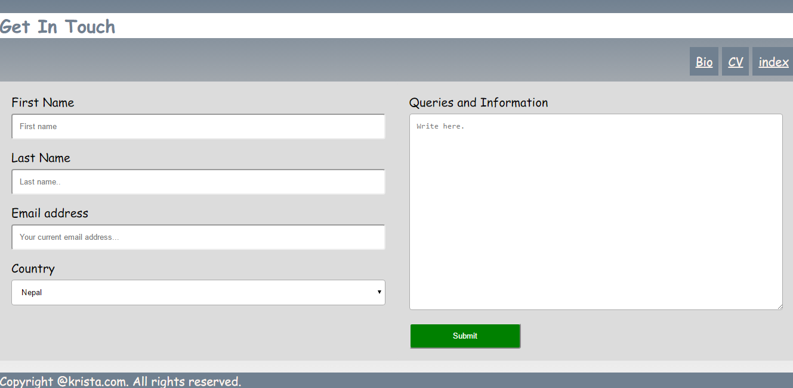

This is the contact form which I did during the last weeks before submission. It has the same common navigation bar with important links on top-right. The section part has left bar where we can see the label for first name last name etc. Also on the right bar, we have section for queries and information. On the bottom, we have footer for copyright. The contact form has a descent color with fair color combination. I took w3schools.com as a reference for the page.