**Introduction To VCS and GitHub Basic Commands**

**Name: Maryam Shabbr MCSF19M013**

**STEP 1:**

**Create New Repository:**

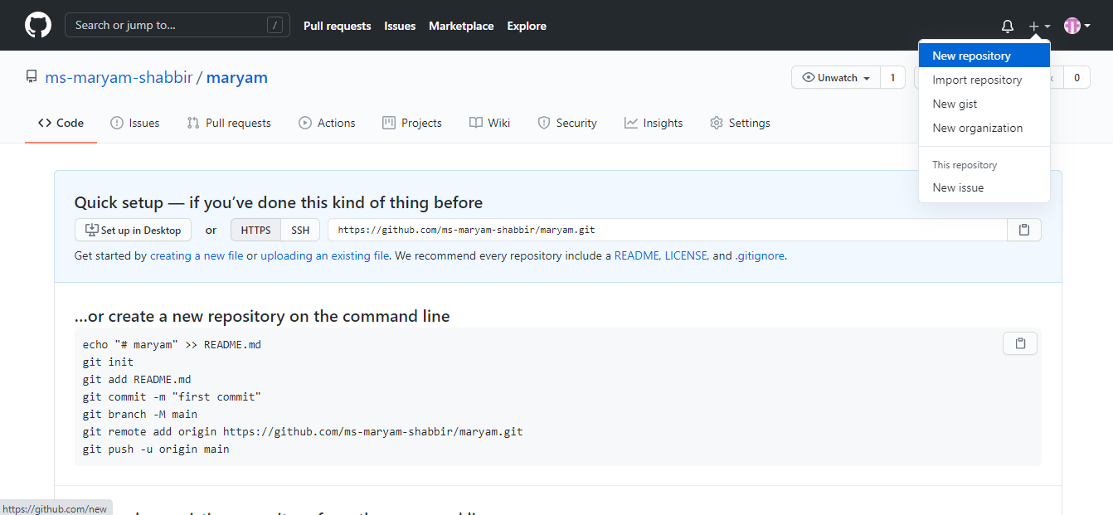

**STEP 2:**

**Assign a valid name to your Repository:**

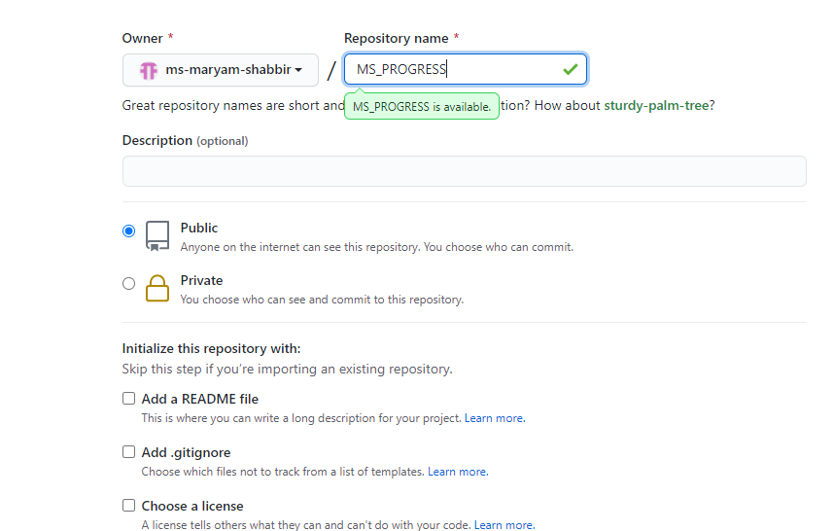

**STEP 3:**

**Clone repository with local device:**

* **Copy the repository’s url link**

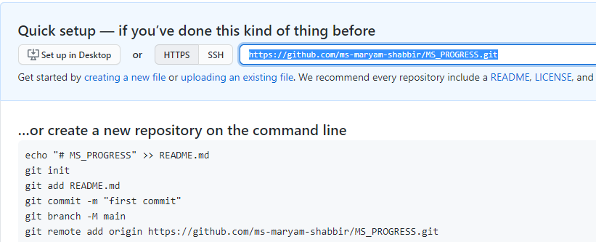

* **Open git cmd and write clone command then paste url.**

**git clone https://github.com/ms-maryam-shabbir/MS_PROGRESS.git**

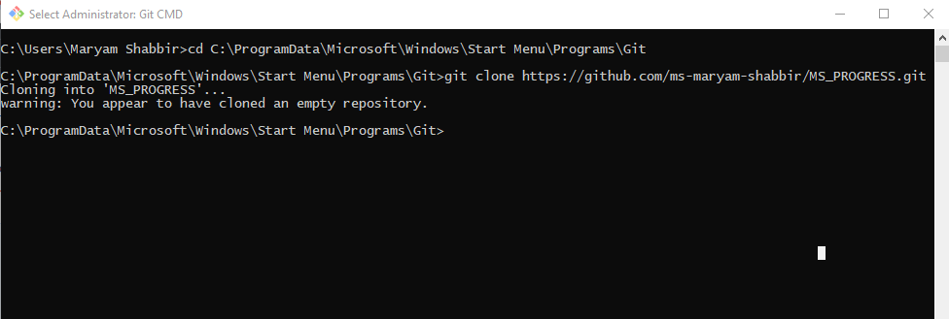

**Clone has been Created!!**

**Step 4:**

**Add files/folders on remote server (Github Repository)**

* Copy file to the repository folder you have cloned(a folder of repository’s name has been created in GIT folder in your device).

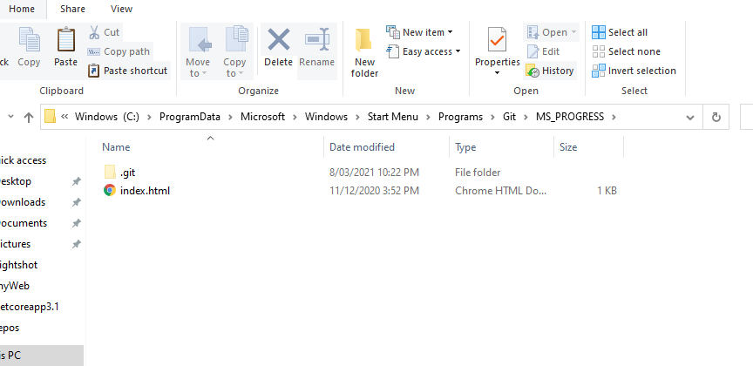

**Now there are three steps to upload a file in online directory.**

* **Git add filename.extension**

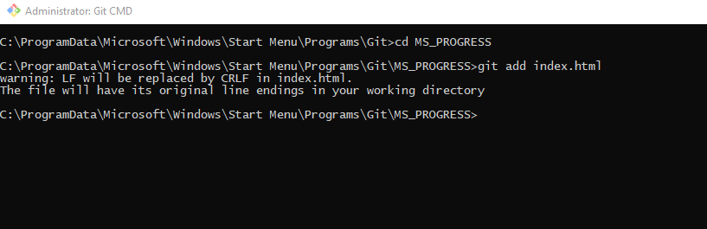

* **git commit -m “message”**

It is use to commit a message about any change you have done.

* **git push**

this command use to push the file tonthe main directory.

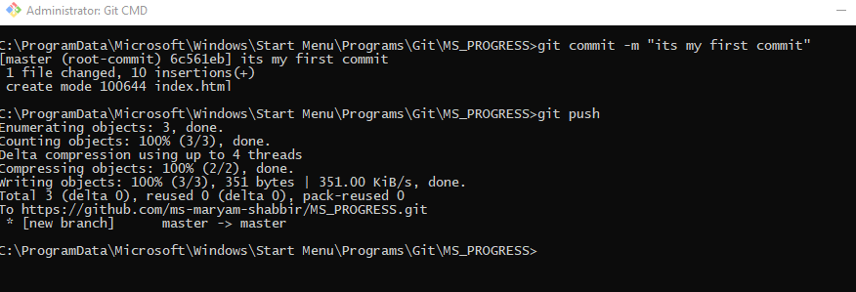

**WOW!! Finally my first file has been pushed to GitHub repository**

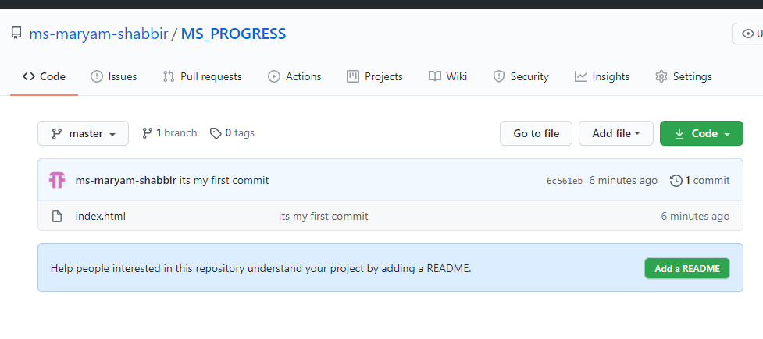

**Git Status:**

Git status is used to get status of git repository.

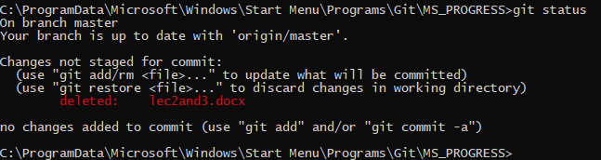

**Again push after changes:**

To push again a file there is same procedure as mentioned above.