Code Quality and Security Scanning POC Report
SonarQube versus GitHub CodeQL and GitHub-native capabilities
POC lead: Naveen | Repository: ms-pwc/github-codeql-poc | Date: 4 August 2026

Executive Summary
This POC compared SonarQube with GitHub CodeQL and GitHub-native security and code-quality capabilities. CodeQL proved strong security coverage and GitHub-native pull-request feedback: five representative Java vulnerabilities were detected and published to Code Scanning.
Recommendation: adopt a hybrid model initially. Use GitHub CodeQL and Secret Scanning for native security feedback, while retaining SonarQube for code quality, technical debt, governance, and reporting until equivalent GitHub coverage is proven.
Functional and Operational Summary
Verified GitHub strengths: SQL injection, command injection, path traversal, unsafe deserialization, and XSS detection; Actions-based analysis; and pull-request checks before merge.
SonarQube strengths to validate with PwC SMEs: mature code-smell analysis, technical-debt reporting, quality profiles, quality gates, dashboards, custom rules, and compliance reporting.
Operational comparison: SonarQube needs server, database, upgrades, plugins, and administration. GitHub uses native Actions and managed services, with no separate analysis server or database.
Figure 1 - Code Scanning Findings
The authenticated GitHub Code Scanning dashboard shows five open CodeQL findings and healthy tool status.
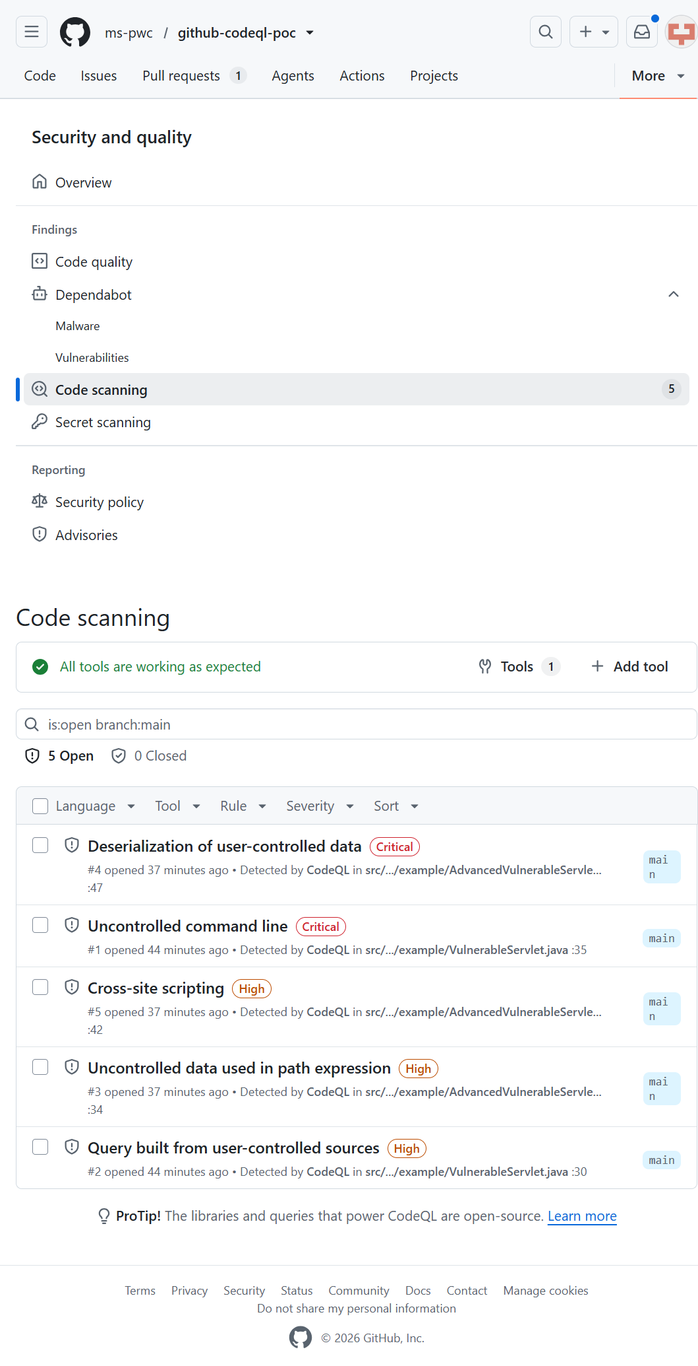
Verified findings: critical command injection; critical unsafe deserialization; high SQL injection; high path traversal; and high XSS.
Figure 2 - Pull Request Checks
The pull-request experience shows CodeQL analysis as a check before merge. New alerts cause the Code Scanning result to fail while the CodeQL analysis job itself completes successfully.
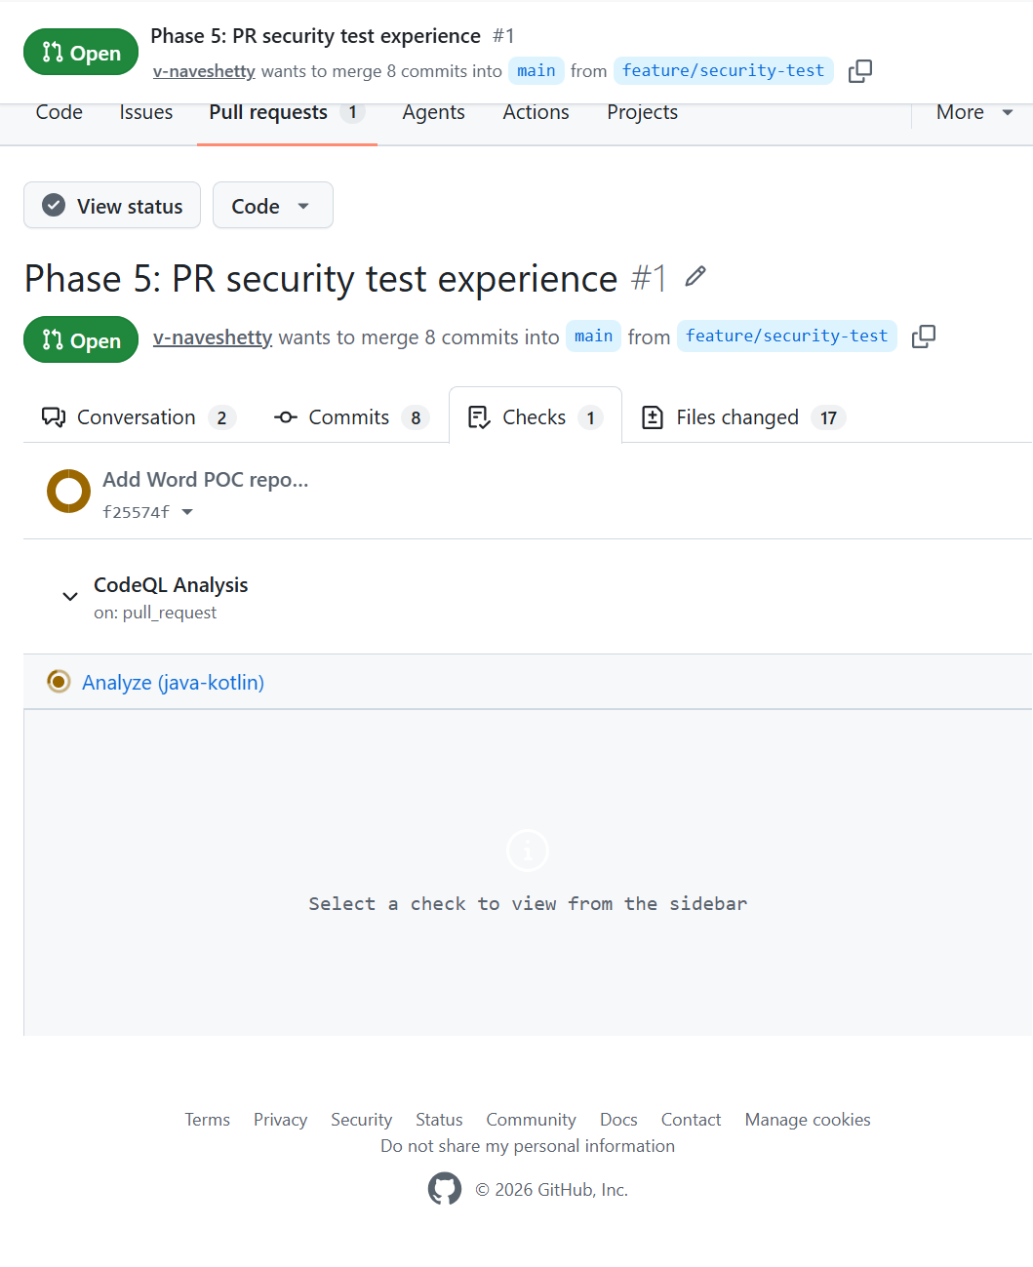
Figure 3 - Successful CodeQL Workflow
The GitHub Actions workflow completed successfully for the pull request, including checkout, Java setup, CodeQL initialization, Maven build, and analysis.
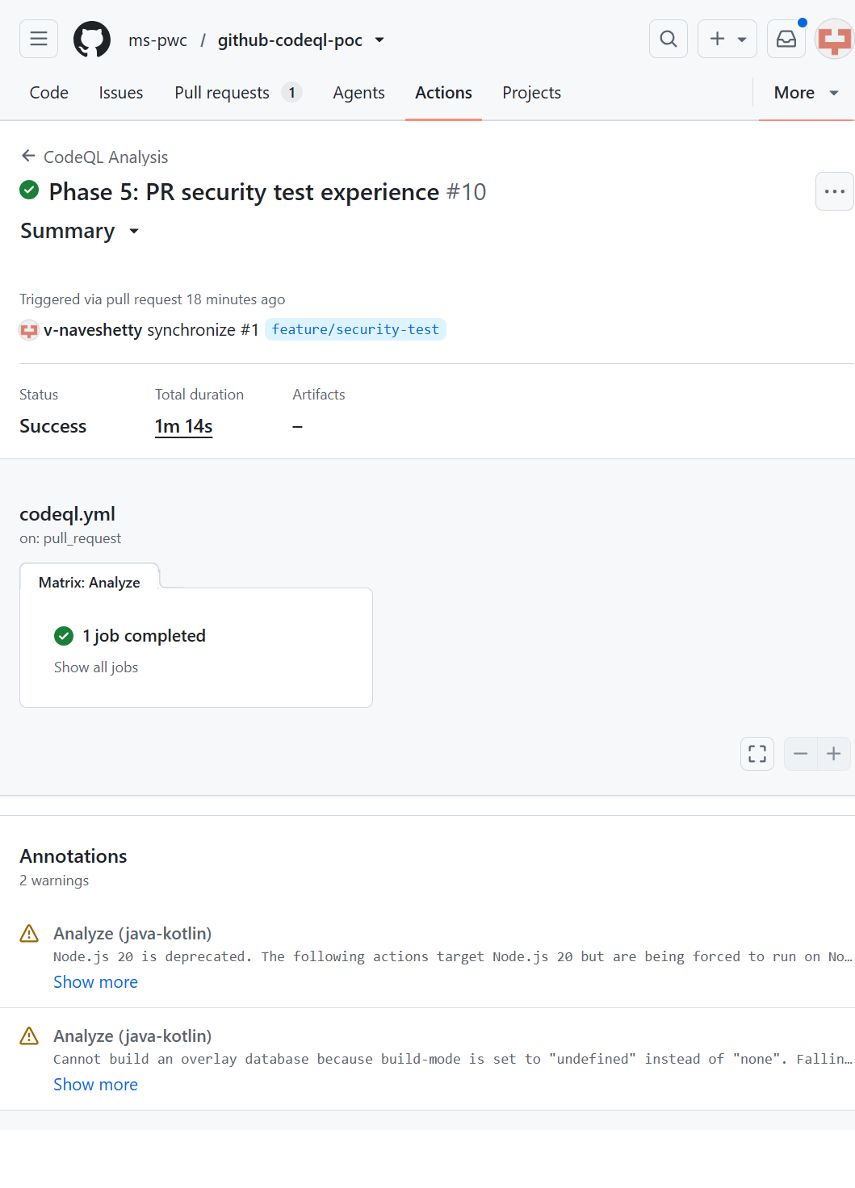
Verified Findings
1. Uncontrolled command line — Critical — VulnerableServlet.java:35.
2. SQL injection — High — VulnerableServlet.java:30.
3. Uncontrolled data used in path expression — High — AdvancedVulnerableServlet.java:34.
4. Deserialization of user-controlled data — Critical — AdvancedVulnerableServlet.java:47.
5. Cross-site scripting — High — AdvancedVulnerableServlet.java:42.
Secret Scanning and Code Quality
Secret Scanning and push protection are enabled. No alert was present for the synthetic fixtures at the time checked; generic passwords are not necessarily recognized provider-secret patterns.
GitHub Code Quality could not be enabled because the applicable Code Security/Advanced Security prerequisite was not satisfied. Code-smell coverage therefore remains unvalidated in this POC.
Questions for SonarQube SMEs
Alex Popps and Jim Jones should confirm PwC SonarQube licensing, required quality gates, mandatory rules, technical-debt and coverage requirements, executive dashboards, audit reporting, integrations, and retirement criteria. Dan is aware that the Microsoft team does not provide SonarQube subject-matter expertise.
Recommendation
Option A: retain SonarQube when mandatory quality gates, technical debt, custom rules, dashboards, or audit reporting cannot be replaced.
Option B: move to GitHub only if CodeQL, Secret Scanning, and GitHub Code Quality meet all policy, licensing, quality, and governance requirements.
Option C (recommended): use a hybrid model. Adopt CodeQL and Secret Scanning for GitHub-native security feedback; retain SonarQube until a 10–15 issue benchmark and SME review demonstrate acceptable equivalent coverage.
Evidence Links
Code Scanning: https://github.com/ms-pwc/github-codeql-poc/security/code-scanning
Pull request: https://github.com/ms-pwc/github-codeql-poc/pull/1
CodeQL workflow: https://github.com/ms-pwc/github-codeql-poc/actions/runs/30887257049

