CLIENT DEMONSTRATION
SonarQube baseline → GitHub-native upgrade
Same code • upgraded quality platform

  - Step-by-step proof using the sonarqube and main branches
Track | Branch | Implementation
1 — Baseline | sonarqube | One SonarQube scanner workflow → SonarQube dashboard
2 — Upgrade | main | One GitHub workflow → quality gate + CodeQL + Roslyn SARIF

Demonstration objective
Show the current SonarQube result first, then show how main upgrades that quality-control implementation to GitHub-native tooling using one workflow, native code scanning, CodeQL, Roslyn analyzers, and Dependabot.

Evidence date: 13 August 2026 | Repository: ms-pwc/pwc-github-code-quality

1. Demonstration flow
1. Open the sonarqube branch — Show the existing SonarQube scanner workflow and explain the server connection.
2. Show the SonarQube result — Walk through the dashboard, eight issues, three security hotspots, coverage, duplication, ratings, and gate status.
3. Switch to main — Show the same solution and the single GitHub-native workflow containing three quality jobs.
4. Show the GitHub result — Open code-scanning evidence and Dependabot remediation, then compare advantages and drawbacks.
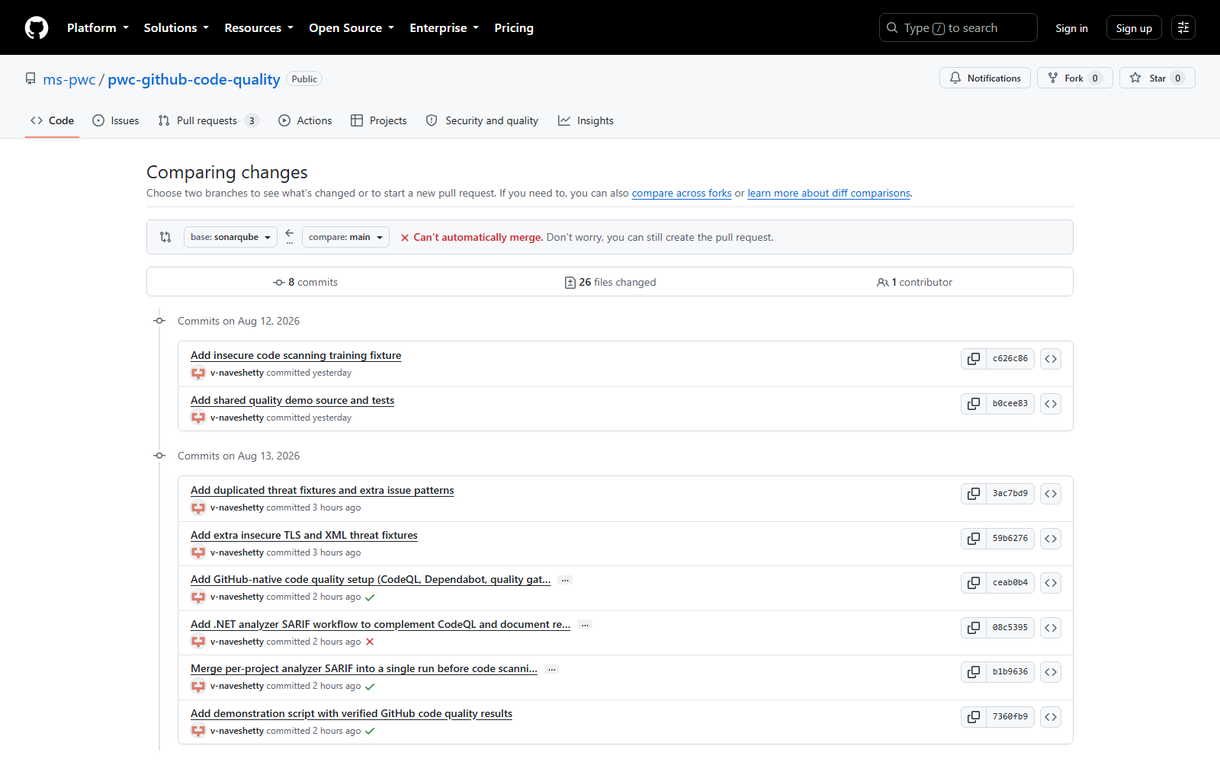
Figure 1 — The sonarqube and main branches provide the baseline and upgrade tracks.
Fair-comparison note
The branches exercise the same training scenario. The main branch removes selected Roslyn suppressions so those diagnostics can be uploaded to GitHub code scanning; this configuration difference should be stated during the demo.

2. Baseline — SonarQube branch
Branch: sonarqube | Workflow: .github/workflows/build-and-sonarqube-scan.yml
1. Checkout and prepare .NET — The workflow restores and builds the same solution used on main.
2. Start Sonar analysis — SonarScanner connects using SONAR_HOST_URL and SONAR_LOGIN.
3. Build, format, and test — The application is compiled and the quality tests are executed.
4. Publish the analysis — SonarScanner sends the report to the SonarQube server and the dashboard calculates issues and metrics.
Verified SonarQube result | Value | What to say
Issues | 8 | 4 vulnerabilities, 2 bugs, 2 code smells
Security hotspots | 3 | One credential pattern and two PATH-search findings require review
Coverage | 84.8% | Corrected workflow generated and imported Visual Studio coverage XML
Duplicated lines | 7.6% | A native SonarQube metric
Technical debt | 10 minutes | Native remediation estimate
Ratings | Security E • Reliability C • Maintainability A | Project-level health summary
Quality gate | Passed | First-baseline/new-code conditions did not reject overall-code findings

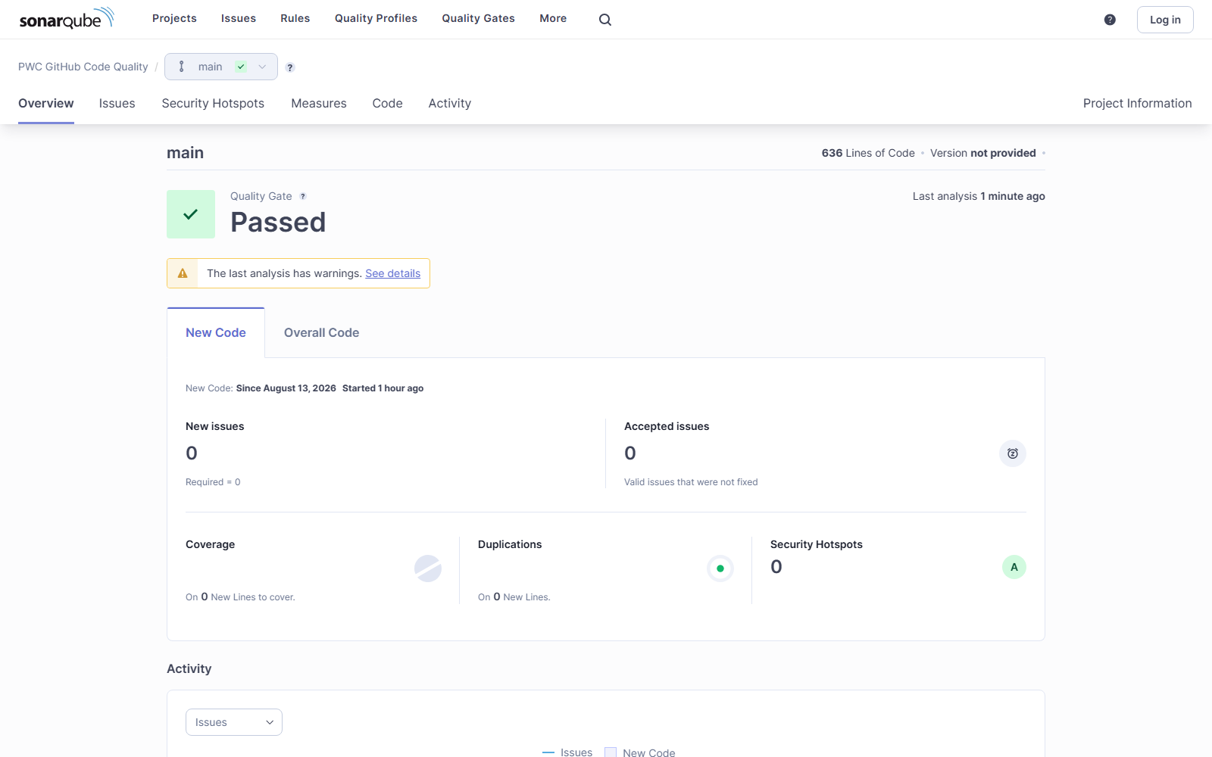
Figure 2 — Actual SonarQube dashboard from the reproduced scan.
Important demonstration point
The gate is green because it evaluates new-code conditions; overall security remains E and reliability C, while corrected coverage import now reports 84.8% and duplication 7.6%. A green gate is meaningful only after the new-code baseline and gate conditions are configured correctly.

2.1 SonarQube issues
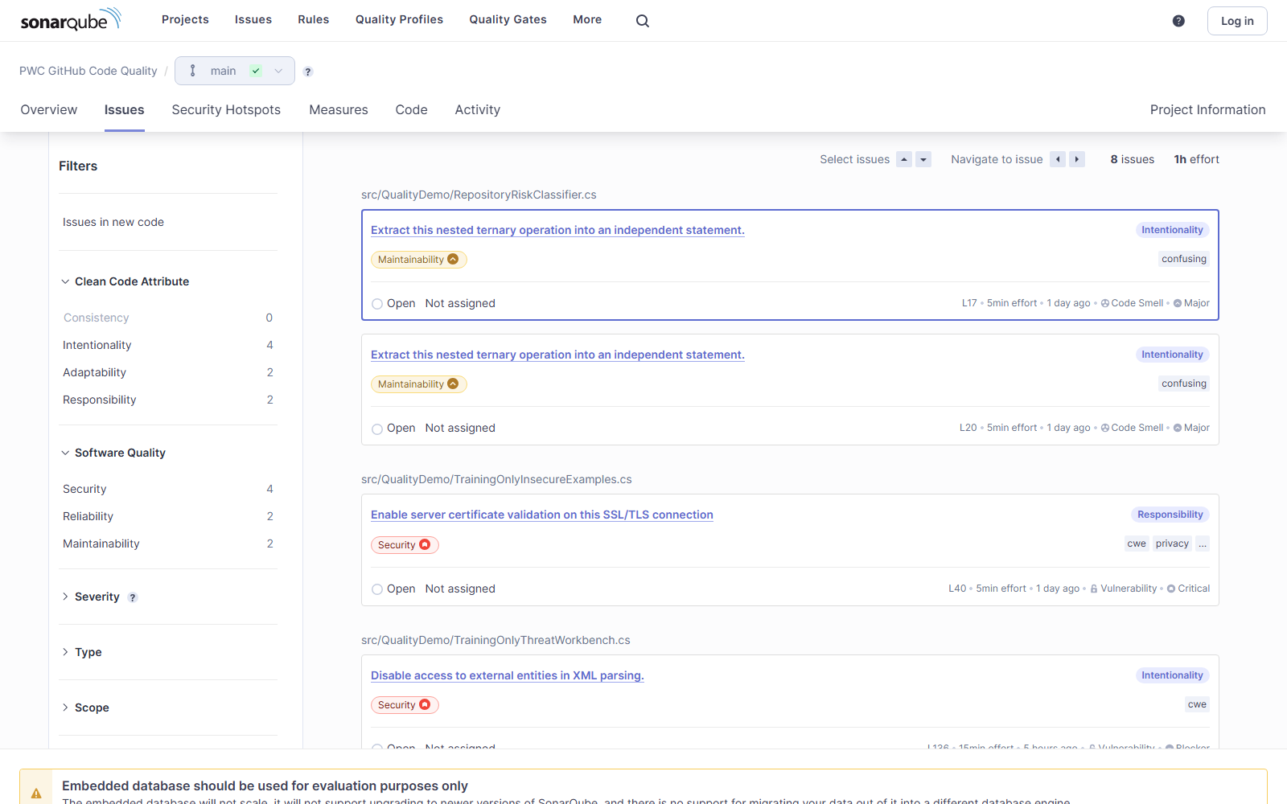
Figure 3 — Actual SonarQube issue list: TLS validation, XML external entities, nested ternaries, and test namespace findings.
Rule | Count | Result
S2755 | 2 | Blocker XML external-entity vulnerabilities
S4830 | 2 | Critical TLS certificate-validation vulnerabilities
S3358 | 2 | Nested-ternary code smells
S3903 | 2 | Global-namespace bugs

2.2 SonarQube security hotspots
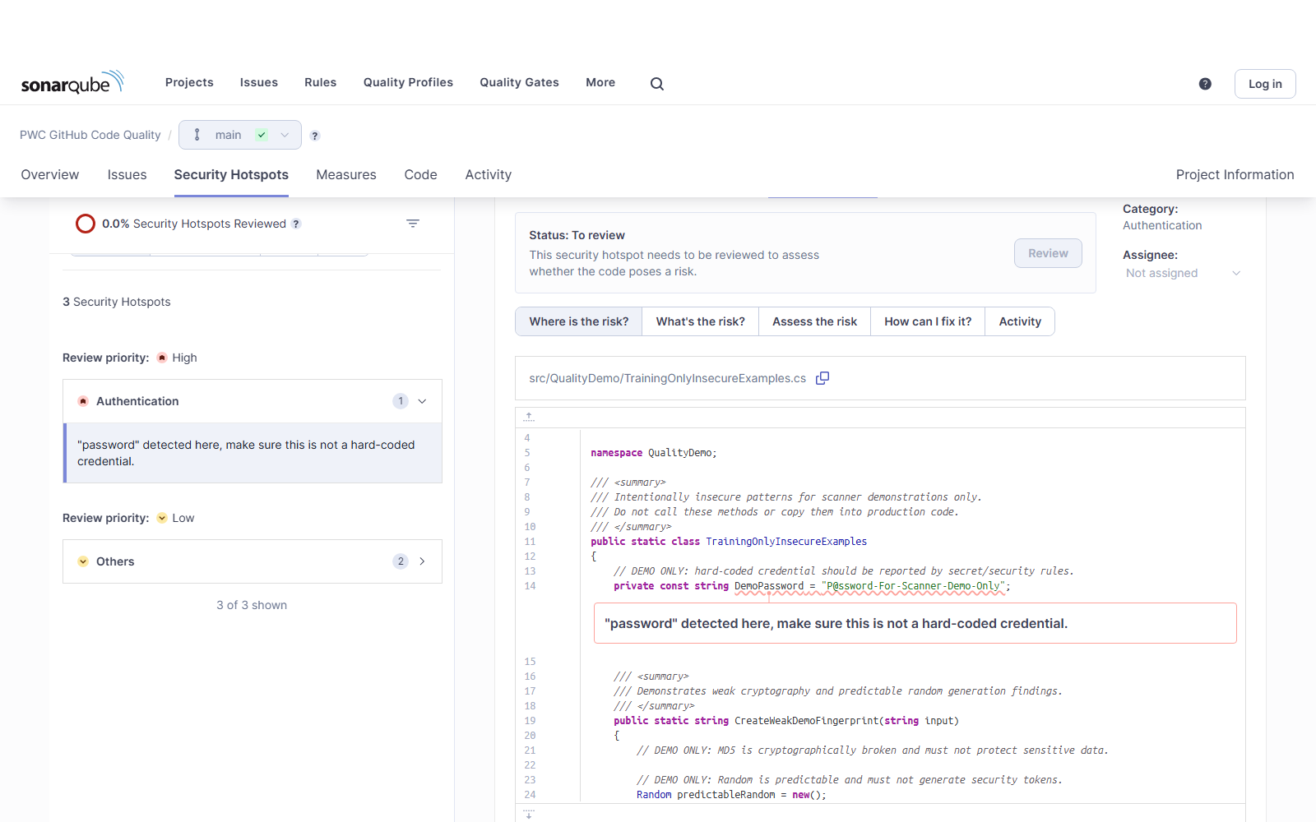
Figure 4 — Actual SonarQube hotspot review for the training credential pattern.
SonarQube baseline conclusion
SonarQube provides a strong unified dashboard and native metrics. Its drawbacks are the separate server/database/token lifecycle and the need to configure the gate and coverage pipeline correctly.

3. Upgrade — GitHub-native main branch
Branch: main | One workflow: .github/workflows/code-quality.yml
1. Build, format, and test job — Restores, builds, verifies formatting, and executes all ten tests.
2. CodeQL job — Runs the C# security-and-quality query suite and publishes data-flow alerts.
3. Roslyn analyzer job — Runs the full .NET analyzer set, merges SARIF, and uploads findings to the same GitHub code-scanning view.
4. Dependabot — Opens dependency and workflow-action update pull requests automatically.
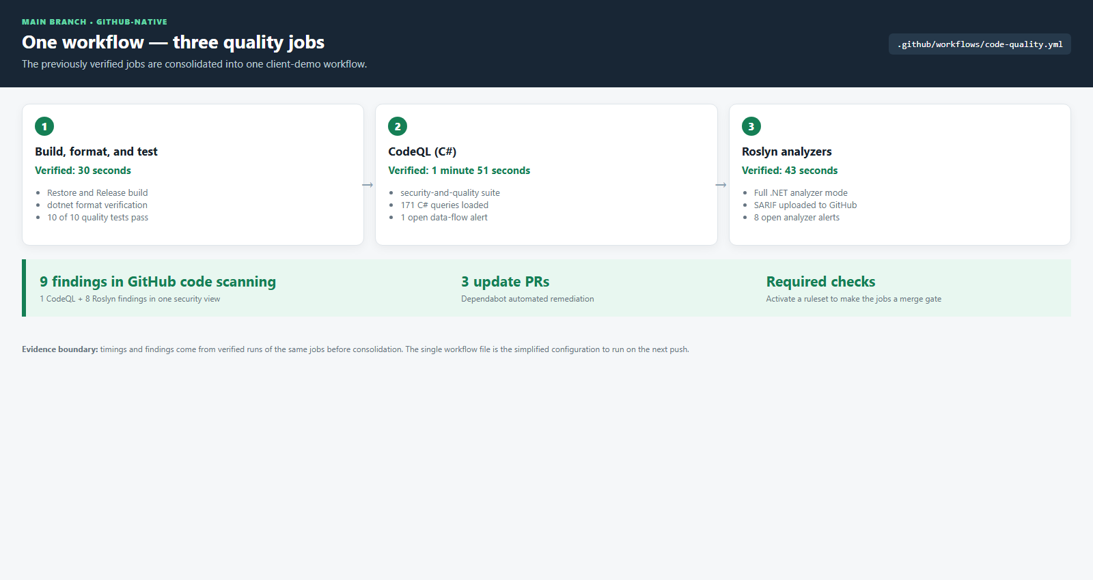
Figure 5 — The simplified main branch now uses one workflow with three quality jobs. Timings are from verified runs of the same jobs before consolidation.
Verified GitHub result | Value
Build, format, and test | Success in 30 seconds • 10/10 tests passed
CodeQL | Success in 1m51s • 171 C# queries • 1 open alert
Roslyn SARIF | Success in 43 seconds • 8 open alerts
Combined code scanning | 9 findings: 1 CodeQL + 8 Roslyn
Dependabot | 3 automated update pull requests

3.1 GitHub code-scanning result
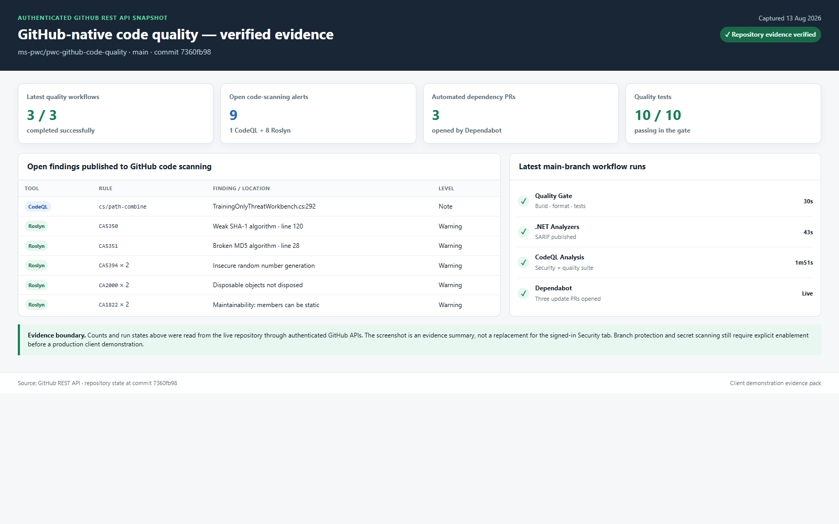
Figure 6 — Authenticated GitHub API evidence: three successful jobs, nine code-scanning findings, and ten passing tests.
How GitHub reaches the quality outcome
CodeQL supplies deep data-flow analysis. Roslyn supplies broad syntactic C# checks. SARIF places both tools in GitHub code scanning, while the workflow jobs can be required by a ruleset to prevent an unsafe merge.

3.2 GitHub dependency remediation
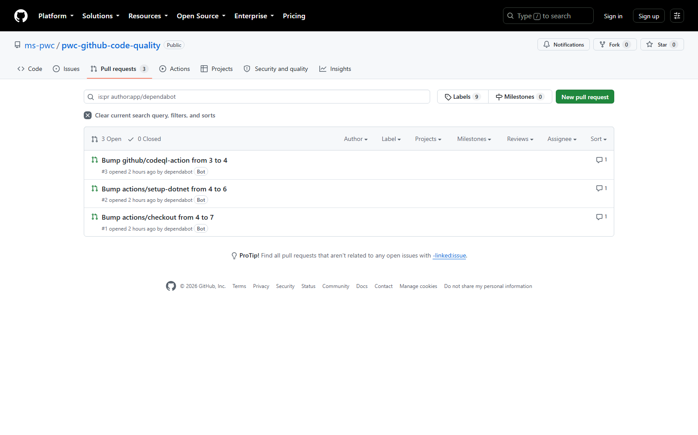
Figure 7 — Actual Dependabot pull requests for checkout, setup-dotnet, and CodeQL Action updates.
GitHub advantage
Dependabot moves beyond reporting: it opens the update pull request and the same quality workflow validates the proposed change.

4. Outcome comparison
Outcome | SonarQube branch | GitHub-native main | Result
Build, format, tests | In scanner workflow | Quality-gate job | Equivalent control
Security analysis | Sonar C# rules | CodeQL data-flow queries | Different engines; both demonstrated
Syntactic C# checks | Sonar quality profile | Roslyn analyzers via SARIF | Equivalent outcome; rule sets differ
Finding review | Issues + hotspots dashboard | GitHub code scanning | Equivalent triage outcome
Dependency remediation | Separate process/capability | Dependabot update PRs | GitHub advantage
Merge gate | Sonar gate + GitHub protection | Required workflow jobs + ruleset | Achievable; ruleset must be activated
Coverage/duplication/debt | Native dashboard metrics | No equivalent native project dashboard | SonarQube advantage

5. Advantages and drawbacks

GitHub-native advantages
• One workflow file contains all three quality jobs.
• No separate SonarQube application, database, or scanner token lifecycle.
• CodeQL and Roslyn findings appear together through SARIF.
• Checks and annotations are available directly in the pull-request workflow.
• Dependabot creates remediation pull requests automatically.

GitHub-native drawbacks
• No native SonarQube-style duplication percentage, technical-debt estimate, or A–E project dashboard.
• Coverage collection and threshold enforcement still require workflow tooling.
• CodeQL, Roslyn, and SonarQube rule sets are not identical; exact alert-count parity is not expected.
• The repository still needs an active ruleset, a valid CODEOWNERS team, secret scanning, and Dependabot security updates before claiming production enforcement.

SonarQube advantages
• Unified project dashboard for issues, hotspots, coverage, duplication, ratings, and debt.
• Strong syntactic findings on library code, even when no reachable untrusted-input source exists.
• Point-and-click quality profiles and gate conditions.

SonarQube drawbacks
• Separate server/database operations, upgrades, backups, tokens, and connectivity.
• A passing gate can be misleading when the baseline or conditions are incomplete.
• Dependency remediation is not demonstrated as an automatic pull-request flow in this setup.
Recommended client message
GitHub-native tooling achieves the pull-request protection outcome — analyze, review, remediate, and block unsafe changes — with less platform overhead. SonarQube remains stronger when the client requires its packaged coverage, duplication, technical-debt, ratings, and trend dashboard.

6. Presenter checklist
1. Open sonarqube — Show the one Sonar workflow and Figures 2–4. State the verified 8 issues, 3 hotspots, and dashboard metrics.
2. Explain the gate caveat — Explain that Passed evaluates new-code conditions while overall security E and reliability C still require remediation.
3. Switch to main — Open .github/workflows/code-quality.yml and show the three jobs in one file.
4. Show GitHub evidence — Use Figures 5–7 to explain nine findings, ten tests, and three Dependabot PRs.
5. Close with the comparison — Use Sections 4 and 5; do not claim identical rules or dashboard metrics.
Final conclusion
The demonstration proves the same governance outcome can be implemented in GitHub using one workflow plus native security and remediation features. A short parallel pilot on representative client applications should confirm rule coverage and decide whether SonarQube metrics must be retained.

