SETUP • MIGRATION • OPERATIONS

GitHub-Native Code Quality

Setup and Migration Runbook
From the SonarQube baseline on sonarqube to the GitHub-native upgrade on main.
Manual steps, exact workflows, repository settings, validation, cutover, rollback, and troubleshooting.

Repository: ms-pwc/pwc-github-code-quality
Evidence date: 13 August 2026
Audience: repository administrators, platform engineers, security engineers, and developers

1. Purpose and target state
This runbook lets a team replace the SonarQube-based pull-request control with a GitHub-native implementation while preserving the business outcome: code is built, formatted, tested, analyzed, reviewed, and prevented from merging when required checks fail.
Migration story. The sonarqube branch is the baseline. The main branch is the upgrade. Application behavior is functionally equivalent; main adds GitHub-native workflow, CodeQL, Roslyn SARIF, Dependabot, and target governance.
Baseline: sonarqube | Upgrade: main
One SonarQube workflow  SonarScanner + reachable server  Sonar dashboard and quality gate  Native coverage, duplication, ratings, debt | One GitHub workflow with three jobs  CodeQL + Roslyn SARIF  GitHub code scanning + Dependabot  Required jobs enforced through a ruleset
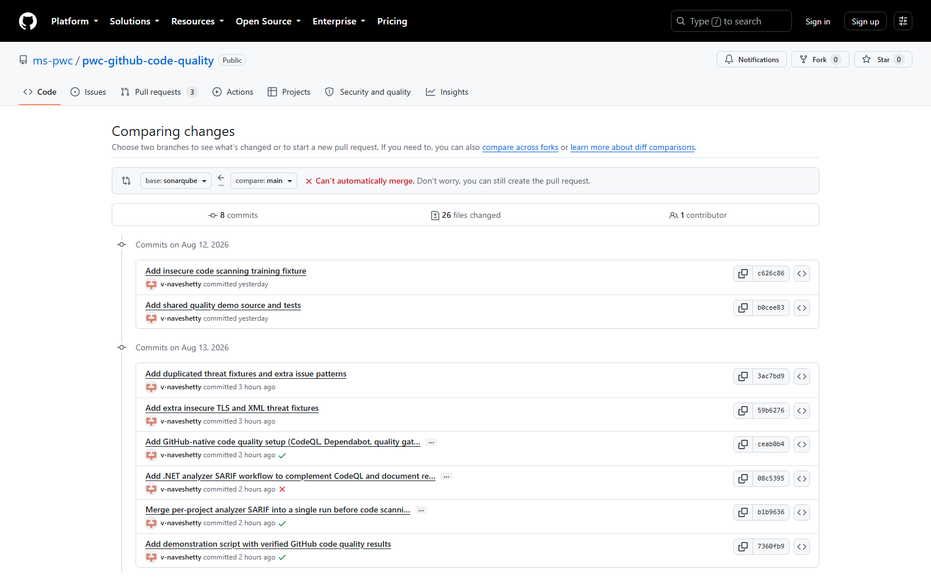
Figure 1 — The source SonarQube baseline and the GitHub-native upgrade branches.
Do not claim identical product parity. GitHub reproduces the pull-request control outcome. It does not natively reproduce SonarQube's duplication percentage, technical-debt estimate, A–E project dashboard, or coverage trend UI.

2. Before starting

2.1 Access and tooling
- Repository admin access and permission to edit Actions, rulesets, security settings, secrets, and teams.
- Git, PowerShell 7+, and .NET 10 SDK for local validation.
- GitHub Actions enabled.
- GitHub Code Security/Advanced Security and Secret Protection entitlements as required by repository visibility and organization plan.
- A valid GitHub team for CODEOWNERS; do not leave the placeholder team.

2.2 Record the SonarQube baseline
Before disabling SonarQube, export or record:
- Quality gate conditions and new-code definition.
- Active C# quality profile and any custom rules.
- Open issues, accepted issues, security hotspots, and owners.
- Coverage and duplication thresholds.
- Required compliance mappings, reports, retention, and audit consumers.
- Any rule that must have an explicit GitHub/CodeQL/Roslyn replacement.
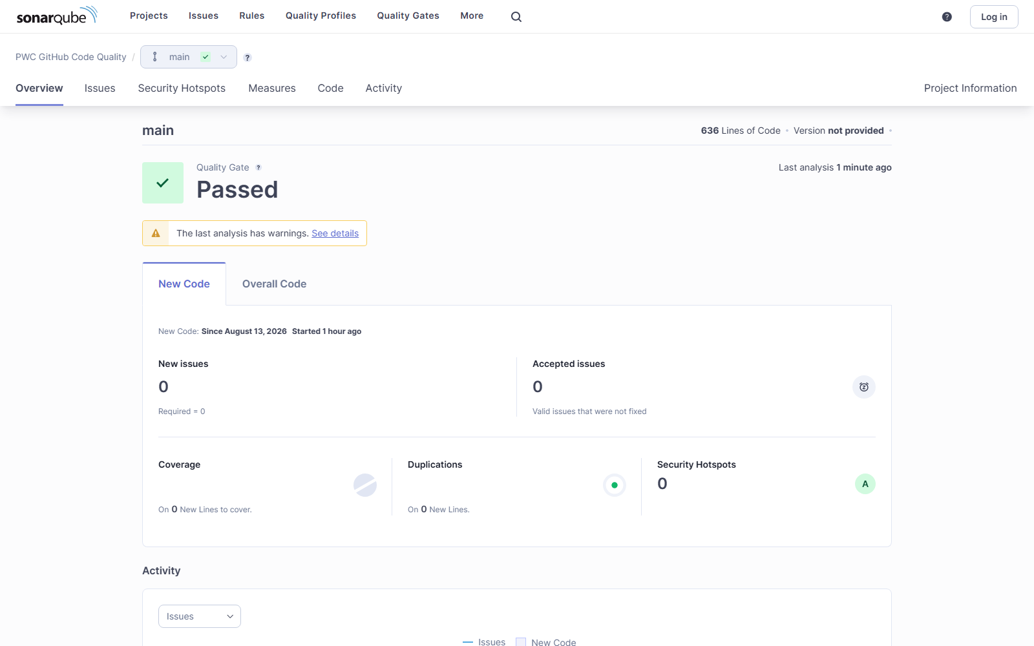
Figure 2 — Current local SonarQube dashboard after the corrected workflow completed and waited for the gate.
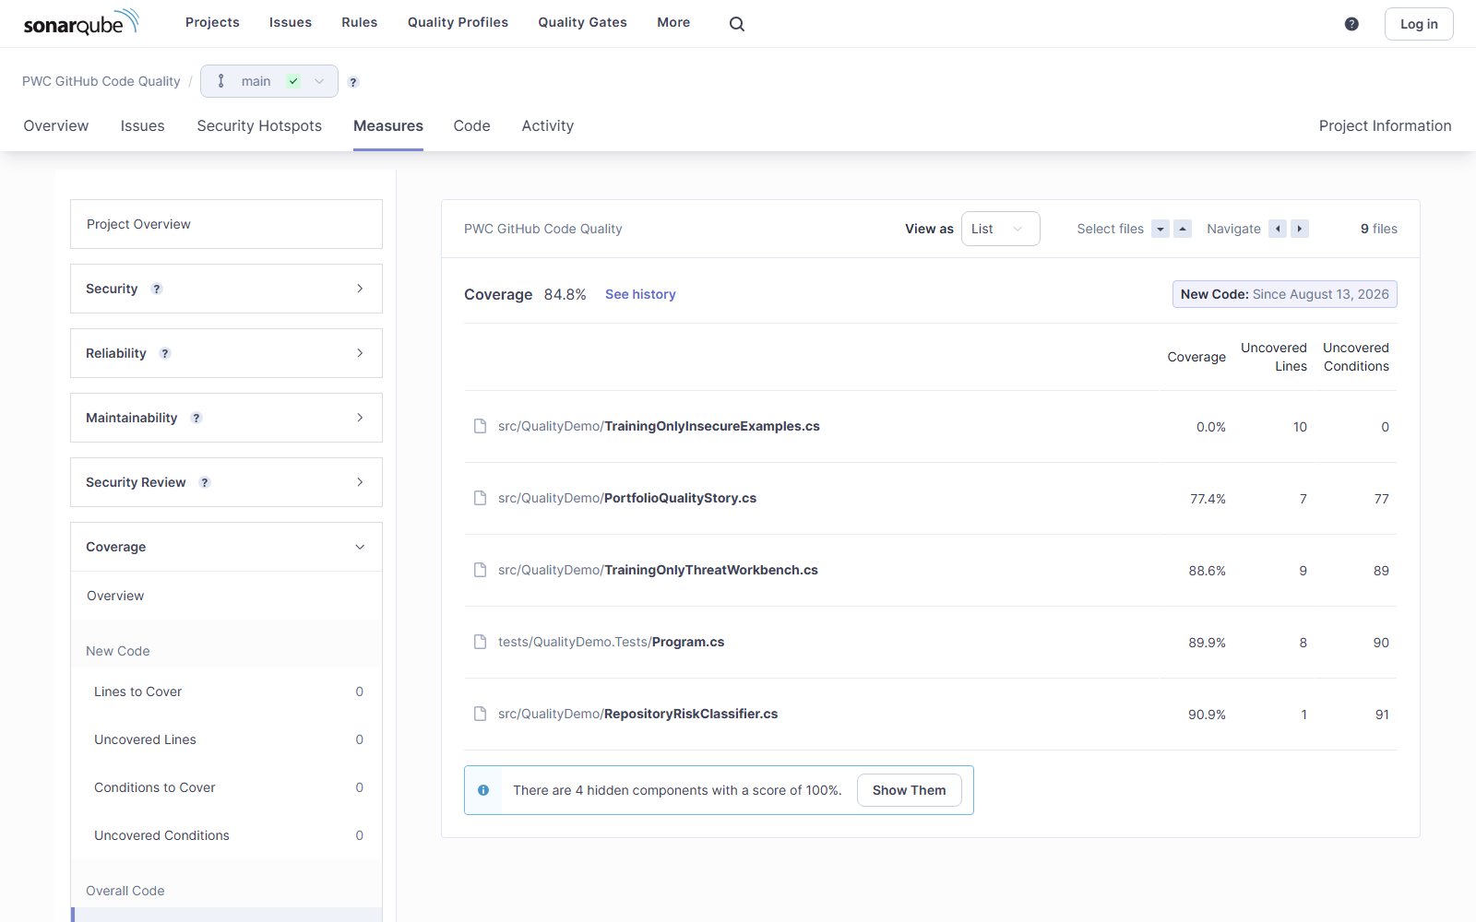
Figure 3 — Corrected workflow imported Visual Studio coverage XML: overall coverage is 84.8%.
Current verified SonarQube baseline | Value
Issues | 8: four vulnerabilities, two bugs, two code smells
Security hotspots | 3 awaiting review
Coverage | 84.8% after corrected workflow import
Duplicated lines | 7.6%
Technical debt | 10 minutes
Ratings | Security E • Reliability C • Maintainability A
Gate | Passed on current new-code conditions

3. Step-by-step GitHub-native setup

Step 1 — Create the upgrade branch
For a new migration, start from the SonarQube-controlled application revision rather than an unrelated codebase:
git fetch origin
git switch sonarqube
git pull --ff-only
git switch -c github-native-quality-upgrade
In this repository the completed target is already represented by main.

Step 2 — Add the single workflow
Create .github/workflows/code-quality.yml. It must contain these independent jobs:
Job | Purpose | Required permission
Build, format, and test | Restore, Release build, format verification, 10 tests | contents: read
CodeQL (C#) | Data-flow security and quality queries | security-events: write
Roslyn analyzers to code scanning | Full .NET analyzers, merged SARIF upload | security-events: write
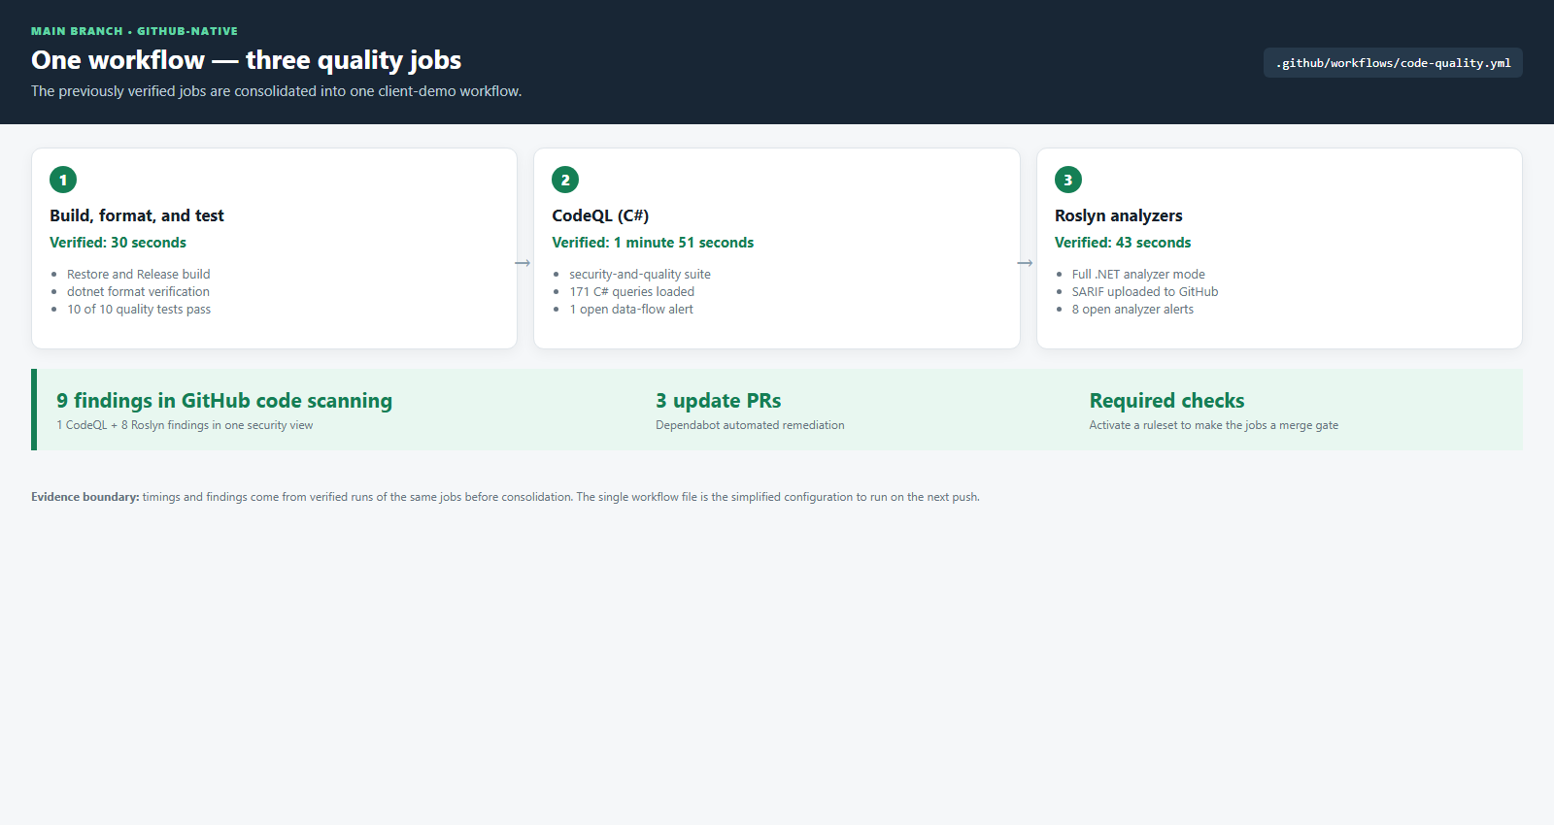
Figure 4 — One workflow file provides the three GitHub-native quality jobs.
First-run note. The verified timings came from the equivalent jobs before consolidation. The consolidated workflow runs the same commands on the next push.

Step 3 — Add the CodeQL path configuration
Create .github/codeql/codeql-config.yml. Keep generated output and documentation outside the analysis scope:
# Custom CodeQL configuration for the GitHub Code Quality demo (main branch).
# Keeps analysis scope aligned with the SonarQube exclusions used on the
# sonarqube branch (sonar.exclusions) so the two approaches scan the same code.
name: "pwc-github-code-quality codeql config"

paths-ignore:
- '**/bin/**'
- '**/obj/**'
- '**/*.g.cs'
- 'docs/**'

paths:
- 'src'
- 'tests'

Step 4 — Enable .NET analyzers
Add the analyzer properties to each production C# project, or centrally through shared MSBuild configuration:
<PropertyGroup>
<EnableNETAnalyzers>true</EnableNETAnalyzers>
<AnalysisMode>All</AnalysisMode>
<WarningsNotAsErrors>CA1822;CA2000;CA3075;CA5350;CA5351;CA5394;CA5359;CA5360;CA5361;CA5362;CA5363</WarningsNotAsErrors>
</PropertyGroup>
Use WarningsNotAsErrors only for intentional training fixtures or an approved baseline. Production policy should normally remediate or explicitly suppress each diagnostic.

Step 5 — Configure per-project SARIF output
Add Directory.Build.props. A single shared ErrorLog file is unsafe because the last project can overwrite earlier results:
<Project>

<!--
GitHub Code Quality demo: per-project SARIF output for Roslyn analyzers.

A solution-wide `-p:ErrorLog=<file>` makes every project write to the SAME
path, so the last project built silently overwrites the earlier results.
Passing `-p:SarifOutputDir=<dir>` instead lets MSBuild expand
$(MSBuildProjectName) per project, producing one SARIF file per project.

The directory is then uploaded to GitHub code scanning by the Roslyn job in
.github/workflows/code-quality.yml.
-->
<PropertyGroup Condition="'$(SarifOutputDir)' != ''">
<ErrorLog>$(SarifOutputDir)/$(MSBuildProjectName).sarif,version=2.1</ErrorLog>
</PropertyGroup>

</Project>

Step 6 — Add the SARIF merge script
Create scripts/Merge-AnalyzerSarif.ps1. The exact script used by this repository is included in Appendix C.

Step 7 — Configure Dependabot
Create .github/dependabot.yml for both NuGet and workflow Actions:
# GitHub Code Quality demo: automated dependency updates.
# This is the GitHub-native equivalent of SonarQube's dependency/vulnerability
# scanning. Dependabot opens pull requests when a dependency has a newer
# version or a known vulnerability (paired with GitHub's Dependency Graph
# and Dependabot alerts, enabled from Settings > Code security).
version: 2
updates:
- package-ecosystem: "nuget"
directory: "/"
schedule:
interval: "weekly"
open-pull-requests-limit: 10
labels:
- "dependencies"

- package-ecosystem: "github-actions"
directory: "/"
schedule:
interval: "weekly"
labels:
- "dependencies"
- "ci"

4. Configure GitHub repository settings

Step 8 — Enable security features
As a repository administrator, open Settings → Security and analysis / Code security and configure:
- Enable the dependency graph.
- Enable Dependabot alerts.
- Enable Dependabot security updates.
- Confirm CodeQL advanced setup is active through the workflow. Do not enable a conflicting duplicate default setup.
- Enable secret scanning and push protection where entitled.
- Enable generic/non-provider patterns and validity checks if required by policy.

Step 9 — Replace the CODEOWNERS placeholder
Update .github/CODEOWNERS with a real organization team:
* @your-real-organization/code-quality-owners
Stop if the team does not exist or lacks repository access. A placeholder CODEOWNERS file does not enforce a review.

Step 10 — Create the main-branch ruleset
Open Settings → Rules → Rulesets, create a branch ruleset, target main, and set enforcement to Active.
- Require a pull request before merging.
- Require at least one approval and code-owner review.
- Dismiss stale approvals and require conversation resolution.
- Require the branch to be current before merge.
- Block force pushes and branch deletion.
- Restrict bypass to a small audited emergency group.
After the workflow has run once, require these exact checks:
Build, format, and test
CodeQL (C#)
Roslyn analyzers to code scanning
Analysis is not enforcement. Green workflow runs prove that checks execute. Only an active ruleset proves that a pull request cannot bypass them.

5. Validate locally before pushing

Step 11 — Run the same build and test commands
dotnet restore Pwc.GitHubCodeQuality.slnx
dotnet build Pwc.GitHubCodeQuality.slnx --configuration Release
dotnet format Pwc.GitHubCodeQuality.slnx --verify-no-changes --verbosity minimal
dotnet run --project tests/QualityDemo.Tests/QualityDemo.Tests.csproj --configuration Release --no-build

# Reproduce the Roslyn SARIF upload input
New-Item -ItemType Directory -Force -Path sarif | Out-Null
dotnet build Pwc.GitHubCodeQuality.slnx --configuration Release --no-incremental `
-p:SarifOutputDir="$PWD/sarif" -p:TreatWarningsAsErrors=false
./scripts/Merge-AnalyzerSarif.ps1 -InputDirectory sarif -OutputPath dotnet-analyzers.sarif
Expected result for this repository:
- PASS Release build and formatting.
- PASS 10 of 10 quality tests.
- PASS Merged SARIF contains eight Roslyn findings.

Step 12 — Commit and push
git add .github Directory.Build.props src scripts README.md SECURITY.md
git commit -m "Migrate code quality controls to GitHub native tooling"
git push -u origin github-native-quality-upgrade
Open a pull request into main and watch the single GitHub Native Code Quality workflow.

Step 13 — Verify GitHub results
- Open Actions and confirm all three jobs succeed.
- Open Security and quality → Code scanning.
- Filter by tool to verify both CodeQL and Microsoft C# compiler/Roslyn results.
- Open Pull requests to verify Dependabot update PRs.
- Create a controlled failing PR and prove the ruleset blocks merge.
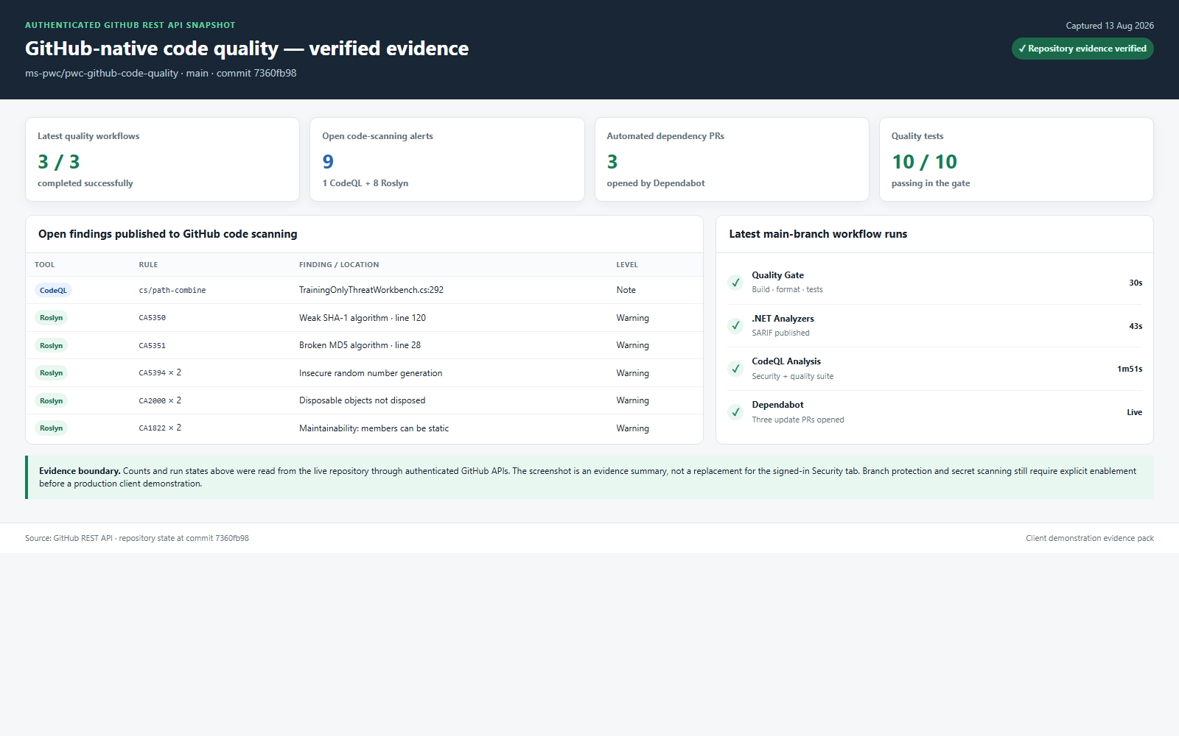
Figure 5 — Verified GitHub evidence: nine findings, ten tests, and successful equivalent jobs.
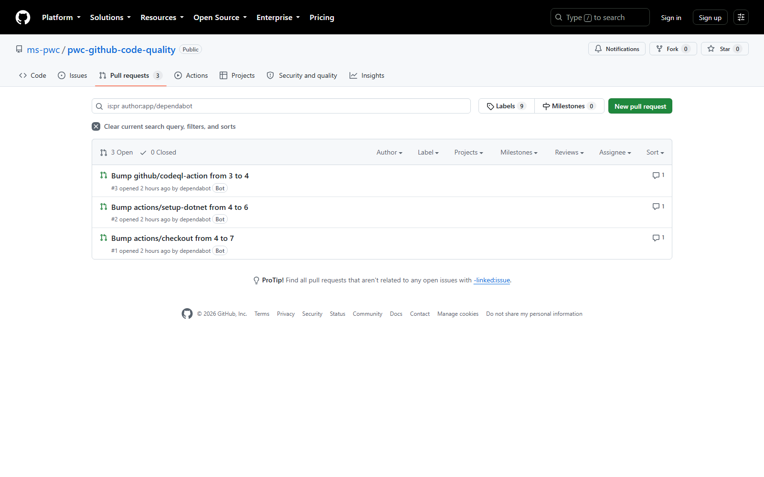
Figure 6 — Dependabot opened three workflow dependency update pull requests.

6. Acceptance and cutover

6.1 Acceptance checklist
Requirement | Acceptance evidence
One workflow | Only code-quality.yml exists under .github/workflows on main
Correctness gate | Build/format/test job passes; 10/10 tests
Deep security analysis | CodeQL job passes and publishes alerts
Broad C# analysis | Roslyn SARIF job publishes eight baseline findings
Central triage | CodeQL and Roslyn findings appear in GitHub code scanning
Dependency automation | Dependabot creates update/security PRs
Merge enforcement | A failing required job demonstrably blocks merge
Ownership | Valid CODEOWNERS review is required
Secrets | Secret scanning and push protection are enabled as entitled
Metric gaps | Coverage/duplication/debt decision is approved

6.2 Recommended migration sequence
- Run SonarQube and GitHub in parallel for one or two sprints.
- Compare by CWE, rule intent, file, and line—not raw alert count.
- Add custom CodeQL models or Roslyn rules for mandatory Sonar-only controls.
- Add coverage and duplication jobs if those thresholds are contractual.
- Prove branch rules block a controlled failing pull request.
- Disable the SonarQube required check only after the acceptance owner signs off.
- Retain SonarQube read-only for the agreed audit period, then decommission server, database, secrets, and webhooks.

6.3 Rollback
If a critical gap appears during cutover:
- Re-enable the SonarQube required status check.
- Keep the GitHub workflow running for evidence collection.
- Restore the prior ruleset from the approved configuration.
- Record the gap, owner, and remediation deadline.
- Resume cutover only after the missing control is demonstrated.

7. Known gaps and decisions
SonarQube capability | GitHub-native position | Decision
Coverage dashboard and trend | Generate coverage in Actions; add a coverage service/report if trend UI is required | Composable, not native
Duplication percentage | Add a CPD tool/job or retain SonarQube for this metric | No first-party equivalent
Technical debt estimate | Use issue SLAs or a metric product | No native aggregate
A–E project ratings | Use alert severity and required-check conclusions | Different executive view
Sonar custom rules | Map to CodeQL packs, Roslyn analyzers, or retain the rule | Engineering effort
Unreachable library patterns | Roslyn supplements CodeQL; validate mandatory patterns explicitly | Rule-by-rule validation
Recommended operating model. Use GitHub as the pull-request control plane. Retain SonarQube or add focused tools only where the client has an explicit metric, reporting, or rule requirement that GitHub does not meet natively.

8. Troubleshooting
Symptom | Likely cause | Resolution
SARIF upload receives 403 | security-events: write is missing or restricted | Add job permission and review organization Actions policy
SARIF upload reports multiple runs | Per-project SARIF files were uploaded without merging | Run Merge-AnalyzerSarif.ps1 and upload the merged file
Required check is not listed | The new job has never completed on the target repository | Run the workflow once, then configure the ruleset
CodeQL reports few alerts | Library has no modeled untrusted-input source | Keep Roslyn, test representative applications, add CodeQL models
Analyzer warnings fail the demo build | TreatWarningsAsErrors conflicts with intentional fixtures | Baseline only approved demo rules; do not broadly disable production policy
Old CodeQL and new workflow both run | Legacy workflow or default setup remains enabled | Keep only code-quality.yml and one CodeQL advanced setup
Sonar scanner cannot reach localhost in Actions | localhost means the hosted runner, not the developer machine | Use a reachable SonarQube URL or a self-hosted runner on the correct network
Sonar format check fails after begin | Sonar analyzers are injected before dotnet format | Run format verification before sonarscanner begin, as in Appendix B
Windows cannot clean .sonarqube | MSBuild/compiler server holds scanner DLLs | Run dotnet build-server shutdown, then remove the generated directory

9. Local SonarQube reference
Current demonstration instance: http://localhost:9000/dashboard?id=pwc-github-code-quality. It is running locally with the corrected scan and 84.8% coverage. It uses an embedded evaluation database and must not be treated as production infrastructure.
Portable manual reproduction:
# Evaluation-only local SonarQube
# From the sonarqube branch:
docker compose up -d
# Open http://localhost:9000 and create an analysis token.

$env:SONAR_HOST_URL = "http://localhost:9000"
$env:SONAR_TOKEN = "<token entered locally>"

dotnet tool install --global dotnet-sonarscanner
dotnet tool install --global dotnet-coverage
dotnet restore Pwc.GitHubCodeQuality.slnx
dotnet format Pwc.GitHubCodeQuality.slnx --verify-no-changes --verbosity minimal

dotnet sonarscanner begin `
/k:"pwc-github-code-quality" `
/n:"PWC GitHub Code Quality" `
/d:sonar.host.url="$env:SONAR_HOST_URL" `
/d:sonar.token="$env:SONAR_TOKEN" `
/d:sonar.cs.vscoveragexml.reportsPaths="TestResults/coverage.xml" `
/d:sonar.qualitygate.wait=true

dotnet build Pwc.GitHubCodeQuality.slnx --configuration Release --no-restore
New-Item -ItemType Directory -Force -Path TestResults | Out-Null
dotnet-coverage collect `
"dotnet run --project tests/QualityDemo.Tests/QualityDemo.Tests.csproj --configuration Release --no-build" `
-f xml -o TestResults/coverage.xml
dotnet sonarscanner end /d:sonar.token="$env:SONAR_TOKEN"
CI requirement. Set repository secrets SONAR_HOST_URL and SONAR_TOKEN. The URL must be reachable from the runner. Never place tokens in workflow YAML, screenshots, or documentation.

Appendix A — Exact GitHub-native workflow
File: .github/workflows/code-quality.yml on main.
# One GitHub-native code quality workflow for the client demonstration.
#
# The three jobs reproduce the pull-request protection outcomes demonstrated
# with SonarQube on the `sonarqube` branch:
# 1. build, formatting, and tests;
# 2. CodeQL data-flow security and quality analysis;
# 3. full .NET/Roslyn analysis uploaded to GitHub code scanning as SARIF.
name: GitHub Native Code Quality

on:
push:
branches:
- main
pull_request:
branches:
- main
schedule:
- cron: "23 3 * * 1"
workflow_dispatch:

permissions:
contents: read

concurrency:
group: code-quality-${{ github.workflow }}-${{ github.ref }}
cancel-in-progress: true

jobs:
quality-gate:
name: Build, format, and test
runs-on: ubuntu-latest
timeout-minutes: 15

steps:
- name: Checkout
uses: actions/checkout@v7

- name: Setup .NET
uses: actions/setup-dotnet@v6
with:
dotnet-version: 10.0.x

- name: Restore dependencies
run: dotnet restore Pwc.GitHubCodeQuality.slnx

- name: Build
run: dotnet build Pwc.GitHubCodeQuality.slnx --configuration Release --no-restore

- name: Verify formatting
run: dotnet format Pwc.GitHubCodeQuality.slnx --verify-no-changes --verbosity minimal

- name: Run quality tests
run: dotnet run --project tests/QualityDemo.Tests/QualityDemo.Tests.csproj --configuration Release --no-build

codeql:
name: CodeQL (C#)
runs-on: ubuntu-latest
timeout-minutes: 30
permissions:
actions: read
contents: read
security-events: write

steps:
- name: Checkout
uses: actions/checkout@v7

- name: Setup .NET
uses: actions/setup-dotnet@v6
with:
dotnet-version: 10.0.x

- name: Initialize CodeQL
uses: github/codeql-action/init@v4
with:
languages: csharp
config-file: ./.github/codeql/codeql-config.yml
queries: security-and-quality

- name: Build solution for CodeQL
run: |
dotnet restore Pwc.GitHubCodeQuality.slnx
dotnet build Pwc.GitHubCodeQuality.slnx --configuration Release --no-restore

- name: Perform CodeQL analysis
uses: github/codeql-action/analyze@v4
with:
category: /language:csharp

dotnet-analyzers:
name: Roslyn analyzers to code scanning
runs-on: ubuntu-latest
timeout-minutes: 15
permissions:
actions: read
contents: read
security-events: write

steps:
- name: Checkout
uses: actions/checkout@v7

- name: Setup .NET
uses: actions/setup-dotnet@v6
with:
dotnet-version: 10.0.x

- name: Restore dependencies
run: dotnet restore Pwc.GitHubCodeQuality.slnx

- name: Build with analyzers and emit SARIF
run: |
mkdir -p sarif
dotnet build Pwc.GitHubCodeQuality.slnx \
--configuration Release \
--no-restore \
--no-incremental \
-p:SarifOutputDir="${{ github.workspace }}/sarif" \
-p:TreatWarningsAsErrors=false

- name: Merge per-project SARIF files
shell: pwsh
run: ./scripts/Merge-AnalyzerSarif.ps1 -InputDirectory sarif -OutputPath dotnet-analyzers.sarif

- name: Upload SARIF to code scanning
uses: github/codeql-action/upload-sarif@v4
with:
sarif_file: dotnet-analyzers.sarif
category: dotnet-analyzers

- name: Upload SARIF artifact
uses: actions/upload-artifact@v4
with:
name: dotnet-analyzers-sarif
path: dotnet-analyzers.sarif

Appendix B — Corrected SonarQube workflow
File: .github/workflows/build-and-sonarqube-scan.yml on sonarqube. The workflow was validated locally in this order: restore → format → begin → build → test/coverage → end/wait.
# SonarQube baseline used by the client demonstration.
#
# Required repository secrets:
# SONAR_HOST_URL - a SonarQube URL reachable from the GitHub-hosted runner
# SONAR_TOKEN - a project analysis token
#
# A developer's http://localhost:9000 is intentionally not used as a fallback:
# localhost on a GitHub-hosted runner is not the developer workstation.
name: SonarQube Code Quality

on:
push:
branches:
- sonarqube
pull_request:
branches:
- sonarqube
workflow_dispatch:

permissions:
contents: read

concurrency:
group: sonarqube-quality-${{ github.workflow }}-${{ github.ref }}
cancel-in-progress: true

jobs:
sonarqube:
name: Build, test, and analyze with SonarQube
runs-on: ubuntu-latest
timeout-minutes: 30

steps:
- name: Checkout
uses: actions/checkout@v7
with:
fetch-depth: 0

- name: Setup .NET
uses: actions/setup-dotnet@v6
with:
dotnet-version: 10.0.x

- name: Install analysis tools
run: |
dotnet tool install --global dotnet-sonarscanner
dotnet tool install --global dotnet-coverage

- name: Restore dependencies
run: dotnet restore Pwc.GitHubCodeQuality.slnx

# Run this before SonarScanner injects the Sonar analyzer targets. Once
# analysis starts, Sonar diagnostics are intentionally emitted as build
# warnings and can make `dotnet format --verify-no-changes` return nonzero.
- name: Verify formatting
run: dotnet format Pwc.GitHubCodeQuality.slnx --verify-no-changes --verbosity minimal

- name: Start SonarQube analysis
env:
SONAR_HOST_URL: ${{ secrets.SONAR_HOST_URL }}
SONAR_TOKEN: ${{ secrets.SONAR_TOKEN }}
run: |
dotnet sonarscanner begin \
/k:"pwc-github-code-quality" \
/n:"PWC GitHub Code Quality" \
/d:sonar.host.url="${SONAR_HOST_URL}" \
/d:sonar.token="${SONAR_TOKEN}" \
/d:sonar.cs.vscoveragexml.reportsPaths="TestResults/coverage.xml" \
/d:sonar.qualitygate.wait=true \
/d:sonar.qualitygate.timeout=300 \
/d:sonar.scanner.scanAll=false \
/d:sonar.exclusions="**/bin/**,**/obj/**,docs/**,.github/**"

- name: Build
run: dotnet build Pwc.GitHubCodeQuality.slnx --configuration Release --no-restore

- name: Run tests and collect coverage
run: |
mkdir -p TestResults
dotnet-coverage collect \
"dotnet run --project tests/QualityDemo.Tests/QualityDemo.Tests.csproj --configuration Release --no-build" \
-f xml \
-o TestResults/coverage.xml

- name: Publish analysis and wait for quality gate
env:
SONAR_TOKEN: ${{ secrets.SONAR_TOKEN }}
run: dotnet sonarscanner end /d:sonar.token="${SONAR_TOKEN}"

Appendix C — Exact SARIF merge script
File: scripts/Merge-AnalyzerSarif.ps1.
<#
.SYNOPSIS
Merges the per-project Roslyn analyzer SARIF files into a single SARIF run.

.DESCRIPTION
GitHub code scanning rejects a SARIF file that contains multiple runs under
the same category:
"The CodeQL Action does not support uploading multiple SARIF runs with
the same category."

The C# compiler emits one SARIF file per project (see Directory.Build.props),
so this script combines them into a single run before upload.

Rule metadata from every project is concatenated and de-duplicated by rule
id. Each result's `ruleIndex`/`rule` fields are removed because those are
positional references into the ORIGINAL per-run rules array and would point
at the wrong rule after merging. SARIF consumers fall back to matching on
`ruleId`, which is preserved, so no information is lost.
#>
[CmdletBinding()]
param(
# Directory containing the per-project *.sarif files produced by the build.
[Parameter(Mandatory = $true)]
[string] $InputDirectory,

# Path of the merged SARIF file to write.
[Parameter(Mandatory = $true)]
[string] $OutputPath
)

$ErrorActionPreference = 'Stop'

$sarifFiles = @(Get-ChildItem -Path $InputDirectory -Filter '*.sarif' -File)
if ($sarifFiles.Count -eq 0) {
throw "No SARIF files were found in '$InputDirectory'. Did the build run with -p:SarifOutputDir?"
}

$documents = foreach ($file in $sarifFiles) {
Get-Content -Path $file.FullName -Raw | ConvertFrom-Json
}

$allRuns = foreach ($document in $documents) { $document.runs }

# De-duplicate rule definitions by id so the merged run keeps full descriptions.
$rulesById = [ordered]@{}
foreach ($run in $allRuns) {
foreach ($rule in @($run.tool.driver.rules)) {
if ($null -ne $rule -and -not $rulesById.Contains($rule.id)) {
$rulesById[$rule.id] = $rule
}
}
}

# Strip positional rule references that are invalid after merging.
$mergedResults = foreach ($run in $allRuns) {
foreach ($result in @($run.results)) {
if ($null -eq $result) { continue }
$result.PSObject.Properties.Remove('ruleIndex')
$result.PSObject.Properties.Remove('rule')
$result
}
}

$firstDriver = $allRuns[0].tool.driver

$merged = [ordered]@{
'$schema' = 'https://json.schemastore.org/sarif-2.1.0.json'
version = '2.1.0'
runs = @(
[ordered]@{
tool = [ordered]@{
driver = [ordered]@{
name = $firstDriver.name
version = $firstDriver.version
semanticVersion = $firstDriver.semanticVersion
rules = @($rulesById.Values)
}
}
results = @($mergedResults)
}
)
}

$merged | ConvertTo-Json -Depth 100 | Set-Content -Path $OutputPath -Encoding utf8

Write-Host "Merged $($sarifFiles.Count) SARIF file(s) into '$OutputPath': $(@($mergedResults).Count) result(s), $($rulesById.Count) rule definition(s)."

Appendix D — Final operator checklist
- ☐ Sonar baseline exported and approved.
- ☐ One GitHub workflow committed.
- ☐ CodeQL path config committed.
- ☐ .NET analyzers and per-project SARIF configured.
- ☐ SARIF merger committed and tested.
- ☐ Dependabot configured.
- ☐ Dependency, code, and secret security settings enabled.
- ☐ Real CODEOWNERS team configured.
- ☐ Active main ruleset requires all three job names.
- ☐ Failing pull request is blocked.
- ☐ CodeQL and Roslyn alerts are visible and owned.
- ☐ Coverage/duplication/debt gap decision approved.
- ☐ Rollback owner and audit-retention period recorded.
Completion criterion. Migration is complete only when required jobs cannot be bypassed without an audited exception and every mandatory SonarQube control has an approved GitHub-native replacement, supplementary tool, or documented retention decision.

