**Results**

*Effect of grass cover on Eucalyptus growth*

We found an overall negative influence of total grass cover on Eucalyptus growth, which, on plot-level was blanketed by many plots with no Eucalyptus present (Fig. 1). Clearer trends were observed on property level. While total grass cover and native grass cover hat no consistent effect on Eucalyptus growth, exotic grass cover in the Winter of 2006 srongly reduced both Eucalyptus canopy cover and Eucaylptus seedling number of all sizes in Autumn of 2007 (Fig. 2; *p* < 0.05). In summary, canopy cover and seedling nr. of Eucalyptus were strongly reduced by exotic, but not by native, grass cover on the property two years earlier.

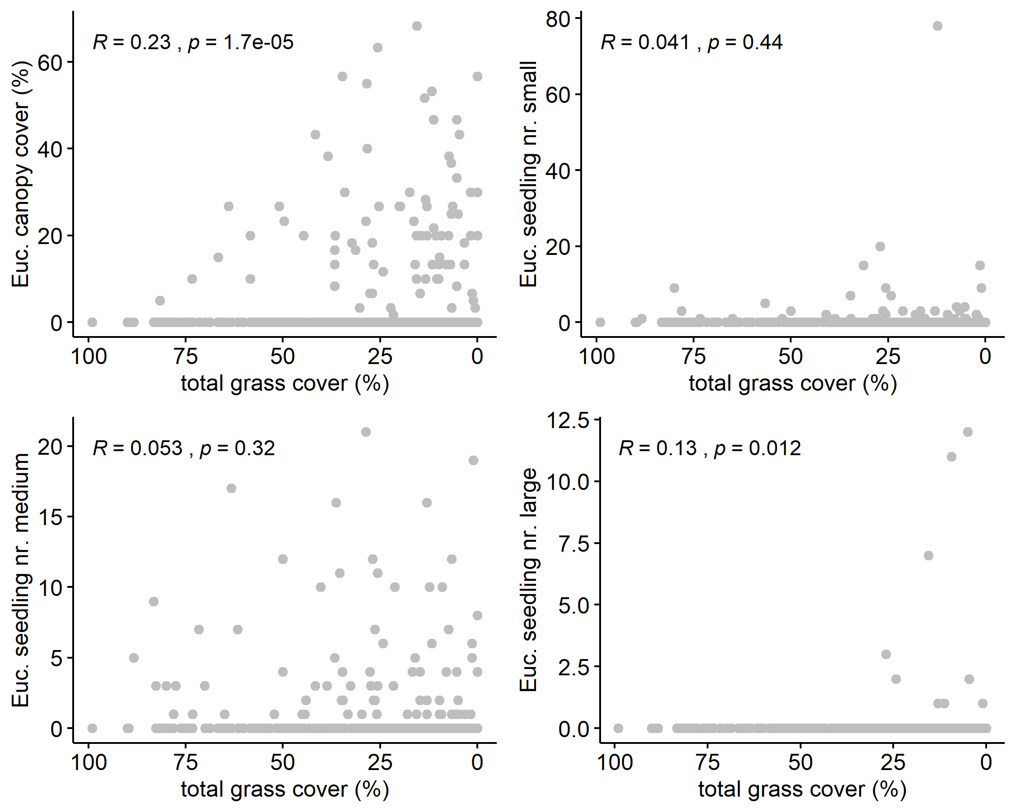

**Figure 1** Plot-level relationships of Eucalyptus canopy cover (upper left) as well as different seedling sizes of Eucalyptus with total grass cover across all times on plot level. R and *p* were determined using Spearman correlations.

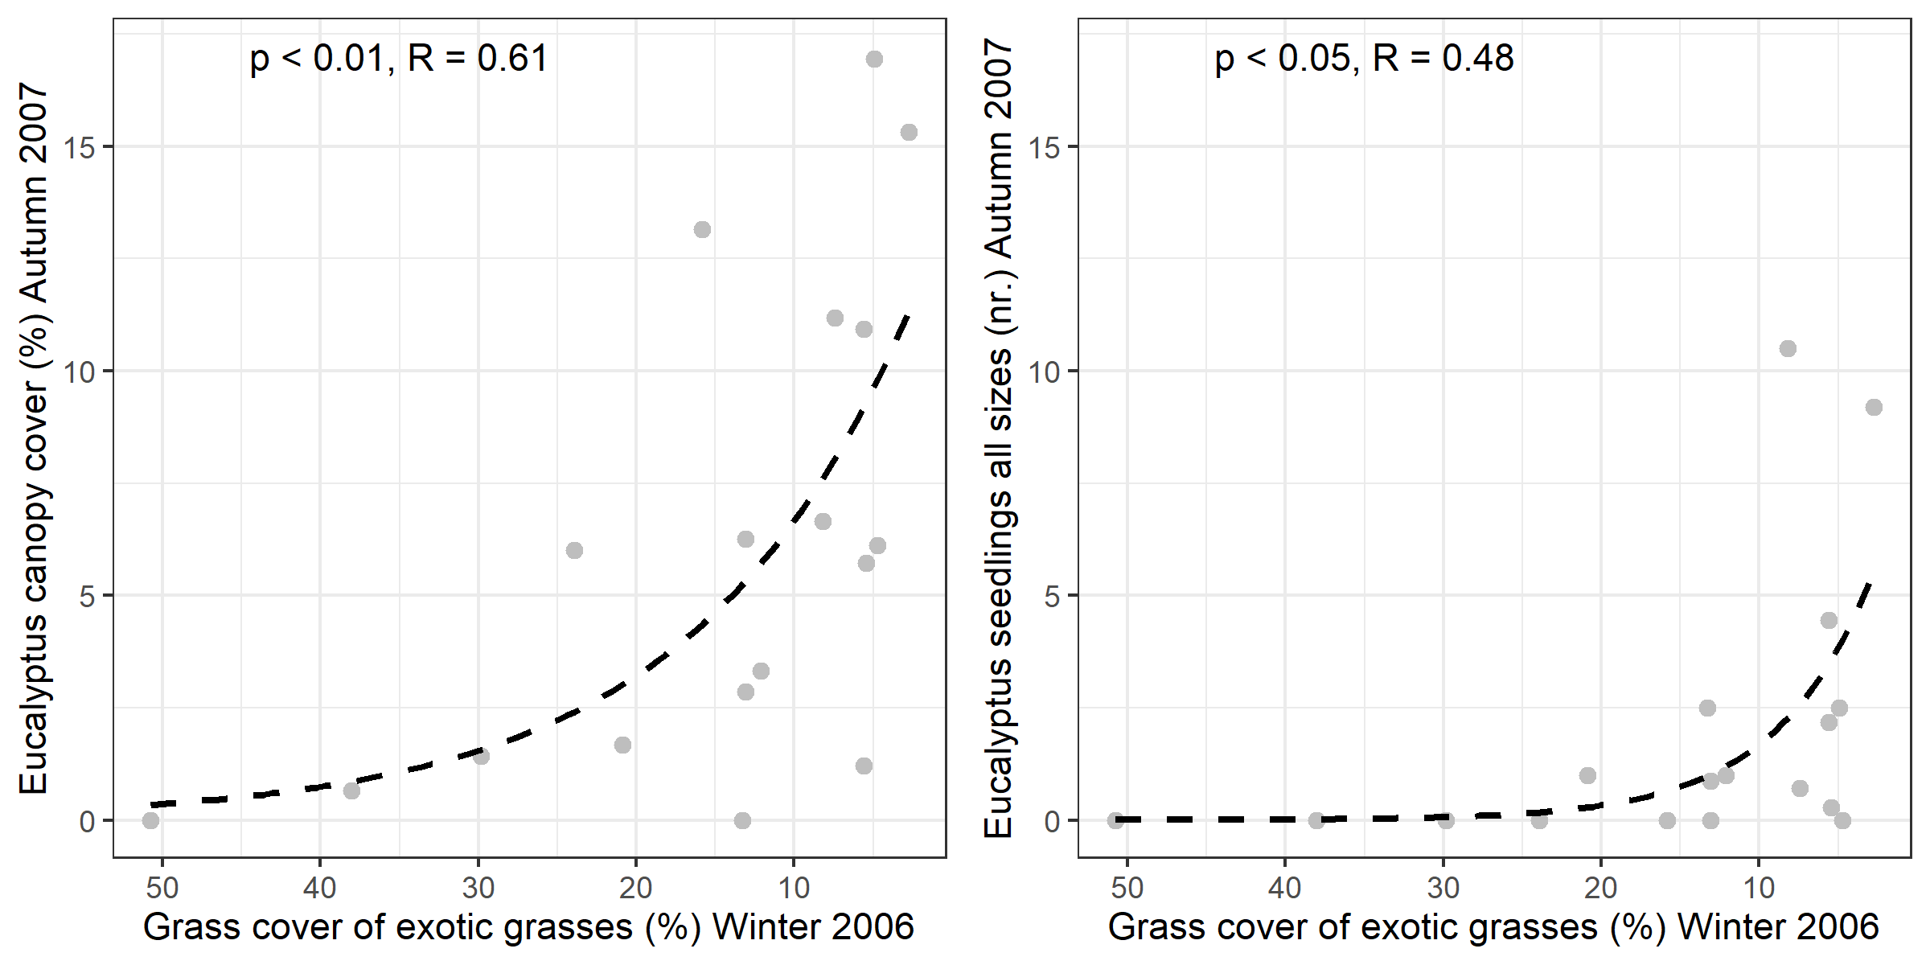

**Figure 2** Property-level relationships of Eucalyptus canopy cover (left) and combined seedlings (right) in Autumn 2007 related to grass cover of exotic grasses in the Winter of 2006. The dashed line represents the best fit with a reversed exponential-decay function. R and *p* were determined through Pearson correlation of observed vs. fitted values. Fitted equations were y = 13.85 ± 4.01 * *e*(-0.07 ± 0.04 * x) (left, canopy cover) and y =8.71 ± 5.48 * *e*(-0.16 ± 0.11 * x) (right, seedling nr.).

*Influence of site parameters on Eucalyptus growth*

[Bernd]