**Results**

*Effect of grass cover on Eucalyptus growth*

We found an overall negative influence of total grass cover on Eucalyptus growth, which, on plot-level was blanketed by many plots with no Eucalyptus present (Fig. 1). Clearer trends were observed on property level. While total grass cover and native grass cover had no consistent effect on Eucalyptus growth, exotic grass cover in the Winter of 2006 strongly reduced both Eucalyptus canopy cover and Eucalyptus seedling number of all sizes in Autumn of 2007 (Fig. 2; *p* < 0.05). In summary, Eucalyptus canopy cover and number of Eucalyptus seedlings were strongly reduced by exotic, but not by native, grass cover on the property two years earlier.

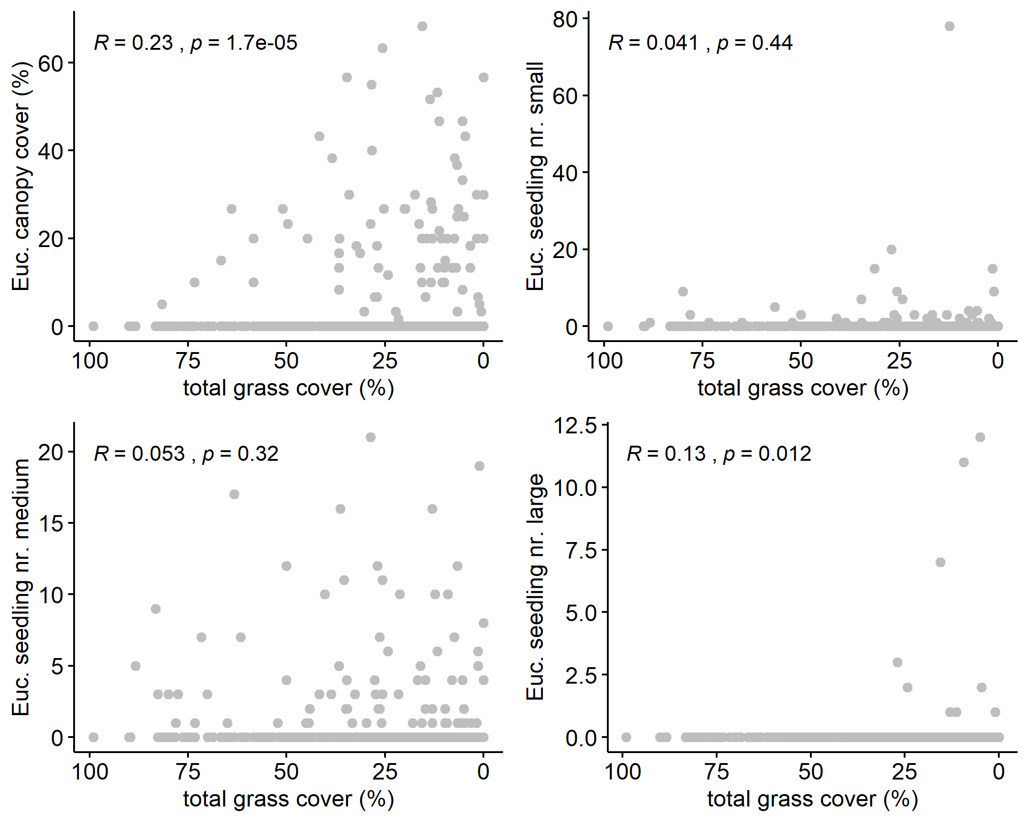

**Figure 1** Plot-level relationships of Eucalyptus canopy cover (upper left) as well as different seedling sizes of Eucalyptus with total grass cover across all times on plot level. R and *p* were determined using Spearman correlations.

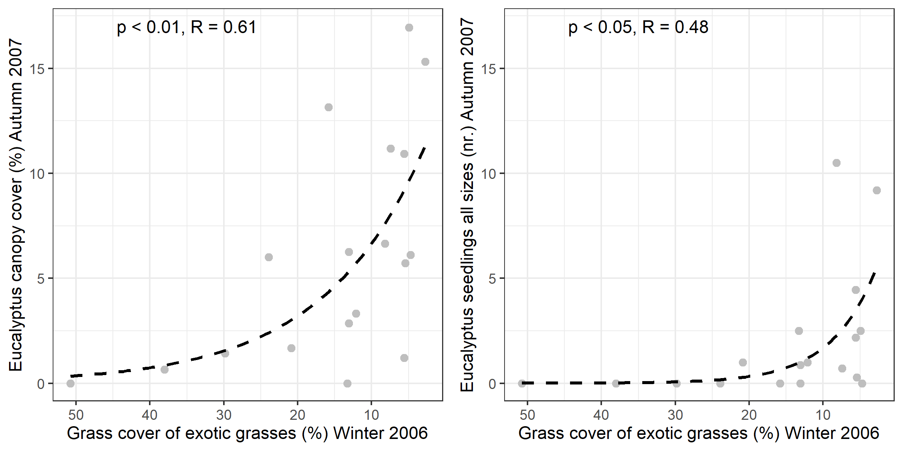

**Figure 2** Property-level relationships of Eucalyptus canopy cover (left) and combined number of seedlings (right) in Autumn 2007 related to grass cover of exotic grasses in the Winter of 2006. The dashed line represents the best fit with a reversed exponential-decay function. R and *p* were determined through Pearson correlation of observed vs. fitted values. Fitted equations were y = 13.85 ± 4.01 * *e*(-0.07 ± 0.04 * x) (left, canopy cover) and y =8.71 ± 5.48 * *e*(-0.16 ± 0.11 * x) (right, seedling number).

*Influence of site parameters on Exotic grass cover*

Exotic grass cover was negatively affected by bare ground, litter, moss & lichen, and, rock cover (for all four predictors p < 0.001) and solar radiation in July (p < 0.05). Also potential evapotranspiration (PET) tended to negatively affect exotic grass cover (p < 0.1). Though, this model being highly significant it explains only little variance (R²marginal = 5.7% and R²central = 6.7%). This hints to a negative effect of open, rocky and likely degraded soil on exotic grass cover.

**Table 1:** Factors influencing exotic grass cover. Model output of linear mixed effect model with corrected variance structure.

|  |  |  |  |  |  |
| --- | --- | --- | --- | --- | --- |
|  | **Value** | **Std.Error** | **DF** | **t-value** | **p-value** |
| *(Intercept)* | 71.351 | 18.319 | 219 | 3.895 | 0 |
| *PET* | -0.026 | 0.013 | 219 | -1.953 | 0.052 |
| *Rock cover [%]* | -0.332 | 0.043 | 219 | -7.723 | 0 |
| *Litter cover [%]* | -0.281 | 0.025 | 219 | -11.32 | 0 |
| *Bare ground cover [%]* | -0.352 | 0.031 | 219 | -11.219 | 0 |
| *Moss & Lichen cover [%]* | -0.22 | 0.027 | 219 | -8.139 | 0 |
| *Solar radiation (Juli)l* | 0 | 0 | 219 | -2.232 | 0.027 |
| *Valley-bottom-flatness Index (MrVBF)* | 0.197 | 0.332 | 219 | 0.595 | 0.553 |
| *Uranium concentration [ppm]* | 0.533 | 0.607 | 219 | 0.878 | 0.381 |
| *Season Spring 2006* | 2.236 | 1.017 | 219 | 2.198 | 0.029 |
| *Season Winter 2006* | -1.364 | 1.038 | 219 | -1.313 | 0.19 |