**Exploratory Data Analysis Pipeline**

**Context of Business and Data Visualization**

**Intended Audience**

The primary target audience for this exploratory data analysis (EDA) is the client organization in search of data insights from a medical dataset. The stakeholders include healthcare professionals, data specialists, and decision-makers from the client’s organization.

**Objective**

The aim of this analysis is to find significant insights that can guide decision-making and tactical planning within the healthcare sector. By using data visualization techniques, we attempt to provide a comprehensive overview of the dataset's features, identify patterns, and detract from tortious conclusions.

**Overview of Data**

The dataset holds 428 rows and 51 columns, containing a range of variables related to health for everyone. These variables include demographic assigns, medical set, laboratory outcome, and outcomes (live or deceased).

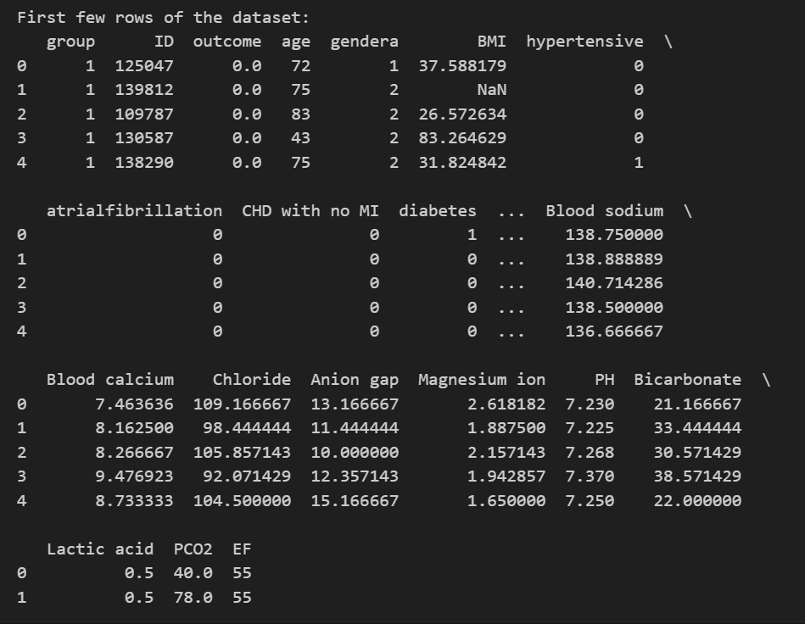

**Discussion on Data Exploration**

**Common Issues with Data Quality**

The primary test revealed the presence of missing values throughout various features, with substantial gaps in the 'BMI,' 'temperature,' Neutrophils,' PH,' Lactic acid,' 'PCO2,' and other columns.

Duplicate Rows: No duplicate rows were detected within the dataset.

**Data Preprocessing**

To address the missing values, a choice was made to remove rows with null values for the sake of simplicity. Furthermore, categorical variables such as 'gendera' were transformed into numerical form, with '0' expressive males and '1' representing females.

**Explanatory Data Visualization**

**Insight 1: Distribution of Age among Patients**

Importance: Understanding the allocation of age is crucial for determining healthcare strategies to different age groups. The dataset includes elderly patients, with a peak in the age range of 70-80.

**Insight 2: Distribution of Gender**

Importance: Analyzing the distribution of gender helps in detecting potential gender-specific health outcomes. The dataset provides a relatively equalized distribution between males (0) and females (1).

**Insight 3: Correlation Heatmap**

Importance: Identifying correlations supports in comprehending the relationships relating different health parameters. Insight: Various features exhibit correlations, such as 'Systolic blood pressure' and 'Diastolic blood pressure'.

**Insight 4: Boxplot of BMI in relation to Outcome**

Importance: Analyzing BMI in relation to outcomes can highlight potential health risks. Insight: Deceased patients (Outcome 1) tend to have a wider distribution of BMI.

**Insight 5: Pairplot of Selected Variables**

Importance: Examining pairs of variables can uncover interesting patterns and potential associations.

Insight: No clear linear relationships are observed between the selected variables.

**Insight 6: Violin Plot of Age Distribution in relation to Outcome**

Importance: Visualizing the age distribution in relation to outcome aids in understanding potential age-related risks. Insight: Deceased patients exhibit a broader distribution of age compared to surviving patients.

**Insight 7: Countplot of Comorbidities in relation to Outcome**

Importance: Analyzing the distribution of comorbidities provides insights into their prevalence among outcomes. Insight: Comorbidities like 'hypertensive' and 'diabetes' are more prevalent among deceased patients.

**Insight 8: Scatter Plot of LVEF vs. NT-proBNP in relation to Outcome**

Importance: Examining the relationship between LVEF and NT-proBNP can aid in assessing cardiovascular risk. Insight: No clear pattern is observed; outcomes are scattered across the plot.

**Insight 9: Bar Chart of Hypertension Prevalence**

Importance: Assessing hypertension prevalence informs potential intervention strategies.

Insight: Hypertension is prevalent in most of the dataset.

**Insight 10: Stacked Bar Chart of Comorbidities by Outcome**

Importance: Stacking comorbidities by outcome highlights their distribution patterns.

Insight: Hypertension and atrial fibrillation are more common among deceased patients.

**Final Discussion and Conclusion**

**Strengths:**

Strong dataset with various health-related variables.

Visualization techniques grant an extensive understanding.

**Limitations:**

Missing values decreased the size of the dataset.

Due to the exploratory nature, limited causation inference.

**Actionable Insights:**

**Age-Specific Interventions:** Personalize healthcare interventions to address age-specific risks, particularly for the elderly.

Gender-Specific Health Programs: Identify and address potential gender-specific health issues.

**BMI Monitoring for At-Risk Individuals:** Apply BMI monitoring, particularly for individuals with outcomes associated with greater BMI distributions.

**Comorbidity Awareness:** Attention on comorbidity management, especially for hypertension and diabetes, between deceased patients.

**Next Steps**

Feature Engineering: Create new features or transform existing ones for improved predictive modeling.

Advanced Modeling applies machine learning algorithms for predictive analysis and risk evaluation.

Continuous Monitoring: Implement continuous data observing strategies to detect real-time insights.

By utilizing these insights and subsequent steps, the client can make informed decisions to improve patient outcomes and improve overall healthcare strategies.