Table of Contents
ASSIGNMENT | Machine Learning for Metabolomics 2
Matthew Spriggs 2
Report 3
1. data prep & exploration [15marks] 3

ASSIGNMENT | Machine Learning for Metabolomics

Matthew Spriggs
Applied Bioinformatics
ESTIMATED WORD COUNT (EXCLUDING FIGURES AND QUESTIONS): 2041 words.

Report

Introduction

Apple introduction

Data Preparation & Exploration [15marks]

Data preparation and exploration: The three raw data files were loaded and checked for missing data. DCA Year 2 had 4 missing values, which came from sample DCA2_S38. This sample was missing values for Fructose, Sorbitol, Glucose and Sucrose, a decision was made to compute the mean value for the column, not accounting for storage week or ripening stage — this seemed low risk. DCA Year 1 had 432 missing values, all predictor variables were missing for samples in week 29. The decision was made to drop these columns from the analysis.

Quality Control: A discrepancy in column names was identified between the DCA Year1 and Year2 for columns 36. Phytohormone 7OH-ABA was labeled "7OH-ABA" in year 1 and "7-OH-ABA" in year 2. The column was renamed to "7-OH-ABA" in both datasets for consistency.

Principal Component Analysis (PCA) — parameter justification: A series of principal component analyses were conducted on the individual datasets to explore patterns in the data. For the PCAs, different data transformations were tried to explore the effect of scaling and centering. Detailed interpretation of these PCAs can be seen in 01_data_prep_QC.R, but to summarize Table 1, centered and scaled PCAs showed a modest explanation of variance in the first 2 principal components (46%) with an acceptable standard deviation (16.63). Whilst scaling only appears to account for 85% of the variation, without centering the data, this variation is still predominantly influenced by the mean structure, with different predictor variables having different units, e.g., Glucose is expressed in mg/g dry weight from 30–157 mg/g whilst ABA ranges from 6.3–185 ng/g. Scaling alone without centering would be inappropriate. Data is shown for CA Year 2 only, but the same trend is evident for all datasets. The decision was taken to scale and centre data for PCAs.
Table 1: PCA normalization tuning for CA Year 2 data.
Dataset | Condition | explained variance for PC1 + PC2 (%) | stDev for PC1 + PC2
ca_year_2_pca | Centered and scaled | 46.20 | 16.63
ca_year_2_pca_scaled | Scaled only | 85.66 | 30.84
ca_year_2_pca_centered | Centered only | 84.56 | 26879.99
ca_year_2_pca_none | Raw | 98.36 | 338073.69

Principal Component Analysis (PCA) — data exploration: biplots from the R library "mixOmics" we used as a way to explore the PCA further. Overlaying factors storage week and ripening stage onto of the principal components 1 and 2 (Figure 1, Figure 2, Figure 3).

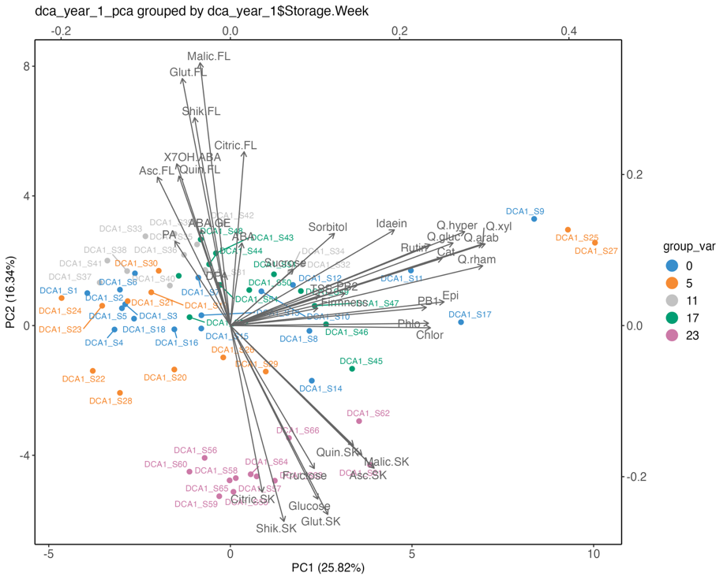
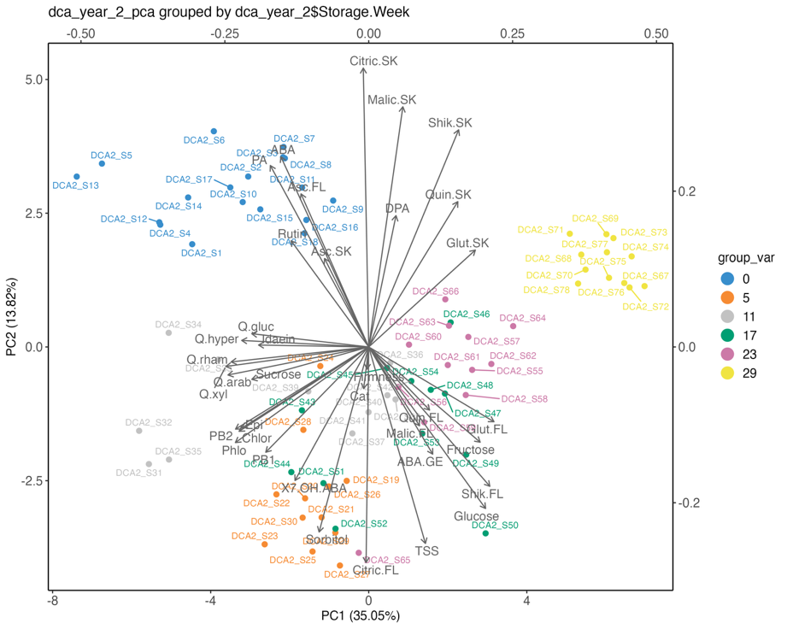
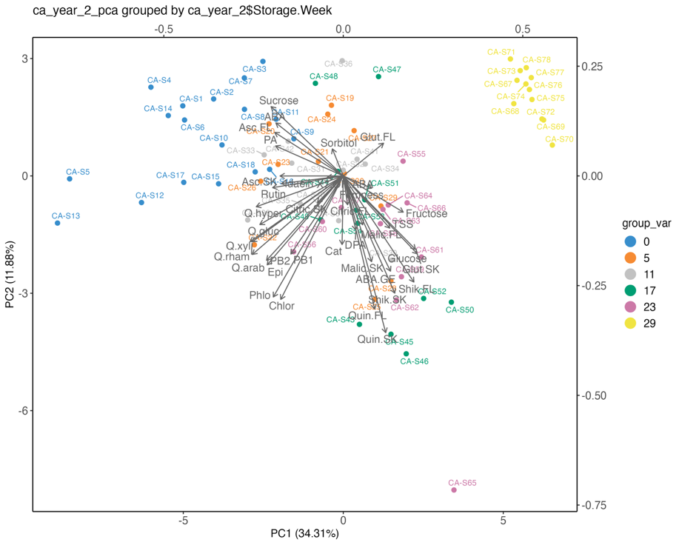
Figure 1: PCA biolots from mixOmics depicting CA Year 2 [1], DCA Year 1 [2] and DCA Year 2 [3] grouped by storage week.

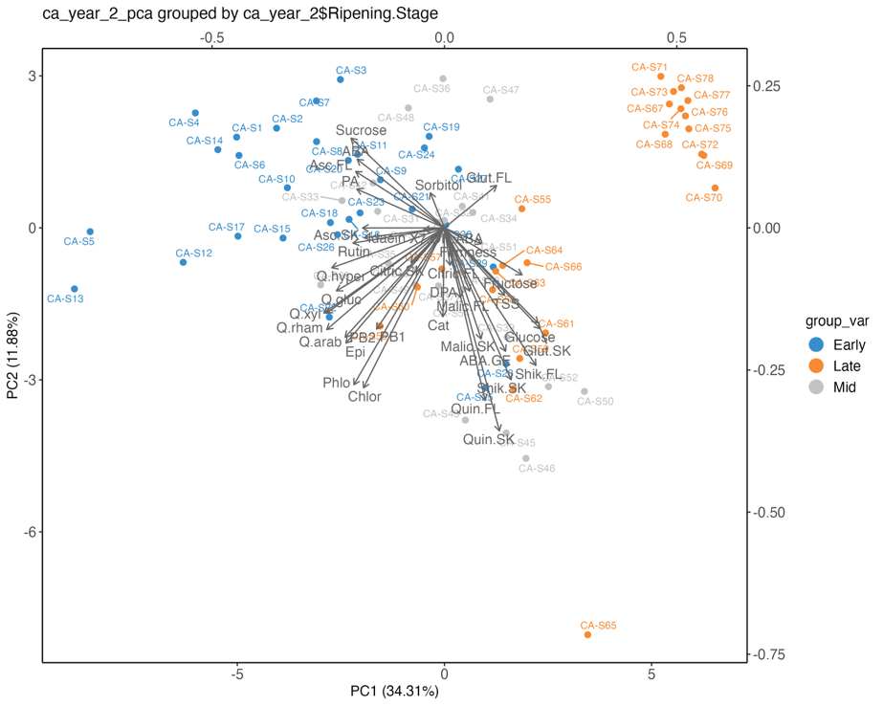
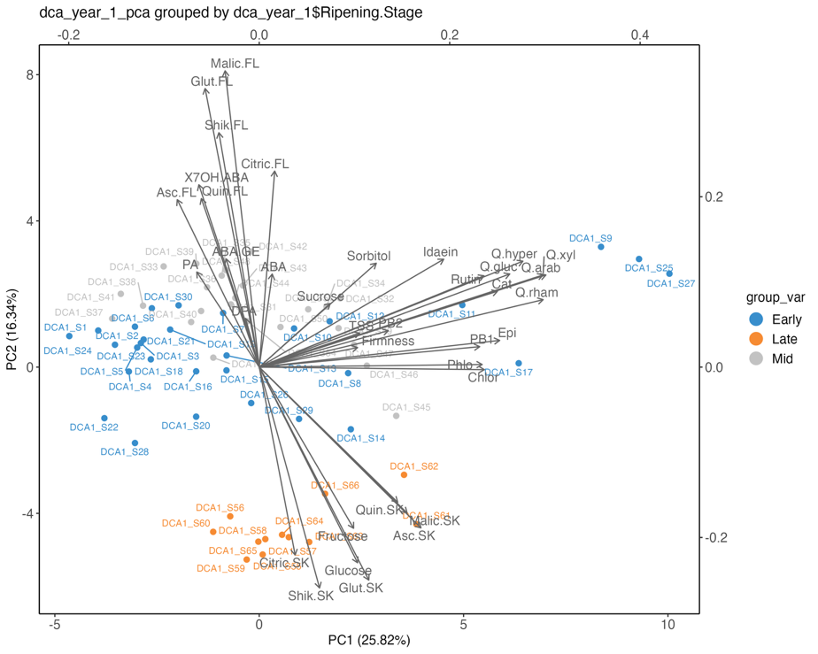
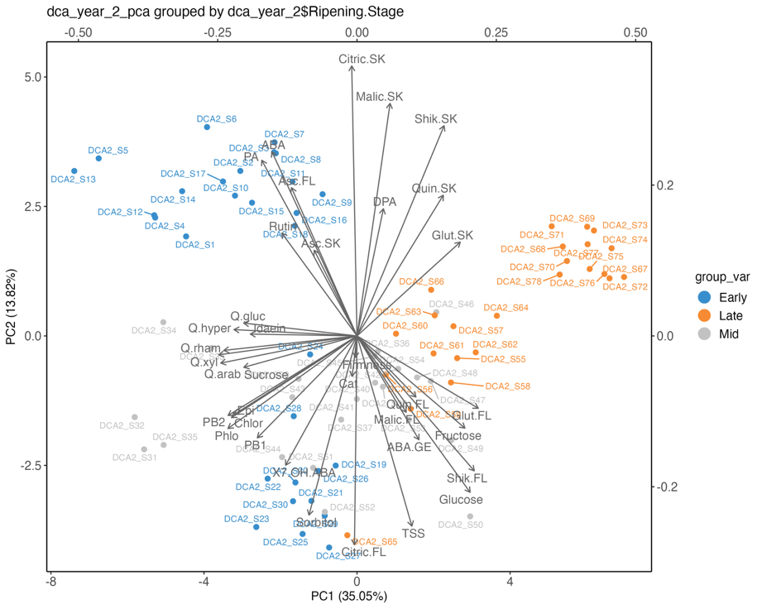
Figure 2: PCA biolots from mixOmics depicting CA Year 2 [1], DCA Year 1 [2] and DCA Year 2 [3] grouped by ripening stage.

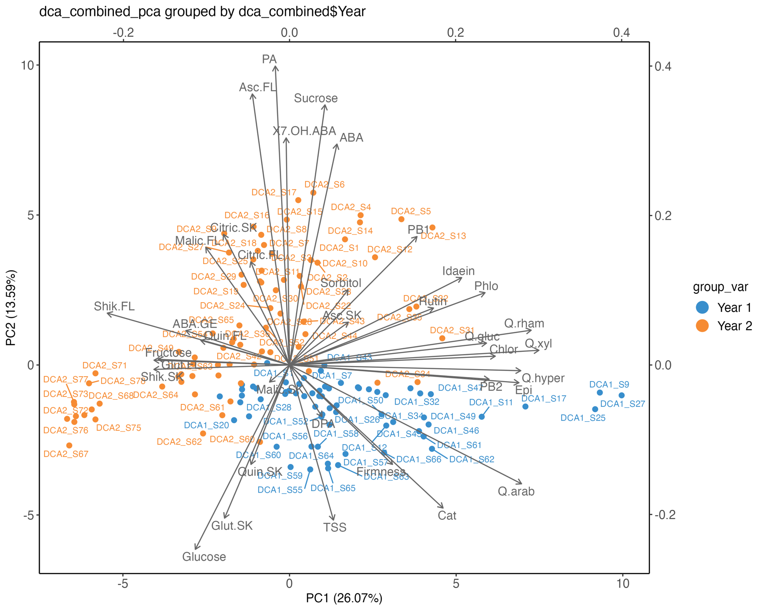
Figure 3: PCA biolots from mixOmics depicting DCA Year 1 and DCA Year 2 combined grouped by year.

Figure 1 depicts the three individual datasets PCA models split by storage week. PC1 had greater explanatory power in datasets CA Year 2 and DCA Year 2—notably, these two datasets have data for week 29 whereas DCA Year 1 does not. In both Figure 1 [1] and [3], week 29 (yellow) points cluster together and week 0 (blue) points cluster together.

Figure 2 depicts the three individual datasets PCA models split by ripening stage. The same trend applies, where the explanatory power of DCA Year 1 is greatly reduced by the missing data. Across the plots, early and late points cluster in groups — with differing degrees of variability, while mid points scatter with less consistency.

Compounds such as ABA and PA may be good indicators of week 0; however, the explanatory power for these PCs is reasonably weak.

To investigate batch effect, the data from DCA Year 1 and Year 2 was merged. There is an apparent separation of group on the y-axis in Figure 3, which is made clear in Figure 4. This implies that the physicochemical parameters between batches need be taken into account when building prediction or classification models.

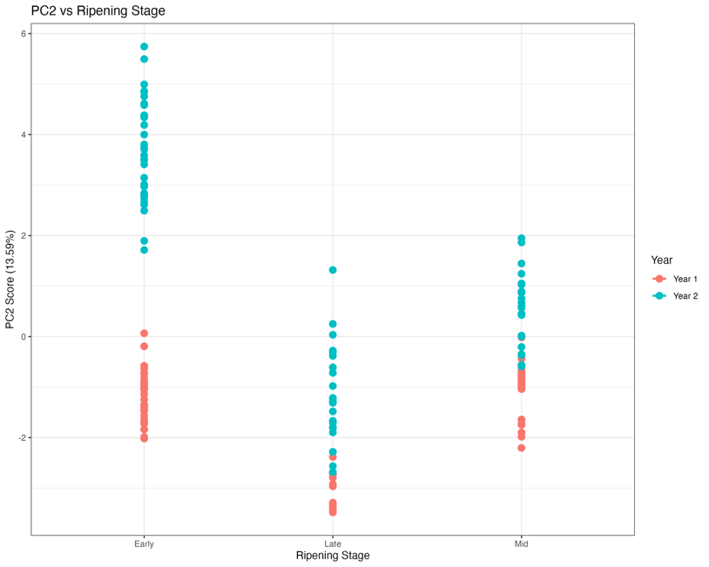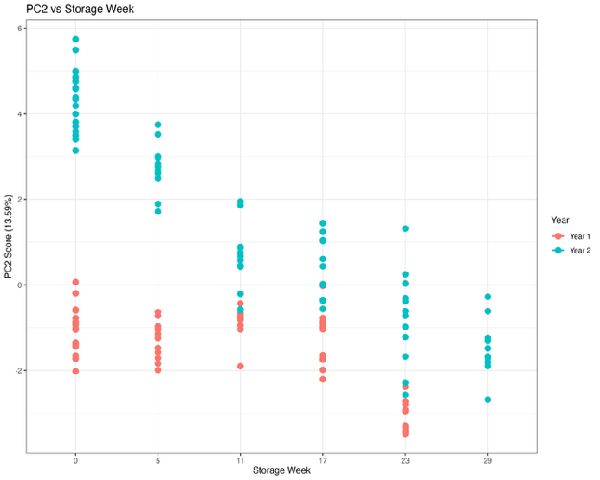
Figure 4: PC2 scores over storage week [1] and ripening stage [2] split by year.

Random Forest Classification for Apple Development Stages [35 marks]

