**Lab 7**

**Introduction**

For this lab, we used the Optitrack motion capture and Biopac amplifier to study reach to grasp movements under several different conditions. To aid in our investigation, electrodes were attached to the ABP muscle of the hand. Our hypothesis is that when moving to pick up the dynamometer, the subject will slow down and open their hand, followed by closing their hand, and lifting the object, before placing it down again.

**Materials**

* Optitrack cameras
* Optitrack markers
* Dynamometer
* Biopac Amplifiers
* Electrodes

**Methods**

The subject, with markers attached to the index finger, thumb, and wrist, reached to the dynamometer, approximately 10” away from the start position, grasped the dynamometer from the side, and lifted it 2-3”, before placing them down again. This was repeated 10 times. This same procedure was repeated with a grip on the side of the dynamometer.

For the second part of the experiment, the same procedure was repeated with eyes closed.

**Results**

Eyes Open

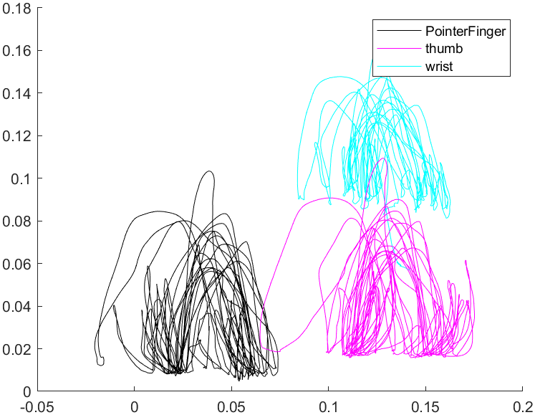

Figure 1. Positional data for pinch

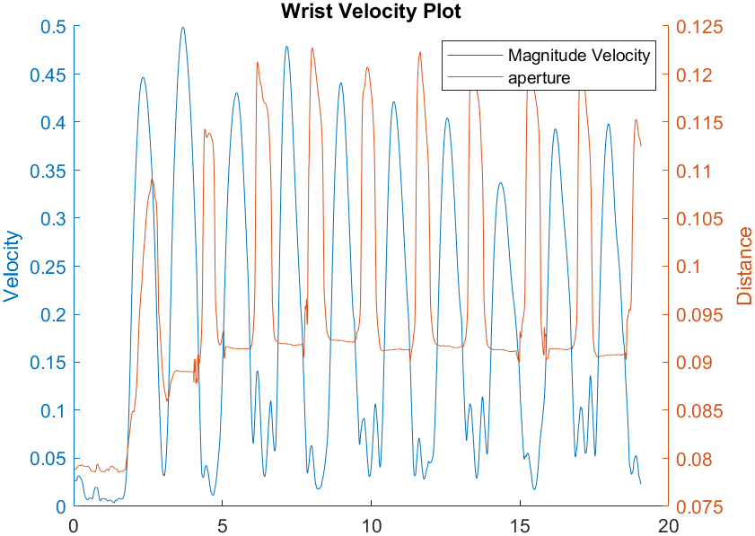

Figure 2. Wrist Velocity and And Aperture For Middle Pinch



Figure 3. Wrist Velocity and And Aperture For Side Pinch

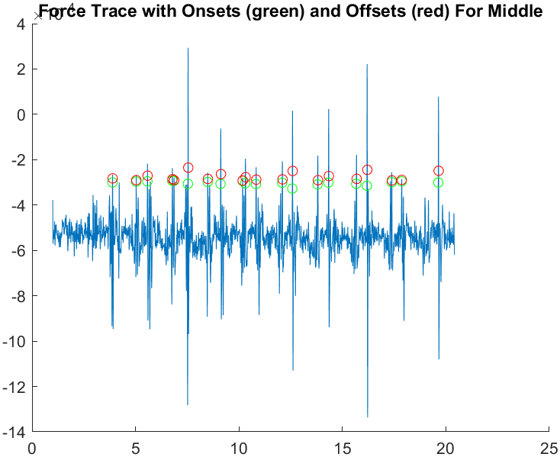

Figure 4. Force Onset and Offset for Middle Pinch

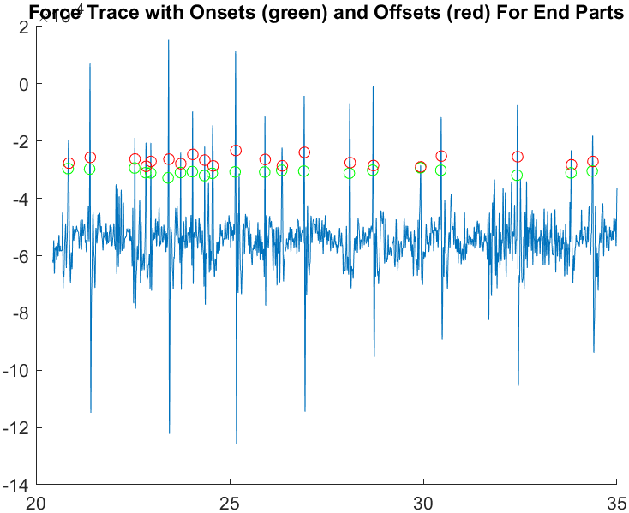

Figure 5. Force Onset and Offset for Side Pinch

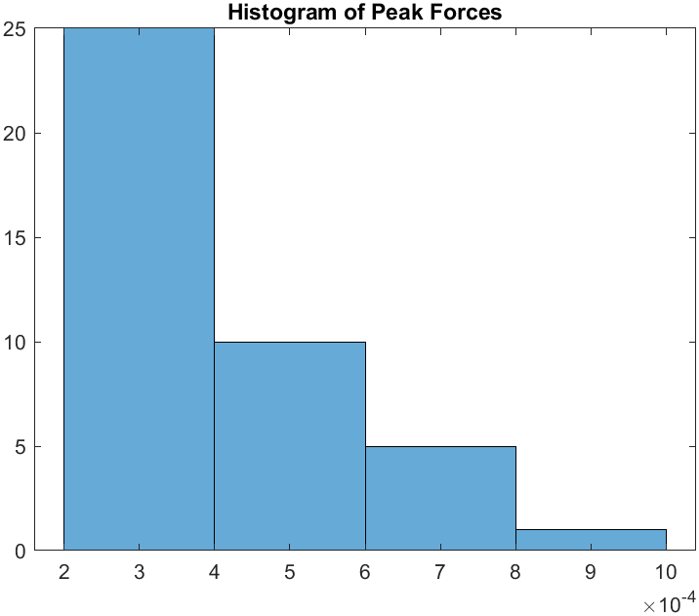

Figure 6. Peak Forces

Areas under the peak force section for part 1

0.0021 0.0016 0.0033 0.0032 0.0018 0.0114 0.0025 0.0079 0.0013 0.0066 0.0040 0.0052 0.0088 0.0070 0.0089 0.0064 0.0119 0.0030 0.0015 0.0092 0.0063 0.0091 0.0032 0.0046 0.0028 0.0108 0.0023 0.0050 0.0024 0.0083 0.0106 0.0044 0.0047 0.0070 0.0095 0.0085 0.0013 0.0059 0.0070 0.0040 0.0061

Eyes Close

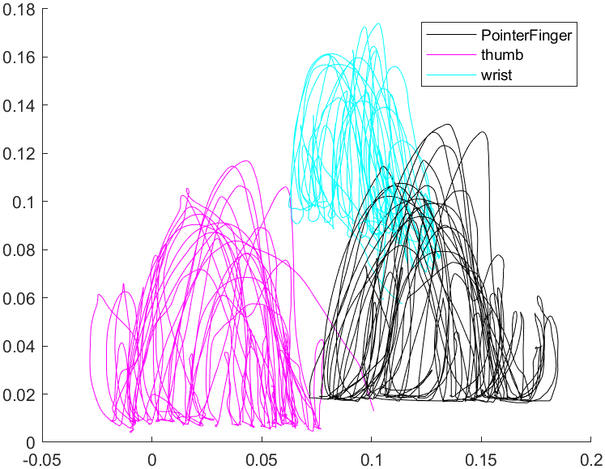

Figure 7. Positional Data For Pinch

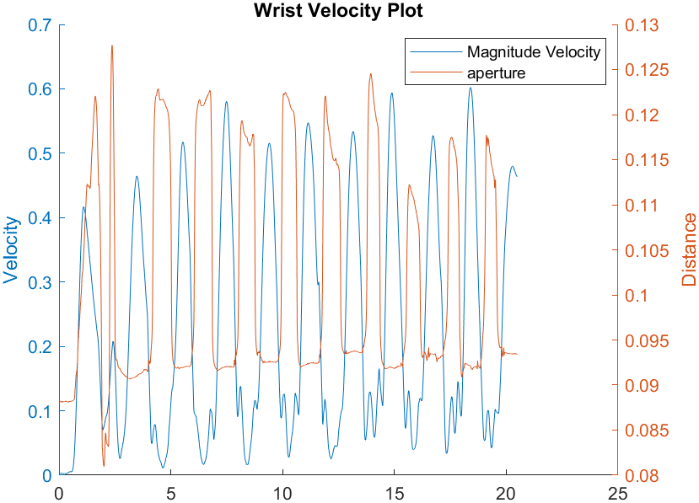

Figure 8. Wrist Velocity and And Aperture For Middle Pinch



Figure 9. Wrist Velocity and And Aperture For Side Pinch

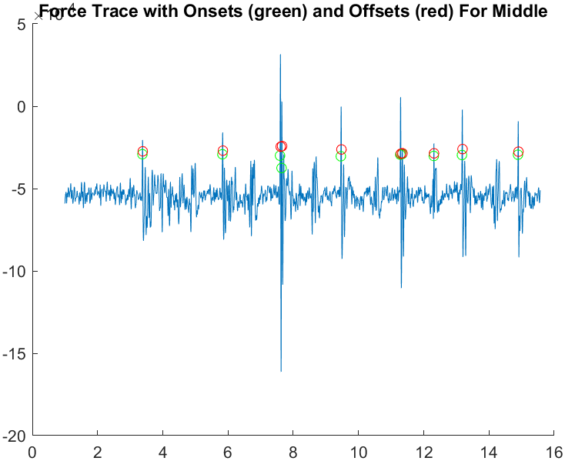

Figure 10. Force Onset and Offset for Middle Pinch

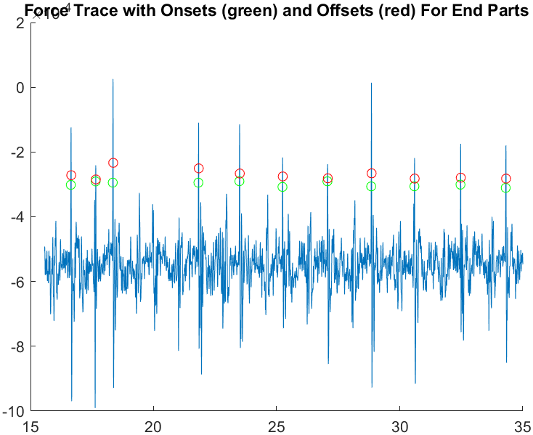

Figure 11. Force Onset and Offset for Side Pinch

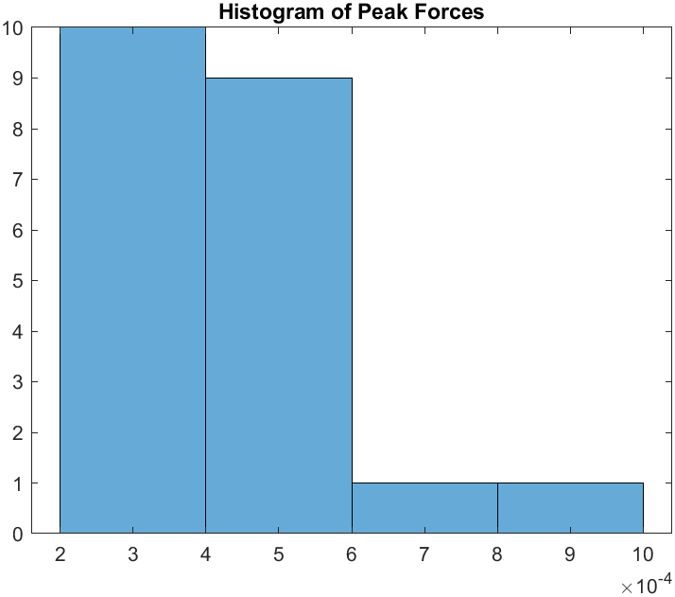

Figure 12. Histogram of Area Under Force Under Pickup

Area under Pickups

0.0035 0.0055 0.0137 0.0078 0.0083 0.0090 0.0019 0.0024 0.0077 0.0057 0.0066 0.0026 0.0088 0.0056 0.0060 0.0036 0.0044 0.0084 0.0033 0.0040 0.0052

**Discussion/Conclusion**

From the wrist and velocity data, it’s clear that the wrist velocity and distance have an inverse relation. This fits with our expectations that as the subject pinches the dynamometer, their wrist velocity would decrease, and the aperture would increase to accommodate the dynamometer, decrease as it closed around the dynamometer, followed by the wrist velocity increasing as the subject lifted the dynamometer. The positional data from Optitrack shows how when the subject had their eyes open, there were smaller, more precise movements. With eyes closed, subjects had slower, more inaccurate movements, illustrating how important sight is for accurate movements. In terms of force data, the middle grip recorded more force than the side grip. This was likely a result of the dynamometer being more sensitive in the middle area as compared to the side areas. In terms of difficulties with this lab, synchronization of the EMG data with the Optitrack data proved difficult, so it was recorded separately. There were also issues regarding Optitrack markers being blanked out if they got too close together. This was most common during the starting position, where the index finger and thumb were required to be together. In addition, the dynamometer’s size was an issue when recording, as it often obstructed the view of the camera, and led to the markers being lost and readded.

**Matlab Code:**

clc

clear

close all

Sub1 = readtable("Lab7- Task 1_Sub1.csv");

Sub2 = readtable("Lab7- Task 2_Sub 1.csv");

Sub1(1:4,:) = [];

Sub2(1:6,:) = [];

Sub2(:,12:end) = [];

Sub1 = table2array(Sub1);

Sub2 = table2array(Sub2);

%% Part 1 (eyes open)

close all

Time = Sub1(:,2);

Position = Sub1(:,3:end);

for k = 1:size(Position, 2)

emptydata = isnan(Position(:, k));

if any(emptydata)

validdata = ~emptydata;

validTime = Time(validdata);

validPosition = Position(validdata, k);

Position(:, k) = interp1(validTime, validPosition, Time, 'pchip', 'extrap');

end

end

X1 = Position(:,1);

Y1 = Position(:,2);

Z1 = Position(:,3);

X2 = Position(:,4);

Y2 = Position(:,5);

Z2 = Position(:,6);

X3 = Position(:,7);

Y3 = Position(:,8);

Z3 = Position(:,9);

figure

hold on

plot3(X1,Y1,Z1,'k-'); % pointerfinger

plot3(X2,Y2,Z2,'Color','m'); % thumb

plot3(X3,Y3,Z3,'c-'); % wrist

hold off

aperturex = X1-X2;

aperturey = Y1-Y2;

aperturez = Z1-Z2;

magaperture = sqrt(aperturex.^2+aperturey.^2+aperturez.^2);

dWristypos = diff(Z3);

dTime = diff(Time);

Wristvelz = dWristypos./dTime;

Wristvelz = Wristvelz';

Wristvelz = [Wristvelz(end),Wristvelz];

Wristvelz = Wristvelz';

dWristxpos = diff(X3);

Wristvelx = dWristxpos./dTime;

Wristvelx = Wristvelx';

Wristvelx = [Wristvelx(end),Wristvelx];

Wristvelx = Wristvelx';

dWristxpos = diff(Y3);

Wristvely = dWristxpos./dTime;

Wristvely = Wristvely';

Wristvely = [Wristvely(end),Wristvely];

Wristvely = Wristvely';

%halving code

halftime = 2289;

Wristvelx2 = Wristvelx(halftime:end,1);

Wristvely2 = Wristvely(halftime:end,1);

Wristvelz2 = Wristvelz(halftime:end,1);

Time2 = Time(halftime:end,1);

Wristvelx = Wristvelx(1:halftime,1);

Wristvely = Wristvely(1:halftime,1);

Wristvelz = Wristvelz(1:halftime,1);

Time = Time(1:halftime,1);

% SIDE GRIP STUFF

figure

plot(Time,Wristvelz) % plots the "transport velocity"

[A, B] = butter(2, 2/60, "low");

Wristvelz = filtfilt(A, B, Wristvelz);

turningPoints = [];

i = 1;

while i <= length(Wristvelz) - 1

% Check if current time is within desired range before evaluating Wristvelz

if Time(i) > 6 && Time(i) < 38

if abs((Wristvelz(i)-Wristvelz(i+10))) >= 0.02||abs((Wristvelz(i)-Wristvelz(i-10))) >= 0.02

if (Wristvelz(i) <= 0.01 && Wristvelz(i + 1) > -0.01)||(Wristvelz(i) >= -0.01 && Wristvelz(i + 1) < 0.01) % Condition for turning point

turningPoints = [turningPoints; i + 1]; % Collect turning point

i = i + 80; %Search for turning Points in set interval

continue;

end

end

end

i = i + 1; % Otherwise, proceed to the next index

end

% Plot Y-velocity over time

figure;

plot(Time, Wristvelz, 'LineWidth', 2);

xlabel('Time');

ylabel('Velocity in Y');

title('Y-Velocity Over Time');

hold on;

% Highlight turning points on the plot

scatter(Time(turningPoints), Wristvelz(turningPoints), 'r', 'filled');

turningPointsX = Time(turningPoints(1:end));

turningPointsX = diff(turningPointsX);

% labeling

legend('X-Velocity', 'Turning Points');

figure;

hold on;

i1 = 1;

addedLegend1 = false;

for i2 = 2:3:length(turningPoints)

h1 = plot3(X3(turningPoints(i1):turningPoints(i2)), ...

Y3(turningPoints(i1):turningPoints(i2)), ...

Z3(turningPoints(i1):turningPoints(i2)), 'Color','r');

if ~addedLegend1

set(h1, 'DisplayName', 'Subject 1');

addedLegend1 = true;

else

set(h1, 'HandleVisibility', 'off');

end

i1 = i1+3;

end

legend show;

hold off

ylabel("anterior displacement (m)")

xlabel("lateral displacement (m)")

magnV = sqrt(Wristvelx.^2+Wristvely.^2+Wristvelz.^2);

magnV = smoothdata(magnV, "movmean", 20);

magaperture2 = magaperture(halftime:end,1);

magaperture = magaperture(1:halftime,1);

figure

hold on

yyaxis left

plot(Time, magnV)

ylabel('Velocity')

yyaxis right

plot(Time, magaperture)

ylabel('Distance')

title('Wrist Velocity Plot')

legend('Magnitude Velocity', 'aperture')

hold off

% MID GRIP

figure

plot(Time2,Wristvelz2) % plots the "transport velocity"

[A, B] = butter(2, 2/60, "low");

Wristvelz2 = filtfilt(A, B, Wristvelz2);

turningPoints = [];

i = 1;

while i <= length(Wristvelz2) - 1

% Check if current time is within desired range before evaluating Wristvelz

if Time2(i) > 6 && Time2(i) < 38

if abs((Wristvelz2(i)-Wristvelz2(i+10))) >= 0.02||abs((Wristvelz2(i)-Wristvelz2(i-10))) >= 0.02

if (Wristvelz2(i) <= 0.01 && Wristvelz2(i + 1) > -0.01)||(Wristvelz2(i) >= -0.01 && Wristvelz2(i + 1) < 0.01) % Condition for turning point

turningPoints = [turningPoints; i + 1]; % Collect turning point

i = i + 80; %Search for turning Points in set interval

continue;

end

end

end

i = i + 1; % Otherwise, proceed to the next index

end

% Plot Y-velocity over time

figure;

plot(Time2, Wristvelz2, 'LineWidth', 2);

xlabel('Time');

ylabel('Velocity in Y');

title('Y-Velocity Over Time');

hold on;

% Highlight turning points on the plot

scatter(Time2(turningPoints), Wristvelz2(turningPoints), 'r', 'filled');

turningPointsX = Time2(turningPoints(1:end));

turningPointsX = diff(turningPointsX);

% labeling

legend('X-Velocity', 'Turning Points');

figure;

hold on;

i1 = 1;

addedLegend1 = false;

for i2 = 2:3:length(turningPoints)

h1 = plot3(X3(turningPoints(i1):turningPoints(i2)), ...

Y3(turningPoints(i1):turningPoints(i2)), ...

Z3(turningPoints(i1):turningPoints(i2)), 'Color','r');

if ~addedLegend1

set(h1, 'DisplayName', 'Subject 1');

addedLegend1 = true;

else

set(h1, 'HandleVisibility', 'off');

end

i1 = i1+3;

end

legend show;

hold off

ylabel("anterior displacement (m)")

xlabel("lateral displacement (m)")

magnV = sqrt(Wristvelx.^2+Wristvely.^2+Wristvelz.^2);

magnV = smoothdata(magnV, "movmean", 20);

figure

hold on

yyaxis left

plot(Time, magnV)

ylabel('Velocity')

yyaxis right

plot(Time, magaperture)

ylabel('Distance')

title('Wrist Velocity Plot')

legend('Magnitude Velocity', 'aperture')

hold off

%%

clc

clear

close all

load('Lab7-Task 1 Dyna Subject 1.mat')

ForceData = ch2data;

[A, B] = butter(2, 25/500, "low");

ForceData = filtfilt(A, B, ForceData);

Time = linspace(1,35,35000);

figure

plot(Time,ForceData)

PositiveForceData = ForceData + abs(mean(ForceData));

threshold = 0.3 * max(PositiveForceData);

figure

plot(Time,PositiveForceData)

onsets = find(diff(PositiveForceData > threshold) == 1);

offsets = find(diff(PositiveForceData > threshold) == -1);

squeezes = cell(length(onsets), 1);

for i = 1:length(onsets)

squeezes{i} = PositiveForceData(onsets(i):offsets(i));

end

peak_forces = zeros(length(squeezes), 1);

for i = 1:length(squeezes)

peak_forces(i) = max(squeezes{i});

end

areas = zeros(length(squeezes), 1);

for i = 1:length(squeezes)

f = @(x) interp1(1:length(squeezes{i}), squeezes{i}, x, 'linear', 'extrap');

areas(i) = trapz(squeezes{i}); % Using trapezoidal integration

end

disp(areas)

figure;

plot(ForceData);

hold on;

scatter(onsets, ForceData(onsets), 'g');

scatter(offsets, ForceData(offsets), 'r');

title('Force Trace with Onsets (green) and Offsets (red)');

hold off;

% Histogram of Peak Forces

figure;

histogram(peak_forces);

title('Histogram of Peak Forces');

%% Part 2 (eyes closed)

close all

Time = Sub2(:,2);

Position = Sub2(:,3:end);

for k = 1:size(Position, 2)

emptydata = isnan(Position(:, k));

if any(emptydata)

validdata = ~emptydata;

validTime = Time(validdata);

validPosition = Position(validdata, k);

Position(:, k) = interp1(validTime, validPosition, Time, 'pchip', 'extrap');

end

end

X1 = Position(:,1);

Y1 = Position(:,2);

Z1 = Position(:,3);

X2 = Position(:,4);

Y2 = Position(:,5);

Z2 = Position(:,6);

X3 = Position(:,7);

Y3 = Position(:,8);

Z3 = Position(:,9);

figure

hold on

plot3(X1,Y1,Z1,'k-'); %pointerfinger

plot3(X2,Y2,Z2,'Color','m'); %thumb

plot3(X3,Y3,Z3,'c-'); %wirst

hold off

aperturex = X1-X2;

aperturey = Y1-Y2;

aperturez = Z1-Z2;

magaperture = sqrt(aperturex.^2+aperturey.^2+aperturez.^2);

dWristypos = diff(Z3);

dTime = diff(Time);

Wristvelz = dWristypos./dTime;

Wristvelz = Wristvelz';

Wristvelz = [Wristvelz(end),Wristvelz];

Wristvelz = Wristvelz';

dWristxpos = diff(X3);

Wristvelx = dWristxpos./dTime;

Wristvelx = Wristvelx';

Wristvelx = [Wristvelx(end),Wristvelx];

Wristvelx = Wristvelx';

dWristxpos = diff(Y3);

Wristvely = dWristxpos./dTime;

Wristvely = Wristvely';

Wristvely = [Wristvely(end),Wristvely];

Wristvely = Wristvely';

figure

plot(Time,Wristvelz)

[A, B] = butter(2, 5/60, "low");

Wristvelz = filtfilt(A, B, Wristvelz);

turningPoints = [];

i = 1;

while i <= length(Wristvelz) - 1

% Check if current time is within desired range before evaluating Wristvelz

if Time(i) > 6 && Time(i) < 36.4

if abs((Wristvelz(i)-Wristvelz(i+10))) >= 0.02||abs((Wristvelz(i)-Wristvelz(i-10))) >= 0.02

if (Wristvelz(i) <= 0.01 && Wristvelz(i + 1) > -0.01)||(Wristvelz(i) >= -0.01 && Wristvelz(i + 1) < 0.01) % Condition for turning point

turningPoints = [turningPoints; i + 1]; % Collect turning point

i = i + 75; %Search for turning Points in set interval

continue;

end

end

end

i = i + 1; % Otherwise, proceed to the next index

end

% Plot Y-velocity over time

figure;

plot(Time, Wristvelz, 'LineWidth', 2);

xlabel('Time');

ylabel('Velocity in Y');

title('Y-Velocity Over Time');

hold on;

% Highlight turning points on the plot

scatter(Time(turningPoints), Wristvelz(turningPoints), 'r', 'filled');

turningPointsX = Time(turningPoints(1:end));

turningPointsX = diff(turningPointsX);

% labeling

legend('X-Velocity', 'Turning Points');

figure;

hold on;

i1 = 1;

addedLegend1 = false;

for i2 = 2:3:length(turningPoints)

h1 = plot3(X3(turningPoints(i1):turningPoints(i2)), ...

Y3(turningPoints(i1):turningPoints(i2)), ...

Z3(turningPoints(i1):turningPoints(i2)), 'Color','r');

if ~addedLegend1

set(h1, 'DisplayName', 'Subject 1');

addedLegend1 = true;

else

set(h1, 'HandleVisibility', 'off');

end

i1 = i1+3;

end

legend show;

hold off

magnV = sqrt(Wristvelx.^2+Wristvely.^2+Wristvelz.^2);

figure

hold on

yyaxis left

plot(Time, magnV)

ylabel('Velocity')

yyaxis right

plot(Time, magaperture)

ylabel('Distance')

title('Wrist Velocity Plot')

legend('Magnitude Velocity', 'aperture')

hold off

%%

close all

load('Lab7-Task 2 Dyna Subject 1.mat')

ForceData = ch2data;

[A, B] = butter(2, 25/500, "low");

ForceData = filtfilt(A, B, ForceData);

Time = linspace(1,35,35000);

figure

plot(Time,ForceData)

PositiveForceData = ForceData + abs(mean(ForceData));

threshold = 0.20 * max(PositiveForceData);

figure

plot(Time,PositiveForceData)

onsets = find(diff(PositiveForceData > threshold) == 1);

offsets = find(diff(PositiveForceData > threshold) == -1);

squeezes = cell(length(onsets), 1);

for i = 1:length(onsets)

squeezes{i} = PositiveForceData(onsets(i):offsets(i));

end

peak_forces = zeros(length(squeezes), 1);

for i = 1:length(squeezes)

peak_forces(i) = max(squeezes{i});

end

areas = zeros(length(squeezes), 1);

for i = 1:length(squeezes)

f = @(x) interp1(1:length(squeezes{i}), squeezes{i}, x, 'linear', 'extrap');

areas(i) = trapz(squeezes{i}); % Using trapezoidal integration

end

disp(areas)

figure;

plot(ForceData);

hold on;

scatter(onsets, ForceData(onsets), 'g');

scatter(offsets, ForceData(offsets), 'r');

title('Force Trace with Onsets (green) and Offsets (red)');

hold off;

% Histogram of Peak Forces

figure;

histogram(peak_forces);

title('Histogram of Peak Forces');