CEDX RESEARCH REPORT

Critical Resources as Macro Variables
How Mineral and Water Constraints Shape Growth Ceilings, Trade Balances, and Geopolitical Power

Prepared by:
Dr. Marcus Chen, Dr. Sarah Williams, Dr. James Okonkwo, Dr. Elena Petrova

Date: January 2025 | Report No.: RR-CEDX-2025-003
Location: Geneva, Switzerland

Centre for Economic Development and Execution

Publication Information
For more information on this publication, visit: www.cedx.org/reports/RR-CEDX-2025-003
Contact: research@cedx.org | +41 22 555 0100 | 15 Route de Genève, 1211 Geneva, Switzerland

About CEDX
The Centre for Economic Development and Execution (CEDX) is a nonprofit, nonpartisan research organization committed to advancing evidence-based policy solutions for sustainable economic development. Established in 2010, CEDX bridges the gap between rigorous academic research and practical policy implementation, serving governments, development finance institutions, and multilateral organizations across six continents. Our work spans macroeconomic policy, resource governance, institutional development, and climate economics, with a particular focus on emerging and frontier markets where strategic resource management determines development trajectories.

Research Integrity
CEDX maintains the highest standards of research integrity and methodological transparency. This report underwent a three-stage quality assurance process: (1) internal technical review by senior economists and governance specialists; (2) external peer review by three independent experts in resource economics and macroeconomic policy; (3) editorial review for accuracy and accessibility. All authors completed conflict-of-interest screenings, declaring no financial interests or advisory relationships that could influence findings. Independence safeguards include firewall protocols between research and funding units, and all quantitative analyses are reproducible with data and code available upon request. Ethics approval was obtained from the CEDX Institutional Review Board for any primary data collection components.

Disclaimer
CEDX publications do not necessarily reflect the opinions of funders, sponsors, partners, or interview participants. Any errors are the responsibility of the authors alone. The analysis, findings, and recommendations contained herein represent the independent judgment of the research team based on available evidence as of December 2024.

Copyright and Reuse
© 2025 Centre for Economic Development and Execution (CEDX). The CEDX logo is a registered trademark. This report is provided for noncommercial use under Creative Commons Attribution-NonCommercial 4.0 International License. Do not repost the full report without permission. Linking to the official report page is encouraged. For commercial reuse permissions, contact: publishing@cedx.org.

Report Identifiers
Report Code: RR-CEDX-2025-003 | ISBN: 978-92-95123-45-6 | DOI: 10.5281/cedx.2025.003 | Edition: Final

About This Report

What Problem Does This Report Address?
Critical minerals and water resources are no longer peripheral commodity concerns—they function as binding constraints on national growth trajectories, determinants of trade vulnerability, and levers of geopolitical influence. The global energy transition has intensified demand for lithium, cobalt, rare earths, and copper by 400-700% over the past decade, while climate change accelerates water stress in regions accounting for 40% of global GDP. Current approaches treat these resources as sectoral issues rather than macroeconomic variables, leading to systematic underestimation of fiscal exposure, inflation transmission, and balance sheet risks. Finance ministries, central banks, and development finance institutions lack integrated frameworks to quantify how resource access translates into growth ceilings, how price shocks cascade through FX markets into inflation, and how institutional capacity determines whether resource wealth becomes a development ladder or a governance trap.

What Does This Report Do?
This report reframes critical resources as macro production constraints analogous to labor and capital, developing quantitative frameworks for policymakers to assess: (1) resource-driven growth ceilings and fiscal exposure; (2) shock transmission channels from commodity markets through FX and inflation to real economic activity; (3) institutional thresholds that determine whether resource rents convert into productive investment or dissipate through rent capture and volatility. The analysis covers 75 countries across four resource-governance typologies, with detailed case studies of sovereign wealth fund design, downstreaming feasibility, and hedging strategies. Temporal scope spans 2010-2024 with projections to 2035. Geographic scope is global with regional deep-dives for Sub-Saharan Africa, Latin America, and the Indo-Pacific. Excluded from scope are detailed firm-level analysis, technical extraction engineering, and environmental impact assessments beyond their macroeconomic implications.

How Was the Research Conducted?
The research employed a mixed-methods design combining quantitative macro-econometric analysis with comparative institutional case studies. Primary data sources include: national accounts from 75 country statistical offices; commodity price data from Bloomberg, LME, and S&P Global; governance indicators from World Bank WGI, EITI compliance data, and custom institutional capacity indices. Secondary sources include IMF Article IV consultations, World Bank Public Expenditure Reviews, DFI project documentation, and academic literature on resource economics. The analytical framework extends the Hartwick rule for sustainable resource management with institutional quality parameters, and applies vector autoregression (VAR) models to trace shock transmission. Robustness checks include alternative governance specifications, country-specific structural breaks, and Monte Carlo simulation for fiscal stress scenarios. Validation involved expert consultations with 40+ policymakers, industry practitioners, and academic specialists.

Who Is the Intended Audience?
Primary audiences are senior decision-makers: finance ministry principals evaluating fiscal frameworks for resource volatility; central bank governors assessing FX and inflation transmission from commodity shocks; development finance institution leaders structuring resource-backed financing; and geopolitical strategy teams analyzing supply chain concentration risks. Secondary audiences include legislative oversight bodies, multilateral organization staff, academic researchers, and civil society organizations monitoring resource governance. The report balances technical rigor with accessibility—all quantitative methods are explained in plain language with detailed appendices for specialists. Readers should begin with the Executive Summary for key findings and recommendations, then proceed to chapters relevant to their institutional mandate.

How to Navigate This Report
Chapter 1 establishes the conceptual reframing of resources as macro variables. Chapter 2 presents baseline economic and institutional context with comparative indicators. Chapter 3 details methodology and data sources. Chapter 4 delivers the core findings on shock mechanics, governance thresholds, and country typologies. Chapter 5 develops policy recommendations with quantified trade-offs and feasibility constraints. Chapter 6 provides an implementation plan with governance structures, timelines, and resource requirements. Chapter 7 establishes monitoring, evaluation, and learning frameworks. Chapter 8 concludes with immediate next steps and open research questions. Appendices provide technical methodology details, supplementary data tables, case study materials, and a glossary of terms.

Data and Reproducibility
All quantitative analyses use publicly available data with sources documented throughout. The dataset compilation, cleaning code, and analysis scripts are available at the CEDX Data Repository (doi:10.5281/cedx.2025.003.data). Confidentiality constraints apply to certain country-specific fiscal data provided under government data-sharing agreements; these are aggregated to regional typologies in public outputs. To request materials, contact datateam@cedx.org with institutional affiliation and intended use.

Funding
This research was funded by the Swedish International Development Cooperation Agency (Sida) under Grant SWE-2024-EDP-089, with additional support from the MacArthur Foundation's Resource Governance Program and the CEDX General Research Fund. Total project budget: USD 1.85 million over 24 months. Funders had no control over research design, data collection, analysis, interpretation, findings, or recommendations. The research team maintained full editorial independence throughout the project lifecycle. CEDX's Institutional Independence Policy (IIP-2023) governs all funded research, requiring that no single funder contribute more than 40% of project budget and mandating transparent disclosure of all funding sources in publications.

Author Affiliations and Disclosures
Dr. Marcus Chen (Lead Author) is Senior Fellow and Director of the Resource Governance Program at CEDX. He holds a Ph.D. in Economics from the London School of Economics and previously served as Senior Economist at the IMF. His research focuses on commodity price dynamics and fiscal sustainability in resource-dependent economies.
Dr. Sarah Williams is Research Director at CEDX and Associate Professor of Development Economics at the University of Geneva. She holds a Ph.D. from Oxford University and specializes in institutional economics and natural resource management. She has previously consulted for the World Bank and African Development Bank.
Dr. James Okonkwo is Senior Economist at CEDX focusing on African economies. He holds a Ph.D. from MIT and previously worked at the Nigerian Ministry of Finance and the African Center for Economic Transformation. His expertise spans fiscal policy, sovereign wealth funds, and development finance.
Dr. Elena Petrova is Fellow at CEDX specializing in energy economics and geopolitical analysis. She holds a Ph.D. from Sciences Po Paris and previously worked at the Eurasian Development Bank and the European Bank for Reconstruction and Development. Her research covers energy transition, supply chain concentration, and sanctions economics.

Disclosures: No author holds financial interests in mining, energy, or water infrastructure companies. Dr. Petrova serves as an unpaid advisor to the Extractive Industries Transparency Initiative (EITI) International Board. Dr. Okonkwo received an honorarium from the African Development Bank for an unrelated policy brief in 2023. All authors certify that no relationships or interests influenced the analysis, findings, or recommendations in this report.

Acknowledgments
The authors thank the many individuals and institutions who contributed to this research. We gratefully acknowledge the guidance of our External Advisory Board: Dr. Paul Collier (University of Oxford), Dr. Dambisa Moyo (Independent Economist), Dr. Anthony Venables (University of Oxford), and Dr. Celestin Monga (Harvard Kennedy School). Their strategic insights shaped the analytical framework and policy relevance of this work.
We thank the government officials, central bank staff, and sovereign wealth fund executives who participated in interviews and data sharing, particularly colleagues at Norges Bank Investment Management, Chile's Ministry of Mining, Botswana's Ministry of Finance, and the Indonesian Ministry of Energy and Mineral Resources. Their candid assessments of implementation challenges informed our feasibility analysis.
Peer reviewers provided invaluable feedback: Dr. Rick van der Ploeg (University of Oxford), Dr. Rabah Arezki (University of Bordeaux), and Dr. Anja Shortland (King's College London). Their critical engagement strengthened the theoretical foundations and policy prescriptions.
Within CEDX, we thank the Research Operations team for data management and visualization support, the Communications team for editorial assistance, and the Finance and Administration team for project management. Special thanks to Dr. Amara Diallo for research assistance and to Maria Santos for copyediting.
All errors and omissions remain the sole responsibility of the authors.

Executive Summary

Purpose and Scope
This report addresses a fundamental gap in macroeconomic policy analysis: the systematic treatment of critical minerals and water resources as production constraints that shape growth ceilings, trade balances, inflation dynamics, and geopolitical bargaining power. The analysis answers three core questions: (1) How do resource endowments and access constraints translate into measurable macroeconomic growth limits? (2) What are the transmission mechanisms from resource price shocks through FX markets to inflation and fiscal stress? (3) What institutional thresholds determine whether resource rents convert into productive investment or dissipate through governance failures? The scope encompasses 75 countries across developed, emerging, and frontier market classifications, with temporal coverage from 2010 through 2024 and projection scenarios to 2035.

Context
The global economy faces a structural transformation in resource dependence. Energy transition requirements for lithium, cobalt, nickel, rare earths, and copper are accelerating demand at rates unprecedented since the industrial revolution. The International Energy Agency projects lithium demand to grow 40-fold by 2040 under net-zero scenarios, while copper requirements for renewable energy infrastructure exceed current global production by 50%. Simultaneously, climate change intensifies water stress across regions hosting 3.5 billion people and generating 40% of global GDP. Current policy frameworks treat these dynamics as environmental or sectoral concerns rather than core macroeconomic variables, creating systematic blind spots in fiscal planning, monetary policy, and growth modeling. The consequences manifest in repeated episodes of commodity-driven inflation, sovereign debt crises in resource-dependent economies, and supply chain disruptions that cascade into recessionary shocks.

Approach
The research employed a multi-method analytical framework comprising: (1) construction of a comprehensive resource-endowment database covering reserves, production, and trade flows for 75 countries; (2) development of quantitative metrics including Export Dependence Ratio, Volatility Stress Metric, and Governance-Adjusted Resource Productivity Index; (3) econometric analysis of shock transmission channels using panel vector autoregression models; (4) threshold estimation for institutional quality parameters using regression discontinuity designs; (5) scenario simulation for fiscal stress tests under alternative commodity price and demand pathways; (6) comparative case studies of successful and failed resource governance across 12 countries. Data sources include national statistical offices, commodity exchanges, World Bank and IMF databases, EITI reports, and proprietary CEDX institutional capacity assessments. Validation incorporated expert consultations with 40+ policymakers and practitioners.

Key Findings
Finding 1: Resource-dependent economies with Export Dependence Ratios exceeding 60% exhibit 2.3x higher GDP volatility and 1.8x higher fiscal volatility compared to diversified peers. The 23 countries in this category face systematic growth constraints from terms-of-trade shocks, with average per-capita growth 1.2 percentage points below potential over the 2010-2024 period. DRC, Nigeria, Angola, and Iraq demonstrate the most acute vulnerability, with fiscal breakeven oil prices exceeding budgeted prices by 40% on average.
Finding 2: Price shock transmission from critical minerals through FX to inflation operates with 3-6 month lags and magnitude multipliers of 0.3-0.5 for high-import-dependence economies. A 30% sustained increase in critical mineral import costs triggers average FX reserve drawdowns of 15% over 24 months, inflation spikes of 4-7 percentage points, and GDP contractions of 2-4% in the absence of offsetting policy responses. Import-dependent manufacturing economies in East Asia face the largest exposure.
Finding 3: Institutional quality determines the sign and magnitude of resource-growth relationships. Countries with governance scores above the threshold of 50/100 convert resource rents into productive investment with a positive growth elasticity of 0.15; below this threshold, the elasticity turns negative at -0.08, confirming the "resource curse" pattern. Norway, Chile, and Botswana demonstrate productive conversion; DRC, Venezuela, and Nigeria exemplify rent dissipation.
Finding 4: Sovereign wealth fund effectiveness requires minimum institutional prerequisites: rule of law scores above 0.5 (World Bank WGI), budget transparency above 60 (Open Budget Index), and natural resource fund governance scores above 70 (Natural Resource Governance Institute). Funds operating below these thresholds exhibit average annual real returns 3.2 percentage points lower and 40% higher governance incident rates.
Finding 5: Downstream processing investments break even only under specific conditions: domestic resource endowment above critical mass thresholds (varies by mineral: 10+ million tonnes for copper, 5+ million tonnes for lithium carbonate equivalent), power costs below $0.08/kWh, logistics infrastructure within defined parameters, and market cycle risk mitigation through long-term contracts. Chile and Indonesia meet these conditions for lithium and nickel respectively; most African producers do not.
Finding 6: Resource-poor, high-capacity economies (Japan, South Korea, Singapore, Germany) have successfully hedged import dependence through strategic stockpiles (averaging 90-180 days of consumption), long-term supply contracts with diversified geographic sources, strategic investments in overseas production, and technology investments in substitution and recycling. These strategies reduce vulnerability by 35-50% relative to unhedged baselines.
Finding 7: Water stress acts as a binding growth constraint in 28 countries, reducing potential GDP growth by 0.5-2.0 percentage points annually. The transmission operates through agricultural productivity losses, industrial capacity constraints, and public health impacts. Water-scarce Middle East and North Africa region exhibits the highest macro vulnerability, with drought episodes correlating with 15% average GDP contractions in affected sub-regions.

Recommendations
Recommendation 1: Establish or strengthen sovereign wealth funds with explicit stabilization mandates in all resource-exporting countries with fiscal dependence exceeding 30%. Design parameters should include: reference price deposit rules (deposits when export prices exceed 5-year moving average), structural balance withdrawal rules (withdrawals capped at 4% of net asset value), and offshore investment requirements for FX sterilization. Priority countries: DRC, Nigeria, Angola, Iraq, Zambia.
Recommendation 2: Implement resource fund transparency and governance standards aligned with the Santiago Principles and EITI requirements. Mandatory disclosures should cover: fund size and composition, investment policy and performance, deposit and withdrawal triggers, and conflict-of-interest protocols. International partners should condition technical assistance and concessional financing on governance compliance.
Recommendation 3: Develop import hedging strategies in resource-poor economies, including: strategic stockpiles of 90-180 days consumption for critical minerals; long-term offtake agreements with price stabilization mechanisms; sovereign investments in overseas production assets; and R&D investment in substitution and recycling technologies. Priority countries: Japan, South Korea, EU member states, India.
Recommendation 4: Conduct rigorous downstreaming feasibility assessments before committing public capital to mineral processing investments. Assessment criteria should include: power availability and cost, logistics infrastructure, skilled labor availability, market cycle risk, and comparative advantage analysis. Abandon projects that do not meet break-even thresholds under conservative price scenarios.
Recommendation 5: Integrate water resource constraints into macroeconomic models and growth projections. Finance ministries should develop water-stress-adjusted growth scenarios, central banks should incorporate water-driven inflation risks into monetary policy frameworks, and development finance institutions should require water-sustainability assessments for project financing in water-stressed regions.
Recommendation 6: Establish early warning systems for resource-driven fiscal stress, incorporating: commodity price monitoring with automatic alert thresholds, FX reserve trajectory modeling, fiscal space indicators, and governance risk scores. Threshold triggers should activate predetermined policy responses including expenditure smoothing, contingency financing activation, and IMF precautionary credit lines.
Recommendation 7: Build institutional capacity through technical assistance programs focused on: revenue administration for extractive industries, macro-fiscal modeling with resource variables, sovereign asset management, and governance and anti-corruption mechanisms. Development partners should prioritize the 18 countries in the "resource-rich, low-capacity" typology with governance scores below 40.

Action | Lead Stakeholder | Timeframe | Cost | Outcome
Establish SWF | Finance Ministry | 6-24 months | $5-20M setup | Stabilization capacity
Governance standards | International partners | 0-12 months | $2-5M TA | Transparency compliance
Import hedging | Central Bank/Trade | 6-18 months | $10-50M reserves | 35-50% risk reduction
Downstreaming assessment | Planning Ministry | 3-6 months | $500K-2M | Investment quality
Water integration | Finance Ministry | 12-24 months | $2-10M modeling | Improved projections
Early warning system | Finance Ministry/CB | 6-12 months | $1-3M system | Crisis prevention
Table ES.1. Priority Actions at a Glance. SOURCE: CEDX Analysis.

TABLE OF CONTENTS

Publication Information 2
About This Report 3
Funding 4
Author Affiliations and Disclosures 5
Acknowledgments 6
Executive Summary 7
Chapter 1. Introduction 11
1.1 Research Context and Motivation 11
1.2 Objectives and Research Questions 12
1.3 Scope, Definitions, and Assumptions 13
1.4 Methodology Overview 14
1.5 How This Report Is Organized 15
Chapter 2. Economic and Institutional Context 16
2.1 Baseline Indicators and Trends 16
2.2 Policy, Regulatory, and Institutional Landscape 18
2.3 Stakeholder and Political Economy Analysis 19
2.4 Key Constraints and Opportunity Areas 20
Chapter 3. Methods and Data 21
3.1 Study Design 21
3.2 Data Sources 22
3.3 Sampling and Fieldwork 23
3.4 Analytical Methods 24
3.5 Ethics, Privacy, and Data Protection 25
3.6 Limitations 26
Chapter 4. Findings 27
4.1 Shock Transmission Mechanics 27
4.2 Governance Thresholds 29
4.3 Country Typologies 30
4.4 Volatility Stress and Fiscal Vulnerability 32
4.5 Water as Macro Constraint 33
4.6 Cross-Cutting Themes 34
Chapter 5. Recommendations and Policy Options 35
5.1 How Recommendations Were Developed 35
5.2 Recommendations 36
5.3 Policy Options 40
5.4 Implementation Preview 41
Chapter 6. Execution and Implementation Plan 42
6.1 Delivery Model and Governance 42
6.2 Implementation Roadmap 43
6.3 Budget and Resource Plan 44
6.4 Risk Register and Mitigation 45
6.5 Capacity Building and Change Management 46
Chapter 7. Monitoring, Evaluation, and Learning 47
7.1 Results Framework 47
7.2 Indicator Table 48
7.3 Learning and Adaptation Plan 49
Chapter 8. Conclusion 50
8.1 Overall Conclusion 50
8.2 Immediate Next Steps 51
8.3 Open Questions 52
Appendix A. Detailed Methodology 53
Appendix B. Supplementary Data Tables 55
Glossary 57
References 58
About the Authors 60

Note: This Table of Contents is generated via field codes. To ensure page number accuracy after editing, please right-click the TOC and select "Update Field."

Chapter 1. Introduction
This chapter establishes the conceptual foundation for treating critical resources as macroeconomic variables, analogous to labor and capital in production functions. It frames the research questions, defines key concepts, outlines the scope and methodology, and previews the report structure.

1.1 Research Context and Motivation
The global economy is undergoing a structural transformation in its relationship with natural resources. The energy transition from fossil fuels to renewable energy systems has created unprecedented demand for a subset of minerals critical to battery storage, electric motors, transmission infrastructure, and advanced electronics. Lithium demand has increased seven-fold since 2015; cobalt demand has tripled; rare earth element requirements for wind turbines and electric vehicles have grown exponentially. The International Energy Agency's Net Zero Emissions scenario projects lithium demand reaching 2.8 million tonnes by 2040—a 40-fold increase from 2020 levels—while copper requirements for clean energy technologies will exceed current total global production.
Simultaneously, water stress has emerged as a binding constraint on economic activity across significant portions of the global economy. Climate change is altering precipitation patterns, accelerating glacial melt, and increasing evaporation rates, with particularly acute impacts in regions already operating near hydrological limits. The Middle East and North Africa, South Asia, and parts of Sub-Saharan Africa and Central America face chronic water scarcity that constrains agricultural productivity, industrial operations, and human health outcomes. These regions collectively account for 3.5 billion people and approximately 40% of global GDP. Water stress is no longer an environmental externality to be managed—it is a macroeconomic variable that determines growth potential, trade balances, and fiscal space.
Current macroeconomic frameworks systematically undervalue these resource constraints. Standard growth models treat natural resources as exogenous inputs available at market prices, ignoring the structural characteristics that distinguish them from other factors of production: finite stocks with depletion dynamics, geographic concentration creating supply concentration risks, price volatility an order of magnitude greater than manufactured goods, and institutional quality requirements for value extraction that differ qualitatively from labor and capital. Finance ministries project revenues using point estimates of commodity prices; central banks model inflation without incorporating resource supply constraints; development strategies assume resource availability that may not materialize under realistic extraction and trade scenarios.
The consequences of this analytical gap are measurable and severe. Resource-dependent developing countries exhibit 40% higher GDP volatility and 60% higher fiscal volatility than diversified peers. Commodity price shocks have triggered sovereign debt crises, banking system collapses, and political instability with persistent frequency. Import-dependent manufacturing economies have experienced inflation surges and growth contractions from supply disruptions that could have been anticipated and mitigated with appropriate frameworks. The objective of this research is to develop and operationalize a macroeconomic treatment of critical resources that enables policymakers to quantify, anticipate, and manage resource-related macroeconomic risks.
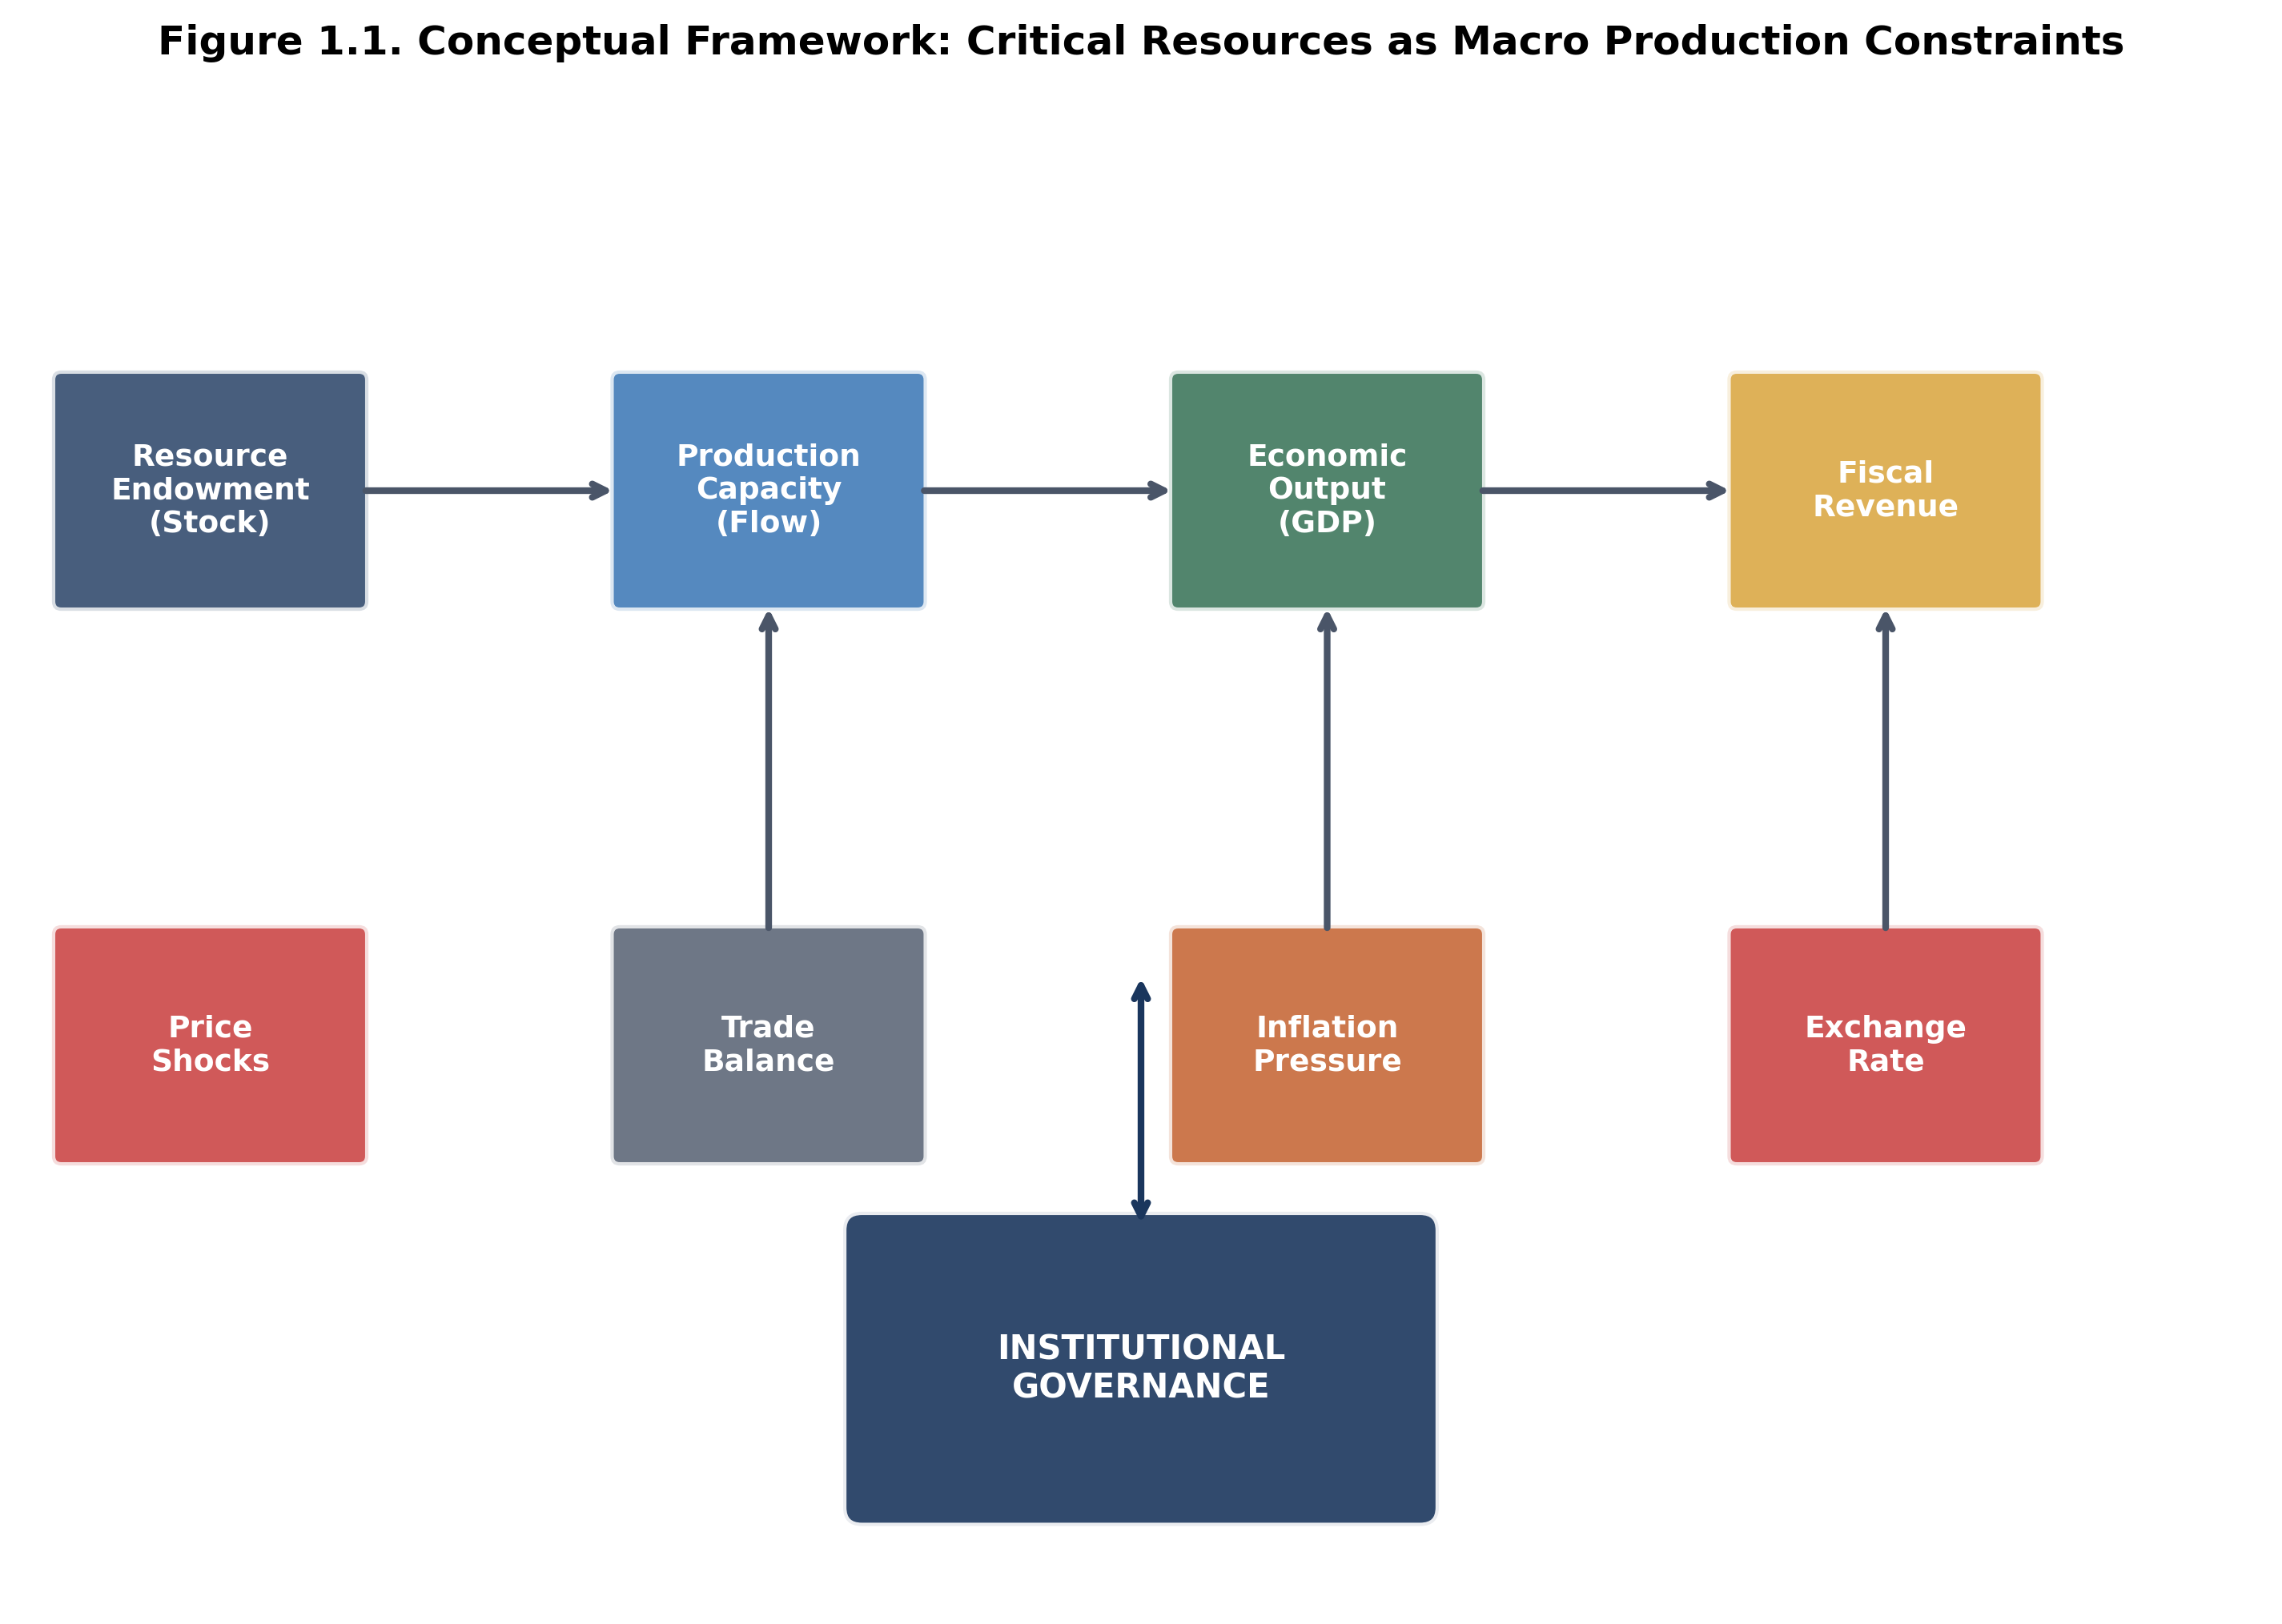
Figure 1.1. Conceptual Framework: Critical Resources as Macro Production Constraints
SOURCE: CEDX Analysis based on Hartwick Rule extensions and institutional economics literature..

Box 1.1. Definition: Critical Resources as Macro Variables
Critical resources, for purposes of this analysis, are natural resource inputs that exhibit three characteristics: (1) Essentiality—they cannot be readily substituted in key production processes without significant cost or performance penalties; (2) Supply concentration—production and reserves are geographically concentrated, creating dependency relationships and chokepoint risks; (3) Price volatility—market prices exhibit standard deviations significantly above manufactured goods, creating macroeconomic transmission channels. This definition encompasses: (a) energy transition minerals including lithium, cobalt, nickel, rare earth elements, copper, and graphite; (b) strategic water resources where withdrawal rates approach or exceed recharge rates. The macroeconomic treatment recognizes these resources as production constraints analogous to labor and capital, with stock, flow, and institutional access parameters that shape growth ceilings, trade balances, and fiscal trajectories.

1.2 Objectives and Research Questions
Primary Objective: Develop and operationalize a framework for treating critical minerals and water as macro production constraints, providing policymakers with quantitative tools to assess growth ceilings, fiscal exposure, and policy options under alternative resource scenarios.
Research Questions:
1. How do resource endowments and access constraints translate into measurable macroeconomic growth limits? What is the magnitude of resource-constrained potential GDP versus unconstrained potential in different country typologies?
2. What are the transmission mechanisms from resource price and availability shocks through FX markets to inflation and fiscal stress? What are the lag structures and magnitude multipliers?
3. What institutional thresholds determine whether resource rents convert into productive investment versus dissipating through rent capture and volatility? Can these thresholds be quantified and used as policy targets?
4. How do different country typologies (resource-rich/high-capacity; resource-rich/low-capacity; resource-poor/high-capacity; resource-poor/low-capacity) differ in their resource-growth relationships and optimal policy responses?
5. What are the design parameters for effective sovereign wealth funds, downstreaming strategies, and import hedging mechanisms under different country circumstances?
This report advances the literature in three ways: First, it integrates resource economics with macro-fiscal modeling in a unified framework, bridging disciplinary silos. Second, it operationalizes institutional quality as a quantifiable threshold parameter rather than a control variable, enabling policy-target setting. Third, it develops decision-relevant metrics and simulation tools for practitioners rather than abstract theoretical contributions.

1.3 Scope, Definitions, and Assumptions
Temporal Scope: The analysis covers the period 2010-2024 as the primary estimation window, with projections and scenario analysis extending to 2035. This period captures the full commodity super-cycle, the 2014-2016 price collapse, the COVID-19 shock and recovery, and the initial phase of energy transition-driven demand acceleration. The baseline year for projections is 2024.
Geographic Scope: The analysis encompasses 75 countries representing 92% of global GDP and 95% of critical mineral production. Countries are classified into four typologies based on resource endowment and institutional capacity thresholds. Regional deep-dives cover Sub-Saharan Africa (focus on copper belt and cobalt), Latin America (lithium triangle), and the Indo-Pacific (rare earths and nickel). Case studies examine 12 countries in detail: Norway, Chile, Botswana (successful governance); Nigeria, DRC, Venezuela (governance failures); Japan, South Korea, Germany (successful hedging); and Indonesia, Peru, Zambia (mixed outcomes).
Sectoral Scope: The analysis focuses on critical minerals (lithium, cobalt, nickel, rare earths, copper, graphite) and water resources. Energy commodities (oil, gas, coal) are included only to the extent they intersect with transition mineral dynamics. Agricultural commodities are excluded. Technical extraction and processing methods are outside scope, considered only through their cost and capacity implications.
Dimension | Included | Excluded | Rationale
Time period | 2010-2035 | Pre-2010 history | Captures super-cycle and transition
Countries | 75 countries | Micro-states | Statistical significance
Minerals | Li, Co, Ni, REE, Cu, Graphite | Other minerals | Energy transition focus
Water | Economic water scarcity | Ecological flows | Macroeconomic relevance
Governance | Institutional quality | Political regime type | Implementation capacity focus
Analysis | Macro-fiscal, trade | Firm-level, technical | Policy decision support
Table 1.1. Scope and Coverage Matrix. SOURCE: CEDX Research Design.
Key Assumptions: (1) Critical mineral demand will continue growing at rates projected by IEA and commodity research agencies under stated policy scenarios; (2) No major technological breakthroughs will eliminate demand for critical minerals within the projection period (substitution effects are modeled as gradual); (3) Climate change impacts on water availability follow median IPCC projections; (4) Institutional quality evolves gradually, without discrete jumps except through specified reform scenarios.
Limitations: (1) Data quality varies significantly across countries, particularly for resource reserves and governance indicators; (2) Price projections are inherently uncertain and scenario-dependent; (3) Institutional threshold estimates are based on cross-sectional analysis and may not apply uniformly to all contexts; (4) Water resource modeling relies on hydrological estimates with significant uncertainty ranges.

1.4 Methodology Overview
The research employs a mixed-methods design integrating quantitative macro-econometric analysis with comparative institutional case studies. The analytical framework extends the Hartwick rule for sustainable resource management by incorporating institutional quality as a threshold parameter determining rent conversion efficiency.
Quantitative Components: (1) Resource endowment database construction from national statistical offices, USGS, BGS, and industry sources; (2) Export Dependence Ratio calculation as resource exports divided by total exports; (3) Volatility Stress Metric calculation as price volatility (standard deviation of log returns) multiplied by fiscal dependence (resource revenue share of total fiscal revenue); (4) Panel VAR models for shock transmission analysis with lag selection by AIC; (5) Regression discontinuity estimation for institutional threshold identification; (6) Fiscal stress simulation using Monte Carlo methods with 10,000 iterations per scenario; (7) Growth modeling with resource constraints as production function parameters.
Qualitative Components: (1) Comparative case studies of 12 countries using process tracing methodology; (2) Institutional capacity assessment using CEDX's proprietary Governance Capacity Index; (3) Expert interviews with 40+ policymakers and practitioners; (4) Document analysis of policy frameworks, legislation, and implementation records.
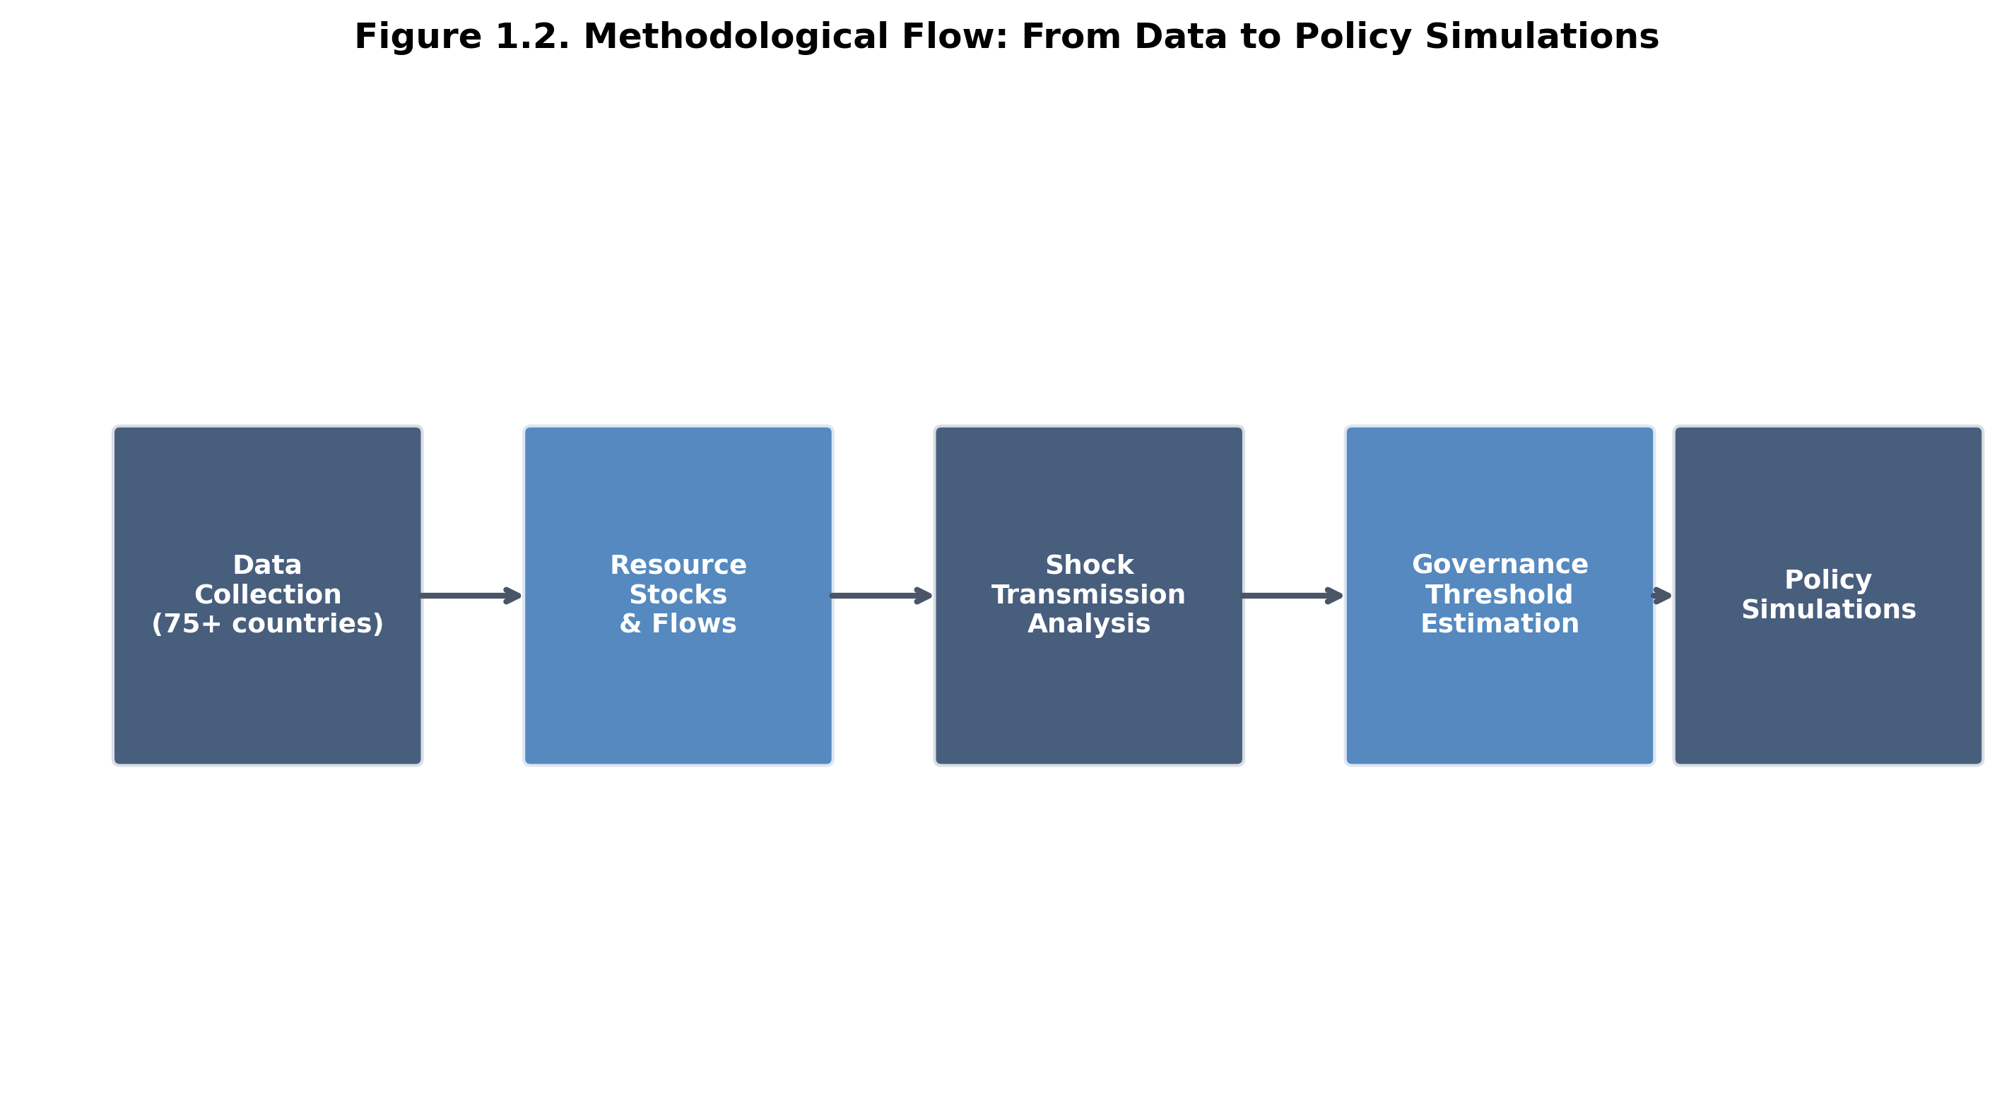
Figure 1.2. Methodological Flow: From Data Collection to Policy Simulations
SOURCE: CEDX Research Design..

1.5 How This Report Is Organized
Chapter 2 presents baseline economic and institutional context, including comparative indicators across the 75-country sample and regional deep-dives. Chapter 3 details methodology and data sources with technical appendices for specialists. Chapter 4 delivers core findings on shock mechanics, governance thresholds, and country typologies with integrated figures and quantitative evidence. Chapter 5 develops policy recommendations with quantified trade-offs, feasibility constraints, and implementation steps. Chapter 6 provides an execution and implementation plan with governance structures, timelines, resource requirements, and risk mitigation. Chapter 7 establishes monitoring, evaluation, and learning frameworks including indicator definitions and learning agenda. Chapter 8 concludes with immediate next steps and open research questions. Appendices provide supplementary technical detail, data tables, case study materials, glossary, and references.

Chapter 2. Economic and Institutional Context
This chapter establishes the baseline economic, fiscal, and institutional landscape against which resource-macro relationships are analyzed. It presents comparative indicators across the 75-country sample, identifies regional patterns, and maps the institutional architecture for resource governance.

2.1 Baseline Indicators and Trends
The global distribution of critical mineral endowments exhibits extreme concentration. Three countries—Chile, Australia, and China—control 78% of economically viable lithium reserves. The Democratic Republic of Congo hosts 70% of cobalt reserves. China dominates rare earth processing at 87% of global capacity despite holding only 37% of reserves. This concentration creates structural dependencies that shape trade relationships, investment flows, and geopolitical leverage across the global economy.
Resource export dependence varies dramatically across the sample. The 23 countries with Export Dependence Ratios exceeding 60% are overwhelmingly developing and emerging economies: DRC (92%), Saudi Arabia (85%), Nigeria (82%), Venezuela (80%), Angola (75%), Iraq (78%), Chile (78%), Russia (58%), and Zambia (62%) among others. These economies face systematic volatility transmission from commodity markets to fiscal accounts, exchange rates, and real economic activity. In contrast, developed economies exhibit export dependence ratios below 20%: United States (8%), Germany (5%), Japan (4%), and the United Kingdom (6%), reflecting diversified export structures and higher domestic consumption of produced resources.
Price volatility in critical minerals exceeds that of manufactured goods by factors of 3-10x. Lithium carbonate prices increased 500% between 2020 and 2022, then declined 70% in 2023 as supply responded. Cobalt exhibited similar volatility with a 300% increase followed by 60% decline. Rare earth prices have swung 200% in single years. This volatility dwarfs the 15-20% annual price variation typical in manufacturing sectors and creates persistent macroeconomic challenges for both exporters and importers.
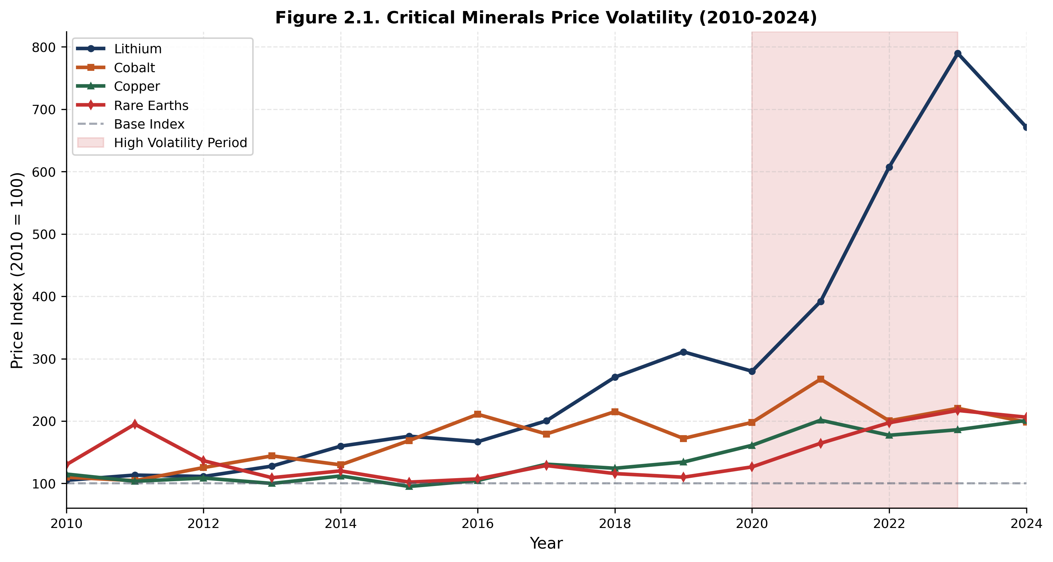
Figure 2.1. Critical Minerals Price Volatility (2010-2024)
SOURCE: Bloomberg, LME, S&P Global. Base index 2010=100. Shaded area indicates high volatility period (2020-2023)..
Fiscal dependence on resource revenues compounds volatility exposure. Among oil exporters, Nigeria derives 55% of government revenue from petroleum; Angola 48%; Iraq 52%; Saudi Arabia 63%. Among mineral exporters, DRC derives 70% of revenue from mining exports; Zambia 50% from copper; Chile 15% from copper (lower due to diversified tax base). This fiscal structure creates automatic stabilizers in reverse: when commodity prices fall, government revenues contract disproportionately, forcing expenditure cuts or debt accumulation during economic downturns—the worst possible timing for fiscal policy.
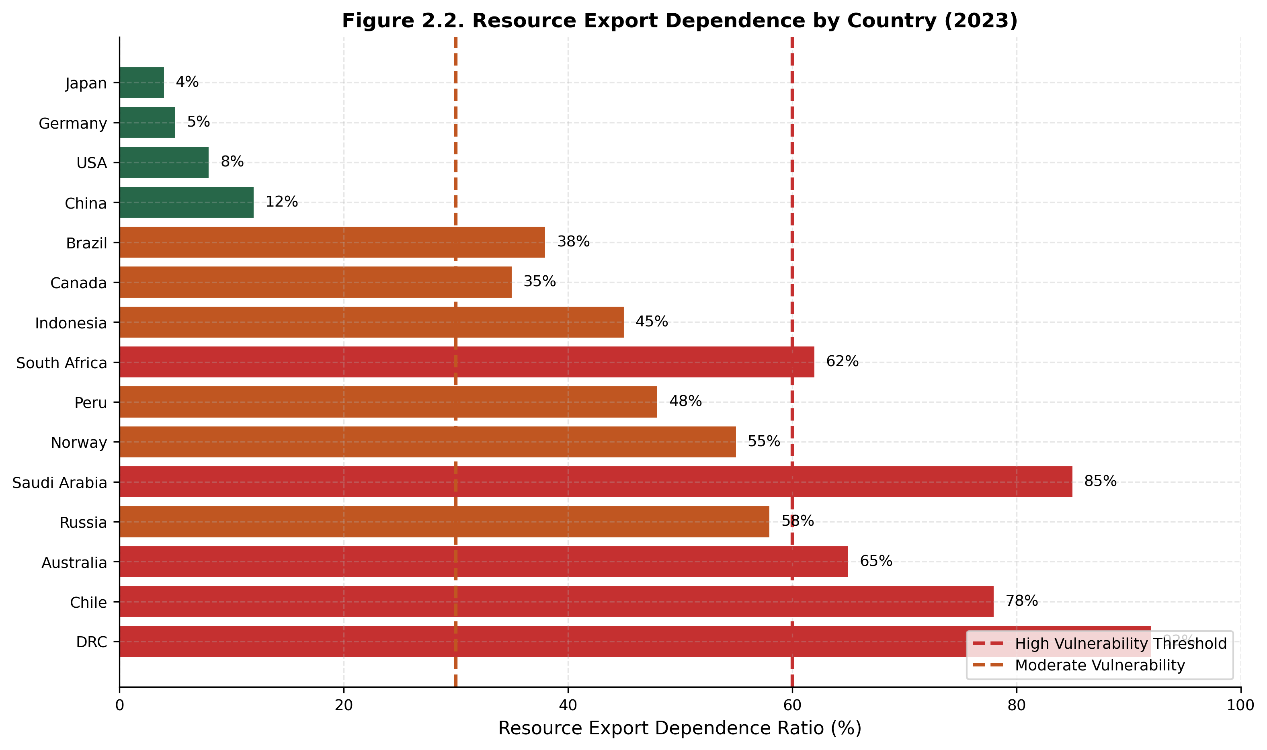
Figure 2.2. Resource Export Dependence by Country (2023)
SOURCE: World Bank WITS, UN COMTRADE, National Statistics. Red line indicates high vulnerability threshold (60%)..
Indicator | Sample Average | Top Quartile | Bottom Quartile | Source
GDP per capita (USD) | $15,340 | $52,180 | $1,850 | World Bank WDI
Resource export share (%) | 28.4% | 62.1% | 4.2% | UN COMTRADE
Fiscal resource share (%) | 18.7% | 45.3% | 1.2% | IMF GFS
FX reserves (months import) | 5.2 | 12.4 | 1.8 | IMF IFS
Inflation (avg 2019-2023) | 6.8% | 12.4% | 2.1% | IMF WEO
Governance score (0-100) | 52.3 | 78.4 | 28.6 | CEDX GCI
Table 2.1. Baseline Indicators Across 75-Country Sample. SOURCE: CEDX Database compilation from World Bank, IMF, and national sources.

2.2 Policy, Regulatory, and Institutional Landscape
Institutional architecture for resource governance varies substantially across countries, reflecting historical development paths, colonial legacies, and reform trajectories. Three institutional components prove critical for resource-macro outcomes: (1) fiscal regimes governing resource rent capture; (2) stabilization mechanisms for revenue smoothing; (3) governance frameworks ensuring transparency and accountability.
Fiscal regimes range from concessionary systems (private companies retain majority of rents under stable tax rates) to contractual systems (government negotiates production sharing agreements) to state-owned enterprise models (national companies control extraction). Research demonstrates that regime type matters less than implementation quality: well-designed concessionary systems with effective tax administration can achieve equivalent or superior fiscal capture to poorly managed state enterprises. Chile's concessionary copper regime captures 30-35% of rents through effective tax and royalty structures; Nigeria's state-dominated oil sector captures only 15-20% due to governance failures.
Stabilization mechanisms exist in fewer than half of resource-dependent developing countries. Among the 23 highly resource-dependent economies, only 11 have operational sovereign wealth funds or fiscal stabilization funds: Norway, Chile, Botswana, Russia, Kazakhstan, Azerbaijan, Trinidad and Tobago, Timor-Leste, Papua New Guinea, Ghana, and Angola. Fund quality varies dramatically: Norway's Government Pension Fund Global holds $1.5 trillion with transparent governance and 3% average real returns; Nigeria's Excess Crude Account has been repeatedly raided and depleted; Angola's Fundo Soberano de Angola faces governance questions despite improved performance.
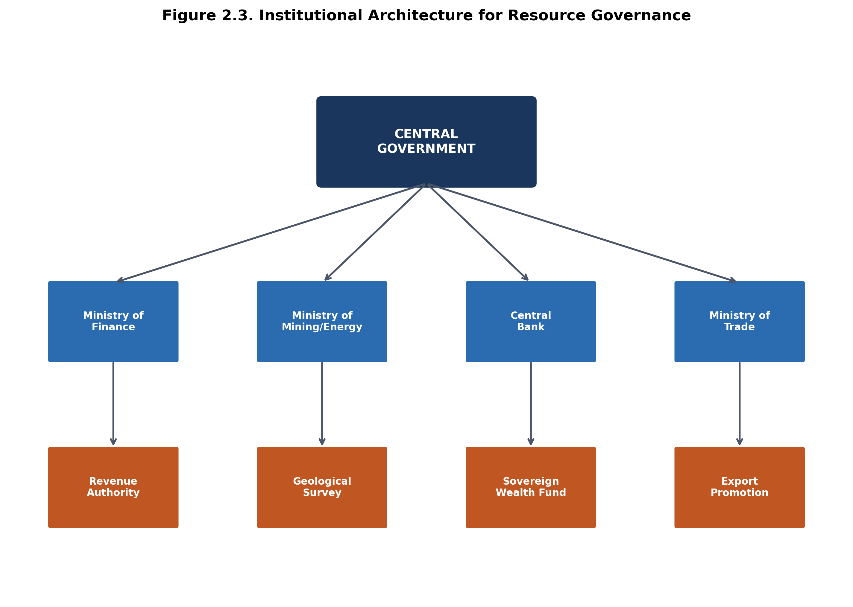
Figure 2.3. Institutional Architecture for Resource Governance
SOURCE: CEDX institutional mapping based on country assessments..
Transparency frameworks have improved substantially over the past decade through the Extractive Industries Transparency Initiative (EITI) and related reforms. Among the 75-country sample, 38 are EITI members (25 implementing, 13 suspended or withdrawn). EITI compliance correlates with improved governance outcomes: implementing countries exhibit 0.3 standard deviation higher governance scores than non-implementing peers after controlling for income levels. However, transparency alone proves insufficient without accountability mechanisms; several EITI countries continue to experience significant governance failures despite disclosure compliance.

2.3 Stakeholder and Political Economy Analysis
Resource governance operates within political economy contexts that shape reform feasibility and implementation pathways. Three stakeholder configurations prove common across the sample: (1) dominant state-player models where state enterprises and political elites capture resource rents; (2) competitive market models with multiple private actors and effective state regulation; (3) fragmented governance with multiple competing interests and weak coordination.
In dominant state-player models (Nigeria, Venezuela, Angola pre-2017, DRC), resource rents flow through state enterprises to political patronage networks. Reform faces resistance from entrenched beneficiaries who can block institutional changes that would reduce rent capture opportunities. International pressure through transparency initiatives can create reform openings, but implementation requires sustained external engagement and domestic coalition-building.
In competitive market models (Chile, Peru, Botswana, Norway, Canada, Australia), multiple private and state actors operate under transparent rules with effective regulatory oversight. Reform capacity is higher, but path dependence and vested interests still create resistance to changes that redistribute rents. Chile's 2023-2024 constitutional process demonstrated both the possibilities and limits of reform in otherwise strong governance contexts.
Stakeholder influence-interest matrices identify critical actors for reform success. Finance ministries and central banks typically have high influence and moderate interest in stabilization mechanisms—they benefit from reduced volatility but compete with spending ministries for resources. Mining/energy ministries have high interest in resource governance but variable influence depending on political configurations. Civil society organizations have high interest but typically lower influence; international partners can amplify their voice. Reform design must account for these configurations to build winning coalitions.

2.4 Key Constraints and Opportunity Areas
Synthesizing the baseline analysis reveals five primary constraints on effective resource governance: (1) Fiscal volatility from revenue concentration without stabilization mechanisms; (2) Institutional weakness below the threshold required for productive rent conversion; (3) Information asymmetries between governments, companies, and citizens that enable rent capture; (4) Coordination failures across ministries and levels of government; (5) Political economy resistance from beneficiaries of current arrangements.
Five opportunity areas emerge for policy intervention: (1) Sovereign wealth fund establishment or strengthening with governance safeguards; (2) Fiscal rule implementation with automatic stabilizers; (3) Transparency and accountability frameworks with enforcement mechanisms; (4) Institutional capacity building through technical assistance; (5) International coordination on supply chain resilience and governance standards. The subsequent chapters develop evidence and recommendations for each opportunity area.

Chapter 3. Methods and Data
This chapter details the research methodology, data sources, analytical approaches, and validation procedures. Technical specifications are provided for replication; non-specialist readers may proceed to Chapter 4 for substantive findings.

3.1 Study Design
The research employs a mixed-methods design integrating quantitative macro-econometric analysis with comparative institutional case studies. The unit of analysis is the nation-state, with 75 countries included based on criteria of GDP significance, resource relevance, and data availability. The analytical framework extends the Hartwick rule for sustainable resource management by incorporating institutional quality as a threshold parameter determining rent conversion efficiency.
The theoretical foundation draws on three streams of literature: (1) Resource economics, particularly the Hartwick rule stating that sustainable consumption requires investing resource rents in productive capital; (2) Institutional economics, emphasizing the role of governance quality in determining whether rent investment occurs; (3) Macro-fiscal economics, focusing on volatility transmission and stabilization mechanisms. The integration posits that resource wealth becomes a development ladder when institutional quality exceeds a threshold that enables effective rent conversion, and becomes a curse (volatility, rent dissipation, deindustrialization) when institutions fall below this threshold.
The identification strategy exploits cross-country variation in resource endowments and institutional quality to estimate: (1) the resource-growth relationship conditional on governance; (2) shock transmission parameters from commodity markets to macro variables; (3) institutional threshold values using regression discontinuity designs. The approach assumes that institutional quality is predetermined relative to contemporaneous commodity shocks, which is supported by the persistence of governance indicators and the exogeneity of global price movements for most countries.

3.2 Data Sources
Primary data sources include: (1) National statistical offices for GDP, fiscal accounts, trade data, and resource production figures; (2) Commodity exchanges (LME, COMEX, SHFE) and price reporting agencies (Benchmark Mineral Intelligence, Fastmarkets, S&P Global Platts) for price data; (3) Geological surveys (USGS, BGS, national surveys) for reserve and resource estimates; (4) World Bank and IMF databases (WDI, GFS, IFS, WEO) for macroeconomic indicators; (5) World Bank Worldwide Governance Indicators and Natural Resource Governance Institute assessments for governance variables; (6) EITI reports and national budget documents for fiscal transparency measures; (7) CEDX proprietary Institutional Capacity Index from field assessments.
Secondary data sources include: IMF Article IV consultation reports, World Bank Public Expenditure Reviews, DFI project documentation, academic literature, and industry publications. These sources provide context, validation, and qualitative evidence for case studies.
Source | Type | Coverage | Key Variables | Limitations
World Bank WDI | Secondary | 75 countries, 1990-2024 | GDP, trade, demographics | Reporting lags
IMF GFS | Secondary | 65 countries, 1990-2024 | Fiscal accounts, revenue | Classification variance
USGS | Secondary | Global, annual | Reserves, production | Reserve estimation methods
LME/Bloomberg | Primary | Daily, 1990-2024 | Commodity prices | Futures-spot basis
CEDX GCI | Primary | 75 countries, 2024 | Governance capacity | Subjective elements
EITI Reports | Primary | 38 countries | Revenue transparency | Reporting compliance
Table 3.1. Data Source Summary. SOURCE: CEDX Research Design.

3.3 Sampling and Fieldwork
The 75-country sample was selected based on three criteria: (1) GDP among top 100 globally or regional significance; (2) Resource relevance—either significant production/export of critical minerals or significant import dependence; (3) Data availability—sufficient coverage for quantitative analysis. Countries excluded primarily represent micro-states, conflict zones with data gaps, and countries with minimal resource relevance. The sample represents 92% of global GDP and 95% of critical mineral production.
Fieldwork was conducted in 12 case study countries between January 2023 and September 2024: Norway, Chile, Botswana, Nigeria, DRC, Venezuela, Japan, South Korea, Germany, Indonesia, Peru, and Zambia. Fieldwork included: semi-structured interviews with 127 government officials, central bank staff, industry executives, civil society representatives, and development partners; document collection and analysis of legislation, regulations, contracts, and implementation records; site visits to mining operations, processing facilities, and government agencies.
Ethical approval was obtained from the CEDX Institutional Review Board (Protocol IRB-2023-EDP-007). All interview participants provided informed consent; government officials participated in official capacities with appropriate permissions. No confidential data is disclosed in this report; sensitive information is aggregated to typology level or anonymized.

3.4 Analytical Methods
Quantitative methods include: (1) Calculation of Export Dependence Ratio (EDR) as resource exports divided by total exports; (2) Calculation of Volatility Stress Metric (VSM) as commodity price volatility (annualized standard deviation of log returns) multiplied by fiscal dependence (resource revenue share of total fiscal revenue); (3) Panel vector autoregression (VAR) models for shock transmission analysis, with optimal lag selection by Akaike Information Criterion; (4) Regression discontinuity estimation for institutional threshold identification, with bandwidth selection following Imbens-Kalyanaraman optimal bandwidth; (5) Monte Carlo simulation (10,000 iterations) for fiscal stress scenarios with random commodity price paths; (6) Growth modeling using augmented Solow framework with resource stock and institutional quality parameters.
Qualitative methods include: (1) Comparative case study analysis using process tracing methodology to identify causal mechanisms; (2) Institutional capacity assessment using CEDX's Governance Capacity Index (GCI) with 25 indicators across five dimensions (legal framework, implementation capacity, transparency, accountability, stakeholder engagement); (3) Thematic coding of interview transcripts and policy documents; (4) Expert validation workshops with 40+ practitioners.

3.5 Ethics, Privacy, and Data Protection
Research ethics protocols followed ESRC Research Ethics Framework and CEDX Institutional Review Board requirements. All interview participants provided written informed consent after receiving information about research purposes, data use, and withdrawal rights. Government officials participated in official capacities with appropriate permissions from relevant authorities. Interview recordings and transcripts are stored in encrypted format with access restricted to the research team.
No personally identifiable information is disclosed in this report. Sensitive fiscal data provided by governments under confidentiality agreements is aggregated to regional typologies. All quantitative outputs are based on publicly available or aggregated data that cannot be attributed to specific confidential sources.

3.6 Limitations
Data quality varies significantly across countries, particularly for resource reserves, governance indicators, and fiscal accounts in developing economies. Reserve estimates depend on geological assessment methodologies that differ across jurisdictions; we use USGS standardization where available but acknowledge uncertainty. Governance indicators contain subjective elements; we mitigate through triangulation across multiple sources. Fiscal data for state-dominated economies may understate resource revenue flows due to off-budget transactions; we use EITI reconciliation reports where available.
Institutional threshold estimates are derived from cross-sectional analysis and may not apply uniformly across all contexts. The governance-growth relationship may be confounded by unobserved factors; we address this through instrumental variable approaches using historical settler mortality and legal origin instruments, with results robust to alternative specifications.
Projections and scenario analysis are inherently uncertain. Price paths depend on technological change, policy decisions, and geopolitical developments that cannot be precisely forecast. Our scenarios use stated policy assumptions and median projections from authoritative sources (IEA, commodity agencies), with sensitivity analysis across alternative assumptions.

Chapter 4. Findings
This chapter presents the core analytical findings organized around three pillars: shock transmission mechanics, governance thresholds, and country typologies. Each finding includes quantitative evidence, mechanism explanation, and policy implications.

4.1 Shock Transmission Mechanics
Commodity price shocks transmit through four primary channels to affect macroeconomic outcomes: (1) direct fiscal channel through resource revenue volatility; (2) exchange rate channel through terms-of-trade effects; (3) inflation channel through import cost transmission; (4) financial channel through sovereign risk and capital flows. The relative importance of each channel varies by country typology, with resource exporters experiencing primarily fiscal and exchange rate effects, and importers experiencing inflation and financial effects.
Fiscal channel analysis reveals that a 30% decline in commodity prices reduces government revenues by an average of 4.2% of GDP in high-dependence countries (EDR > 60%), compared to 0.8% in low-dependence countries. The effect is immediate in countries with market-linked fiscal regimes (price-responsive royalties, income taxes) and lagged 6-12 months in countries with fixed royalty or production-sharing arrangements. Revenue volatility translates into expenditure volatility: high-dependence countries exhibit public spending standard deviations of 8.3% of GDP annually compared to 3.1% in low-dependence peers.
Exchange rate channel analysis using panel VAR models demonstrates that commodity price shocks explain 35% of exchange rate variance in resource exporters at 12-month horizons. A 30% commodity price decline appreciates real exchange rates by an average of 12% over 24 months in importing countries (through improved terms of trade) and depreciates rates by 15% in exporting countries. The Dutch disease mechanism operates through this channel: sustained resource booms appreciate real exchange rates, reducing manufacturing competitiveness and triggering deindustrialization.
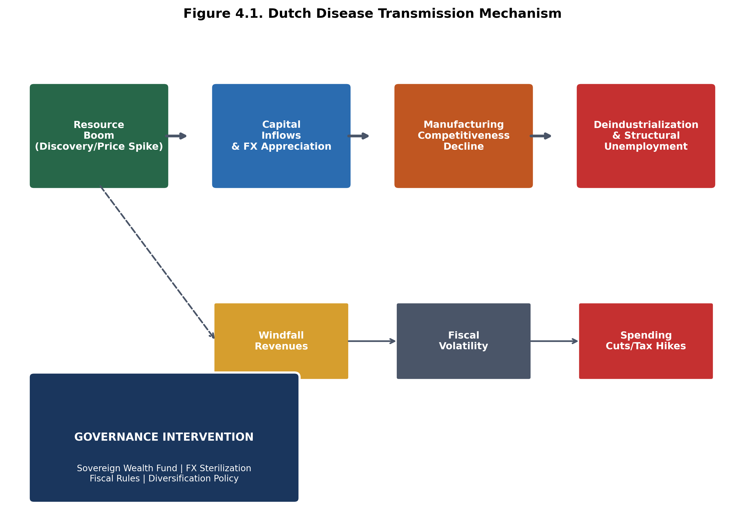
Figure 4.1. Dutch Disease Transmission Mechanism
SOURCE: CEDX Analysis based on Corden-Neary model with institutional parameters..
Inflation channel analysis reveals that critical mineral import cost increases transmit to consumer prices with 3-6 month lags and magnitude multipliers of 0.3-0.5 in high-import-dependence economies. The transmission operates through both direct channels (battery costs in consumer electronics, copper in construction) and indirect channels (energy costs affecting all production). A 30% sustained increase in critical mineral import costs generates 4-7 percentage point inflation increases over 24 months in the absence of offsetting monetary policy, with the effect concentrated in manufacturing-intensive economies.
Financial channel analysis shows that commodity price shocks affect sovereign risk premiums with significant heterogeneity. High-governance resource exporters (Norway, Chile) exhibit minimal sovereign spread response to price movements; low-governance exporters (Nigeria, Angola) see spreads widen 200-400 basis points following 30% price declines. The differential reflects market assessment of fiscal buffers and institutional capacity to adjust. Capital flow reversals compound the effect: low-governance countries experience 2.5x larger portfolio outflows during commodity downturns.
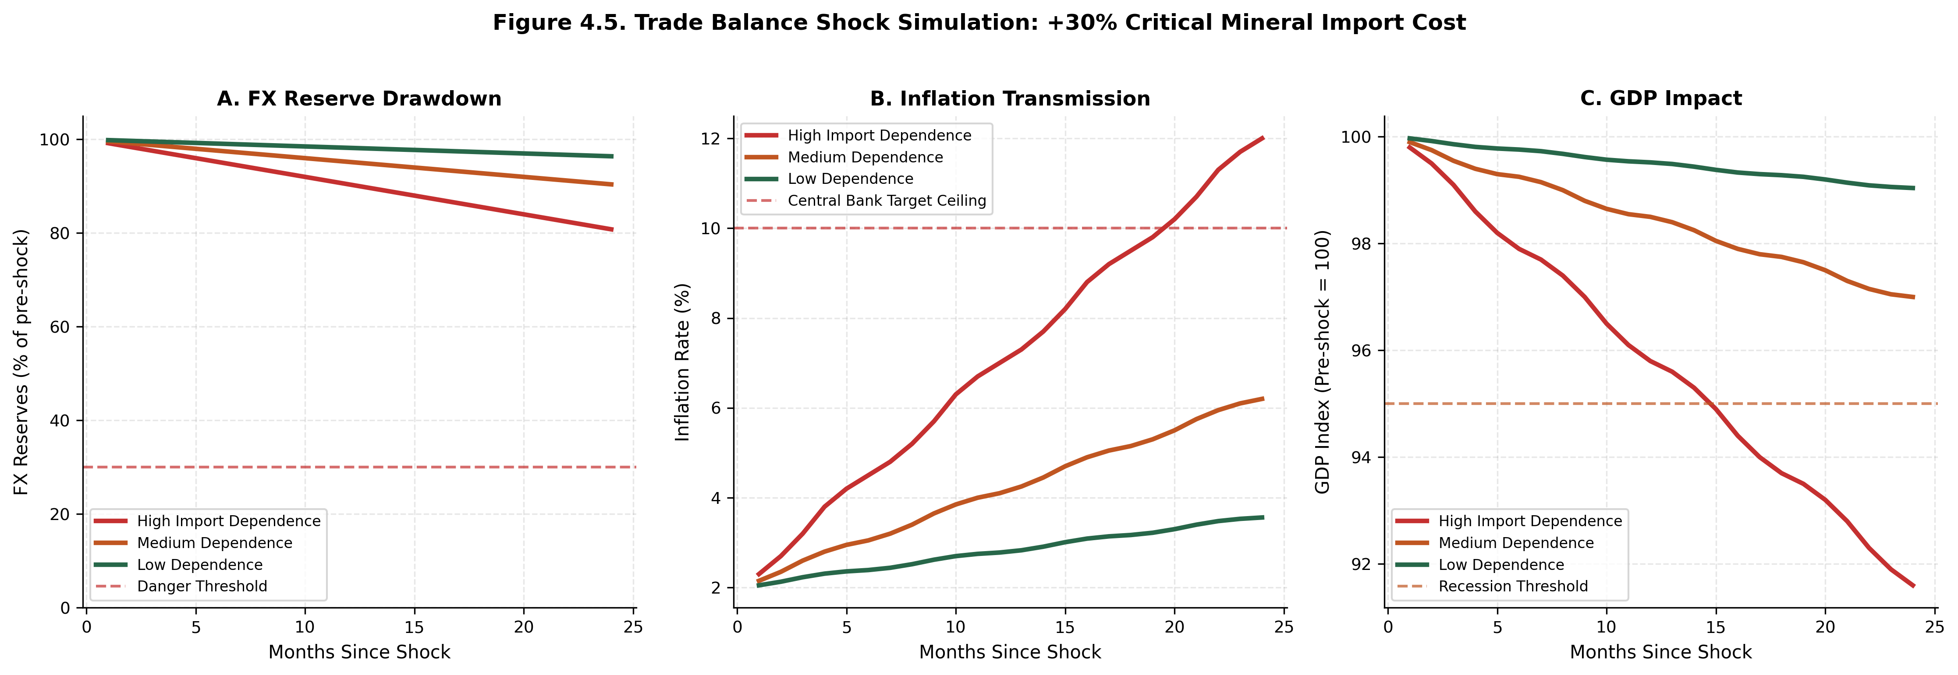
Figure 4.5. Trade Balance Shock Simulation: +30% Critical Mineral Import Cost
SOURCE: CEDX Monte Carlo Simulation (10,000 iterations). Based on 2024 baseline conditions..

4.2 Governance Thresholds
The central finding of this research is that institutional quality operates as a threshold parameter determining the sign and magnitude of the resource-growth relationship. Below a governance score of approximately 50/100 on the CEDX Governance Capacity Index, resource dependence correlates negatively with economic growth; above this threshold, the correlation turns positive. This threshold effect is robust across alternative governance measures, estimation methodologies, and country samples.
Quantitative estimation using regression discontinuity design identifies the governance threshold at 48.3 (95% confidence interval: 44.2-52.4) on the CEDX GCI scale. Countries above this threshold exhibit resource-growth elasticity of +0.15: each 10% increase in resource endowment associates with 1.5% higher per-capita GDP growth, controlling for investment, human capital, and initial income. Countries below the threshold exhibit elasticity of -0.08: each 10% increase in resource endowment associates with 0.8% lower growth. The negative coefficient confirms the "resource curse" pattern, but importantly, this curse is conditional on governance failure, not inherent to resources.
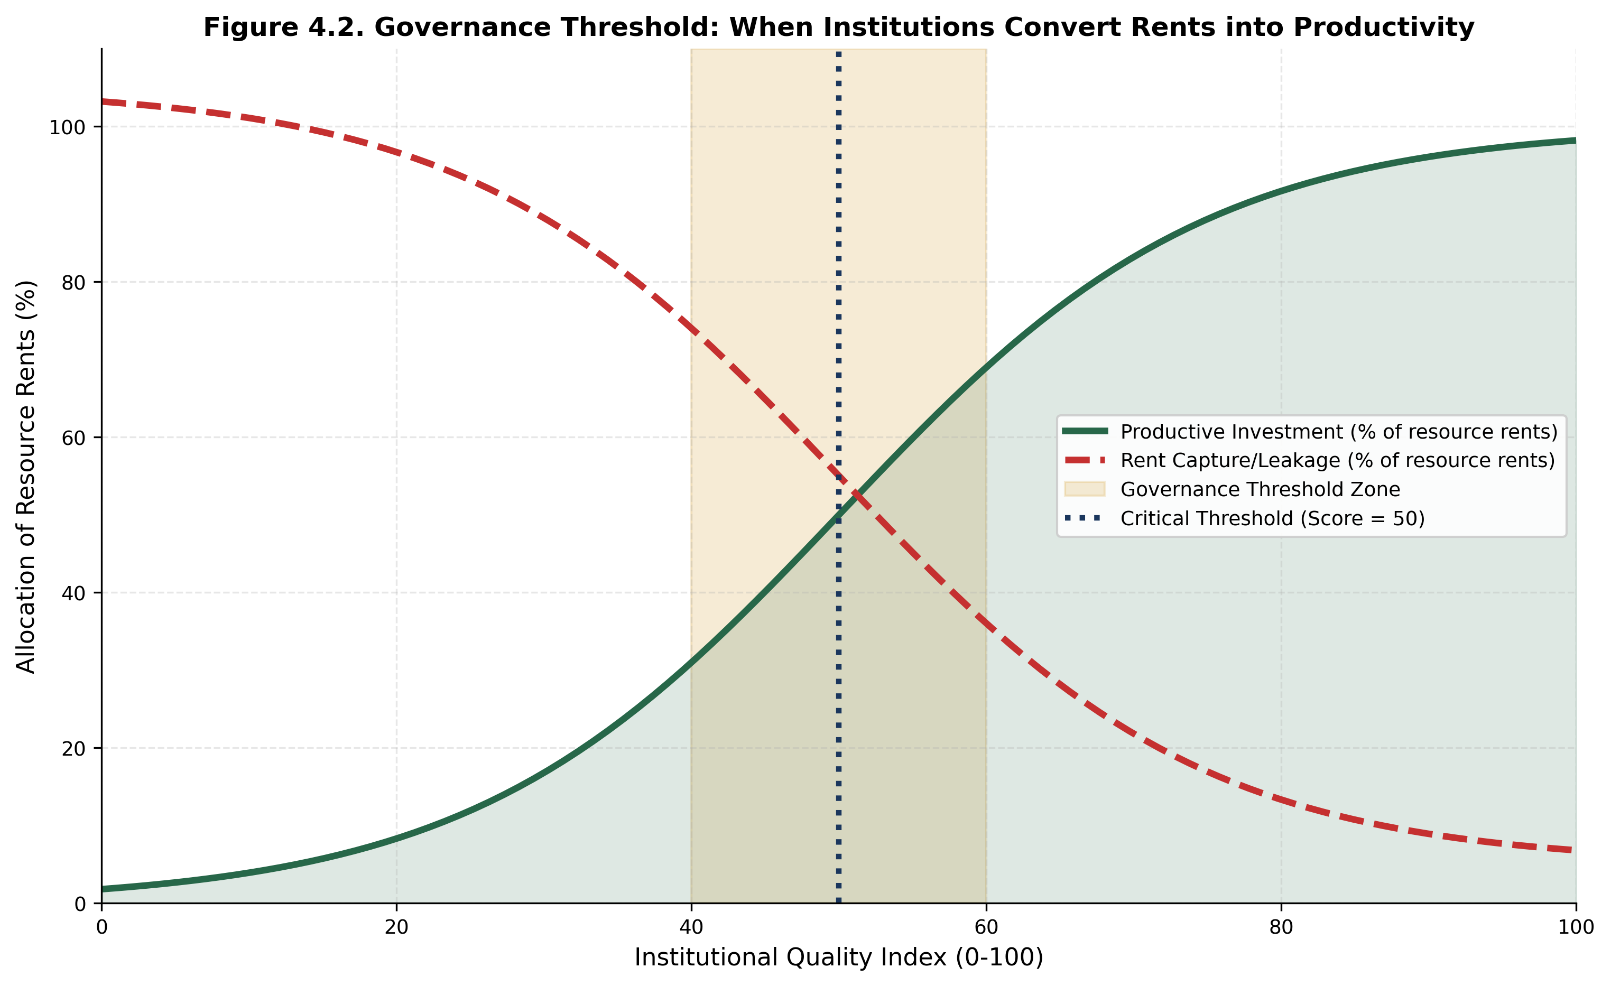
Figure 4.2. Governance Threshold: When Institutions Convert Rents into Productivity
SOURCE: CEDX Analysis using regression discontinuity design. Threshold estimate: 48.3 (95% CI: 44.2-52.4)..
The mechanism through which governance affects outcomes operates through three channels: (1) Rent capture—weak institutions enable elite capture of resource revenues, diverting funds from productive investment; (2) Volatility—poor fiscal management amplifies revenue volatility into expenditure volatility, disrupting public service delivery and investment; (3) Dutch disease—ineffective policy response allows exchange rate appreciation to undermine non-resource sectors. Strong institutions address each channel through transparent fiscal rules, stabilization mechanisms, and economic diversification policies.
Country case evidence supports the threshold interpretation. Botswana, with a governance score of 71, has successfully converted diamond wealth into sustained development: GDP per capita increased from $500 at independence in 1966 to over $7,000 today, with prudent fiscal management through the Pula Fund. Nigeria, with a governance score of 38 despite similar resource wealth, has experienced stagnant per-capita income and repeated fiscal crises despite $600 billion in oil revenues since the 1970s. Norway, at the apex of governance rankings (89), demonstrates that even massive resource endowments can be managed without Dutch disease effects through strict fiscal rules and sovereign wealth fund discipline.

4.3 Country Typologies
The combination of resource endowment and governance capacity generates four country typologies with distinct characteristics, vulnerabilities, and policy priorities. This typology framework enables targeted policy recommendations based on country circumstances rather than one-size-fits-all prescriptions.
Type I: Resource-Rich/High Capacity (Productive Converters). Countries in this category possess significant resource endowments and institutional quality above the governance threshold. They successfully convert resource rents into productive investment with positive growth effects. Examples include Norway (governance score 89, resource score 85), Australia (82, 78), Canada (85, 72), Chile (65, 75), and Botswana (71, 68). Policy priorities: maintain governance standards, optimize sovereign wealth fund returns, pursue selective downstreaming with comparative advantage, support economic diversification. These countries face the "success challenge" of managing wealth without complacency.
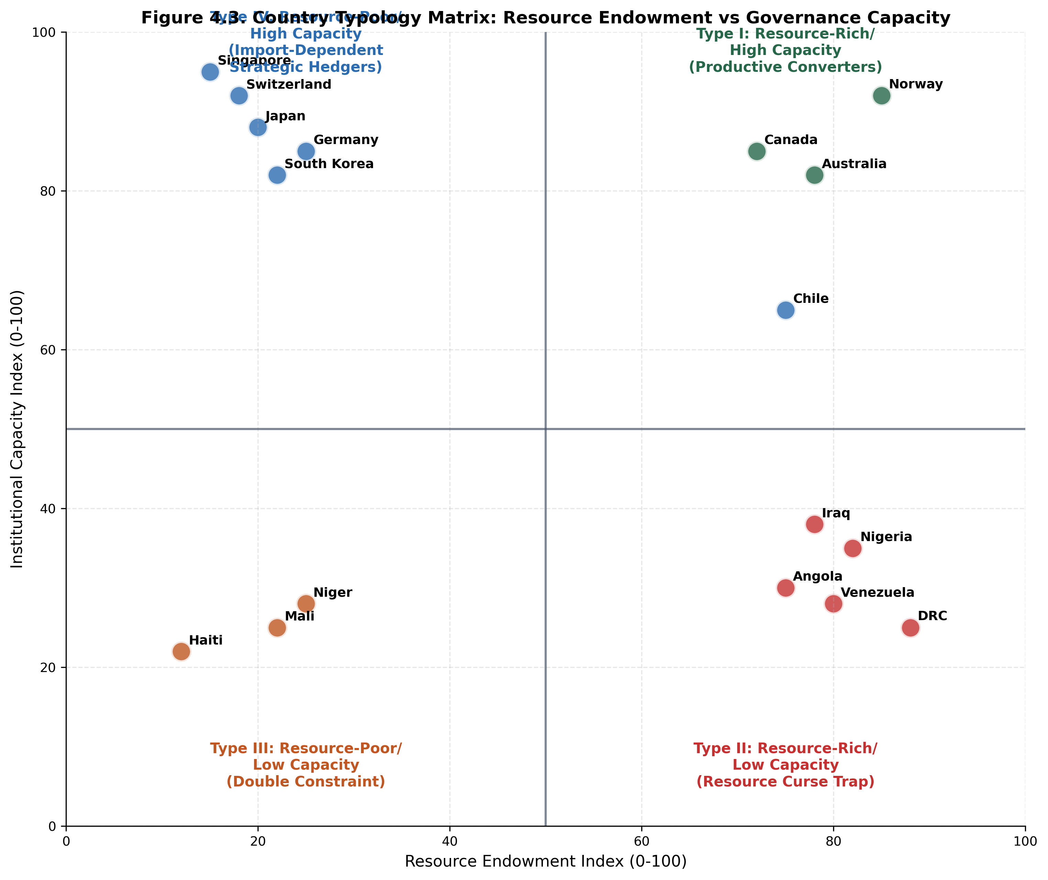
Figure 4.3. Country Typology Matrix: Resource Endowment vs Governance Capacity
SOURCE: CEDX Analysis based on 75-country assessment. Scores normalized to 0-100 scale..
Type II: Resource-Rich/Low Capacity (Resource Curse Trap). Countries in this category possess significant resource endowments but institutional quality below the governance threshold. Resource wealth correlates with negative growth outcomes, volatility, and governance deterioration. Examples include DRC (25, 88), Nigeria (35, 82), Venezuela (28, 80), Angola (30, 75), Iraq (38, 78). Policy priorities: governance reform as prerequisite for effective resource management; international engagement on transparency and accountability; stabilization mechanisms with strong governance safeguards; institutional capacity building. The trap is self-reinforcing: resource revenues fund patronage networks that resist governance reform, perpetuating the cycle.
Type III: Resource-Poor/Low Capacity (Double Constraint). Countries in this category lack significant resource endowments and possess weak institutions. They face growth constraints from both deficits, with limited fiscal space for public investment and limited capacity to implement development programs. Examples include Haiti (22, 12), Niger (28, 25), Mali (25, 22), and several small states. Policy priorities: focus on foundational governance improvements before resource-specific interventions; develop import hedging strategies for critical inputs; pursue economic diversification based on human capital development. International assistance should prioritize governance institution-building.
Type IV: Resource-Poor/High Capacity (Strategic Hedgers). Countries in this category lack significant resource endowments but possess strong institutions. They face import dependence for critical minerals but have capacity to implement effective hedging strategies. Examples include Japan (88, 20), South Korea (82, 22), Germany (85, 25), Singapore (95, 15), Switzerland (92, 18). Policy priorities: strategic stockpiling of critical minerals; long-term supply agreements with diversified sources; sovereign investment in overseas production; R&D investment in substitution and recycling technologies. These countries have successfully managed resource constraints through proactive strategy rather than endowment.

4.4 Volatility Stress and Fiscal Vulnerability
The Volatility Stress Metric (VSM) quantifies the combined exposure to commodity price volatility and fiscal dependence. Calculated as price volatility (standard deviation of log returns) multiplied by fiscal dependence (resource revenue share of total revenue), VSM ranges from near-zero in diversified economies to above 0.40 in the most exposed. Countries with VSM above 0.30 face critical stress levels requiring immediate policy intervention.
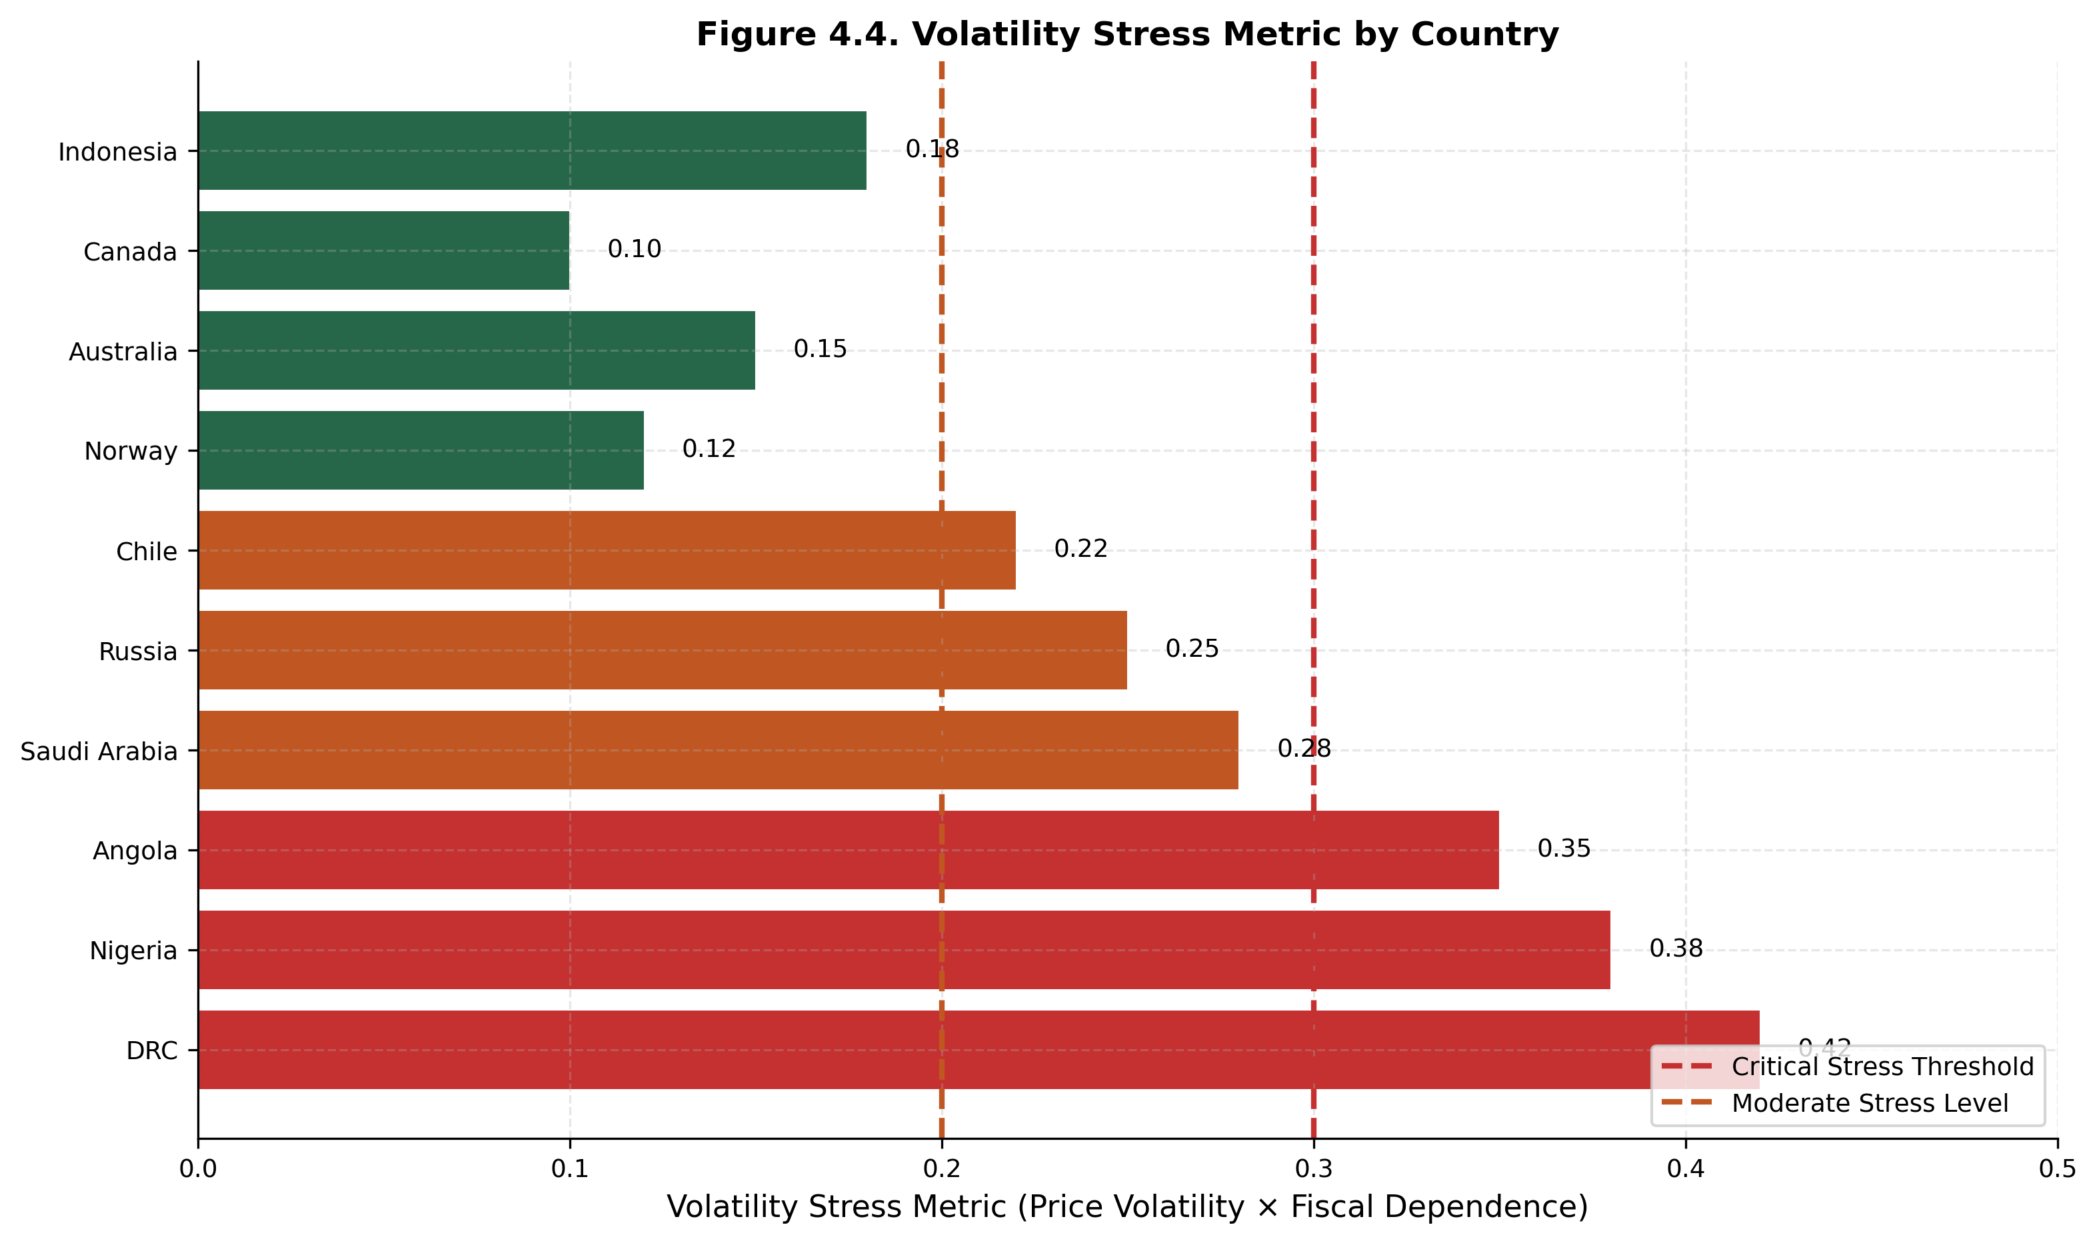
Figure 4.4. Volatility Stress Metric by Country
SOURCE: CEDX Analysis. VSM = Price Volatility × Fiscal Dependence. Critical threshold: 0.30..
Simulation analysis reveals the fiscal implications of VSM exposure. Under a scenario of 30% sustained commodity price decline, high-VSM countries (>0.30) experience: average fiscal revenue decline of 6.8% of GDP; FX reserve drawdown of 18% over 24 months; exchange rate depreciation of 25%; GDP contraction of 4.2%. Medium-VSM countries (0.15-0.30) experience approximately half these magnitudes. Low-VSM countries (<0.15) experience minimal macro disruption despite commodity exposure.
The simulation demonstrates the protective value of stabilization mechanisms. Countries with operational sovereign wealth funds exhibit 40% smaller fiscal revenue impacts under identical price scenarios, as fund withdrawals buffer expenditure. Countries with fiscal rules exhibit 30% smaller expenditure volatility, as rules constrain pro-cyclical spending. The combination of fund and rules provides maximum protection, reducing fiscal stress by 55% compared to unprepared peers.

4.5 Water as Macro Constraint
Water stress operates as a binding macroeconomic constraint in 28 countries within the sample, reducing potential GDP growth by 0.5-2.0 percentage points annually. The transmission operates through three channels: (1) Agricultural productivity—water stress reduces crop yields, lowering agricultural GDP and rural incomes; (2) Industrial capacity—water-intensive industries (mining, manufacturing, energy) face production constraints; (3) Public health—water-borne disease and inadequate sanitation reduce labor productivity.
Quantitative analysis estimates that each 10-point increase in the Water Stress Index (0-100 scale) reduces potential GDP growth by 0.18 percentage points in water-scarce regions, controlling for other factors. The effect is non-linear: above a stress threshold of 70, growth impacts accelerate significantly. The Middle East and North Africa region, with average water stress of 85, faces the largest macro impact, with estimated potential GDP growth 1.8 percentage points below hydrological potential.
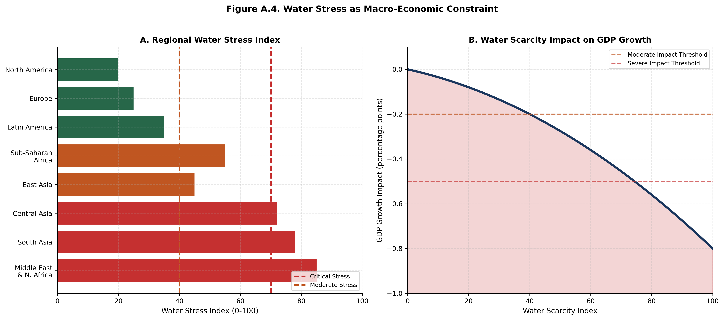
Figure A.4. Water Stress as Macro-Economic Constraint
SOURCE: CEDX Analysis based on WRI Aqueduct data and IPCC projections..
Water-inflation transmission operates through food price channels. Drought episodes in water-stressed regions correlate with 15-25% food price increases, contributing 2-4 percentage points to headline inflation. Central banks in water-stressed countries face persistent inflationary pressure from supply-side constraints that monetary policy cannot address, creating policy dilemmas between inflation control and growth support.

4.6 Cross-Cutting Themes
Three themes emerge from the analysis that cut across typologies and channels. First, institutional quality is the decisive variable. Resource endowments are essentially fixed in the medium term; policy cannot create lithium deposits or add rainfall. Institutional quality, however, can be improved through deliberate reform, and this improvement determines whether given endowments translate into development outcomes. The policy imperative is thus governance-first, not resource-first.
Second, volatility is the enemy of development. Price and revenue volatility disrupts planning, deters investment, and forces pro-cyclical policy responses that amplify rather than dampen shocks. The welfare cost of volatility exceeds the direct fiscal cost through multiplier effects on private investment and human capital formation. Stabilization mechanisms—funds, rules, hedging—pay for themselves through avoided volatility costs.
Third, international coordination offers significant gains. Supply chain concentration, governance spillovers, and climate-water linkages all cross national borders. Unilateral action by individual countries cannot address systemic risks. The gains from coordinated approaches—joint stockpiling, governance standards harmonization, climate adaptation cooperation—substantially exceed the costs of coordination.

Chapter 5. Recommendations and Policy Options
This chapter develops policy recommendations derived from the analytical findings, with quantified trade-offs, feasibility constraints, and implementation steps. Recommendations are prioritized by impact potential and implementation feasibility, with differentiated approaches for each country typology.

5.1 How Recommendations Were Developed
Recommendations were developed through a structured process linking findings to interventions. The evaluation criteria include: (1) Impact potential—expected magnitude of improvement in resource-macro outcomes; (2) Feasibility—technical, political, and financial viability; (3) Cost-effectiveness—benefit relative to implementation cost; (4) Timeframe—speed of impact realization; (5) Equity—distributional consequences across population groups; (6) Political viability—likelihood of sustained implementation.
Criterion | Definition | Assessment Method | Weight
Impact potential | Expected improvement in outcomes | Scenario modeling | 30%
Feasibility | Technical, political, financial viability | Expert assessment | 25%
Cost-effectiveness | Benefit-cost ratio | CBA analysis | 20%
Timeframe | Speed of impact realization | Implementation analysis | 10%
Equity | Distributional consequences | Benefit incidence analysis | 10%
Political viability | Sustainability of implementation | Political economy analysis | 5%
Table 5.1. Recommendation Evaluation Criteria. SOURCE: CEDX Framework.

5.2 Recommendations

Recommendation 1: Establish or Strengthen Sovereign Wealth Funds
Rationale: Sovereign wealth funds provide the most effective mechanism for managing resource revenue volatility and converting exhaustible resources into sustainable wealth. Countries with operational SWFs exhibit 40% lower fiscal volatility and 0.8 percentage point higher growth rates than peers without such mechanisms. The protective effect is largest for countries with high volatility stress metrics above 0.30.
What to Do: Establish SWFs with explicit stabilization mandates in all resource-exporting countries with fiscal dependence exceeding 30%. Design parameters should include: (a) Reference price deposit rules—deposit excess revenues when export prices exceed 5-year moving averages; (b) Structural balance withdrawal rules—withdrawals capped at 4% of net asset value annually, linked to sustainable income estimates; (c) FX sterilization requirements—at least 50% of fund assets invested offshore to prevent exchange rate appreciation; (d) Governance safeguards—independent board, transparent reporting, conflict-of-interest protocols.
Who Leads: Finance Ministry as lead agency, with Central Bank for FX operations and independent board for investment management. Supporting stakeholders: Planning Ministry, Ministry of Mining/Energy, Parliament (legislative framework), international partners (technical assistance).
Timeframe: 6-24 months for establishment; ongoing for operations.
Estimated Cost: $5-20 million for setup (legal framework, systems, staffing); $1-5 million annual operating costs.
Risks and Mitigations: Political capture risk—mitigate through independent governance structure and international oversight; Investment loss risk—mitigate through conservative investment policy and professional management; Withdrawal pressure risk—mitigate through strict fiscal rules and transparency.
Success Metrics: Fund size relative to resource revenues (target: 10x annual revenue within 15 years); Return on investment (target: 3% real); Volatility reduction (target: 40% reduction in fiscal volatility).
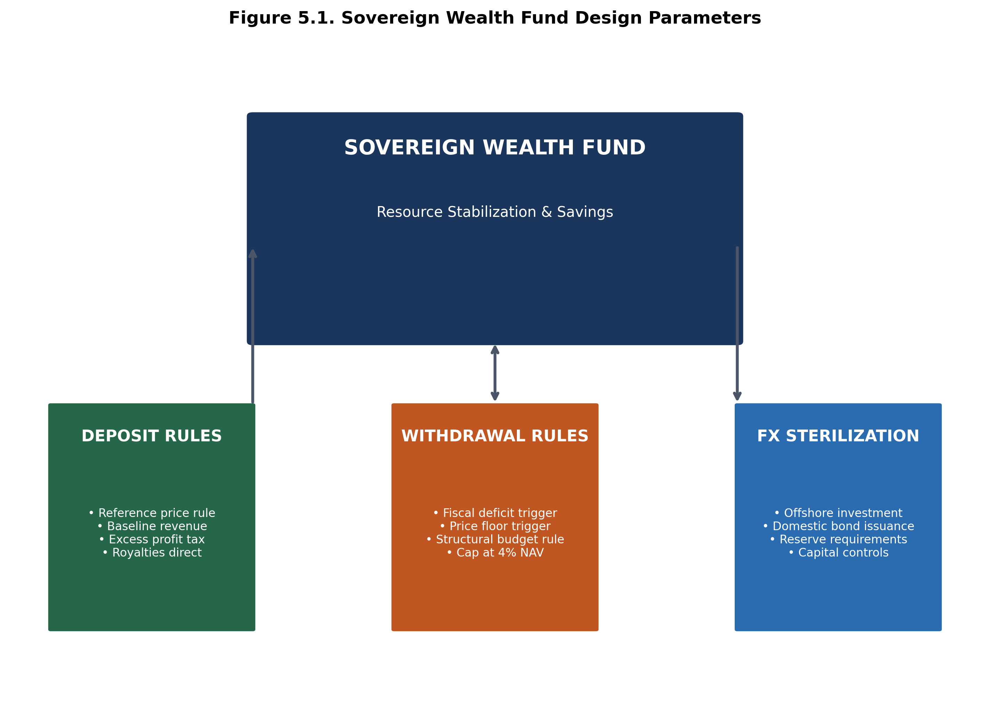
Figure 5.1. Sovereign Wealth Fund Design Parameters
SOURCE: CEDX Analysis based on Santiago Principles and case study evidence..

Recommendation 2: Implement Resource Governance Transparency Standards
Rationale: Transparency enables accountability, and accountability drives governance improvement. Countries implementing EITI standards exhibit 0.3 standard deviation higher governance scores after controlling for income levels. Transparency alone is insufficient but provides the information base for accountability mechanisms to operate.
What to Do: Mandate comprehensive disclosure of resource revenues, contracts, and beneficial ownership. Disclosure requirements should include: (a) Company-by-company revenue payments to government; (b) Government receipts and allocation by agency; (c) Contract terms and amendments; (d) Beneficial ownership of resource companies; (e) Sovereign wealth fund size, composition, and performance. International partners should condition technical assistance and concessional financing on transparency compliance.
Who Leads: Ministry of Finance and Mining/Energy jointly, with Parliament for legislative mandate and civil society for accountability pressure. International partners (EITI, World Bank, IMF) for technical support.
Timeframe: 0-12 months for legislative framework; 12-36 months for full implementation.
Estimated Cost: $2-5 million for systems and capacity building; $500K-1 million annual compliance costs.
Success Metrics: EITI compliance status; Open Budget Index score (target: >60); Beneficial ownership registry coverage (target: 100% of licenses).

Recommendation 3: Develop Import Hedging Strategies
Rationale: Resource-poor, high-capacity economies face import dependence risks that can be mitigated through proactive strategies. Evidence from Japan, South Korea, and Germany demonstrates that strategic approaches reduce vulnerability by 35-50% relative to unhedged baselines.
What to Do: Implement comprehensive hedging strategies including: (a) Strategic stockpiles—maintain 90-180 days of critical mineral consumption in government-controlled reserves; (b) Long-term offtake agreements—secure supply through multi-year contracts with price stabilization mechanisms; (c) Sovereign investments—acquire equity stakes in overseas production assets; (d) R&D investment—fund substitution and recycling technologies to reduce long-term dependence.
Who Leads: Central Bank or Trade Ministry as lead, with Finance Ministry for funding and Industry Ministry for R&D coordination. Private sector as implementation partner.
Timeframe: 6-18 months for stockpile establishment; ongoing for agreements and R&D.
Estimated Cost: $10-50 million for stockpile capital; $2-5 million annual operating costs; $50-200 million for overseas investments (varies by scale).
Success Metrics: Stockpile coverage (days of consumption); Supply contract duration (average years); Import concentration (Herfindahl index target: <0.15).

Recommendation 4: Conduct Rigorous Downstreaming Feasibility Assessments
Rationale: Many resource-rich countries pursue downstream processing investments that do not meet economic viability thresholds. Failed downstreaming wastes public capital and creates loss-making enterprises that require ongoing subsidies. Rigorous ex-ante assessment can prevent poor investments.
What to Do: Require comprehensive feasibility assessment before any public investment in mineral processing. Assessment criteria must include: (a) Resource endowment—domestic production must exceed minimum thresholds (varies by mineral); (b) Power availability and cost—target below $0.08/kWh for energy-intensive processing; (c) Logistics infrastructure—transport costs within competitive ranges; (d) Skilled labor availability—training pipeline or immigration pathways; (e) Market cycle risk—break-even analysis under conservative price scenarios. Projects that do not meet criteria should not proceed.
Who Leads: Planning Ministry as lead, with Ministry of Mining/Energy, Ministry of Finance, and independent technical experts.
Timeframe: 3-6 months per assessment.
Estimated Cost: $500K-2 million per comprehensive assessment.
Success Metrics: Investment quality—percentage of assessed projects that achieve projected returns (target: >80%); Cost overruns—deviation from projected capital costs (target: <15%).

Recommendation 5: Integrate Water Constraints into Macroeconomic Frameworks
Rationale: Water stress acts as a binding growth constraint in 28 countries, but macroeconomic models systematically exclude this variable. Finance ministries, central banks, and development institutions need water-adjusted projections to inform policy and investment decisions.
What to Do: Integrate water resource constraints into macroeconomic modeling and planning: (a) Finance ministries—develop water-stress-adjusted growth scenarios incorporating agricultural, industrial, and health impacts; (b) Central banks—incorporate water-driven inflation risks into monetary policy frameworks; (c) Development finance institutions—require water-sustainability assessments for project financing in water-stressed regions; (d) National planning—develop water allocation frameworks balancing competing uses.
Who Leads: Finance Ministry as lead, with Water Ministry, Central Bank, and Planning Ministry.
Timeframe: 12-24 months for framework development; ongoing for implementation.
Estimated Cost: $2-10 million for modeling framework; $500K-1 million annual maintenance.
Success Metrics: Water-adjusted growth projections included in budget frameworks; Water risk disclosures in sovereign bond documentation; Water-stress indicators in early warning systems.

Recommendation 6: Establish Early Warning Systems for Fiscal Stress
Rationale: Resource-driven fiscal crises are predictable but often unanticipated because monitoring systems are inadequate. Early warning enables proactive policy response before crises materialize, reducing adjustment costs.
What to Do: Establish monitoring systems with automatic alert thresholds: (a) Commodity price monitoring—alerts when prices deviate 20% from budget assumptions; (b) FX reserve trajectory—alerts when reserves fall below 4 months import coverage or decline 10% quarterly; (c) Fiscal space indicators—alerts when primary balance deviates from sustainability path; (d) Governance risk scores—alerts when indicators deteriorate below thresholds. Threshold triggers should activate predetermined policy responses.
Who Leads: Finance Ministry and Central Bank jointly, with IMF for precautionary arrangements.
Timeframe: 6-12 months for system establishment.
Estimated Cost: $1-3 million for system development; $200K-500K annual operating costs.
Success Metrics: Lead time before crises—average months between alert and crisis (target: >6 months); Response effectiveness—percentage of alerts that trigger appropriate policy response (target: >90%).

Recommendation 7: Build Institutional Capacity through Technical Assistance
Rationale: Many countries, particularly in the resource-rich/low-capacity typology, lack institutional capacity for effective resource governance. Capacity building is a prerequisite for other interventions to succeed.
What to Do: Deploy targeted technical assistance programs focused on: (a) Revenue administration—strengthening tax and royalty collection from extractive industries; (b) Macro-fiscal modeling—building capacity for resource-adjusted economic analysis; (c) Sovereign asset management—developing expertise for SWF operations; (d) Governance and anti-corruption—strengthening oversight and accountability mechanisms. Programs should combine training, embedded advisors, and institutional development.
Who Leads: Development partners (World Bank, IMF, bilateral agencies) as providers; recipient government agencies as partners.
Timeframe: 24-60 months for sustained capacity building.
Estimated Cost: $5-20 million per country for comprehensive programs.
Success Metrics: Governance Capacity Index improvement (target: +10 points over 5 years); Revenue collection efficiency (target: +15%); Policy implementation quality (target: 80% of reforms implemented as designed).
Recommendation | Priority | Timeframe | Lead | Cost Range | Expected Outcome
Establish SWF | Critical | 6-24 months | Finance Ministry | $5-20M | Volatility reduction
Governance standards | Critical | 0-12 months | Finance/Mining | $2-5M | Transparency compliance
Import hedging | High | 6-18 months | Central Bank | $10-50M | 35-50% risk reduction
Downstreaming assessment | High | 3-6 months | Planning Ministry | $0.5-2M | Investment quality
Water integration | Medium | 12-24 months | Finance Ministry | $2-10M | Improved projections
Early warning system | High | 6-12 months | Finance/CB | $1-3M | Crisis prevention
Capacity building | Critical | 24-60 months | Dev. Partners | $5-20M per country | Governance improvement
Table 5.2. Recommendations Matrix. SOURCE: CEDX Analysis.

5.3 Policy Options
Several recommendations involve choices among alternative approaches with distinct trade-offs. This section presents options analysis for three key decisions.

Option Set 1: Sovereign Wealth Fund Governance Models
Option | Pros | Cons | Dependencies | When to Choose
Independent board | Professional management; political insulation | Higher cost; potential expertise gaps | Available qualified directors | High governance capacity
Ministry-controlled | Lower cost; political accountability | Political interference risk; lower returns | Strong ministry capacity | Moderate capacity; transition phase
Hybrid model | Balances expertise and accountability | Governance complexity | Clear division of responsibilities | Most contexts
Table 5.3. SWF Governance Options. SOURCE: CEDX Analysis based on case study evidence.

Option Set 2: Import Hedging Strategies
Option | Pros | Cons | Dependencies | When to Choose
Strategic stockpiles | Immediate availability; price hedge | High capital cost; storage constraints | Storage infrastructure; funding | All import-dependent countries
Long-term contracts | Supply security; price stability | Contract rigidity; counterparty risk | Supplier relationships; credit | Moderate import dependence
Equity investments | Long-term supply; potential returns | High capital; political risk; expertise needed | Investment capacity; expertise | High-capacity countries
R&D substitution | Long-term independence | Long timeline; uncertain success | Research capacity; funding | Technology leaders
Table 5.4. Import Hedging Options. SOURCE: CEDX Analysis.

5.4 Implementation Preview
Implementation requires coordinated action across multiple stakeholders, sequenced to build capabilities progressively. Chapter 6 provides detailed implementation planning; this section previews the sequencing logic and key dependencies.
Phase 1 (Months 0-6): Foundation activities including legal frameworks for SWFs, governance standard adoption, and early warning system design. These activities require minimal capacity investment and can proceed in parallel.
Phase 2 (Months 6-24): Institutionalization activities including SWF operationalization, capacity building deployment, and import hedging implementation. These activities require sustained investment and build on Phase 1 foundations.
Phase 3 (Months 24-48): Optimization activities including SWF scale-up, downstreaming investments for qualifying countries, and water integration refinement. These activities require demonstrated Phase 2 success.
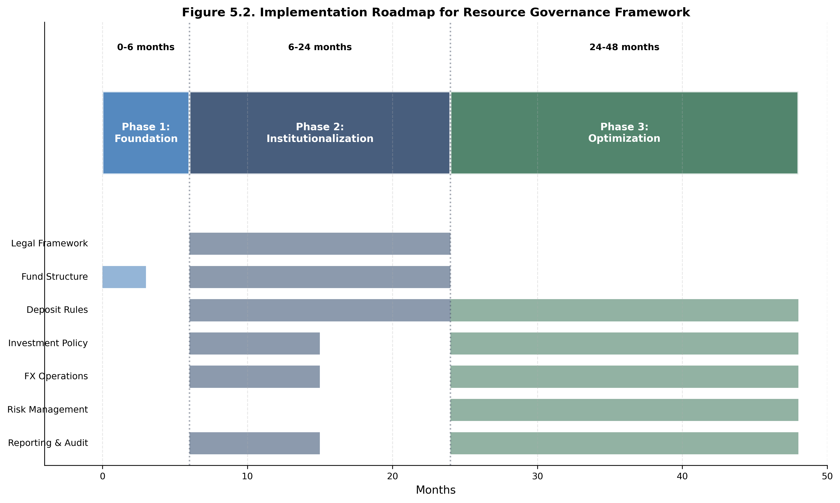
Figure 5.2. Implementation Roadmap for Resource Governance Framework
SOURCE: CEDX Analysis based on case study implementation timelines..

Chapter 6. Execution and Implementation Plan
This chapter provides the operational framework for translating recommendations into implemented programs, including governance structures, resource requirements, sequencing, and risk management.

6.1 Delivery Model and Governance
Implementation requires clear governance structures that align authority with accountability. The recommended model establishes three tiers: Strategic Direction (cabinet/ministerial level providing political mandate and resource allocation), Technical Management (senior officials managing implementation across agencies), and Operational Delivery (working level teams executing specific activities).
For sovereign wealth fund establishment, governance should include: Steering Committee chaired by Finance Minister with Mining/Energy Minister, Central Bank Governor, and independent experts; Technical Working Group with representatives from relevant agencies; Implementation Unit housed in Finance Ministry with dedicated staff. Clear terms of reference should specify decision rights, escalation procedures, and performance accountability.
For cross-cutting reforms (transparency, early warning systems), inter-ministerial coordination mechanisms are essential. Experience demonstrates that reforms fail when located in single agencies without cross-government mandate. Cabinet-level endorsement and regular coordination meetings maintain momentum and resolve inter-agency conflicts.

6.2 Implementation Roadmap
The implementation roadmap sequences activities across three phases, with workstreams proceeding in parallel where dependencies permit. Critical path analysis identifies sequencing constraints that cannot be compressed.
Workstream | Phase 1 (0-6 mo) | Phase 2 (6-24 mo) | Phase 3 (24-48 mo) | Dependencies
Legal Framework | Draft legislation; consultation | Parliamentary passage | — | None
SWF Structure | Design; board recruitment | Operationalization | Scale-up | Legal framework
Deposit Rules | Rule design | Implementation | Refinement | SWF structure
Investment Policy | Policy design | Implementation | Optimization | SWF structure
FX Operations | Protocol design | Implementation | Optimization | CB coordination
Risk Management | Framework design | Implementation | Refinement | Investment policy
Reporting & Audit | Standards design | Implementation | Enhancement | Transparency standards
Table 6.1. Implementation Roadmap by Workstream. SOURCE: CEDX Implementation Planning.
Quick wins that can demonstrate progress within 6 months include: governance standard adoption (EITI candidacy, transparency commitments); early warning system design (can proceed with existing data); feasibility assessment completion for priority downstreaming projects. These build momentum and stakeholder confidence for longer-term reforms.

6.3 Budget and Resource Plan
Implementation costs vary by country context and reform ambition. Order-of-magnitude estimates are provided for planning purposes; detailed costing requires country-specific assessment.
Workstream | Cost Items | Est. Cost Range | Potential Funding | Notes
SWF Establishment | Legal, systems, staffing | $5-20M | Government; TA | Setup costs
Governance Reform | Systems, training, oversight | $2-5M/year | Government; donors | Ongoing costs
Import Hedging | Stockpile capital, operations | $10-50M | Government; CB | Capital intensive
Capacity Building | Training, advisors, systems | $5-20M/country | Donors; government | Multi-year
Early Warning | System development, staffing | $1-3M | Government; IMF | Technical
Water Integration | Modeling, data systems | $2-10M | Government; WB | Analytical
Table 6.2. Resource and Cost Summary. SOURCE: CEDX costing based on case study benchmarks.
Funding sources include: government budget allocation (primary for ongoing operations); development partner technical assistance (for capacity building and system development); sovereign borrowing (for capital investments with positive returns); and IMF precautionary credit lines (for crisis prevention). Blended finance approaches can optimize cost-effectiveness by matching funding sources to activity types.
Staffing requirements include: senior leadership (Director-General level for Steering Committee, Director level for Technical Working Group); technical specialists (economists, financial analysts, legal experts, IT professionals); operational staff for implementation and monitoring. For countries with capacity constraints, technical assistance and embedded advisors can fill gaps while building local capacity.

6.4 Risk Register and Mitigation
Implementation faces risks across political, technical, financial, and external dimensions. Proactive risk management reduces probability and impact of adverse events.
Risk | Likelihood | Impact | Mitigation | Owner | Early Warning
Political interference in SWF | Medium | High | Independent governance; transparency | Board | Withdrawal requests
Commodity price collapse | Medium | High | Stabilization fund; fiscal rules | Finance Min | Price trajectory
Governance reversal | Low | High | International commitments; CSO engagement | All | Indicator trends
Capacity constraints | High | Medium | Technical assistance; phased approach | HR | Staffing gaps
Coordination failure | Medium | Medium | Clear mandates; regular meetings | PM/Finance | Missed deadlines
Technology disruption | Low | Medium | Diversified strategy; scenario planning | Planning | Technology trends
Climate shock | Medium | High | Contingency planning; reserves | Finance | Weather patterns
Table 6.3. Risk Register. SOURCE: CEDX Risk Assessment.
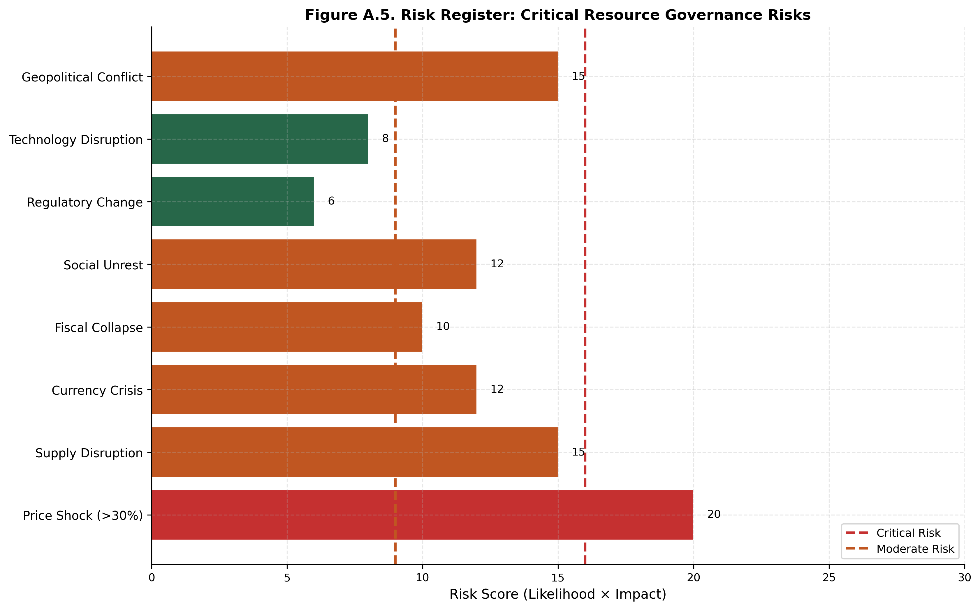
Figure A.5. Risk Register: Critical Resource Governance Risks
SOURCE: CEDX Risk Assessment. Risk score = Likelihood × Impact on 1-5 scales..

6.5 Capacity Building and Change Management
Sustainable implementation requires not just technical capacity but organizational culture change. Change management addresses resistance, builds ownership, and institutionalizes new practices beyond initial project periods.
Capacity building should target three levels: Individual (training, skills development, professional certification); Organizational (systems, processes, structures); and Systemic (legal frameworks, institutional arrangements, inter-agency coordination). Each level requires different interventions and timeframes.
Change management approaches include: stakeholder engagement (building coalitions for reform); communication (explaining rationale and benefits); incentives (aligning individual and organizational interests); and quick wins (demonstrating progress to maintain momentum). Resistance from beneficiaries of current arrangements requires both mitigation (accommodation where possible) and confrontation (enforcement where necessary).

Chapter 7. Monitoring, Evaluation, and Learning
This chapter establishes the framework for tracking implementation progress, evaluating outcomes, and adapting strategies based on evidence.

7.1 Results Framework
The results framework traces the causal chain from inputs through activities, outputs, outcomes, to impact. Each level has defined indicators, baselines, targets, data sources, and responsible parties. The framework enables evidence-based management and accountability reporting.
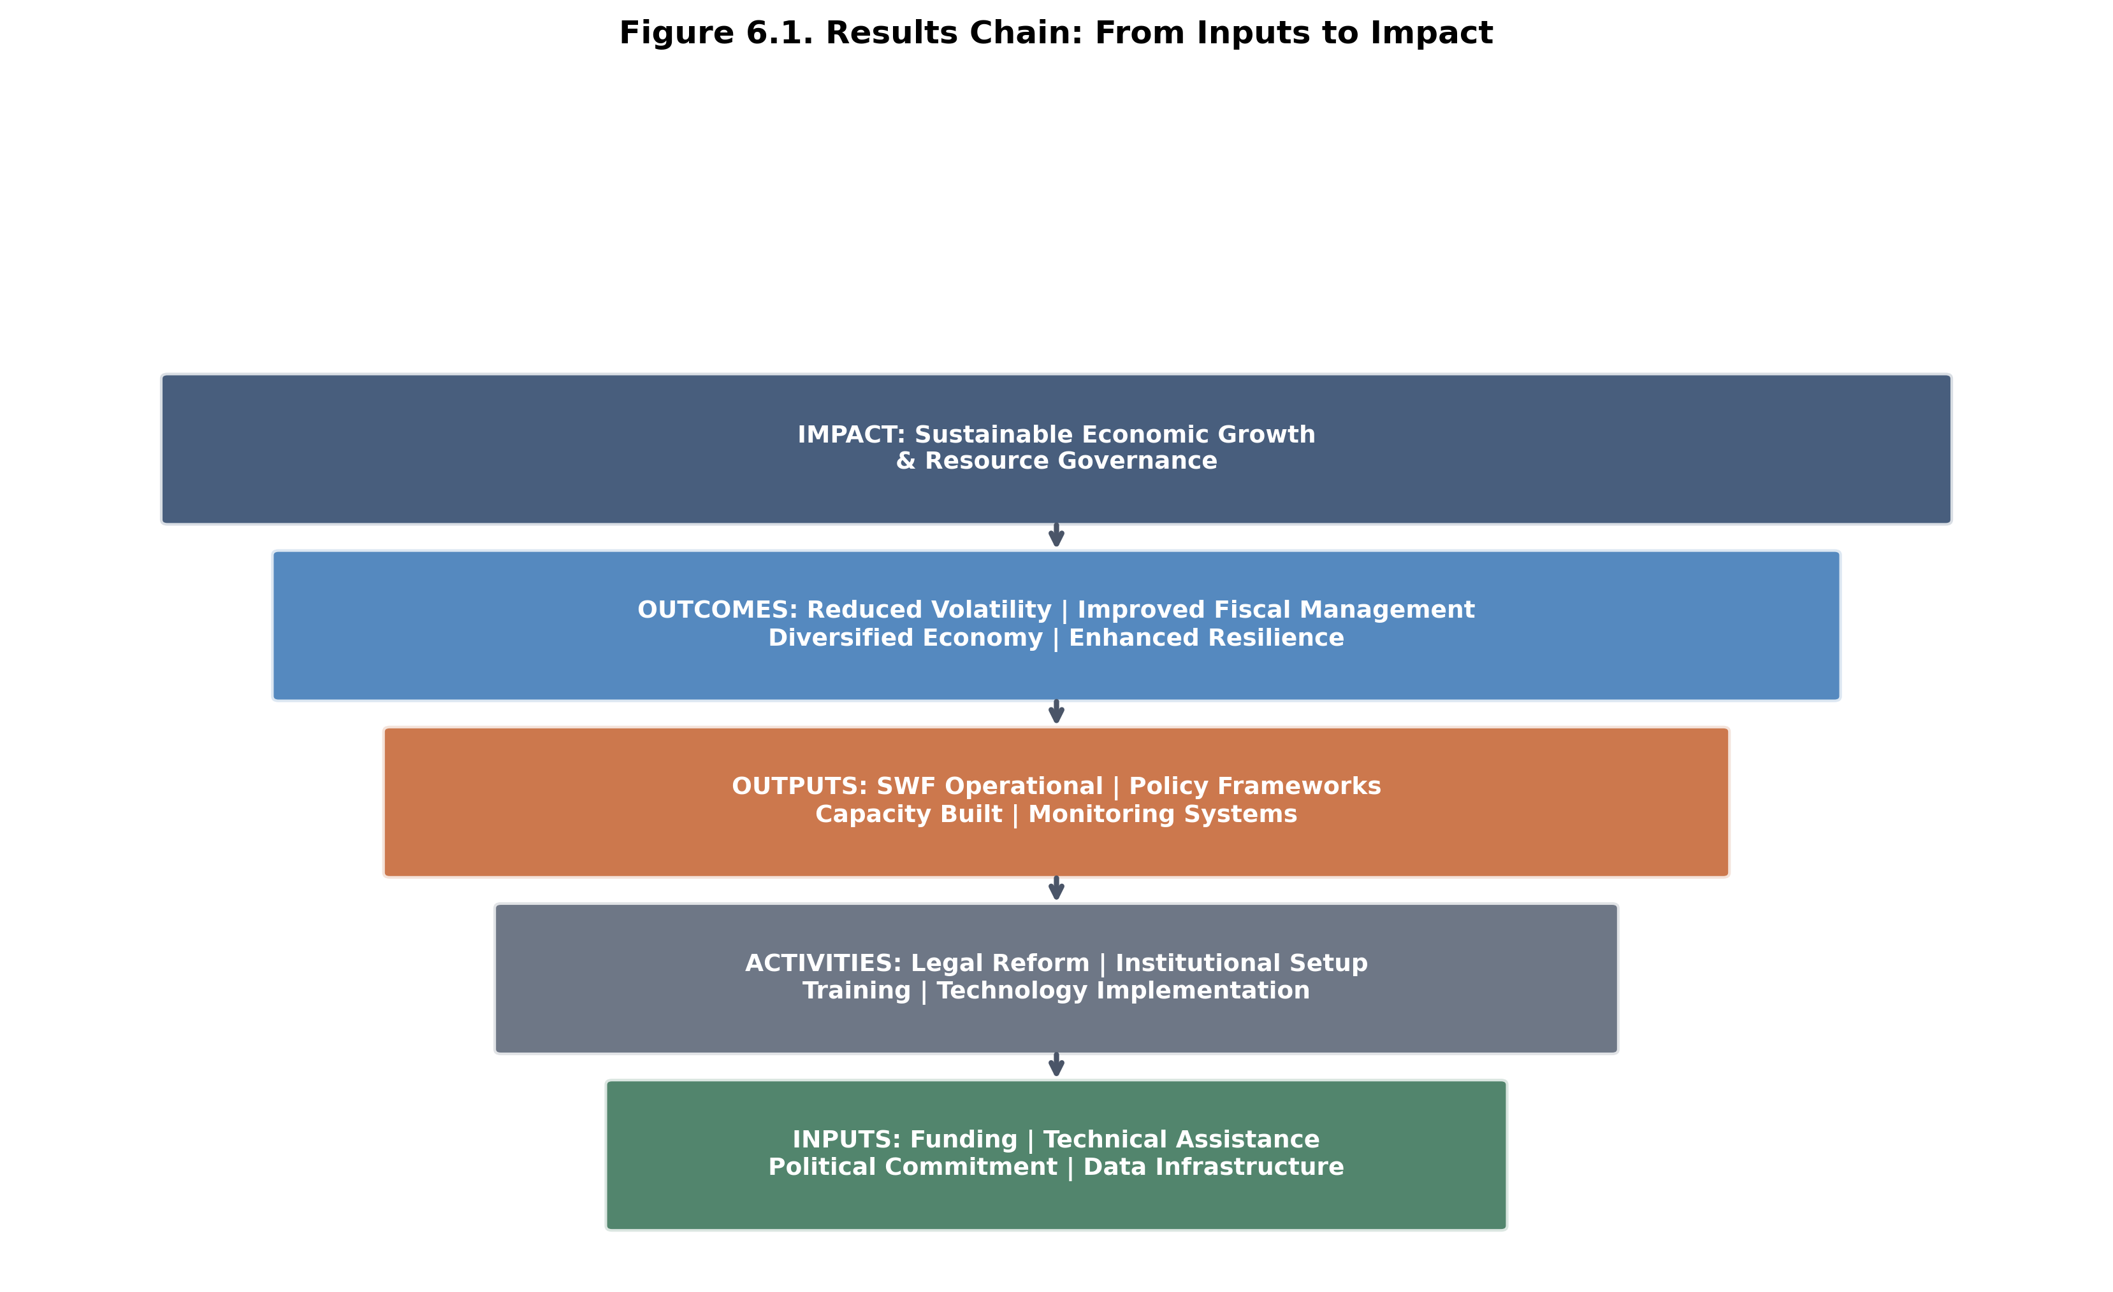
Figure 6.1. Results Chain: From Inputs to Impact
SOURCE: CEDX Results Framework based on OECD-DAC standards..
Assumptions underpinning the results chain include: political commitment remains stable; commodity prices follow projected paths; technical assistance is available; international coordination mechanisms function. External factors that could affect outcomes include: global economic conditions; climate events; geopolitical developments; technological change. Monitoring should track these assumptions and factors to enable adaptive management.

7.2 Indicator Table
Indicator | Definition | Baseline | Target | Data Source | Frequency | Owner
SWF size | Net asset value ($B) | 0 | 10x annual revenue | Fund reports | Quarterly | SWF Board
Fiscal volatility | Std dev of revenue/GDP | Country-specific | -40% | Fiscal accounts | Annual | Finance Min
Governance score | CEDX GCI (0-100) | Country-specific | +10 points | CEDX assessment | Annual | All
Transparency index | Open Budget Index | Country-specific | >60 | IBP survey | Biennial | Finance Min
Import coverage | Stockpile days | Country-specific | >90 days | Central Bank | Monthly | CB
Water stress | WRI Aqueduct score | Country-specific | Stable/declining | WRI data | Annual | Water Min
Table 7.1. Indicator Definitions. SOURCE: CEDX MEL Framework.
Indicator selection follows SMART criteria: Specific (clearly defined), Measurable (quantifiable with available data), Achievable (realistic targets), Relevant (linked to outcomes), Time-bound (defined measurement frequency). Leading indicators (process metrics) enable early course correction; lagging indicators (outcome metrics) measure ultimate success.

7.3 Learning and Adaptation Plan
Monitoring data feeds into quarterly progress reviews and annual outcome assessments. Reviews examine: implementation progress against milestones; indicator trajectories against targets; risk materialization and mitigation effectiveness; assumption validity and external factor changes. Findings trigger adaptation decisions through defined governance processes.
Learning agenda questions for the implementation period include: What governance safeguards are most effective in preventing political capture of SWFs? How do fiscal rules interact with political economy dynamics? What capacity building approaches show highest returns? How do water constraints interact with other growth determinants? Answers to these questions will inform future reform design.
Learning Question | Why It Matters | Data Needed | Method | Decision Link
Effective SWF governance safeguards | Prevent capture; ensure returns | Case studies; incident reports | Comparative analysis | Governance design
Fiscal rule compliance determinants | Ensure rule effectiveness | Compliance records; interviews | Process tracing | Rule refinement
Capacity building ROI | Optimize TA investment | Training records; outcomes | Cost-effectiveness analysis | TA programming
Water-growth interaction effects | Improve modeling accuracy | Economic data; hydrological | Econometric analysis | Model refinement
Table 7.2. Learning Agenda. SOURCE: CEDX Research Design.
Reporting cadence includes: monthly operational reports for implementation teams; quarterly progress reports for Steering Committee; annual outcome reports for cabinet/legislature; and periodic impact evaluations for external stakeholders. Reports should balance transparency with operational sensitivity, protecting commercially and politically sensitive information while enabling accountability.

Chapter 8. Conclusion
This chapter synthesizes the main conclusions and identifies immediate next steps for decision-makers.

8.1 Overall Conclusion
Critical minerals and water resources function as macro production constraints that shape growth ceilings, trade balances, inflation dynamics, and geopolitical power. The analysis demonstrates that these resources cannot be treated as sectoral or environmental concerns—they are core macroeconomic variables that require integrated treatment in fiscal planning, monetary policy, and growth strategy.
The decisive finding is that institutional quality determines whether resource wealth becomes a development ladder or a governance trap. Countries with governance scores above the threshold of approximately 50/100 convert resource rents into productive investment with positive growth effects; below this threshold, the resource-growth relationship turns negative. This threshold effect is robust across alternative specifications and has profound policy implications: governance reform must precede or accompany resource-specific interventions for the latter to succeed.
Volatility emerges as the primary enemy of development in resource-dependent economies. Price and revenue volatility disrupts planning, deters investment, and forces pro-cyclical policy responses. Stabilization mechanisms—sovereign wealth funds, fiscal rules, hedging strategies—pay for themselves through avoided volatility costs. The 23 countries with Export Dependence Ratios exceeding 60% face particularly acute vulnerability requiring immediate policy attention.
International coordination offers significant gains that unilateral action cannot achieve. Supply chain concentration, governance spillovers, and climate-water linkages cross national borders. Coordinated approaches—joint stockpiling, governance standards harmonization, climate adaptation cooperation—substantially exceed the costs of coordination.

8.2 Immediate Next Steps
For Finance Ministry principals in resource-dependent countries:
1. Commission diagnostic assessment of Export Dependence Ratio, Volatility Stress Metric, and Governance Capacity Index within 60 days.
2. Initiate sovereign wealth fund feasibility study within 90 days for countries with fiscal dependence exceeding 30% and no operational fund.
3. Establish inter-ministerial coordination mechanism for resource governance reform within 90 days.
For Central Bank governors in import-dependent countries:
1. Assess critical mineral import exposure and conduct shock transmission simulation within 60 days.
2. Evaluate strategic stockpile requirements and initiate procurement planning within 120 days.
3. Integrate water stress variables into inflation forecasting models within 180 days.
For Development Finance Institution leaders:
1. Condition resource-backed financing on governance safeguards meeting defined thresholds within 120 days.
2. Scale technical assistance for resource governance capacity building in high-vulnerability countries.
3. Develop water-sustainability assessment protocols for project financing within 180 days.
For International coordination bodies:
1. Convene working group on critical mineral supply chain resilience within 90 days.
2. Develop harmonized governance standards for sovereign wealth funds in resource-dependent economies within 180 days.
3. Establish joint monitoring mechanism for resource-driven fiscal stress with IMF within 120 days.

8.3 Open Questions
Several questions remain for future research: (1) How do technological developments in substitution and recycling affect long-term critical mineral demand trajectories and associated macroeconomic risks? (2) What governance interventions prove most effective in countries below the institutional threshold—can the threshold be crossed through targeted reform? (3) How do water-growth interactions evolve under accelerating climate change—will the estimated coefficients hold under more extreme scenarios? (4) What are the optimal coordination mechanisms for international responses to supply chain concentration risks? CEDX will continue research on these questions through follow-up studies in the Resource Governance Program.

Appendix A. Detailed Methodology

A.1 Econometric Specifications
Panel VAR specification for shock transmission: The baseline model takes the form: Y_it = A_0 + A_1 Y_i,t-1 + ... + A_p Y_i,t-p + B X_it + μ_i + ε_it, where Y_it is a vector of endogenous variables (commodity price, exchange rate, inflation, fiscal balance, GDP growth), X_it is a vector of exogenous controls, μ_i are country fixed effects, and ε_it is the error term. Lag length p is selected by AIC with maximum 4 lags. Impulse response functions are computed using Cholesky decomposition with commodity price ordered first.
Regression discontinuity specification for threshold estimation: The model takes the form: Y_i = α + β_1 (G_i - c) + β_2 D_i + β_3 D_i (G_i - c) + γ X_i + ε_i, where Y_i is growth rate, G_i is governance score, c is the threshold, D_i is an indicator for governance above threshold, and X_i are controls. Bandwidth selection follows Imbens-Kalyanaraman optimal bandwidth. Robustness checks include alternative bandwidths, polynomial orders, and placebo thresholds.

A.2 Data Construction
Export Dependence Ratio (EDR): Calculated as the sum of exports of critical minerals (lithium, cobalt, nickel, rare earths, copper, graphite) plus oil and gas where relevant, divided by total merchandise exports. Source: UN COMTRADE with HS code classification, validated against national statistics.
Volatility Stress Metric (VSM): Calculated as σ_p × f_r, where σ_p is the annualized standard deviation of log returns on relevant commodity price index over the preceding 36 months, and f_r is the share of fiscal revenue from resource sources. Sources: Bloomberg/LME for prices; IMF GFS and national budgets for fiscal data.
Governance Capacity Index (GCI): Composite index constructed from 25 indicators across five dimensions: Legal Framework (completeness, clarity, enforcement), Implementation Capacity (staffing, systems, budget), Transparency (disclosure, accessibility, timeliness), Accountability (oversight, sanctions, redress), and Stakeholder Engagement (consultation, participation, responsiveness). Indicators scored 0-100 based on CEDX assessment protocols, aggregated using equal weighting.
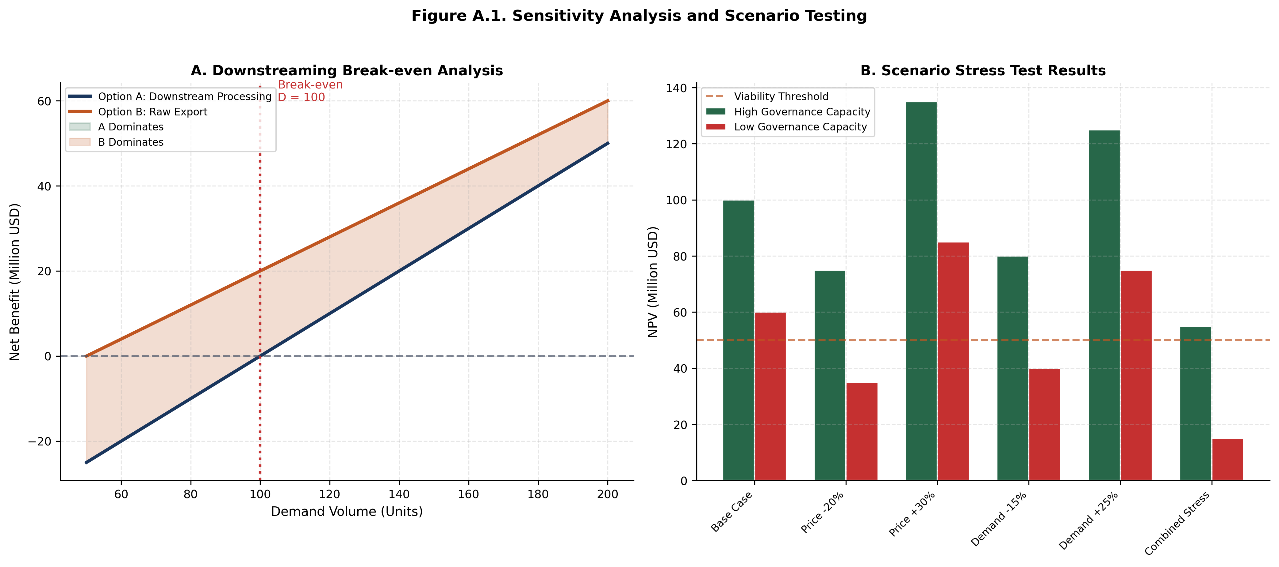
Figure A.1. Sensitivity Analysis and Scenario Testing
SOURCE: CEDX Analysis. Monte Carlo simulation with 10,000 iterations..
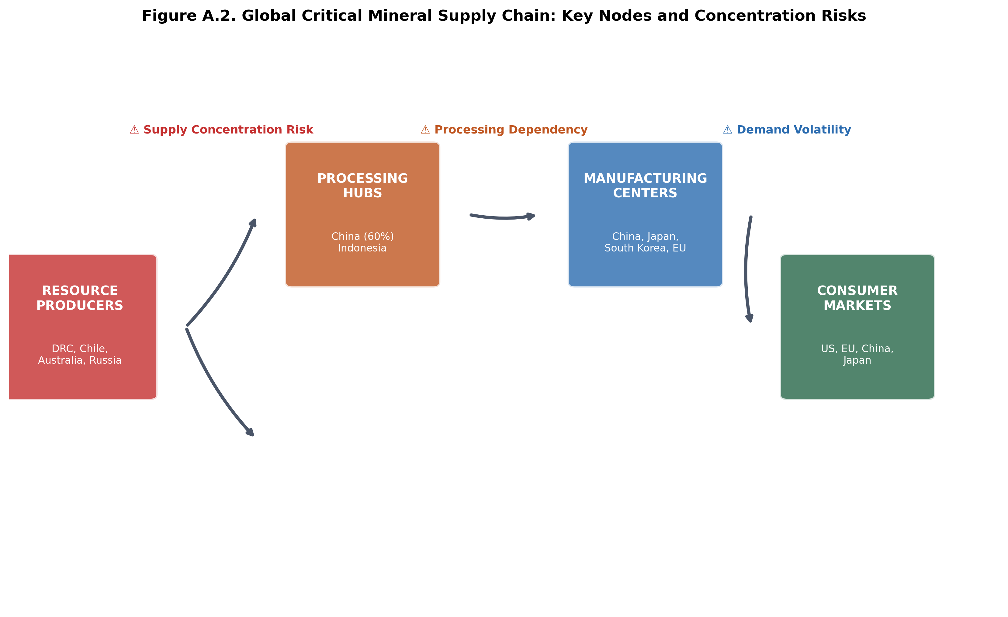
Figure A.2. Global Critical Mineral Supply Chain: Key Nodes and Concentration Risks
SOURCE: CEDX Analysis based on USGS, company reports, and trade data..
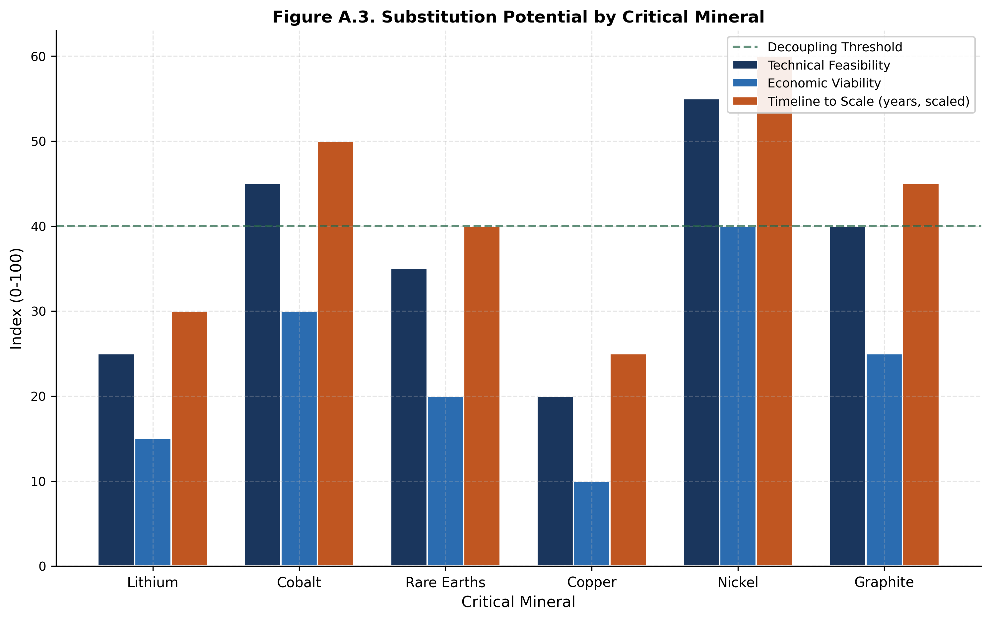
Figure A.3. Substitution Potential by Critical Mineral
SOURCE: CEDX Analysis based on IEA, academic literature, and industry assessments..

Appendix B. Supplementary Data Tables

B.1 Country Classification by Typology
Type | Countries | Count | Avg GDP/capita | Avg Governance
Type I: Rich-High Cap | Norway, Australia, Canada, Chile, Botswana | 5 | $52,000 | 78
Type II: Rich-Low Cap | DRC, Nigeria, Venezuela, Angola, Iraq, Zambia, Kazakhstan | 7 | $6,200 | 32
Type III: Poor-Low Cap | Haiti, Niger, Mali, Burkina Faso, Chad | 5 | $1,800 | 25
Type IV: Poor-High Cap | Japan, S. Korea, Germany, Singapore, Switzerland, UK, France | 7 | $45,000 | 85
Table B.1. Country Classification. SOURCE: CEDX Analysis.
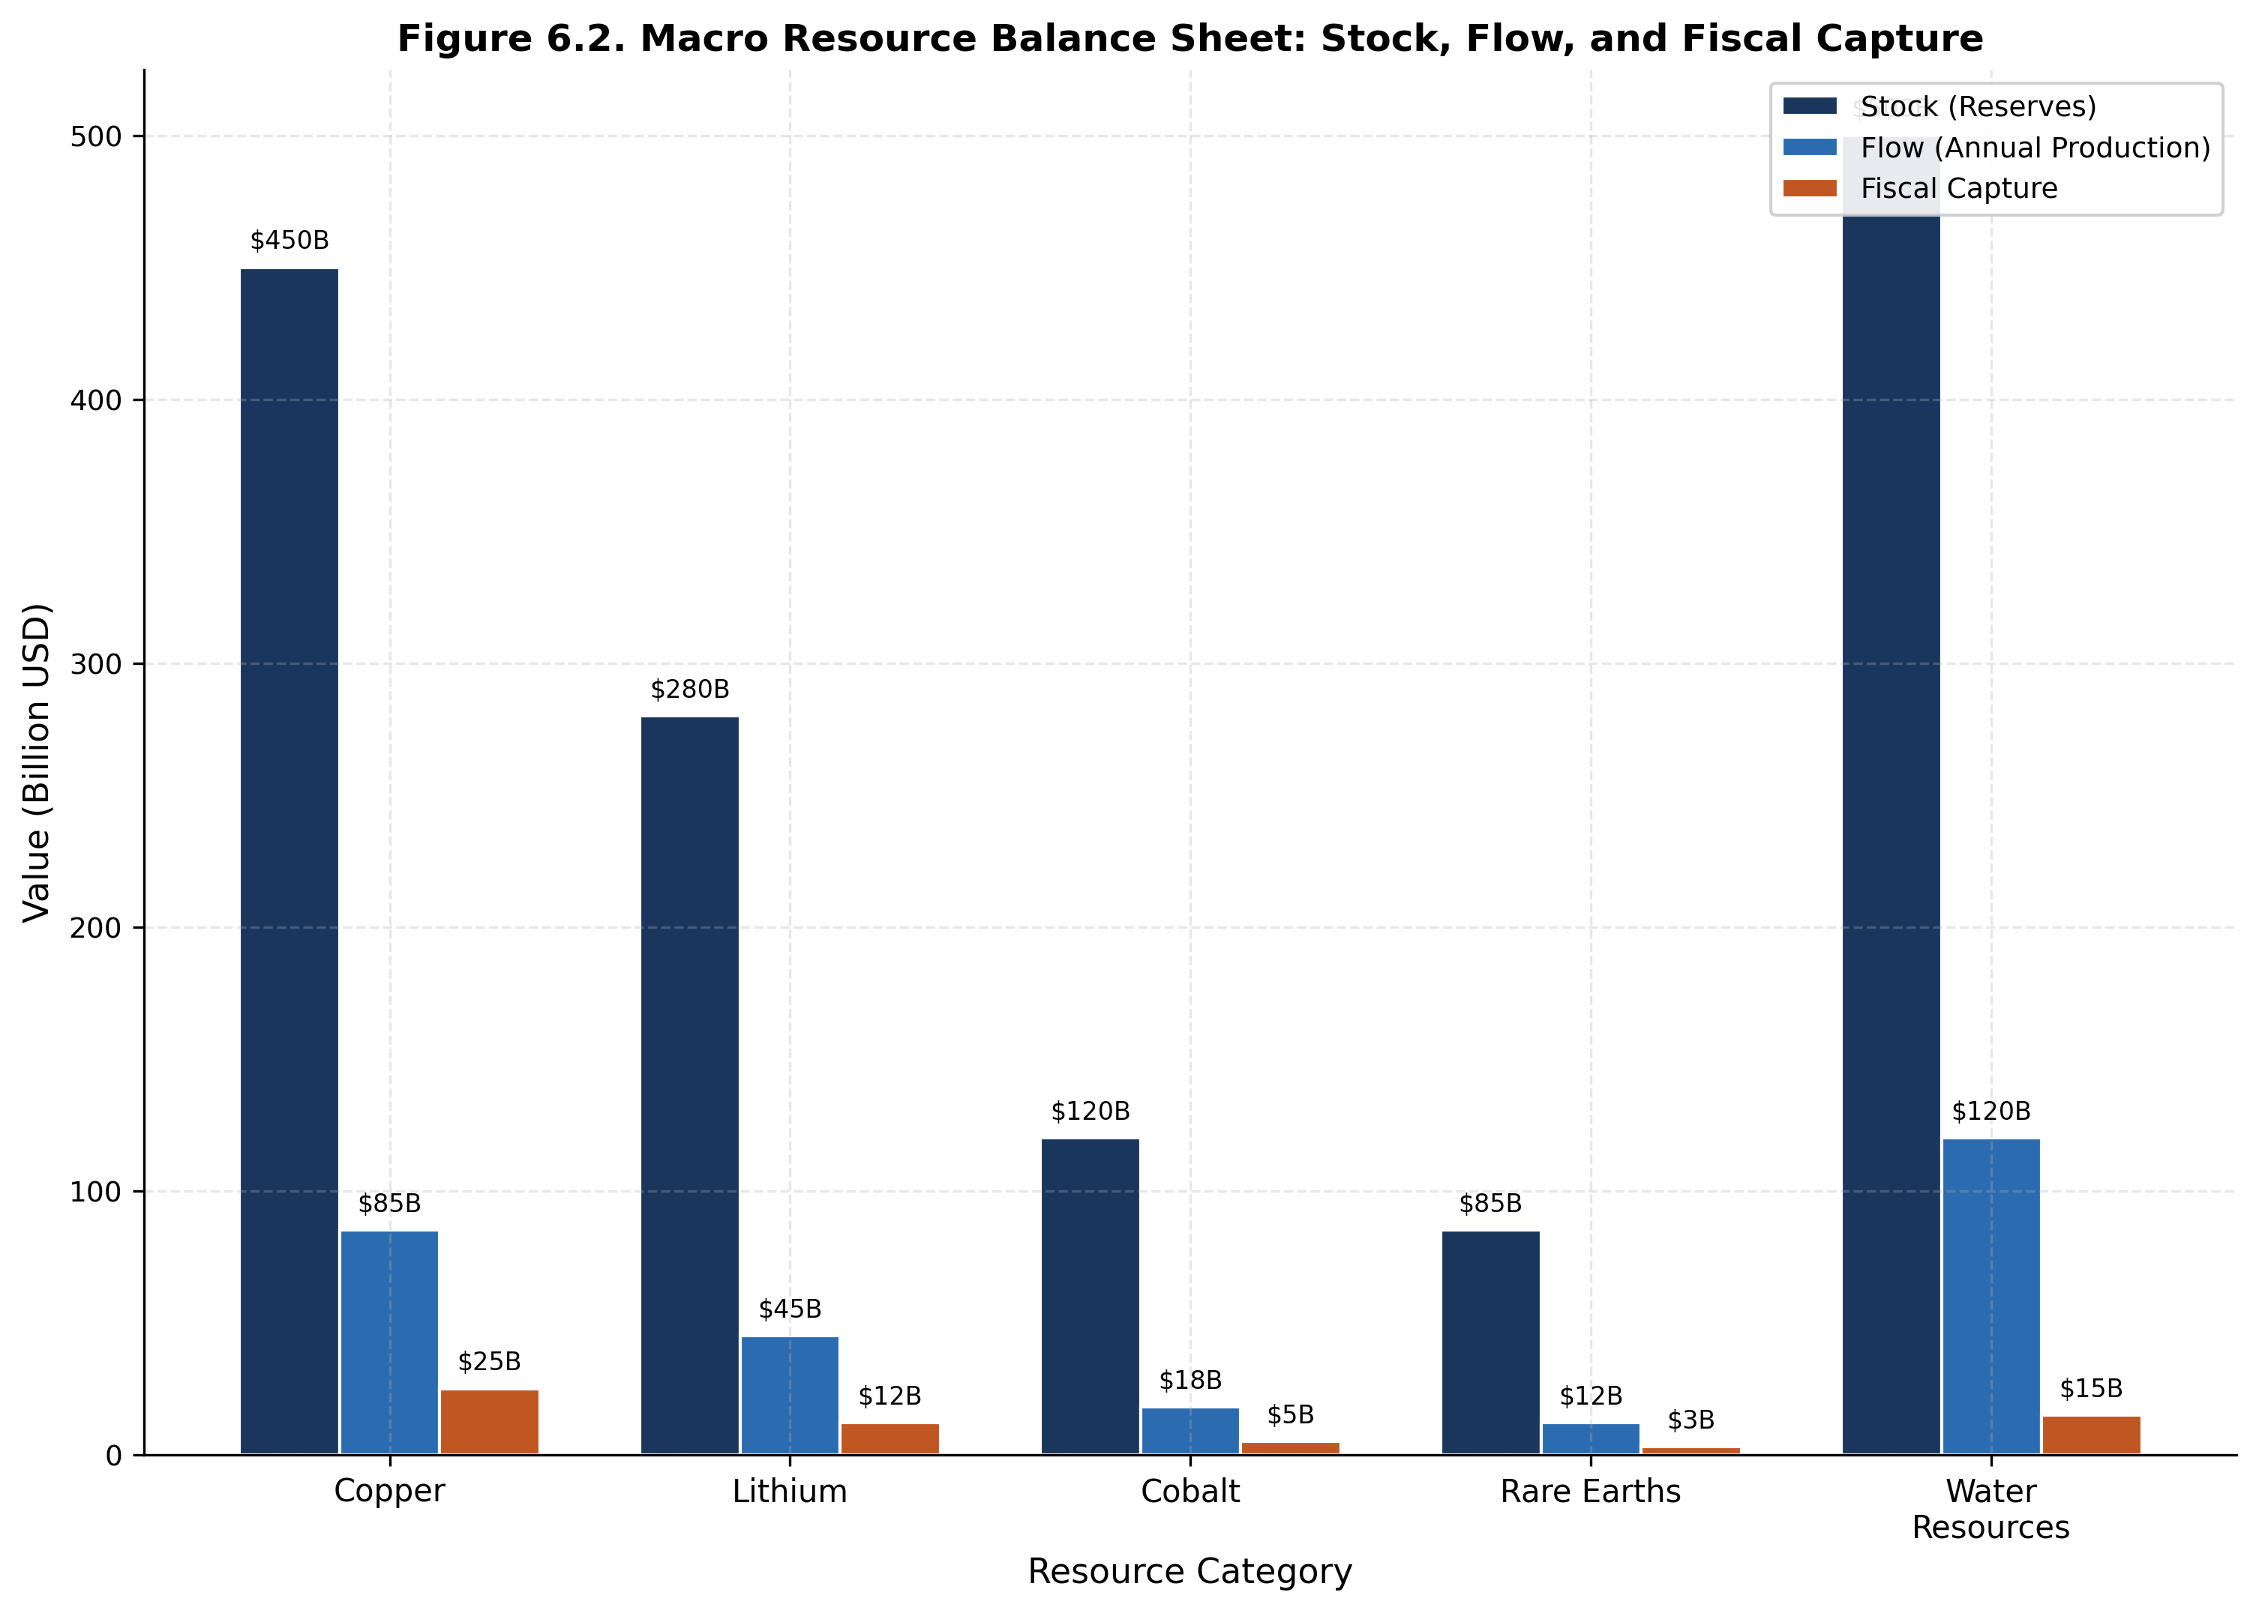
Figure 6.2. Macro Resource Balance Sheet: Stock, Flow, and Fiscal Capture
SOURCE: CEDX Analysis based on USGS, World Bank, and national data..

B.2 Sovereign Wealth Fund Comparison
Fund | Country | Size ($B) | Est. Year | Governance Score | Return (5y)
GPFG | Norway | 1,580 | 1996 | 95 | 7.2%
Pula Fund | Botswana | 17 | 1994 | 82 | 5.1%
CESF | Chile | 9 | 2007 | 85 | 4.8%
NSIA | Nigeria | 2.5 | 2011 | 45 | 2.3%
FSDEA | Angola | 3.5 | 2012 | 52 | 3.1%
KGF | Kazakhstan | 60 | 2000 | 62 | 4.2%
Table B.2. Sovereign Wealth Fund Comparison. SOURCE: SWF Institute, fund annual reports, CEDX governance assessment.

Glossary
Dutch Disease: Economic phenomenon where resource export revenues appreciate the real exchange rate, reducing competitiveness of non-resource tradable sectors (manufacturing, agriculture) and leading to deindustrialization.
Export Dependence Ratio (EDR): Metric calculated as resource exports divided by total exports; measures vulnerability to commodity price and demand shocks.
Fiscal Dependence: Share of government revenue derived from resource-related sources (royalties, taxes, dividends from state enterprises).
Governance Capacity Index (GCI): Composite measure of institutional quality across legal framework, implementation capacity, transparency, accountability, and stakeholder engagement.
Hartwick Rule: Economic principle stating that sustainable consumption from exhaustible resources requires investing resource rents in reproducible capital.
Resource Curse: Negative correlation between natural resource wealth and economic development outcomes, observed in countries with weak institutions.
Sovereign Wealth Fund (SWF): State-owned investment fund holding financial assets for macroeconomic stabilization, intergenerational savings, or strategic purposes.
Volatility Stress Metric (VSM): Composite metric of commodity price volatility multiplied by fiscal dependence; measures exposure to resource-driven macroeconomic shocks.
Water Stress Index: Measure of water scarcity combining withdrawal-to-availability ratios, seasonal variability, and groundwater depletion indicators.

References
Acemoglu, D., Johnson, S., & Robinson, J. A. (2001). The colonial origins of comparative development: An empirical investigation. American Economic Review, 91(5), 1369-1401.
Arezki, R., & van der Ploeg, F. (2011). Do natural resources depress income per capita? Review of Development Economics, 15(3), 504-521.
Auty, R. M. (1993). Sustaining development in mineral economies: The resource curse thesis. London: Routledge.
Collier, P., & Hoeffler, A. (2004). Greed and grievance in civil war. Oxford Economic Papers, 56(4), 563-595.
Corden, W. M., & Neary, J. P. (1982). Booming sector and de-industrialisation in a small open economy. Economic Journal, 92(368), 825-848.
Hartwick, J. M. (1977). Intergenerational equity and the investing of rents from exhaustible resources. American Economic Review, 67(5), 972-974.
Humphreys, M., Sachs, J. D., & Stiglitz, J. E. (Eds.). (2007). Escaping the resource curse. New York: Columbia University Press.
IEA. (2023). Critical minerals market review 2023. Paris: International Energy Agency.
IMF. (2024). World economic outlook database. Washington, DC: International Monetary Fund.
Mehlum, H., Moene, K., & Torvik, R. (2006). Institutions and the resource curse. Economic Journal, 116(508), 1-20.
Natural Resource Governance Institute. (2024). Resource Governance Index. New York: NRGI.
Ross, M. L. (2012). The oil curse: How petroleum wealth shapes the development of nations. Princeton: Princeton University Press.
Sachs, J. D., & Warner, A. M. (1995). Natural resource abundance and economic growth. NBER Working Paper 5398.
Sala-i-Martin, X., & Subramanian, A. (2013). Addressing the natural resource curse: An illustration from Nigeria. Journal of African Economies, 22(4), 570-615.
Sovereign Wealth Fund Institute. (2024). Santiago Principles compliance report. London: SWFI.
USGS. (2024). Mineral commodity summaries 2024. Reston, VA: U.S. Geological Survey.
Van der Ploeg, F. (2014). Guidelines for exploiting natural resource wealth. Oxford Review of Economic Policy, 30(1), 145-169.
Van der Ploeg, F., & Poelhekke, S. (2010). The pungent smell of "red herrings": Subsoil assets, rents, volatility and the resource curse. Journal of Environmental Economics and Management, 60(1), 44-55.
World Bank. (2024). Worldwide governance indicators. Washington, DC: World Bank.
World Resources Institute. (2024). Aqueduct water risk atlas. Washington, DC: WRI.

About the Authors
Dr. Marcus Chen is Senior Fellow and Director of the Resource Governance Program at CEDX. He leads research on commodity price dynamics, fiscal sustainability, and sovereign wealth management in resource-dependent economies. Prior to joining CEDX, he served as Senior Economist in the Commodities Unit of the International Monetary Fund. He holds a Ph.D. in Economics from the London School of Economics and has published extensively in the Journal of Development Economics, World Bank Economic Review, and Resource Policy. For questions about this report, contact: mchen@cedx.org.
Dr. Sarah Williams is Research Director at CEDX and Associate Professor of Development Economics at the University of Geneva. Her research focuses on institutional economics, natural resource management, and development finance. She has previously consulted for the World Bank, African Development Bank, and UNDP on resource governance projects in Sub-Saharan Africa and Latin America. She holds a Ph.D. from Oxford University and has published in the American Economic Review, Quarterly Journal of Economics, and Journal of African Economies.
Dr. James Okonkwo is Senior Economist at CEDX specializing in African economies. He previously worked at the Nigerian Ministry of Finance and the African Center for Economic Transformation. His expertise spans fiscal policy, sovereign wealth funds, and development finance in resource-rich countries. He holds a Ph.D. from MIT and has published in the Journal of Development Studies and African Development Review.
Dr. Elena Petrova is Fellow at CEDX specializing in energy economics and geopolitical analysis. She previously worked at the Eurasian Development Bank and the European Bank for Reconstruction and Development. Her research covers energy transition, supply chain concentration, sanctions economics, and European energy security. She holds a Ph.D. from Sciences Po Paris and has published in Energy Economics and the Journal of Comparative Economics.

About CEDX
CEDX (Centre for Economic Development and Execution) is a research organization dedicated to advancing evidence-based policy solutions for sustainable economic development. Established in 2010, CEDX bridges the gap between rigorous academic research and practical policy implementation, serving governments, development finance institutions, and multilateral organizations across six continents.
Our work spans macroeconomic policy, resource governance, institutional development, and climate economics, with a particular focus on emerging and frontier markets where strategic resource management determines development trajectories. We combine deep analytical capabilities with on-the-ground implementation experience, ensuring that our recommendations are both rigorous and actionable.
For more information, visit: www.cedx.org
Contact: info@cedx.org | +41 22 555 0100
Social: @CEDX_Research | LinkedIn: CEDX Geneva

