**Create Course Manual Test**

* The account that I used to conduct the test is a ‘teacher’ account, which was set up to test features only available to ‘teacher’ learner. The account email is “goku@gmail.com” and the password is “pass”.

|  |  |  |  |  |  |
| --- | --- | --- | --- | --- | --- |
| Test No | Description | TEX (Typical, Erroneous, Extreme) | Expected Outcome | Actual Outcome | Comments and Corrective Actions |
| 1 | Enter a value in the ‘Course name’ field. | T: A valid name is entered. | Name will be accepted. | Screenshot 1.1. | This process passed. |
| E: String of numbers, with special characters is entered. | Error message, “Enter an appropriate course name” will appear below field. | Screenshot 1.2. | This process passed. |
| E: Blank field | “Field is required” error should be shown below the input field. | Screenshot 1.3. | This process passed. |
| X: Course name that already exists in the system is entered. | Message, “This course name is already registered” will appear below the field. | Screenshot 1.4. | This process is passed. |
| 2 | Enter a value in the ‘Max number of learners’ field. | T: A valid number is entered. | Number is accepted. | Screenshot 2.1. | This process passed. |
| E: Blank | “Field is required” error should be shown below the input field. | Screenshot 2.2. | This process passed. |
| X: String is entered. | “Enter a whole number between 1 to 300 (no preceding 0)” error should be shown below input field. | Screenshot 2.3. | This process passed. |
| 3 | Choosing a date from the calendar widget for the ‘Start Date’ field. | T: A valid date is chosen. | Date is accepted. | Screenshot 3.1. | This process passed. |
| E: Choose a past date. | “Please enter a future date” error should be displayed below input field. | Screenshot 3.2. | This process passed. |
| E: Choose today’s current date. (30/04/17) | “Please enter a future date” error should be displayed below input field. | Screenshot 3.3. | This process passed. |
| 4 | Choosing a course difficulty level from a drop down list. From the ‘Difficulty Level’ field. | T: Choose a difficulty level from drop down list. | Value is accepted and field is green. | Screenshot 4.1. | This process passed. |
| E: Not selecting an option. | “Please select a level” error message will appear below field and field will turn red. | Screenshot 4.2. | This process passed. |
| 5 | Choosing a ‘Course Category’ option from the drop down list. | T: Choose a course category from drop down list. | Value is accepted and field is green. | Screenshot 5.1. | This process passed. |
| E: Blank | “Please select a category” error message will appear below field and field will turn red. | Screenshot 5.2. | This process passed. |
| 6 | Entering a description into the ‘Course Description’ field. | T: Enter a valid description. | Value is accepted. | Screenshot 6.1. | This process passed. |
| E: Blank | “Field is required” error should be shown below the input field. | Screenshot 6.2. | This process passed. |
| E: Enter a description less than 10 characters. | “Please enter description between the character limit of 10 to 2000”, error message will show below field. | Screenshot 6.3. | This process passed. |
| E: Enter a description more than 2000 characters. | “Please enter description between the character limit of 10 to 2000”, error message will show below field. | Screenshot 6.4. | This process passed. |
| 7 | ‘Submit Button’ |  | Should be disabled until all valid inputs are entered. | Screenshot 7.1. | This process passed. |
|  | Should become available when all fields are valid. | Screenshot 7.2. | This process passed. |
| 8 | Form submitted after valid inputs. |  | Course page should be displayed, with details matching input. | Screenshot 8.1. | This process passed. |

**Screenshot Evidence for Testing:**

**Test 1:**

**Screenshot 1.1:**



**Screenshot 1.2:**



**Screenshot 1.3:**



**Screenshot 1.4:**



**Test 2:**

**Screenshot 2.1:**



**Screenshot 2.2:**



**Screenshot 2.3:  
**

**Test 3:**

**Screenshot 3.1:**



**Screenshot 3.2:**



**Screenshot 3.3:**



**Test 4:**

**Screenshot 4.1:**



**Screenshot 4.2:**

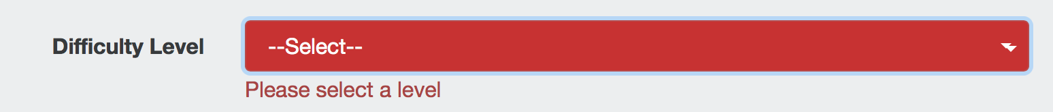

**Test 5:**

**Screenshot 5.1:**



**Screenshot 5.2:**



**Test 6:**

**Screenshot 6.1:**

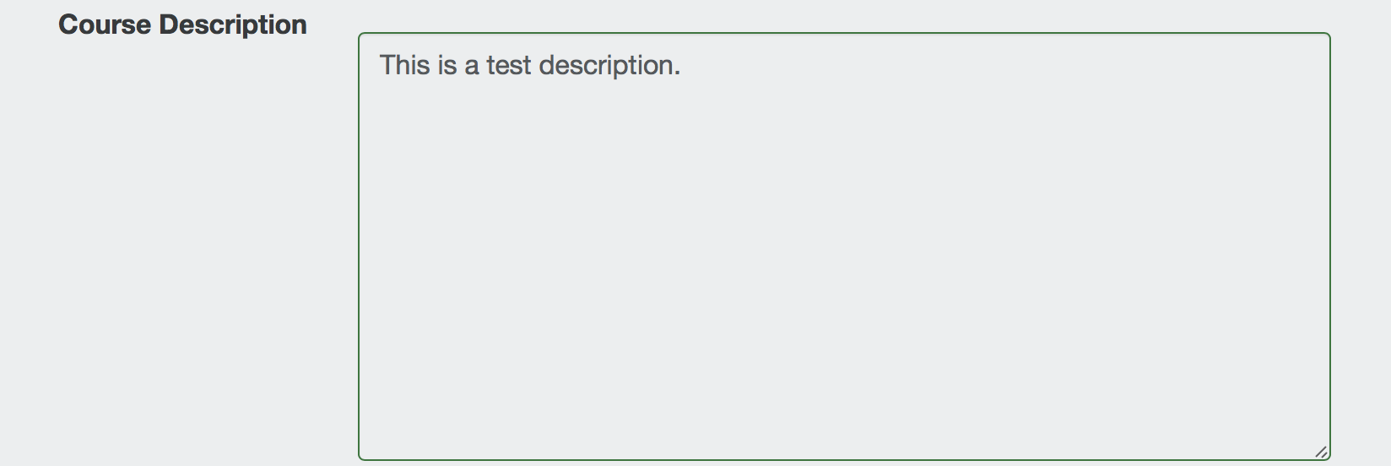

**Screenshot 6.2:**

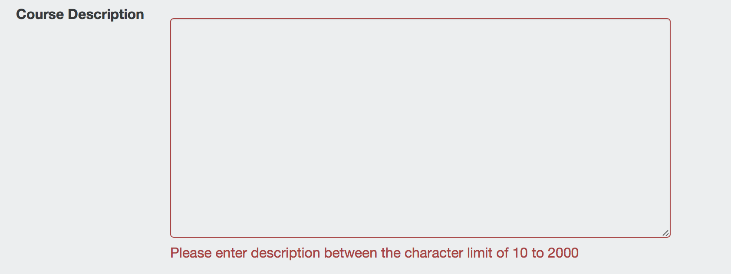

**Screenshot 6.3:**

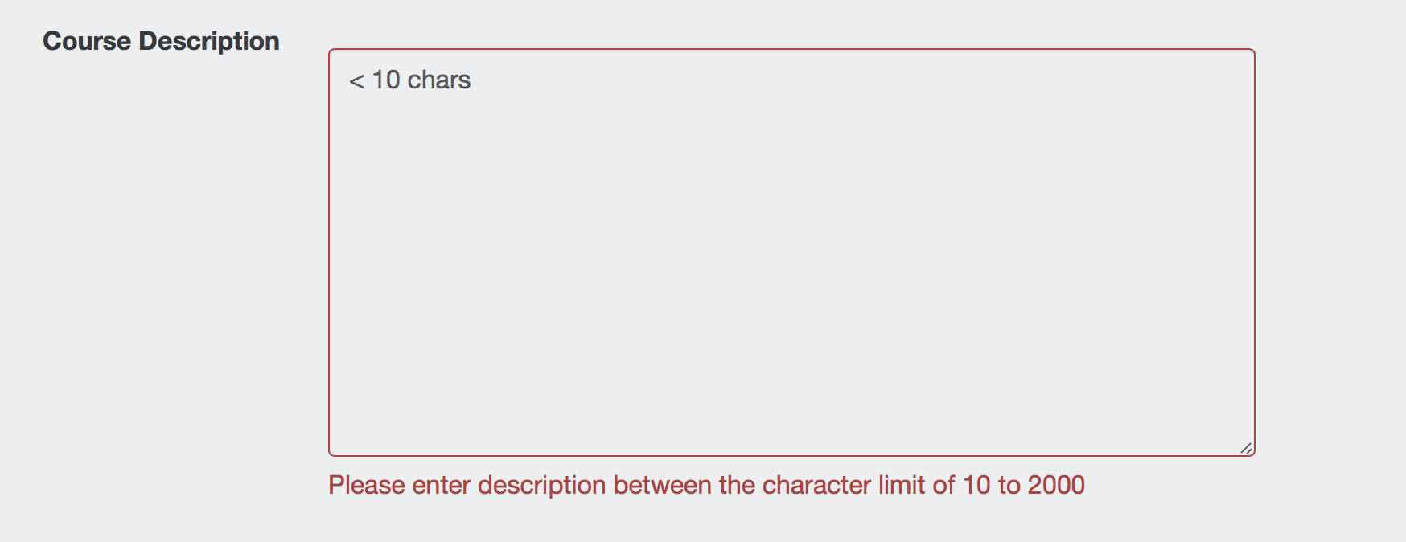

**Screenshot 6.4:**

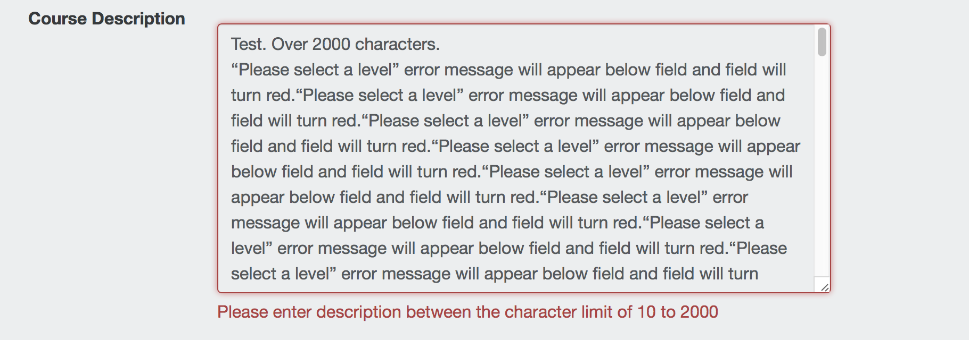

**Test 7:**

**Screenshot 7.1:**

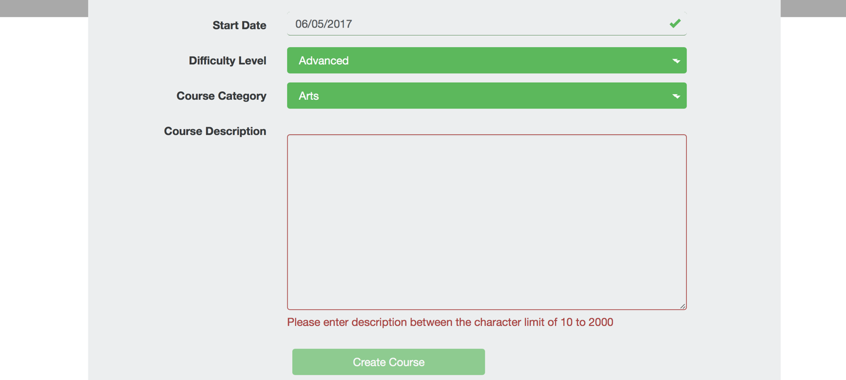

**Screenshot 7.2:**

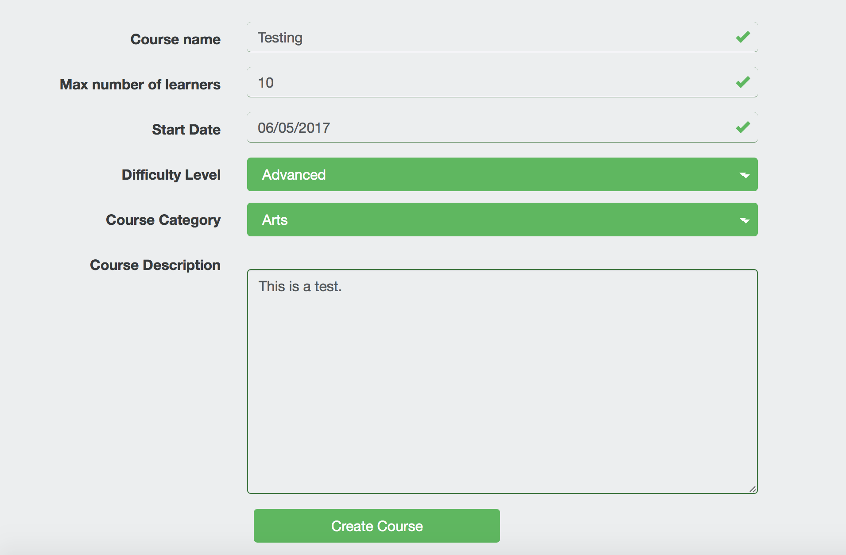

**Test 8:**

**Screenshot 8.1 (Values input match screenshot 7.2):**

