|  |  |  |  |  |  |  |  |
| --- | --- | --- | --- | --- | --- | --- | --- |
| Test No | Description | TEX (Typical, Erroneous, Extreme) | Description | TEX (Typical, Erroneous, Extreme) | Expected Outcome | Actual Outcome | Comments and Corrective Actions |
| 1 | Value entered or not entered in “Email” input field. | T: A valid email is entered | Value entered or not entered in “Password” input field | T: A valid password is entered | Successfully log into the right page. | Screenshot in test 1.1 | This process passed. |
| E: Blank | “Invalid email address or password. Please try again.” Error should be showed below the URL. | Screenshot in test 1.2 | This process passed. |
| X: Value doesn't match the value in database | “Invalid email address or password. Please try again.” Error should be showed below the URL. | Screenshot in test 1.3 | This process passed. |
| E: Email isn't verified | Value entered or not entered in “Password” input field | T: A valid password is entered | Show that the email is not verified and give a link show them how to verify. | Screenshot in test 1.4 | This process passed. |
| E: Blank | “Invalid email address or password. Please try again.” Error should be showed below the URL. | Screenshot in test 1.5 | This process passed. |
| X: Value doesn't match the value in database | “Invalid email address or password. Please try again.” Error should be showed below the URL. | Screenshot in test 1.6 | This process passed. |
| X: Blank | Value entered or not entered in “Password” input field | T: A valid password is entered | “Invalid email address or password. Please try again.” Error should be showed below the URL. | Screenshot in test 1.7 | This process passed. |
| E: Blank | “Invalid email address or password. Please try again.” Error should be showed below the URL. | Screenshot in test 1.8 | This process passed. |
| X: Value is not valid | “Invalid email address or password. Please try again.” Error should be showed below the URL. | Screenshot in test 1.9 | This process passed. |
| X: Not a valid email | Value entered or not entered in “Password” input field | T: A valid password is entered | “Could not log you in right now. Please try again.” Error should be showed below the URL. | Screenshot in test 1.10 | This process passed. |
| E: Blank | “Could not log you in right now. Please try again.” Error should be showed below the URL. | Screenshot in test 1.11 | This process passed. |
| X: Value is not valid | “Could not log you in right now. Please try again.” Error should be showed below the URL. | Screenshot in test 1.12 | This process passed. |
| 2. | Mail send to verify the email. |  |  |  | Verification email should be sent to the email provided by the user. | Screenshot in test 2 | This process passed. |

Test 1.1

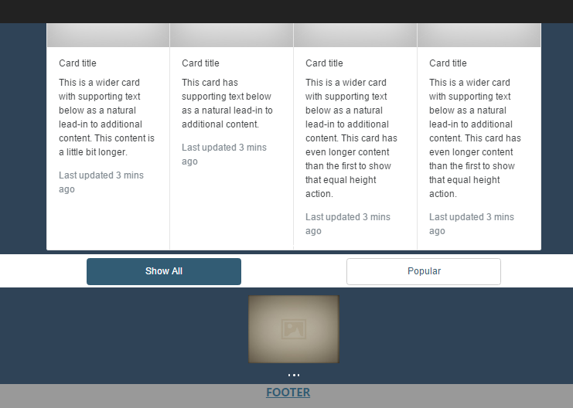The screenshot below shows that valid input is accepted.

Test 1.2

The screenshot below shows when the password is blank.

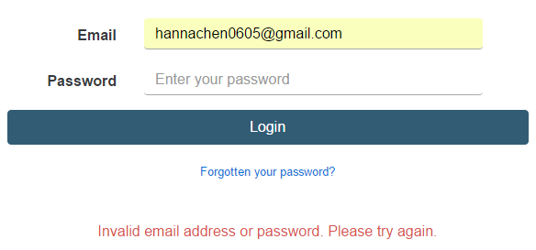

Test 1.3

The screenshot below shows when the password is not valid.

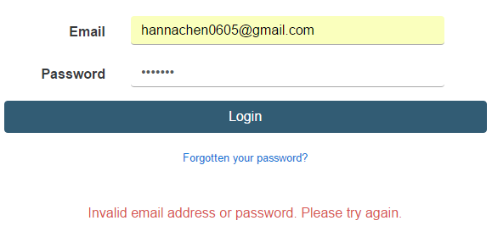

Test 1.4

The screenshot below shows when the email isn’t verified.

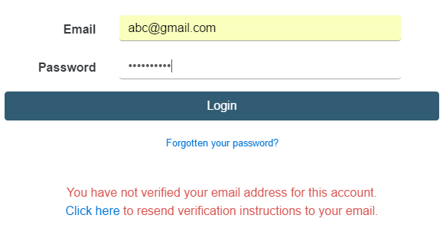

Test 1.5

The screenshot below shows the error shown when the email is not verified the password field is left empty

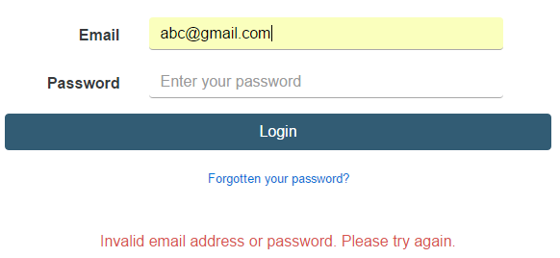.

Test 1.6

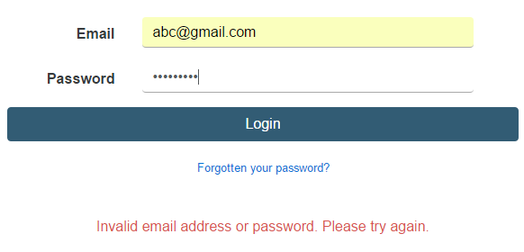The screenshot below shows the error shown when the email is not verified and the password is wrong.

Test 1.7

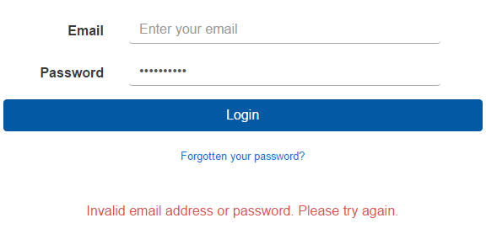The screenshot below shows the error shown when the email field is left empty.

Test 1.8

The screenshot below shows the error shown when the email field and the password field are left empty.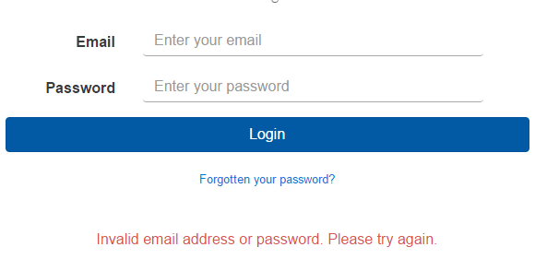

Test 1.9

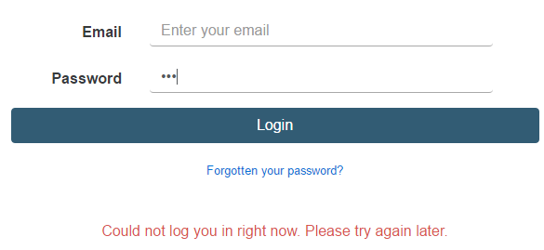The screenshot below shows the error shown when the email field is left empty and the password is not valid.

Test 1.10

The screenshot below shows the error shown when the email is not valid.

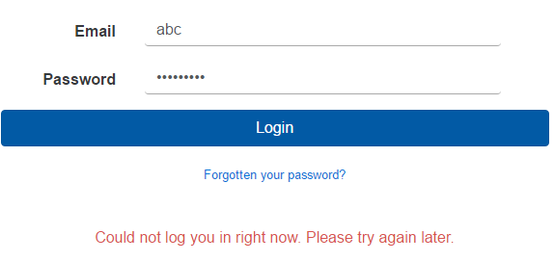

Test 1.11

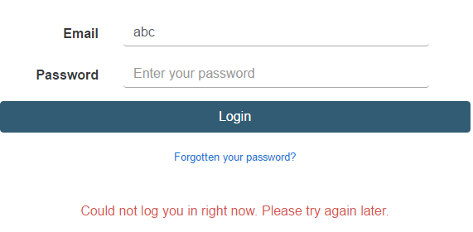The screenshot below shows the error shown when the email is not valid and the password field is left empty.

Test 1.12

The screenshot below shows the error shown when the email is not valid and the password is not valid.



Test 2

The screenshot below shows that email was sent to “[abc@gmail.com](mailto:abc@gmail.com)” provided by the user.

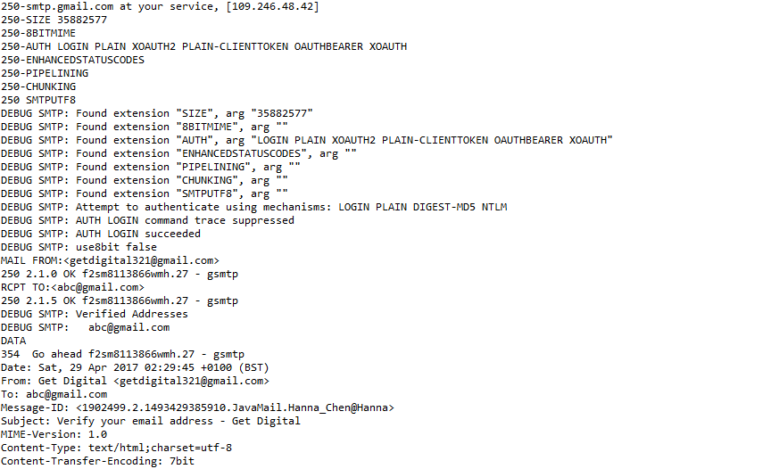

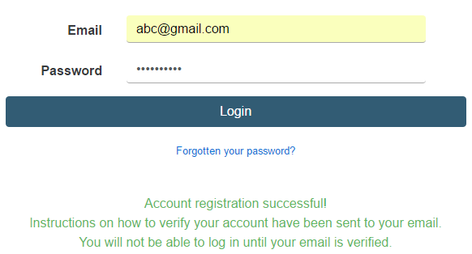The screenshot below shows after mail has sent to email successfully.