reset form test

|  |  |  |  |  |  |
| --- | --- | --- | --- | --- | --- |
| Test No | Description | TEX (Typical, Erroneous, Extreme) | Expected Outcome | Actual Outcome | Comments and Corrective Actions |
| 1. | Value entered or not entered in “Enter your email” input field. | T: A valid email is entered | Value is accepted | Screenshot in test 1.1 | This process passed. |
| E: Blank, not a valid email | Blank: “There is no user registered with that email. Please try again later.” error should be shown below the URL “return to login”  Not a valid email: “There is no user registered with that email. Please try again later.” error should be shown below the URL “return to login” | Screenshot in test 1.2 | This process passed. |
| E: Network doesn't work. | “Could not request a password reset now. Please try again later.” error should be shown below the URL. | Screenshot in test 1.3 | This process passed. |
| X: Email didn't register, | “There is no user registered with that email. Please try again later.” error should be shown below the URL. | Screenshot in test 1.4 | This process passed. |

Test 1.1

The screenshot below shows that valid input is accepted.

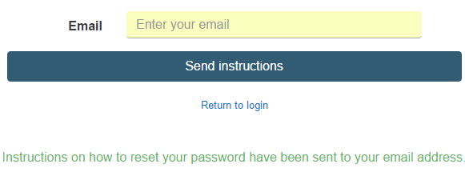

The screenshot below shows that email was sent to “[hannachen0605@gmail.com](mailto:hannachen0605@gmail.com)” provided by the user.

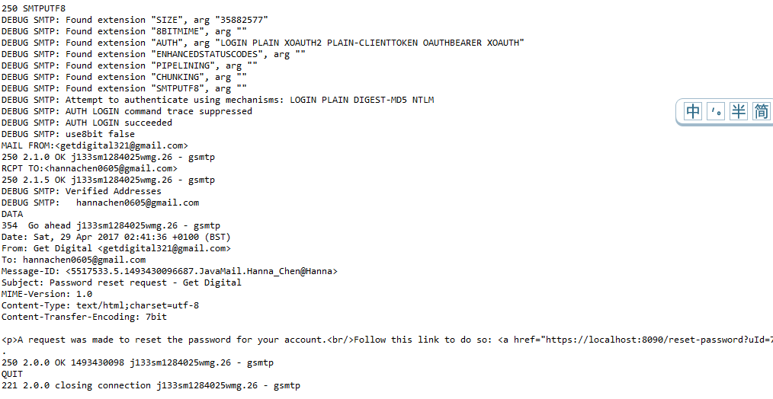

The screenshots below show that the verification email was received.

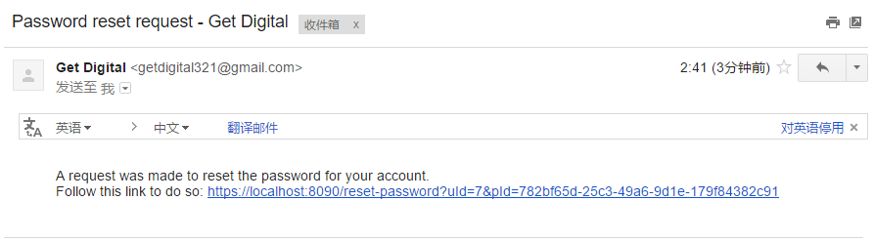

Test 1.2

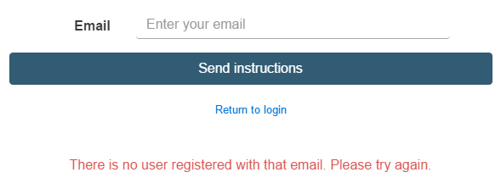The screenshots below show the errors that appear when field is blank and when the value entered is not a valid email.

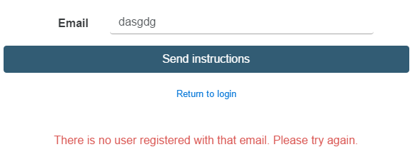

Test 1.3

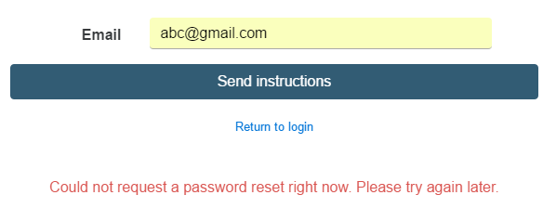The screenshot below shows the error that appears when network doesn't work.

Test 1.4

The screenshot below shows the error that appears when email didn't register.

