Signup form test

Test No | Description | TEX (Typical, Erroneous, Extreme) | Expected Outcome | Actual Outcome | Comments and Corrective Actions
1 | Choose between learner and teacher button |  | User should be able to choose only one of the buttons | Screenshot in test 1 | This process passed.
2 | Value entered or not entered in “Display name” input field. | T: A valid name is entered | Value is accepted | Screenshot in test 2.1 | This process passed.
2 | Value entered or not entered in “Display name” input field. | E: Blank | “Field is required” error should be shown below the input field | Screenshot in test 2.2 | This process passed.
2 | Value entered or not entered in “Display name” input field. | X: Numbers entered, input is less than 3 characters | “Enter your full name” error should be shown below the input field | Screenshot in test 2.3 | This process passed.
3 | Value entered or not entered in “Email” input field. | T : A valid email is entered | Value is accepted | Screenshot in test 3.1 | This process passed.
3 | Value entered or not entered in “Email” input field. | E: Blank, not a valid email | Blank: “Field is required”.  Not a valid email: “Enter a valid email”. One of the above errors should be shown below the input field. | Screenshot in test 3.2 | This process passed.
3 | Value entered or not entered in “Email” input field. | X: Email already exists in database | “Email already exists” error should be shown below the input field. | Screenshot in test 3.3 | This process passed.
4 | Value entered or not entered in “Re-enter Email” input field. | T: Same value is entered as the “Email” field | Value is accepted | Screenshot in test 4.1 | This process passed.
4 |  | E: Blank | “Field is required” error should be shown below the input field. | Screenshot in test 4.2 | This process passed.
4 |  | X: Another email value is enetered | “Emails do not match” error should be shown below the input field | Screenshot in test 4.3 | This process passed.
5 | Value entered or not entered in “Password” input field. | T: An alpha-numeric value is entered of at least 8 characters | Value is accepted | Screenshot in test 5.1 | This process passed.
5 | Value entered or not entered in “Password” input field. | E: Blank | “Field is required” error should be shown below the input field. | Screenshot in test 5.2 | This process passed.
5 | Value entered or not entered in “Password” input field. | X: Value without numbers, or of length below 8 is entered | “Password should be minimum of 8 characters and contain numberst” error should be shown below the input field | Screenshot in test 5.3 | This process passed.
6 | Value entered or not entered in “Re-enter Password” input field. | T: Value same as the “Password” field is entered | Value is accepted | Screenshot in test 6.1 | This process passed.
6 |  | E: Blank | “Field is required” error should be shown below the input field. | Screenshot in test 6.2 | This process passed.
6 |  | X: Value doesn’t match the “Password” field’s value | “Passwords do not match” error should be shown below the input field | Screenshot in test 6.3 | This process passed.
7 | “Submit button” |  | Should be disabled until all valid inputs are entered | Screenshot in test 7 | This process passed.
8 | Form submitted after valid inputs |  | Verification email should be sent to the email provided by the user. | Screenshot in test 8 | This process passed.

Test 1
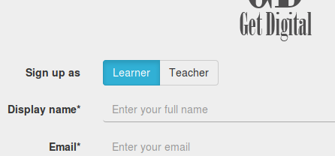
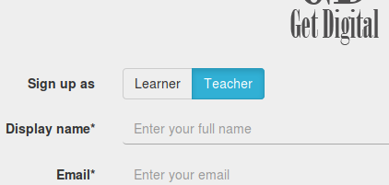
The screenshots below show that the user is able to choose either the “Learner” or “Teacher” button.

Test 2.1
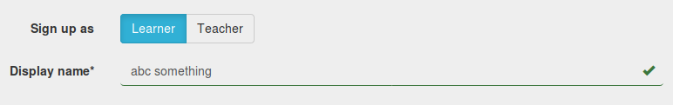
The screenshot below shows that valid input is accepted.

Test 2.2
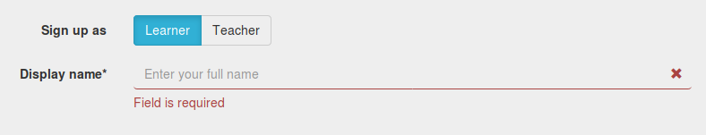
The screenshot below shows the error shown when the field is left empty.

Test 2.3
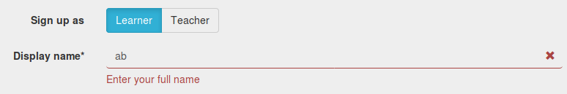
The screenshot below shows the error shown when the value entered is not valid.

Test 3.1
The screenshot below shows the value is accepted when a valid email is entered.
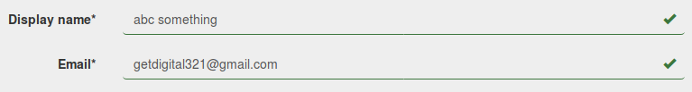

Test 3.2
The screenshots below show the errors that appear when field is blank and when the value entered is not a valid email.
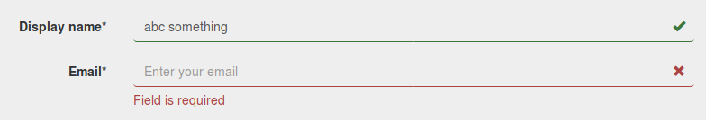

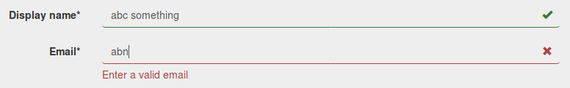

Test 3.3
The screenshot below shows the error that appears when email is already in database.
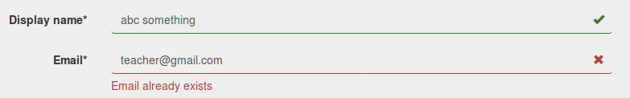

Test 4.1
The screenshot below shows the value is accepted when the emails are same.
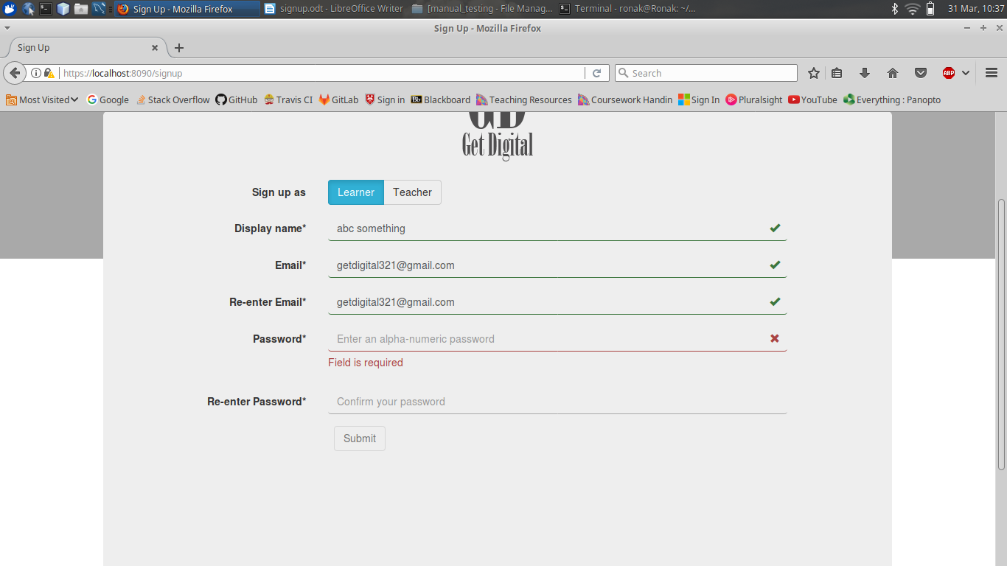

Test 4.2
The screenshot below shows the error that appears when the field is left blank.
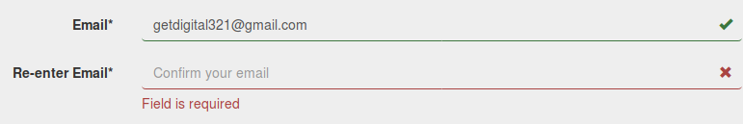

Test 4.3
The screenshot below shows the error when the field doesn’t match the “Email” field.
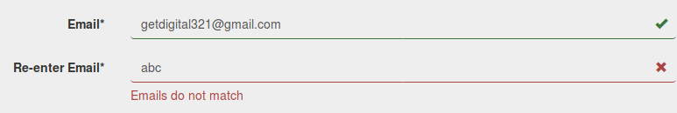

Test 5.1
The screenshot below shows the value is accepted when a valid alpha-numeric password is entered.
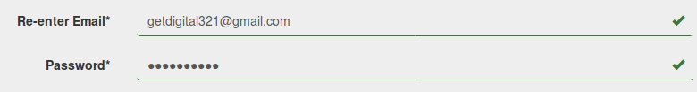

Test 5.2
The screenshot below shows the error that appears when the field is left blank.
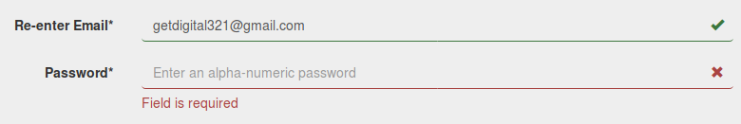

Test 5.3
The screenshots below shows the error that appears when only alphabets are entered or when the entered value length is below 8 characters.
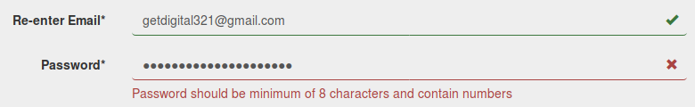

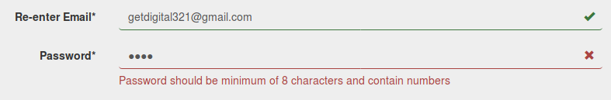

Test 6.1
The screenshot below shows the value is accepted when the passwords are same.
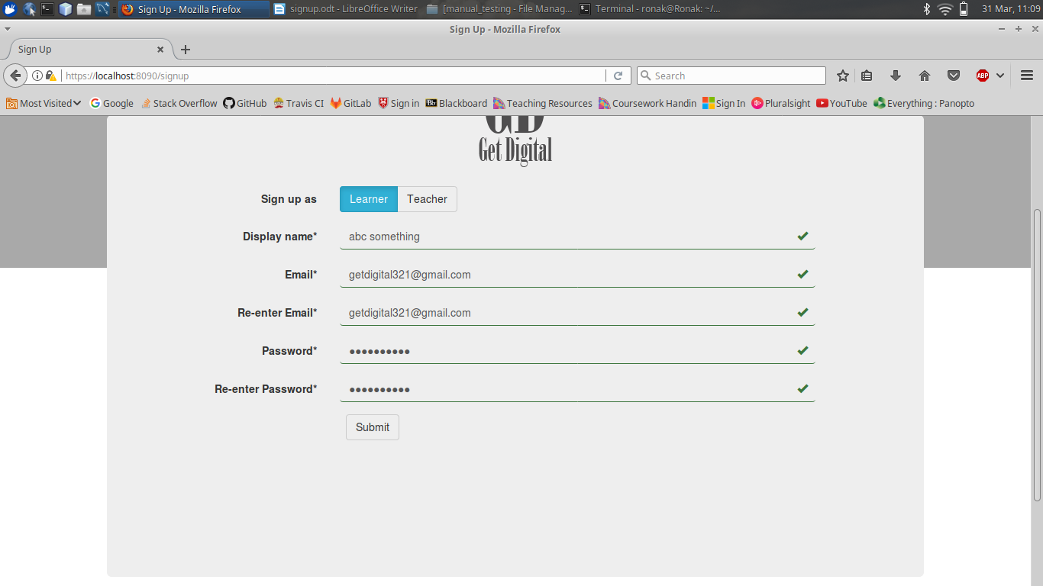

Test 6.2
The screenshot below shows the error that appears when the field is left blank.
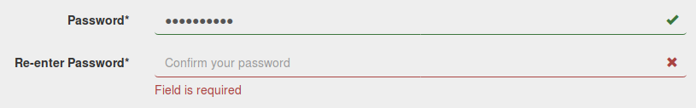

Test 6.3
The screenshot below shows the error that appears when the entered value doesn’t match the “Password” field’s value.
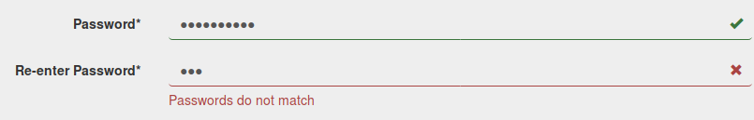

Test 7
The screenshot below shows that “Submit” button is disabled when one or more fields are missing.

The screenshot below shows that “Submit” button is enabled when all the fields are accepted.

Test 8
The screentshot below shows that email was sent to “getdigital321@gmail.com” provided by the user. It was sent at 11:18 on Friday, 31 March 2017.
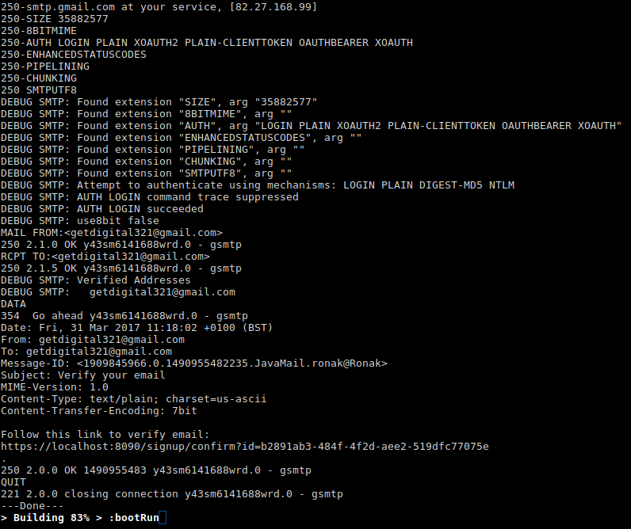

The screenshots below show that the verification email was received at 11:18 am on Friday, 31 March 2017.

