Sequence Diagram

한빛교육센터 LMS Sequence Diagram

6Class.4조.박미선

Login Sequence

6Class.4조

제출자:박미선

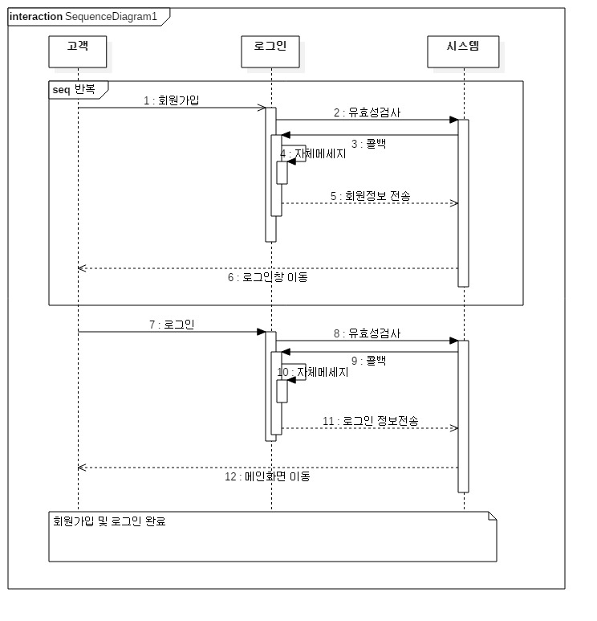

1

Membership Sequence

6Class.4조

제출자:박미선

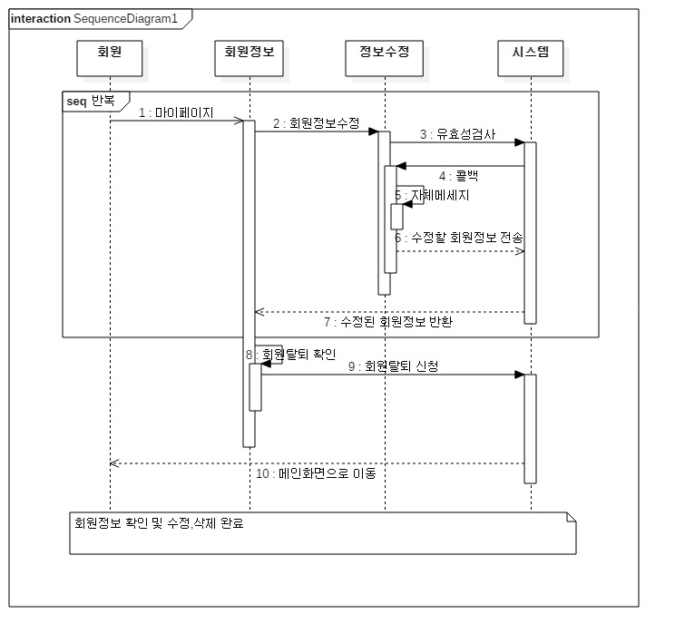

2

Grade Sequence

6Class.4조

제출자:박미선

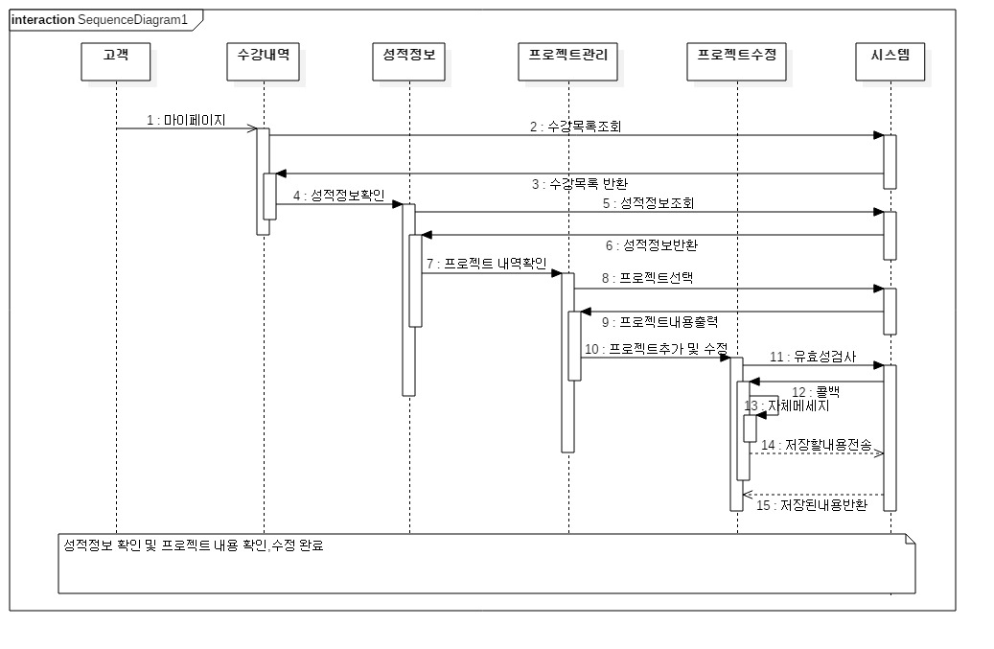

3

[Instructor](https://search.naver.com/p/crd/rd?m=1&px=358&py=318&sx=358&sy=318&p=TtYlHlpySDGssatOa5Vssssssu4-473367&q=%B0%AD%BB%E7&ssc=tab.nx.all&f=nexearch&w=nexearch&s=bzVAs7oKOOxCbsonFKcjPw==&time=1478222063848&t=14&a=ldc_btm*e.auto&r=1&i=08099047_000000000602&u=http://endic.naver.com/search.nhn?query=instructor&cr=3) Sequence

6Class.4조

제출자:박미선

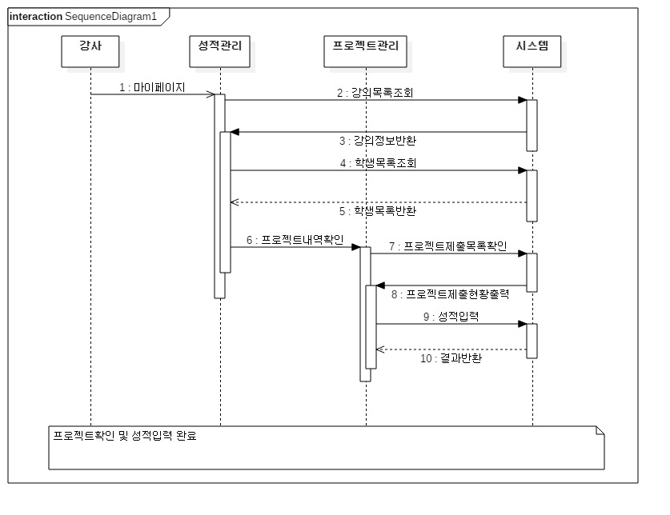

4

[Sales](https://search.naver.com/p/crd/rd?m=1&px=340&py=681&sx=340&sy=681&p=TtYQvlpySoGssbJaa30sssssss0-349619&q=%BF%B5%BE%F7&ssc=tab.nx.all&f=nexearch&w=nexearch&s=bzVAs7oKOOxCbsonFKcjPw==&time=1478221590736&t=14&a=ldc_btm*e.auto&r=1&i=08099047_000000018362&u=http://endic.naver.com/search.nhn?query=sales&cr=3) Sequence

6Class.4조

제출자:박미선

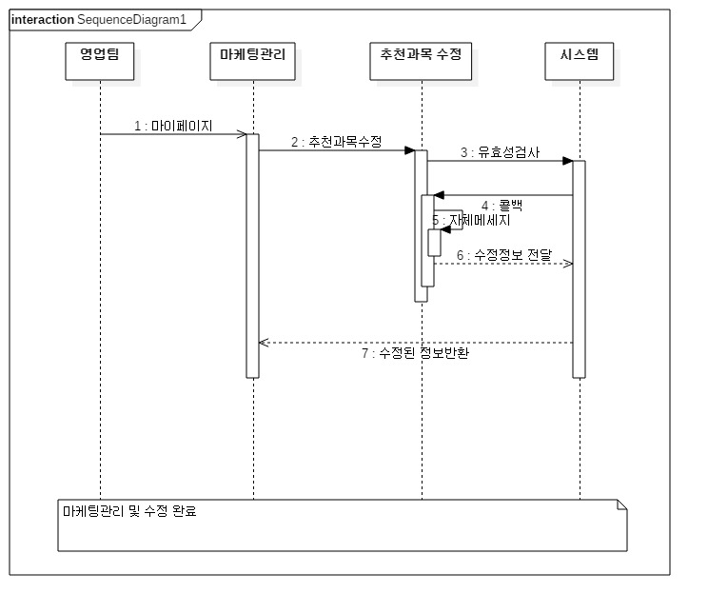

5

[Administration](http://endic.naver.com/search.nhn?query=administration) Sequence

6Class.4조

제출자:박미선

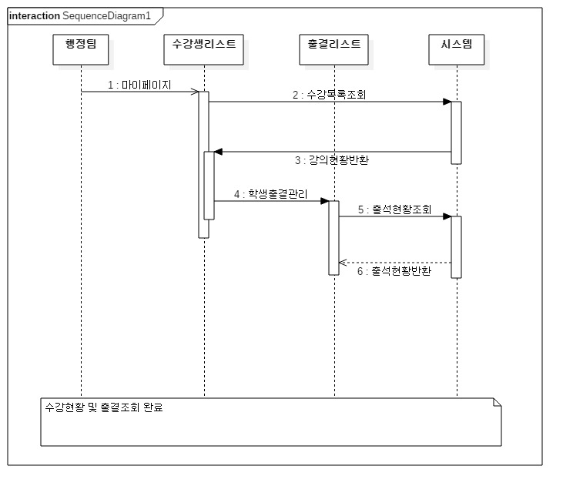

6

[Administration](http://endic.naver.com/search.nhn?query=administration) Sequence

6Class.4조

제출자:박미선

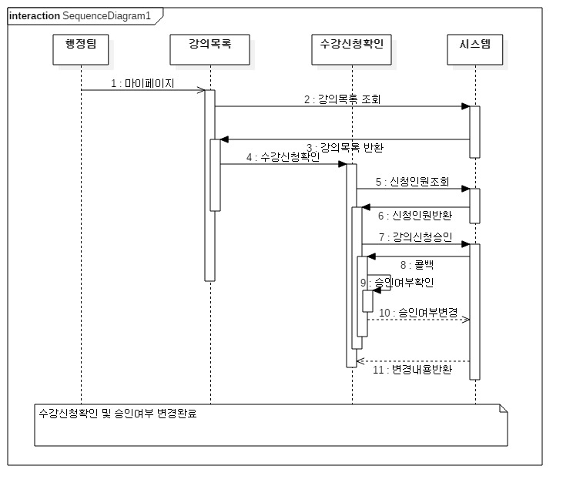

7

Menu Sequence

6Class.4조

제출자:박미선

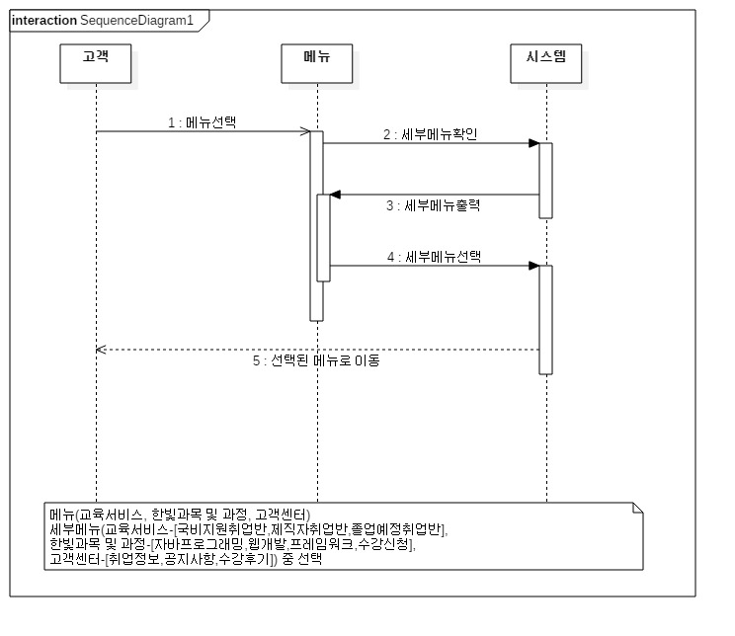

8