# E-Learning System: Technical Documentation

## Executive Summary

The technical report is designed to give insight into the evolution and realisation of the E-learning system which unlike other systems, has a dual interface to assist both students and the tutor. This system also contains basic components of course management, user and content management, and progress tracking of the course completers.

## 1. Introduction

### 1.1 Purpose

The purpose of this e-learning system is to implement appropriate technology which will allow sufficiently interactive learning environment while students have direct contact with the tutor and the course is not compromised .

### 1.2 Scope

Payment integration, content, course and progress management system as well as an interface for both students’ and tutors’ to carry out these operations will be provided in the system.

## 2. System Architecture

### 2.1 User Authentication

The system provides a standard login or signup to an account and supports two major account types which include the following:

* A student log in
* A tutor log in

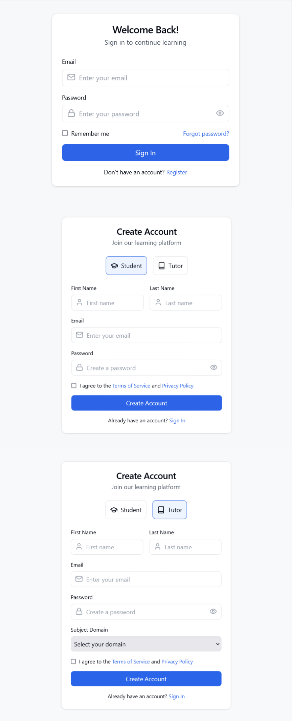

2.2 Core Functionalities

#### 2.2.1 Student Interface

* The ability to search for and register in the courses offered.
* Payment systems for access to paid courses
* The ability to track the student’s activity levels.
* A page where the course students can submit assigned work.
* A page where the user can go and take quizzes and tests.
* A page where the students are able to evaluate the course content and its structural components.
* Search and some other filters.

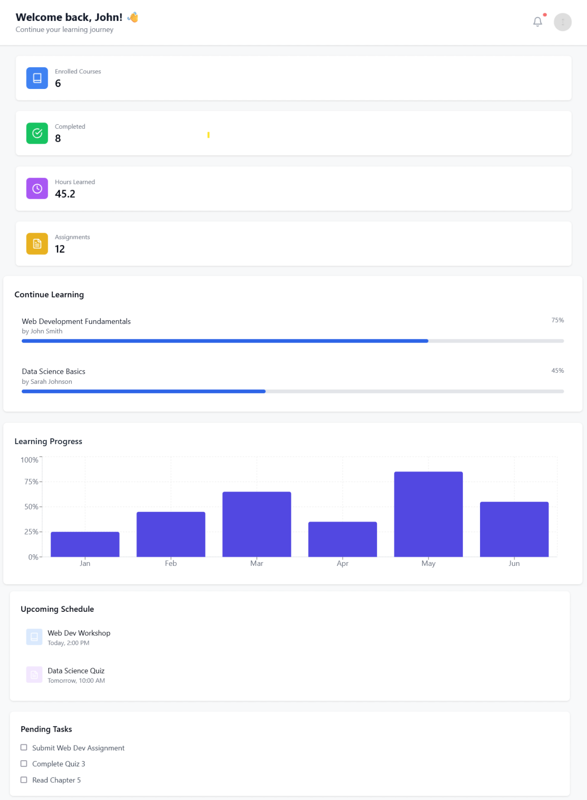

#### 2.2.2 Tutor Interface

* A complete dashboard with all functionalities for effective course administrative duties
* Course creation and editing functionality
* Assignment Management System or framework.
* Tracking of students
* Revenue collection and payment tracking
* System for alerts, when courses are bought

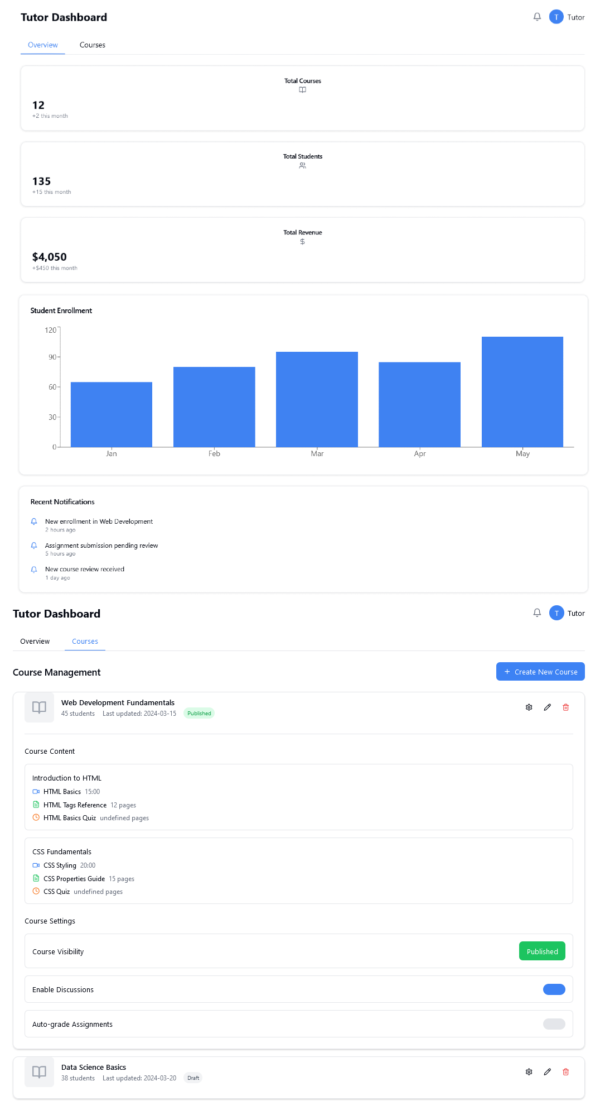

## **3. Key Features Implementation**

### 3.1 Course Management System

* Mechanisms for course creation and modification.
* Facilitation of content management.
* Incorporating overhead such as assignments along with quizzes.
* System of controlling reviews

### **3.2 Payment Integration**

* Payment transaction with the students.
* Monitor and control the income of the tutors.
* Keeping track of transactions.
* Automated alerts.

### 3.3 Progress Tracking

* Focusing on student performance.
* Tracking the students that have completed the course.
* Tracking students that submitted their assignments.
* Controlling students quiz.

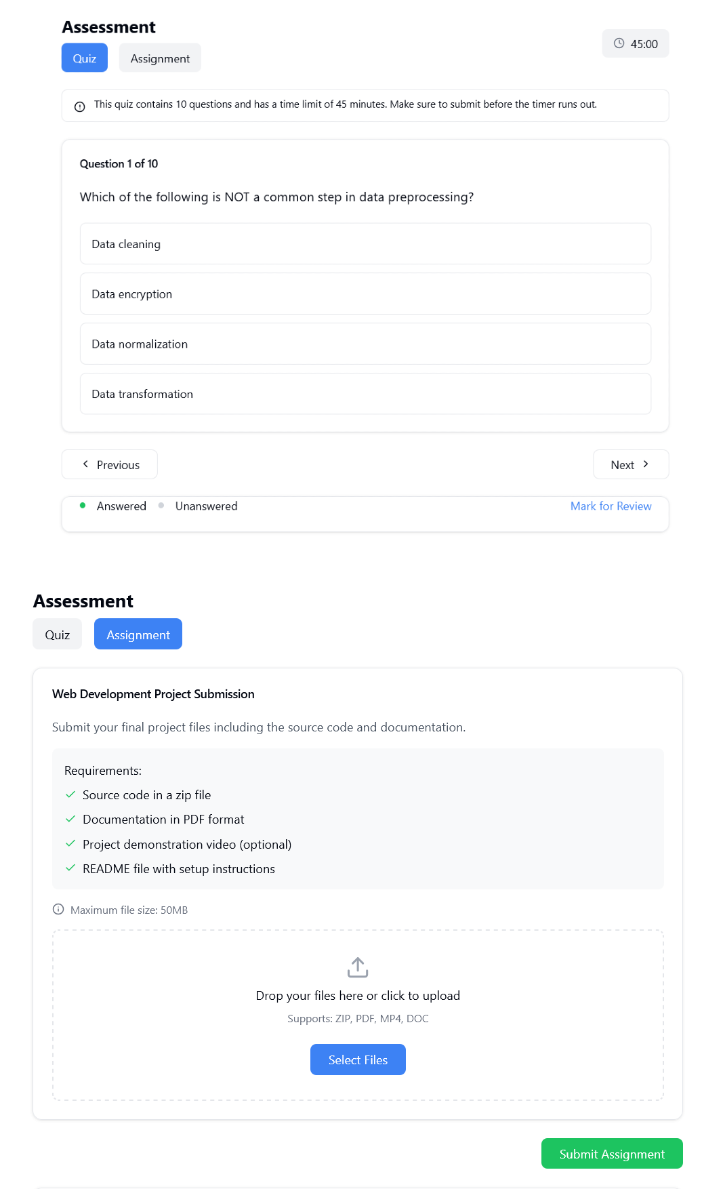

## User Interface Design

### 4.1 Student Portal

The student interface is designed with a focus on simplicity in going through the different pages and getting information regarding the progress of the courses.

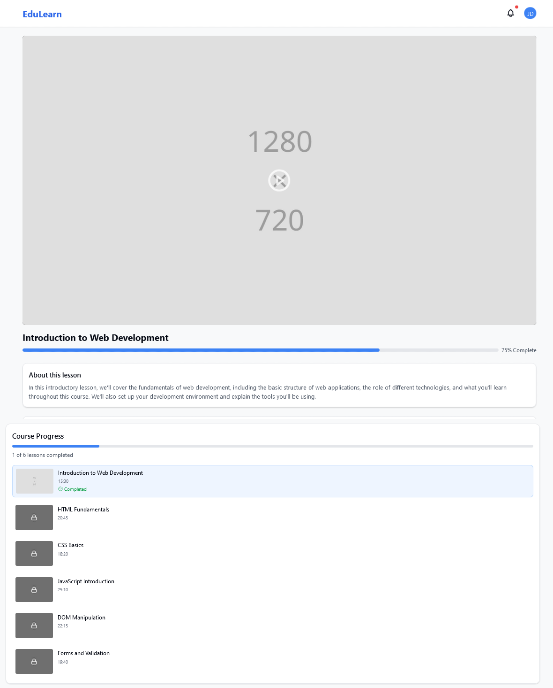

### 4.2 Tutor Dashboard

The tutor mobile interface is designed to be able to manage the course, track students, and then manage students all in one interface.

## 5. System Features

### 5.1 Search and Filter Functionality

* Course filters
* Tutor profile
* Rating criteria
* Filtering by category
* Calendar

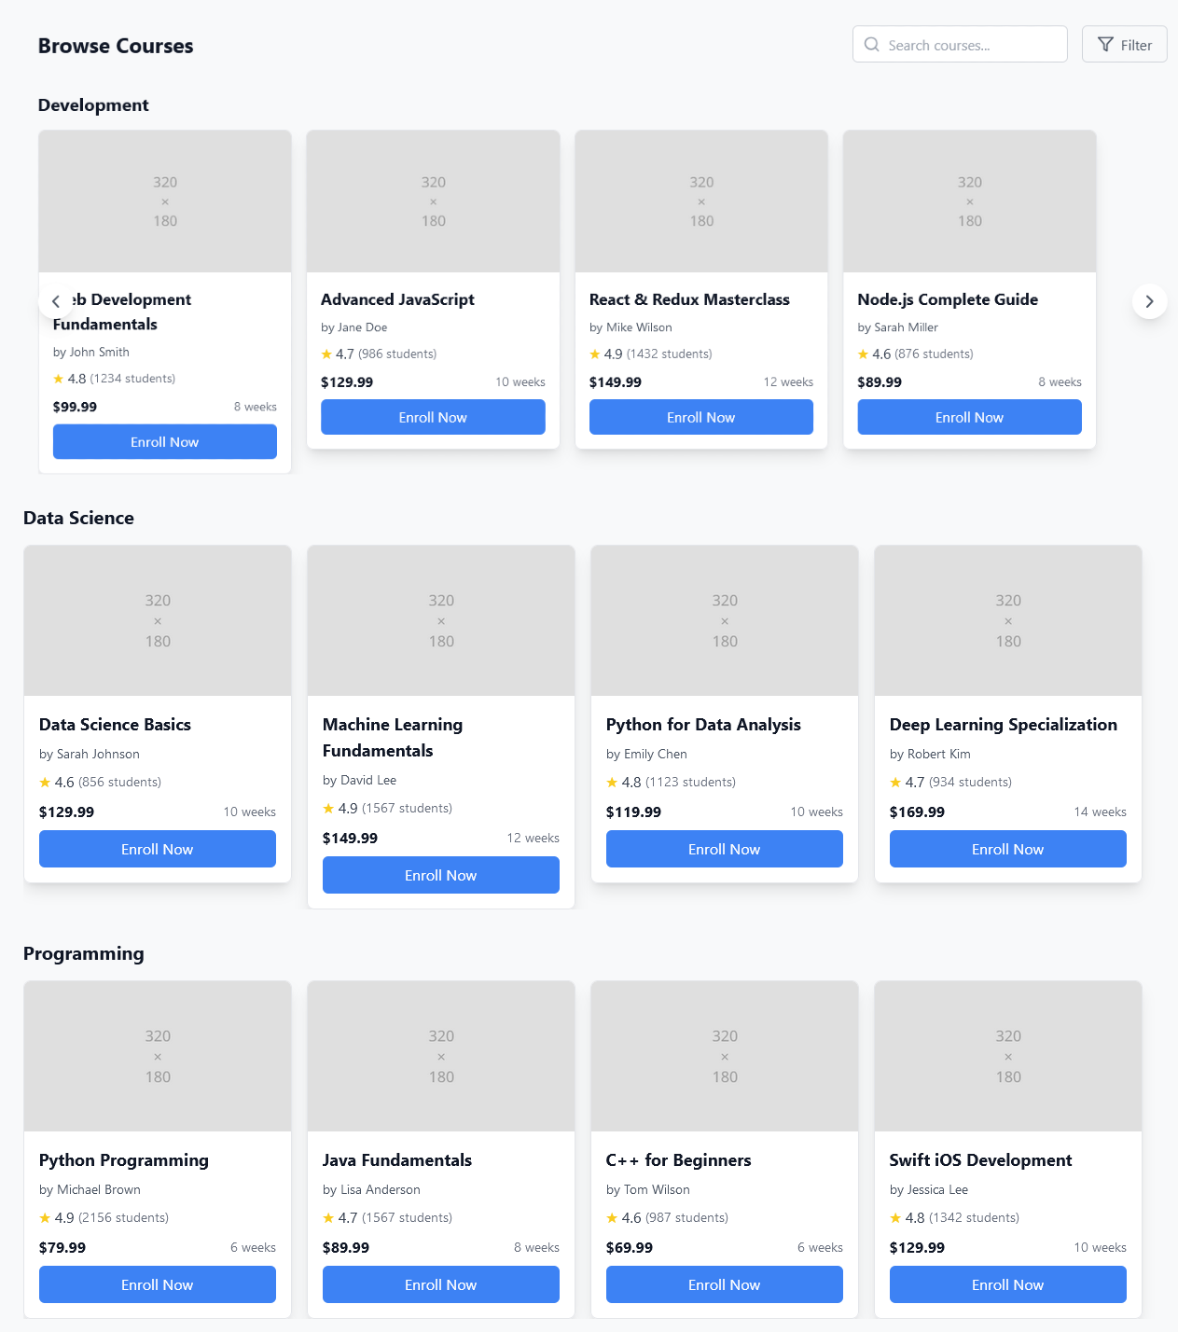

### 5.2 Content Management

* Option to upload courses
* The option of designing and allocating target tasks
* Facilities for creating specific Quizzes
* Allow a system for checking content

## 6. Technical Specifications

The system utilizes modern web technologies to ensure responsive design and optimal performance across devices.

## 7 . Software Diagrams of System

### Data flow Diagrams:

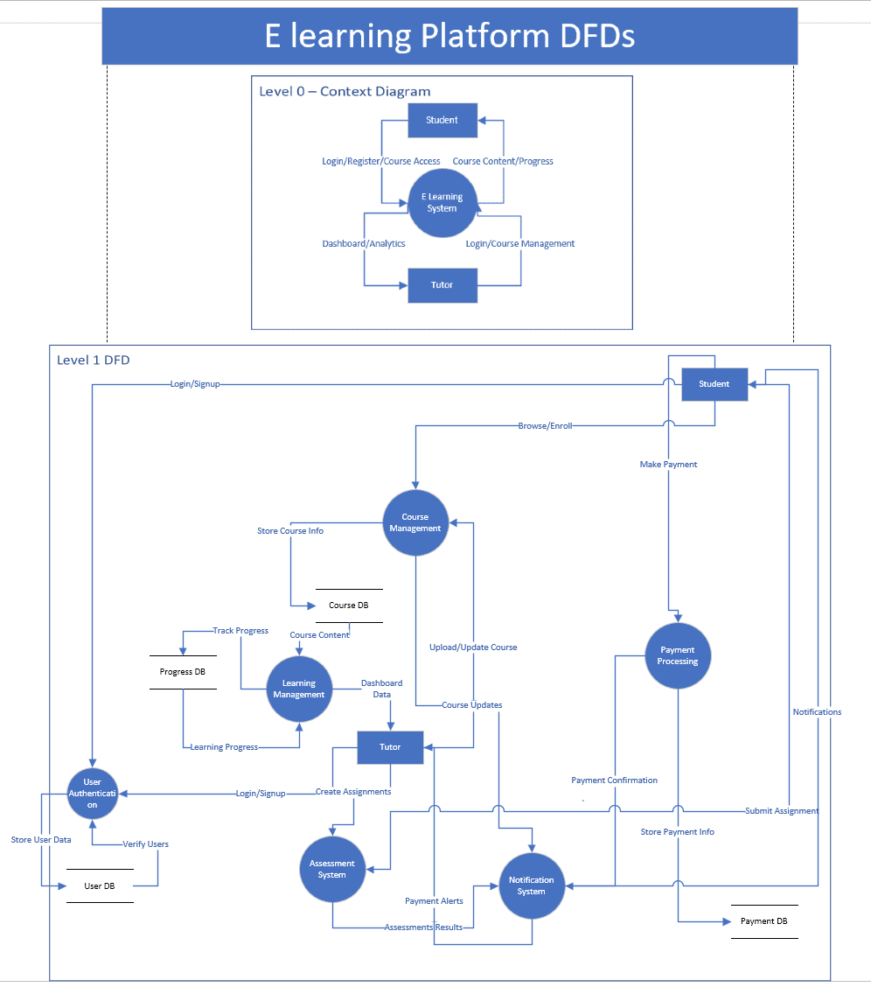

#### Explanation:

The DFDs illustrate the two main levels of interaction employed in the E-Learning Platform, which are Level 0 and Level 1. Level 0 also known as a Context Diagram is relatively simple and demonstrates participants of basic functionality that involves students, tutors, and the core E-Learning System. Level 1, and which is the most specific one, builds on and demonstrates the functions of course management, learning management, assessment system and processing payment. The said diagram depicts how the information flows through these processes which include but not limited to user registration, course distribution, feedback, and course payment. Various flows integrate the processes and these flows signify course registration, coursework turnover, and registration for payment.

### Usecase Diagram:

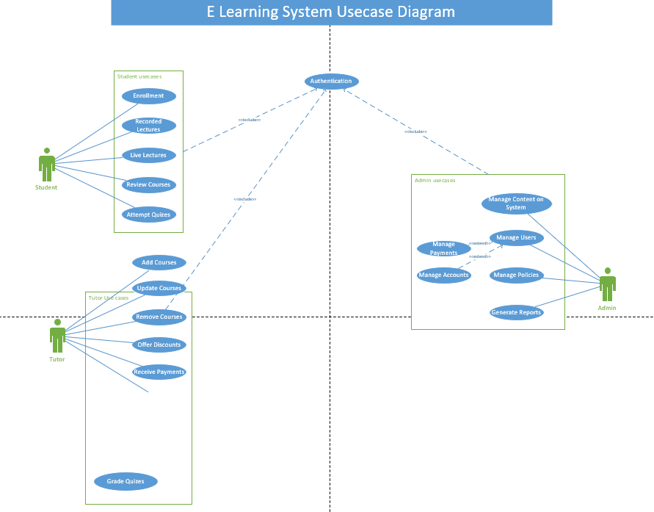

#### Explanation:

The purpose of the Use case diagram is to show all possible relationships between E-Learning System and its different user elements. The users such as Students, Tutors/Instructors and Administrators are actors in essence measurable and sayable that comes from three main categories. Students are able to undertake actions such as enroll in courses, preview materials, and upload papers. Tutors have the disbursement of and assign the specific tasks pertaining to the course. The administrator has the most extensive responsibilities that include the management of the system, control of content and users. The diagram gives a better depiction of the action of the system as different users perform different tasks.

### Class Diagram:

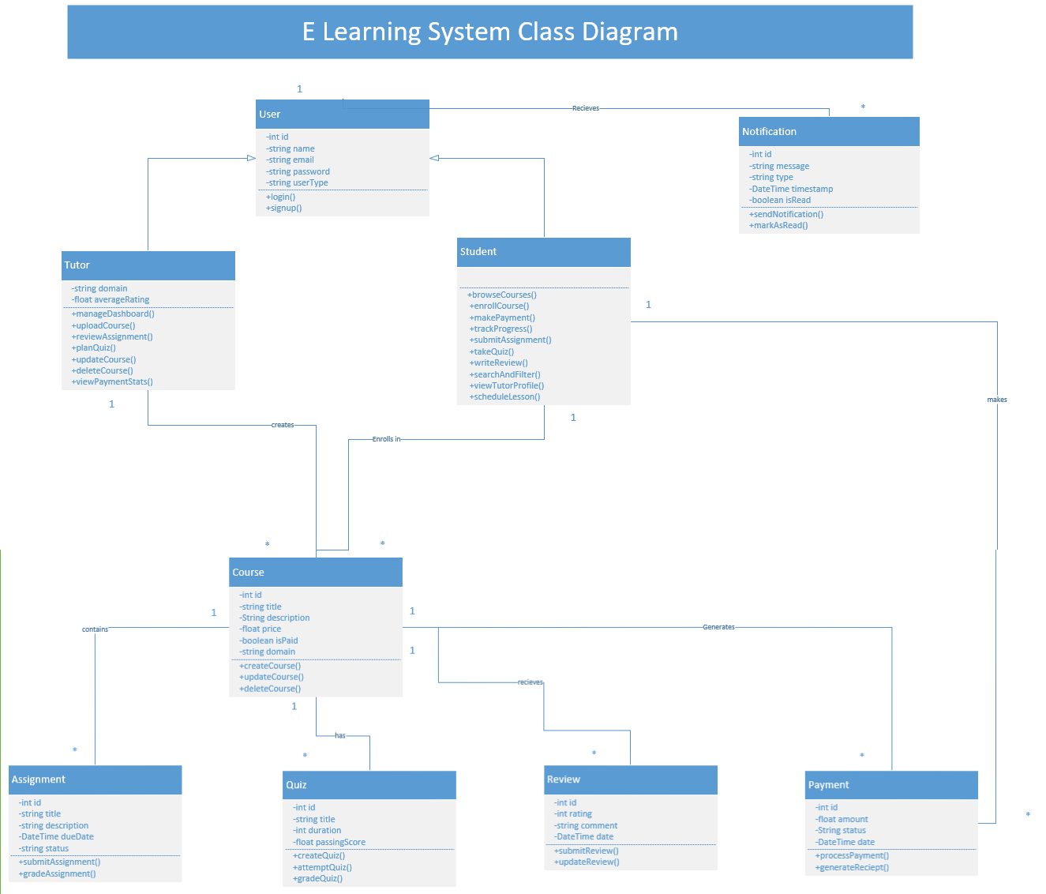

#### Explanation

The Class diagram serves as a technological map that illustrates the object-oriented design of the E-Learning System. It displays the hierarchy of the different classes like the User (the general class), Student, Tutor, Course, Assignment, Payment and Notification classes. Each of these classes has its respective characteristics (data fields) and functions (methods), and the relationships between them are clearly defined. For example, the Student class has a derived relationship with the User class and has associations with Course and Assignment classes. The diagram depicts the different classes, their subclass relationships, their associations as well as the multiplicities, all using UML so as to give a clear picture of the systems technical design.

### Swimlane Diagram

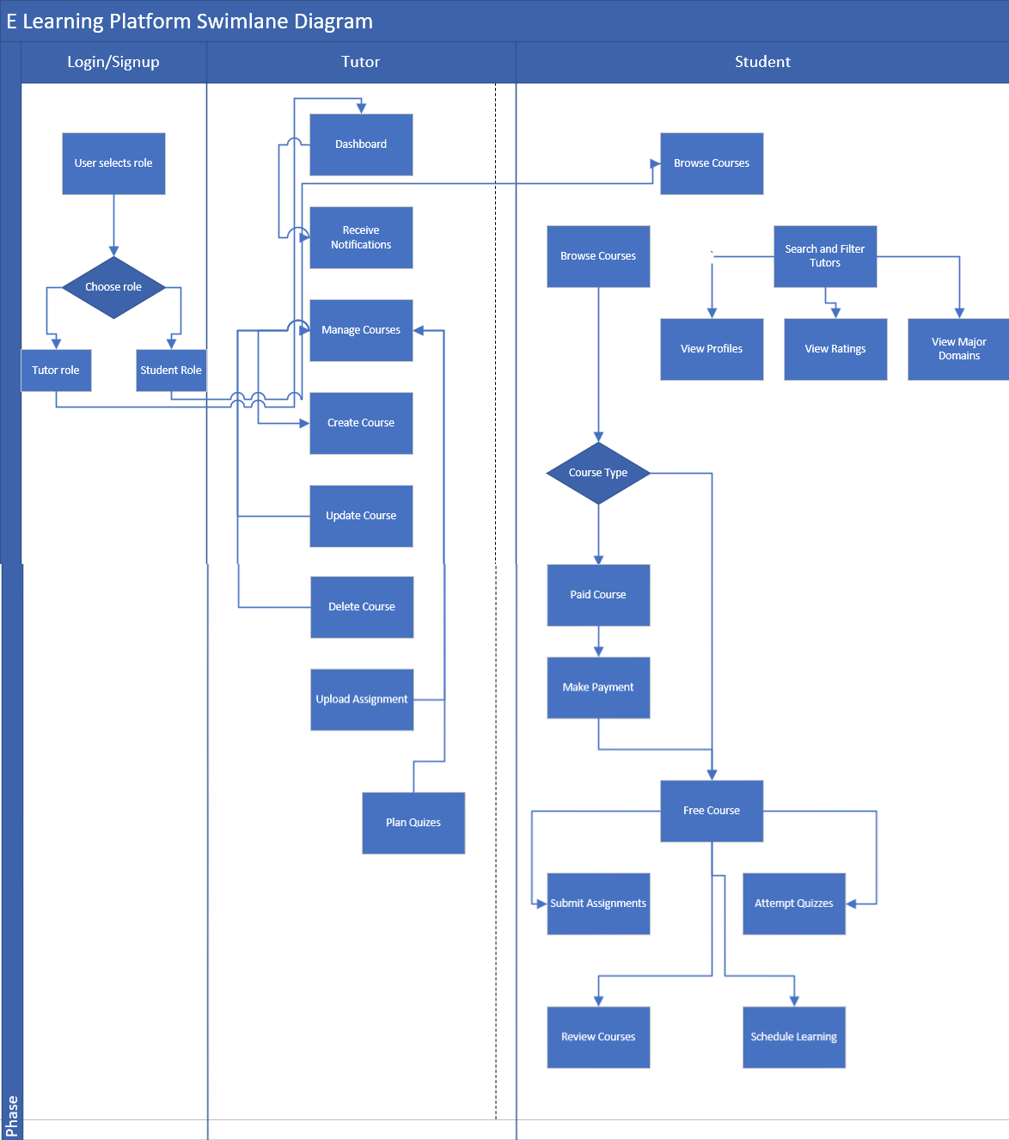

#### Explanation

A process flow diagram in which actions are organized into three Guru focused lanes (Login/Signup, Tutor, and Student) identifying the users and explaining the tasks of the E-Learning system. The tutors are able to log in to the dashboard, create, change and delete courses, upload assignments and plan quizzes. The students are able to find courses, pay for paid courses, complete quizzes, submit assignments and schedule when they want to study. The diagram presents a neat step-by-step connection of events where every user role is expected to perform certain actions including making a choice on the type of course to undertake at that stage.

### Sequence Diagram

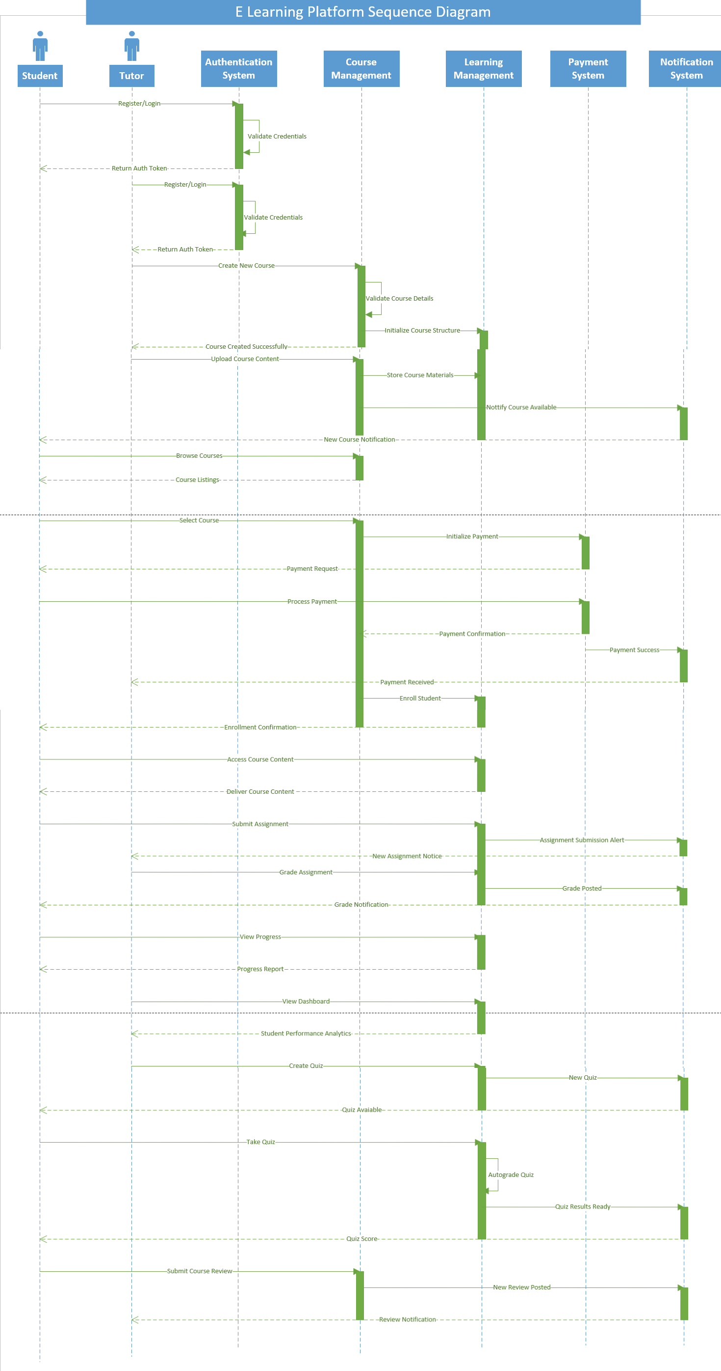

#### Explanation

It is a schematic of the system that represents in time the interactions of all the components in the system that are present. It provides in detail how the message travels from the user logging in to the course lifecycle management. The diagram contains key processes, which include, the registration of users, adding new courses and students, making payments, submitting assignments, grading and notifying users. All these interactions are time bound and so, include sequenced validation management and confirmation messages as well so that all system operations are comprehensively viewed from its onset to its completion.

### Collaboration Diagram

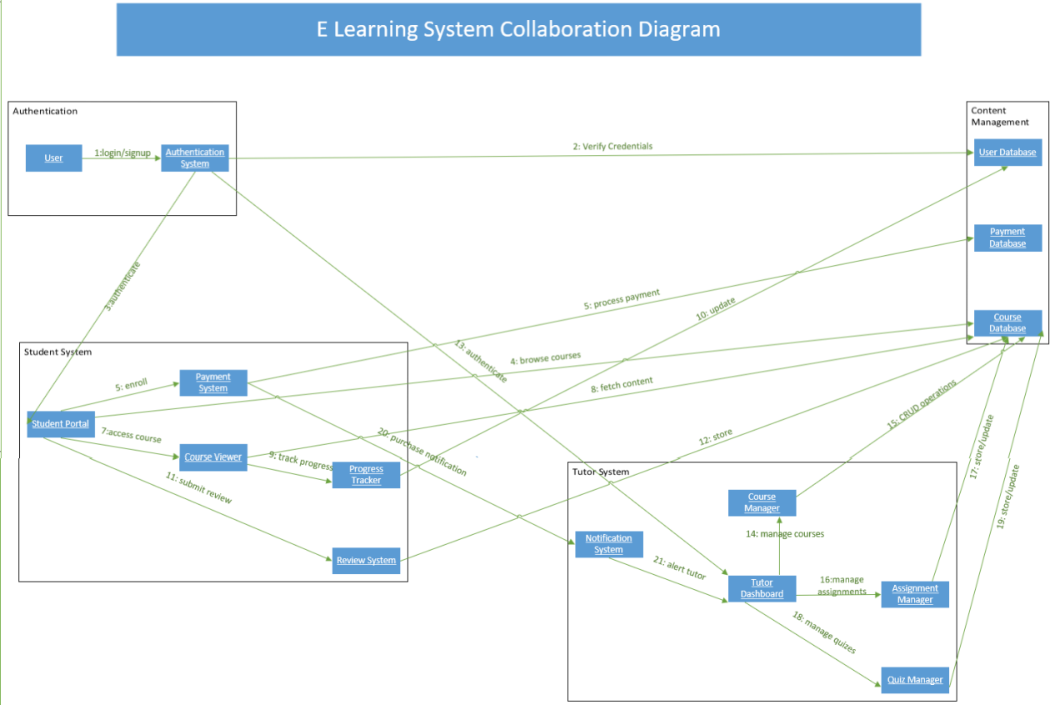

#### Explanation

Illustrates the system design, via the components and the message flow between them. The components of this diagram can be divided into various systems namely; Authentication system – this is the module that manages user login credentials, Student System – this module manages learners activities and Tutor System – this module manages the facilitation of courses and Content Management. A diagrammatic illustration also provides an overview of the connections between major system operation processes labelled numerically from one to twenty five (1-25) of how the systems interact to facilitate the functionalities of the modules like course registration, make payment and supply content. The sequence of the diagram emphasizes more on the spatial arrangement of components than the time ordering of the components..

### State Diagram

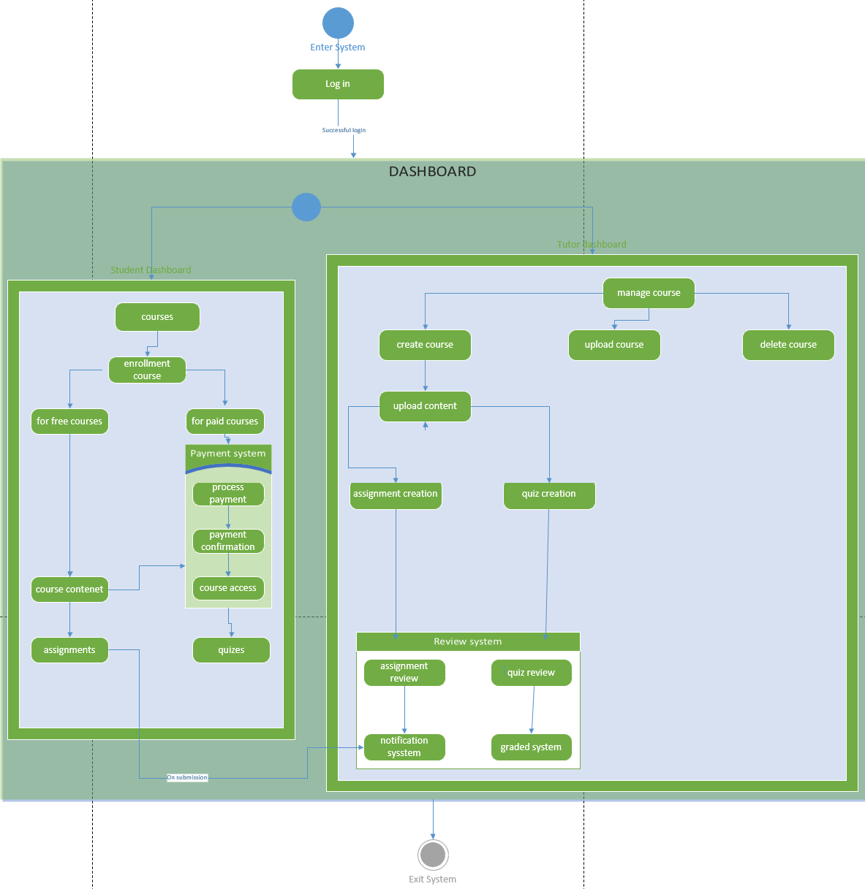

#### Explanation

This diagram depicts the state-based architecture of the e-learning system. It shows the key components and their interactions:

* Authentication System: Handles user login and verification.
* Dashboard: Serves as the central interface for system operations.
* Payment System: Manages course enrollment, payments, and financial transactions.
* Learning System: Encompasses course content delivery and student activities.

These components communicate through various operations to enable features like user login, course management, content uploads, and payment processing.

### Activity Diagram:

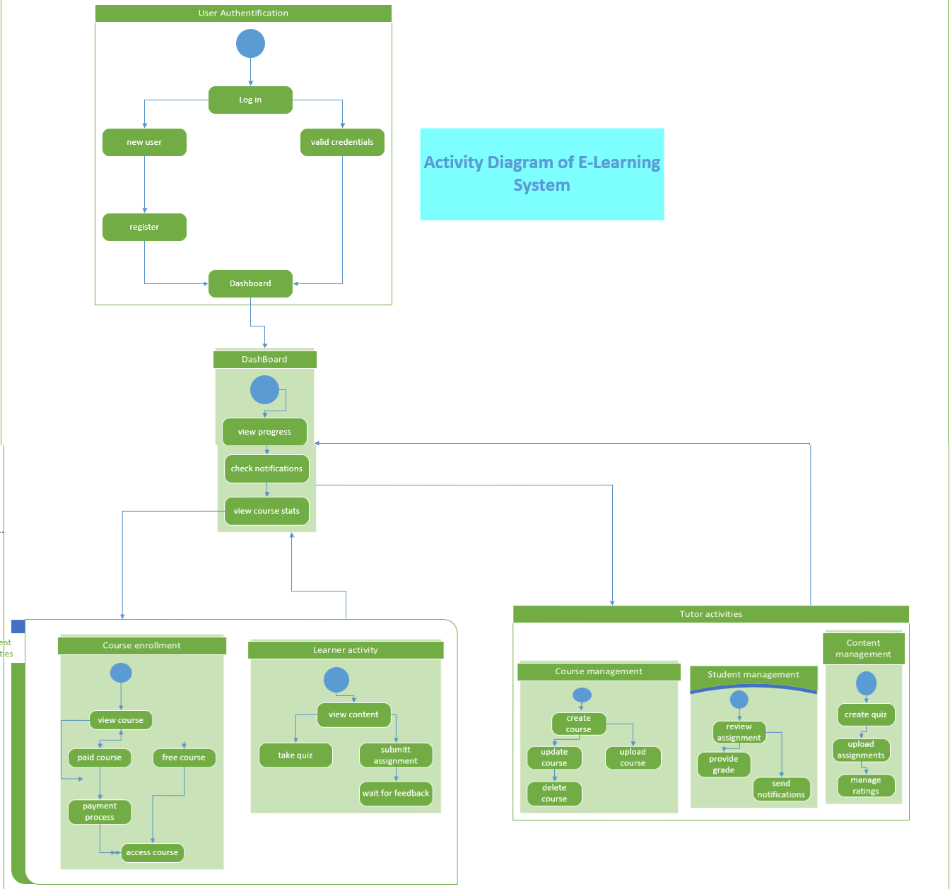

#### Explanation

This diagram presents the activity flow within the e-learning system, highlighting the interactions between key modules:

* User Authentication: Manages login, credential validation, and authentication processes.
* Dashboard: Acts as the central access point for user interactions.
* Course Management: Handles course enrollment, content uploads, and related functions.
* Content Management: Responsible for storing, organizing, and distributing educational resources.

This diagram illustrates the activity sequence and data exchanges between these modules, showcasing the system's core functionality.

## 8. Future Enhancements

* A future goal includes the creation of an advanced analytics dashboard.
* Interactive virtual classrooms.
* Designing mobile applications is also another goal.
* Use AI to personalize content recommendations.

## 9. Conclusion

The E-learning system does this well since all the functionalities that are required have been integrated alongside easy to use interfaces for both the students and the tutors as well. The system provides a flexible delivery of online education as an opportunity for growth with effective course management and interaction features.