Field Inspection Report
This report is auto generated from Survey123 mirroring field submissions. The field notes are cleaned using OpenAI gpt-4o-mini, whilst maps are generated locally.

Site 94 — 2026-04-15
Inspector | Alice Mouton
Coordinates | 30.2241, -92.0198
Creation date | 2026-04-15

Inspector observation:
Cracked DI top.

Site photo | Location map
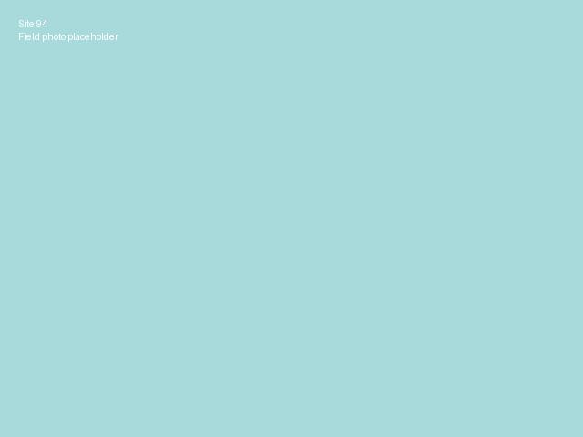 | 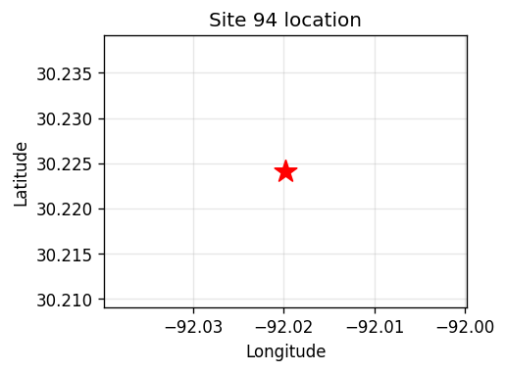

Site 95 — 2026-04-15
Inspector | Bob Hebert
Coordinates | 30.2305, -92.0254
Creation date | 2026-04-15

Inspector observation:
The DI top is cracked on the edge.

Site photo | Location map
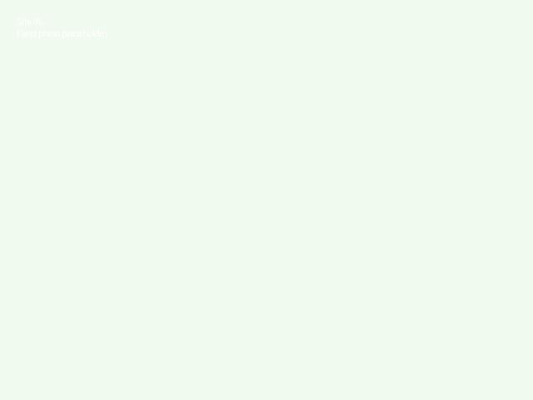 | 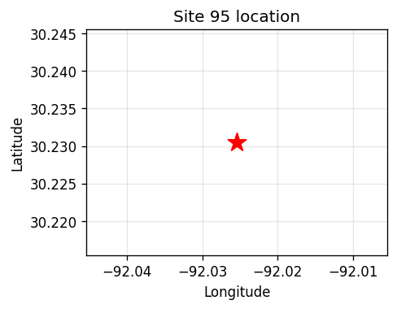

Site 96 — 2026-04-16
Inspector | Alice Mouton
Coordinates | 30.2189, -92.0142
Creation date | 2026-04-16

Inspector observation:
Sloping TP to the building.

Site photo | Location map
 | 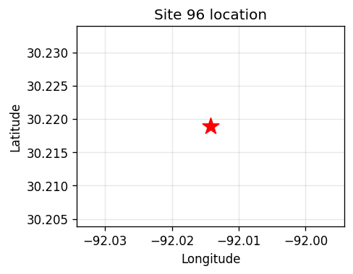

Site 97 — 2026-04-16
Inspector | Coy LeBlanc
Coordinates | 30.235, -92.0301
Creation date | 2026-04-16

Inspector observation:
The grading TP step is not correct.

Site photo | Location map
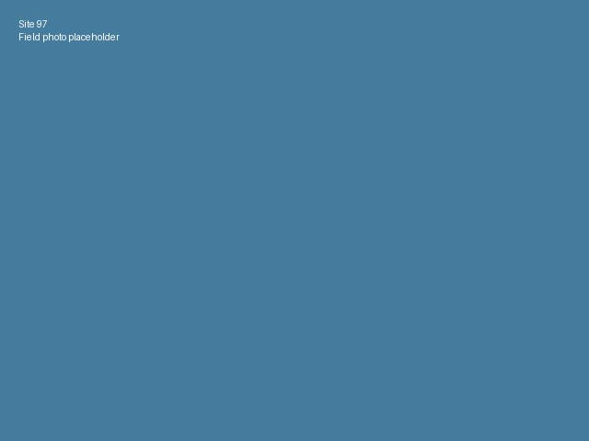 | 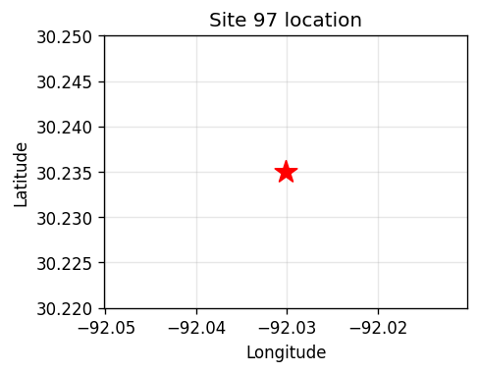

Site 98 — 2026-04-17
Inspector | Bob Hebert
Coordinates | 30.226, -92.022
Creation date | 2026-04-17

Inspector observation:
Conduit exposed at base needs cover ASAP.

Site photo | Location map
 | 