**Freelancing**

**Masterclass 1**

* Gigster, Toptal, usebraintrust, turing, remotebase - talent networks.
* Don’t cut the middleman.
* Cash > Stock, if -50k cash then +150k stock. General rule of thumb 2-3 times increase in stock.
* Strike price and fair market value, you make on whatever the company sells for above the strike price.
* Upwork doesn’t get you long term projects.
* Remote – No DSA, System Design, Code along project.
* Status codes matter a lot in talent networks interview. Write tests. Write a lot of comments. OpenAPI file, swagger page.
* They’ll break your confident and would want you to make live changes.
* For DSA question, time is live 12, 15, 16 minutes. JS is preferred.

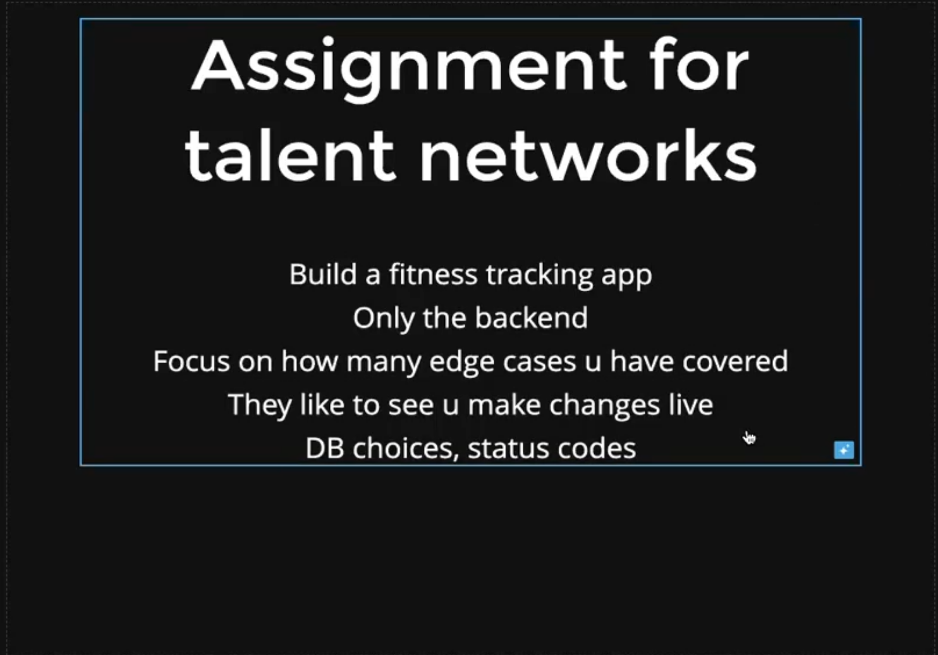

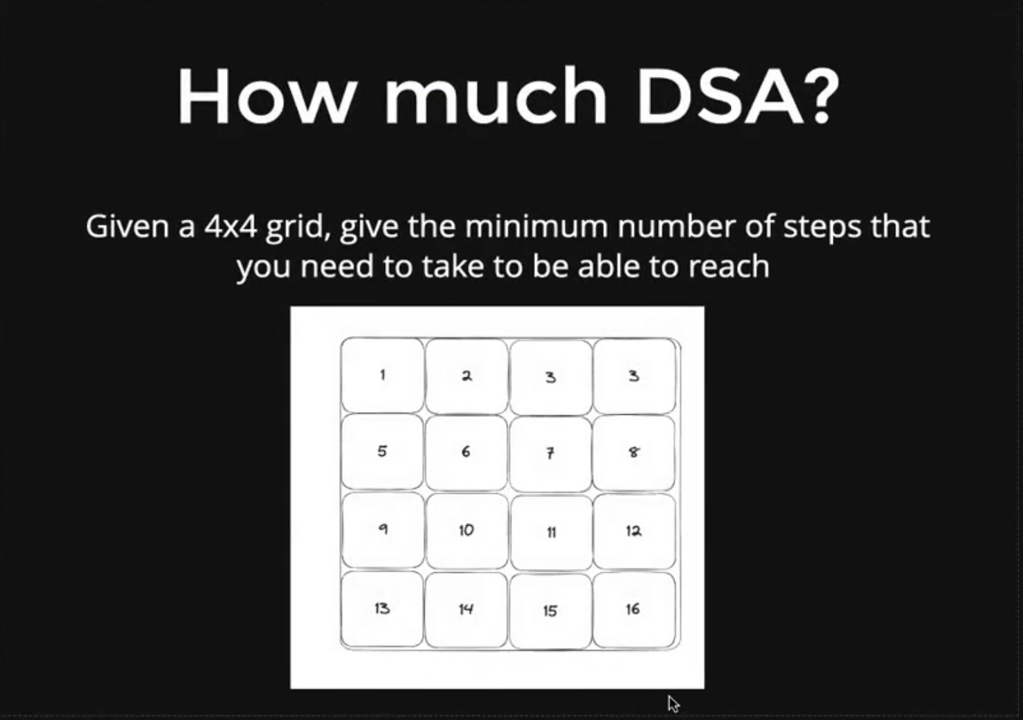

**Masterclass 2**

* ycombinator.com/companies?batch=S24.
* Go to their website 🡪 build a better website 🡪 message them 🡪 saw you on ycombinator, doing great, website is shit.
* Keep a solid GitHub handy. Opensource and personal projects are the key.
* 26.45

