**Section 1: Metadata**

*to be filled by the student*

**1.1. Project Information** to be filled by the student

| Title: NGOConnect | |
| --- | --- |
| Section: L4 | Instructor: Qasim Pasta |

**1.2. Student(s) Information**

| Name: Muhammad Saad | ID: 08063 |
| --- | --- |
| Section: L4 | Batch: 2026 |

| Name: Ali Ahsan | ID: 07832 |
| --- | --- |
| Section: L4 | Batch: 2026 |

| Name: Mannan Muhammad Rangooia | ID: 07882 |
| --- | --- |
| Section: L4 | Batch: 2026 |

| Name: syed murtuza | ID: 07882 |
| --- | --- |
| Section: L4 | Batch: 2026 |

**Submission guideline:** Save your project proposal as a pdf file and rename as Project Proposal_L1_ProposedTitle where L1 is to be replaced with your section

**Section 2: The Project**

*to be filled by the student*

**2.1. Project Description:** *Please provide a brief introduction of the project including its scope.*

The NGOConnect project aims to create a comprehensive and accessible platform for organizing all social work information in one place, enabling NGOs to make informed decisions about where and what kind of social work is needed in specific areas, and providing the general public with valuable information about nearby NGO services. This initiative bridges the gap between NGOs and the public, fostering community engagement, collaboration among NGOs, and informed decision-making.

The NGOConnect project has a far-reaching impact by empowering communities with access to nearby NGO services, enabling efficient resource allocation for NGOs, fostering community resilience to natural disasters, engaging the community effectively in relief efforts, and promoting data-driven decision-making during crises. By providing a user-friendly platform that connects NGOs with the community, it supports social responsibility and community engagement, allowing users to discover local NGOs, learn about their initiatives, and actively contribute to social causes.

Additionally, the project fosters collaboration among NGOs, thereby enhancing the overall efficiency and effectiveness of social work efforts. This centralized platform proves crucial not only for ongoing social work but also for rapid and coordinated responses to natural disasters, ultimately enhancing community well-being, disaster management, and social impact.

**2.2 Functional Requirements**

*This section describes each function/feature provided by your system. These functions are logically grouped into modules based on their purposes. The users in your system must be categorized such as client, customer or administrator etc. These users will be accessing the database with the level of access that they are authorized with.*

**Module 1: NGO Information Management**

**Function 1: NGO Profile Management**

* **Subfunction 1a**: NGOs can register an account, providing essential details such as organization name, contact information, and a brief description.
* **Subfunction 1b:** NGOs can update their profile information, including contact details and descriptions of their mission and activities, to ensure accurate and current representation.
* **Subfunction 1c**: NGOs can list their ongoing projects, including project names, descriptions, targeted areas, and other pertinent details, creating a comprehensive portfolio of their work.
* **Subfunction 1d**: NGOs can edit and add/delete their data

**Module 2: User Interaction**

**Function 2: Search and Filtering**

* **Subfunction 2a**: Users can search for projects conducted by NGOs, using similar filtering options such as location, category, and keywords. The system displays project listings that meet the specified criteria, enhancing user engagement and participation in community service.

**Module 3: Admin Control Panel**

**Function 3: Administrative Oversight**

* **Subfunction 3a**: The system includes an admin panel accessible only to authorized administrators. Within the admin panel, administrators can manage data, review account registrations, and oversee the verification process.

**2.3. Planned Schedule:** *Kindly list the start/end dates and the timeline for the achievement of any intermediate milestones and the expected contribution to be made by the participant(s).*

**Step 1: Database Design and Architecture (partcipant responsible: Muhammad Mannan, tentative schedule: week 5- Week 7)**

* Design the database schema, including tables for NGOs, projects, users, locations, and categories.
* Define relationships between database tables.

**Step 2: Frontend and Backend Development using PyQt and SQL (partcipant responsible: Ali Ahsan and Muhammad Saad, tentative schedule: week 7- Week 10)**

* Implement user registration, login, and profile management functionalities.
* Create features for NGOs to create and manage profiles and projects.
* Develop the search and filter functionality for users to find NGOs and projects.
* Ensure data is stored, retrieved, and updated in the database as needed.
* Define user roles (e.g., regular users, NGOs, administrators).
* Ensure that only authorized users can perform specific actions (e.g., NGOs can edit their profiles, admins can verify NGOs).
* Create an admin panel with features for managing user data, verifying NGOs, and overseeing data accuracy.
* similarly creating panels for general users and NGOs with relevant features

**Step 3: Data Collection and Storage (partcipant responsible: Syed Murtuza, tentative schedule: week 10- Week 11)**

* Identify sources of data for NGO profiles and projects, and storing it in the database
* Ensure that data is organized and indexed for efficient retrieval

**2.4. Technology Stack:** *If you are utilizing any language or database besides PyQt and SQL Server, please complete this section; otherwise, leave it blank. Specify the programming language and database management system intended for constructing this application, as well as the application type (Desktop, Web, or Mobile).*

**2.5. Screens:** *Provide images of all application screens, showcasing clear input and corresponding outputs. Ensure each image includes a concise caption explaining user action and expected/observed output. You can create these screens using Qt Designer.*

**Image 1: Home screen-**The project's entry point, designed for ease of navigation, will cater to users, NGOs, and administrators based on their designated roles. 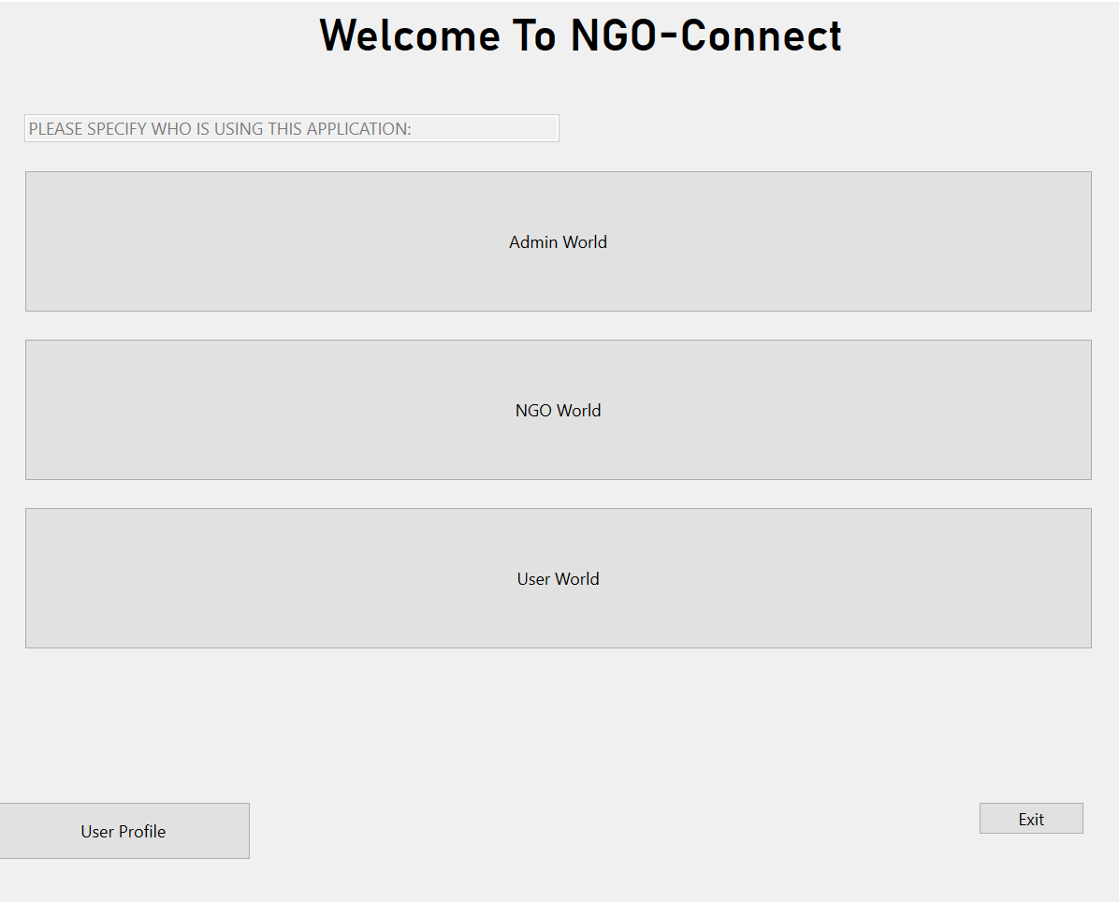

**Image 2: Admin Dashboard-** This vital screen provides administrators with comprehensive control over NGOConnect. Administrators can perform a range of tasks, including data management (adding, deleting, and editing data), user management, and overseeing other administrative functions.

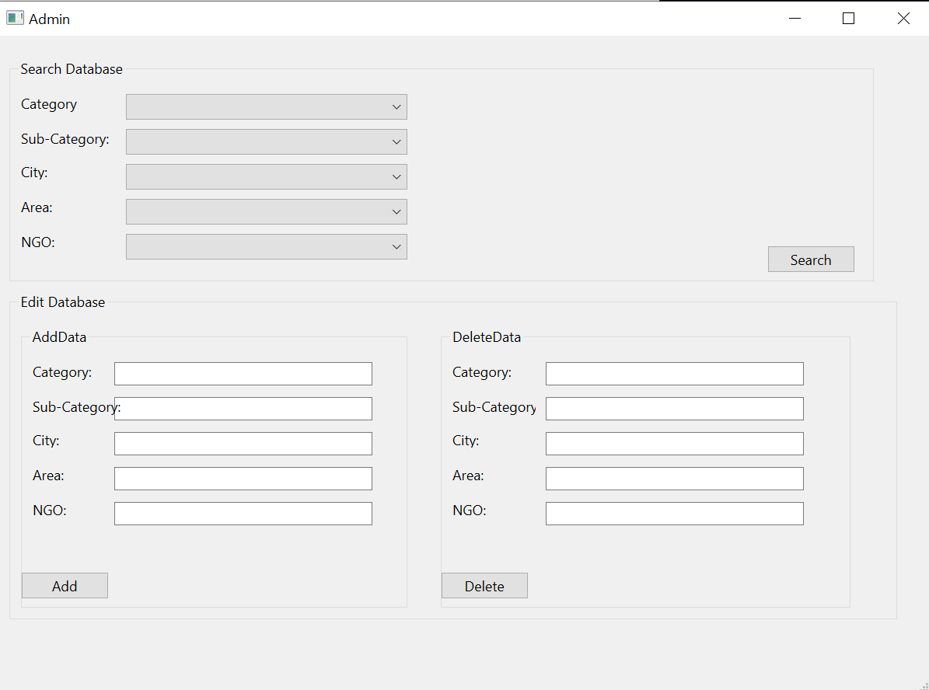

**Image 3: NGO Dashboard-** Designed with NGOs in mind, this screen empowers NGOs to manage their profiles and projects seamlessly. NGOs can add, delete, or edit data related to their projects, ensuring that their information remains accurate and up-to-date.

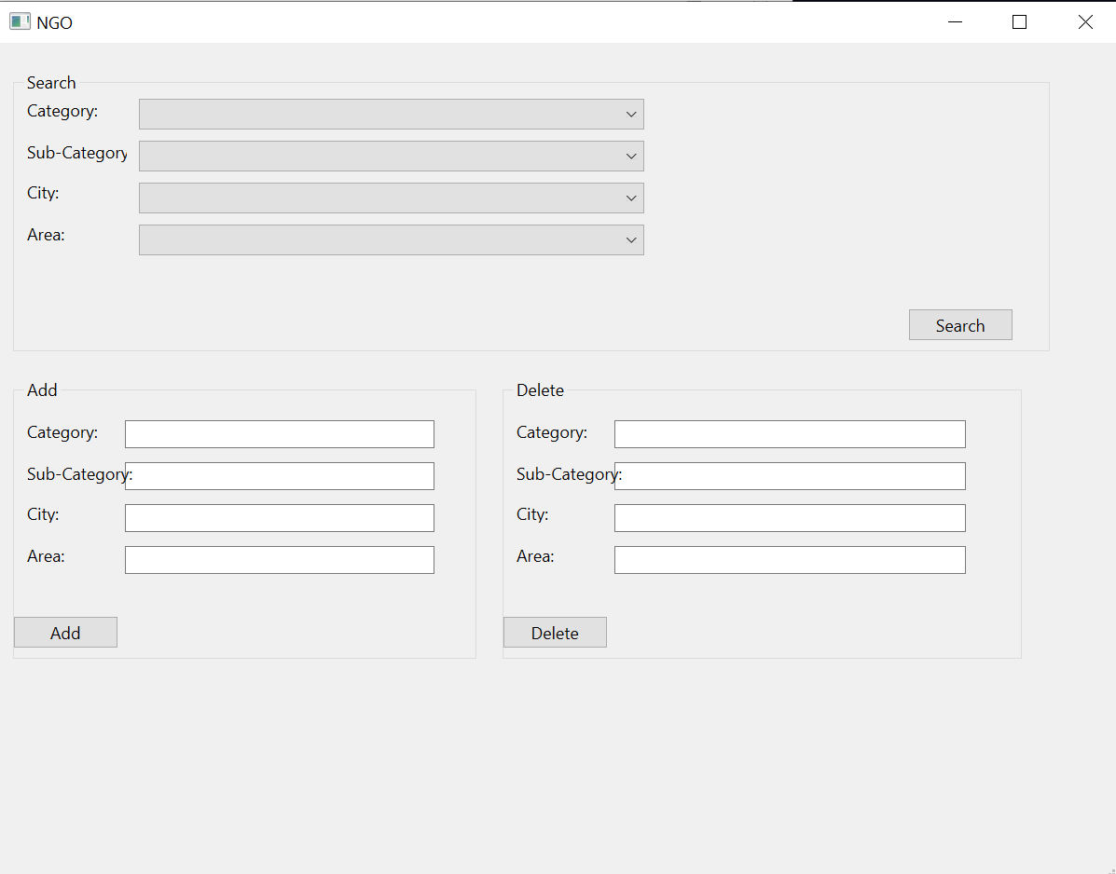

**Image 4: General user Dashboard-** Users will have access to a personalized dashboard where they can search for NGOs and projects based on their preferences.

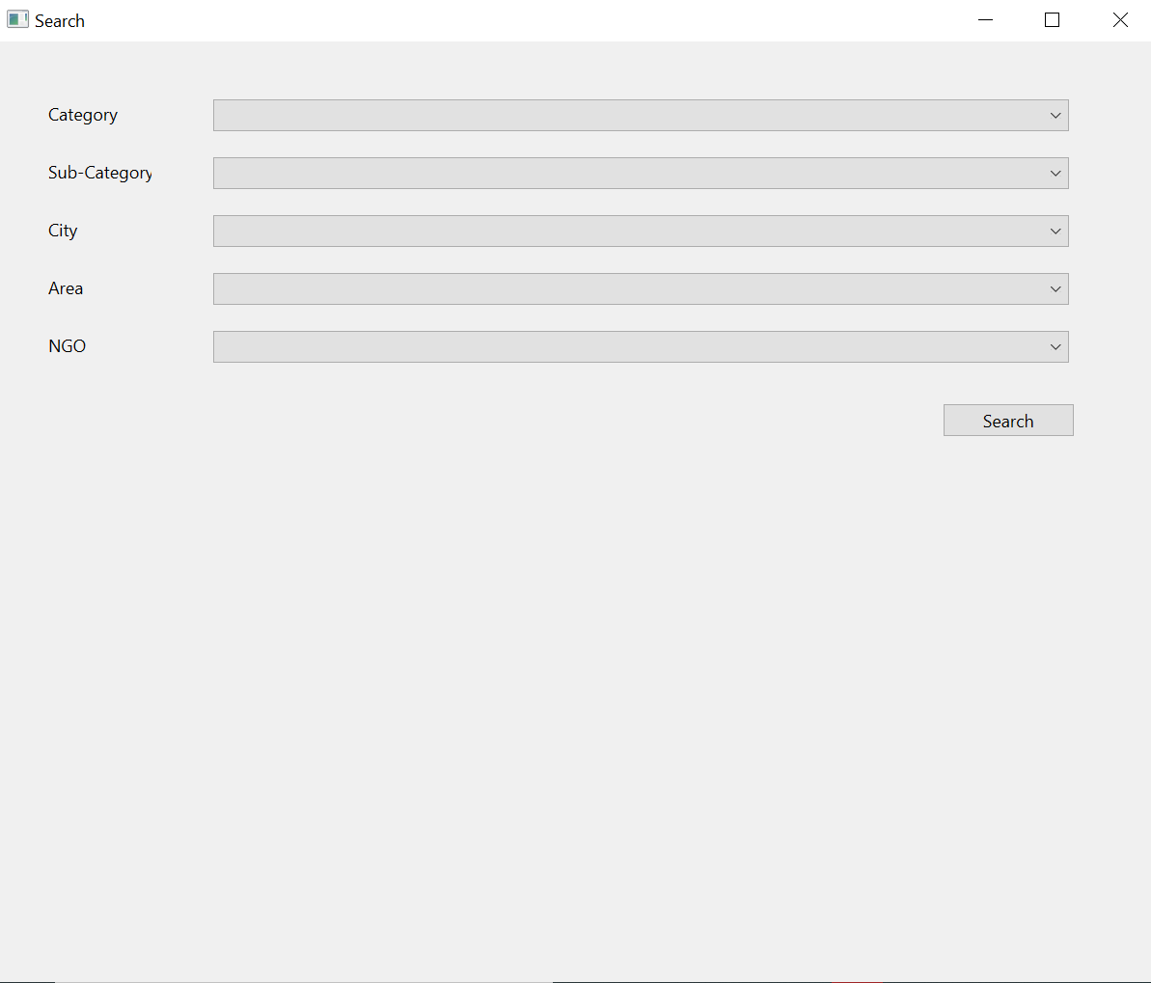

**Image 5: Output screen for search result-**The "Output Screen" serves as the dynamic hub where users, NGOs, and administrators interact with their search results based on their respective roles and permissions within the NGOConnect platform.

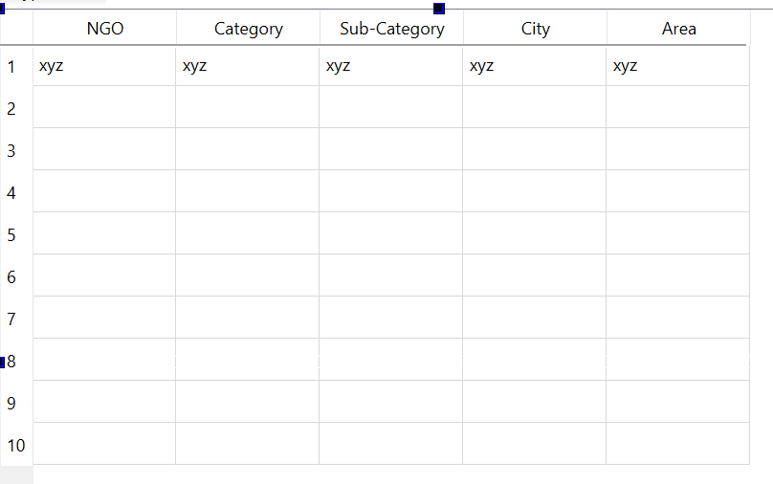

**2.5. ERD:** *Please incorporate an initial ERD for your project, ensuring clear highlighting of primary keys and accurate depiction of table relationships. Avoid manual ERD creation; utilize tools like DBdesigner for this purpose.*

The following ERD represents a database schema for an NGO management system. It includes entities and their relationships, facilitating the management of NGOs, their projects, users, and operational aspects.

**NGO**: Stores information about NGOs, including name, registration date, and address.

**Category**: Represents categories that NGOs can belong to.

**City**: Stores information about cities and their respective countries.

**Project**: Contains details about projects undertaken by NGOs, including project name, scale, start date, and end date.

**User**: Represents users of the system, with attributes such as email, name, username, and password.

**OperatingAreas**: Connects NGOs to their operating areas.

**OperatingCities**: Links NGOs to the cities they operate in.

**OperatingCategories**: Associates NGOs with the categories they fall under.

**SavedProjects**: Represents projects saved by users.

**DonatedProjects**: Records projects donated to by users.

**Area**: Contains information about specific geographic areas, including area name.

