TABLE DESIGN

DATABASE MANAGEMENT

LOGIN TABLE

Field Name | Data Type | Constraint | Description
login_id | Integer field | Primary Key | Login id
email | Email field | Not null | Email of the user
password | Char field | Not null | Password of the user
keyuser | Char field | Not null | Specifies the type of user

JOB SEEKER TABLE

Field Name | Data Type | Constraint | Description
seeker_id | Integer field | Primary Key | Seeker id
name | Char field | Not null | Name of the seeker
dob | Date field | Not null | Date Of Birth
address | Char field | Not null | Address of the seeker
email | Email field | Not null | Email of the seeker
phone_no | Integer field | Not null | Phone number of the seeker
qualification | Document field | Not null | Highest qualification of the seeker
cv | Document field | Not null | Curriculum vitae of the seeker

JOB PROVIDER TABLE

Field Name | Data Type | Constraint | Description
provider_id | Integer field | Primary key | Provider id
name | Char field | Not null | Name of the provider
address | Char field | Not null | Address of the provider
email | Email field | Not null | Email of the provider
phone_no | Integer field | Not null | Phone number of the provider
license_no | Document field | Not null | Business license number of the provider
Description | Document field | Not null | Description about the provider

VACANCY TABLE

Field Name | Data Type | Constraint | Description
vacancy_id | Integer field | Primary key | Vacancy id
provider_id | Integer field | Foreign key | Provider id
title | Char field | Not null | Title of the job
qualification | Char field | Not null | Qualification of the seeker
exp | Integer field | Not null | Experience of the seeker
no of vacancies | Integer field | Not null | Number of vacancies

VACANCY RESPONDS TABLE

Field Name | Data Type | Constraint | Description
id | Integer field | Primary key | id
vacancy_id | Integer field | Foreign key | Vacancy id
seeker_id | Integer field | Foreign key | Seeker id

FEEDBACK TABLE

Field Name | Data Type | Constraint | Description
feedback_id | Integer field | Primary key | Feedback id
feedback | Char field | Not null | Feedback

DATAFLOW DIAGRAM

LEVEL 0 - LOGIN
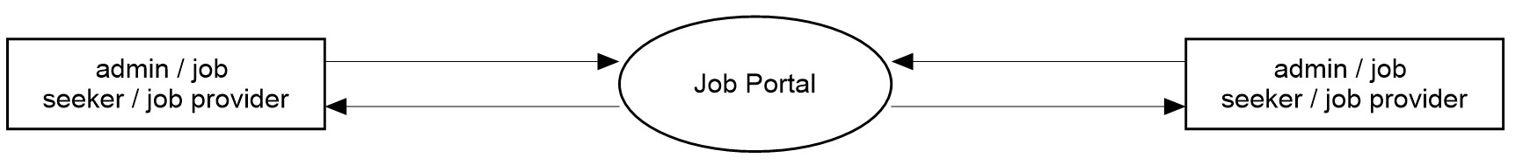

LEVEL 1 - ADMIN

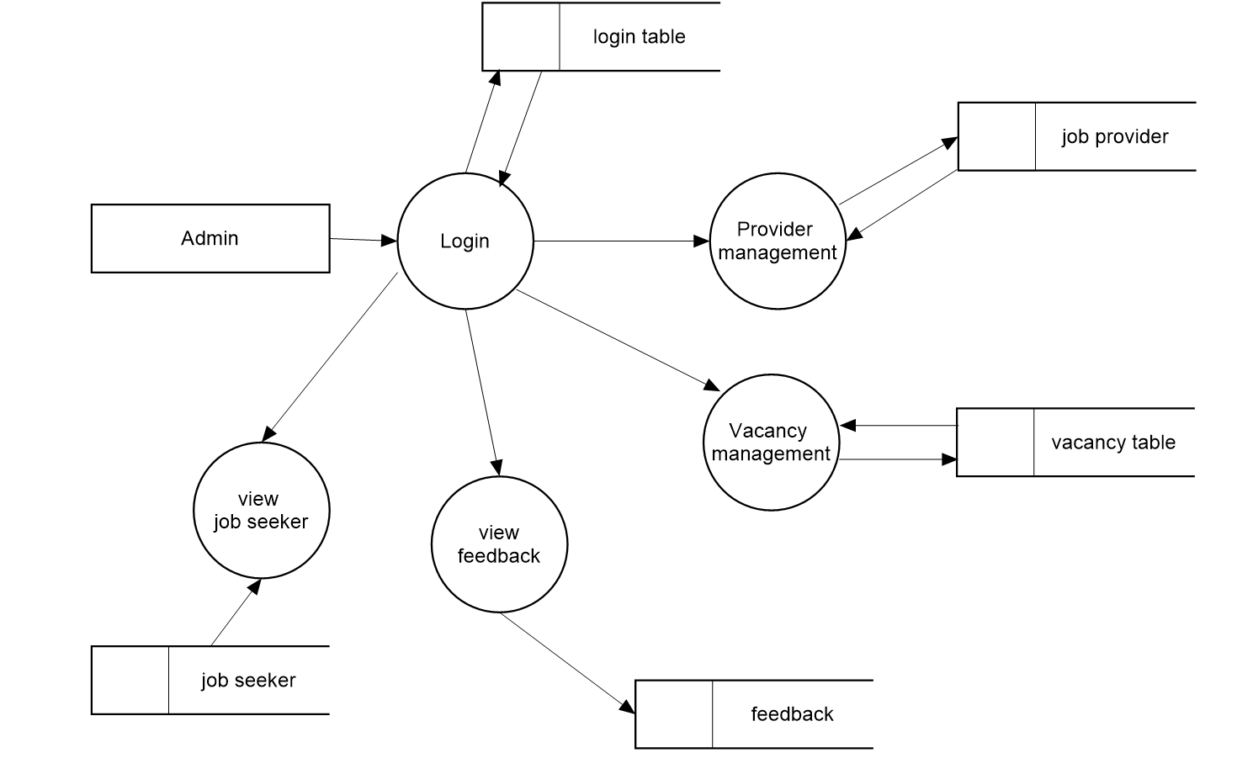

LEVEL 1 – PROVIDER

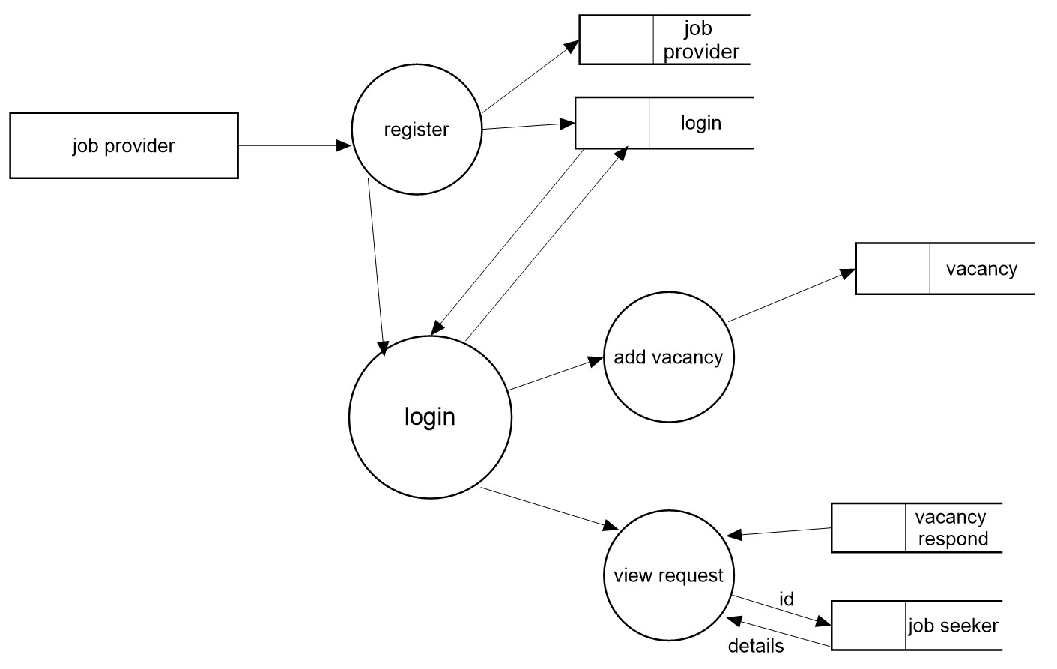

LEVEL 1 – SEEKER

