SEMINAR REPORT
Submitted in the partial fulfillment of the requirements for the award of degree in
BACHELOR OF COMPUTER APPLICATION

Submitted By,
LIJITH R S (200021091287)
SEMESTER VI



SWAMY SASWATHIKANANDA COLLEGE
POOTHOTTA
(Affiliated to Mahatma Gandhi University, Kottayam, Kerala)
2021

SWAMY SASWATHIKANANDA COLLEGE
POOTHOTTA
(Affiliated to Mahatma Gandhi University)

CERTIFICATE

This is to certify that the seminar report entitled “SILENT SOUND TECHNOLOGY” submitted in the partial fulfillment of the requirement for the award of the degree in BACHELOR OF COMPUTER APPLICATION is a bonafide report of the seminar done by LIJITH R S (200021091287) during the Semester VI of the academic year 2022-2023.

Internal Guide Head of the department

Examiners:
1………………………..
2………………………..

College Seal Department Seal

DECLARATION

I hereby declare that this seminar entitled “SILENT SOUND TECHNOLOGY” is a report done by me under the guidance of Thusharamol.P.A, Asst./Assoc. Professor, Department of Computer Science, SWAMY SASWATHIKANANDA COLLEGE, and the seminar has not formed the basis for the award of any Degree/Diploma or similar title to any candidate of University.

Internal Guide: Signature of Student
THUSHARAMOL.P.A

ACKNOWLEDGEMENT
At the outset, we thank God Almighty for making this endeavor a success.
I express my gratitude to Prof. K.S. ULLAS, Principal of SWAMY SASWATHIKANANDA COLLEGE, POOTHOTTA for providing me with adequate facilities, ways and means by which I am able to complete the seminar work.
I express my sincere thanks to Assoc. Professor Ms. DIVYA R, Head of the Department of Computer Science, and my seminar coordinators Ms. SREEJA MATHEW and Ms. CHITRAVANI G.S. and my seminar guide THUSHARAMOL.P.A who has been showing deep interest in my seminar and inspired me through valuable suggestions, and all the faculty members of the department of Computer Science for their sincere help and support.
Last but not the least, I also express my profound gratitude to all other members of the faculty, friends and well-wishers who assisted me in various occasions during the seminar work.

CONTENTS

- ABSTRACT……………………………………………………….............1
- INTRODUCTION....................................................................................... 2-4
- NEED OF SILENT SOUND TECHNOLOGY............................................5-6
- METHODS....................................................................................................6-8
- ELECTROMYOGRAPHY...........................................................................8-14
- IMAGE-PROCESSING................................................................................15-20
- FEATURES OF SILENT SOUND TECHNOLOGY...................................21
- LIMITATIONS..............................................................................................22
- APPLICATIONS............................................................................................23
- CONCLUSION...............................................................................................24
- REFERENCES................................................................................................25

Name of Student

ABSTRACT

Silent sound technology SST has be introduced to put end to noise pollution and help the people that have lost their voice and cannot speak on mobile phone. This device is developed at Karlsruhe institute of technology and expected to be see in near feature. This device will notice the lip movement inform of electrical impulse and transfer it to sound speech that can be understood. It will be useful for people that want to make a silent call by just receiving the electrical impulse from lips movement and neglect all other surrounding noise and convert it to sound speech at the receiver ends. It will be useful for secrete calling because the caller

don’t need to utter a word loudly just the lips movement.

1

SWAMY SASWATHIKANANDA COLLEGE
SILENT SOUND TECHNOLOGY

1. INTRODUCTION

Silence is the best answer for all the situations …even your mobile understands!

- The word Cell Phone has become greatest buzz word in Cellular Communication industry.

- There are lots and lots of technology that tries to reduce the Noise pollution and make the environment a better place to live in.

- I will tell about a new technology known as Silent Sound Technology that will put an end to Noise pollution.

You are in a movie theater or noisy restaurant or a bus etc. where there is lot of noise around is big issue while talking on a mobile phone. But in the future this problem is eliminated with” silent sounds”, a new technology unveiled at the CeBIT fair on Tuesday that transforms lip movements into a computer-generated voice for the listener at the other end of the phone.

It is a technology that helps you to transmit information without using your vocal cords. This technology aims to notice lip movements & transform them into a computer-generated sound that can be transmitted over a phone. Hence person on other end of phone receives the information in audio.

In the 2010 CeBIT's "future park", a concept "Silent Sound" Technology demonstrated which aims to notice every movement of the lips and transform them into sounds, which could help people who lose voices to speak, and allow people to make silent calls without bothering others.

The device, developed by the Karlsruhe Institute of Technology (KIT), uses electromyography, monitoring tiny muscular movements that occur when we speak and converting them into electrical pulses that can then be turned into speech, without a sound uttered.

2

SWAMY SASWATHIKANANDA COLLEGE
SILENT SOUND TECHNOLOGY

‘Silent Sound’ technology aims to notice every movement of the lips and transform them into sounds, which could help people who lose voices to speak, and allow people to make silent calls without bothering others. Rather than making any sounds, your handset would decipher the movements your mouth makes by measuring muscle activity, then convert this into speech that

the person on the other end of the call can hear. So, basically, it reads your lips.

“We currently use electrodes which are glued to the skin. In the future, such electrodes might for

example by incorporated into cellphones,” said Michael Wand, from the KIT.




People talking in a same place with disturbance

3

SWAMY SASWATHIKANANDA COLLEGE
SILENT SOUND TECHNOLOGY

The technology opens up a host of applications, from helping people who have lost their voice due to illness or accident to telling a trusted friend your PIN number over the phone without anyone eavesdropping — assuming no lip-readers are around.

The technology can also turn you into an instant polyglot. Because the electrical pulses are universal, they can be immediately transformed into the language of the user’s choice.

“Native speakers can silently utter a sentence in their language, and the receivers hear the translated sentence in their language. It appears as if the native speaker produced speech in a foreign language,” said Wand.

The translation technology works for languages like English, French and German, but for languages like Chinese, where different tones can hold many different meanings, poses a problem, he added.

Noisy people in your office? Not anymore. “We are also working on technology to be used in an office environment,” the KIT scientist told AFP.

The engineers have got the device working to 99 percent efficiency, so the mechanical voice at the other end of the phone gets one word in 100 wrong, explained Wand.

“But we’re working to overcome the remaining technical difficulties. In five, maybe ten years, this will be useable, everyday technology,” he said.

4

SWAMY SASWATHIKANANDA COLLEGE
SILENT SOUND TECHNOLOGY

2. NEED OF SILENT SOUND TECHNOLOGY

Silent Sound Technology will put an end to embarrassed situation such as-

- A person answering his silent, but vibrating cell phone in a meeting, lecture or performance, and whispering loudly, ‘I can’t talk to you right now’.

- In the case of an urgent call, apologetically rushing out of the room in order to answer or call the person back

2.1 ORGINATION

Humans are capable of producing and understanding whisper speech in quiet environments + lip-reading the idea of interpreting silent speech electronically or with a computer has been around for a long time, and was popularized in the 1968 Stanley Kubrick science-fiction film

‘‘2001 – A Space Odyssey” A major focal point was the DARPA Advanced Speech Encoding Program (ASE) of the early 2000’s, which funded research on low bit rate speech synthesis ‘‘with acceptable intelligibility, quality, and aural speaker recognizability in acoustically harsh environments”,

5

SWAMY SASWATHIKANANDA COLLEGE
SILENT SOUND TECHNOLOGY

When you add lawnmowers, snow blowers, leaf blowers, jack hammers, jet engines, transport trucks, and horns and buzzers of all types and descriptions you have a wall of constant noise and irritation. Even when watching a television program at a reasonable volume level you are blown out of your chair when a commercial comes on at the decibel level of a jet.

The technology opens up a host of applications, from helping people who have lost their voice due to illness or accident to telling a trusted friend your PIN number over the phone without anyone eavesdropping — assuming no lip-readers are around. Native speakers can silently utter a sentence in their language, and the receivers hear the translated sentence in their language. It appears as if the native speaker produced speech in a foreign language.

3. METHODS

Silent Sound Technology is processed through some ways or methods. They are

- Electromyography (EMG)

- Image Processing

- The Silent Sound Technology uses electromyography, monitoring tiny muscular movements that occur when we speak.

6

SWAMY SASWATHIKANANDA COLLEGE
SILENT SOUND TECHNOLOGY

- Monitored signals are converted into electrical pulses that can then be turned into speech, without a sound uttered.

- Electromyography (EMG) is a technique for evaluating and recording the electrical activity produced by skeletal muscles.

- An electromyography detects the electrical potential generated by muscle cells, when these cells are electrically or neurologically activated.

- Electromyographic sensors attached to the face records the electric signals produced by the facial muscles, compare them with prerecorded signal pattern of spoken words.

- When there is a match that sound is transmitted on to the other end of the line and person at the other end listen to the spoken words

Image Processing:

- The simplest form of digital image processing converts the digital data tape into a film image with minimal corrections and calibrations.

- Then large mainframe computers are employed for sophisticated interactive manipulation of the data.

- In the present context, overhead prospective are employed to analyze the picture.

In electrical engineering and computer science, image processing is any form of signal processing for which the input is an image, such as a photograph or video frame; the output of image processing may be either an image or, a set of characteristics or parameters related to the image. Most image-processing

7

SWAMY SASWATHIKANANDA COLLEGE
SILENT SOUND TECHNOLOGY

techniques involve treating the image as a two-dimensional signal and applying standard signal-processing techniques to it.

4.ELECTROMYOGRAPHY

Electromyography (EMG) is a technique for evaluating and recording the electrical activity produced by skeletal muscles. EMG is performed using an instrument called an electromyograph, to produce a record called an electromyogram. An electromyograph detects the electrical potential generated by muscle cells when these cells are electrically or neurologically activated. The signals can be analyzed to detect medical abnormalities, activation level, recruitment order or to analyze the biomechanics of human or animal movement.

- The Silent Sound Technology uses electromyography, monitoring tiny muscular movements that occur when we speak.

- Monitored signals are converted into electrical pulses that can then be turned into speech, without a sound uttered.

- Electromyography (EMG) is a technique for evaluating and recording the electrical activity produced by skeletal muscles.

- An electromyography detects the electrical potential generated by muscle cells, when these cells are electrically or neurologically activated

8

SWAMY SASWATHIKANANDA COLLEGE
SILENT SOUND TECHNOLOGY

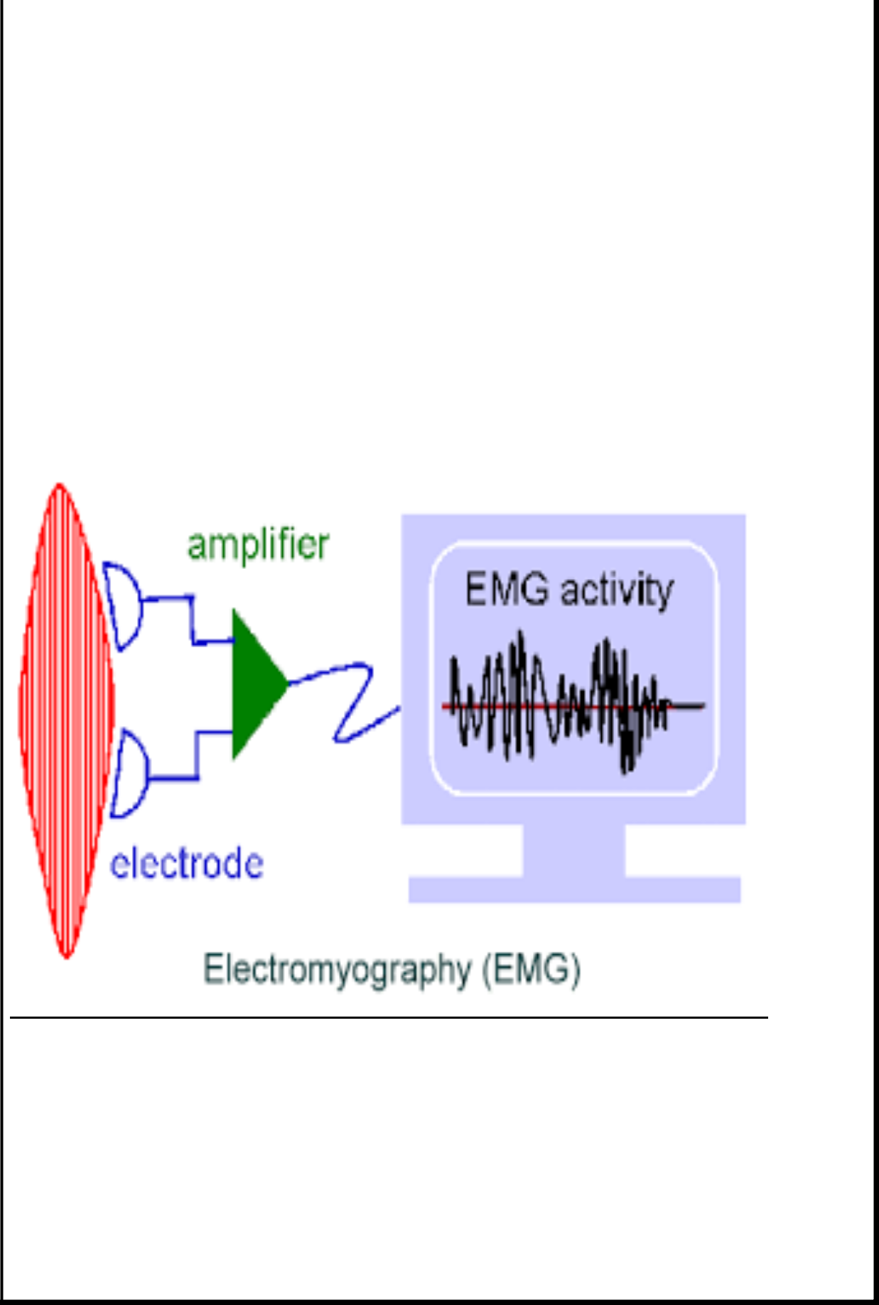

9

SWAMY SASWATHIKANANDA COLLEGE
SILENT SOUND TECHNOLOGY

4.1 WORKING OF ELECTROMYOGRAPHY

- A needle containing two fine-wired electrodes is inserted through the skin into the muscle tissue.

- Then the electrical activity when the muscle is at rest is observed. Each electrode track gives only a very local picture of the activity of the whole muscle

- Because skeletal muscles differ in the inner structure, the electrode has to be placed at various locations to obtain an accurate signal.

10

SWAMY SASWATHIKANANDA COLLEGE
SILENT SOUND TECHNOLOGY

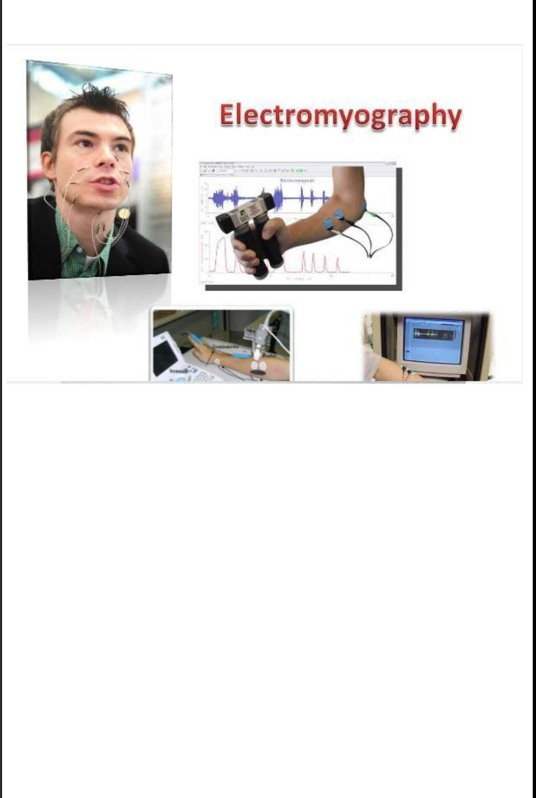

Intramuscular EMG may be considered too invasive or unnecessary in some cases. Instead, a surface electrode may be used to monitor the general picture of muscle activation, as opposed to the activity of only a few fibres as observed using an intramuscular EMG. This technique is used in a number of settings; for example, in the physiotherapy clinic, muscle activation is monitored using surface EMG and patients have an auditory or visual stimulus to help them know when they are activating the muscle (biofeedback).

11

SWAMY SASWATHIKANANDA COLLEGE
SILENT SOUND TECHNOLOGY

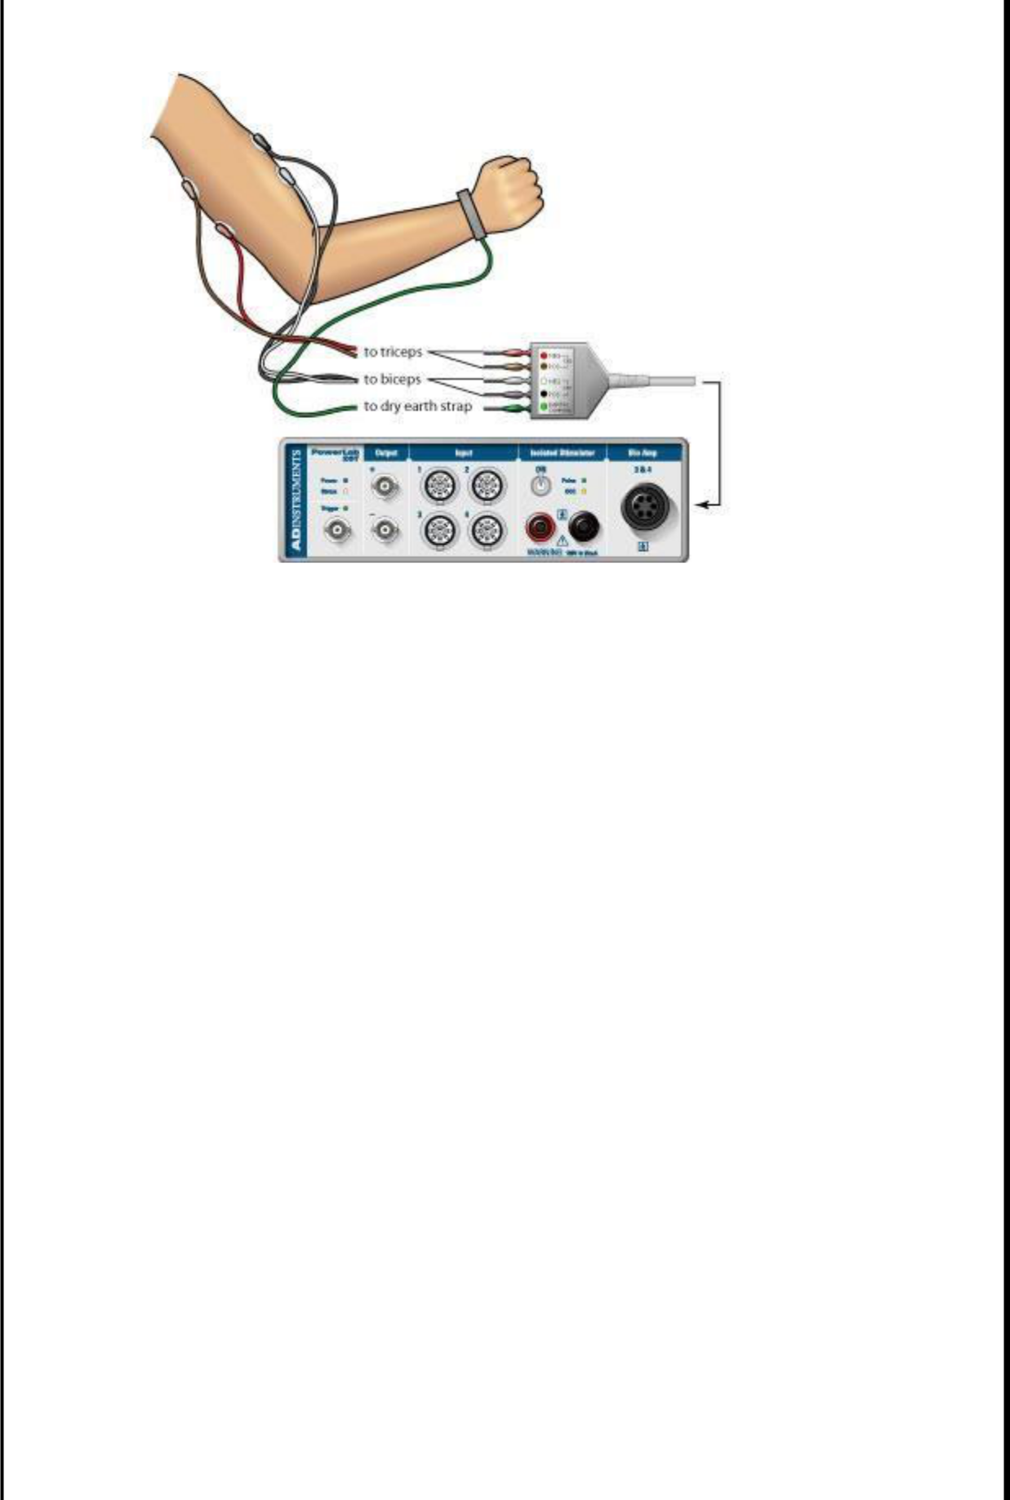

Interfacing with electromyographer and body:

A motor unit is defined as one motor neuron and all of the muscle fibers it innervates. When a motor unit fires, the impulse (called an action potential) is carried down the motor neuron to the muscle. The area where the nerve contacts the muscle is called the neuromuscular junction, or the motor end plate. After the action potential is transmitted across the neuromuscular junction, an action potential is elicited in all of the innervated muscle fibers of that particular motor unit. The sum of all this electrical activity is known as a motor unit action potential (MUAP). This electrophysiologic activity from multiple motor units is the signal typically evaluated during an EMG. The composition of the motor unit, the number of muscle fibers per motor unit, the metabolic type of muscle fibres and many other factors affect the shape of the motor unit potentials in the myogram.

Nerve conduction testing is also often done at the same time as an EMG to diagnose neurological diseases.

12

SWAMY SASWATHIKANANDA COLLEGE
SILENT SOUND TECHNOLOGY

Some patients can find the procedure somewhat painful, whereas others experience only a small amount of discomfort when the needle is inserted. The muscle or muscles being tested may be slightly sore for a day or two after the procedure.

Normal results:

Muscle tissue at rest is normally electrically inactive. After the electrical activity caused by the irritation of needle insertion subsides, the electromyograph should detect no abnormal spontaneous activity (i.e., a muscle at rest should be electrically silent, with the exception of the area of the neuromuscular junction, which is, under normal circumstances, very spontaneously active). When the muscle is voluntarily contracted, action potentials begin to appear. As the strength of the muscle contraction is increased, more and more muscle fibers produce action potentials. When the muscle is fully contracted, there should appear a disorderly group of action potentials of varying rates and amplitudes (a complete recruitment and interference pattern).

Abnormal results:

EMG is used to diagnose diseases that generally may be classified into one of the following categories: neuropathies, neuromuscular junction diseases and myopathies.

Neuropathic disease has the following defining EMG characteristics:

- An action potential amplitude that is twice normal due to the increased number of fibres per motor unit because of reinnervation of denervated fibres

- An increase in duration of the action potential

- A decrease in the number of motor units in the muscle (as found using motor unit number estimation techniques)

Myopathic disease has these defining EMG characteristics:

- A decrease in duration of the action potential

13
SWAMY SASWATHIKANANDA COLLEGE
SILENT SOUND TECHNOLOGY

- A reduction in the area to amplitude ratio of the action potential

Because of the individuality of each patient and disease, some of these characteristics may not appear in eve

4.2 Applications of EMG:

EMG signals are used in many clinical and biomedical applications. EMG is used as a diagnostics tool for identifying neuromuscular diseases, assessing low-back pain, kinesiology, and disorders of motor control. EMG signals are also used as a control signal for prosthetic devices such as prosthetic hands, arms, and lower limbs.

EMG can be used to sense isometric muscular activity where no movement is produced. This enables definition of a class of subtle motionless gestures to control interfaces without being noticed and without disrupting the surrounding environment. These signals can be used to control a prosthesis or as a control signal for an electronic device such as a mobile phone or PDA.

EMG signals have been targeted as control for flight systems. The Human Senses Group at the NASA Ames Research Center at Moffett Field, CA seeks to advance man-machine interfaces by directly connecting a person to a computer. In this project, an EMG signal is used to substitute for mechanical joysticks and keyboards. EMG has also been used in research towards a "wearable cockpit," which employs EMG-based gestures to manipulate switches and control sticks necessary for flight in conjunction with a goggle-based display.

Unvoiced speech recognition recognizes speech by observing the EMG activity of muscles associated with speech. It is targeted for use in noisy environments, and may be helpful for people without vocal cords and people with aphasia.

14

SWAMY SASWATHIKANANDA COLLEGE
SILENT SOUND TECHNOLOGY

5. IMAGE PROCESSING

The simplest form of digital image processing converts the digital data tape into a film image with minimal corrections and calibrations. Then large mainframe computers are employed for sophisticated interactive manipulation of the data. In the present context, overhead prospective are employed to analyze the picture.

In electrical engineering and computer science, image processing is any form of signal processing for which the input is an image, such as a photograph or video frame the output of image processing may be either an image or, a set of characteristics or parameters related to the image. Most image-processing techniques involve treating the image as a two-dimensional signal and applying standard signal-processing techniques to it.

Image processing usually refers to digital image processing, but optical and analogue image processing also are possible. The acquisition of images (producing the input image in the first place) is referred to as imaging.

Image processing is a physical process used to convert an image signal into a physical image. The image signal can be either digital or analog. The actual output itself can be an actual physical image or the characteristics of an image.

The most common type of image processing is photography. In this process, an image is captured using a camera to create a digital or analog image. In order to produce a physical picture, the image is processed using the appropriate technology based on the input source type.

In digital photography, the image is stored as a computer file. This file is translated using photographic software to generate an actual image. The colors, shading, and nuances are all

15

SWAMY SASWATHIKANANDA COLLEGE
SILENT SOUND TECHNOLOGY

captured at the time the photograph is taken the software translates this information into an image.

When creating images using analog photography, the image is burned into a film using a chemical reaction triggered by controlled exposure to light. The image is processed in a darkroom, using special chemicals to create the actual image. This process is decreasing in popularity due to the advent of digital photography, which requires less effort and special training to product images.

In addition to photography, there are a wide range of other image processing operations. The field of digital imaging has created a whole range of new applications and tools that were previously impossible. Face recognition software, medical image processing and remote sensing are all possible due to the development of digital image processing. Specialized computer programs are used to enhance and correct images. These programs apply algorithms to the actual data and are able to reduce signal distortion, clarify fuzzy images and add light to an underexposed image.

Image processing techniques were first developed in 1960 through the collaboration of a wide range of scientists and academics. The main focus of their work was to develop medical imaging, character recognition and create high quality images at the microscopic level. During this period, equipment and processing costs were prohibitively high.

The financial constraints had a serious impact on the depth and breadth of technology development that could be done. By the 1970s, computing equipment costs had dropped substantially making digital image processing more realistic. Film and software companies invested significant funds into the development and enhancement of image processing, creating a new industry.

There are three major benefits to digital image processing. The consistent high quality of the image, the low cost of processing and the ability to manipulate all aspects of the process are all great benefits. As long as computer processing speed continues to

16

SWAMY SASWATHIKANANDA COLLEGE
SILENT SOUND TECHNOLOGY

increase while the cost of storage memory continues to drop, the field of image processing will grow.

5.I MAGE PROCESSING TECHNQUES

Analysis of remotely sensed data is done using various image processing techniques and methods that includes:

- Analog image processing

- Digital image processing

5.2 ANALOG IMAGE PROCESSING

- Analog processing technique is applied to hard copy data such as photographs or printouts.

- It adopts certain elements of interpretation, such as primary element, spatial arrangement etc.,

- With the combination of multi-concept of examining remotely sensed data in multispectral, multitemporal, multiscale and in conjunction with multidisciplinary, allows us to make a verdict not only as to what an object is but also its importance.

- Apart from these it also includes optical photogrammetric techniques allowing for precise measurement of the height, width, location, etc. of an object.

Analog processing techniques is applied to hard copy data such as photographs or printouts. Image analysis in visual techniques adopts certain elements of interpretation, which are as follow:

The use of these fundamental elements of depends not only on the area being studied, but the knowledge of the analyst has of the study area. For example, the texture of an object is also very useful in distinguishing objects that may appear the same if the judging solely on

17

SWAMY SASWATHIKANANDA COLLEGE
SILENT SOUND TECHNOLOGY

tone (i.e., water and tree canopy, may have the same mean brightness values, but their texture is much different. Association is a very powerful image analysis tool when coupled with the general knowledge of the site. Thus, we are adept at applying collateral data and personal knowledge to the task of image processing. With the combination of multi-concept of examining remotely sensed data in multispectral, multitemporal, multiscale and in conjunction with multidisciplinary, allows us to make a verdict not only as to what an object is but also its importance. Apart from these analog image processing techniques also includes optical photogrammetric techniques allowing for precise measurement of the height, width, location, etc. of an object.

Image processing is a physical process used to convert an image signal into a physical image. The image signal can be either digital or analog. The actual output itself can be an actual physical image or the characteristics of an image.

5.3 DIGITAL IMAGE PROCESSING

Digital Image Processing involves a collection of techniques for the manipulation of digital images by computers. Digital image processing is the use of computer algorithms to perform image processing and digital images. As a subcategory or field of digital signal processing, digital image processing has many advantages over analog image processing. It allows a much wider range of algorithms to be applied to the input data and can avoid problems such as the build-up of noise and signal distortion during processing. Since images are defined over two dimensions (perhaps more) digital image processing may be modeled in the form of Multidimensional system

Digital Image Processing involves a collection of techniques for the manipulation of digital images by computers. It contains some flaws. To overcome the flaws and deficiencies in order to get the originality of the data, it needs to undergo several steps of processing.

Digital Image Processing undergoes three general steps:

- Pre-processing
- Display and enhancement
3. Information extraction

18

SWAMY SASWATHIKANANDA COLLEGE
SILENT SOUND TECHNOLOGY

PREPROCESSING

- Pre-processing consists pf those operations that prepare data for subsequent analysis that attempts to correct or compensate for systematic errors.

- Then analyst may use feature extraction to reduce the dimensionality of the data.

- Thus feature extraction is the process of isolating the most useful components of the data for further study while discarding the less useful aspects

- It reduces the number of variables that must be examined thereby saving time and resources.

IMAGE ENHANCEMENT

- Improves the interpretability of the image by increasing apparent contrast among various features in the scene.

- The enhancement techniques depend upon the two factors mainly

- The digital data (that is, with spectral bands and resolution)

- The objectives of interpretation

- Common enhancements include image reduction, image rectification, image magnification, contrast adjustments, principal component analysis texture transformation and so on.

19

SWAMY SASWATHIKANANDA COLLEGE
SILENT SOUND TECHNOLOGY

INFORMATION EXTRACTION

- In information extraction the remotely sensed data is subjected to quantitive analysis to assign individual pixels to specific classes. It is then classified

- It is necessary to evaluate its accuracy by comparing the categories on the classified images with the areas of known identity on the ground.

- The final result of the analysis consists of the maps data and a report. then these are converted to corresponding signals

20

SWAMY SASWATHIKANANDA COLLEGE
SILENT SOUND TECHNOLOGY

6.FEATURES OF SILENT SOUND TECHNOLOGY

Some of the features of silent sound technology are

- Native speakers can silently utter a sentence in their language, and the receivers can hear the translated sentence in their language. It appears as if the native speaker produced speech in a foreign language. The translation technology works for languages like English, French and German, except Chinese, where different tones can hold many different meanings.

- Allow people to make silent calls without bothering others.

- The Technology opens up a host of application such as mentioned below

    - Helping people who have lost their voice due to illness or accident.

  - Telling a trusted friend your PIN number over the phone without anyone eavesdropping assuming no lip-readers are around.

    - Silent Sound Techniques is applied in Military for communicating secret/confidential matters to others.

21

SWAMY SASWATHIKANANDA COLLEGE
SILENT SOUND TECHNOLOGY

7.LIMITATIONS

Translation into majority of languages but for languages such as Chinese different meaning tone holds different meaning, facial movements being the same.

From security point of view recognizing who you are talking to gets complicated.

You will always feel you are talking to a robot, because of computerized voice.

This device presently needs nine leads to be attached to our face which is quite impractical to make it usage.

22

SWAMY SASWATHIKANANDA COLLEGE
SILENT SOUND TECHNOLOGY

8.APPLICATIONS

The Technology opens up a host of application such as mentioned below:

- Helping people who have lost their voice due to illness or accident.

- Telling a trusted friend your PIN number over the phone without anyone eavesdropping — assuming no lip-readers are around.

- Silent Sound Techniques is applied in Military for communicating secret/confidential matters to others.

- Native speakers can silently utter a sentence in their language, and the receivers can hear the translated sentence in their language. It appears as if the native speaker produced speech in a foreign language. The translation technology works for languages like English, French and German, except Chinese, where different tones can hold many different meanings.

Allow people to make silent calls without bothering others.

23

SWAMY SASWATHIKANANDA COLLEGE
SILENT SOUND TECHNOLOGY

9.CONCLUSION

- Thus, Silent Sound Technology, one of the recent trends in the field of information technology implements” Talking Without Talking”.

- It will be one of the innovation and useful technology and in mere future this technology will be use in our day-to-day life.

‘Silent Sound’ technology aims to notice every movement of the lips and transform them into sounds, which could help people who lose voices to speak, and allow people to make silent calls without bothering others. Rather than making any sounds, your handset would decipher the movements your mouth makes by measuring muscle activity, then convert this into speech that the person on the other end of the call can hear. So, basically, it reads your lips.

24

SWAMY SASWATHIKANANDA COLLEGE
SILENT SOUND TECHNOLOGY

10.REFERENCES

www.google.com

www.wikipedia.com

www.studymafia.org

25

SWAMY SASWATHIKANANDA COLLEGE

