**TABLE DESIGN**

DATABASE MANAGEMENT

LOGIN TABLE

|  |  |  |  |
| --- | --- | --- | --- |
| Field Name | Data Type | Constraint | Description |
| login_id | Integer field | Primary Key | Login id |
| email | Email field | Not null | Email of the user |
| password | Char field | Not null | Password of the user |
| keyuser | Char field | Not null | Specifies the type of user |

JOB SEEKER TABLE

|  |  |  |  |
| --- | --- | --- | --- |
| Field Name | Data Type | Constraint | Description |
| seeker_id | Integer field | Primary Key | Seeker id |
| name | Char field | Not null | Name of the seeker |
| dob | Date field | Not null | Date Of Birth |
| address | Char field | Not null | Address of the seeker |
| email | Email field | Not null | Email of the seeker |
| phone_no | Integer field | Not null | Phone number of the seeker |
| qualification | Document field | Not null | Highest qualification of the seeker |
| cv | Document field | Not null | Curriculum vitae of the seeker |

JOB PROVIDER TABLE

|  |  |  |  |
| --- | --- | --- | --- |
| Field Name | Data Type | Constraint | Description |
| provider_id | Integer field | Primary key | Provider id |
| name | Char field | Not null | Name of the provider |
| address | Char field | Not null | Address of the provider |
| email | Email field | Not null | Email of the provider |
| phone_no | Integer field | Not null | Phone number of the provider |
| license_no | Document field | Not null | Business license number of the provider |
| Description | Document field | Not null | Description about the provider |

VACANCY TABLE

|  |  |  |  |
| --- | --- | --- | --- |
| Field Name | Data Type | Constraint | Description |
| vacancy_id | Integer field | Primary key | Vacancy id |
| provider_id | Integer field | Foreign key | Provider id |
| title | Char field | Not null | Title of the job |
| qualification | Char field | Not null | Qualification of the seeker |
| exp | Integer field | Not null | Experience of the seeker |
| no of vacancies | Integer field | Not null | Number of vacancies |

VACANCY RESPONSE TABLE

|  |  |  |  |
| --- | --- | --- | --- |
| Field Name | Data Type | Constraint | Description |
| id | Integer field | Primary key | id |
| vacancy_id | Integer field | Foreign key | Vacancy id |
| seeker_id | Integer field | Foreign key | Seeker id |

FEEDBACK TABLE

|  |  |  |  |
| --- | --- | --- | --- |
| Field Name | Data Type | Constraint | Description |
| feedback_id | Integer field | Primary key | Feedback id |
| feedback | Char field | Not null | Feedback |

**DATAFLOW DIAGRAM**

LEVEL 0 - LOGIN

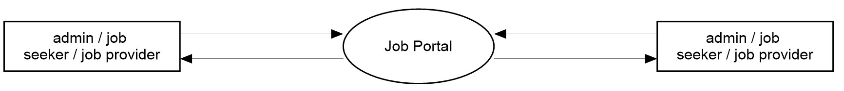

LEVEL 1 - ADMIN

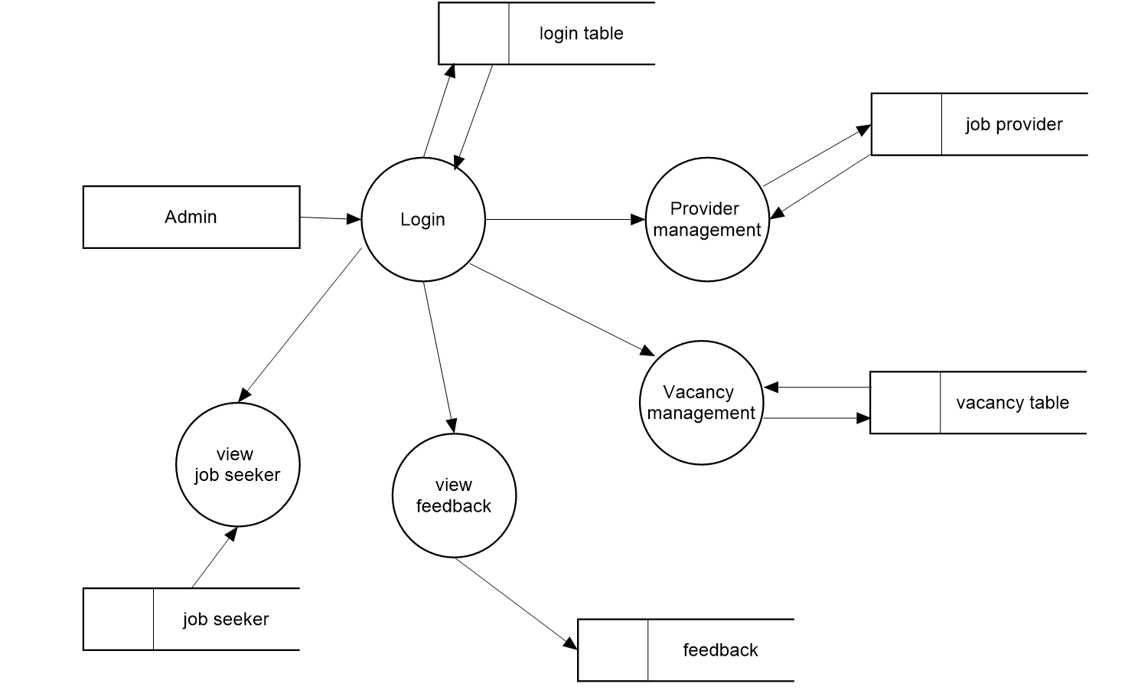

LEVEL 1 – PROVIDER

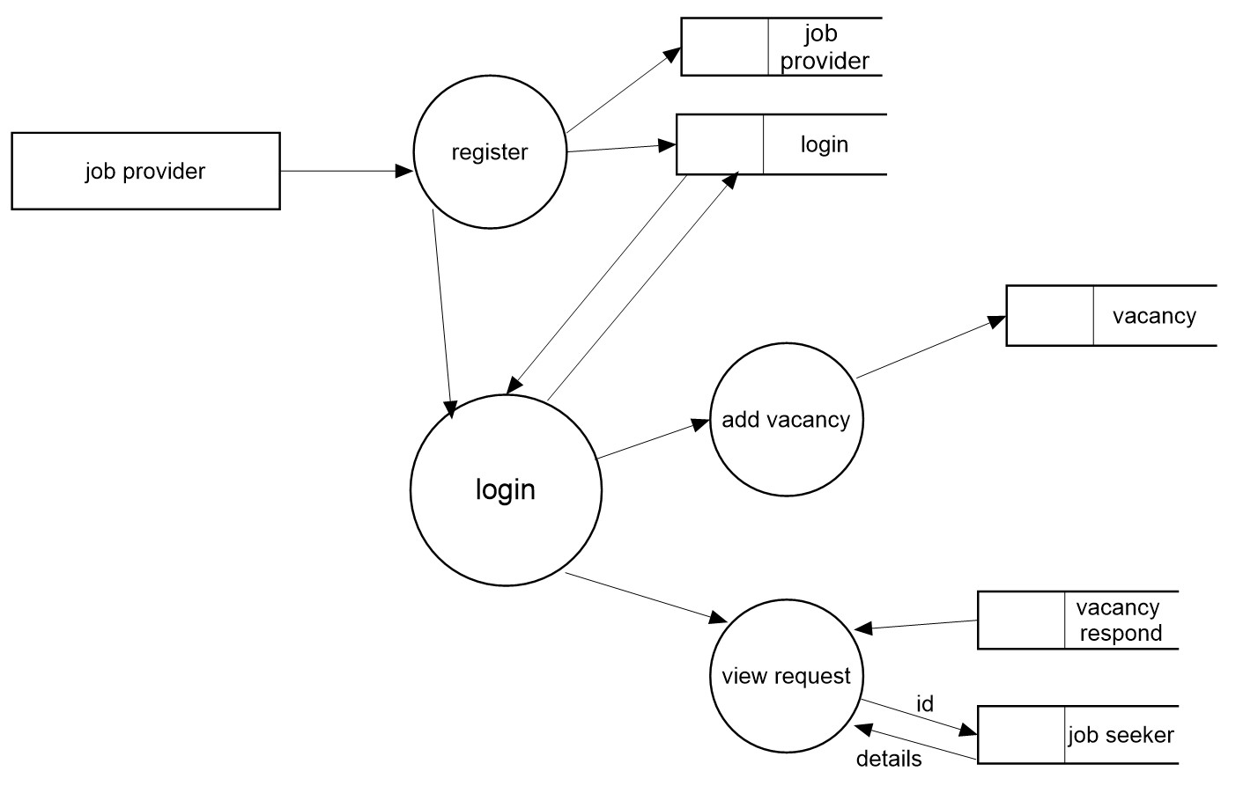

LEVEL 1 – SEEKER

