Big Data and Data Mining
Assignment Report
Dataset: UK Accident Data and Facebook Data

Submitted by: Muhammad Saad Abdullah

Github link to file uploads:
https://github.com/msabm/Big-_Data_and_Data_Mining_Assignment/upload/main

Word Count: 3,374

Contents
Exercise 1: Analysis of UK Traffic Accident Data 2
1. Introduction 2
2. Analysis and Results 2
2.1 Data Cleaning 2
2.2 Hourly and Daily Accident Patterns 3
2.3 Motorcycle Accident Patterns 4
2.4 Pedestrian Accident Patterns 4
2.5 Association Rule Mining – Apriori 5
2.6 Clustering of West Yorkshire Accidents 5
2.7 SARIMA Weekly Accident Forecasting 7
2.8 Daily ARIMA Forecast – Top 30 West Yorkshire LSOAs 8
3. Discussion 9
4. Recommendations 10
Exercise 2: Social Network Analysis 10
5. Introduction 10
6. Analysis and Results 10
6.1 Network Construction and Basic Characteristics 10
6.2 Edge Betweenness Centrality 11
6.3 Community Detection – Louvain vs Girvan-Newman 12
7. Discussion 13
8. Conclusions 13
9. References 14

Exercise 1: Analysis of UK Traffic Accident Data

1. Introduction
This report analyses real-world road traffic accident data from the accident data database, sourced from the UK Department for Transport (DfT). The database contains four tables — accident, casualty, vehicle, and lsoa — covering records from 2017 to 2019. In total, 370,153 accident records, 484,748 casualty records, and 681,716 vehicle records were loaded for analysis across all three years. The primary analysis focuses on the 122,635 accidents, 160,597 casualty records, and 226,409 vehicle records recorded in 2018. The objective is to identify temporal and spatial accident patterns, mine association rules, apply geographic clustering, and forecast future accident counts in order to produce evidence-based road safety policy recommendations for the DfT.

2. Analysis and Results

2.1 Data Cleaning
Null values were identified in the accident table only, across four coordinate columns. The vehicle, casualty, and LSOA tables contained no null values. A deduplication check on the primary key (accident index) confirmed no duplicate accident records existed. A temporal consistency check verified that the parsed year from the date column matched year for all records. Similarly, a referential integrity check showed no orphaned casualty records without a corresponding vehicle entry via the accidentvehicle_id join key. A check for unassigned police force records found none in the dataset.
Out-of-bound values were found in several columns across the casualty and vehicle tables. The most notable were age of driver (86,546 entries) and casualty (8,357 entries) in their respective tables. Rather than dropping these records, all -1 values in categorical label columns were mapped to an explicit “Unknown” label using lookup dictionaries, preserving record counts whilst making the unknown classification transparent.

2.2 Hourly and Daily Accident Patterns
Analysis of 2018 accident data revealed a pronounced afternoon peak, with the highest accident frequency occurring at 17:00, consistent with evening rush-hour traffic. The top five peak hours were 17:00, 16:00, 15:00, 18:00, and 08:00, reflecting both commuting peaks clearly. Friday recorded the highest daily accident count (20,021), likely attributable to increased leisure travel and end-of-week tiredness. The hour-by-day heatmap portrayed concentrated risk on weekday afternoons, particularly Friday between 15:00 and 18:00, whilst Sunday mornings showed the lowest accident frequency across all hours.
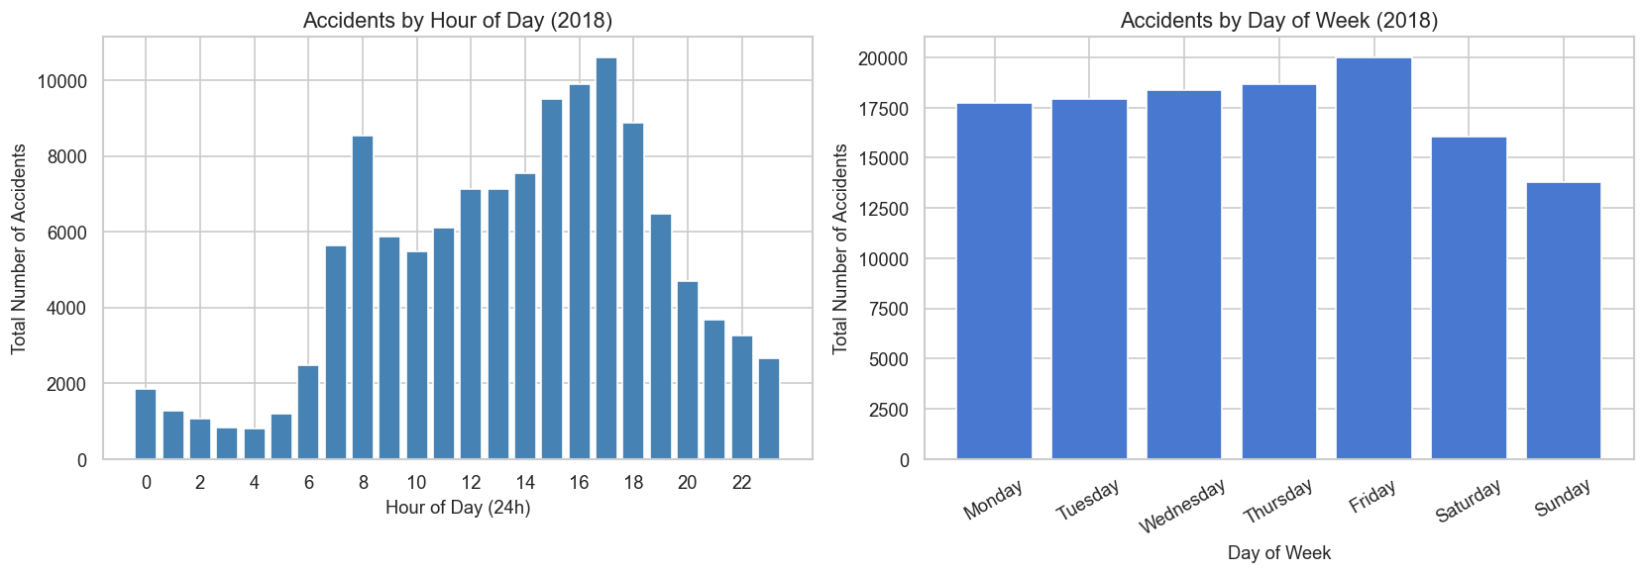
Figure 1: Total accident counts by hour of day and day of week for 2018
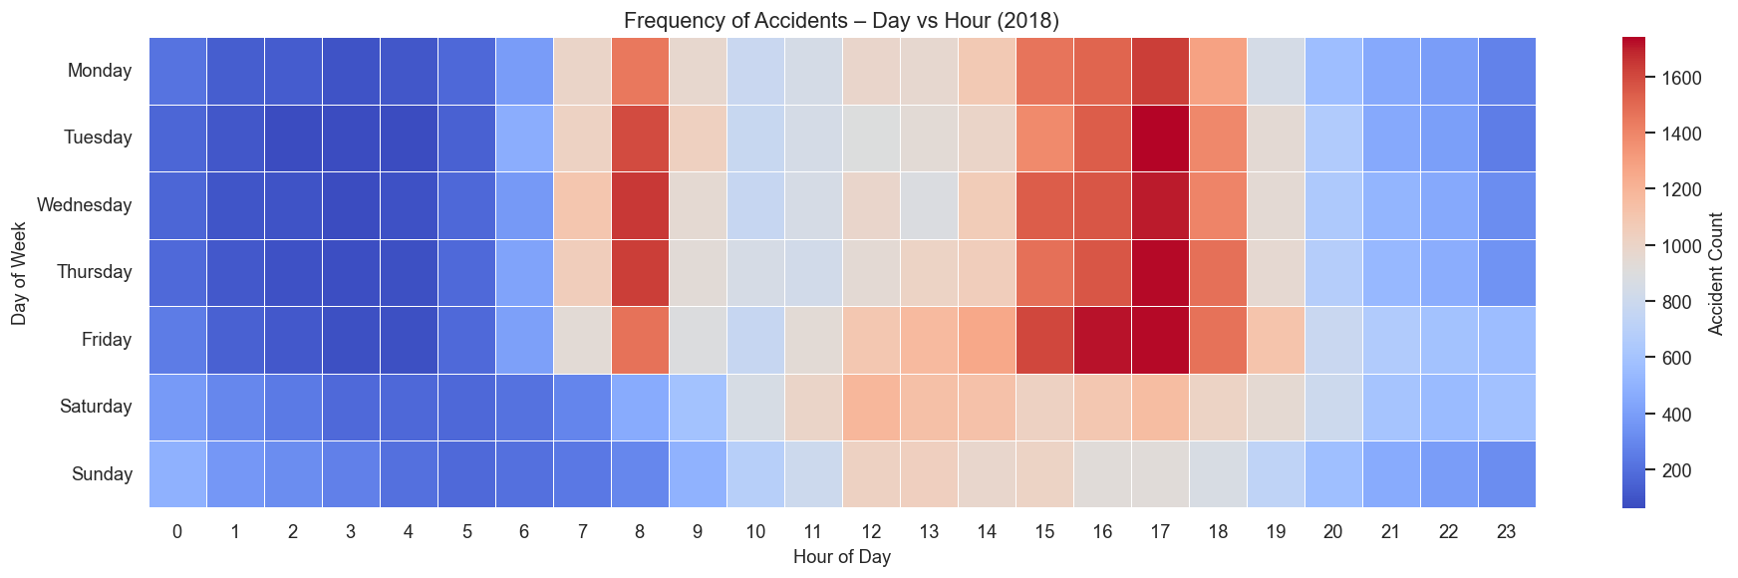
Figure 2: Heatmap of accident frequency by day of week and hour of day

Hour | Accident Count
17:00 | 10,615
16:00 | 9,905
15:00 | 9,500
18:00 | 8,891
08:00 | 8,538
Table 1: Top five peak accident hours in 2018

2.3 Motorcycle Accident Patterns
A total of 15,890 motorcycle-involved accident records were identified across three engine categories. Motorcycles of 125cc was the largest group, followed by motorcycles over 500cc, and then 126–500cc category. All three categories shared the same peak hour of 17:00, aligning with the general commuter pattern. However, motorcycles over 500cc showed a distinct peak day of Thursday rather than Friday, which is shared by both lower-powered categories. This divergence likely reflects a recreational riding pattern among higher-powered motorcycle users. The lower total count for the 126–500cc category likely reflects its smaller share of registered motorcycles on UK roads rather than superior safety outcomes.
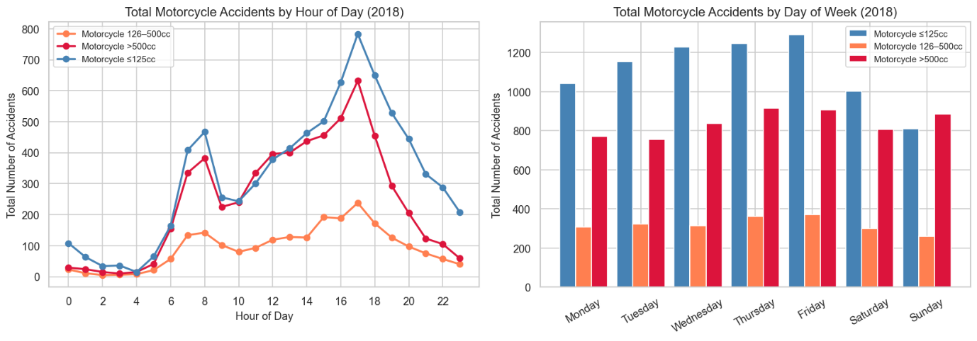
Figure 3: Motorcycle accidents by hour of day and day of week

Category | Total Accidents | Peak Hour | Peak Day
Motorcycle ≤125cc | 7,774 | 17:00 | Friday
Motorcycle 126–500cc | 2,240 | 17:00 | Friday
Motorcycle >500cc | 5,876 | 17:00 | Thursday
Table 2: Motorcycle accident summary by engine category, 2018

2.4 Pedestrian Accident Patterns
A total of 21,644 distinct pedestrian-involved accidents were identified in 2018. The peak accident hour had 2,317 accidents, one hour earlier than the general traffic peak of 17:00. This earlier afternoon peak likely suggests an after-school pattern, with increased child pedestrian exposure on residential roads during the period. Friday was the highest-risk day (3,720 accidents), consistent with general traffic patterns. A secondary morning peak was observed at 08:00–09:00, coinciding with the morning school time. The systematic divergence between pedestrian and general accident timing is a key policy finding: interventions targeted at commuter traffic peaks would miss the window of highest pedestrian vulnerability.
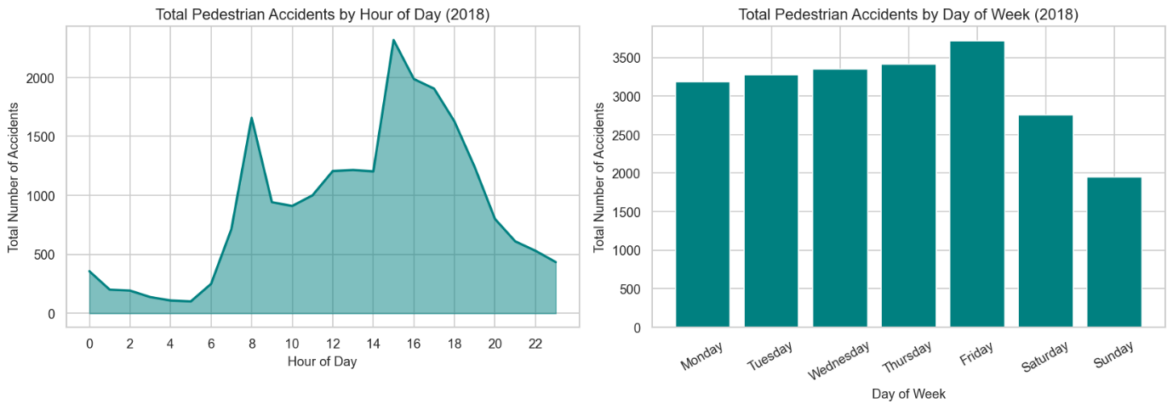
Figure 4: Pedestrian accident frequency by hour of day and day of week

2.5 Association Rule Mining – Apriori
The Apriori algorithm was applied to 118,608 records after filtering out Unknown-labelled entries. A minimum support threshold of 0.05 was selected to ensure rules are statistically representative across the dataset whilst excluding low-frequency combinations. Seven features were included in each transaction: severity, lighting, weather, road surface, speed limit, urban/rural area, and time period. A total of 489 frequent itemsets and 1,733 severity-consequent rules were generated. The top-ranked rule by lift (4.48) linked {Wet/Damp surface, Urban area} to {Raining weather, Slight severity}. This finding challenges the assumption that adverse weather directly causes serious outcomes: drivers appear to moderate their behaviour in poor urban weather conditions, producing slight rather than serious injuries. The second-ranked rule cluster also centred on wet/raining conditions and slight severity, reinforcing this pattern. In contrast, rural 60mph conditions on dry roads produced rule clusters with lift values of 3.0–3.4 associating with slight outcomes, reflecting the high volume of collisions on A-roads at speed but at relatively lower injury severity than might be expected, likely because motorway roads have more well-planned roadside geometry.
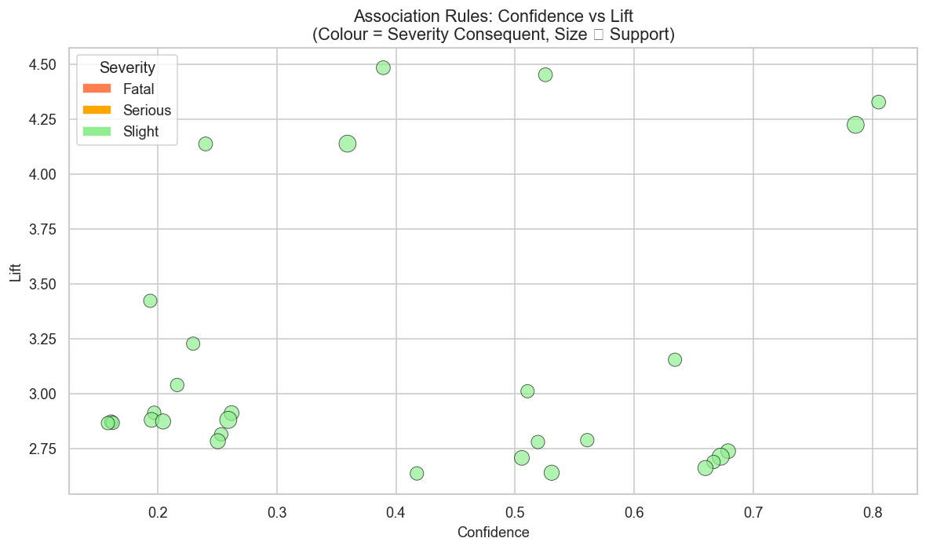
Figure 5: Scatter plot of top 30 severity-consequent association rules

2.6 Clustering of West Yorkshire Accidents
West Yorkshire contributed 4,132 accidents with valid geographic coordinates in 2018. Latitude ranged from 53.54°N to 53.94°N and longitude from -2.14° to -1.23°. Coordinates were standardised using StandardScaler prior to clustering. The optimal number of KMeans clusters was determined as k=8 using silhouette score maximisation. For DBSCAN, the eps parameter of 0.08 was selected from the elbow point of the k-distance plot, with minimum samples 5. DBSCAN identified 68 density-based clusters with 10.6% noise points.
KMeans cluster 3 was the largest, corresponding to the Leeds city centre and inner ring road corridor. Cluster 7 exhibited the highest fatal accident rate (2.8%) and serious rate (22.8%), with only 325 accidents showing a geographically concentrated high-severity zone, likely a semi-rural or high-speed road corridor. Cluster 4 showed the lowest fatal rate (0.8%), consistent with a dense urban area with lower speed limits. DBSCAN’s noise points (10.6%) represent geographically dispersed rural accidents that do not form density clusters, which is itself informative: these isolated incidents are resistant to traditional geographic clustering and may require individual road-level investigation.
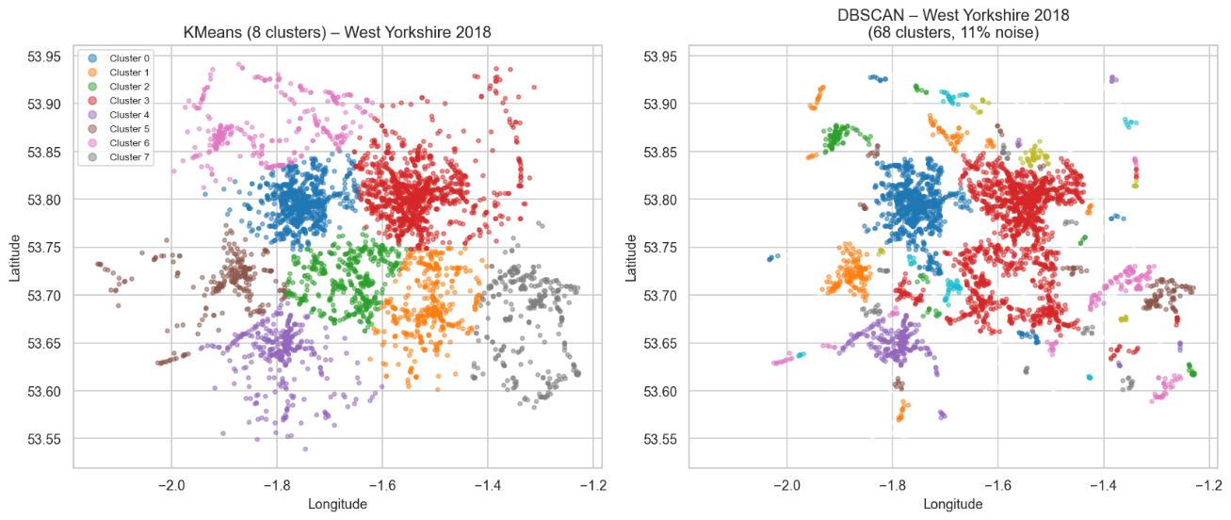
Figure 6: Geographic scatter of clusters
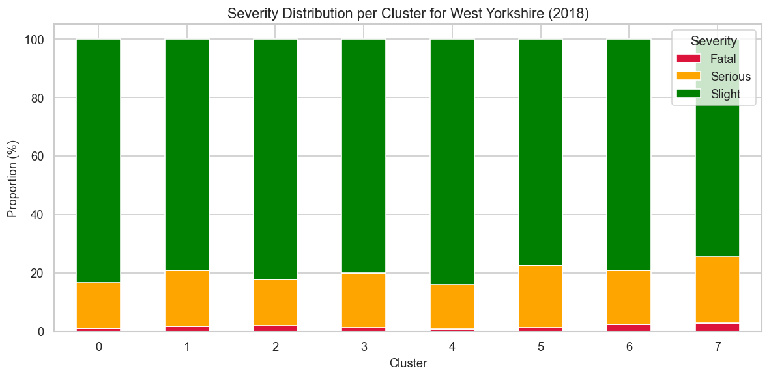
Figure 7: Fatal, Serious, and Slight accident proportions per KMeans cluster
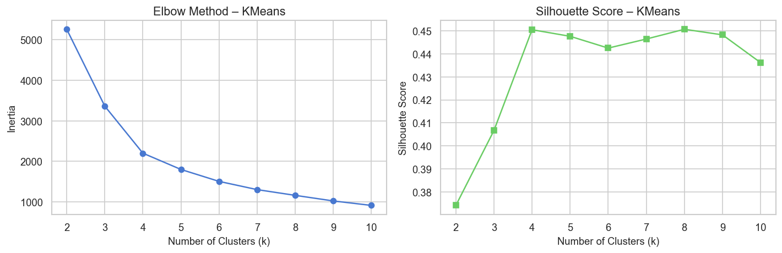
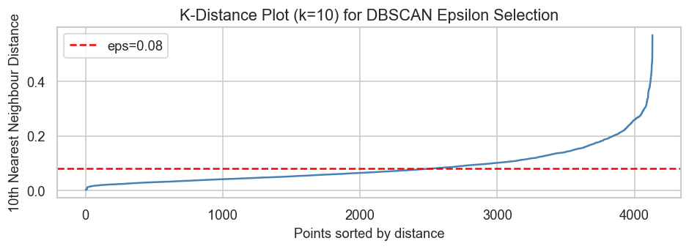
Figure 8: Fatal, Serious, and Slight accident proportions per KMeans cluster

2.7 SARIMA Weekly Accident Forecasting
SARIMA models were fitted to weekly accident counts for three police forces: Metropolitan (code 1), Greater Manchester (code 6), and West Yorkshire (code 13). The model order was selected following inspection of ACF and PACF plots, which showed significant correlation at lag 1 and evidence of a 52-week seasonal pattern. All training series (106 weeks, 2017–2018) were confirmed stationary by the Augmented Dickey-Fuller test. Models were then used to forecast 53 weeks of 2019 actuals.
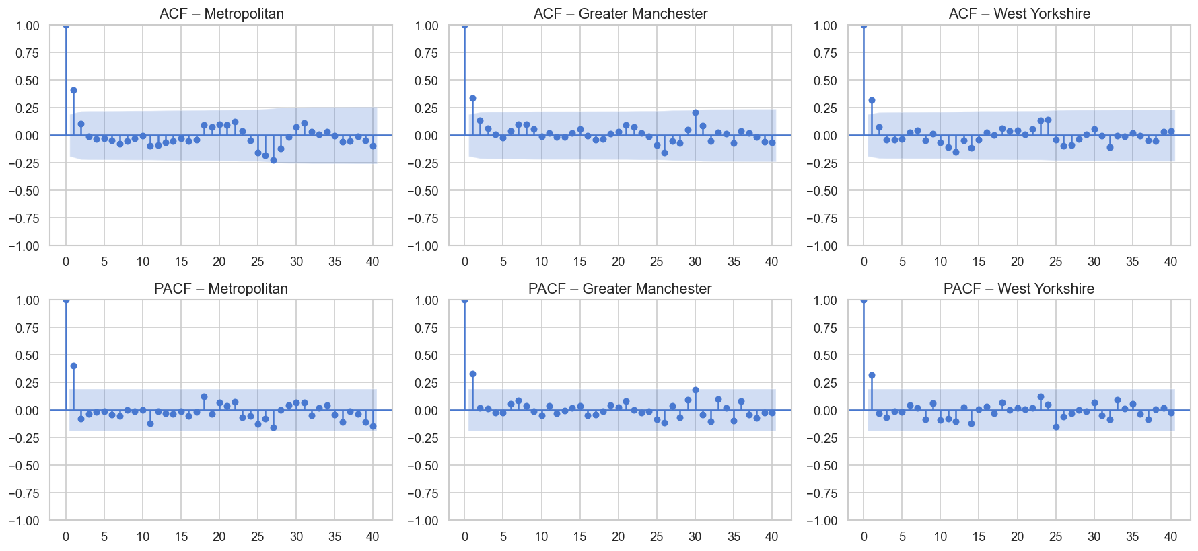
West Yorkshire produced the most accurate forecast (MAE=57.4, RMSE=64.1), followed by Greater Manchester (MAE=72.2, RMSE=78.9). The Metropolitan Police model substantially underperformed. This divergence is attributed to the complexity of London’s traffic system where accident counts in the Metropolitan area are influenced by a wider range of exogenous factors including public transport disruptions, major public events, road closures, and construction activity. Residual diagnostics confirmed that all models produced approximately white noise residuals, validating the SARIMA specification.

Figure 9: ACF and PACF for the weekly training series of each police force
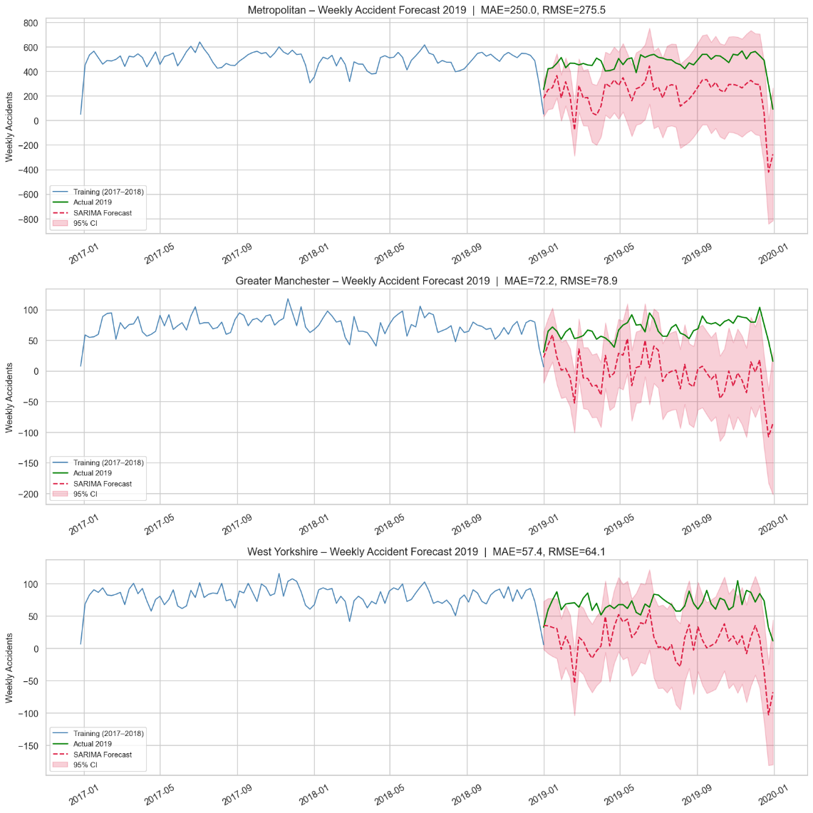
Figure 10: SARIMA forecast vs actual 2019 weekly accident counts for all three police forces
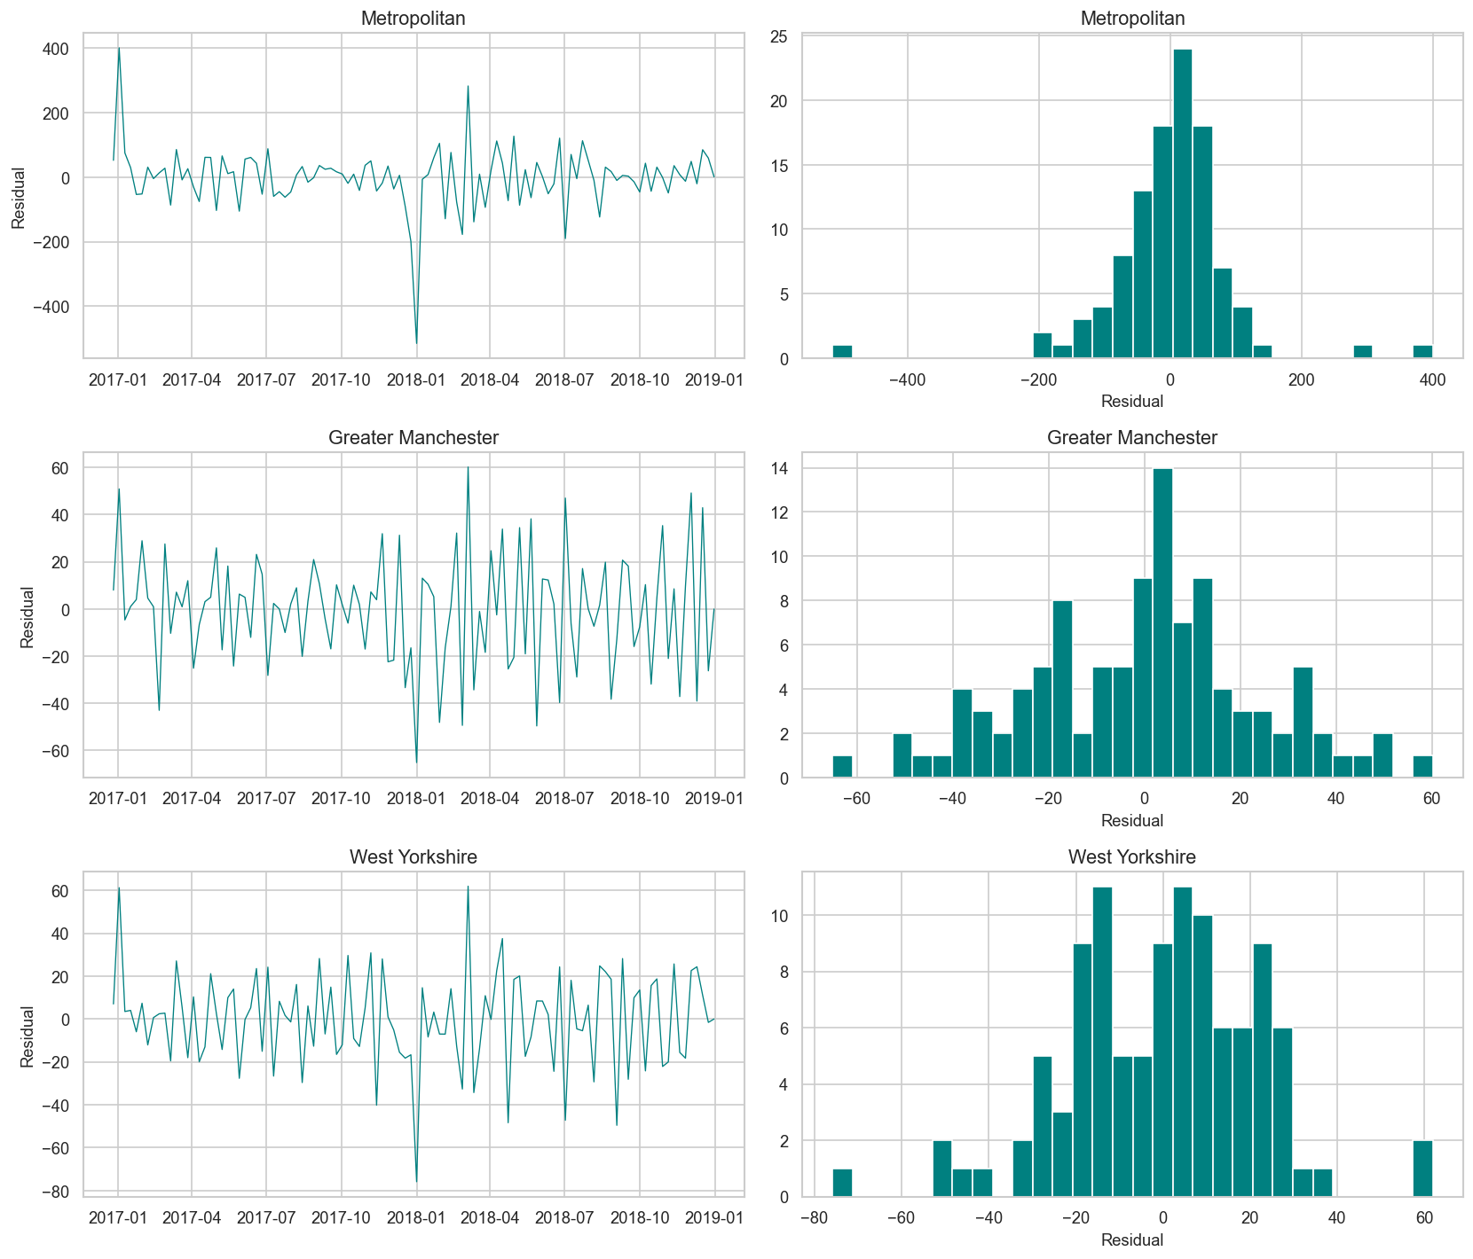
Figure 11: Residual time plots and residual distributions for each SARIMA model

Police Force | Train Weeks | ADF Statistic | p-value | MAE | RMSE
Metropolitan | 106 | -3.422 | 0.0102 | 250.0 | 275.5
Greater Manchester | 106 | -6.722 | <0.001 | 72.2 | 78.9
West Yorkshire | 106 | -6.689 | <0.001 | 57.4 | 64.1
Table 3: SARIMA model stationarity tests and forecast performance metrics (2019).

2.8 Daily ARIMA Forecast – Top 30 West Yorkshire LSOAs
The top 30 LSOAs in West Yorkshire by Q1 2018 accident frequency were identified, with the highest count of 11 accidents. Daily accident counts for these 30 LSOAs were aggregated over January–June 2018, producing a 180-day training series with a mean of 1.54 accidents per day and a maximum of 6. The ADF test confirmed stationarity (ADF=-3.409, p=0.0107). An ARIMA model was fitted (AIC=576.09, BIC=592.03). The order was selected based on the ADF result confirming d=1, and ACF/PACF diagnostics. Residual diagnostics indicated acceptable model fit: the Ljung-Box test showed no significant autocorrelation in residuals (Q=0.00, p=0.97), and the Jarque-Bera test indicated (JB=9.42, p=0.01, skew=0.51, kurtosis=3.48). All AR and MA coefficients were statistically significant (p<0.01) except MA(L1) (p=0.099). The model forecast July 2018 daily accident counts with MAE=1.02 and RMSE=1.20, representing strong predictive accuracy given the low integer-valued counts.
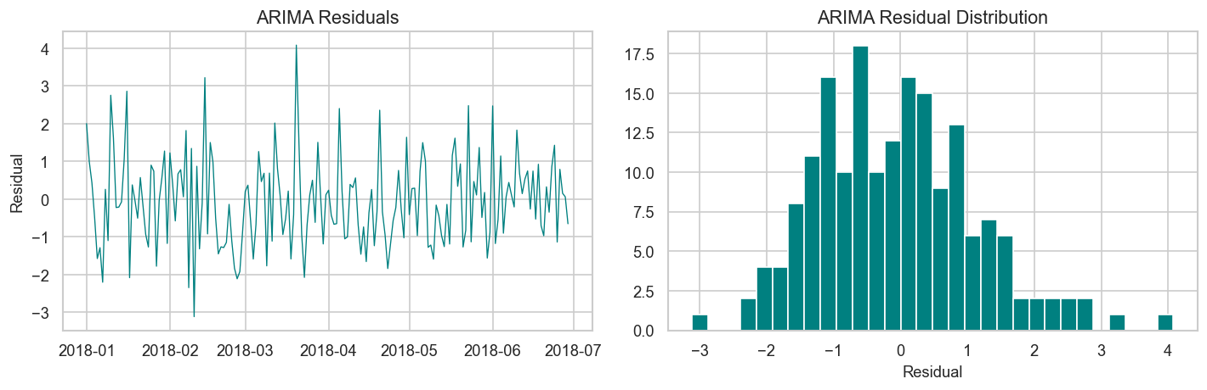
Figure 12: ARIMA residual time plot and residual distribution
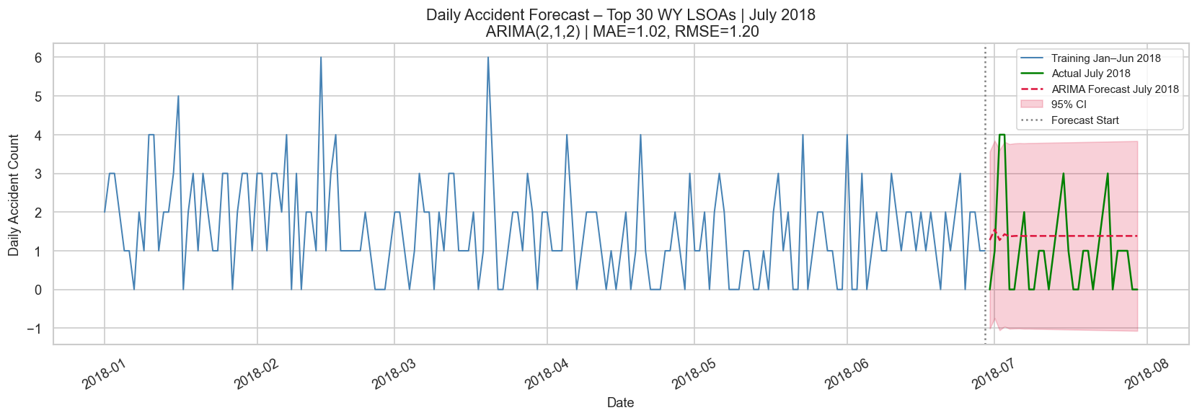
Figure 13: ARIMA(2,1,2) forecast for July 2018 vs actual daily counts across top 30 West Yorkshire LSOAs.

3. Discussion
The temporal analyses consistently identify Friday afternoons between 15:00 and 18:00 as the highest-risk window across all road user types. However, the pedestrian peak at 15:00 is systematically one to two hours earlier than the general traffic peak at 17:00, confirming a distinct school-related exposure window. This finding has direct policy implications: enforcement and infrastructure measures targeting the commuter peak would not address the period of greatest pedestrian risk. Separate interventions such as school zone speed reductions, crossing officer deployment, and 20mph zone activation should be timed around the 14:30–16:00 window.
The Apriori results challenge the intuitive assumption that wet or adverse weather conditions are primary drivers of serious accidents. The highest-lift rules associate wet urban conditions with slight outcomes, suggesting that drivers consciously or unconsciously reduce speed and increase following distance in poor weather. Conversely, the strong association between rural 60mph roads on dry fine days and slight outcomes requires interpretation: the high volume of such conditions means they dominate rule coverage, potentially masking a smaller subset of high-severity incidents. Future analysis should stratify by rural road type to distinguish between A-road and minor road behaviour.
The West Yorkshire clustering demonstrates the complementary value of KMeans and DBSCAN in spatial accident analysis. KMeans provides interpretable geographic segments aligned with known urban areas, whilst DBSCAN reveals fine-grained density hotspots and flags isolated rural incidents as noise. The high fatal rate in cluster 7 is particularly notable given its smaller accident count, this pattern is consistent with a high-speed road corridor where low accident frequency covers individually severe events. Such clusters are precisely the locations most likely to be overlooked by volume-based safety prioritisation approaches.
The SARIMA forecasting results demonstrate that weekly accident patterns in West Yorkshire and Greater Manchester are well-captured by historical seasonal models. The Metropolitan model’s substantially higher forecast error highlights a fundamental limitation of univariate time series approaches in complex urban environments. London’s accident patterns are influenced by a far wider range of factors than historical accident data can encode, suggesting that a SARIMAX approach incorporating exogenous regressors would be necessary to achieve comparable forecast accuracy.

4. Recommendations
- Introduce time-separated speed restrictions in school zones activated between 14:30 and 16:00 on weekdays, directly targeting the pedestrian vulnerability window. Electronic variable speed limit signs with school hours activation would provide a cost-effective implementation pathway.
- Commission infrastructure safety reviews for West Yorkshire KMeans cluster 7, which recorded the highest combined fatal and serious injury rate despite a relatively low accident volume. The concentration of severe outcomes in a small geographic area suggests localised road geometry, speed, or signage issues justifying targeted intervention.
- Deploy wet weather driver behaviour campaigns in urban areas, wet conditions are already associated with slight rather than serious outcomes. Rather than focusing on bad weather itself, campaigns should target the false sense of safety that may accompany dry conditions on rural roads, where high-speed slight accidents remain frequent.
- Introduce specific awareness campaigns and potential licensing review for motorcycles over 500cc, targeting the Thursday recreational peak that distinguishes this group from lower-powered categories. A focus on rural high-speed riding conditions, where fatal outcomes are disproportionately represented, would maximise impact.
- Develop a SARIMAX forecasting model for the Metropolitan Police area incorporating exogenous variables such as road works schedules, major event calendars, and public transport disruption data, to address the substantially higher forecast errors observed relative to other forces and enable proactive resource deployment.

Exercise 2: Social Network Analysis

5. Introduction
This exercise analyses the Facebook network dataset from the Stanford Network Analysis Platform (SNAP). The dataset comprises an undirected edge list representing anonymised friendship connections across multiple Facebook networks. A graph was constructed from this edge list and analysed to characterise its structural properties, quantify edge-level centrality, detect communities using two algorithms, and interpret the findings within a network science framework.

6. Analysis and Results

6.1 Network Construction and Basic Characteristics
The graph was loaded as an undirected network using NetworkX, yielding 4,039 nodes and 88,234 edges. The network is fully connected (one component), confirmed by the LCC containing all 4,039 nodes. Network density was 0.010820, indicating a sparse graph, each node is connected to approximately 1.1% of all other nodes, consistent with real-world social networks where individuals maintain connections with a small fraction of the total population. The average degree of 43.69 is relatively high for a sparse network, reflecting the ego-network sampling method used by SNAP. Each sampled node is already known to share connections with an ego node, artificially inflating local connectivity compared to a random sample of the same network. The average clustering coefficient of 0.6055 indicates that most of a user’s friends also know each other; a defining characteristic of social networks (Watts and Strogatz, 1998). The network diameter of 8 confirms the small-world property that any two users are connected by at most 8 friendship steps.
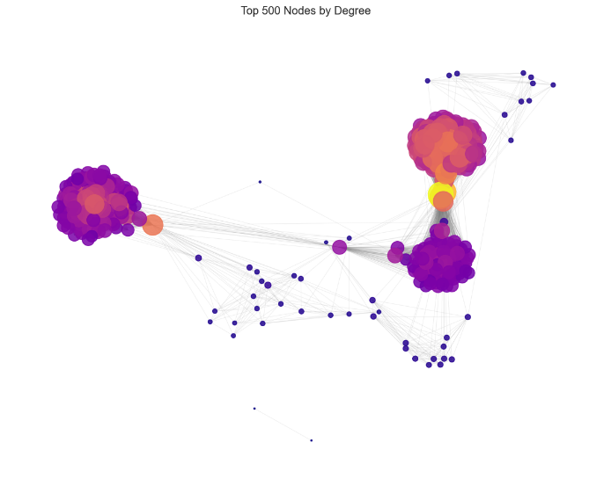
The degree distribution exhibited a tail, consistent with scale-free network characteristics described by Barabási and Albert (1999). A small number of high-degree nodes likely the ego users themselves dominate connectivity, whilst the majority of nodes maintain moderate degrees.
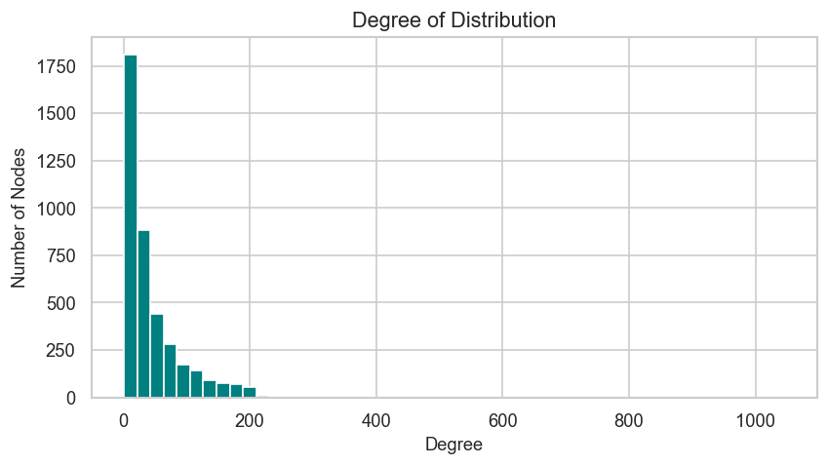

Figure 14: Degree distribution histogram and spring-layout visualisation of the top 500 nodes by degree.
Metric | Value
Nodes | 4,039
Edges | 88,234
Network Density | 0.010820
Average Degree | 43.69
Average Clustering Coefficient | 0.6055
Diameter (LCC) | 8
Connected | Yes (single component)
Table 4: Basic network characteristics of the Facebook network.

6.2 Edge Betweenness Centrality
Edge betweenness centrality (EBC) measures the proportion of shortest paths between all node pairs that pass through a given edge (Girvan and Newman, 2002). It was computed across all 88,234 edges using normalised values. The distribution was heavily right-skewed: the minimum EBC was 0.000000, the median was 0.000001, the mean was 0.000042, and the maximum was 0.171493. Over 90% of edges have EBC values below 0.01, whilst a small number of bridge edges carry a disproportionate share of all inter-community shortest paths.
The highest-EBC edge was (107, 1684) with EBC=0.171493, followed by (107, 1085) at 0.129675. The repeated appearance of nodes 107, 1684, 1085, and 3437 in the top 10 bridge edges identifies these as critical connector nodes between sections of the network. Removal of any of these edges would substantially increase the average shortest path length between communities. This pattern is consistent with the bottleneck structure typical of network data, where individual ego nodes serve as the primary links between their separate friend groups.
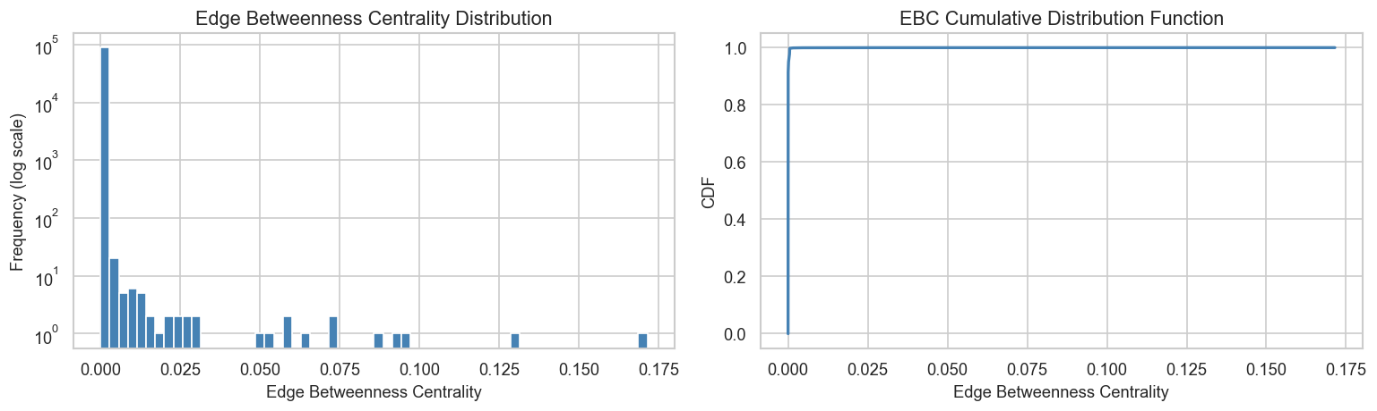
Figure 15: EBC histogram on log frequency scale and cumulative distribution function

6.3 Community Detection – Louvain vs Girvan-Newman
Two community detection algorithms were applied. The Louvain method was applied to the full graph of 4,039 nodes, maximising modularity through a greedy hierarchical approach. It identified 15 communities with a modularity score of 0.8349. Community sizes ranged from 19 to 548 nodes, with a mean of 269.3 nodes. A modularity above 0.7 is generally considered indicative of strong community structure (Newman, 2006), and the score of 0.8349 reflects very well-defined partitioning.
The Girvan-Newman algorithm was applied to a representative subgraph of the 500 highest-degree nodes due to its O(m²n) computational complexity, which makes full-graph application intractable for networks of this size (Fortunato, 2010). The algorithm iteratively removes the highest-EBC edge until the same number of communities as Louvain (15) was reached. It produced 15 communities with sizes ranging from 1 to 190 nodes and a mean of 33.3 nodes. The stark contrast in mean community size reflects a fundamental difference in methodology: Louvain optimises for globally balanced partitions on the full graph, whilst Girvan-Newman’s hierarchical splitting on a subgraph tends to fragment one dominant component into a large residual cluster and many small splinter groups.
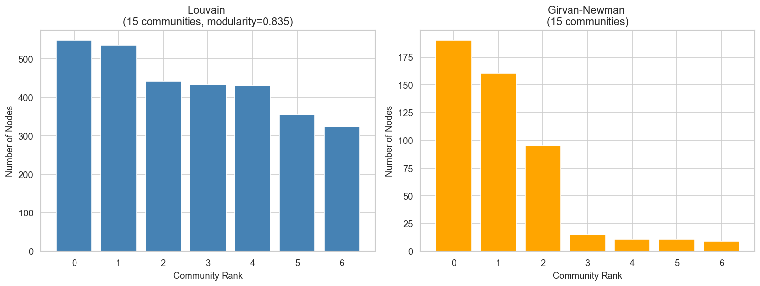
Figure 16: Top 7 community sizes for Louvain and Girvan-Newman
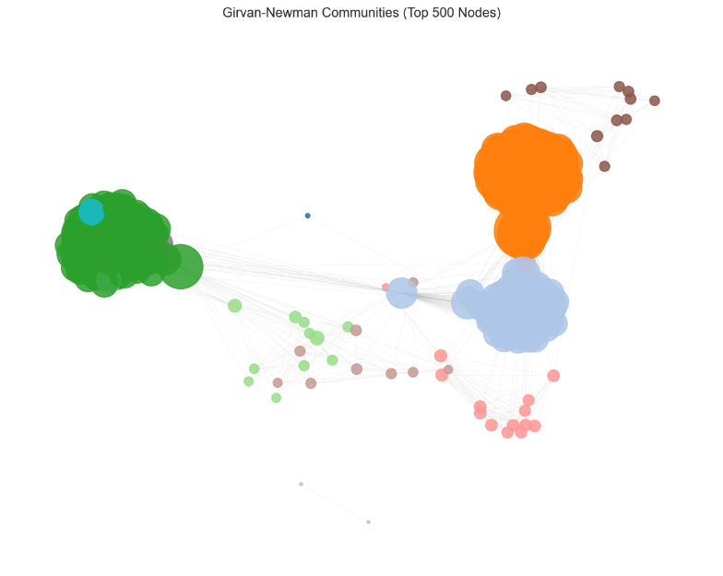
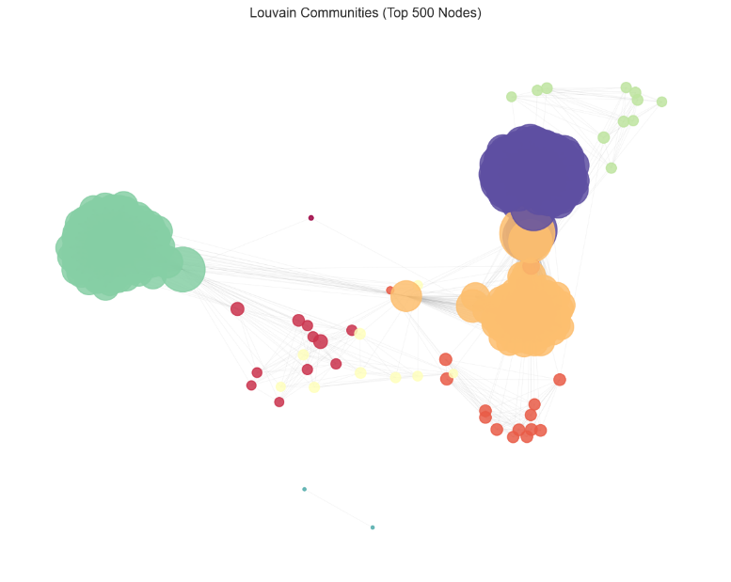
Figure 17: Network visualisation with nodes coloured by each detection algorithm

Algorithm | Scope | Communities | Largest | Smallest | Mean Size | Modularity
Louvain | Full graph (4,039 nodes) | 15 | 548 | 19 | 269.3 | 0.8349
Girvan-Newman | Top-500 subgraph | 15 | 190 | 1 | 33.3 | N/A
Table 5: Community detection algorithm comparison.

7. Discussion
The combination of high clustering, short diameter, and power-law degree distribution confirms that the Facebook network exhibits both small-world and scale-free properties. These structural features have important implications for information diffusion, namely, the hub nodes identified through high degree and high EBC are both the fastest propagators of information and the most critical bottlenecks for inter-community communication.
The 15 Louvain communities and the high modularity score most likely reflect the distinct ego-networks from which the SNAP dataset was assembled. Each ego user’s friend group forms a dense internal cluster with limited cross-ego connections, producing an artificially modular structure. This is an important as the communities may partly reflect data collection methodology rather than purely emergent social groupings. Applying Louvain to a dataset with genuine organic network growth (rather than ego-sampled nodes) would likely yield lower but more sociologically meaningful modularity.
The divergence between Louvain and Girvan-Newman in community size is methodologically expected. Louvain’s resolution limit can absorb small communities into larger ones when operating on the full graph (Fortunato and Barthélemy, 2007), whilst Girvan-Newman’s iterative edge removal on a subgraph naturally produces one large residual community and many small fragments. For practical community detection on large networks, Louvain is the preferred choice due to its linear time complexity and consistent modularity optimisation. Girvan-Newman remains valuable for hierarchical community analysis and for networks where EBC-based bridging is the primary concept of interest.

8. Conclusions
This analysis confirmed that the Facebook network exhibits canonical and small-world properties.. Edge betweenness centrality successfully identified a small set of bridge edges whose removal would most fragment inter-community connectivity. The Louvain algorithm produced 15 well-defined communities on the full graph, whilst Girvan-Newman applied to a 500-node subgraph produced the same number of communities but with substantially different size distributions. These findings have practical applications in information diffusion modelling, targeted intervention design, and community-based recommendation systems.

9. References
Barabási, A.L. and Albert, R. (1999) ‘Emergence of scaling in random networks’, Science, 286(5439), pp. 509–512.
Department for Transport (2023) Road Safety Data. Available at: https://www.data.gov.uk/dataset/cb7ae6f0-4be6-4935-9277-47e5ce24a11f/road-safety-data (Accessed: 25 April 2026).
Fortunato, S. (2010) ‘Community detection in graphs’, Physics Reports, 486(3–5), pp. 75–174.
Fortunato, S. and Barthélemy, M. (2007) ‘Resolution limit in community detection’, Proceedings of the National Academy of Sciences, 104(1), pp. 36–41.
Girvan, M. and Newman, M.E.J. (2002) ‘Community structure in social and biological networks’, Proceedings of the National Academy of Sciences, 99(12), pp. 7821–7826.
Newman, M.E.J. (2006) ‘Modularity and community structure in networks’, Proceedings of the National Academy of Sciences, 103(23), pp. 8577–8582.
Watts, D.J. and Strogatz, S.H. (1998) ‘Collective dynamics of small-world networks’, Nature, 393(6684), pp. 440–442.

