**Comparing two binary trees and finding whether they are equal or not**

Mohd Sadique(A20380442)

Compile : make

Run: make run

Or

./btree

Implementation:-

1. Create two btree based on input
2. Traverse both trees simultaneously, and while traversing we need to compare data and children of the trees.

Algorithm :-

Compare_tree(Btree1, Btree2)

1. If both trees are NULL(empty) then return TRUE
2. Else if both trees are not NULL(empty)
3. Compare data of root node of both btree

(Btree1->data == Btree->data)

1. Check left subtrees recursively

Compare_tree(Btree1->left, Btree2->left)

1. Check right subtree recursively

Compare_tree(Btree1->right,Btree1->right)

1. If all a , b , c return TRUE then return TRUE
2. else return False

Testing

Four Data set is tested

1). int a1[N] = {5,3,2,4,7,6,8};

int b1[N] = {5,3,2,4,7,6,8};

test_data(a1,b1,n1,n2);

Both make same Btree structure :-

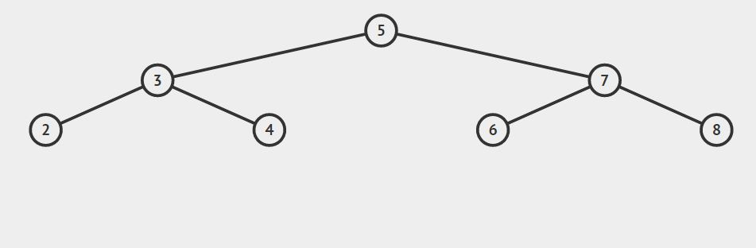

Output :-

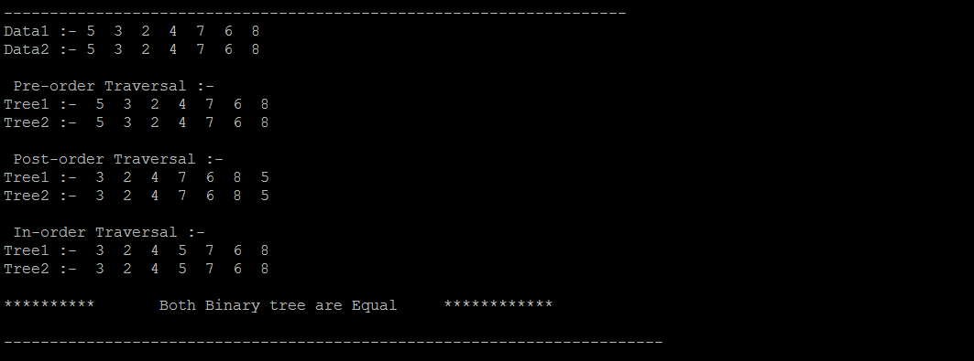

2) Test :-

int a2[N] = {5,3,2,4,7,6,8};

int b2[N] = {5,3,2,4,7,6};

test_data(a2,b2,n1,n2);

A2 Tree :-



B2 tree

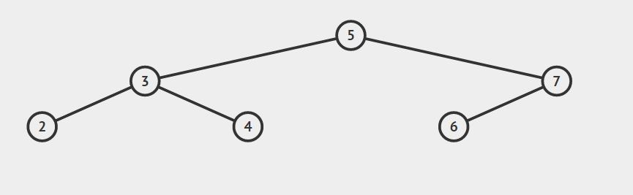

Output:-

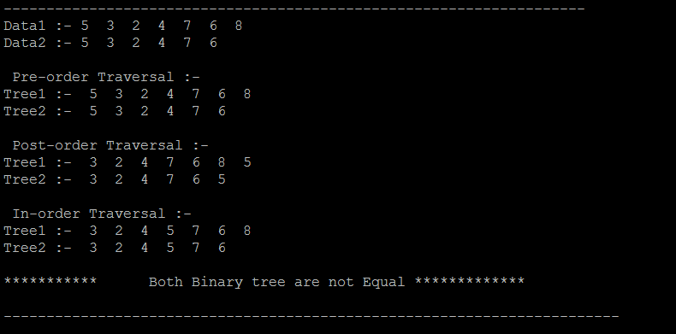

3) Test:-

int a3[N] = {5,3,2,4,7,6,8};

int b3[N] = {4,3,1,5,8,6,7};

test_data(a3,b3,n1,n2);

BTree1:-



BTree2:-

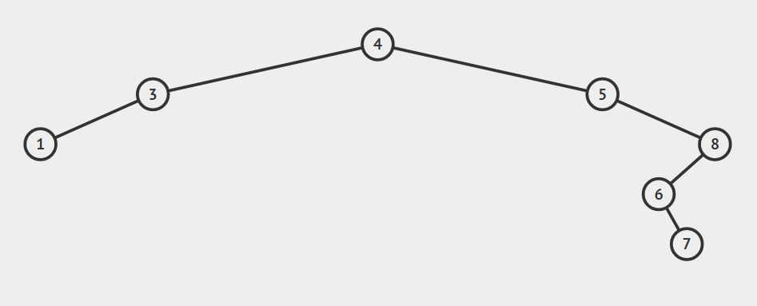

Output:-

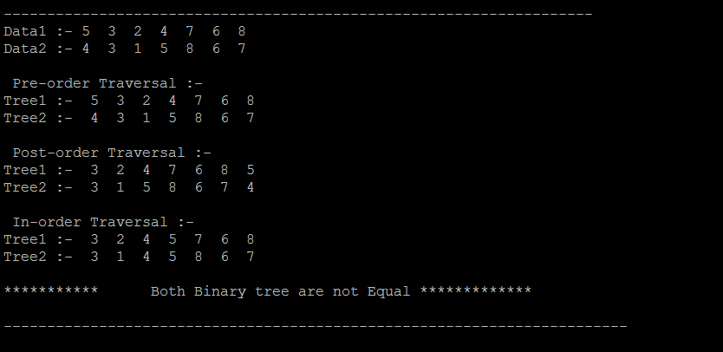

4) Testing 4

int a4[N] = {9,6,15,3,8,12,17,1,5,7,11,13,16,18};

int b4[N] = {9,6,3,1,5,8,7,15,12,11,13,17,16,18};

Btree1 and Btree2 :- Make Same Btree

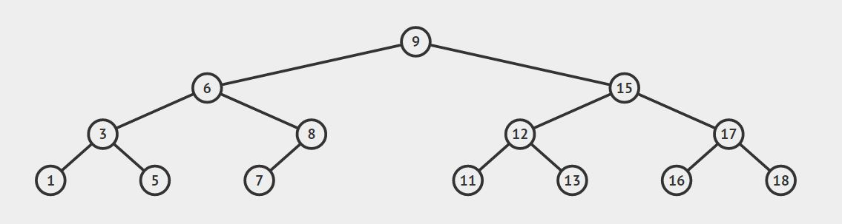

Output:-

