User Manual

Bluetooth based Management and Advertisement
Utility for Malls

Designed by :
Mohd Sadique

User Manual
15/01/2010

Table of Contents

Introduction…………………………………………..3
Features………………………………………...3
Product Look up………………………………..5
System Requirements………………………………...6
Hardware Requirements…………………………..6
Software Requirements…………………………...6
Operations and Functionalities……………………….7
Creating an account…………………………….7
Password Retrieval……………………………..8
Administrator Page……………………………..9
Adding a new customer………………………..10
Shopping History………………………………12
Storing records…………………………....12
Display records…………………………..13
Sending Messages…………………………………..14
Final Notes………………………………………… 15

Introduction

This multi-utility for Malls is aimed for outlets providing them facility for managing customers’ visits, purchasing history and other details and at the same time giving an option to customers to receive updates on their mobile sets about different offers and sales as soon as they enter the mall.

Features:
- It provides an inter platform application that will store details of all loyal customers in a database in any outlet including their visits, purchasing history, and many more.

- When any of the listed customers is found in the Private Area Network (PAN) of the Mall which will of course be created with Bluetooth technology , the application will send the ongoing offers and sales being offered by that specific outlet to their respective Bluetooth enabled mobile handsets.

- Every outlet can have its own application or register to a Central application employed in the mall.

- The registered customers will have the option to select between these two:
1) Notify
2) Do not disturb
- Track all the customers and their contact details.

- Manage all the account details such as user name, company, phone numbers, address, websites, email addresses of all the customers from one central location.

- Group the contacts together in a single account according to some criteria.

- Capture, View and edit all user transactions, including email, and services calls in a single system.

- End user agreement and to verify which users want to receive support and updates.

- All the updates and changes will be carried out maintaining the integrity of the database.

- All transfer of messages will be under a secure connection using a 8 bit encryption.

- Due respect will be given to customers’ privacy by providing facilities like DND (Do Not Disturb).

Product Look up

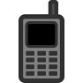

Database
(DB2)

Application
at
Server side (At Outlets)
Bluetooth Network
(Private Area Network)

Network Server

Clients

Hardware Requirements:

- 50 MB Hard disk space
- 128 MB system RAM
- 800 MHz Pentium III (CPU)

Mobile hardware requirements :

- 128 Kb permanent storage for J2ME application
- 32 Kb RAM for applications to run
- A screen at least 96 pixels wide and 54 pixels tall

Software Requirements:

- WIN XP/NT
- WidComm 4.0 or later
- Bluecove 2.1.0
- JAVA SE 1.6
- IBM DB2 V 9.0

Operations and Functionalities

The entire application can be made to run on a single account with a password. This restricts the usage to an authorized person.

Creating an Account

When the application is run for the first time, the user can create a new account by clicking on “Register” in Login page. Once the account has been created, the user can change his/her password or retrieve the same using “Change password” and “Forgot password” respectively.

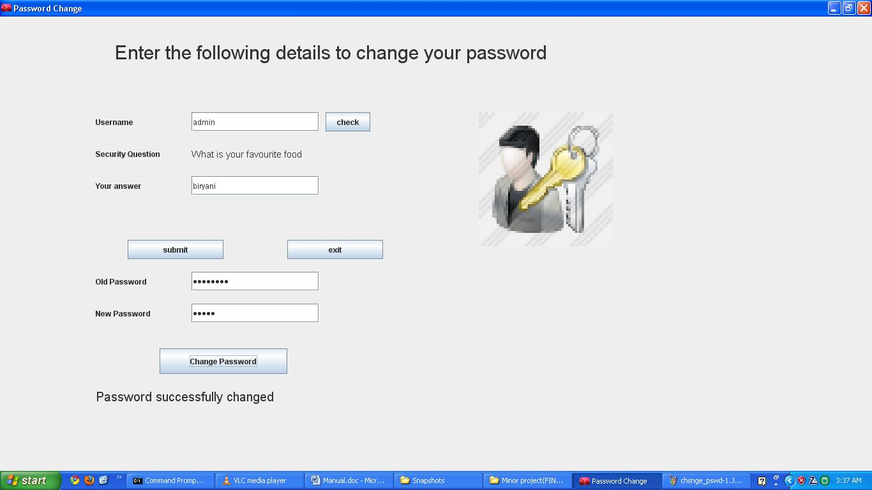

Password retrieval:

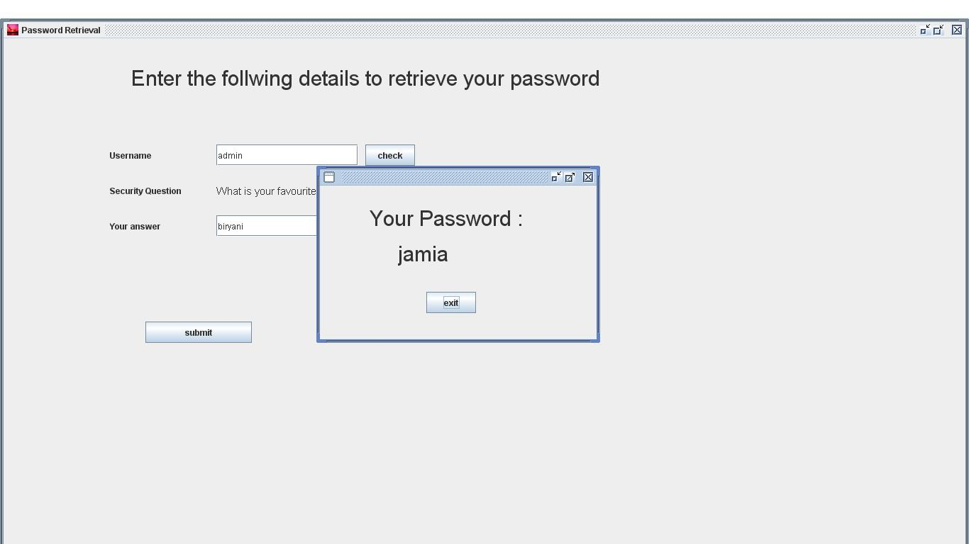

Administrator page

The administrator page follows the login page after a successful login. It is the primary page of the application which provides different services to the administrator (user). The services include:
- Customers’ details
- Customers’ address
- Shopping history of the customer
- Send messages to the customer via Bluetooth regarding updates and offers

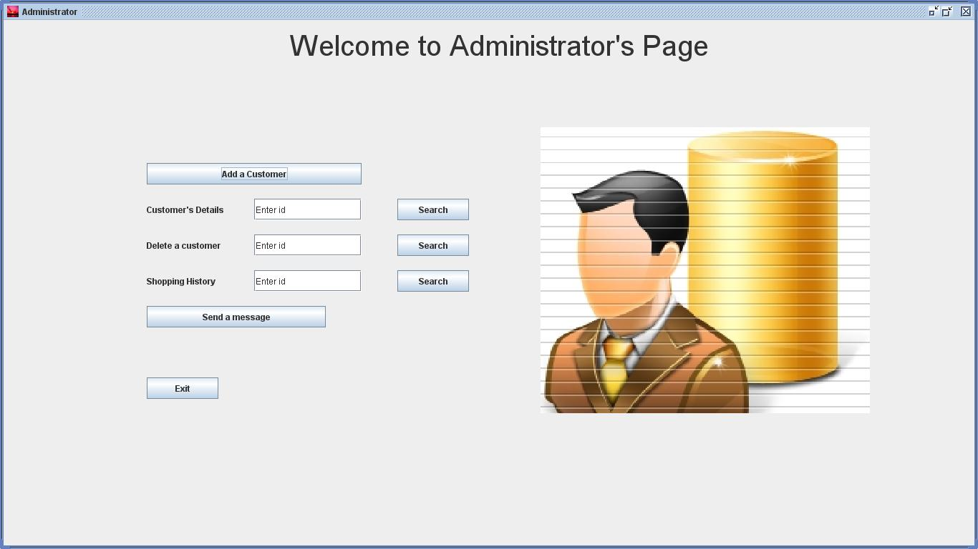

Adding a new Customer to the record

This page provides services like adding and deleting the details of a customer. It also leads to Address page where the mailing address of the customer can be stored.

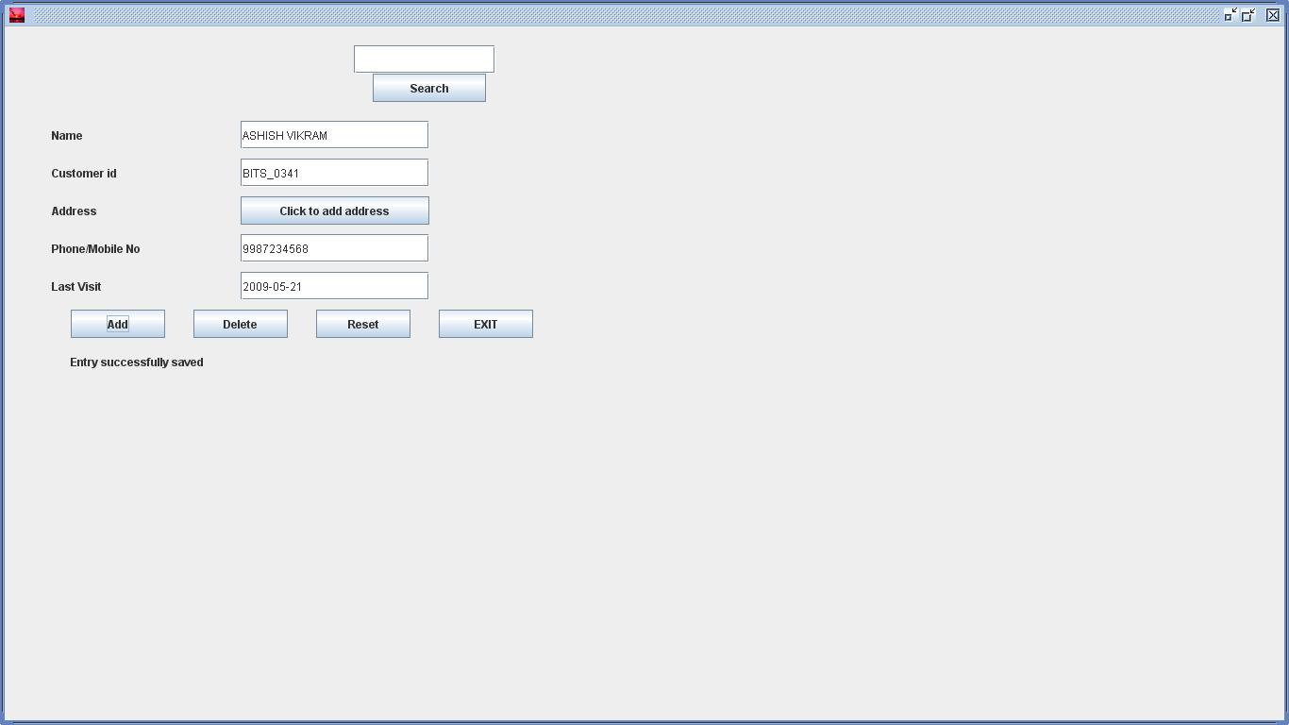

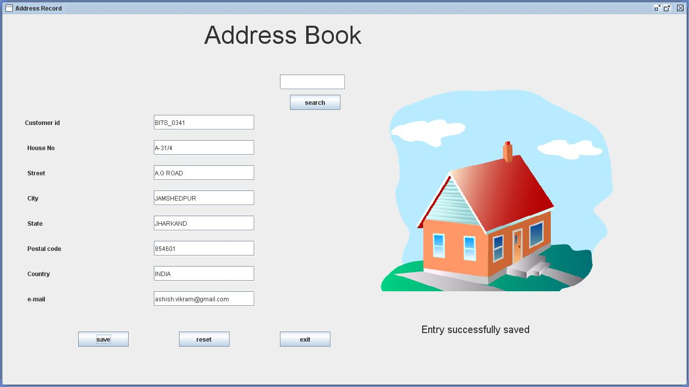

Storing the address of the customer

Note: All the date fields should be filled as yyyy-mm-dd format.

Example: 2009-05-21 should be entered for May 21,2009.

Shopping History

It provides the user with a facility to store all the transaction carried out by a customer. The record will include the product id, type, price, discount and date of purchase. The user can also view all the records of a particular customer in a tabular view. The records of a particular customer can also be deleted.

Services in shopping page:

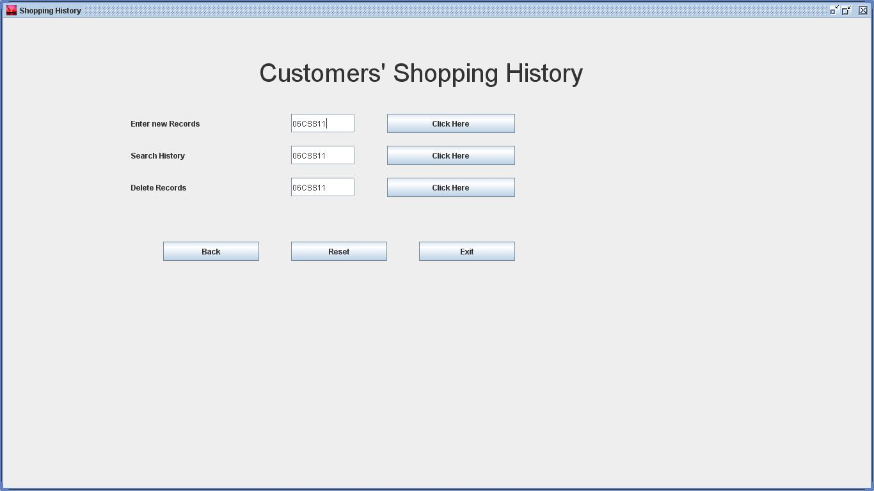

Shopping history :

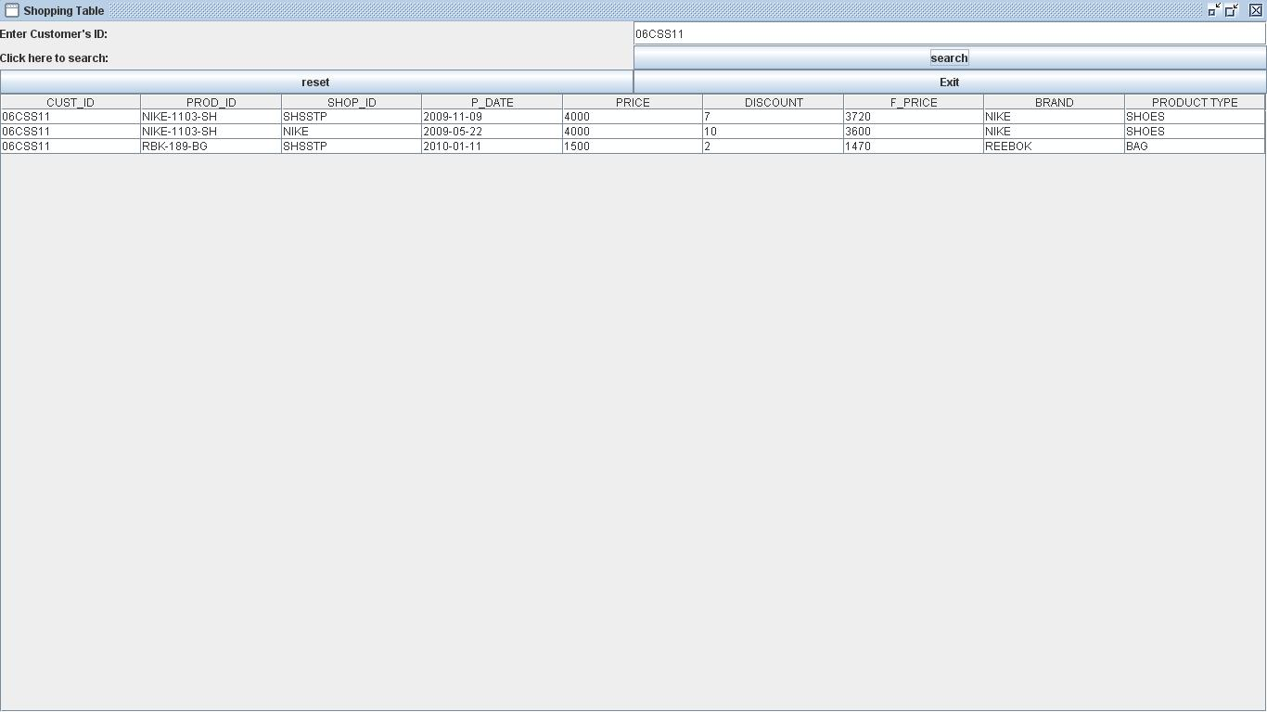

The shopping history of a particular customer can be viewed by entering his/her customer id.

Sending Messages:

Now we are facing one of the most important feature of this application. The send message can be used to send offer and sales’ updates to the customers. In order to receive these messages , the customer should fulfill following two conditions:

- The mobile application be started.
- Bluetooth on the mobile set should be on.

Final notes

The application has been designed in a way that any person can run and manage the application without any know how of the underlying database or any other technical aspect. The entire interface is easy to use and attractive as well.

We hope to deliver the best to our customers and we always work towards this end.

