EVENT LEDGER
Project Walkthrough & Technical Guide
Architecture, implementation decisions, resiliency, observability, testing, bonus features, and production trade-offs

Author | Mohd Sadique
Repository | https://github.com/msadique/financial-event-ledger
Implementation | Python, FastAPI, SQLAlchemy, SQLite, Docker Compose
Observability | OpenTelemetry Collector, Jaeger, Prometheus
Prepared | June 27, 2026
Purpose
This document is designed for the technical walkthrough after repository review. It explains what was built, why key decisions were made, how the system behaves under failure, how it is validated, and how the design would evolve for production scale.

Document status and evidence
Validation status: Cross-service distributed tracing through the OpenTelemetry Collector into Jaeger has been validated end to end and is supported by the Jaeger trace screenshot in this document. The Jaeger Monitor / RED-metrics path is implemented through the Collector spanmetrics connector and Prometheus; run make test-monitoring in the final local environment to record the final validation result before submission.

Area | Evidence in repository | Status represented in this guide
Core services | Docker Compose health checks; API and service tests | Implemented
Idempotency / ordering | Unit, integration, and functional tests | Implemented and tested
Resiliency / fallback | test-resiliency.sh and async-fallback tests | Implemented
Persistence | Named volumes and test-persistence.sh | Implemented
Distributed traces | test-tracing.sh and Jaeger trace screenshot | Validated
Jaeger Monitor | spanmetrics + Prometheus + test-monitoring.sh | Implemented; final local rerun recommended
Coverage | 25 Account tests and 51 Gateway tests; coverage artifacts | 100% statement/branch in current artifacts
Contract testing | Pact V4 consumer/provider suites | Implemented

Contents
• 1. Executive summary | • 11. Rate limiting and operational protection
• 2. Problem and engineering goals | • 12. Testing and quality strategy
• 3. System architecture | • 13. Bonus features
• 4. Service responsibilities and data ownership | • 14. Docker and operational runbook
• 5. Data model and persistence | • 15. Design trade-offs and production evolution
• 6. API contract and status behavior | • 16. Suggested interview walkthrough
• 7. End-to-end processing flows | • 17. Likely review questions and answers
• 8. Financial correctness, idempotency, and ordering | • Appendix A. Commands and endpoints
• 9. Resiliency strategy | • Appendix B. Repository artifacts and file map
• 10. Observability and distributed tracing

1. Executive summary
Event Ledger is a two-service financial transaction system designed to demonstrate distributed-systems fundamentals within a compact take-home implementation. A public Event Gateway validates and records events, then calls an internal Account Service that owns balances and the applied transaction ledger. Each service has its own SQLite database and no shared in-process state.
- Correctness: Decimal-based money, duplicate protection in both services, conflict detection, and chronological queries for out-of-order arrivals.
- Reliability: Timeouts, bounded retries, exponential backoff with jitter, a circuit breaker, and a durable fallback queue.
- Operational readiness: Health endpoints, structured JSON logs, Prometheus metrics, audit records, Docker Compose, and Make commands.
- Distributed observability: W3C trace context, OpenTelemetry instrumentation, Collector-based export, Jaeger visualization, and Prometheus-backed span metrics.
- Quality: Unit/integration tests, public-API functional tests, Pact consumer/provider contract tests, coverage thresholds, and operational scripts.

Solution at a glance
Dimension | Implementation
Public API | FastAPI Event Gateway on port 8080
Internal API | FastAPI Account Service on port 8081
Persistence | Independent file-based SQLite databases in Docker named volumes
Money | Python Decimal and SQL NUMERIC(19,4)
Communication | Synchronous HTTP/JSON with HTTPX
Tracing | X-Trace-ID plus OpenTelemetry/W3C traceparent
Metrics | Application Prometheus endpoints and Collector-derived RED metrics
Container orchestration | Docker Compose with health-aware dependencies
Testing | Pytest, pytest-cov, functional tests, Pact V4, operational Bash scripts

2. Problem and engineering goals
The system receives financial events from upstream systems that may be delayed, duplicated, or temporarily unable to reach downstream dependencies. The implementation therefore prioritizes the following properties:
- Accept valid CREDIT and DEBIT events and update account balances accurately.
- Process an event at most once even when the same message is delivered repeatedly.
- Reject a reused eventId when the payload conflicts with the original event.
- Accept events in any arrival order while returning chronological history.
- Remain understandable and diagnosable during partial failure.
- Keep the two services independently deployable and independently persistent.
- Provide repeatable build, test, and validation commands suitable for reviewer use.

Non-goals for the exercise
- Global, strongly consistent transactions across both service databases.
- Horizontally scalable rate limiting or circuit-breaker coordination.
- Production-grade authentication, authorization, secrets management, or encryption policy.
- High-throughput multi-writer database performance beyond SQLite's intended scope.
- Durable production trace storage; Jaeger uses in-memory trace storage in the local stack.

3. System architecture
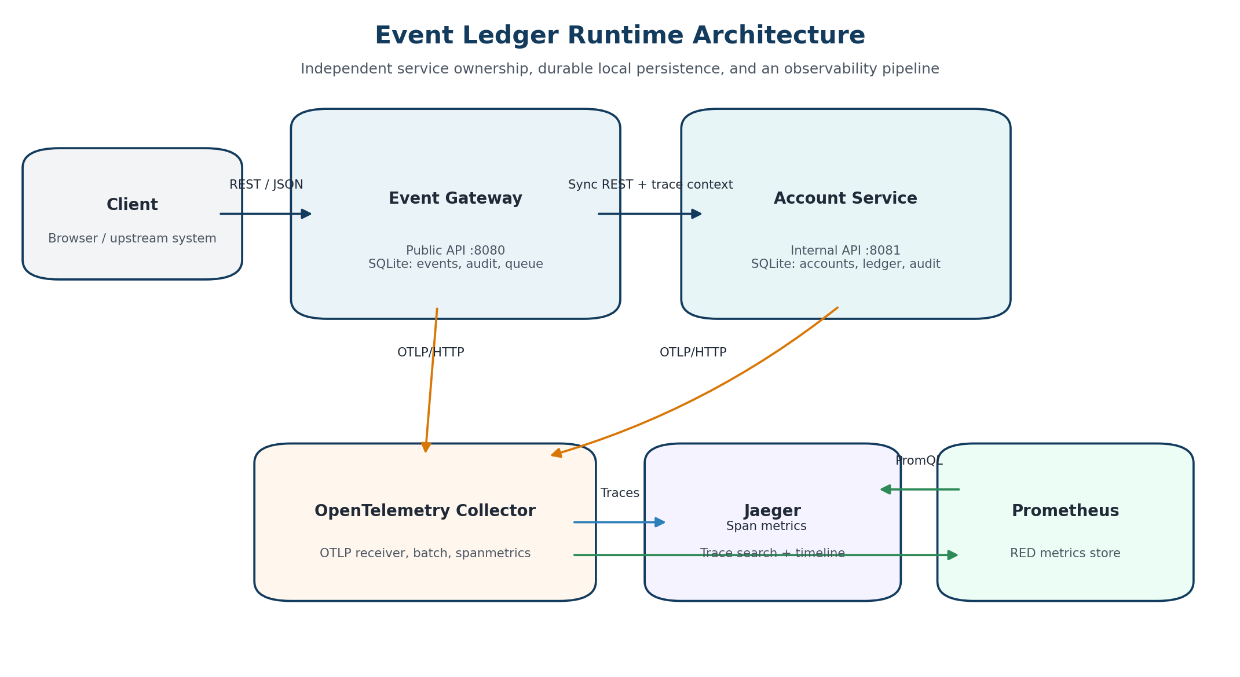
Figure 1. Runtime architecture and observability data flow.

Architectural principles
- Clear ownership: The Gateway owns public event intake and processing state; the Account Service owns balances and the applied ledger.
- No shared database: Each service persists only its own domain state.
- Defense in depth: Idempotency exists in both services because retries and network ambiguity can occur after either side commits.
- Local atomicity: Account balance, transaction record, and audit entries are committed in one Account Service database transaction.
- Operational decoupling: Traces and metrics are exported asynchronously so observability infrastructure is not on the request-critical path.

4. Service responsibilities and data ownership
Capability | Event Gateway | Account Service
API exposure | Public-facing event and balance proxy APIs | Internal account APIs
Primary domain state | Event record and processing status | Account balance and transaction ledger
Idempotency key | events.event_id primary key | transactions.event_id primary key
Audit | Event lifecycle and queue actions | Account creation, balance, and transaction actions
Resiliency | Timeout, retry, jitter, circuit breaker, fallback queue | Idempotent provider semantics
Rate limiting | Sliding window by client IP | Not required for internal service
Telemetry | Server spans, HTTPX child spans, logs, metrics | Continued server spans, logs, metrics

Gateway responsibilities
- Validate the event schema and return a standard error contract.
- Accept or generate X-Trace-ID and expose X-OpenTelemetry-Trace-ID.
- Detect identical replays and conflicting eventId reuse.
- Store new events as PENDING before downstream processing.
- Call the Account Service using the resiliency client.
- Return 201, 202, 200, 409, 429, 422, 404, or 503 as appropriate.
- Persist and process pending deliveries when asynchronous fallback is enabled.
- Expose event history, balance proxy, audit, health, and metrics endpoints.

Account Service responsibilities
- Own account currency and balance.
- Apply CREDIT as a positive delta and DEBIT as a negative delta.
- Enforce provider-side idempotency and conflict detection.
- Reject account/currency mismatches.
- Commit the balance, transaction ledger, and audit records atomically.
- Expose balance, account detail, transaction history, audit, health, and metrics APIs.

5. Data model and persistence
Database | Table | Key fields / purpose
Gateway | events | event_id PK; account_id; type; amount; currency; event_timestamp; metadata; processing_status; timestamps
Gateway | pending_deliveries | event_id PK; serialized payload; trace_id; attempt_count; next_attempt_at; last_error
Gateway | audit_records | audit_id PK; action; outcome; trace_id; event/account references; details; timestamp
Account | accounts | account_id PK; currency; NUMERIC(19,4) balance; timestamps
Account | transactions | event_id PK; account_id FK; type; amount; currency; event_timestamp; applied_at
Account | audit_records | audit_id PK; account/transaction actions, outcome, trace and details

Persistence rationale
File-based SQLite was chosen to satisfy embedded-database simplicity while still demonstrating durable data across process and container restarts. Docker named volumes isolate the two databases and preserve them until explicitly removed with a volume cleanup command.
Production alternative: PostgreSQL or another transactional database would be preferred for higher concurrency, operational tooling, backups, replication, schema migration, and long-term support. The domain boundaries remain the same.

6. API contract and status behavior
Service | Method and endpoint | Purpose
Gateway | POST /events | Submit a financial event
Gateway | GET /events/{eventId} | Retrieve one event and its processing status
Gateway | GET /events?account={accountId} | List account events chronologically with pagination
Gateway | GET /accounts/{accountId}/balance | Proxy current balance from Account Service
Gateway | GET /audit/events/{eventId} | Gateway-side event audit trail
Gateway | GET /health, /metrics | Operational status and metrics
Account | POST /accounts/{accountId}/transactions | Apply one ledger transaction
Account | GET /accounts/{accountId}/balance | Return current account balance
Account | GET /accounts/{accountId} | Balance plus recent transactions
Account | GET /audit/events/{eventId} | Account-side audit trail
Account | GET /health, /metrics | Operational status and metrics

Representative event payload
{
"eventId": "evt-001",
"accountId": "acct-123",
"type": "CREDIT",
"amount": "150.00",
"currency": "USD",
"eventTimestamp": "2026-05-15T14:02:11Z",
"metadata": {
"source": "mainframe-batch",
"batchId": "B-9042"
}
}

HTTP status model
Scenario | Status | Important response behavior
New event applied synchronously | 201 Created | Location header and trace headers
New event durably queued | 202 Accepted | processingStatus=QUEUED
Identical duplicate | 200 OK | Idempotent-Replay: true
Conflicting duplicate | 409 Conflict | EVENT_ID_CONFLICT
Currency or business conflict | 409 Conflict | Structured business error
Rate limit exceeded | 429 Too Many Requests | Retry-After and X-RateLimit-*
Invalid payload | 422 Unprocessable Entity | Standard error envelope
Unknown event/account | 404 Not Found | Standard error envelope
Downstream unavailable and fallback disabled | 503 Service Unavailable | retryable=true

Standard error envelope
{
"error": {
"code": "ACCOUNT_SERVICE_UNAVAILABLE",
"message": "Account processing is temporarily unavailable",
"traceId": "...",
"retryable": true
}
}

7. End-to-end processing flows
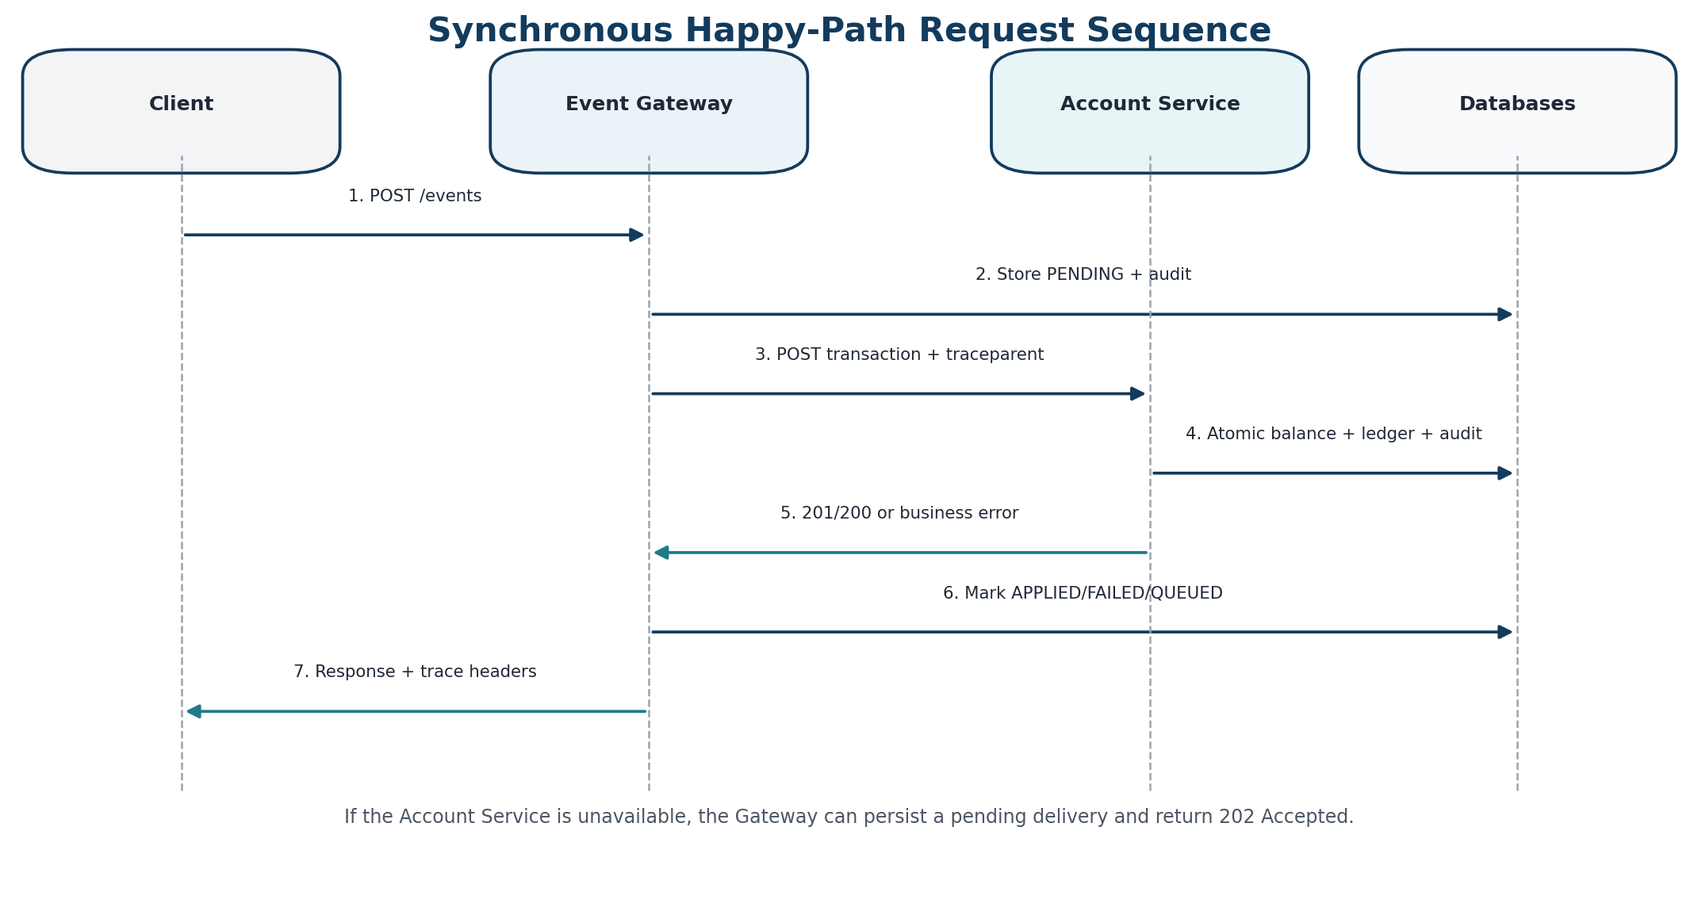
Figure 2. Synchronous event-processing sequence.

New event, successful downstream call
→ The Gateway accepts or creates a correlation ID and starts/continues the OpenTelemetry trace.
→ Pydantic validates event ID, account ID, positive amount, currency format, and timezone-aware timestamp.
→ The Gateway checks its event repository for a prior eventId.
→ A new record is stored as PENDING and an EVENT_STORED audit record is written.
→ The Account Service applies the transaction atomically and returns the new balance.
→ The Gateway changes processingStatus to APPLIED, writes EVENT_APPLIED, and returns 201.

Identical replay
→ The Gateway finds the existing eventId and compares all material fields.
→ No downstream transaction is re-applied.
→ The existing event is returned with HTTP 200 and Idempotent-Replay: true.
→ The Account Service also supports identical replay in case the Gateway must retry after a lost response.

Conflicting replay
→ The same eventId arrives with different account, type, amount, currency, timestamp, or metadata.
→ The Gateway records EVENT_CONFLICT_REJECTED and returns 409.
→ Provider-side conflict detection gives the same protection if a conflicting call reaches the Account Service.

Downstream outage with durable fallback
→ Synchronous attempts fail after timeout/retry/circuit-breaker handling.
→ The Gateway sets the event to QUEUED and creates a pending_deliveries record in the same local database.
→ The API returns 202 Accepted instead of losing the event.
→ The background worker polls due deliveries, preserves the original correlation ID, and retries with bounded backoff and jitter.
→ Success changes the event to APPLIED and deletes the queue row; a permanent business rejection changes it to FAILED.
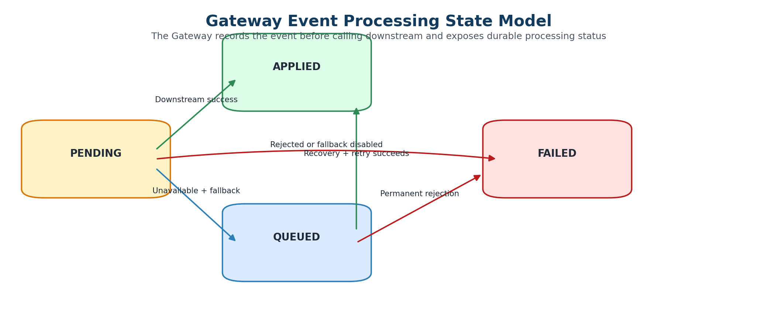
Figure 3. Gateway processing-state transitions.

8. Financial correctness, idempotency, and ordering

Decimal money
All financial amounts and balances use Python Decimal and SQL NUMERIC(19,4). The API serializes financial values without binary floating-point conversion, preserving predictable decimal arithmetic and four decimal places in persistence.
CREDIT: new_balance = current_balance + amount
DEBIT: new_balance = current_balance - amount

Two-layer idempotency
The same eventId is a primary key in both databases. This is intentional: network timeouts can occur after the Account Service commits but before the Gateway receives the response. A safe retry must therefore be accepted as an identical replay by the provider without changing the balance twice.
Input | Gateway result | Account result | Balance effect
New eventId | Create event and call downstream | Insert transaction | Applied once
Same ID, identical data | Return existing event | Return existing transaction if retried | No additional effect
Same ID, conflicting data | 409 conflict | 409 conflict if it reaches provider | No effect

Out-of-order arrivals
Because CREDIT and DEBIT are additive deltas, the final balance is independent of arrival order. The historical query contract restores business chronology by sorting on eventTimestamp and then eventId as a deterministic tie-breaker.
Arrival: e3 (-30), e1 (+100), e2 (+20)
Final balance: 90 regardless of arrival order
Query order: e1, e2, e3 by eventTimestamp ASC, eventId ASC

9. Resiliency strategy
Mechanism | Behavior | Reason
Timeout | Per-attempt timeout (default 2s) | Bounds latency and avoids indefinite waits
Retry | Limited attempts (default 3) | Handles transient network/downstream failures
Exponential backoff | Delay increases after each attempt | Reduces synchronized retry pressure
Jitter | Random delay added to backoff | Avoids thundering herds
Circuit breaker | Opens after threshold; recovery window | Fails fast during sustained outage
Durable queue | SQLite-backed pending deliveries | Preserves accepted events during outage
Provider idempotency | Duplicate-safe transaction API | Makes retry after ambiguous failure safe

Circuit-breaker scope
The circuit breaker is process-local and lightweight, which is appropriate for the exercise. In production, each instance would maintain its own breaker or use service-mesh/API-gateway resilience. Shared coordination is not always desirable because local breakers can adapt to each instance’s observed dependency health.

Known consistency window
Important trade-off: There is no distributed transaction between the Gateway and Account Service. The Account Service may commit while the Gateway times out and temporarily records failure or queue state. Provider idempotency enables safe replay; a production implementation would add reconciliation, an outbox/inbox pattern, or asynchronous messaging.

10. Observability and distributed tracing

Correlation versus distributed trace identifiers
Identifier | Purpose | Behavior
X-Trace-ID | Application correlation ID | Accepted/generated by Gateway, logged, propagated, audited, stored with queue items
traceparent / OpenTelemetry trace ID | Standards-based distributed trace | Automatically propagated by instrumented HTTP client/server
X-OpenTelemetry-Trace-ID | Reviewer convenience | Gateway returns the active 32-character trace ID for direct Jaeger lookup

Trace pipeline
→ FastAPI server instrumentation creates incoming request spans.
→ HTTPX instrumentation creates a child client span for the Gateway-to-Account-Service call.
→ The Account Service continues the W3C trace context.
→ Both services export OTLP/HTTP to the OpenTelemetry Collector.
→ The Collector applies memory limiting and batching, then exports traces over OTLP/gRPC to Jaeger.
→ The spanmetrics connector creates call-count and duration histograms.
→ Prometheus scrapes span metrics; Jaeger queries Prometheus for request rate, error rate, and latency.

Validated distributed trace
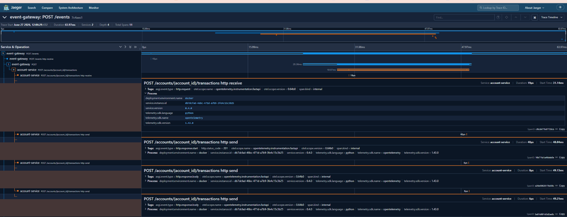
Figure 4. Jaeger timeline showing one POST /events trace across event-gateway and account-service (two services, 11 spans).
The validated trace demonstrates parent-child continuity across both services, including the Gateway HTTP client span and Account Service receive/send spans. Service metadata includes environment, service version, SDK language, and response status.

Structured logging and auditability
- JSON logs include traceId, eventId, accountId, status, and outcome fields where relevant.
- Operational logs describe retries, queue scheduling, permanent rejection, and successful recovery.
- Audit records are domain evidence rather than transient logs and remain queryable by eventId.
- Sensitive data is intentionally excluded from audit details; only operationally relevant non-sensitive context is stored.

Metrics
Source | Examples | Use
Service /metrics | HTTP counts/latency; fallback queue counters and depth; rate-limit rejections | Application health and behavior
Collector :8889 | calls_total; duration histogram buckets/count | Span-derived RED metrics
Prometheus :9090 | Scraped time series from Collector and Jaeger internals | Query and Jaeger Monitor backend
Jaeger :16686 | Trace search, timelines, Monitor view | Request-level and aggregated diagnostics

11. Rate limiting and operational protection
The Gateway includes a process-local sliding-window limiter keyed by client IP. It protects public API routes while excluding health, metrics, and documentation endpoints. Successful responses expose remaining quota; rejected requests return a structured 429 response with retry guidance.
RATE_LIMIT_ENABLED=true
RATE_LIMIT_REQUESTS=120
RATE_LIMIT_WINDOW_SECONDS=60

Production evolution: Use an API gateway, service mesh, or Redis-backed distributed limiter for horizontally scaled deployments. Authentication-aware keys and customer-specific quotas would normally replace raw client IP as the primary identity.

12. Testing and quality strategy

Test pyramid
Layer | Scope | Representative coverage
Unit / component | Services, repositories, schemas, middleware, retry, breaker, rate limiter, queue worker | Fast and branch-focused
Service integration | FastAPI routes with database and client behavior | API semantics and persistence
Functional | Running Dockerized public APIs | Health, lifecycle, validation, trace propagation
Contract | Pact consumer and provider | Gateway client ↔ Account Service API compatibility
Operational scripts | Outage, persistence, tracing, Monitor pipeline | Real Docker lifecycle and observability

Current repository test evidence
Suite | Result represented in current artifacts
Account Service | 25 passed; 100% statement and branch coverage
Event Gateway | 51 passed; 100% statement and branch coverage
Service total | 76 tests
Functional tests | 5 passed
Pact | 1 consumer generation + 1 provider verification
Combined automated suites | 83 test cases/interactions across service, functional, and Pact suites
Minimum configured threshold | 80%

Submission hygiene: Regenerate reports with make coverage and capture make test output immediately before submission. This ensures the repository artifacts match the final commit and local environment.

Coverage focus
- Happy path CREDIT/DEBIT calculations and account creation.
- Identical replay and conflicting replay in both services.
- Timezone, currency, amount, and path/payload validation.
- Retries, zero-attempt edge conditions, breaker open/recovery behavior.
- Queue enqueue/update/delete, backoff, orphan cleanup, rejection, recovery, and worker-loop errors.
- Rate-limit validation, reset, middleware success/exception, and direct 429 trace behavior.
- OpenTelemetry middleware attributes and trace response headers.
- Health, metrics, error handlers, startup/shutdown lifecycle branches.

13. Bonus features
Bonus feature | Implementation summary | Validation
Prometheus metrics | Service metrics plus span-derived RED metrics | /metrics, Collector :8889, Prometheus queries
Retry with backoff/jitter | Bounded HTTPX attempts with exponential delay and random jitter | Client and resiliency tests
Rate limiting | Configurable sliding window and structured 429 contract | Middleware/unit tests
Pact contract testing | V4 consumer contract generated from real Gateway client and replayed against real provider | make contract-test
Durable async fallback | SQLite pending_deliveries and background worker | make test-resiliency
OpenTelemetry + Jaeger | Collector pipeline and cross-service trace visualization | make test-tracing
Jaeger Monitor | spanmetrics connector → Prometheus → Jaeger metrics backend | make test-monitoring

14. Docker and operational runbook

Start and inspect
make up-build
make ps
make logs

Core validation
make test
make coverage
make functional-test
make contract-test

Operational validation
make test-resiliency
make test-persistence
make test-tracing
make test-monitoring

Complete workflow
make verify

Local endpoints
Component | URL
Gateway | http://localhost:8080
Gateway OpenAPI | http://localhost:8080/docs
Account Service | http://localhost:8081
Jaeger traces | http://localhost:16686
Jaeger Monitor | http://localhost:16686/monitor
Prometheus | http://localhost:9090
Prometheus targets | http://localhost:9090/targets
Collector health | http://localhost:13133
Collector span metrics | http://localhost:8889/metrics

Typical demonstration sequence
→ Open the Gateway Swagger UI and submit a new CREDIT event.
→ Show the 201 response, Location, X-Trace-ID, and X-OpenTelemetry-Trace-ID headers.
→ Replay the same event and show 200 plus Idempotent-Replay: true.
→ Change the amount with the same eventId and show 409 conflict.
→ Submit out-of-order events and show chronological GET results.
→ Open the balance and both audit endpoints.
→ Paste the OpenTelemetry trace ID into Jaeger and explain the parent-child spans.
→ Stop the Account Service, submit an event, show 202 QUEUED, restart the service, and show eventual APPLIED.
→ Open Prometheus targets and the Jaeger Monitor view after traffic generation.

15. Design trade-offs and production evolution
Current exercise decision | Benefit | Production evolution
SQLite per service | Simple, durable, zero external DB setup | PostgreSQL, migrations, backups, replicas
Synchronous REST | Easy to understand and demo | Event bus / queue for throughput and decoupling
No distributed transaction | Preserves service independence | Outbox/inbox, saga, reconciliation
Local circuit breaker | Minimal dependency and clear behavior | Mesh/client policy with per-instance telemetry
Local rate limiter | Simple and testable | Gateway/Redis distributed quotas
Polling fallback worker | Durable recovery with SQLite | Broker consumer, leases, dead-letter queue
In-memory Jaeger traces | Easy local setup | Persistent scalable trace backend and retention policy
Full payload comparison | Strong duplicate/conflict semantics | Canonical payload hash and schema versioning

Security and compliance considerations
- Authenticate and authorize both public and service-to-service calls.
- Use TLS/mTLS and managed secrets rather than plaintext local environment values.
- Define financial data retention, privacy, audit immutability, and access controls.
- Add request-size limits, schema versioning, fraud controls, and abuse monitoring.
- Use signed images, vulnerability scanning, SBOMs, and CI policy gates.
- Avoid exposing internal Account Service ports outside the private network in production.

16. Suggested interview walkthrough
Time | Topic | What to emphasize
0–2 min | Problem and architecture | Two independent services, data ownership, no shared database
2–5 min | Correctness | Decimal money, dual idempotency, conflict detection, out-of-order handling
5–8 min | Failure behavior | Timeout/retry/breaker, PENDING→QUEUED/APPLIED, safe replay
8–11 min | Observability | Correlation ID vs trace ID, Collector, Jaeger trace, Prometheus RED metrics
11–14 min | Testing | 76 service tests, coverage, functional, Pact, operational scripts
14–17 min | Trade-offs | SQLite, sync REST, consistency window, production evolution
17–20 min | Live demo / questions | Replay, conflict, outage recovery, trace visualization

One-minute opening
Suggested wording: “I built the solution as two independently deployable FastAPI services. The Gateway owns the public event record and processing state; the Account Service owns balances and the transaction ledger. I focused first on financial correctness and duplicate safety, then added bounded resiliency, durable fallback, distributed tracing, Prometheus-backed span metrics, contract tests, and operational validation. The main design trade-off is that there is no distributed transaction, so I rely on provider idempotency and would add reconciliation or an outbox pattern in production.”

17. Likely review questions and answers
Why is idempotency implemented twice?
Because an HTTP timeout can occur after the Account Service commits. The Gateway may retry without knowing the first call succeeded. Provider-side idempotency prevents a double balance update, while Gateway-side idempotency protects the public API and avoids unnecessary calls.
How do you handle out-of-order events?
The balance is computed as additive deltas, so the final total is commutative. Historical APIs sort by event timestamp and event ID. If the business required event-time-dependent rules, the design would need replayable projections or sequence/version checks.
What happens if the Account Service commits but the Gateway times out?
The Gateway may queue or mark a local failure, but a retry is safe because the Account Service returns an idempotent replay. The Gateway eventually converges to APPLIED. A production reconciliation process would detect and repair any remaining divergence.
Why SQLite?
It gives durable state and independent service databases without external infrastructure, which is appropriate for a short exercise. It is explicitly not positioned as the high-concurrency production database.
Why synchronous REST plus a fallback queue?
REST keeps the primary flow simple and matches the exercise architecture. The fallback queue demonstrates graceful degradation without redesigning the entire system as event-driven.
How is the trace propagated?
OpenTelemetry instrumentation uses W3C traceparent across HTTPX and FastAPI. X-Trace-ID is a separate application correlation ID used in logs and audits. The Gateway returns the OpenTelemetry trace ID for direct Jaeger lookup.
How would you scale the queue worker?
Move pending work to a broker, use consumer groups and leases, add a dead-letter queue, expose retry age and failure metrics, and keep provider idempotency as the final safety boundary.
What would you improve first?
Replace deprecated FastAPI startup/shutdown hooks with lifespan handlers, add migrations, persist traces, add authentication/mTLS, introduce reconciliation/outbox, and run the entire validation workflow in CI.

Appendix A. Commands and endpoints

Most important Make commands
Command | Purpose
make up-build | Build and start the complete stack in the background
make ps | Show container status
make test | Run Account and Gateway service tests
make coverage | Generate branch-aware text and XML reports
make functional-test | Exercise live APIs
make contract-test | Generate and verify Pact contracts
make test-resiliency | Validate queueing during outage and recovery
make test-persistence | Validate SQLite data across restart
make test-tracing | Validate one cross-service trace in Jaeger
make test-monitoring | Validate Collector spanmetrics, Prometheus, and Jaeger Monitor
make verify | Run the complete validation sequence
make clean | Remove containers, volumes, and generated contracts

Key configuration defaults
Variable | Default | Purpose
ACCOUNT_SERVICE_TIMEOUT_SECONDS | 2 | Per-attempt timeout
ACCOUNT_SERVICE_MAX_ATTEMPTS | 3 | Synchronous attempts
CIRCUIT_BREAKER_FAILURE_THRESHOLD | 5 | Failures before opening
CIRCUIT_BREAKER_RECOVERY_SECONDS | 30 | Open-state recovery delay
RATE_LIMIT_REQUESTS | 120 | Requests per window
RATE_LIMIT_WINDOW_SECONDS | 60 | Sliding-window duration
ASYNC_FALLBACK_POLL_SECONDS | 1 | Worker poll interval
ASYNC_FALLBACK_BATCH_SIZE | 25 | Due deliveries per iteration
ASYNC_FALLBACK_MAX_BACKOFF_SECONDS | 60 | Maximum retry delay
OTEL_EXPORTER_OTLP_ENDPOINT | http://otel-collector:4318 | Application OTLP/HTTP destination

Appendix B. Repository artifacts and file map
Artifact | Purpose
README.md | Architecture, setup, API examples, commands, design decisions, and validation
docs/Requirement.docx | Requirements document
docs/Design.docx | Detailed design document
docs/design.md | Markdown design summary
docs/diagrams/ | Architecture diagrams
docs/ai-assisted-development.md | AI-assisted workflow and verification approach
docs/commit-plan.md | Incremental implementation and commit strategy
docs/bonus-features.md | Rate limiting, Pact, fallback, and tracing summary
docs/opentelemetry-jaeger.md | Trace/metrics pipeline and manual validation
reports/ | Coverage, functional-test, QA, and bonus-feature artifacts
scripts/test-resiliency.sh | Outage and recovery scenario
scripts/test-persistence.sh | Container restart persistence scenario
scripts/test-tracing.sh | Cross-service trace validation
scripts/test-monitoring.sh | Spanmetrics/Prometheus/Jaeger Monitor validation
otel-collector-config.yaml | OTLP receiver, processors, trace export, spanmetrics
prometheus.yml | Collector and Jaeger scrape configuration
jaeger-config.yaml | Trace storage and Prometheus metric backend
docker-compose.yml | Service orchestration, volumes, health checks, and test profiles
Makefile | Reviewer-friendly lifecycle and validation commands

Final submission checklist
- Confirm the public repository opens without authentication.
- Run make test and make coverage; update report artifacts if needed.
- Run make functional-test and make contract-test.
- Run make test-resiliency, make test-persistence, and make test-tracing.
- Complete the final local make test-monitoring rerun and capture its output.
- Verify README links and command names match the final files.
- Review git status and push the final logical commit.
- Send the repository link in a reply-all email.
End of guide

