Event Ledger
Implementation Design Document
Version 1.0 | Python / FastAPI Reference Design
Two independently deployable microservices for reliable financial-event processing
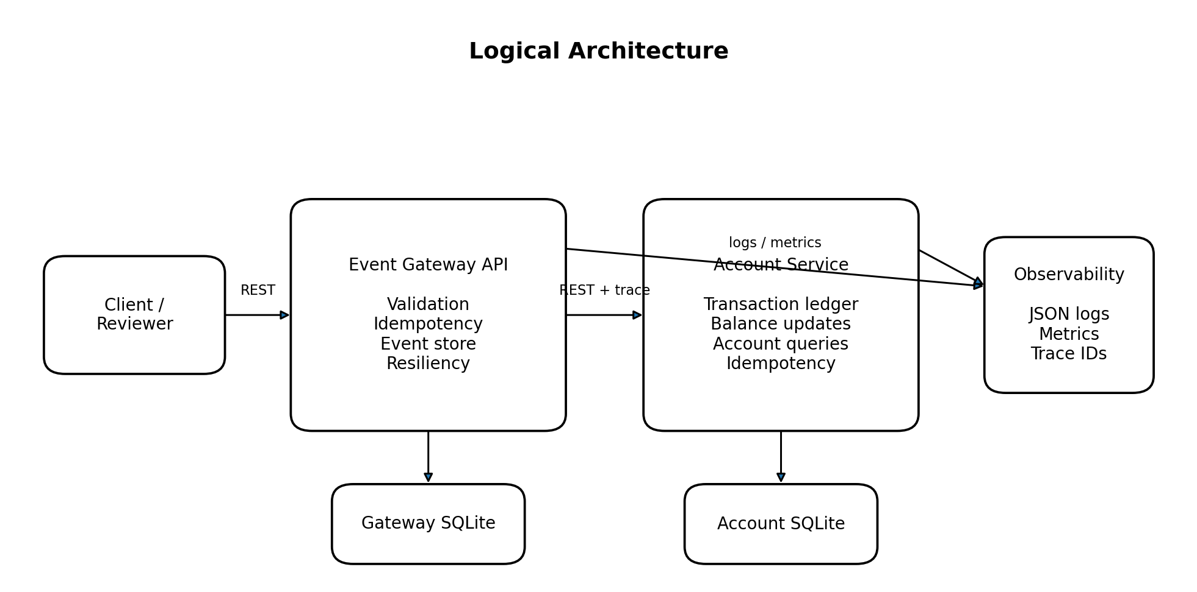
Figure 1. High-level architecture
Prepared for implementation and technical walkthrough

1. Purpose and Design Goals
This document translates the Event Ledger requirements into an implementation-ready design. It defines service boundaries, APIs, persistence, failure handling, observability, testing, and local deployment decisions. The design is deliberately sized for a take-home exercise while demonstrating production-oriented engineering judgment.
- Correctness first: each event affects an account at most once.
- Independent services and databases with REST-only communication.
- Bounded failure behavior through timeout, retry, and circuit breaker.
- Traceable operations through propagated trace IDs and structured logs.
- Simple local execution using Docker Compose and SQLite.

2. Scope and Assumptions
Area | Decision
Language and framework | Python 3.12, FastAPI, Pydantic, SQLAlchemy, HTTPX, Pytest
Databases | One SQLite database per service; no shared tables or files
Money | Decimal values serialized as strings; two-decimal validation for USD-style currencies
Accounts | Created on first successful transaction; one currency per account
Balances | Negative balances are allowed; no overdraft rules
Duplicates | Same eventId and same business payload returns the existing result; conflicting payload returns 409
Failure persistence | Gateway stores the event first as PENDING, then marks APPLIED or FAILED
Recovery | A replay of PENDING/FAILED may safely attempt downstream processing again
Security | No authentication required for exercise; Account Service is internal-only in Compose
Ordering | Business history sorted by eventTimestamp, then eventId for deterministic ties

3. Architecture

Figure 2. Logical component architecture

3.1 Event Gateway Responsibilities
- Expose the public event APIs and account balance proxy.
- Validate payloads and normalize monetary and timestamp fields.
- Persist the public event record and enforce eventId uniqueness.
- Call Account Service through a resilient HTTP client.
- Generate or accept a trace ID and propagate it downstream.
- Expose health, metrics, and structured request logs.

3.2 Account Service Responsibilities
- Own the authoritative transaction ledger and account balance.
- Independently deduplicate transaction application by eventId.
- Atomically insert a transaction and update the account balance.
- Expose internal account and balance APIs.
- Log propagated trace IDs and expose health and metrics.

3.3 Why Both Services Enforce Idempotency
A timeout does not prove that a downstream transaction failed. The Account Service may commit and the response may be lost. Gateway-only deduplication is therefore insufficient. The Account Service treats eventId as a unique transaction key, making retries safe after ambiguous network failures.

4. Internal Component Design
Layer | Gateway | Account Service
API | Event routes, account proxy, health, metrics | Transaction routes, account routes, health, metrics
Schemas | EventCreate, EventResponse, ErrorResponse | TransactionCreate, AccountResponse, BalanceResponse
Service | Event orchestration and state transitions | Atomic transaction application and queries
Repository | Event CRUD and uniqueness handling | Account and transaction persistence
Client | Resilient AccountServiceClient | Not applicable
Observability | Trace middleware, JSON logging, Prometheus | Trace middleware, JSON logging, Prometheus
Configuration | Environment-based settings | Environment-based settings

4.1 Recommended Package Structure
event-ledger/
docker-compose.yml
Makefile
README.md
docs/
requirements.docx
design.docx
event-gateway/
app/
api/routes_events.py
api/routes_accounts.py
clients/account_service.py
core/config.py
core/logging.py
core/tracing.py
db/models.py
db/session.py
repositories/events.py
schemas/events.py
services/event_service.py
main.py
tests/
account-service/
app/
api/routes_accounts.py
core/config.py
core/logging.py
core/tracing.py
db/models.py
db/session.py
repositories/accounts.py
schemas/accounts.py
services/account_service.py
main.py
tests/

5. Data Design
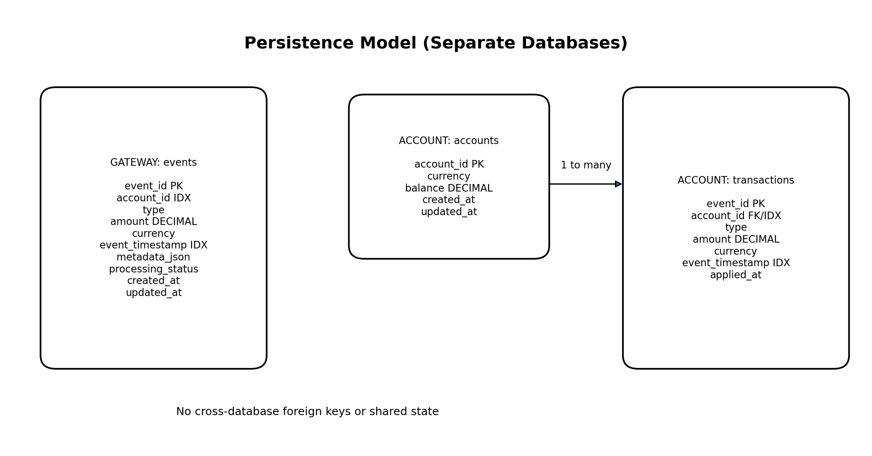
Figure 3. Data model and database separation

5.1 Gateway Event Record
Column | Type / Constraint | Purpose
event_id | TEXT PRIMARY KEY | Global idempotency key
account_id | TEXT NOT NULL, INDEX | Account lookup
type | TEXT NOT NULL | CREDIT or DEBIT
amount | NUMERIC NOT NULL | Decimal monetary amount
currency | TEXT NOT NULL | Three-letter code
event_timestamp | TIMESTAMP NOT NULL, INDEX | Original business time
metadata_json | JSON/TEXT NULL | Optional metadata
processing_status | TEXT NOT NULL | PENDING, APPLIED, FAILED
created_at | TIMESTAMP NOT NULL | Gateway receive time
updated_at | TIMESTAMP NOT NULL | Last state change

5.2 Account and Transaction Records
Table | Key fields | Notes
accounts | account_id PK, currency, balance, timestamps | Balance is updated atomically and can be rebuilt from ledger
transactions | event_id PK, account_id IDX, type, amount, currency, event_timestamp, applied_at | event_id guarantees at-most-once application

5.3 Transaction Boundary
Account Service transaction application occurs in one database transaction: load or create account, validate currency, insert transaction, update balance, and commit. A uniqueness error is converted into an idempotent replay lookup rather than a second balance update.

6. API Design
Service | Method and path | Success | Main errors
Gateway | POST /events | 201 new; 200 replay | 409 conflict, 422 validation, 503 downstream unavailable
Gateway | GET /events/{eventId} | 200 | 404
Gateway | GET /events?account={id} | 200 | 422 missing query
Gateway | GET /accounts/{id}/balance | 200 | 404, 503
Gateway | GET /health, GET /metrics | 200 | 503 for own DB failure
Account | POST /accounts/{id}/transactions | 201 new; 200 replay | 409 conflict/currency, 422 validation
Account | GET /accounts/{id}/balance | 200 | 404
Account | GET /accounts/{id} | 200 | 404
Account | GET /health, GET /metrics | 200 | 503 for own DB failure

6.1 Error Contract
{
"error": {
"code": "ACCOUNT_SERVICE_UNAVAILABLE",
"message": "Account processing is temporarily unavailable",
"traceId": "84d61b183fe7486fa985d4af56a4b620",
"retryable": true,
"details": []
}
}

6.2 Trace Headers
- Accept X-Trace-ID when syntactically valid; otherwise generate a UUID hex value.
- Return X-Trace-ID on every response.
- Propagate X-Trace-ID on every Gateway-to-Account call.
- Optional extension: W3C traceparent through OpenTelemetry.

7. Core Processing Flows

7.1 New Event
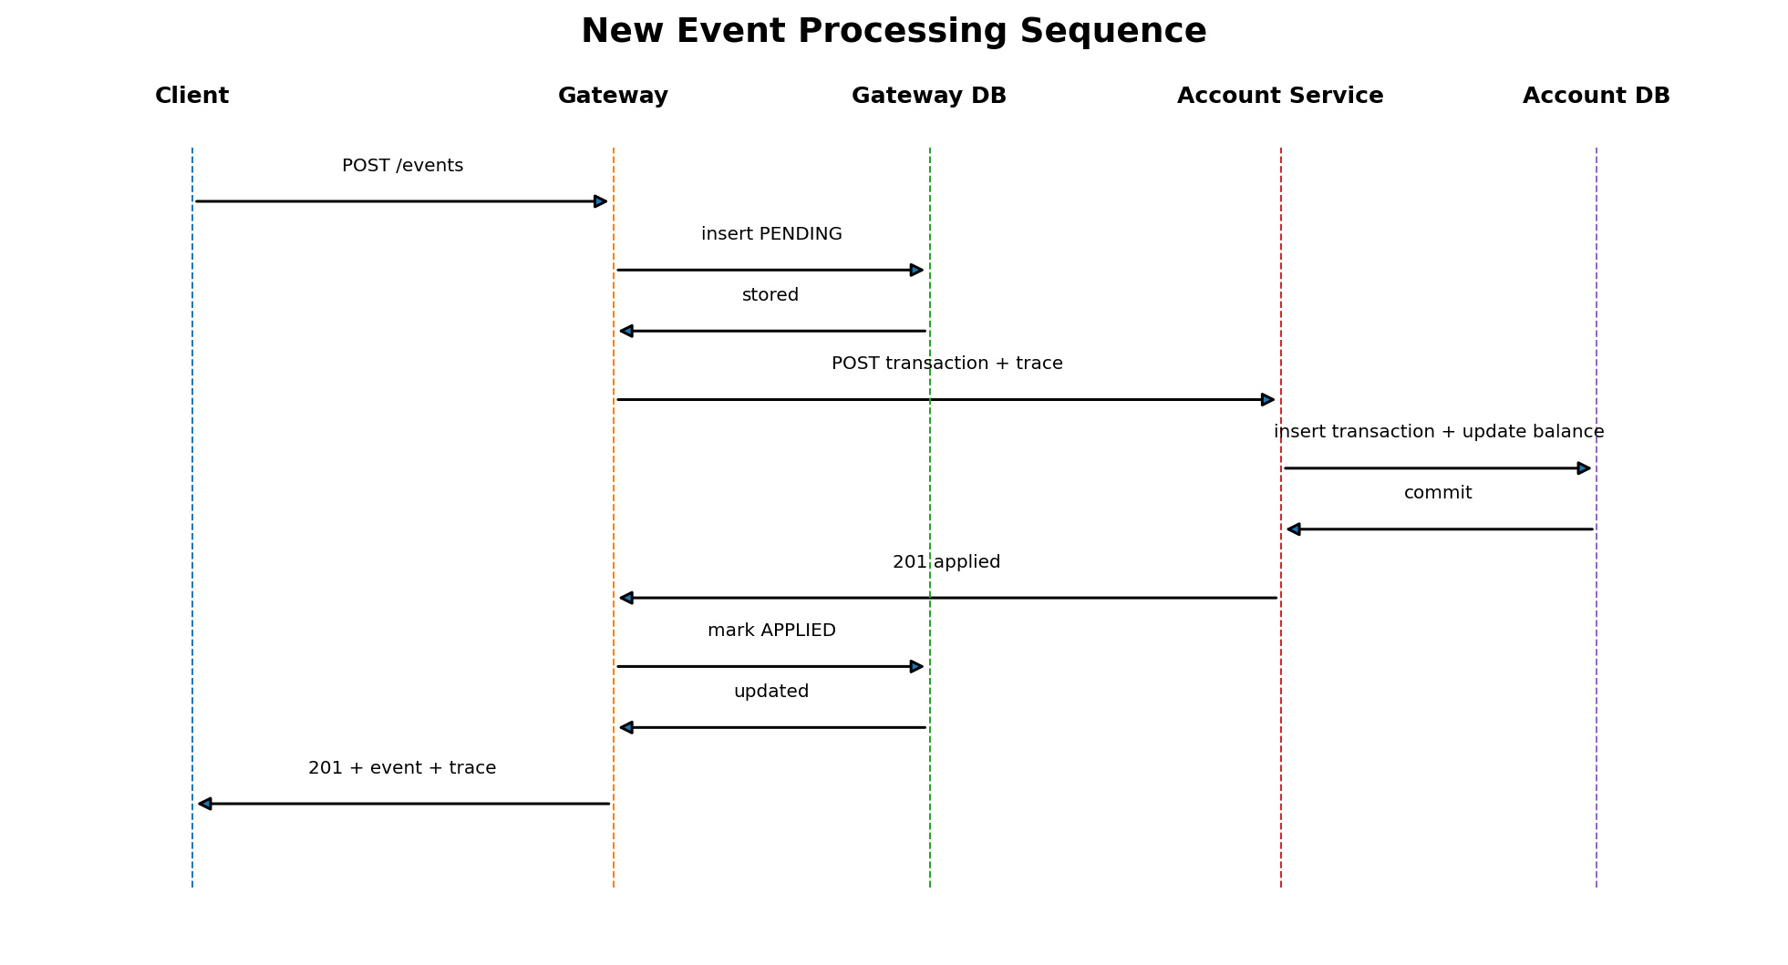
Figure 4. New event processing sequence
- Validate request and create trace context.
- Attempt insert of Gateway event with PENDING status.
- Invoke Account Service using timeout, retry, and circuit breaker.
- Account Service inserts transaction and updates balance atomically.
- Gateway marks event APPLIED and returns 201.

7.2 Duplicate and Conflict Handling
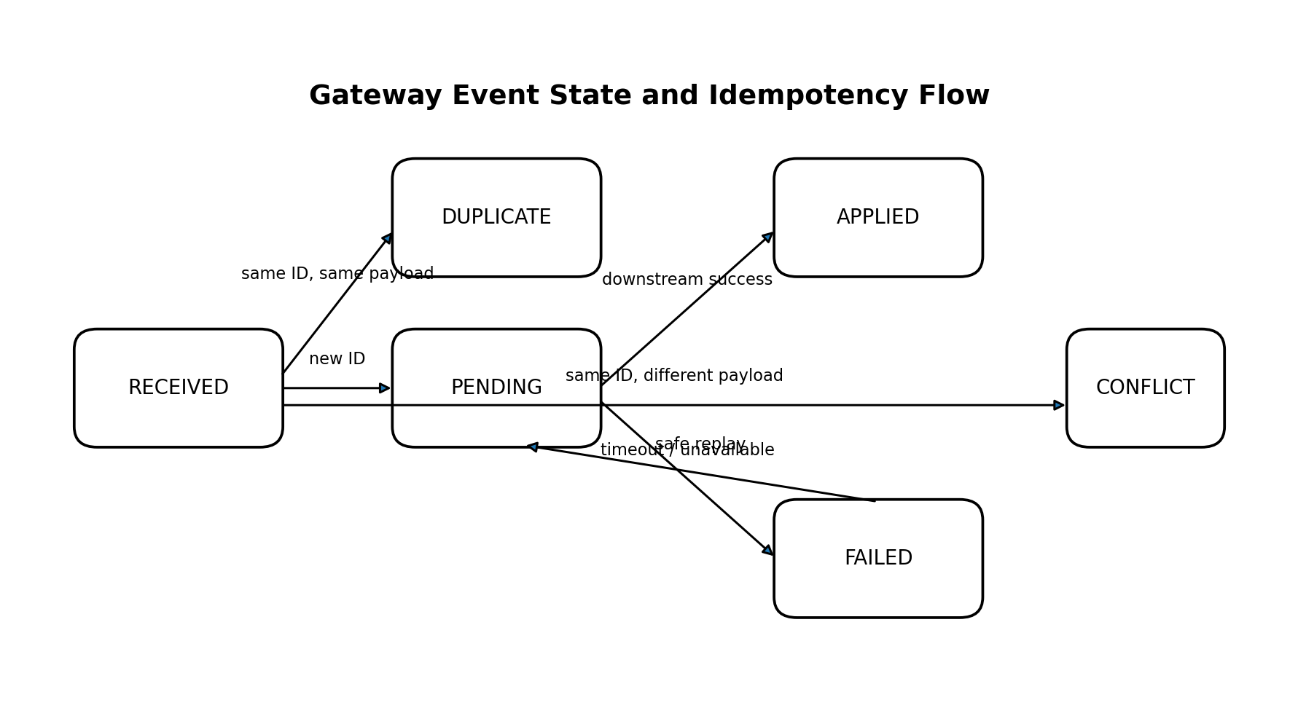
Figure 5. Gateway event state and replay behavior
Business-payload equality uses canonical fields: accountId, type, normalized decimal amount, currency, and normalized UTC eventTimestamp. Metadata may also be compared strictly for simplicity. A duplicate request never creates a new event and never directly changes account state.

7.3 Out-of-Order Events
- No monotonic timestamp check is applied.
- Balance calculation uses signed amount and is independent of arrival order.
- Listings sort by eventTimestamp ascending, then eventId.
- Both eventTimestamp and processing timestamps are stored.

8. Resiliency and Failure Handling

8.1 Timeout and Retry
Setting | Recommended default
Connect timeout | 0.5 seconds
Read / total timeout | 2.0 seconds
Maximum attempts | 3 including initial call
Backoff | Exponential: 0.1s, 0.3s plus jitter
Retry conditions | Connection errors, timeouts, 502, 503, 504
Do not retry | 4xx validation or conflict responses

8.2 Circuit Breaker
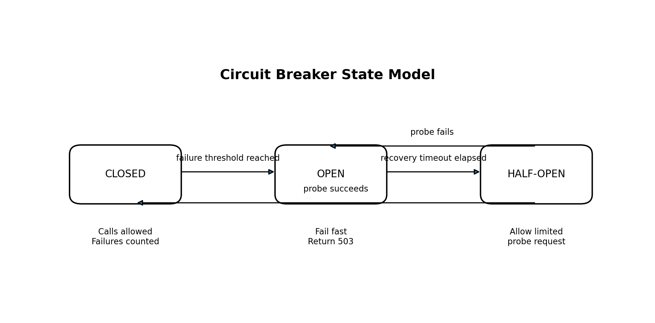
Figure 6. Circuit breaker state transitions
- Open after five consecutive retry-exhausted failures.
- Remain open for 30 seconds and fail fast with 503.
- Allow one or a limited number of half-open probes.
- Close after a successful probe; reopen after a failed probe.
- Expose state through logs and a gauge metric.

8.3 Failure Semantics
Failure | Gateway behavior | Stored event state
Validation failure | Return 422; no downstream call | Not stored
Account 4xx conflict | Return mapped 409/422 | FAILED
Timeout or connection failure | Exhaust bounded retries, return 503 | FAILED
Circuit already open | Fail immediately with 503 | FAILED for new event
Ambiguous downstream commit | Safe replay because Account Service deduplicates | May transition to APPLIED on replay
Gateway DB unavailable | Return 503 from affected operations | Unknown / no write

9. Observability Design

9.1 Structured Logging
{
"timestamp": "2026-05-15T14:02:12.031Z",
"level": "INFO",
"service": "event-gateway",
"message": "event applied",
"traceId": "84d61b183fe7486fa985d4af56a4b620",
"eventId": "evt-001",
"accountId": "acct-123",
"statusCode": 201,
"durationMs": 42
}

9.2 Metrics
Metric | Type | Labels
http_requests_total | Counter | service, method, route, status
http_request_duration_seconds | Histogram | service, method, route
events_submitted_total | Counter | result=new|duplicate|conflict|failed
account_service_calls_total | Counter | result=success|failure|short_circuit
circuit_breaker_state | Gauge | state
transactions_applied_total | Counter | type=CREDIT|DEBIT

9.3 Health
- Each service checks its own database connectivity.
- Gateway may report Account Service as a dependency diagnostic without declaring itself DOWN.
- Own database failure returns 503.
- Health endpoints are lightweight and do not mutate state.

10. Docker and Runtime Design
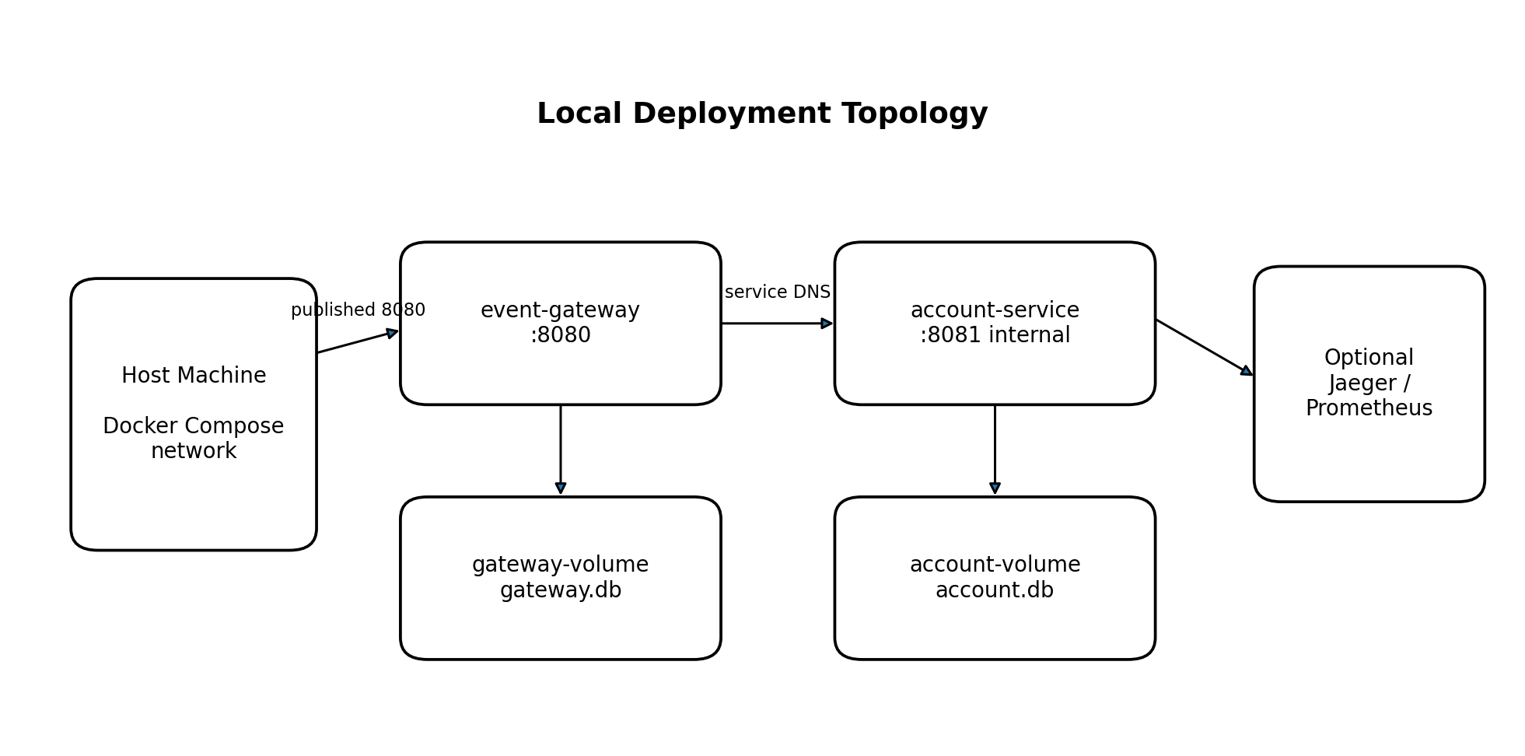
Figure 7. Docker Compose deployment
services:
event-gateway:
build: ./event-gateway
ports: ["8080:8080"]
environment:
ACCOUNT_SERVICE_URL: http://account-service:8081
depends_on:
account-service:
condition: service_healthy
account-service:
build: ./account-service
expose: ["8081"]
volumes:
gateway-data:
account-data:

10.1 Configuration
Gateway variable | Purpose
DATABASE_URL | Gateway SQLite path
ACCOUNT_SERVICE_URL | Internal service URL
ACCOUNT_SERVICE_TIMEOUT_SECONDS | Bounded downstream timeout
ACCOUNT_SERVICE_MAX_ATTEMPTS | Retry limit
CIRCUIT_BREAKER_FAILURE_THRESHOLD | Open threshold
CIRCUIT_BREAKER_RECOVERY_SECONDS | Open-to-half-open delay
LOG_LEVEL | Runtime log verbosity

11. Key Implementation Algorithms

11.1 Gateway Submit Event
validate_and_normalize(request)
trace_id = get_or_create_trace_id()
existing = repository.find(event_id)
if existing:
if same_business_payload(existing, request):
if existing.status in {PENDING, FAILED}:
optionally_retry_apply(existing)
return 200 existing
raise 409 EVENT_ID_CONFLICT
repository.insert(status=PENDING)
try:
result = resilient_account_client.apply(request, trace_id)
repository.mark_applied(event_id)
return 201 event
except DownstreamUnavailable:
repository.mark_failed(event_id)
raise 503 ACCOUNT_SERVICE_UNAVAILABLE

11.2 Account Apply Transaction
begin database transaction
existing = transaction_repository.find(event_id)
if existing:
if same_business_payload(existing, request): return 200 replay
raise 409 EVENT_ID_CONFLICT
account = account_repository.get_or_create(account_id, currency)
assert account.currency == request.currency
signed_amount = amount if CREDIT else -amount
insert transaction(event_id, ...)
update account set balance = balance + signed_amount
commit
return 201 applied

12. Testing Strategy
Test level | Coverage
Schema / validation | Required fields, amount > 0, enum, ISO timestamp, currency format
Repository | Uniqueness, ordering, status updates, atomic balance update
Service unit | Duplicate replay, conflict, signed balance, currency mismatch
Gateway client | Timeout, retry selection, backoff, circuit transitions
API | Status codes, error contract, trace response header
Integration | Full Gateway -> Account flow with separate databases
Failure integration | Account stopped or stubbed; Gateway local reads remain available
Concurrency | Concurrent same-event submissions result in one transaction

12.1 Required End-to-End Scenarios
- Submit CREDIT 150.00; verify event and balance 150.00.
- Replay the same event; verify 200 and unchanged balance.
- Submit same ID with different amount; verify 409.
- Submit CREDIT/DEBIT events out of order; verify chronological listing and correct net balance.
- Stop Account Service; verify POST returns 503 while GET event APIs continue working.
- Verify the same X-Trace-ID appears in both service logs or test-captured requests.

13. Security, Trade-offs, and Limitations

13.1 Minimum Security Controls
- Use ORM or parameterized SQL.
- Do not return stack traces or internal paths.
- Do not commit secrets; provide .env.example only.
- Keep Account Service un-published to the host in Docker Compose.
- Run containers as a non-root user when practical.

13.2 Trade-offs
Decision | Benefit | Limitation / mitigation
Synchronous REST | Simple and matches assignment | No distributed atomicity; mitigate with dual idempotency
SQLite | Zero setup and easy review | Limited concurrent writes; acceptable for exercise
Stored balance plus ledger | Fast reads | Must update atomically; ledger permits reconciliation
Custom X-Trace-ID | Easy to demonstrate | Not full tracing; OpenTelemetry is an optional extension
Store-before-call | Gateway reads remain available | FAILED/PENDING records require replay or optional recovery worker

14. Implementation Plan and Commit Strategy
Phase | Deliverables | Suggested commit
1. Skeleton | Two FastAPI apps, settings, health endpoints | Initialize Gateway and Account Service
2. Account domain | Account/transaction models, atomic apply API, tests | Implement idempotent account transactions
3. Gateway domain | Event model, validation, list/get APIs | Implement Gateway event persistence
4. Integration | HTTP client, trace propagation, state transitions | Connect Gateway to Account Service
5. Resiliency | Timeout, retry, circuit breaker, failure tests | Add downstream resiliency handling
6. Observability | JSON logs, metrics, enhanced health | Add tracing and observability
7. Packaging | Dockerfiles, Compose, Makefile | Add Docker Compose runtime
8. Documentation | README, examples, design decisions | Document architecture and operations

15. Design Acceptance Checklist
- Two independently runnable services and two separate databases.
- At-most-once balance application under duplicates and retries.
- Correct balance regardless of event arrival order.
- Meaningful 4xx and 503 errors with trace IDs.
- Gateway-local reads survive Account Service outage.
- Timeout, bounded retry, and circuit breaker are test-covered.
- JSON logs, health checks, and custom metrics are available.
- Docker Compose starts the complete system.
- One command runs all automated tests.
- README explains setup, API examples, assumptions, trade-offs, and resiliency.

