Case 1: Sales Performance Analysis
Company Background
TechSupply Co. is a regional distributor that sells electronics, office supplies, and office furniture to both retail and business customers. Management wants to better understand sales trends, customer purchasing behavior, and regional performance to improve future sales strategies.
You have been hired as a junior data analyst to explore the sales dataset and provide insights. Your task is to use Excel filtering and sorting tools to answer business questions and provide recommendations.
Dataset: use the techsupply_dataset.xlsx
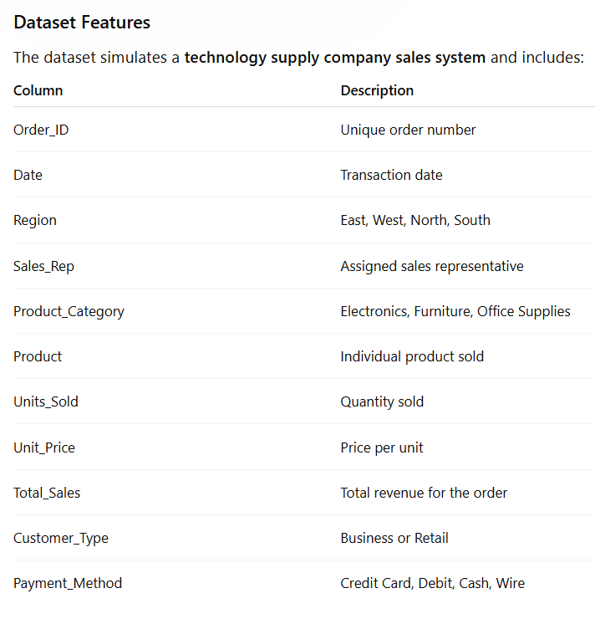

Complete the following 5 tasks.
REGIONAL PERFORMANCE ANALYSIS
Task 1: Use filters to explore sales by region.
- Filter by Region = East
- Sort Total_Sales from Largest to Smallest
Questions:
- What is the largest sale in the East region?
The largest Sale in the East Regain is 52,950
- Which product category appears most frequently?
The product category that appears more frequently is electronic
- Which sales representative appears most often?
The most frequent sales representative is Brown and Johnson
CUSTOMER BEHAVIOR ANALYSIS
Task 2: Filter by
- Customer_Type = Business
Questions
- Which product category do business customers purchase most often?
The product category that business customers most often purchase is furniture
- What is the largest business transaction?
The largest business transactions are $63,646.20
- Which sales rep handles the most business orders?
The sale rep that handles the most business orders is both Brown and Gracia
PRODUCT PERFORMANCE
Task 3: Use filters to analyze Product_Category.
Analyze each category separately:
- Electronics
- Furniture
- Office Supplies
Questions
- Which category appears to generate the highest total sales?
Furniture generates the highest total sales of $1,290,860.65
- Which specific product appears most frequently?
The most frequent products are Filing Cabinets, Printer Paper and Notebooks with 26 orders each
- Which category tends to have the largest individual transactions?
The electronic category tends to have the largest individual transactions at $75,929.88
PAYMENT PATTERN ANALYSIS
Task 4: Filter by Payment_Method
Analyze:
- Credit Card
- Debit
- Cash
- Wire
Questions
- Which payment method is used most frequently?
The Credit Card payment is used more frequently with 88 orders
- Do business customers prefer a specific payment type?
Business customers prefer the common payment method of Debit with 48 orders followed by Cash with 42
- Which payment type is associated with larger purchases?
Wire payments had the highest average transaction value
TOP SALES REPRESENTATIVES
Task 5: Sort by:
- Sales_Rep
- Total_Sales(Largset > Smallest)
Questions
- Which sales rep appears to handle high-value transactions?
Garcia handled the largest individual transaction worth $75,929.88
- Which rep appears most frequently in the dataset?
Brown appeared most frequently handling 45 orders
- Which region do they appear to sell in most often?
Browns’ most frequent sales region was the West with 15 orders
ANALYST RECOMMENDATION
Imagine you are presenting your findings to management.
Answer the following:
- Which region appears to be the strongest market?
The East region seems the strongest by total sales generating approximately $582,612,36
- Which product category should the company promote more?
The company should promote the Furniture more because it’s the one that generates the highest total sales with $1,290,860.65
- Are business customers or retail customers more valuable?
Retail customers are more valuable because they generate the highest total sales with $1,101,169.19 while a business customer total sale is approximately $1,063,718.90
- What two recommendations would you give the sales manager?
Since most bought products are furniture create bundles promotion with this item to encourage the purchase of other products. Also investigate why the East region is doing better to apply similar strategies to other regions.

Bonus
Build
- Bar Chart – Sales by Product Category
- Pie Chart – Customer Type Distribution
- Column Chart – Sales by Region
What story does the data tell?

