- Weak Prompt “Explain regression”
Improved Prompt:
Explain what regression is to an entry-level data analytics student and provide a beginner-friendly response. Include real-world examples and other relevant relationships and definitions of regression

Generative AI Output :
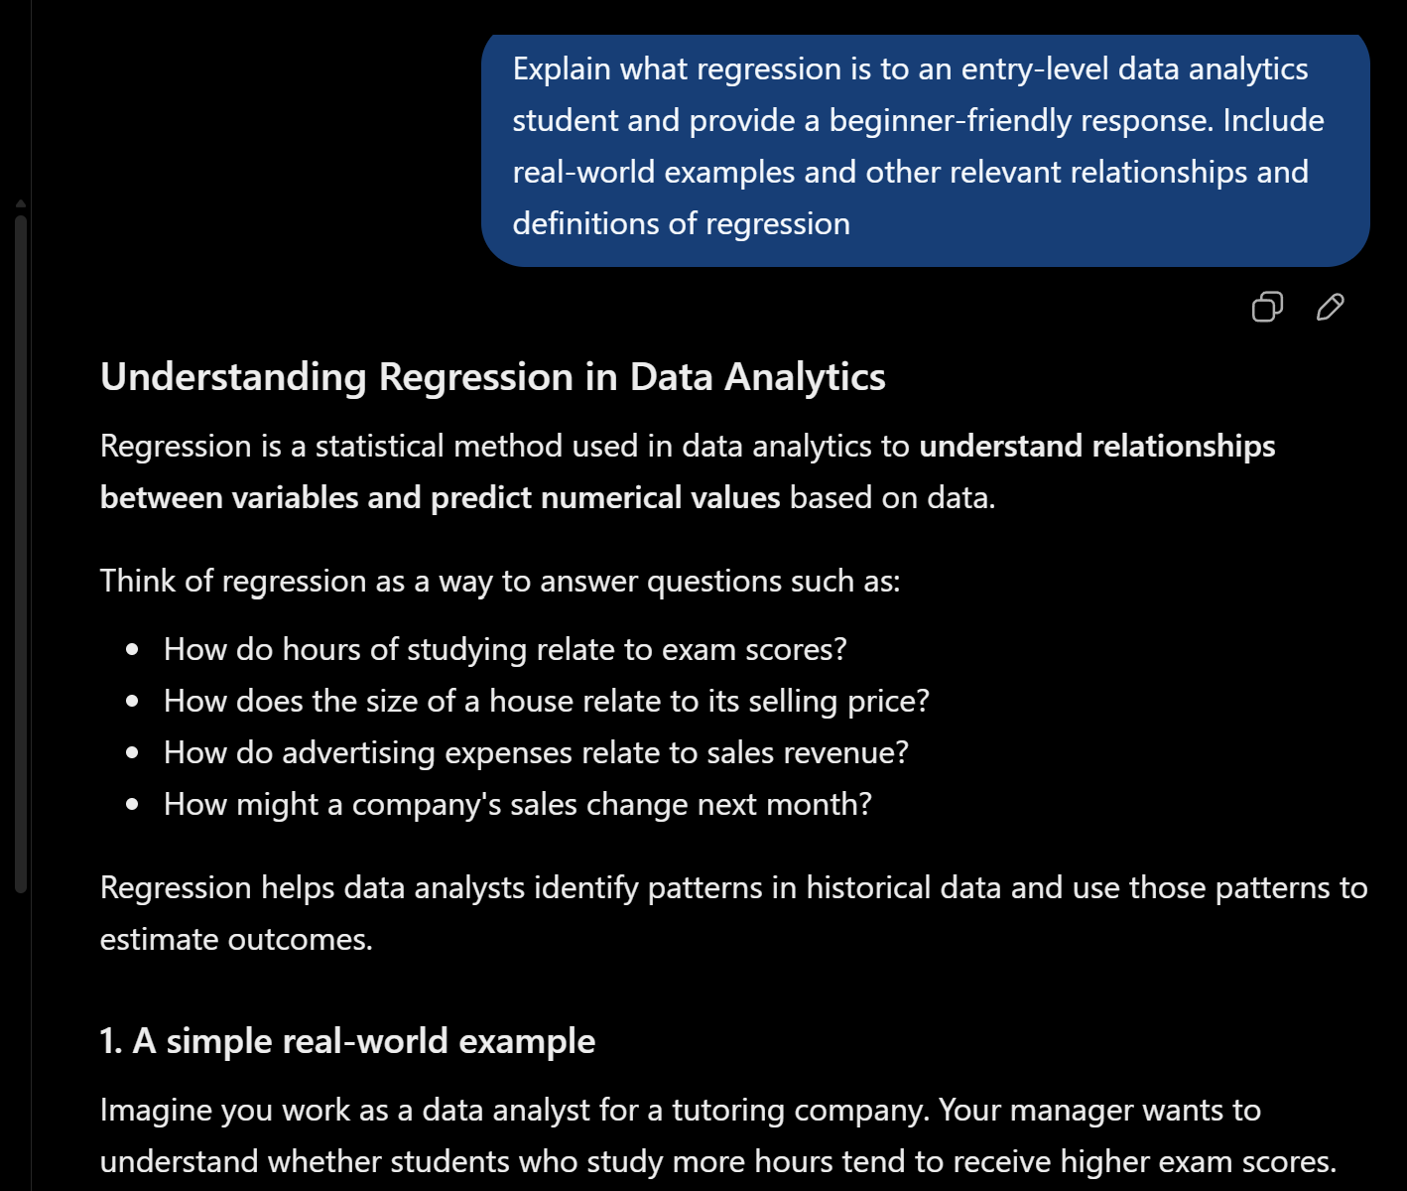
Why This Prompt Is Stronger:
The prompt version is stronger because being specific to the audience it should be generating the response for. While asking it to define and give real-world examples to are specific to regression. As well as any other topics that can correlate to regression
- Help me understand SQL
Improved Prompt:
Can you create a beginner-friendly 10 module lesson for understanding SQL. In the modules include key points, definitions and objectives of the module to better learn SQL Include entry-level questions and practice problems to help develop SQL skills.

Generative AI Output:
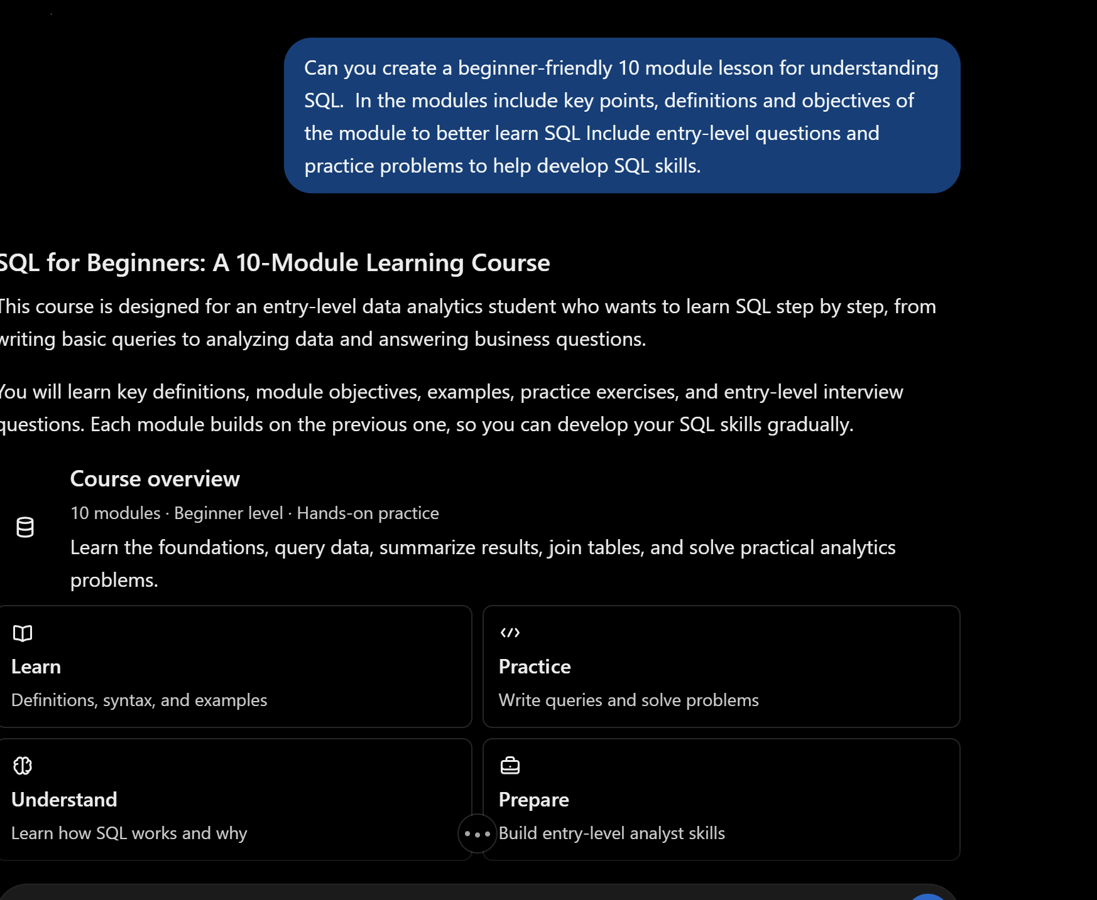

Why This Prompt Is Stronger:
This prompt is stronger because it specifically shows ChatGPT how to help me understand SQL. By asking it to more focused on creating a beginner friendly lesson on topics that necessary in learning SQL. While including practice problems and definitions to enhance my data analytic skills through the provide information.

- Create a dataset
Improved Prompt:

Can you create a realistic sample dataset containing 10 students. Include the studentID, FirstName, LastName, Major and GPA and make sure it is formatted into a table dataset
Generate AI Output:
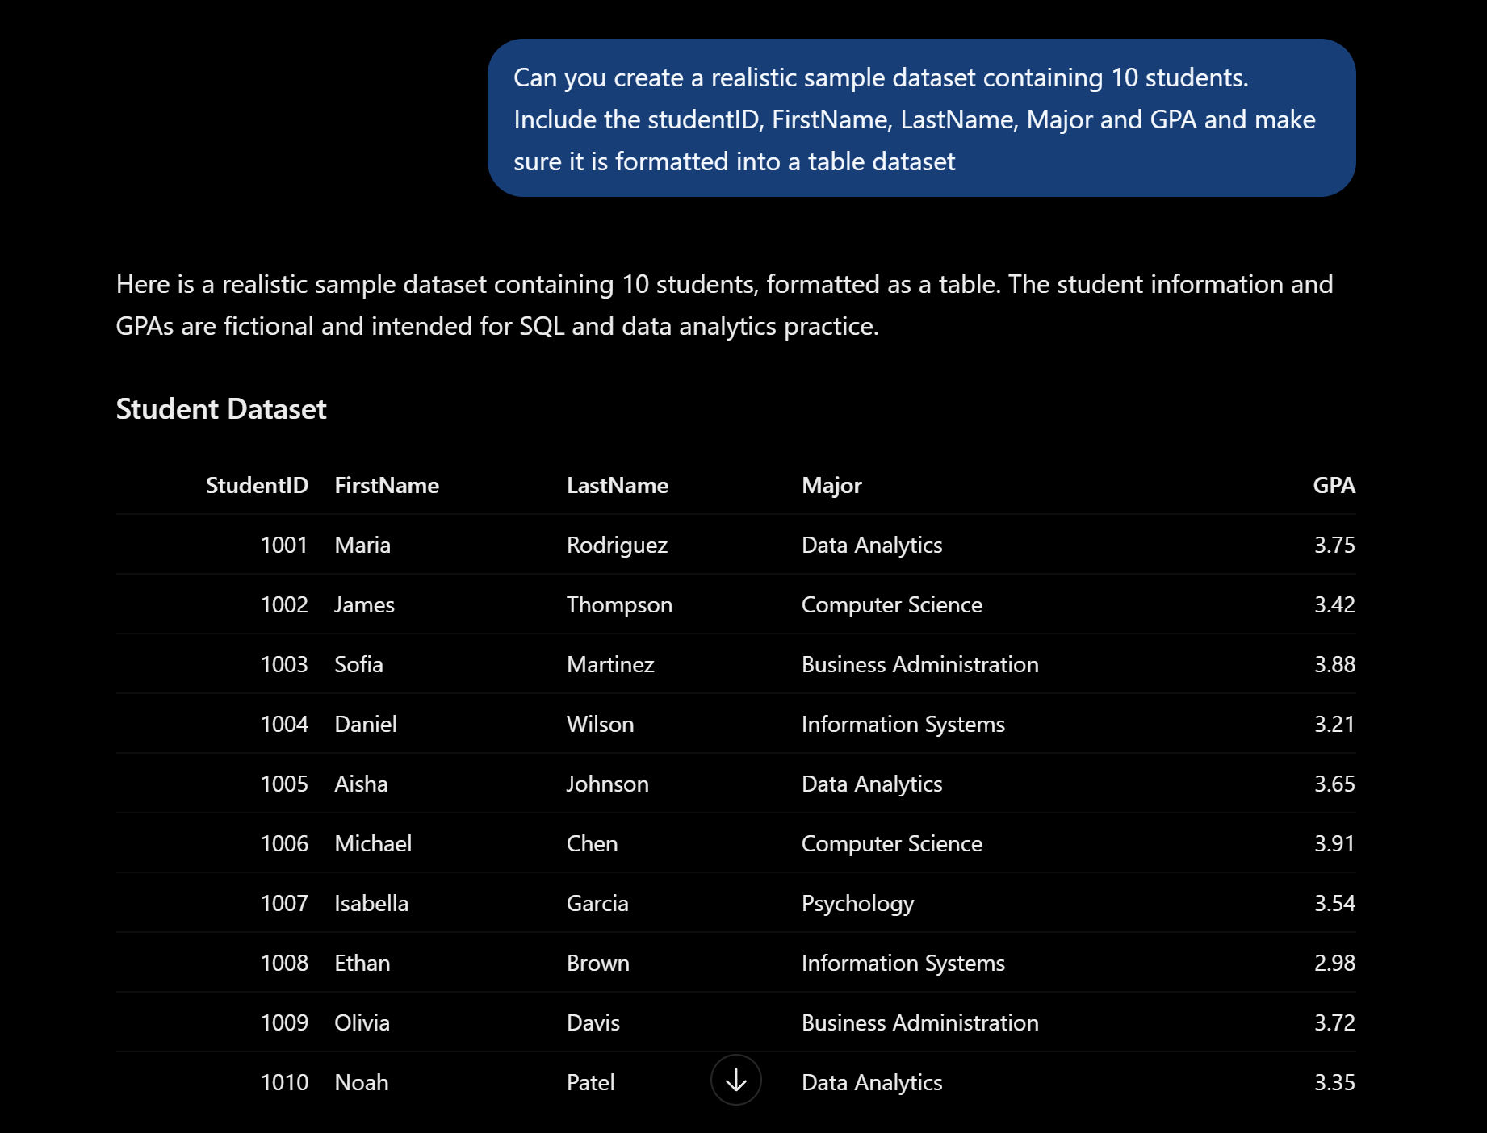

Why is This Prompt Stronger:
This prompt is stronger because it asks generative AI to create a realistic a specific what type of dataset I want. For instance, I specified the type of element I wanted to be included in the column. Also specify that I wanted the dataset in a table form with a certain number of students.

