Data Analytics Academy
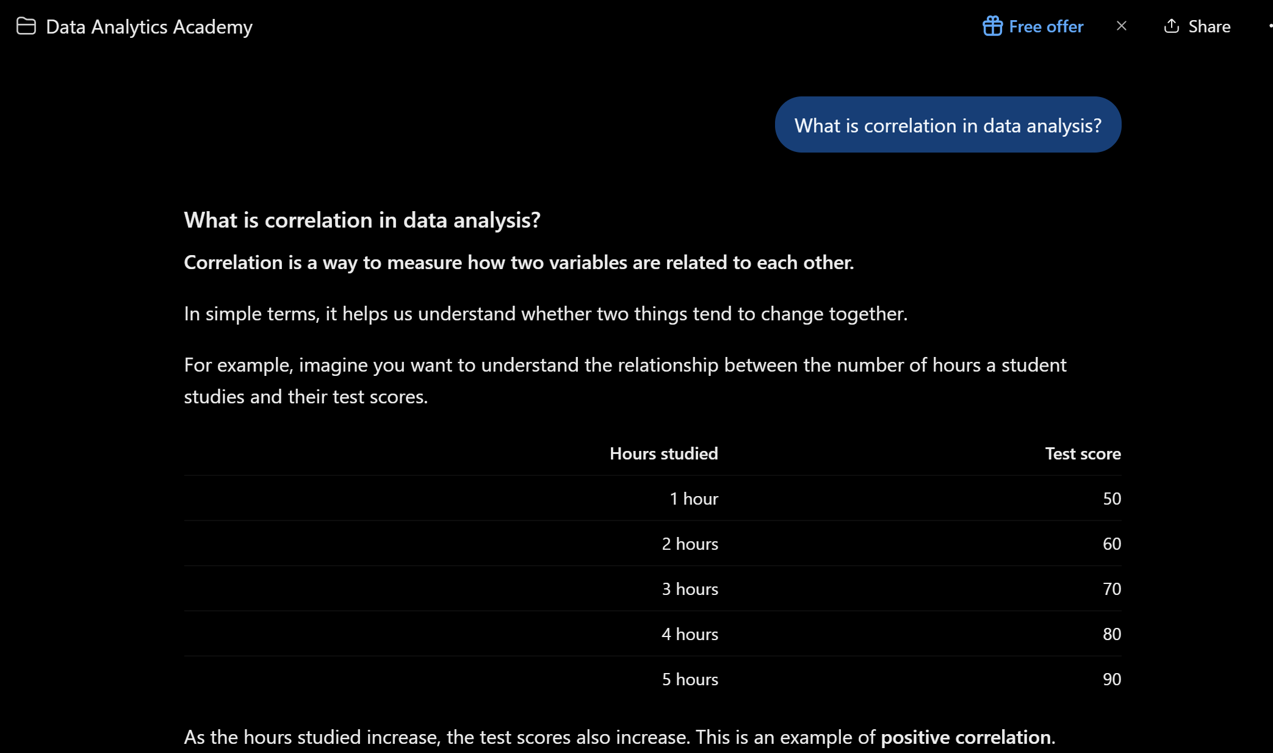

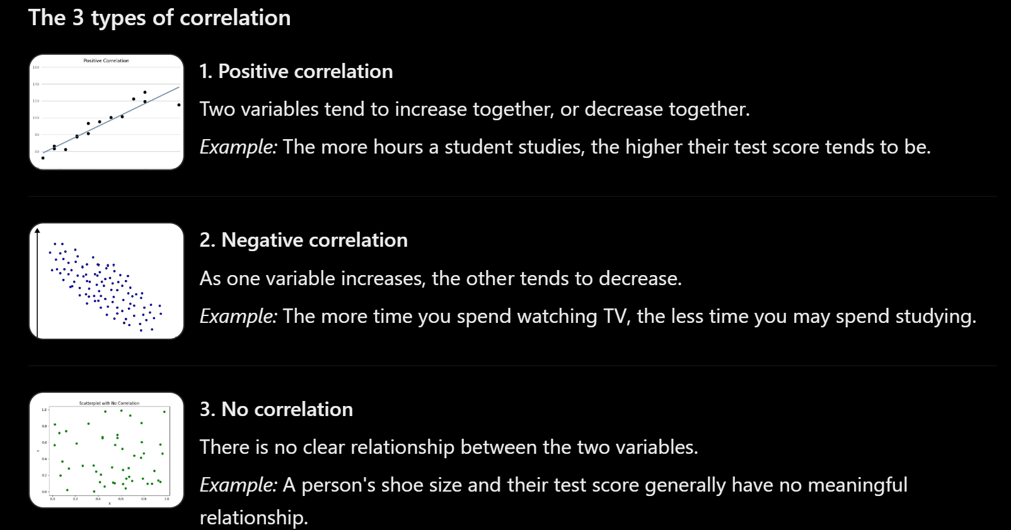

Write 3-4 sentences explaining how persistent instructions influenced the
response
Having persistent instructions does have a positive influence in the generative AI output. This is because by providing specific instructions to AI it was able to produce the exact outcome you wanted. In this insistence making a beginner-friendly data analytics learning assistance by providing definitions, examples and practice problem to test your knowledge.

