**ABSTRACT**

**Design of 3-bit Gray code counter using Jk flip-flop**

**Aim:** To design a 3-bit Gray code synchronous counter using Jkflip flop.

**Project Description:** This project is a gray code counter which shows the gray codes for 0 to 7. Here Jk flip flop is used. With the help of JKflip flop out puts we count the gray code. A counter counts the numbers in an order.

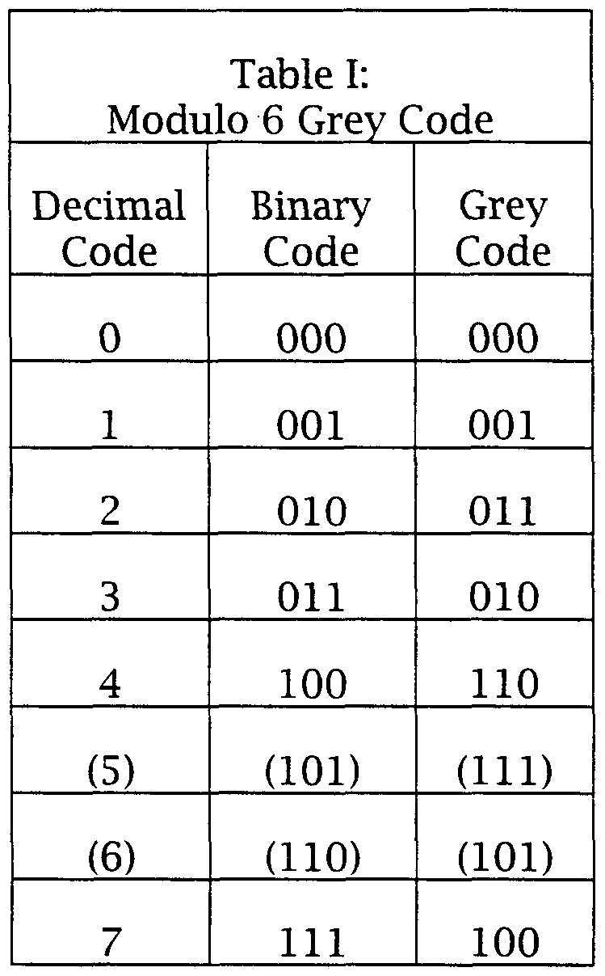



The arrow in the center shows the direction of the counter. However, it is possible to progress through the state table in the reverse order. If we start at 000, the next state is 001. From 001 the next state is 011. We progress through all possible states until the sequence repeats. It is shown in a table.

# Circuit Diagram:

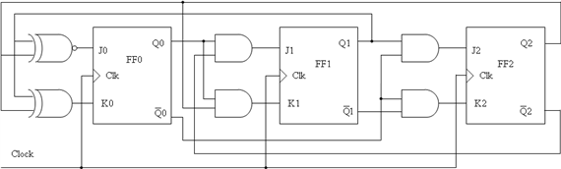

# Procedure:

|  |  |  |  |  |  |  |  |  |  |
| --- | --- | --- | --- | --- | --- | --- | --- | --- | --- |
| STATE TRANSISTIONS | | | OUTPUT CONDITION | | | FLIP-FLOP INPUTS | | | |
| QC | QB | QA | QC | QB | QA | JC KC | JB KB | JA KA |
| 0 → 0 | 0 → 0 | 0 → 1 | R/H | R/H | S/T | 0 X | 0 X | 1 X |
| 0 → 0 | 0 → 1 | 1 → 1 | R/H | S/T | S/H | 0 X | 1 X | X 0 |
| 0 → 0 | 1 → 1 | 1 → 0 | R/H | S/H | R/T | 0 X | X 0 | X 1 |
| 0 → 1 | 1 → 1 | 0 → 0 | S/T | S/H | R/H | 1 X | X 0 | 0 X |
| 1 → 1 | 1 → 1 | 0 → 1 | S/H | S/H | S/T | X 0 | X 0 | 1 X |
| 1 → 1 | 1 → 0 | 1 → 1 | S/H | R/T | S/H | X 0 | X 1 | X 0 |
| 1 → 1 | 0 → 0 | 1 → 0 | S/H | R/H | R/T | X 0 | 0 X | X 1 |
| 1 → 0 | 0 → 0 | 0 → 0 | R/T | R/H | R/H | X 1 | 0 X | 0 X |

The Transition Table shows the flip-flop inputs required to make the counter go from the present state to the proper next state.

Each transition can be accomplished by two of the four possible conditions:

For S/T we see an entry of 0 → 1. This means we can have a 0 to 1 transition by Setting the flip-flop or by Toggling the flip-flop. For Set, J=1 and K = 0.

For Toggle, J = 1 and K = 1. Therefore, J must be 1, but K can be 0 or 1. Since K can be either 0 or 1, the K input is X (Don't Care), we place 1 in the J column and X in the K column

For S/H, the entry is 1 → 1. For Set, J = 1 and K = 0. For Hold, J = 0 and K = 0. Therefore, the flip-flop inputs for J and K is X 0.

For R/T, the entry is 1 → 0. For Set, J = 0 and K = 1. For Toggle, J = 1 and K = 1. Therefore, the flip-flops inputs for J and K is X 1. For R/H, the entry is 0 → 0.

For Set, J = 0 and K =1. For Hold, J = 0 and K = 0. Therefore, the flipflop inputs for J and K is 0 X.

By

**MD. Sahil Afrid Farookhi (150030590)**

**MD. Gousiya Nasreen (150030592)**

**M. Raghu Vamsi (150030606)**