**SOFTWARE ENGINEERING**

**PROJECT BASED LAB REPORT**

On

**UNIVERSITY ADMISSION SYSTEM**

submitted in partial fulfilment of the

Requirements for the award of the Degree of

**Bachelor of Technology**

In

**COMPUTER SCIENCE ENGINEERING**

By

MD. Sahil Afrid Farookhi (150030590)

U. L. Radha Yashwanth (150030939)

**UNDER THE GUIDENCE OF**

Dr. V. SUCHARITHA

**DEPARTMENT OF COMPUTER SCIENCE ENGINEERING**

**K L University**

Green Fields, Vaddeswaram, Guntur district – 522 502



**CERTIFICATE**

This is to certify that the course-based project titled **“UNIVERSITY ADMISSION SYSTEM”**, being submitted by **MD. Sahil Afrid Farookhi (150030590)** and **U. L. Radha Yashwanth (150030939)** in partial fulfilment for the award of degree of **Bachelor of Technology** in Computer Science and Engineering is a record of bonafide work carried out by them under my guidance during the academic year **2016 – 2017** and it has been found worthy of acceptance according to the requirements of the university.

**UNDER THE GUIDENCE OF**

**DR. V. SUCHARITHA**

DECLARATION

We declare that the project work entitled “UNIVERSITY ADMISSION SYSTEM” was carried out by us during OCTOBER 2016, and this work is not the same as that of any other and has not been submitted for award of any other degree/diploma.

Signature of the Student

Place: K L University

Date: 24/10/2016

**INDEX**

|  |  |
| --- | --- |
| CONTENT: |  |
| ACKNOWLEGEMENTS |  |
| ABSTRACT |  |
| Introduction |  |
|  |  |
| Purpose |  |
| Scope |  |
| Tools used |  |
| System functions |  |
| Conclusion |  |

**ACKNOWLEDGMENT**

The satisfaction that accompanies that the successful completion of any task would be incomplete without the mention of people whose ceaseless cooperation made it possible, whose constant guidance and encouragement crown all efforts with success.

We are grateful to our project-based Lab guide **DR. V. SUCHARITHA** madam**,** Computer Science & Engineering for the guidance, inspiration and constructive suggestions that helped us in the completion of this project.

At the outset we thank our Head of the Department, **DR. V. SRIKANTH** sir for the moral support and the excellent facilities provided. We would also like to thank all the teaching and non-teaching staff members of Computer Science department who have extended their full cooperation during the course of our project based labs.

We thank all our friends who helped us in sharing knowledge with us.

**PROJECT BATCH**

Md. Sahil Afrid Farookhi (150030590)

U. L. Radha Yashwanth (150030939)

**ABSTRACT**

**ON**

**UNIVERSITY ADMISSION PROCESS**

**Introduction:**

Students admissions are a vital part of any university’s running because students are what keep a university alive. The student admission is one of the most important activities within a university as one cannot survive without students. Poor admissions system can mean fewer students being admitted into a university because of mistakes or an overlay slow response time.

**DESCRIPTION:**

By using university admission process, we process the admissions of university which has different courses based on various categories such as rank or the score obtained by the student in an exam conducted by the university management.

**REQUIREMENTS:**

STUDENT MODULE:

* Qualify
* Form
* Courses of choice
* Fee

DATA ANALYST:

* Information collection
* Update
* Process
* Result declaration

SERVER:

* Receives the data from student through analyst
* Cross checking
* Maintain the progress
* Declare the allotment

**ACTORS:**

* Student
* Data analyst
* Server

**PROCESS:**

First the student needs to fill the form and report that form to analyst, who gives it to the server. The student needs to fill each and every prospect of the form. Server checks the details given by the student. If the data is correct then it continues the further process of admission through rank or the score obtained by the student. The course is allotted to the student based on the rank or the score. This process is followed by the payment of admission fee and some formal fees by the student. The server verifies all the information and allots a course for the student based on his choice. The allotment is procced by the analyst to the student.

By:

Md. Sahil afrid farookhi – 150030590

U. L. Radha Yashwanth – 150030939

**University Admission System**

**Problem Definition**:

Today all the work at the time of admission of the students is done manually by ink and paper, which is very slow and consuming much efforts and time. It is required to Design of a Computerized Automated Student Admission System, to speed up and make it easy to use system.

**Purpose:**

1). Student Admission System Supports the student admission and registration process, the maintenance of student personal, academic and fee related data. 2). Database maintained by this system usually contains the student’s personal, academic and its fee related information. It focuses on storing and processing (insertion, updating) by using web pages 3). Generates student information in formatted html tables, generates the fees invoice. 4). Generate Student’s Academic Detail Report. 5). Generate Student’s Personal Detail Report. 6). Generate Student’s Fee Deposition Status Report. 7). Generate Student’s all student’s currently deposited their fees. 8). It Stores Merit list provided by University.

**Scope:**

An application Software it will work for an institute conducting a professional course like MCA/MBA under a governing university. SAS Manages student (personal, academic, fees) Details. Students are admitted per the college allotted by university per their merit in examination and their choice of college.

Activities like Updating, Creations done in the system by the System Operator will be maintained in the form of tables for auditing and maintaining the integrity of the system. Project Requirements: ➢ Automate manual paper work done at the time of student’s admission (fees deposition) in the institute. ➢ Eliminate paper work. ➢ Efficiently manage the student (academic, personal, fee) details.

**Software Required:**

Operating System: Microsoft Windows XP Front End tools: HTML, ASP.NET Back End tools: MS Access, SQL Server

**Hardware Required:**

CPU: Pentium VI processor RAM: 512 MB HDD: 40 GB Keyboard, Monitor, Mouse, Printer

**Working of the Present System:**

In present, all work is done manually by hand in bulk of files which is hard to operate and hard to maintain the reports of the student presently, took admission in institute.

1. When the student comes in college.

2. First of all, he/she takes admission form from reception.

3. Fills it and submits it into office.

4. Filled form is first checked with documents like merit list and details came from university and verified by an official person, if there is any mistake then it is corrected.

5. At the time of submission of it the fees are deposited by the candidate.

6. At the time of submission of admission form enrolment no. is assigned to the candidate by the institute.

7. Candidate gets the receipt of fees deposition.

**Disadvantages of Present System:**

1. Require much man power i.e. much efforts, much cost and hard to operate and maintain.

2. Since, all the work is done in papers so it is very hard to locate a student record when it is required.

**Proposed System: -**

1. It is automated computerized web based software system. 2. It uses latest technologies like ASP.NET and SQL Server. 3. It is easy to operate. 4. Attractive User Interface

**USE CASE DIAGRAM:**

A **use case diagram** in the Unified Modeling language (UML) is a type of behavioral diagram defined by and created from a Use case analysis.

In this system four actors are there.

* Applicant, visitor, student and administrator.
* Processes like inquiry, login admission form filling, merit generation, final admission, payment of admission.

Also, login process includes some authentication sub cases.

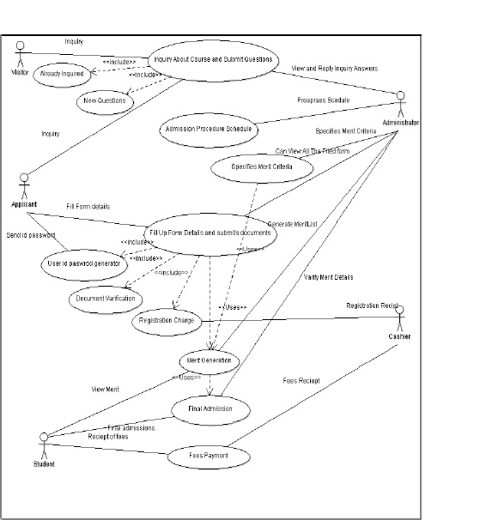

**Activity diagrams:**

Graphical representations of workflows of stepwise activities and actions with support for choice, iteration and concurrency.

 This system contains activities like inquiring, applying merit generating final admission confirmation payments etc.

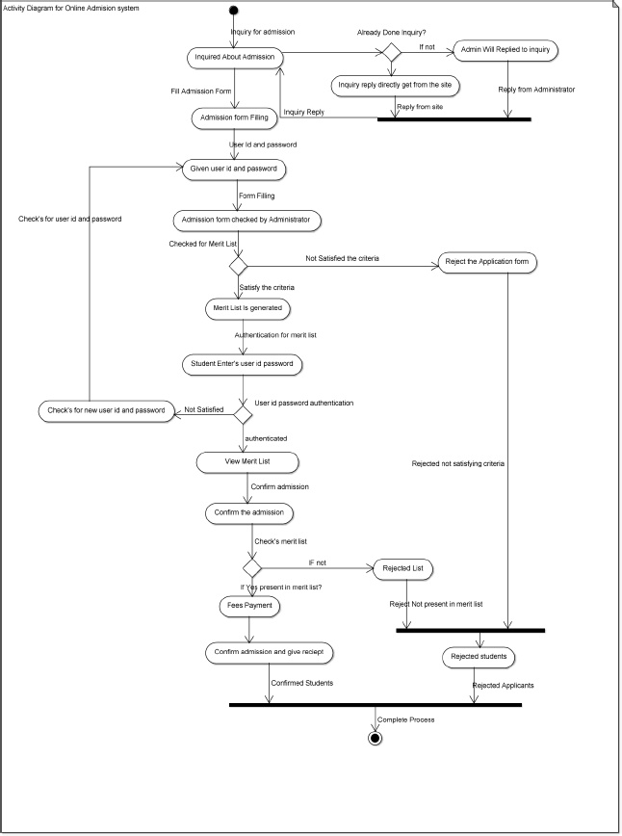

**Sequence Diagram:**

A **sequence diagram** in Unified modeling language (UML) is a kind of Interaction diagram it shows how processes operate with one another and in what order.

It shows how object behaves with another object during its life line

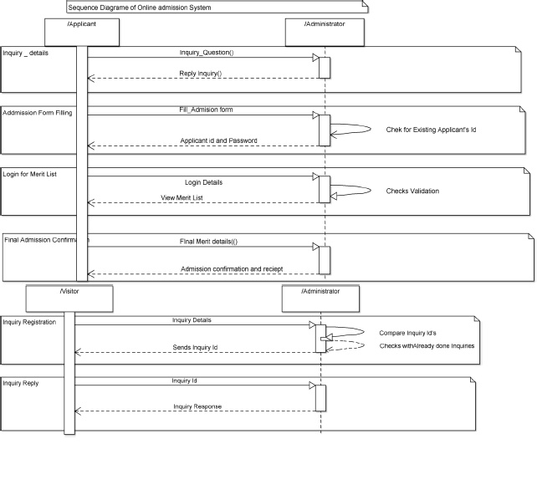

**CLASS DIAGRAM**

**Class diagram** in the Unified Modeling Language (UML) is a type of static structure diagram that describes the structure of a system by showing the system’s classes, their attributes, operations (or methods), and the relationships among the classes.

It contains classes for person class Admin side may be interviewer etc.

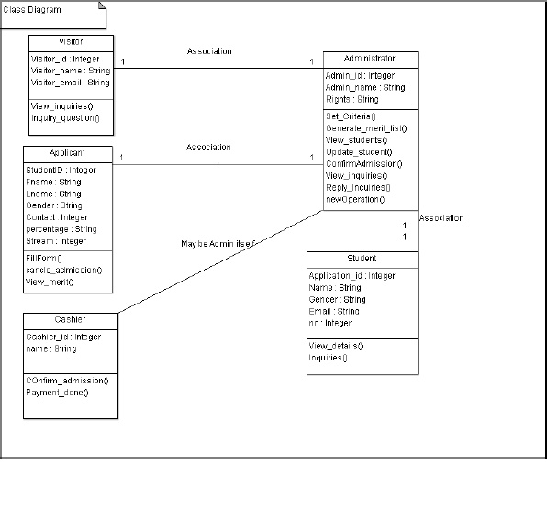

**SCREENSHOTS:**

