# **Cybersecurity Incident Report: Network Traffic Analysis**

**Scenario**

You are a cybersecurity analyst working at a company that specializes in providing IT services for clients. Several customers of clients reported that they were not able to access the client company website www.yummyrecipesforme.com, and saw the error “destination port unreachable” after waiting for the page to load.

You are tasked with analysing the situation and determining which network protocol was affected during this incident. To start, you attempt to visit the website and you also receive the error “destination port unreachable.” To troubleshoot the issue, you load your network analyser tool, tcpdump, and attempt to load the webpage again. To load the webpage, your browser sends a query to a DNS server via the UDP protocol to retrieve the IP address for the website's domain name. The analyser shows that when you send UDP packets to the DNS server, you receive ICMP packets containing the error message: “udp port 53 unreachable.”

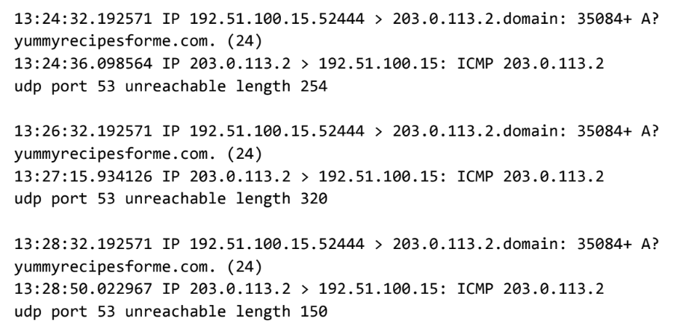

Now that you have captured data packets using a network analyser tool, it is your job to identify which network protocol and service were impacted by this incident. Then, you will need to write a follow-up report.

|  |
| --- |
| Part 1: Provide a summary of the problem found in the tcpdump log |
| As part of the DNS protocol, the UDP protocol was used to contact the DNS server to retrieve the IP address for the domain name of yummyrecipesforme.com. The ICMP protocol was used to respond with an error message, indicating issues contacting the DNS server. The UDP message going from your browser to the DNS server is shown in the first two lines of every log event. The ICMP error response from the DNS server to your browser is displayed in the third and fourth lines of every log event with the error message, “udp port 53 unreachable.” Since port 53 is associated with DNS protocol traffic, we know this is an issue with the DNS server. Issues with performing the DNS protocol are further evident because the plus sign after the query identification number 35084 indicates flags with the UDP message and the “A?” symbol indicates flags with performing DNS protocol operations. Due to the ICMP error response message about port 53, it is highly likely that the DNS server is not responding. This assumption is further supported by the flags associated with the outgoing UDP message and domain name retrieval. |
|

|  |
| --- |
| Part 2: Explain your analysis of the data and provide at least one cause of the incident. |
| The incident occurred today at 1:24 p.m. Customers notified the organization that they received the message “destination port unreachable” when they attempted to visit the website yummyrecipesforme.com. The cybersecurity team providing IT services to their client organization are currently investigating the issue so customers can access the website again. In our investigation into the issue, we conducted packet sniffing tests using tcpdump. In the resulting log file, we found that DNS port 53 was unreachable. The next step is to identify whether the DNS server is down or traffic to port 53 is blocked by the firewall. The DNS server might be down due to a successful Denial of Service attack or a misconfiguration. |