**6**

***ECOLOGY***

**Chapter coverage**

6.1 *Introduction of Ecology*

6.2 *Ecosystem*

6.3 *Energy flow and nutrients circulation*

6.4 *Biomes – major ecosystems*

6.5 *Ecological succession*

6.6 *Habitat and ecological niche*

6.7 *Population dynamics*

6.8 *Natural resources and conservation*

6.9 *Methods of studying ecology*

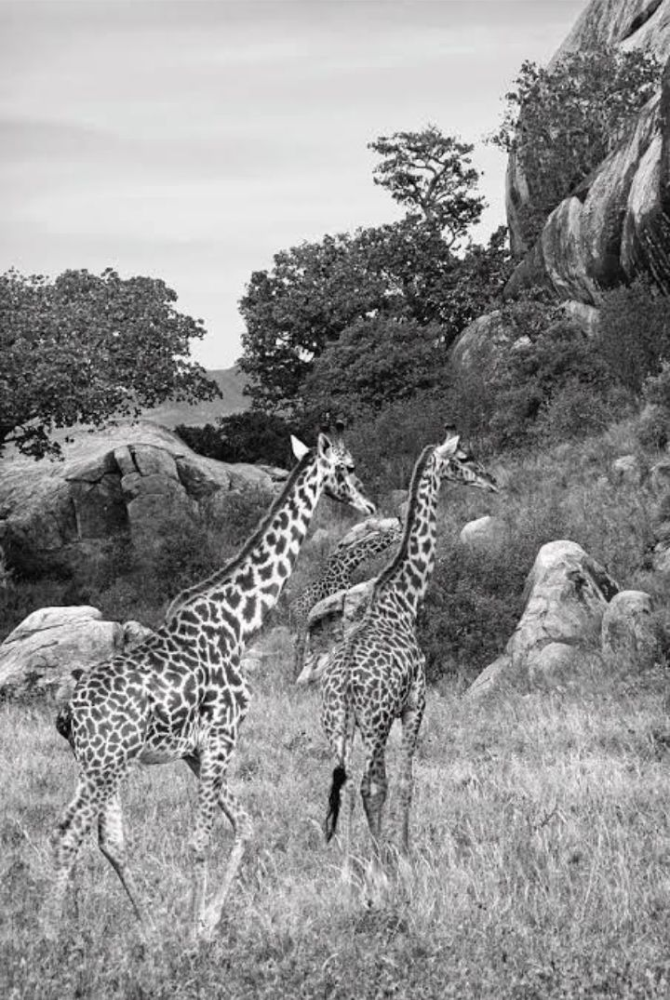

***Fig 6.1*** *what is an ecology?*

**6.1 INTRODUCTION OF ECOLOGY**

Imagine that you are the person who photographed Figure 6.1. Everything around you is your ***environment***. Part of your environment is ***living***. The giraffes, trees, shrubs and grasses are examples. And, the other part of your environment is ***non-living*.** Soil, rocks, wind, air and light are examples. Can you think of ways that you interact with the other animals? That is, how do you depend on them? And how do they depend on you?

How do you interact with the trees? The grasses? And how do you interact with non-living factors? No organism lives completely on its own. It depends on other organisms and they depend on it. It also depends on the non-living environment in which it lives.

***Ecology*** is the study of the relationship among living organisms and between organisms and their environment. In ecology the study of relationship between living organisms themselves

is called ***synecology*,** while the study of interrelationship between living organisms and their environment is called ***autecology***.

**Importance of studying ecology**

1. It enables us to understand the relationship between organisms.
2. It enables us to understand the relationship between organisms and their environment.
3. It enables us to understand the energy flow and nutrients circulation through ecosystem.
4. It gives us the basic of predictions, preventing and controlling pollution.
5. It gives awareness of the sustainable use of natural resources.e.g. Water, forest and wildlife.
6. It enables us to understand agriculture, forestry and fisheries.
7. It enables us to understand the ways of controlling population.

***SAQ 6.1***

***TAHOSSA 2012***

* Differentiate between autecology and synecology.
* Explain briefly four points which show the importance of an ecology study.

**6.2 ECOSYSTEM**

An ***ecosystem*** is the interaction between living components (biotic) and non-living components (abiotic) of the environment through which energy flow and nutrients circulate. In nature, two major categories of ecosystems may be distinguished: (i) terrestrial or land ecosystem such desert as shown in Figure 6.2, grasslands and forests and (ii) aquatic or water ecosystem such as ponds, lakes, rivers and oceans.

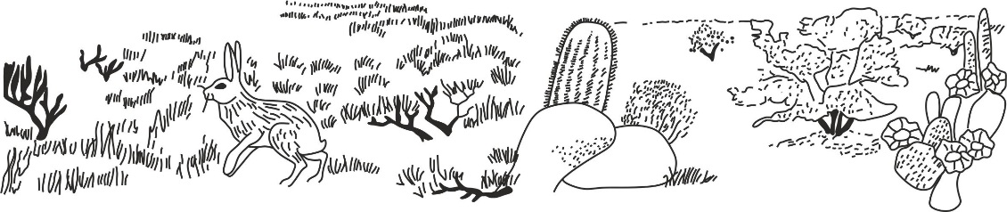

***Figure 6.2*** *desert as an ecosystem*

**Components of ecosystem**

The ecosystem is made up of two components, these are: Abiotic components and biotic components.

***Abiotic components***

The biotic components are non-living components of the ecosystem. The survival and distribution of the biotic components is largely determined by the interaction with the abiotic components. Among the abiotic factors the most important are ***climatic*** and ***edaphic factors***.

1. **Climatic factors**

These include elements of weather condition, namely: temperature, light, rainfall, wind and humidity.

1. **Light:**

The effect of light on the activities of living organisms include:

1. ***Photosynthesis*:** In green plants light provides the energy for the manufacturing of food.
2. ***Transpiration*:** Evaporation of water and opening of the stomata is caused by light.
3. ***Vision*:** In most animals light stimulates photoreceptors for seeing of objects.
4. ***Movement*:** light enables organisms to move from one area to another or to extend their organs like photonasty.
5. ***Photoperiodism***: Light is important to synching of behaviour among organism in different seasons like reproduction.
6. ***Synthesis of vitamins***: light stimulates the synthesis of vitamin D on the skin.
7. **Temperature:**

Temperature affects the enzyme activity on physiological processes such as germination, growth, respiration and photosynthesis.

1. **Rainfall:**

Rainfall determines the type of vegetation and influence plant (flora) growth and distribution.

1. **Humidity**

Humidity determine the rate of water loss from the plants through transpiration and from the animals through sweating and also humidity determine the amount of soil water and moisture in the air and soil, which in turn affects precipitations such as rainfall.

1. **Wind**
2. Wind influence the dispersal of seeds and fruits.
3. Wind affects the direction of birds and insects migration.
4. Wind affect abiotic factors such as humidity, temperature and transpiration.

***SAQ 6.2***

***TAHOSSA DAR 2022***

* Identify five ways in which light affects the activities of living organisms.

1. **Edaphic factors**

These consist of soil physical, chemical and biological properties. They include soil structure, soil texture, soil pH, soil air, humus, inorganic matter and topography. These factors determine the types of fauna and flora that are found in particular habitat.

1. **Soil texture and structure:**

Refers to the size and nature of soil particles, this influence the water – holding capacity of soil and the type of plants which can grow on it.

1. **Soil pH**:

Refers to the degree of *acidity* or *alkalinity* of soil. Most plants grow well in soil with moderate or near neutral pH for their survival. Some plants prefer slightly acidic such as tomatoes and pineapples, while onions and cabbage prefer slightly alkaline soils. At very high or low pH, some minerals such as nitrogen become unavailable to plants.

1. **Soil air**

Roots derive their oxygen directly from the soil, if the soil become waterlogged, the air is driven out and this can lead to poor air circulation which is detrimental to most plants except plant such as sedges which can tolerate such condition.

1. **Humus**

This constitutes all dead and decaying remains of organisms in the soil. Humus or organic matter act like sponge in retaining water and act as cementing materials in holding soil particles together, hence improve soil structure. Humus also release nutrients to the soil and makes them available for plant growth. This, in turn affects the distribution of plants and other organisms depending on them.

1. **Inorganic matter**

As for the mineral content of soil, various plants require macro and micro nutrients. The ability of soil to supply these minerals will determine the distribution of plants growing in particular soil, and hence, distribution of animals which depend on them.

1. **Topography**

Refers to the physical appearance of land such as hills, plains (altitude) or slopes which affects the biotic component of the ecosystem. Higher altitude unlike lower altitude are associated with low temperature (colder), high precipitation and low pressure, which altogether affect plant and animal growth and their distribution.

***SAQ 6.2***

***MOCK SOUTHERN ZONE 2021***

* Explain what is meant by the term ecosystem?
* With references to examples from named ecosystem, explain what do you understand by each of the following:

1. Ecological niche
2. Edaphic factors
3. Decomposers
4. Succession

***Biotic components***

The biotic component of an ecosystem consists of living organisms such as plants, animals, fungi and bacteria. Based on the flow of energy within the ecosystem, living organisms in the ecosystem can be grouped into three categories, namely: producers, consumers and decomposers.

1. **Producers (autotrophs)**

These are organisms which are capable of manufacturing their own food from simple inorganic substances such as water and carbondioxide under the presence of light or chemical energy. They include green plants, algae and chemosynthetic bacteria. Since they are primary producer of energy to the consumers, they are called primary producers. Producers make the first trophic level in a food chain.

**Roles of producers on ecosystem**

1. They are source of food for all organisms in ecosystem.
2. They are convert sunlight energy into chemical energy.
3. They are source of oxygen for aerobic respiration.
4. They reduce carbondioxide concentration from the atmosphere and control global warming.
5. **Consumers (heterotrophs)**

Heterotrophs are organisms that obtain their food from other living organisms as they unable to manufacture their own food. They feed on ready – made organic matter synthesized by primary producers.

**Types of consumers**

Consumers fall into three levels, which are the primary, secondary and tertiary consumers.

1. **Primary consumers**

These are organisms that feed directly on producers. They include all herbivores that are further categorized into ***grazers*** such as buffalo, zebra, cattle, mice, rabbits, insects; which mainly feed on grasses as shown in Figure 6.2 and ***browsers*** such as giraffe and goats which largely feed on shrubs and tree leaves. Some herbivores are aquatic organisms such as herbivores fish, crustacean, mollusc and tadpole amphibians. The herbivores or primary consumers make the second trophic level in the food chain.

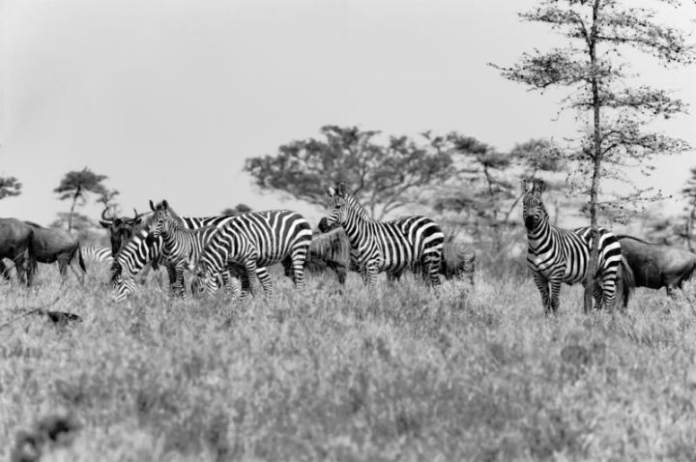

***Figure 6.2*** *Primary consumers in ecosystem*

1. **Secondary consumers**

Secondary consumers are animals that feed directly on primary consumers. The organisms in this level are commonly defined as carnivores or flesh feeders which include, dogs, cats, leopard, and hyena and lions.

1. **Tertiary consumers**

Tertiary consumers are animals that feed directly on secondary consumers. These animals are capable of feeding on herbivores and are also known as secondary carnivores such as large birds (eagles, vultures) and marine mammals such as seal and carnivores fish such as Nile perch.

**Roles of consumers on ecosystem**

1. They release carbondioxide gas which is required by producers for photosynthesis.
2. They ensure proper balancing of population in ecosystem.
3. **Decomposers (detritivorous)**

Decomposers are organisms that feed on dead decaying organic matter (detritus) at any feeding level ranging from producers to consumers. The decomposers are also known as saprophytes such as fungi and certain bacteria.

**Roles of decomposers on the ecosystem**

1. They ensure nutrients circulation in the ecosystem.
2. They act as environmental cleaners as they degrade and decompose organic remains and animals excreta.

**Interaction of components of ecosystem**

In the ecosystem living organisms do not exist in isolation, but they interact with each other in various ways. These inter- relationships among biotic components of ecosystem include, competition, predation and symbiosis.

1. **Competition**

Competition refers to a struggle between living organisms for the limited environmental resources such as light, food, water, mate, air and space. Competition occurs not always among the organisms of the same species but also among totally unrelated species. Thus, competition between organisms of the same species is called **intraspecific competition** for instance, carnivores animals such as tigers compete for the prey or several cock compete for the same hen for mating or plants such as maize grown very close to each other compete for light from the sun and nutrients from the soil; while that between individuals of different species is termed as **interspecific competition** for instance, buffalo, zebra and gazelle both compete for grass. Generally the interspecific competition is more intense than intraspecific competition, requirements of individuals of same species are similar, and therefore, competition is more intense.

***SAQ 6.3***

***DAR MOCK 2020***

* Describe the types of competition in an ecosystem.

1. **Predation**

Refers to a biological relationship in which one species or predator kills and eats on another animal of a different species. The eaten animal is called ***prey*** whereas the animal that eats the prey is called a ***predator***. For example, cats eat mice or hawks predating over a small bird. In ecosystem with a predator – prey relationship, the two populations regulate each other and result into cyclic changes in the population size. The reasoning underlying is straight forward. As a prey population increases in number it provides more food for the predators and so, after an interval of time, the predator population increases too. The predators increase to the point where they are eating the prey species faster than it can reproduce, so the population of prey decreases. In turn, this limits the food supply of the predators and so their number will fall as well, allowing the prey to increase again and the cyclic changes continues as shown in Figure 6.3.

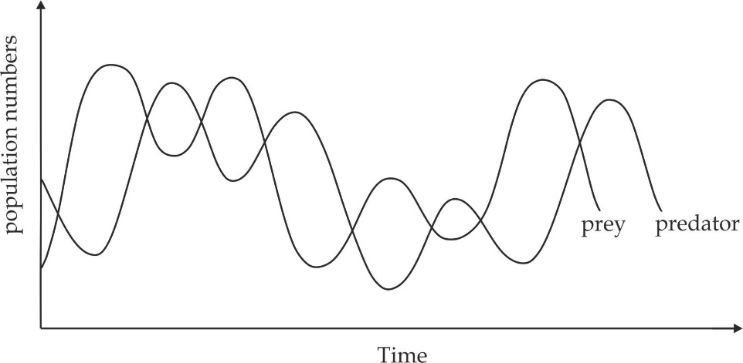

***Figure 6. 3*** *Relationship between predator and prey relationship*

**As** explained earlier, the decline in predator’s number gives room for the prey’s population to increase and subsequently support an increase in the number of predators as shown in above graph.

***SAQ 6.4***

***MTWARA AND LINDI MOCK 2022***

* Draw and briefly explain the predator – prey relationship curve as expected to occur in an ecosystem.

1. **Symbiosis**

Symbiosis is the relationship between two or more organisms of different species living together in which one organism (symbiont) or both may benefit from the relationship. There are three common types of symbiotic relationship, namely: mutualism, commensalism and parasitism.

1. **Mutualism**

Refers to interaction or relationship between two organisms of different species living in close association in which both partners benefit. For example ***lichens***, which are composite entities made up of a fungus and alga. The fungus from the main body of the lichen. It also provides fixation, water, minerals and shelter to the alga. The alga prepares food for itself as well as to the fungus as indicated in Figure 6.4. The second example is ***symbiotic nitrogen fixation*** which found between bacterium Rhizobium found in the root nodules of leguminous plants which fixes atmospheric nitrogen in the soil in the form of nitrates which is used by plant, and in return plant supplies water, minerals and organic food to the bacterium.

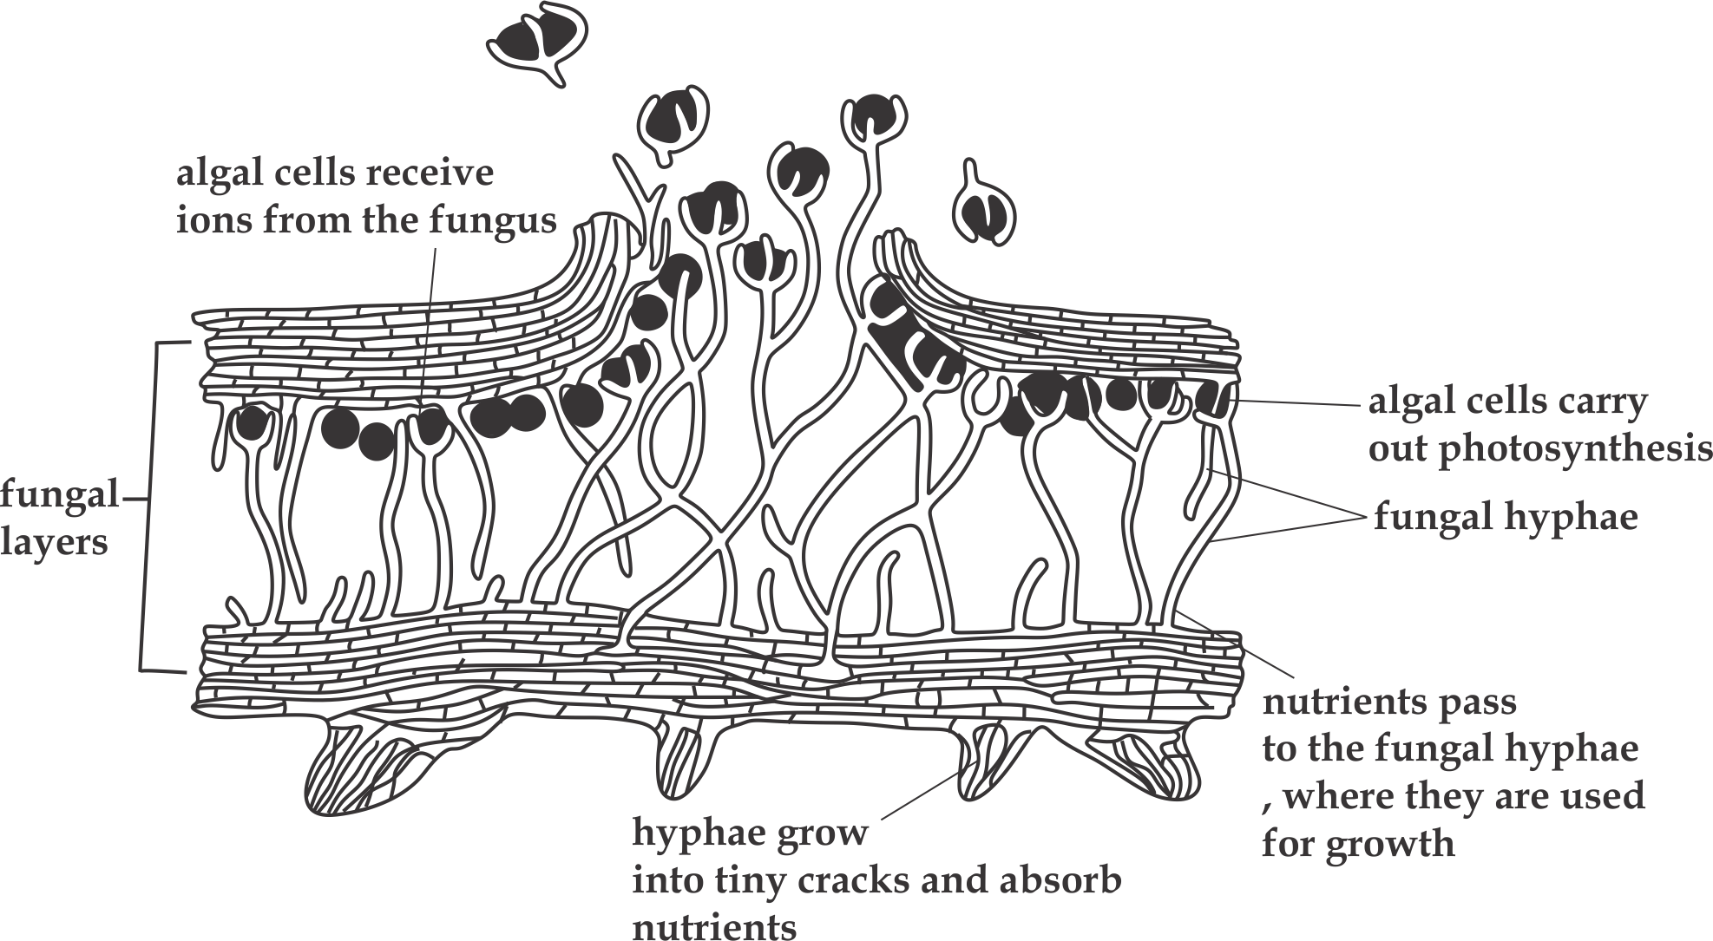

***Figure 6.4*** *Symbiotic relationship in lichen*

1. **Commensalism**

This refers to the association between two living organisms of different species in which one living organism (commensal) benefits and the other organism (host) neither benefits nor is harmed. One of the best examples is the relationship a type of hermit crab and colonial hydroid *Hydractinia echinata.* The hydroid obtains food particles from the crab and gain a way of moving about while the crab neither benefits nor is harmed. Another example of commensalism is evident between cattle egrets follows herds of cattle or buffalo and feed on insects disturbed by the animals, the cattle and buffalo are not harmed by the feeding activities of the cattle ergot. Therefore, in this association one member (The cattle egret) benefits while the other member (cattle or buffalo) neither benefits nor harmed.

1. **Parasitism**

Parasitism refers to the close association between two organisms of different species whereby one organism called a parasite benefits by obtain its nutrients and shelter from another living organism called a host. Usually, the parasite may ultimately cause harm to the host, but in some cases it can exist without killing the host. Some parasites, for example tapeworm and liver fluke live inside the host body. These parasites are called ***endoparasites*.** On the other hand, some parasites such as ticks and bed bugs attach themselves on the surface of the body of their host and suck fluids from them, and these are called***ectoparasites*.**

***SAQ 6.5***

***NECTA 2002***

* Identify the components of the ecosystem and explain how they interact.

**6.3 THE ENERGY FLOW AND NUTRIENTS CIRCULATION**

**Energy flow in ecosystem**

The primary source of energy in all ecosystems is the sun. Primary producers (photosynthetic organisms) such as green plants are the only organisms that are capable of converting sunlight energy into chemical energy during photosynthesis. This energy is then fixed in the bonds of synthesized organic matter from where it is made available to consumers (heterotrophs). The total amount of energy received by the primary producers from the sun, is known as ***Gross Primary Productivity (GPP)*** which is utilized for respiration and other physiological process by plant. The energy which remains thereafter, is the ***Net Primary Productivity (NPP),*** this is stored in plants and made available to higher trophic level (herbivores and carnivores) during feeding, from the primary producer, the energy pass to the primary consumer then the energy continues to flow through various consumer levels until it reaches the decomposer as shown in Figure 6.5. This is a one way and non – cyclic energy flow, as it never flows back to sun which is the primary source of energy. Generally. There is an existing relationship between trophic level and energy flow. Energy always flows from lower trophic level to the upper trophic level. As the energy flows from one trophic level to the next, there is a decrease in its amount due to the fact;

1. Some of the energy is used to carry out physiological processes. These activities include movement, respiration and growth which may convert the stored energy into heat, hence, lost into the atmosphere.
2. Physiological process such as digestion and assimilation are not 100% efficient. Thus, some of the energy remains interlocked in the molecules of the undigested food remains.
3. Not all parts of the consumed organism are digestible. For example if a carnivores eats a herbivore, the energy which is contained in parts such as horns, bones and hooves will remain fixed in these parts as they are mostly inedible.

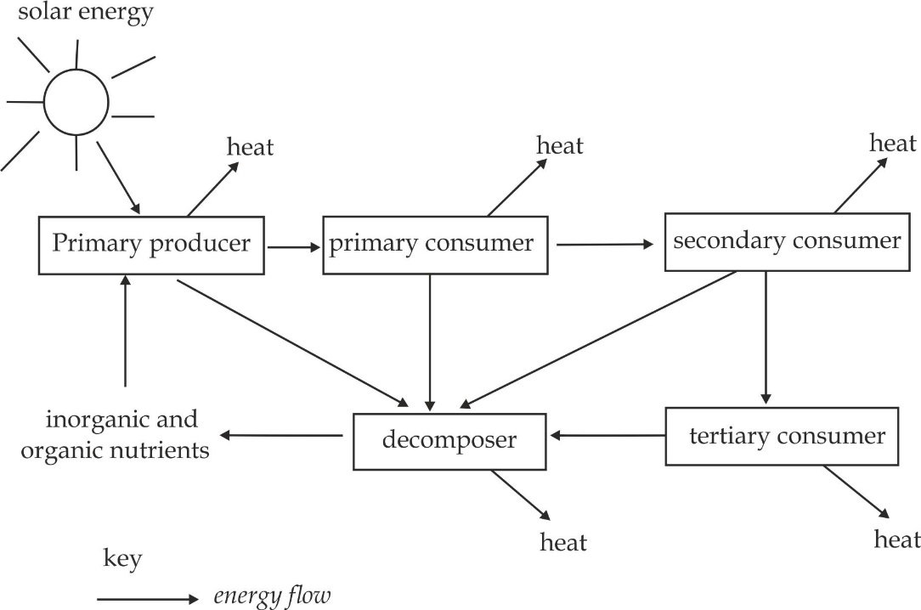

***Figure 6.5*** *Flow of energy at different levels of ecosystem*

***Key terms***

.

* **Trophic level** is a group of organisms with a similar feeding behaviour or nutritional habit in the ecosystem, for example, producers.
* **Respiratory loss** is the amount of energy which is lost or decrease as energy flow from one trophic level to another.
* **Gross Primary Productivity (GPP)**is the total amount of light energy received by the primary producers from the sun.
* **Net Primary Productivity (NPP)** is the energy which remains thereafter

utilized for respiration and other physiological process by plant.

***SAQ 6.6***

***JECAS 2012***

* Explain briefly the following:

1. Gross primary productivity (GPP)
2. Respiratory loss

* Comment on the flow of energy through ecosystem.

**Factors influence the flow of energy in ecosystem**

Human activities can either increase or decrease the flow of energy in the ecosystem in number of ways:

1. **Afforestation:**

Refers to the planting of trees to make new forests (forests that were never there), Afforestation which is practised by human favours energy flow since it increases the number of producers.

1. **Deforestation**

Refers to the burning or cutting down of trees, deforestation which is practised by human decreases the energy flow since it decreases the number of producers in the ecosystem.

1. **Use of pesticides in agriculture**

These remove primary consumers in the ecosystem, thereby decreasing the flow of energy in the ecosystem.

1. **Poaching**

It is the act of man killing animals especially in national parks, mostly primary consumers such as zebra, elephants, and giraffes. Poaching which is practised by humans decrease the flow of energy, since it decreases the number of consumers.

1. **Dynamite fishing**

Refers to use of explosive in fishing, this generates fumes of different types which are harmful to the life of living organisms, Dynamite which is practised by humans decrease the energy flow since it decreases the number of producers as well as consumers in water.

***SAQ 6.6***

***NECTA 2005***

* Discuss the various way in which human activities can interfere the flow of energy at all levels in a terrestrial ecosystem.

**Ways of energy flow on the ecosystem**

The feeding relationship among biotic components from one trophic level to another in the ecosystem can be represented in the number of ways, include; food chain, food web and ecological pyramids.

1. **Food chain**

A ***food chain*** is a linear sequence of energy transfer from one trophic level to another in the ecosystem. Thus, food chain can also be defined as the transfer of nutrients and energy through a succession of organisms through repeated process of eating and being eaten.

**Types of food chain**

The classification of food chain depends on the type of organisms that constitute the first trophic level. On this basis two common types namely the grazing food chain and detritus food chain are recognized.

1. **Grazing food chain**

Grazing is the type of food chain in which the first trophic level is occupied by the autotrophs such as green plants, algae and some bacteria and the second trophic level is occupied by a grazing animal (herbivore). It is the most common type of food chain, simple examples of grazing food chain are depicted below:( *arrow indicates the direction of energy).*

Grass Goat Man

Grass Grasshopper Toad snake Hawk

Plant Frog Snake Hawk

Plant Rabbit Fox wolf Tiger

1. **Detritus food chain**

Detritus is the type of food chain in which the first trophic level is occupied by the decomposing material (detritus) such as leaf litter and the second trophic level is occupied by the decomposer (detritivorous) such as millipede, earthworms and beetles. Simple examples of detritus food chains are depicted below:

Leaf litter Earthworm black sparrow Hawk

Detritus Caterpillar Frog snake

Detritus Woodlouse Bird Fox Hawk

**Figure 6.1: Differences between grazing food chain and detritus food chain**

|  |  |
| --- | --- |
| **Grazing food chain** | **Detritus food chain** |
| It begins with producers as the first trophic level | It begins with detritus as the first trophic level |
| Energy for the food chain comes from the sun | Energy for the food chain comes from the organic remains or detritus |
| It helps in complexing of inorganic nutrients | It helps in releasing or producing inorganic nutrients |
| It adds energy into the ecosystem | It retrievers energy from detritus |
| It is more common | It is less common |

**Advantages of food chain**

1. It is easy and simple to study since it shows the simple system of feeding relationship.
2. It takes a short period of time to construct and investigate so as to make a pyramid.
3. It is simple in studying the energy difference of different trophic levels.

**Disadvantages of food chain**

1. It does not give a complete picture of the interrelationship among the various organisms on the ecosystem.
2. It does not shows all sources of food an organism depends on in the ecosystem. Hence, a single producer is a food source for only one primary consumer and a consumer has only one food source.
3. It is less realistic than food web; for instance omnivores cannot be shown on a food chain but possible to be shown on a food web.
4. It does not evaluate the significance of biochemical cycle.
5. It increases the instability of organisms on the ecosystem.
6. **Food web**

A ***food web*** is a network of food chains which are interconnected at various trophic levels, so as to show alternative sources of food among different organisms of a biotic community. In the example of food web indicated in Figure 6.6; wild cats prey upon mice as well as birds and squirrels. A wolf eats not only fox but also rabbit and deer. Therefore the concept of food web appear more real ecologically than the concept of a simple food chain.

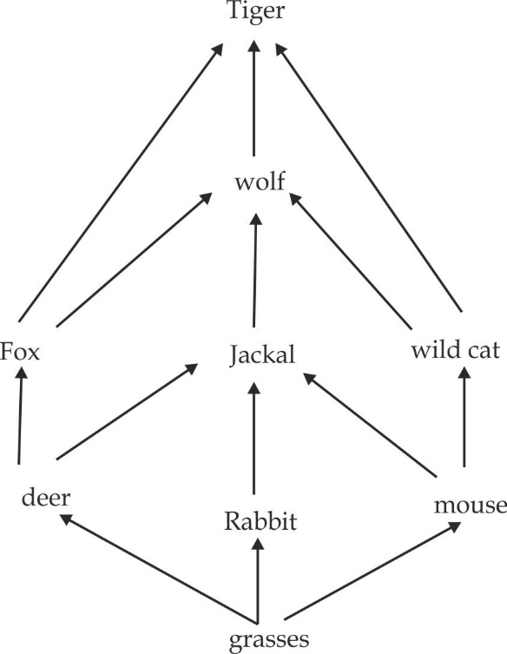

***Figure 6.6*** *illustration of food web*

**Advantages of food web**

1. It gives a complete picture of the interrelationship among the various organisms of an ecosystem.
2. It shows all sources of food an organism depends on in the ecosystem. Hence, a single producer is a food source for many number of primary consumers and a consumer might have a number of different food sources on the same or different trophic levels.
3. It is more realistic than food web; for instance omnivores can be shown on a food web but not possible to be shown on a food chain.
4. It evaluates the significance of biochemical cycle.
5. It increases the stability and improve adaptability of organisms on the ecosystem.

**Disadvantages of food web**

1. It is complex to study because there are many organisms of different trophic levels.
2. It takes a long period of time to construct and investigate so as to make a pyramid.
3. It is difficult in studying the energy difference of different trophic levels.

**Figure 6.2 Differences between food chain and food web**

|  |  |
| --- | --- |
| **Food chain** | **Food web** |
| It is a straight single path of transfer of food energy in the ecosystem | It consists of a number of connected food chains through which food passes in the ecosystem |
| Members of higher trophic level feed upon single type of organisms of lower trophic level | Members of higher trophic level can feed upon many of organisms of lower trophic level |
| Presence of separate and isolated food chains adds instability to the ecosystem | Presence of food web increases the stability of the ecosystem |
| It does not give a complete picture of the interrelationship among the various organisms of an ecosystem | It gives a complete picture of the interrelationship among the various organisms of an ecosystem |

***SAQ 6.7***

***MARIAN GIRLS AND BOYS JOINT EXAM 2017***

* What are the advantages and disadvantages of:

1. Food chains over food web.
2. Food web over food chain.

**Worked examples of food chain and food web**

***Worked example 01***

***NECTA 2002***

1. Define trophic level**.**
2. Study the food web in ***Figure 3*** and answer the questions below:
3. How many trophic levels are shown in this food web?
4. Name them and give one example of an organism for each trophic level.
5. Name one animal in the food web which feeds at all three trophic levels.
6. Write down the longest food chain shown in the food web.

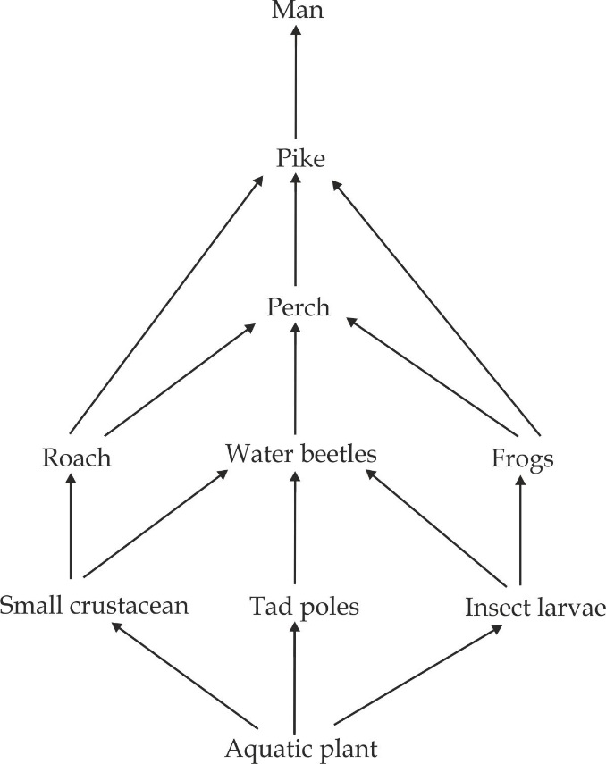

*Figure 3*

**Solution**

1. i. There are five trophic level
2. First trophic level – Primary producer, i.e. aquatic plant.

Second trophic level – Primary consumer, i.e. Tadpoles.

Third trophic level – Secondary consumer, i.e. Frogs.

Fourth trophic level – Tertiary consumer, i.e. Perch.

Fifth trophic level – Quaternary consumer, i.e. Man

1. Man
2. Aq plant Tad poles water beetles perch pike

Man

***Worked example 02***

***NECTA 1993***

The diagram below shows a food web for an aquatic ecosystem.

1. From the information in the diagram, name:
2. A primary consumer ii. A tertiary consumer.
3. Suggest how this community might be altered if the population of water beetles died out.
4. Only small percentage of the energy absorbed by the green algae is incorporated into the tissues of pike. Give three reasons why this should be so?

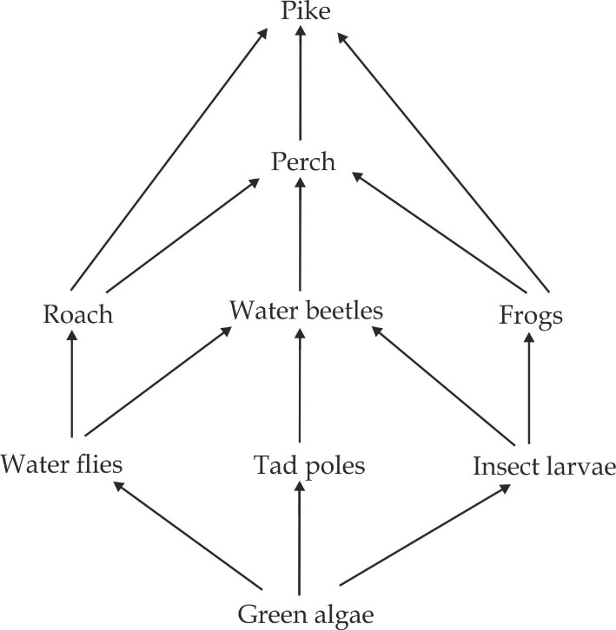

**Solution:**

1. i. Primary consumer – Tadpoles
2. Tertiary consumer – Perch
3. If water beetles dies, the number of water flies, tadpoles and insect larvae increase, as they are no longer eaten by beetles. The number of green algae will be depleted as they are eaten more by water fleas, tad poles and insect larvae.
4. Reasons:

* Not all energy available in the primary producers are used by the consumers.
* Some of the energy is lost as heat energy during physiological processes such as respiration.
* Some of the food remains undigested and lost as faeces.

***Worked example 03***

***NECTA 2005***

Below (***figure 3***) is a simple food web of five organisms, **P – T**.

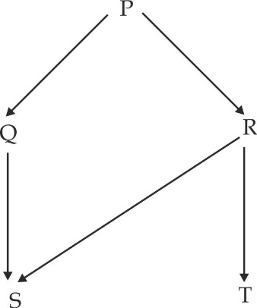

***Figure 3***

Explain the effects of a sudden removal of organism R on the proportion of organism P, S and T.

**Solution**

The number of organism **P** increases as they are no longer eaten by organism **R** which has been removed, thus proportion of organism **P** increases. The proportion of organism **S** decreases because of scarcity of food as organism **R** are removed from the food web. The number of organism **T** become depleted in the food web because of complete absence of their food since organism **R** have been removed from the food web.

***Worked example 04***

***NECTA 2010***

Prepare a possible food web from the following living organisms; Rabbit, small bird, fox, frog, hawk, grasshopper, green plants and earthworm.

**Solution**

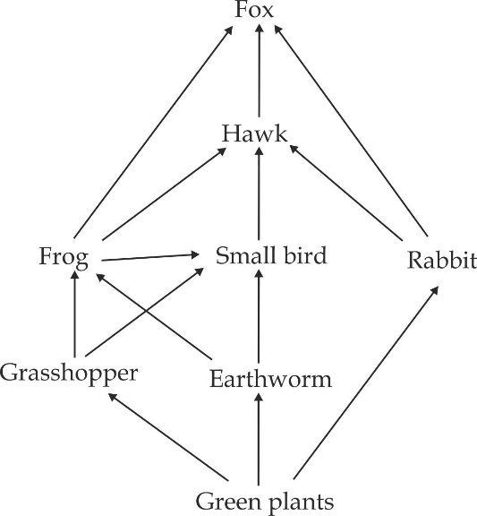

1. **Ecological pyramids**

Food webs can give a useful description of the feeding relationships in a community. However, they are non – quantitative. The first attempt to provide quantitative account of the feeding relationships in a community was made by the English ecologist ***Charles Elton*** and they are referred to as ecological pyramids or Eltonian pyramids*.* The ***ecological pyramids*** can defined as a graphical representation of feeding relationship and energy transfer through the biotic components of the ecosystem.

**Types of ecological pyramids**

There are three main types of ecological pyramids namely, the pyramid of numbers, biomass and energy.

***Pyramid of number***

The pyramid of number represents the total number of organisms per unit present at each trophic level. It is constructed by counting the number of organisms at each trophic level. There is a considerable reduction in number of individuals from the base to the top of the pyramid. The shape of the pyramid of numbers depend on the size of the bottom bar which represents the number of producers, The pyramid on number in a grassland community has a broad base because the producers are small and numerous as exemplified in Figure 6.7 (a). Similarly, in a pond ecosystem, the pyramid has a broad base because of a large number of phytoplanktons, which are producers in this case. Thus, in both the grassland and the pond ecosystems, the pyramids are upright However in a forest ecosystem, the pyramid of number has a narrow base because a single tree is likely to feed numerous such as caterpillar. The ecological pyramid of this type is normally said to be inverted. An inverted pyramid is also experienced in communities with parasites, in which a single host can harbour hundreds of parasites as shown in Figure 6.7 (b).

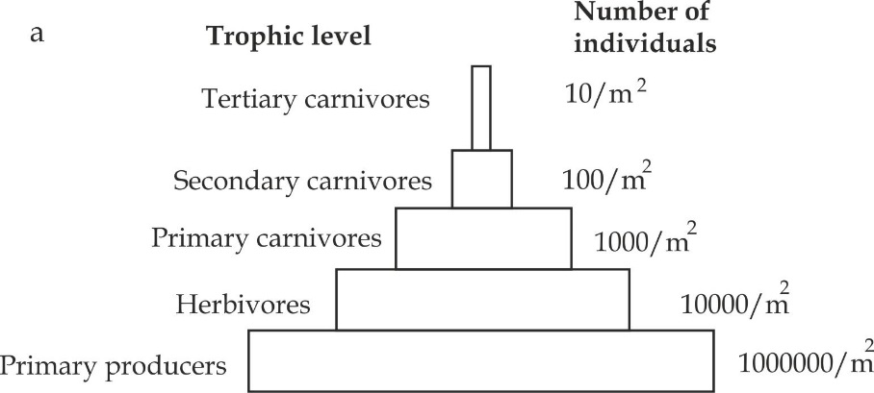

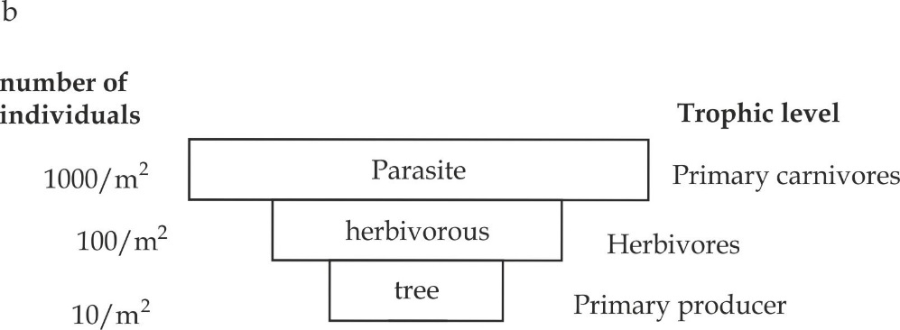

***Figure 6.7*** *Pyramid of numbers:*

*(a) Grassland ecosystem and (b) forest ecosystem*

**Advantages of the pyramid of numbers**

1. It is simple to collect data by using simple sampling techniques.
2. It is simple to construct compared to other pyramids.
3. It is not a destructive method, i.e. it does not involve killing of organisms.
4. It is a good method of comparing changes in population numbers at different times of the year, for example, in wet and dry seasons.

**Disadvantages of the pyramid of number**

1. It is difficult to decide the trophic level to which the organism belong.
2. The inverted pyramid is obtained, because sometimes the number of organisms increase from the lower trophic level to the upper trophic level.
3. The size of producers varies, and yet one grass plant is given the same status as a baobab tree. This explains why a true pyramid of numbers is not often obtained.
4. The range of numbers from the producers to the top carnivores may be so great that it becomes very difficult to draw the pyramid to scale.

***SAQ 6.8***

***MTWARA AND LINDI MOCK 2021***

* What is ecological pyramid? Describe the pyramid of numbers with relevant examples.

***Pyramid of biomass***

The amount of organic matter present in a particular organism is called a ***biomass.*** The pyramid of biomass represent the total amount of organic matter present at each trophic level per unit area. It is constructed by killing and dried organisms so as to obtain the dry mass. In most terrestrial ecosystems, there is a gradual decrease in the biomass from the base to the top of the pyramid as shown in figure 6.8 a.On the contrary, in many aquatic ecosystems, the pyramid of biomass may usual assume an inverted form. This is because the producers are tiny phytoplanktons that grow and reproduce rapidly. Phytoplanktons are consumed by larger organisms called zooplanktons that are relatively larger compared to them, as a result, the pyramid of biomass has a narrow base and the structure of pyramid, therefore, assumes inverted shape as indicated in Figure 6.8 b.

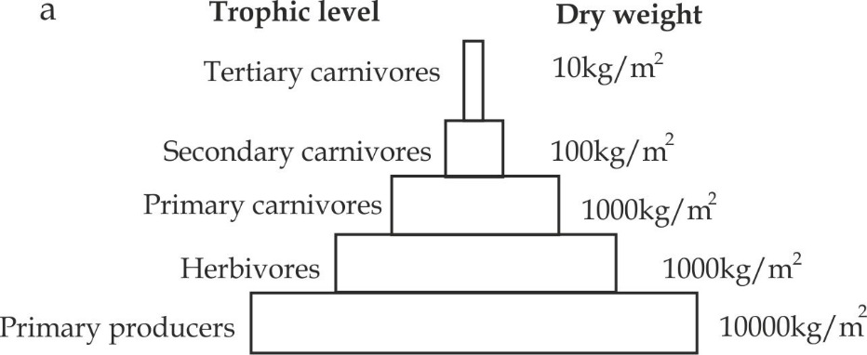

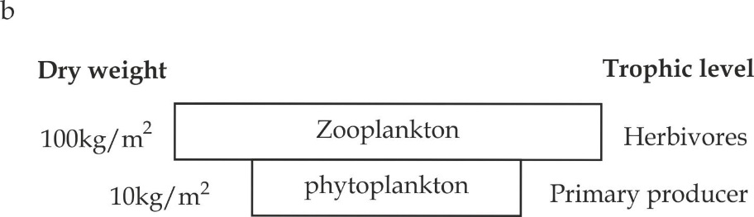

***Figure 6.8*** *Pyramid of numbers:*

1. *Grassland ecosystem and (b) aquatic ecosystem*

**Advantages of pyramid of biomass**

1. It gives a more accurate assessment or measure of energy at each trophic level since the judgement on the amount of energy is based on the dry mass.
2. It takes into account of the size difference of organisms, thus, overcoming limitations of using pyramid of numbers, this explains why it is known as the ***true pyramid***.

**Disadvantages of the pyramid of biomass**

1. It is difficult to obtain data, because it is impossible to measure the biomass of all individuals in a population.
2. It is difficult to construct, because it is more laborious and expensive in terms of time and equipment.
3. It is a destructive method, since it involves killing of organisms.
4. It does not indicate the rate of productivity.

***Pyramid of energy***

Pyramids of numbers and biomass provide to an ecologists with useful information. However, to get a fuller understanding of what happens in communities, pyramids of energy are often constructed. The ***Pyramid of*** ***energy*** represents the rate of energy flow per unit area at each trophic level. It is constructed by burning representative organisms at each trophic level. The pyramid of energy always tapers towards the apex because the energy normally decreases as it flows from one trophic level to another. Thus, the last trophic level receives a minimum rate of energy content at successive trophic level from the producers through the consumer’s results in the upright shape of the pyramid of energy that is never inverted as indicated in Figure 6.9.

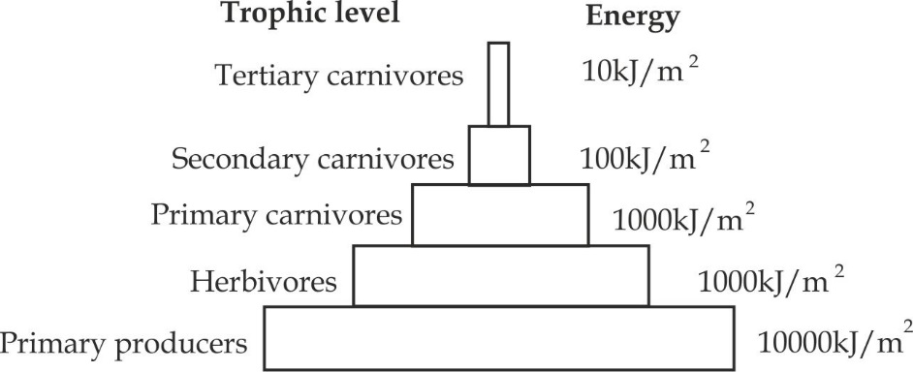

***Figure 6.9*** *Pyramid of energy*

**Advantages of the pyramid of energy**

1. No inverted pyramids are obtained, since the inverted pyramid indicates a community is about to collapse.
2. It allows comparison of relative importance of different populations within one ecosystem to be compared.
3. It is dynamic and therefore, it is likely to accommodate changes.
4. It considers the rate of productivity per unit area.

**Disadvantages of pyramid of energy**

1. It is difficult to obtain data because more measurements are required than for the pyramid of biomass.
2. It is a destructive method of obtain data, this is because it involves killing and combustion of the representative organisms in the population.
3. It is impossible to measure the energy content of all individuals in a given trophic level.
4. It is not easy to identify the organisms, trophic level with accuracy because many organisms feed at various trophic levels.

***SAQ 6.9***

***JECAS 2019***

* Describe the ecological pyramids; discuss the drawbacks of each ecological pyramid.
* Give reasons to why the ecological pyramids are tapered.

**Nutrients circulation**

In contrast to energy flow in ecosystems which passes through in one direction, nutrients are constantly recycled. ***Nutrients cycling*** describe the movement of elements within and between the various biotic and abiotic entities. These elements can be extracted from their mineral or atmospheric sources or recycled from their organic forms by converting them to ions that can be absorbed and ultimately returned to the nutrients pool.

In the ecosystem, when an organism dies, the decomposers such as bacteria and fungi act upon it, thereby setting free inorganic nutrients in the nutrient pool such soil and water. From the pool, nutrients are absorbed by plants to support them to grow, reproduce and multiply in numbers, from the primary producer, nutrients then go on passing into secondary, tertiary and finally top consumers, which then decompose them into the pool to make the cycle started again. The nutrients cycled, in this case, are from an organic origin, that is, unlocked in the bodies of dead organisms. Another common source and then fixed in organisms such as nitrogen cycle or carbon cycle.

***Carbon cycle***

The basic source of carbon for the living organisms is carbondioxide which is located in the atmosphere. Atmosphere, having a concentration of 0.031 percentage of carbondioxide, acts as its reservoir. Carbondioxide from the atmosphere is absorbed by plants and used for photosynthesis, during the photosynthesis simple sugar like glucose is normally synthesized which is subsequently converted into other organic compounds like polysaccharides, proteins and lipids. These are passed from plants (producers) to the herbivore and carnivorous animals (consumers). The respiratory activity of plants and animals return back fixed carbon as carbondioxide into the atmosphere. The excretory wastes of living organisms having accumulated carbon compounds and they after death and decomposed by microorganisms (decomposer) in the soil to release carbondioxide back into the environment. Burning of wood and fossil fuel, dissolution of carbonate rocks and volcanic activities, all release carbondioxide into the environment for its recycling as shown in figure 6.10.

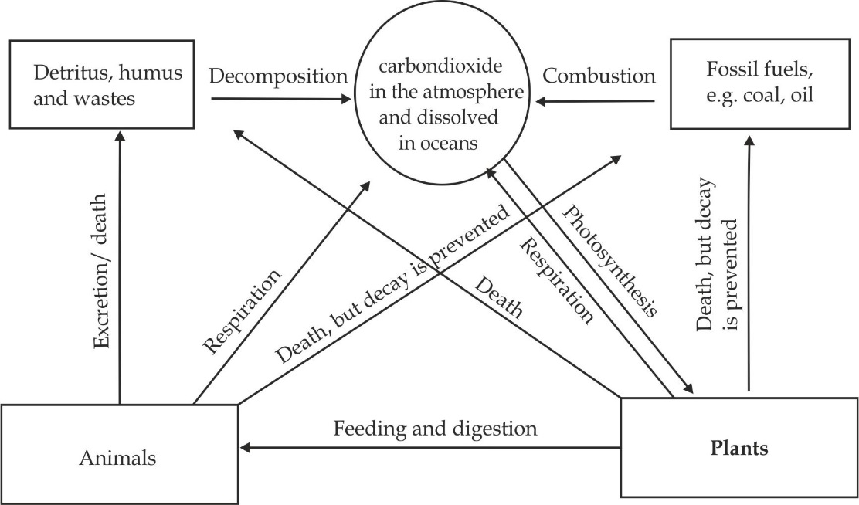

***Figure 6.10*** *the carbon cycle*

***SAQ 6.10***

***ST MARYS MAZINDE JUU 2002***

* Describe the cycling of carbon in a named ecosystem.

***Nitrogen cycle***

Of all elements that plants absorb from the soil, nitrogen is most important for plant growth. This is required in greatest quantity. Nitrogen is required for the synthesis of amino acids, proteins, enzymes, chlorophyll, nucleic acids etc. Green plants usual obtain nitrogen from the soil solution in the form of ammonium, nitrate and nitrite ions, but the main source of all these nitrogen compounds is the atmospheric nitrogen. The ultimate source of nitrogen to the ecosystems is molecular nitrogen in the atmosphere, which cannot be directly metabolized by plants or animals. Thus, all nitrogen accumulated in various ecosystems, is derived from the atmosphere by biological and physical processes. The important processes in the nitrogen cycle include nitrogen fixation, ammonification, nitrification and denitrification.

1. **Nitrogen fixation:**

The conversion of nitrogen gas into nitrates is carried out through biological processes. This process is affected by bacteria such as rhizobium, which live in the root nodules of leguminous plants.

1. **Nitrogen assimilation:**

The elemental or inorganic nitrogen cannot be assimilated by plants. They absorb nitrogen in the form of nitrate or ammonium ions, for instance, calcium ammonium nitrate fertilizer, which has first to be reduced to nitrate. This is then reduced to ammonia, the organic form of nitrogen. Ammonium will then be incorporated or assimilated into protein and other organic nitrogenous compounds such as amino acids, nucleic acids and chlorophyll.

1. **Ammonification:**

In leguminous plants such as beans, which have a symbiotic association with rhizobium, some nitrogen is assimilated directly from the nodules in the form of ammonium ions through a process known as mineralisation or ammonification. In this process, decomposers such as bacteria and fungi convert nitrogen with the remains of dead organisms back into ammonium ions.

1. **Nitrification:**

During nitrification there is a conversion of ammonium to nitrate by nitrifying bacteria such as nitrosomonas.

2NH4 + 202 N032- + 2H20 + energy

*Nitrobacter*

2N02- + 02 2N03- + energy

1. **Denitrification**:

Ammonium and nitrates are converted into free nitrogen by nitrobacteria such as pseudomonas. Denitrifying bacteria transform nitrate nitrogen to nitrous and nitric oxides, and ultimately to gaseous nitrogen, which goes to atmosphere as shown in Figure 6.11.

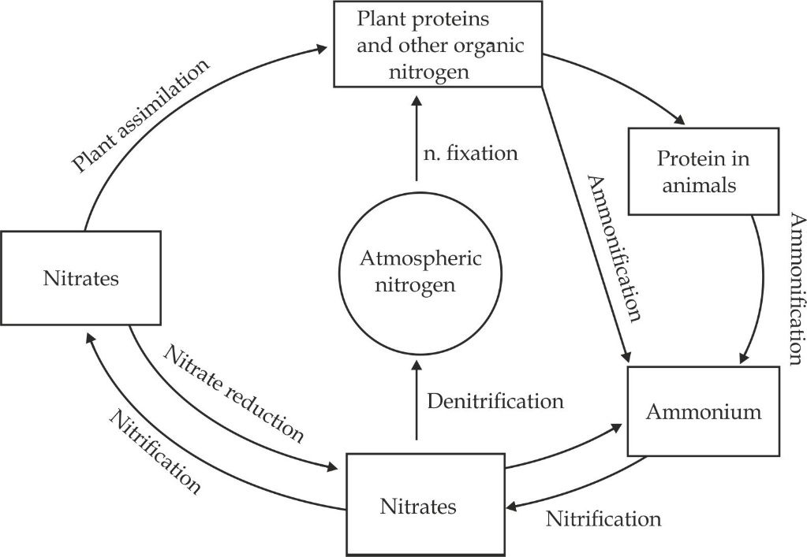

***Figure 6.11*** *Nitrogen cycle in ecosystem*

***SAQ 6.11***

***TAI QUESTION***

* Write short notes on the nitrogen cycle citing its significance in terrestrial ecosystem.

**6.4 BIOMES – THE MAJOR ECOSYSTEMS**

The largest ecosystem is the ***biosphere*** – Is the part of the planet earth which is inhabited by living organism, i.e. the life supporting atmosphere, seas and soils of the planet earth and organisms which live upon it. However, the biosphere is so large that it is very difficult to study as a whole. The biosphere

Is divided into ***biomes*** which are readily visible around the planet. A biome is a large area of the earth’s surface, which has particular climatic factors and characteristics flora (plants) and fauna (animals).

**Types of biomes and their global distributions**

The biomes are divided into seven major types depending on the climatic conditions and type of flora and fauna, which include – tundra, taiga, savannah (grassland), desert, tropical rain forest, temperate deciduous forest and chaparral as shown in Figure 6.12.

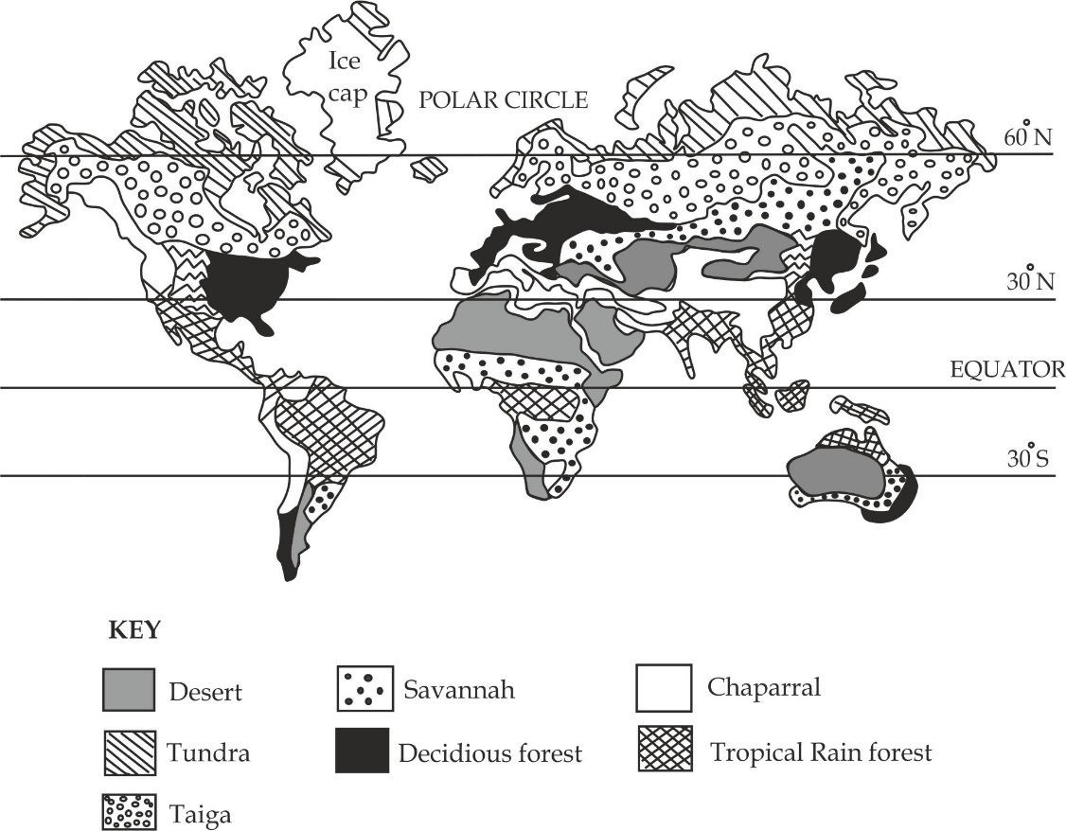

***Figure 6.12*** *the major biomes and their global distributions*

***Tundra – coldest biome***

The Arctic Circle, which is a circle that extends the 60 º North Pole, i.e. Northern America, northern Asia and northern Europe.

Extremely low temperature ranging between – 34 º C to 12 º C and low precipitation (rainfall), i.e. less than 250 mm/ year.

It consists of treeless plains with grasses as shown in Figure 6.13 with lichens and mosses.

The most abundant are larger herbivores of this biome are reindeer and wolves.

**Geographical location**:

**Climatic conditions**

**Dominant flora**:

**Dominant fauna**

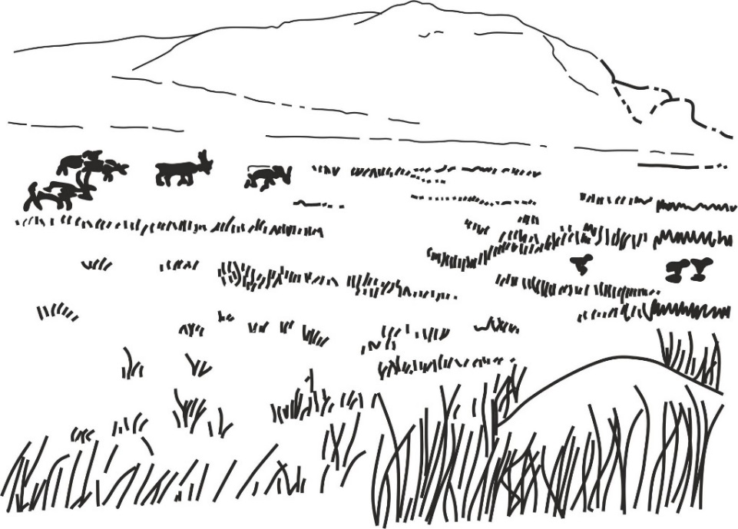

***Figure 6.13*** *Tundra biome with grasses*

***Boreal forest (taiga/ coniferous forest****)*

This is the largest biome on the earth located on the southern border of the arctic tundra, i.e. North America, Canada, USA, N. Europe and Asia.

Very cold temperature but relatively less severe compared to tundra biome and heavy rainfall (precipitation) of about 650mm .The climatic conditions and acidic nature of the evergreen needles meddles make the soil more acidic after decomposition.

They have needles shaped trees such as pine family such as coniferous sprue and balsam as shown in Figure 6.14.

Animals with thick coat of fur to survive cold such as Wolves, bears, deer’s

**Geographical location**:

**Climatic conditions**

**Dominant flora**:

**Dominant fauna**

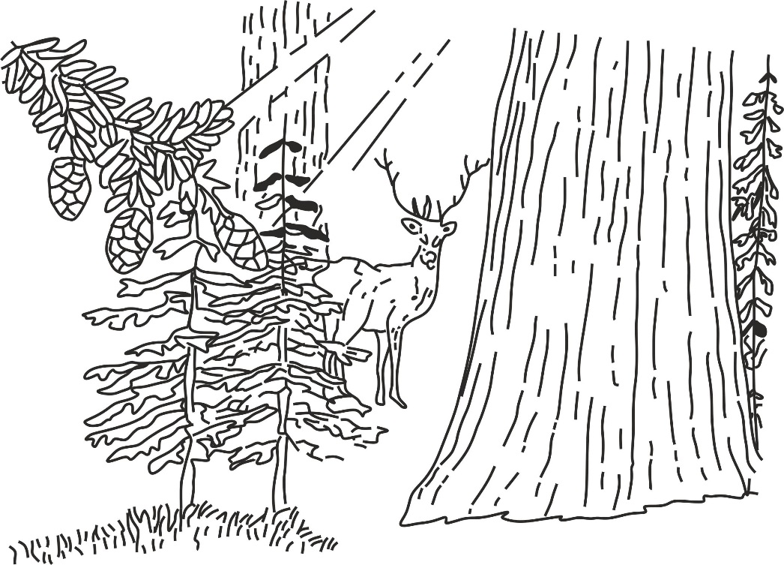

***Figure 6.14*** *Boreal forest with evergreen needle – like leaves*

***Tropical savannas***

It is located between the tropic of cancer and tropic of Capricorn, especially they cover S. America, largest part of Africa, largest area of Australia and India.

Worm temperature and low rainfall ranging between 500 – 900 mm / year.

The dominant flora are grasses and drought tolerant – fire resistant tree of shrubs as shown in Figure 6.15.

The dominat fauna are:

* Elephant
* Giraffes
* Antelope
* Zebra

**Geographical location**:

**Climatic conditions**

**Dominant flora**:

**Dominant fauna**

* Lions
* Leopard
* Rhinos

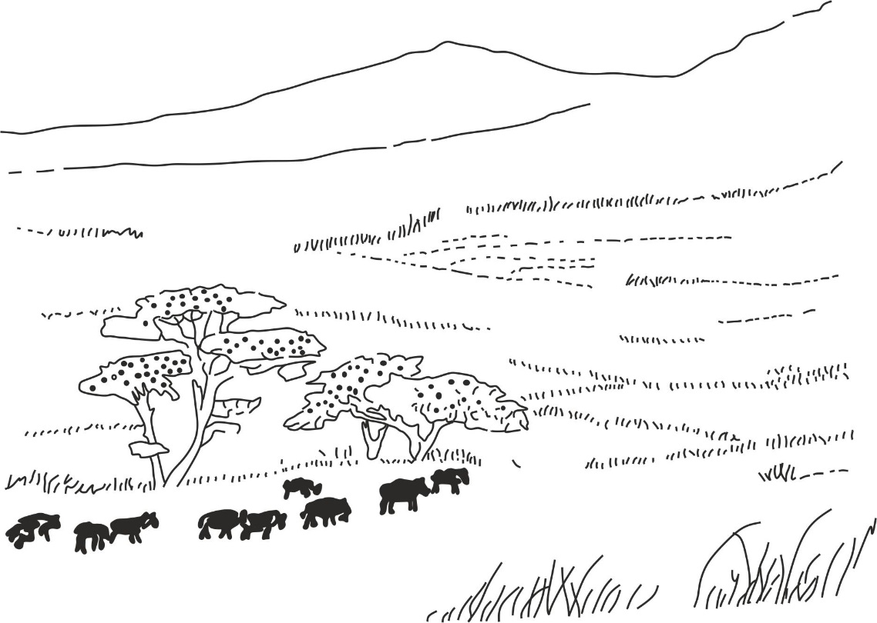

***Figure 6.15*** *Savannah biome in Africa*

***Temperate shrubland (chaparral)***

It is located southwest coast of United States on the west Coast of Chile, in countries bordering Mediterranean Sea, and along the southern coast of Australia.

The chaparral biome is similar to desert biome by both being hot and dry climate but it differs from desert biome by receiving relatively more rainfall per year.

The dominant vegetation are the fire resistant evergreen shrubs which are re – sprout in winter season as it rains as shown in 6.16.

Reptiles such as snakes. Lizards, tortoise and herbivores such as mice, squirrels, rabbits.

**Geographical location**:

**Climatic conditions**

**Dominant flora**:

**Dominant fauna**

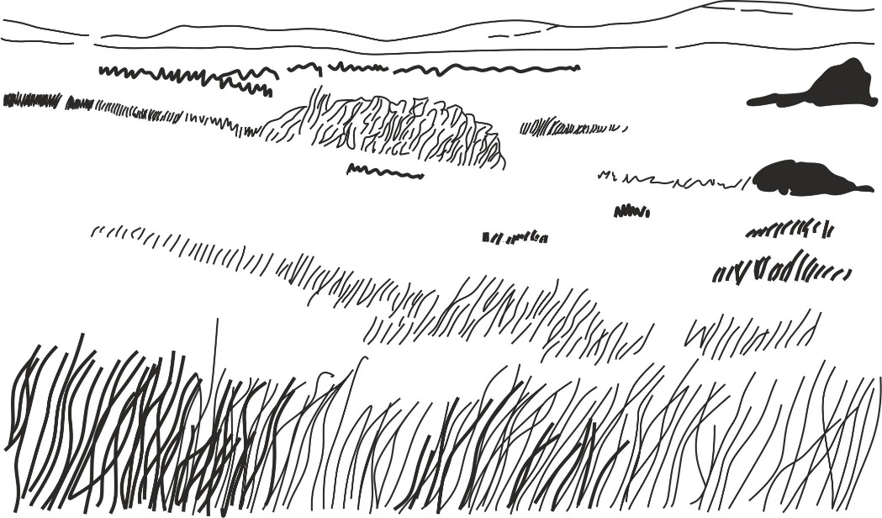

***Figure 6.16*** *Temperate shrubland (Chaparral)*

***Desert – sandy or rocky biome***

**Hot desert**: southern part, W. part of USA, In Africa, Sahara in the northern part which covers countries such as Chad, Algeria, Libya, Sudan, Egypt, Niger,Tunisia,Kalahari in Namibia and Botswana. In Middle East cover Saudi Arabia, Oman, south Yemen, S. Pakistan, and S. Afghanistan Australia cover Great Sandy Desert in Western Australia and The Great Victoria Desert in S. Australia.

**Cold desert**: Iran and Turkey

Hot days and cold at night.

Cactus as shown in Figure 6.17.

The dominant fauna are:

* Reptiles such as tortoise, rattlesnakes and lizards.
* Birds such as owl, hawk.
* Herbivores such as camels

**Geographical location**:

**Climatic conditions**

**Dominant flora**:

**Dominant fauna**



***Figure 6.17*** *Desert biome*

***Temperate deciduous forest***

**Geographical location**:

**Climatic conditions**

**Dominant flora**:

**Dominant fauna**

In south America occurs in Argentina; In Europe on the eastern part and Australia is found on the North – west coast between Brome and Onslow.

Warm in summer and snow in winter and high rainfall 500 – 1500 mm/year.

Tree shed leaves as shown in Figure 6.18.

Salamander, Black hear and Fox.

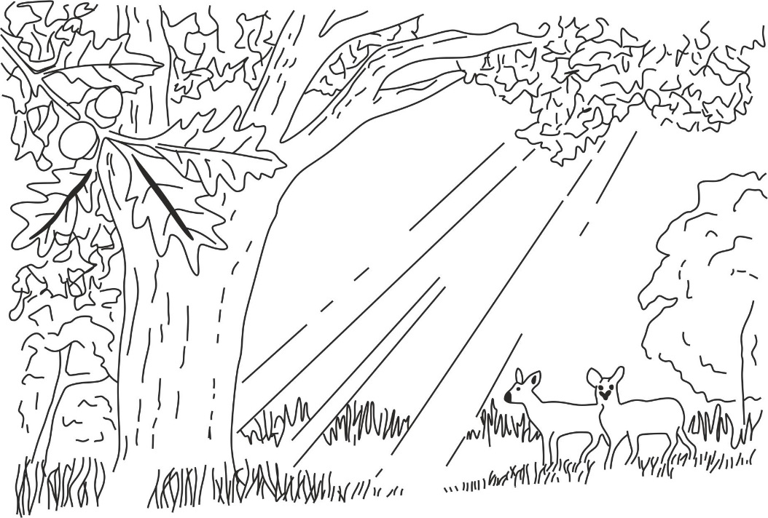

***Figure 6.18*** *Temperate deciduous forest*

***Tropic rain forest***

**Geographical location**:

**Climatic conditions**

**Dominant flora**:

**Dominant fauna**

The tropic rain forests are located in the equatorial region. They cover the lowlands of the humid tropics of Africa, central and South America, southern Asia, and the islands of Indonesia.

Warm temperature ranging from 20 º C to 34 º C and the humidity is relatively low. The annual rainfall is high and commonly exceeds 2000 mm

The broad leaved evergreen trees and large woody vines and climbing plants as shown in Figure in Figure 6.19.

Fauna in this biome includes predators such as jaguars; the herbivores such as antelopes, gazelles and giraffes; mammals such as monkeys; amphibians such as frogs; insects such as butterflies and beetles and ants.

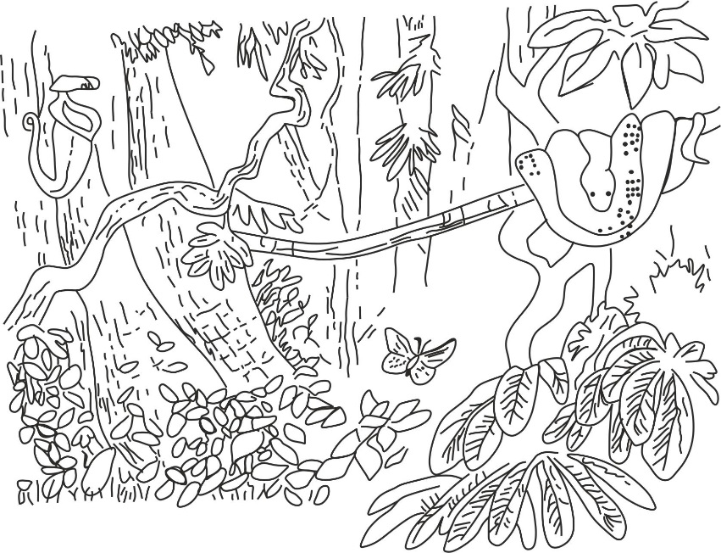

***Figure 6.19*** *Tropic rain forest*

***SAQ 6.12***

***NECTA 2016***

* Describe main types of communities (biomes) and their global distribution.

**6.5 ECOLOGICAL SUCCESSION – HOW ECOSYSTEMS EVOLVE**

The major biomes just described are the result of processes occurring over long stretches of time, changing the original bare rock of the earth into the ecosystems of today. This change has been brought about by ***succession –*** A series of progressive directional and accumulative changes through which the structure of a biological community evolves over time. During this process, there is series of gradual replacement of one community by another, until a dynamically stable community or equilibrium is established. New communities are usually started by plant species known as ***pioneers***. These plants interact with the abiotic environment and thus change the habitat. Other organisms, both plants and animals, then enter the community which passes through stages in a succession known as ***sere*** until finally a stable community is reached. This is known as the ***climax***. There are two main types of succession, ***primary succession*** and ***secondary succession***, which we shall go on to look at in more detail.

***Primary succession***

Primary succession is an ecological succession which occurs in a newly formed area where no life previously existed, i.e. it occurs in areas that have never been inhabited by vegetation. Primary successions are usual named according to the conditions in which they start, A succession beginning on a very dry substratum, such as bare rock, sand dune or cooled volcanic lava, is a ***Xerosere*** , the pioneer plants are described as ***xerophytes.*** A succession that begins with water is called a ***hydrosere***. The pioneer plants are described as ***hydrophytes***.

**Mechanism of primary succession in a bare rock**

The first stage in primary succession is colonization and establishment of primary colonizers or pioneers which are called lichens (algae and fungus), fungal hyphae inhabit bare rock surfaces and release chemicals that enhance disintegration and formation of cracks as the result hyphae penetrate and absorb water and minerals from the soil to algae and algae use them to manufacture food and produce it to the fungus. The second stage in primary succession is characterized by arrival of increasing plants called early colonizers; due to weathering of rocks and dead of lichen soil will be formed, which will support the growth of mosses. Finally as the species continue the disintegration of the rocks and increase organic matter as they decay, this builds up a thicker layer of soil and creates a relatively more condusive environment; eventually, the mosses will be replaced by grasses, ferns, shrubs, small trees set in and progressively tall and long lived trees (forest) ultimately established themselves as shown in Figure 6.20.

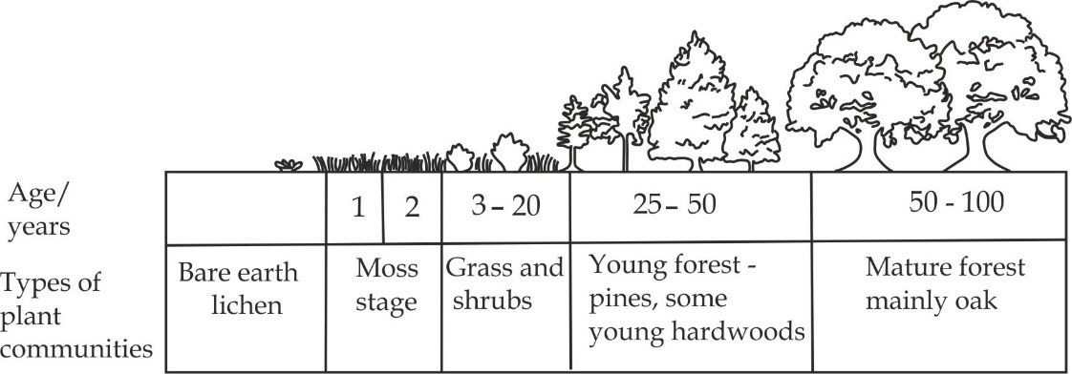

***Figure 6.20*** *Primary ecological succession*

***Secondary succession***

Secondary succession is a type of succession which takes place in an area in an area in which life is already existed but has been altered to certain degree by firing, flooding or ploughing.

**Mechanism of secondary succession**

A classic example of secondary succession is seen in a fresh cleared by rampant fires. Since the disturbed area already has nutrients rich soil, it is recolonized much more quickly than a bare rock as in primary succession. Due to fire, most trees do not sprout back immediately. The first plants to grow back during secondary succession usually are annual plants; within few years, an influx of the quickly growing and spreading grasses occur. The growth of grasses and similar species over many years causes environmental changes that favour the growth of shrubs. Later all trees emerge and gradually increase in number. At this stage, the community starts to assume its previous state and with time it will regain its original pre – fire species composition. The secondary succession often takes not less than 150 years for the woodland forests as in Miombo woodlands .Unlike the primary succession that may take up to 400 years or more to reach the climax, secondary succession may take up to 200 years to reach the stable climax.

***SAQ 6.13***

***NECTA 2014***

* Elaborate how primary and secondary ecological succession take place.

**6.6 HABITAT AND ECOLOGICAL NICHE**

An ecosystem can be divided up into various components. This individual organisms live in a small part of the ecosystem known as their ***habitat*** or if the area is very small, as a ***microhabitat***, when we refer to how an organism lives as well as plays their roles we are describing a ***niche***.

**HABITAT**

**Habitat** is a specific place or locality where an organism lives, habitat usually refers to a relatively large area, such as freshwater ponds, a forest, rock pools and ocean. If the area is extremely small we call it a **microhabitat**, For example, the insects that inhabit the crevices in the bark of a tree are in their own microhabitat. The conditions of microhabitats are likely to be very different in the surrounding habitat. For example, the conditions on the underside of a leaf, in a hedge for instance, will differ from those on the upper side, similarly the lower side of a stone in a stream will be markedly different from the top side. A particular microhabitat will support certain organisms but not others, as you can easily see for yourself by turning over a fallen long in a wood.

**ECOLOGICAL NICHE**

**Ecological niche** the term “*niche*″ was first introduced by ***Grinnel (1971)***. Each species of a community lives in a very specific part of a habitat and performs certain functions. The habitat together with the functions of a species is called *niche* or *ecological niche* of the species. In other words, the concept of niche involves food relations, predators, tolerance level to the physical factors and other habits of a particular species. Each species within a community has a separate ecological niche. No two species within a given community can have exactly the same niche and live permanently together. In such case, there would be a direct competition with each other till one eliminates the other. It is due to competitive exclusion (***Gauses hypothesis***). If two species are found in the same space, it is sure. That they have different niche, a famous example of competitive exclusion principle involve tow species of paramecium, which is *P, candatum* and *P. aurelia.* When raised separately in the laboratory, both species will thrive, but when raised in the same test tube (habitat), with fixed amount of nutrient, both will grow more poorly and *P. aurelia* will eventually out compete *P. caudatum* for food leading to death of *P. caudatum.* There are two types of niches, namely; ***Fundamental*** and ***realized niches***. *Fundamental niche* of the species includes the total range of environmental conditions that are suitable for existences without the influence of interspecific competition or predation. In other words, it is the potential niche that would prevail in the absence of competition and other factors that might constrain it acquisition and use of the resources.  *Realized niche* describes the part of the fundamental niche, which is actually occupied by the species. This is the actual niche, which an organism occupies as a result of competition for its resources and problems in acquiring those resources. The realized niche is smaller than the fundamental niche.

**Table 6.3 Differences between habitat and niche**

|  |  |
| --- | --- |
| **Habitat** | **Niche** |
| Habitat is a specific place or locality where a community lives. | Niche is an ecological component of habitat in which the species live and play their roles. |
| A habitat has a number of niche | A niche does not have components |
| It supports number of species | It supports a single species |
| Number of environmental variable occur in a habitat. | Niche has a specific set of variable |

***SAQ 6.14***

***MAZINDE JUU***

* Differentiate between habitat and niche

**6.7 POPULATION DYNAMICS**

An individual usual cannot live in isolation in nature. The individual is often associated with other individual organisms of its own kind for survival and perpetuation of its species. All the individuals of a species occurring in a locality constitute a population. Thus in ecology ***population*** is a group of individuals of the same species, inhabiting the same area and functioning as a unity of biological community. Individuals of the same population can interbreed to produce fertile offspring, different population constitute a community. For example, the population of elephants in Mikumi national or population of lions in Serengeti national park. The increase in the actual number of organisms in a population is called ***population size***; this can be affected by natality (birth), mortality (death), Immigration or emigration. The maximum reproduction rate of a population under ideal conditions, is called ***biotic potential***. To reach its biotic potential a population must have all of the food, water and space it needs to survive. It also needs a climate and the absence of competitions and disease. However, populations do not reach their biotic potential due to ***environmental resistance*** – the combination of biotic and abiotic factors that limit population growth. The study of how and why these factors occur in a population is called ***population dynamics***.

In population dynamics the following aspects should be discussed:

* Factors which regulate population size
* Population growth patterns.
* Survivorship curves
* Population explosion and their consequences
* Pollution
* Biological control of population
* Methods of estimating population size

**6.7.1 Factors which regulate population size**

These are also known as factors which regulate population distribution, these factors can either be ***density dependent*** and ***density independent factors***.

1. **Density dependent factors – Biotic factors**

These are factors that decrease population size when population density increases, they are referred to as density – dependent because their factors effects depending on the density of population. For example, it includes all biotic factors (living factors) which includes, predation, diseases, competition and parasitism.

1. **Competition**

Competition among individuals seems to be the major biotic factor determining the population growth and distribution. The competition may be directly for resources such as sunlight, food or minerals or it may be for space, net sites or mates. If competition occurs between organisms for the limited resources such as food, usually the weaker species may not survive or reproduce or leave the areas, hence affect population growth and distribution. However, if the resources are plentiful and there is no competition for them, the numbers of individuals will increase more quickly.

1. **Predation**

The presence of organisms that prey on or parasites a particular species may play a crucial role in the regulation of population size. If predation occurs between organisms, usually prey will not survive or leave the areas, hence affect population growth and distribution, many parasites do not kill their host, whereas predators do.

1. **Diseases and pest**

Diseases and pest slow down the growth and reproductive rate of an organisms within a population hence limiting their population growth and distribution. Diseases are more a problem in large populations because disease can spread easily from one individual to another, especially epidemic outbreak such as covid 19 and ebora.

1. **Density independent factors – Abiotic factors**

These are factors which decrease population size regardless of population density. They are referred to as density – independent because their effect do not dependent on the density of population. For example, it includes all abiotic factors (non-living factors) which are:

1. **Availability of water**

The availabity and quantity of water is essential for survival of living organisms. The availability of water will favour high reproduction and immigration of other organisms from place where such resources are scarce. This will lead to rapid population growth or increase in population size; on the other hand, their shortage slow reproduction, increase mortality and emigration hence limiting the population growth or reducing population size.

1. **Availability of food**

Adequate of nutrients favour high reproduction (natality) and immigration of other organisms from places where such resources are scarce. This will lead to population growth or increase in population size. In contrast, insufficiency amount of food leads to competition, emigration, slow reproduction and high mortality of organisms hence limiting the population growth or reducing population size.

1. **Sunlight**

Sunlight quality, quantity and duration affect much of the plant population because they depend on light for photosynthesis, when sunlight is sufficient plants will reproduce, thrive hence leading to population growth. In contrast, when *sunlight* is poor and inadequate plants compete and others dies hence limiting population growth or reducing population size.

1. **Weather**

Weather conditions such as temperature, wind rain, humidity affect much the population growth of populations at a given habitat. Every species is able to survive within a range of each of these factors. This is called the species tolerance range; near the upper or lower limit of the tolerance range, individuals experience stress. This will reduce their health and rate of growth and reproduction and even cause emigration hence limiting population growth. The largest and healthiest population of a species will occur when conditions are within the optimal range.

1. **Natural disasters**

Natural disasters such as earthquakes, volcanic eruption, drought, hurricanes, tsunamis and volcanic eruption cause drastic changes in the environment leading to the destruction of the resources and even may cause deaths of members of a population hence limiting growth of population.

1. **Availability of shelter**

Shelter may be for protection against predation or physical factors such as excessive heat. Availability of living space and shelter favours high natality and immigration consequently leading to increase in population size, however, shortage of living space and shelter leads to competition, emigration and high mortality of living organisms hence limiting the population growth or reducing the population size.

***SAQ 6.15***

***NECTA 2016***

* Explain how different abiotic (living) factors affect population distribution.

**6.7.2 POPULATION GROWTH PATTERN**

Experimental data obtained from studies in the growth patterns of different groups of organisms reveals two basic growth patterns. These are J – shaped or exponential growth pattern and S – shaped or sigmoid growth pattern, also called logistic growth pattern.

***J – Shaped growth pattern***

It is a type of growth curve in which population continuous to grow to the absence of environmental resistance such as no shortage of food, no predator and no any type of competition as shown in Figure 6.21. This growth curve is called exponential because the population will grow exponentially doubling for each unit of time, i.e*. 2, 4, 8, 16, 32* until reaches the maximum rate. J – Shaped growth curve is very rare in natural population due to environmental resistance.

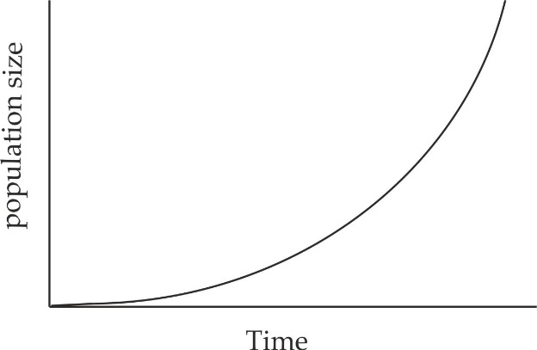

***Figure 6.21*** *exponential growth curve*

***S – Shaped growth curve***

It is a type of growth curve is a type of growth curve in which a population continues to grow until it reaches the carrying capacity due to the presence of environmental resistance, the maximum population size a particular environment can support, is called the carrying capacity. Therefore, in reality because resources are limited, the growth patterns of organism is S – shaped or sigmoid curve. There are an S – shaped curve which are:

1. **Lag phase:**

At this stage the population size will initially increase slowly in a positive acceleration because the number of reproducing individuals is still adapting the environment.

1. **Exponential or logarithm phase**

In this phase there is a rapid increase in the population as in J – shaped curve, because, there is no environmental resistance, individuals are well adapted to their environment, the natality is higher than mortality and the number of reproducing individuals is large.

1. **Decline phase**

Lastly, growth rate is decelerating. This occurs as the environmental resistance sets in, leading to increased mortality than natality. Eventually, the growth rate reaches a stable equilibrium phase where it levels off as the mortality equals natality as shown in Figure 6.22. This is called a ***zero*** ***growth rate*** phase which leads to population stabilisation. This point is known as the saturation value or carrying capacity of the environment for such organisms.

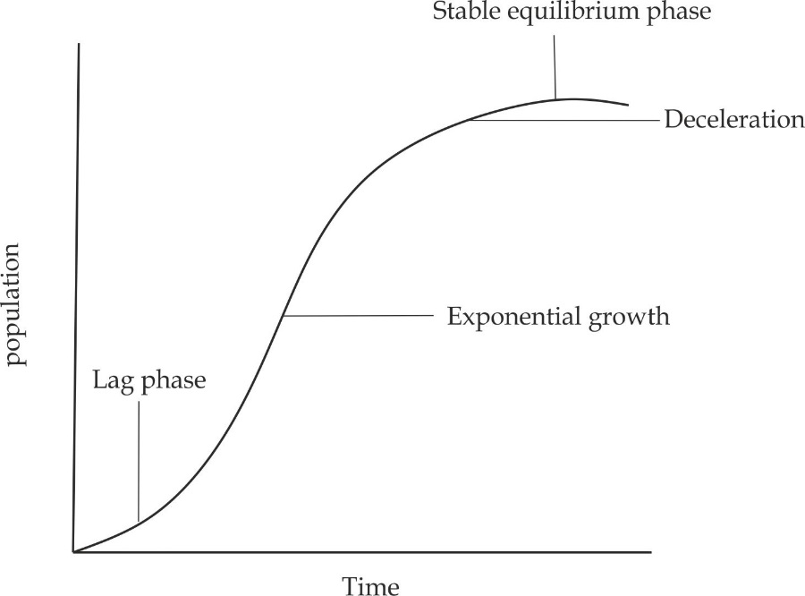

***Figure 6.22*** *the logistic growth curve*

***SAQ 6.16***

***PRE NECTA 2022***

* With the aid of illustrations describe the following:

1. Exponential population growth
2. Logistic population growth

**6.7.3 SURVIVORSHIP CURVES**

A survivorship curve is a graph showing the percentage number of survival at each age for a given species against time. Typically, the number of individuals of the population is plotted on the Y – axis of the graph and the age of survivorship is plotted on the X – axis of the graph. There are three types of survivorship curves and they simply referred to as type I, type II and type III.

**A type I survivorship curve** **– convex a**

It shows individuals that have a high probability of surviving through early and middle life but have a rapid decline in the number of individuals in surviving into late life. It represents the population with high mortality rate at late age. It occur in high developed countries due to advanced medicines, more food supply and less diseases.

**A type II survivorship curve - Diagonal b**

It shows a roughly constant mortality rate for the individuals through its entire life. It represents the population with constant mortality rate throught the life. In other words, type II curve is an intermediate between type I and type II. Type II survivorship curves are plotted as a diagonal line going downward on a graph. It occurs in moderate countries with moderate social services.

**A type III survivorship curve – concave c**

It shows the greatest mortality rate early on life. This type of survivorship curve is drawn as a concave on a graph and it occurs in developing countries due to poor social services.

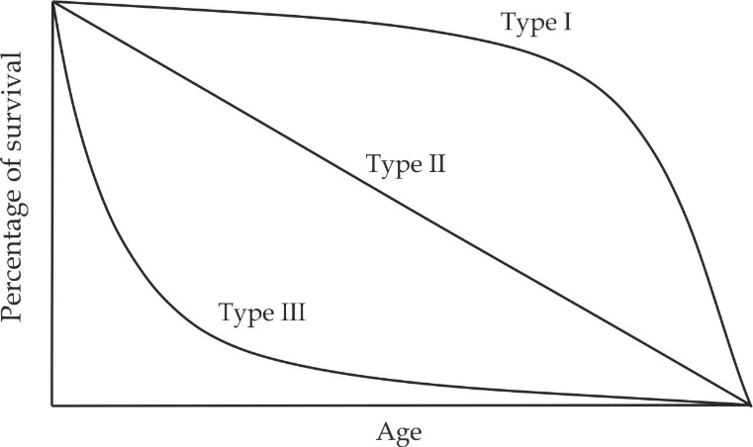

***Figure 6.23*** *survivorship curves*

**6.7.4 POPULATION EXPLOSION AND THEIR CONSEQUENCES**

Population explosion is an abnormal and rapid increase in population of a given area. The population explosion is due to increase food production and distribution, improved public services such as water, sanitation, improved medical technology and communication.

***Consequences of human population explosion***

1. **Increased chances for diseases outbreaks**

There is a rapid spread of epidemic diseases such as cholera and the chances of being infected increase with increased overcrowding.

1. **Increased chances for environmental degradation**

It leads to environmental degradation, as the population increases, forests are more extensively cleared to make place for *settlement* and uncontrolled agricultural practise such as cultivation in steep slopes, monocroping and overgrazing may lead to soil erosion.

1. **Overexploitation of the natural resources**

The earth can only produce a limited amount of environmental natural resources, population explosion leads to environmental exploitation such as deforestation, overgrazing, poaching and dynamite fishing.

1. **Rise in unemployment**

Overpopulation gives rise to unemployment as there fewer jobs to support large number of people. This leads to robbery, beggary, prostitution and murder. The terrorist activities that we find today in various parts of the world are the reflection of frustration among educated unemployed youth.

***Control measure of population explosion***

* Improvement of social services in rural areas so as to avoid urbanization.
* Encouragement of family planning.
* Discouraging bad traditions such as early marriage and polygamy.
* Provision of reproductive health care.

***SAQ 6.17***

***NECTA 2018***

* Define the term population explosion and explain three causes of it and State five main negative consequences of population explosion.

**6.7.5 POLLUTION**

Pollution is the addition of substances to the environment which have harmful, offensive and unwanted effects to living organisms. Pollution may affect any part of the environment such as air, water and land, therefore there are three main types of pollution. These are air pollution. Water pollution and soil pollution.

***Air pollution***

Air pollution is the addition of substances to the atmosphere which have harmful or poisonous effects to the living organisms. The major causes of air pollution are deforestation, burning of fossil fuels such as wood, charcoal, explosive in wars and natural causes such as volcanic eruptions.

**Common air pollutant**

The most common air pollutant or gaseous chemicals are;

1. **Oxides of carbon** such as carbondioxide *(CO2)* and carbonmonoxide *(CO)* primarily produced by cigarette smoking, automobile burning of fuels in horses or industries.
2. **Oxide of sulphur** such as sulphur dioxide *(SO2)* and sulphur trioxide *(SO3)* produced by burning coal or fossil fuels.
3. **Oxide of nitrogen** such as nitrogen monoxide *(NO)* and nitrogen dioxide *(NO2)* released by motor vehicles and particular fertilizers industries.

***Effects of air pollution***

Air pollution affects our health, our vegetation and climate.

**Effect of air pollution on human health**

Our health depends on the quantity of air we breathe in our immediate environment. Severe air pollution affects our health causing many fatal diseases and disorders, some of the effects caused by inhaling polluted air are listed:

1. Oxide of carbon and sulphur diffuse into the blood stream to combine with haemoglobin causing reduction in its oxygen carrying capacity, carbonmonoxide severely damages cardiovascular system and disturbs psychomotor functions.
2. Sulphur dioxide irritate to the respiratory system (bronchitis) drying of mouth, sore throat and eye irritation (conjunctivitis).
3. Dust, soot and smog cause several respiratory diseases such as bronchitis, asthma, emphysema and lung cancer, cotton dust produces lung fibrosis or pneumoconiosis. Pneumoconiosis also affect the coal miners and flour mill workers, Lung fibrosis produced in the workers of some other industries include asbestosis (asbestos industry), silicosis (stone grinding) and siderosis (iron mill).

**Effect of air pollution on vegetation**

1. Carbonmonoxide smoke deposit to the plant leaves which reducing photosynthesis by blocking stomata.
2. Sulphur dioxide reduces the growth of many plants.

***Effects of air pollution on climate***

1. **Global warming**

Is a gradual increase in earth’s surface temperature which result from increase in the concentration of the so – called greenhouses gases (*CO2*, *CH4, CFCs* and *N2O*) in the atmosphere due to human activities, the causes of global warming includes, burning of fossil fuels, eg. Factories, automobiles, deforestation which increase carbondioxide concentration to the atmosphere, overgrazing which cause methane emission from animals, explosive in wars and natural causes such as volcanic eruption. Ways to reduce global warming includes; reducing burning fuels by replacing with other energy sources such as wind, encourage afforestation and reducing overgrazing.

1. **Acid rains**

As the population increases, various industrial activities may lead to emission of gases such as *CO2*, *NO2* and *SO2* which combine with atmospheric water and result to acid rains. Acids rains affect metals and building, they also pollute soil and water.

***Control of air pollution***

Most kinds of air pollutions can be controlled by modern technology. However, the following measures can help to a great extent in keeping the environment free from air pollution:

1. The use of crude fuels should be avoided and the use of high quality fuels should be recommended. This will considerably reduce sulphur content and hydrogen carbons in the atmosphere.
2. The use of automobiles should be minimized which will reduce the nitrogen content in the atmosphere.
3. The use of efficient engines that can reduce the unborn hydrocarbons in auto – emission.
4. The industrial smokes must be filtered before releasing into the atmosphere.
5. The population growth which is supposed to be a major cause of pollution should be brought under control.
6. Nuclear explosions should be avoided.
7. Afforestation should be increased which will reduce carbondioxide content of the environment and make it pure by releasing oxygen.
8. Legal control of air pollution is also helpful in making the environment free from air pollutant to some extent.

***SAQ 6.18***

***DODOMA MOCK 2008***

1. i. What do you understand by the term global warming?
2. Briefly explain how it is caused,
3. What can you do as an individual to slowing down global warming?
4. Discuss how smoke and sulphur dioxide *(SO2)* in the polluted atmospheric air affect living organisms.

***Water pollution***

Water pollution is the addition of substances in the water have harmful effects to the living organism. The major causes of water pollution are the domestic sewage such as human faecal matter, animal wastes and industrial wastes such as nitrates and phosphates of detergents, pesticides, herbicides.

***Effect of water pollution in aquatic ecosystem - eutrophication***

The main effect of water pollution in water bodies is called ***eutrophication* –** It is the enrichment of excess nutrients like phosphate and nitrate in the water that stimulates the growth algae, a condition known as *algae blooms*. The main sources of nutrients are chemical fertilizers, Detergents and Industrial wastes.

**Effects of eutrophication**

* Turbidity increases.
* Anoxic conditions developed.
* Species diversity decreases.
* Rate of sedimentation increases.
* Plants, algae and animal biomasses increases.

**Problems of eutrophication**

* Difficult to treat water**.**
* The value of water may decrease.
* Commercial important species may disappear.
* Vegetation’s may impede water flow and navigation.
* Water may be danger to the life of living organisms.

***SAQ 6.19***

***KILIMANJARO MOCK 2018***

* Explain five (5) effects of eutrophication in the ecosystem.

**6.7.6 BIOLOGICAL CONTROL OF POPULATION**

Control of pest numbers with chemicals often has unfortunate consequences. An alternative is to use one species to control the numbers of another species. This is called ***biological control*** – is a method of population control by using a biological enemies such predators, parasites and pathogens.

**Examples of biological control**

|  |  |
| --- | --- |
| **Target** | **Control agent** |
| Snails | ducks |
| Rodents | cats |
| weed | Pig |
| Bittle | Caterpillar |

**Advantages of biological control**

1. It is specific to the target.
2. It reproduces itself, i.e. the small quantity is applied.
3. It has no pollution to the environment.
4. I t has no toxity to human.
5. It has no resistance.

**Disadvantages of biological control**

1. Time of action is slowly.
2. It is expensive.
3. It requires skilled labour.
4. It can lead to imbalance of ecosystem when predators overcome prey.

***SAQ 6.20***

***NECTA 1999***

* What is meant by biological control?
* What are the advantages and disadvantages of using biological control over the other methods of pest control?

**6.7.7 METHODS OF ESTIMATING POPULATION SIZE**

Population estimation methods include:

* Quadrant method
* Line transect
* Capture recapture method

***Quadrant method***

A quadrant is a square frame of metal or wood thrown randomly on the ground to count the total number of plant population in a given sample area as shown in Figure 6.24.

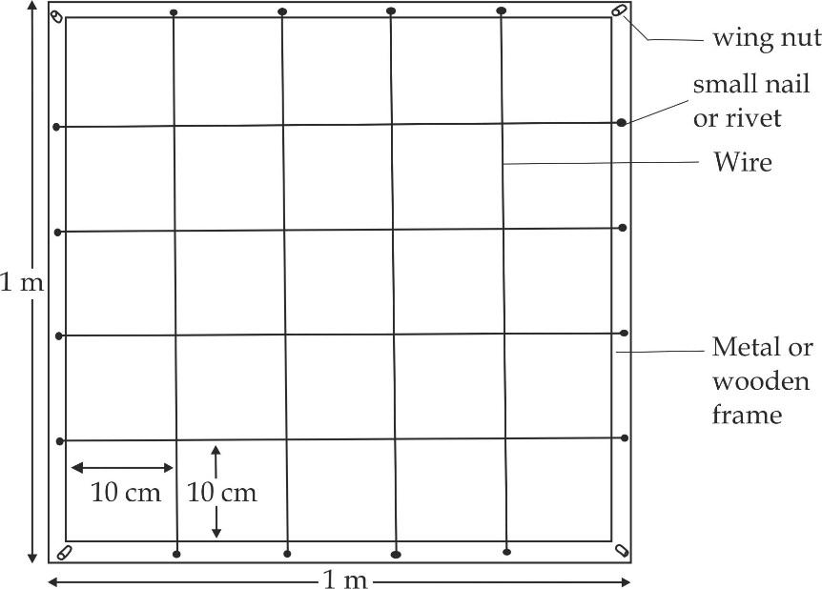

***Figure 6.24*** *a frame quadrant*

***Aspects used to estimate population by quadrant***

There are three aspects which are used to estimate the population size by quadrant, includes; species density, species frequency and species cover.

1. **Species density**

This refers to the number of individuals of a given species in a given area in each of the randomly thrown quadrants.

**Example;**

|  |  |  |  |  |  |  |  |  |  |
| --- | --- | --- | --- | --- | --- | --- | --- | --- | --- |
| **quadrant** | 1 | 2 | 3 | 4 | 5 | 6 | 7 | 8 | 9 |
| **organisms** | 0 | 5 | 0 | 10 | 2 | 1 | 6 | 0 | 12 |

**Advantages of species density**

1. It is accurate aspect of quadrant because it provides absolute measure.
2. It allows different areas and different species to be compared.

**Disadvantages of species density**

1. It is time consuming aspect.
2. It is used in small scale ecosystem.
3. It requires individuals to be defined.
4. **Species frequency**

This refers to the probability/ chances of finding organism in each of the randomly thrown quadrant.

**Example;**

|  |  |  |  |  |  |  |  |  |  |
| --- | --- | --- | --- | --- | --- | --- | --- | --- | --- |
| **quadrant** | 1 | 2 | 3 | 4 | 5 | 6 | 7 | 8 | 9 |
| **organisms** | 0 | 5 | 0 | 10 | 2 | 1 | 6 | 0 | 12 |

% species frequency = number of sampling units organisms occur x 100%

Total number of sampling units

From the above given data: 6 x 100%

9

**Advantages of species frequency**

1. It is not time consuming because it does not require counting of individual species but recording its *presence* or *absence* in the sample.
2. It is used in large scale ecosystem.

**Disadvantages of species frequency**

1. It is not accurate because it does not provide absolute measure**.**
2. It is affected by plant size and quadrant size.
3. **Species cover or species abundance**

This refers to the percentage of the ground occupied by the species in a given sample area.

**Advantages of species cover**

1. It is used to measure different species in a given community.

**Disadvantages of species cover**

1. It is very slowly
2. It is used to measure species in areas which organisms are hard to count.

***SAQ 6.21***

***NECTA 2001***

* Explain how a quadrant can be used to estimate population size with respects to the three aspects of species distribution namely; species density, species frequency and species cover.

***Line transect***

Line transects is a method which is used to count the number of plants distributed across a line or strip in a given ground. then the data along the length of the line randomly or systematically that touch or cover the line are recorded, at regular interval of say 10 cm as shown in Figure 6.25.It is the way in which we find out how the distribution of organisms varies across a habitat.

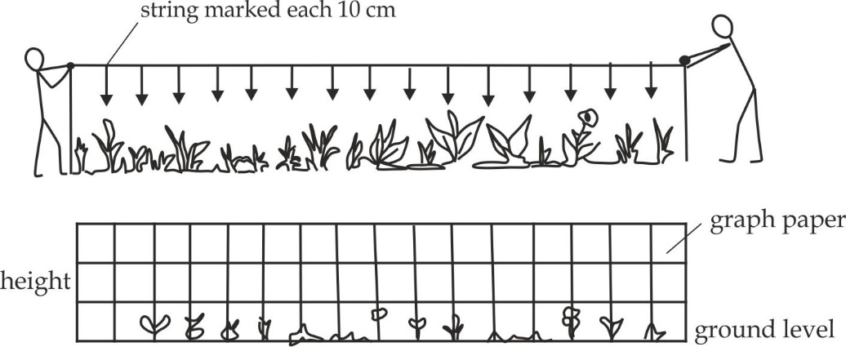

***Figure 6.23*** *line transects*

***Capture – recapturing method***

This refers to the method used to count the total number of individuals by capturing them in the same way without causing any damage and replace to the same area so that can resume a normal role in a population. It is usually used to estimate the population size of small mobile animals such as insects.

**Procedure for capture recapturing method**

1. Capture a first sample of individuals from a population.
2. Count a first sample of individuals and record as **n1.**
3. Marked all captured animals (Given them each an identified).
4. Release them back into the original population.
5. Provide enough time for released animals to remix with the whole population.
6. Capture a second sample of individuals from the same population.
7. Count a second sample of individuals and record as **n2**.
8. Count the number of marked recaptured individuals in a second sample and record as **n3.**
9. Use the following formula to calculate the number of population size called ***Lincoln index***:

N = n1 x n2

n3

N = Estimated population size

n1= Captured sample 1

n1= Captured sample 2

n3= recapture sample 2

**Assumption of Lincoln index**:

1. Individuals mix randomly within the population.
2. Sufficient time must elapse between capture and recapture to allow randomly mixing.
3. It is only applicable to population whose movement is restricted geographically.
4. Organisms must disperse evenly within the geographically area of the population.
5. Change in population as a result of immigration, emigration, birth and death are negligible.
6. Marking does not hinder the movement of organisms.

***SAQ 6.22***

***DAR JOINT***

* What is capture – recapture method.
* Outline seven procedures used to estimate population under capture – recapture method.
* Outline five assumptions of Lincoln index.
* In an attempt to estimate the number of grasshopper in a secluded area, 775 grasshopper were netted, marked and released. On the second day 1023 grasshopper were netted and of these 279 has been marked. What was the estimated size of the grasshopper population?

**Solution:**

N = n1 x n2 = 775 x 1023 = 2842

n3 279

The estimated size of the grasshopper population is 2842

**6.8 NATURAL RESOURCES AND CONSERVATION**

**Natural resources** are naturally occurring substances in the environment that are valuable in their relatively unmodified form. Examples are land, water, forests, minerals, petroleum and coal.

**Types of natural resources**

Basically, there are two types of natural resources, namely; *renewable* and *non-renewable resources*.

***Renewable natural resources***

These are natural resources that can be used without depleting its reserves. Examples are wind and solar energy.

***Non-renewable natural resources***

These are natural resources that can be depleted as they are used in excess. Examples are minerals and fuel.

**Sustainable use of natural resources**

This refers to the use of natural resources in a manner that do not endanger its availability in future.

**Advantages of sustainable use of natural resources**

1. It ensures availability of resources for future generation.
2. It maintains the balance of ecosystem.
3. It ensures the availability of habitat.
4. It ensures the availability of clean water supply.
5. It provides raw materials for industrial use.
6. It ensures availability of resources for economic development.

***SAQ 6.23***

***NECTA 2011***

* What are natural resources?
* Using relevant examples, describe the two main types of natural resources.
* Why is it wise to use environmental resources sustainably?

**Conservation of natural resources**

Environmental conservation is a phenomenon on which natural resources are kept away from harmful *destructive practises* thus preventing their depletion.

**Measure to be observed when conserving the environment**

1. **Education**

People should be educated to understand that it is the duty of every one to conserve our natural resources for the betterment of the country.

1. **Laws**

Government should make laws against those who destruct natural resources, example; wildlife conservation act No. 12 of 1974 with its 1978 amendment.

1. **Avoiding deforestation** (*conservation of forest)*
2. By reducing the number of livestock.
3. By reducing burning or cutting down trees.
4. By planting trees for future use.
5. **Avoiding land degradation** (*conservation of land*)
6. By cultivating along the contour lines, i.e. against the slope.
7. By efficient grazing.
8. By planting trees to prevent soil erosion.
9. By avoiding extensively mining.
10. **Avoiding water pollution** *(conservation of fish in lakes and ocean)*
11. By avoiding sewage disposal such as pesticides and fertilizers.
12. By avoiding agricultural activities near by the ocean or lakes.
13. By avoiding industrial activities nearby ocean or lakes.
14. By avoiding use of explosive/dynamite in fishing.

***SAQ 6.24***

***NECTA 2002***

* Discuss the main measure which should be observed when conserving the environment.

**Importance of conserving natural resources**

1. **Wildlife**
2. Provision of food such as meat from antelope.
3. Provision of raw materials for industrial purposes such as skin for making shoes and belt**.**
4. Provision of foreign currency through tourist attraction.
5. Addition of nutrients to the soil when organism dies or through faecal matter.
6. Provision of ornaments such as horns.
7. **Water**
8. For irrigation purposes.
9. For electrical purposes such as hydroelectric power.
10. For rain formation when evaporates.
11. For habitat of wild animals such as crocodiles.
12. For drinking.
13. For navigation**.**
14. **Forest**
15. Aid in rain formation.
16. Prevents soil erosion.
17. Habitat for wildlife animals.
18. Source of medicine.
19. Source of food such as fruits.
20. Provision of raw materials for industrial use such as timber for making papers and furniture’s.

***SAQ 6.25***

***PRE MOCK DAR 2018***

* As a member of the school biology club, you have been requested to conduct a lesson to form four students on conservation of natural resources. Discuss the points you would present to explain the:

1. Meaning of conservation.
2. Importance of conserving the following natural resources; wildlife, water and forest.

**6.9 METHODS OF STUDYING ECOLOGY**

The aim of studying ecology is to understand the existing relationship between organisms and how each in turn, interact with its environment. The aims and objectives of an ecological study will determine sampling methods and techniques to be employed.

***The concept of sampling***

Sampling is the process of selecting representative units from a group or population to be used as a basis for estimating the charactestics of a larger population. A sample may be defined as a small part, quantity, or group drawn from a larger population to represent the characteristics of the entire ecological studies.

**Advantages of sampling**

1. It saves time and cost as the size of the sample is small as compared to the population.
2. It is the only practical method for the infinite population.
3. Results may be very representative of the actual population.
4. It provides a detail and comprehensive information.

**Disadvantages of sampling**

1. Difficult of getting the representative sample, particular where the sample size is small.
2. Chances of committing the errors in sampling.
3. It needs expertise for careful sampling.
4. It provides the chances for bias in such a way that some members of the intended population are less likely to be included than others.

**Types of sampling technique**

There are three types of sampling technique in which members of the population have a known chance or probability of being selected, these are:

* Simple random sampling
* Systematic sampling
* Stratified random sampling

***Simple random sampling***

This is the probability sampling in which each member of the population has equal chances of being selected. It is usually carried out when the area under study is fairly uniform, very large and there is limited time available. When using simple random sampling technique, samples are taken from segments of the larger habitat. The computer – generated numbers or table of random numbers determine the sampling points and the samples are taken using a quadrant frame. The frame is placed on the ground and the animals or plants inside it counted, measured or collected depending on what the study is for. This is done many times at different points within the habitat to give a large number of different samples.

**Advantages of simple random sampling**

1. It needs only minimum knowledge of the study group of population.
2. It ensures a high degree of representativeness of the population.
3. It is totally free from bias because it ensures that each member is given equal opportunities of being selected
4. It is very easy to assess the sampling error in this method.

**Disadvantages of simple random sampling**

1. It cannot be employed where the population units are heterogeneous**.**
2. It is time consuming particularly, when dealing with large sample.

***Systematic random sampling***

Systematic random sampling is the type of probability sampling method whereby sample members from a large population are selected after a certain interval of time. The piece of data is chosen at a fixed interval, say after every 500 meters along the line for the inclusion in the sample. For example, if one has a population total of 100 individuals and needs 12 subjects, he /she then picks the starting number, say 5. If the interval which is picked is 8, then the numbers of the sample will be 5, 13, 21, 29, 37, 45, 53, 61, 69, 77, 85 and 93.

**Advantages of systematic random sampling**

1. It is simple to select sample and suitable sampling frame.
2. The method ensures an even sampling of the population.

**Disadvantages of systematic random sampling**

1. The sample may be biased if the process of selection can interact with hidden periodicity of the trait in population.
2. The method is more biased because not all members or points have an equal chance of being selected.

***Stratified random sampling***

The name stratified sampling derives its meaning from the term stratum (plural = strata), which means small subdivisions. Stratified sampling, therefore, is a probability sampling method in which a population is divided into two or more groups (strata) based on one or common characteristics. This method of sampling, therefore, intends to guarantee that, the sample represents specific subgroups or strata. The application of a stratified sampling method involves dividing populations into subgroups and selecting subjects from each stratum in a proportionate manner. In this way, the method may solve problems of simple and systematic random sampling.

**Advantages of stratified random sampling**

1. It ensures that each group is represented in the sample**.**
2. It is a flexible method and can be used to many areas and populations.
3. Correlations and comparison can be made between sub groups.
4. It can be used with random or systematic sampling and other methods of population study.

**Disadvantages of stratified random sampling**

1. It is tiresome and time consuming.
2. It requires large samples than other methods.
3. It requires more skills and technique than other methods.
4. Some individual’s in sub groups have no chance of being selected in samples.

***SAQ 6.26***

***TAHOSSA – NORTH EASTERN ZONE 2015***

* Explain the concept of sampling.
* Describe the methods of sampling.