**SECTION C: CLASSIFICATION**

At the end of this section, a student should be able to understand three main practical works:

1. Classification of famous specimens
2. Dichotomous key
3. Flower structure
4. **CLASSIFICATION OF FAMOUS SPECIMENS**

In this section; only three kingdoms are involved in practical work, since their specimens/ organisms are easily seen by our own naked eyes; these are:

* Kingdom fungi
* kingdom Plantae
* Kingdom Animalia.

1. **KINGDOM FUNGI**

Fungi are large group of organisms composed about 100,000 species. It is estimated that there are over 1 million species for identification. For many years they were classified with the plants but are now recognized as a separate kingdom.

**General features of kingdom fungi**

Fungi have both, animal and plant like characteristics:

**Fungi as animals**

Similar to animals fungi have the following features:

1. They store carbohydrates in the form of glycogen.
2. They are heterotrophs. Thus, they cannot manufacture their own food since they are either saprophytes or parasites.
3. They have centrioles for nuclear division.
4. They do not have chlorophyll.
5. They have chitin as a structural carbohydrate in the cell wall. This is a feature typical of animals such as arthropods; example, insects.

**Fungi as plants**

Similar to plants, fungi have the following features:

1. Their cells have cell wall.
2. They are non-motile.
3. They grow from the ground.
4. They reproduce asexually by producing spores.
5. Some fungi have vegetative bodies that are superficially differentiated into shoot like and root like systems.

**Taxonomy classification of kingdom fungi**

There are **three (3)** main phyla in kingdom fungi, namely; basidiomycota, zygomycota and ascomycota.

**Phylum basidiomycota**

This phylum normally consists of basidiomycetes which contain about 25 000 species. It is the most common and widely known phylum of kingdom fungi. This phylum got its name due to the presence of a characteristics club shaped structure known as basidia from which **basidiospores** are produced, which are characteristics sexual reproductive structures of basidiomycetes.

**Common organism**: Mushroom (Agaricus)

**Habitat:** Damp shaded places

**Class:** Agaricomycete

**Scientific name:** Agaricus compestris

**Mode of nutrition:** Saprophytism

**Mode of reproduction**: sexual by basidiospores and asexual by sporulation.

**Distinctive features of phylum basidiomycota**

Member of phylum basidiomycota have the following distinctive features that differentiate them from other phyla:

1. They have septate hyphae with distinctive pores.
2. They reproduce sexually by basidiospores inside the basidia.
3. They reproduce asexually by spore formation through sporulation.

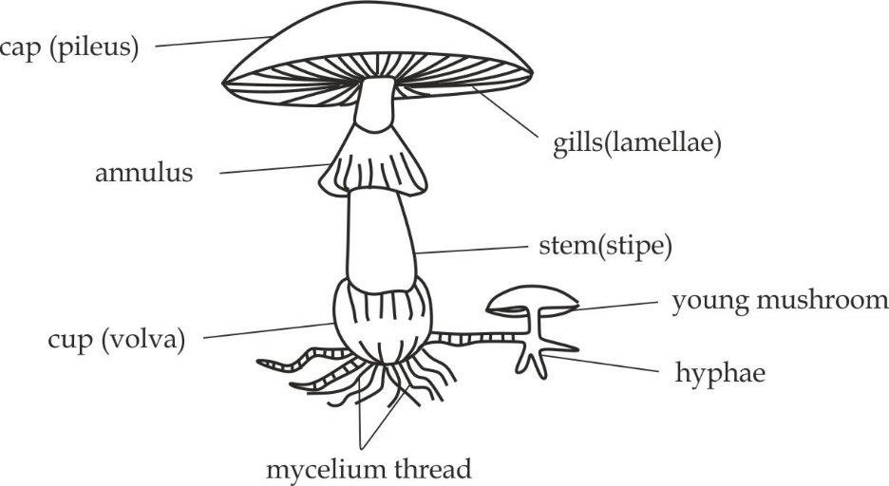

*Structure of an Agaricus compestris (mushroom)*

**Adaptation of mushroom (Agaricus) to its mode of life:**

Members of the genus Agaricus are adapted to saprophytic mode of life. The adaptations of Agaricus to its mode of life are as follows:

1. They produce larger number of spores to ensure its survival chances.
2. They produce light spores for easy dispersal by the wind.
3. They have cap which protects basidiospores which is situated on the long stalk for easy dispersal by the wind.
4. They have well developed hyphae for anchorage and absorption of the nutrients.
5. They produce larger number of enzymes for extracellular digestion.
6. They reproduce both asexual and sexual to ensure survival chances.
7. They are able to grow and survive on different substrata to increase chances of survival.
8. They store carbohydrates in the form of glycogen for use during shortage of food supply.

**Economic importance of mushroom**

1. They are source of food to human.
2. They are used in biological research.
3. They increase soil fertility.
4. They cause food poison and death to human such as Amanita species.

**Phylum zygomycota**

Fungi belonging to this phylum produce asexual resting spores called **zygospores**, which is produced when two opposite mating strains come close together and their haploid nuclei unite.

**Common organism**: Bread mould (Mucor)

**Habitat:** In dead organic matter especially in warmth such as bread.

**Class:** Mucormycotina

**Scientific name:** Rhizopus stolonifer

**Mode of nutrition:** Saprophytism

**Mode of reproduction**: sexual by conjugation and asexual by conidia.

**Distinctive features of phylum Zygomycota**

Member of phylum zygomycota have the following distinctive features that differentiate them from other phyla:

1. They have septate hyphae with no distinctive pores.i.e, they lack cross walls between adjacent cells.
2. They reproduce sexually by conjugation.
3. They reproduce asexually by spore formation inside the conidia.

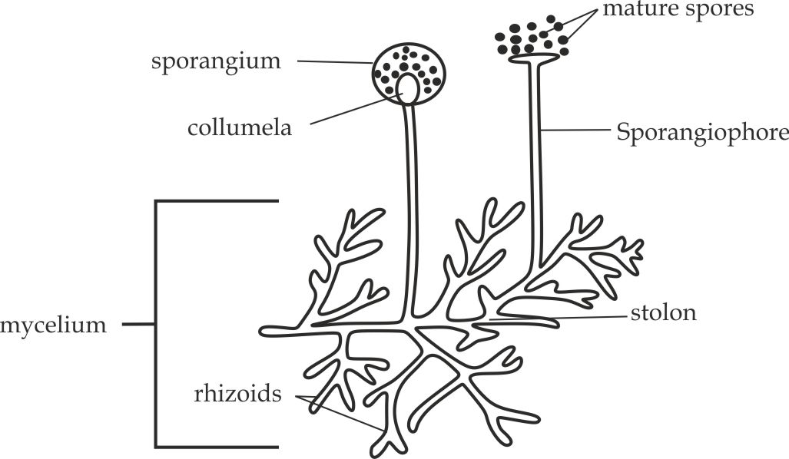

*Structure of a Rhizopus* (mucor)

**Adaptation of mucor (Rhizopus) to its mode of life:**

Members of the genus Rhizopus are adapted to saprophytic mode of life. The adaptations of Rhizopus to its mode of life are as follows:

1. Pressure in collumela makes the sporangium burst to release haploid spores.
2. They produce light spores for easy dispersal by the wind.
3. They produce larger quantity of spores to ensure survival chances.
4. They have sporangium situated on the long sporangiophore assisting in wind dispersal.
5. They have well developed hyphae for anchorage and absorption of nutrients.
6. They produce large enzymes for extracellular digestion.
7. They reproduce asexual and sexual to ensure survival chances.
8. Their hyphae show chemotropism; in response to the digested food.

**Economic importance of mucor:**

1. They are used in scientific studies as specimen.
2. They are used in scientific research because they have high rate of reproduction.
3. They increase soil fertility by decomposing organic matter.
4. They ensure energy flow and nutrients circulation.
5. They are used in sewage treatment to convert harmful products into harmless.
6. They cause spoilage of food.

**Phylum Ascomycota**

These are ascocarp forming fungi. The ascocarp are cup like structures that containing small sacs which produce spores known as **ascospores**, resulting from sexual reproduction.

**Common organism**: Yeast (saccharomyces)

**Habitat:** Decaying organic matter.

**Class:** Hemiascomycetes

**Scientific name:** Saccharomyces cerevisiae

**Mode of nutrition:** Saprophytism

**Mode of reproduction**: sexual by ascospores and asexual by budding.

**Distinctive features of phylum Ascomycota**

Member of phylum ascomycota have the following distinctive features that differentiate them from other phyla:

1. They have aseptate hyphae.
2. They reproduce sexually by ascospores inside ascocarp.
3. They reproduce asexually by budding.

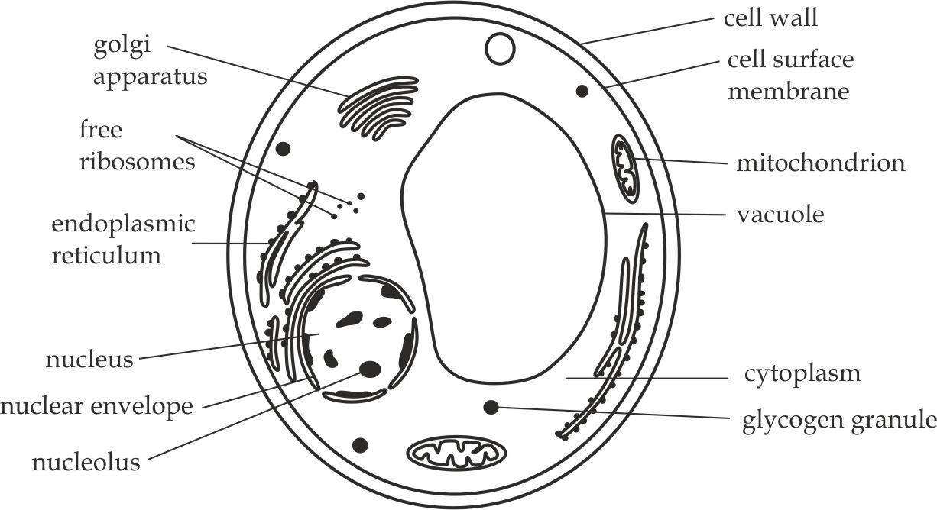

*Structure of saccharomyces (yeast cell)*

**Adaptation of saccharomyces to its mode of life**

Saccharomyces species have the following adaptive features that enable them suit to their mode of life:

1. They have cell wall and membranes permeable to soluble food.
2. They store carbohydrates in the form of glycogen for use during the shortage of food supply.
3. They have large number of enzymes for extracellular digestion.
4. They respire anaerobically hence can survive in the very low oxygen tension environment.
5. They have centrioles that aid in cell division.
6. They have high reproductive potential through budding to increase survival chances.
7. Ability of the spores to remain dormant in the unfavorable conditions to ensure survival chances.

**Economic importance of yeast**

1. They are mainly used in brewery industries for manufacturing of beer.
2. They are used in backery industries to raise dough.

**ECONOMIC IMPORTANCE OF MEMBERS OF KINGDOM FUNGI**

1. Some members of kingdom fungi such as *Agaricus species* are source of food to human being.
2. Some members of kingdom fungi are used in the production of medicines such as penicillin from *peniccilium species.*
3. Some members of fungi such as yeast are used in fermentation to produce alcohol.
4. Some members of kingdom fungi such as *saprophytic species* are used in biological control as they obtain their food by destroying other organisms like amoeba and nematodes.
5. Some members of fungi such as *Gibberella fujikuroi* are used as a source of phytohomes.
6. Some members of fungi such as *Neurospora* are used in biological research.
7. **KINGDOM PLANTAE**

Plants can all be broadly defined as the multicellular, eukaryotic and photoautotrophs.

**General characteristics of kingdom Plantae**

1. They possess green pigments called chlorophyll for photosynthesis.
2. They have cell wall made up with cellulose.
3. They store carbohydrates in the form of starch.
4. They have localized growth.
5. They possess large central and permanent cell vacuole in their cells.
6. They have alternation of generation in their life cycle.

**Divisions of kingdom Plantae**

There are four (4) main divisions in kingdom Plantae, namely; brophyta, filicinophyta, Coniferophyta and angiospermtophyta.

**Division Brophyta**

They are the most primitive terrestrial plants.

**General characteristics of division bryophyta**

Bryophytes possess the following features which differentiate them from members of other divisions:

1. They do not have true roots, leaves or stems.
2. They lack vascular tissues such as xylem and phloem.
3. They have roots like structures called rhizoids.
4. They have alternation of generation in their life cycle, with the dominant gametophyte generation.

**Common organism**: Moss plants (Funaria)

**Habitat:** Damp shaded moist places

**Class:** Musci

**Scientific name:** Funaria hygrometrica

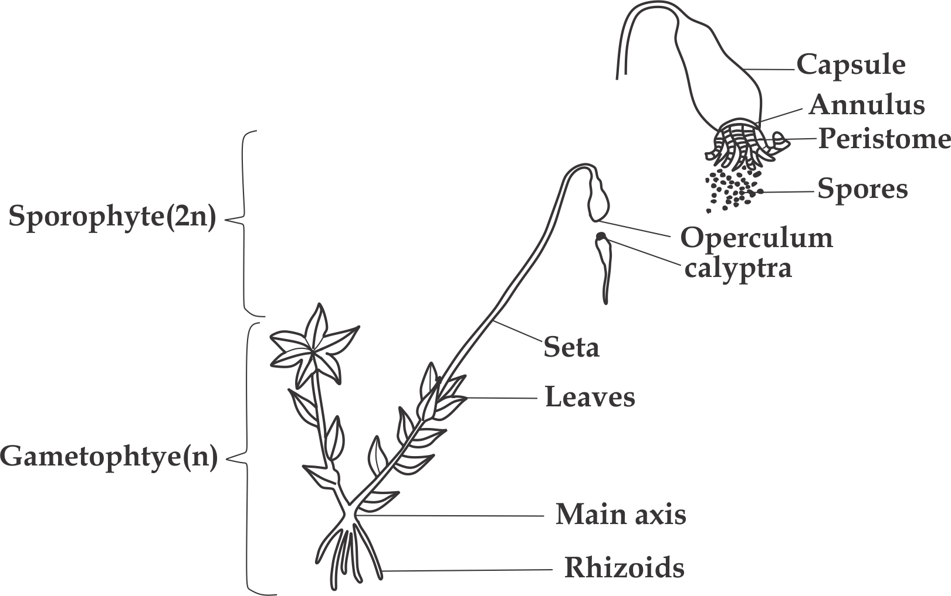

*Structure of a Funaria / moss plant*

**Adaptations of Funaria to its mode of life**:

1. The seta is raised above the gametophyte for easy dispersal of spores.
2. They produce large number of spores to increase the survival chances.
3. They produce light spores for easy dispersal.
4. They grow in damp (moist) places enable to tolerate desiccation.
5. They possess chlorophyll which enable them to manufacture their own food.

**Economic importance of mosses/ Funaria**

**Advantages of mosses/ Funaria**

1. Mosses help to decompose dead logs.
2. Mosses serves a pioneer plants on the bare ground and help to create a suitable environment for the growth and development of other plants.
3. Mosses retain a lot of water, therefore help to keep the soil moist.
4. Mosses provide shelter for insects and other small animals.
5. Mosses are burnt as fuel in some area, i.e. Scotland and Ireland.
6. Mosses are used as Cushing materials in furniture.
7. Due to their good water holding capacity, mosses are mixed with soil to improve the soil moisture contents.
8. Sphagnum mosses have antiseptic properties, during World War II were used as bandage for wounded soldiers.
9. Sphagnum mosses are harvested and used in plant nurseries as a plant growing medium.

**Disadvantages of mosses/ Funaria**

1. Mosses growing around the pond and other water bodies can cause the area to become marshy and dirty.

**Division Filicinophyta**

Members of division filicinophyta are called **pteridophytes.**

**Common organism**: Fern (Dryopteris)

**Habitat:** Moist places

**Class:** Filicinae

**Scientific name:** Dryopteris felix - mass

**General characteristics of division filicinophyta**

Filicinophyta possess the following features which differentiate them from members of other divisions:

1. They have relative large leaves called fronds.
2. They have underground stem called rhizome.
3. They have true vascular system
4. They have sporangia which are formed in clusters known as sori.
5. They have young folded and circinate leaves.
6. They have alternation of generation in which sporophyte is dominant.

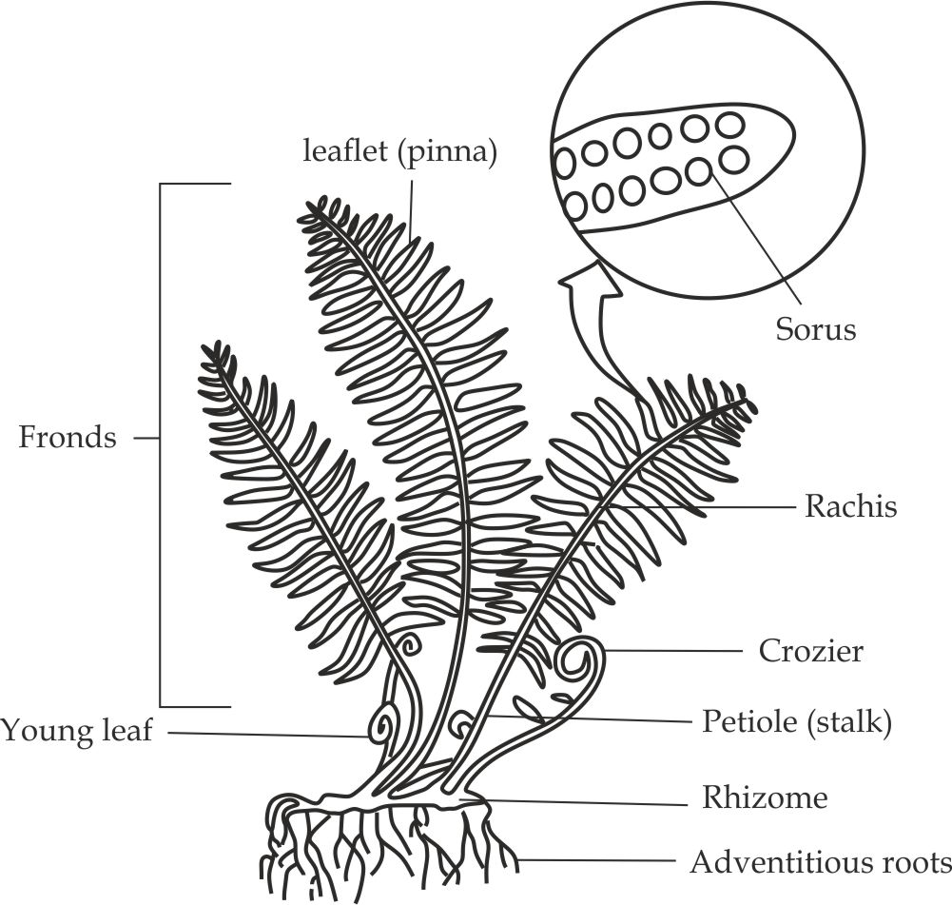

*Structure of a fern (Dryopteris)*

**Adaptations of fern to its mode of life**

1. They have many larger leaves containing chloroplast called fronds for the maximum photosynthetic process.
2. They have waxy cuticle in their leaves which prevent excess water loss by transpiration.
3. They have larger number of stomata in their leaves for maximum gaseous exchange.
4. They have vascular tissues for conducting water and dissolved mineral salts.
5. They have extensive roots system for absorption of water and plant anchorage.
6. They live in moist place to support the sperm (antheridia) to swim toward the egg cell (archegonia) for the purpose of fertilization.
7. The reproductive organs (sori) are well protected by the indusium.

**Economic importance of fern plants**

**Advantages of fern plants**

1. Ferns are used as food for the heterotrophs in the ecosystem.
2. Ferns help in the formation of coal which is used as fuel.
3. Ferns bind to the soil, thus prevent soil erosion.
4. The sporophyte of fern is used as an ornament for decoration.
5. In some parts of the world the fiddle heads of some types of ferns are eaten.
6. Ferns release oxygen needed by animals for respiration.
7. Mosquito ferns are used as biological fertilizers, they are able to fix nitrogen from air into compound that can be used by rice plants.
8. Some species of ferns are the source of medicines in some tribals.

**Disadvantages of fern plants**

1. They spread very fast because of the rhizome, therefore quickly cover the land meant for other uses.
2. Ferns are very difficult to control/ prevent due to their high rate of reproduction.

**The similarities between bryophytes and filicinophyta/ pteridophytes**

Ferns are related to bryophytes in several ways, indicating that they might have probably descended from bryophytes due to the following reasons:

1. Like bryophytes, pteridophytes zygotes are retained and develop inside the archegonia.
2. Sexual mode of reproduction in pteridophytes depend on water like in bryophytes.
3. Both lack vascular tissues, they depend on capillarity and diffusion to move materials in their bodies.
4. Both are monoecius.

**The differences between bryophytes and pteridophytes**

|  |  |
| --- | --- |
| **Bryophytes** | **Pteridophytes** |
| Gametophyte is dominant | Sporophyte is dominant |
| They have simple leaves | They have relatively larger leaves |
| No vascular bundles | Vascular bundles are present |
| The spores are in capsule | The spores are in sori |

**Division Coniferophyta**

Species belonging to this division are evolutionary, more advanced than pteridophyte. They have more advanced vascular tissues and they do not require water for fertilization.

**Common organism**: Conifer (pinus)

**Habitat:** In land, they are very abundant in cold and moist regions.

**Class:** Pinopsida

**Scientific name:** Pinus longaeva

**General characteristics of division filicinophyta**

Conifers possess the following features which differentiate them from members of other divisions:

1. They produce naked seeds.
2. They do not produce fruits as they have no ovaries.
3. They have needle shaped leaves.
4. They reproduce by female and male cones.
5. Their xylem tissues lack vessel elements, but have only tracheid as the conducting elements.

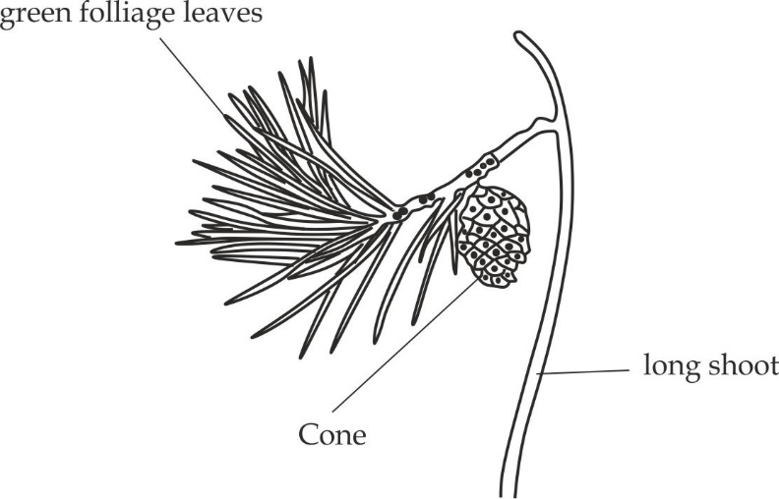

*Structure of a conifer*

**Adaptations of pinus/ conifer to its mode of life**

1. They have needle shaped leaves to prevent excess water loss by transpiration.
2. They have vascular tissues for conducting water and dissolved minerals.
3. They have extensive root system for absorption of water and anchorage.
4. They have seeds that are resistant to dry seasonal.
5. They have winged seeds to facilitate easy dispersal.
6. They reproduce both asexual and sexual to increase the survival chances.

**Economic importance of conifers**

1. They are source of food for heterotrophs.
2. They prevent soil erosion.
3. They provide habitat to animals.
4. They produce turpentine and resins from pines.
5. They provide soft wood for construction and paper industries.
6. They release oxygen gas for aerobic respiration.
7. They reduce carbondioxide from the atmosphere.
8. Certain conifers such as firs and spruces provide ornaments such as christimas trees.
9. Pine nuts are increasable used in cooking.
10. They are sources of income through tourism attraction.

**Division Angiospermatophyta**

These are flowering plants are the most advanced and adapted plants to terrestrial and aquatic life. They produce seeds enclosed in the ovary, which later matures to become a fruit. They are the predominant group of the modern world. The number of angiosperms species is over 257,000 existing in various shapes, size and forms such as grasses, herbs, shrubs and trees.

Common organisms:

**Class monocotyledoneae;** Maize plants

**Class dicotyledonoaae;** bean plant

**General characteristics of division Angiospermatophyta**

1. They have reproductive structures called flowers.
2. They bear seeds that are enclosed in ovaries.
3. They exhibit double fertilization.
4. They have vascular tissues in roots, stem and leaves.

**Class monocotyledoneae**

**Common organism:** Maize plant

**Scientific name:** Zea mays

**Habitat:** Terrestrial

**Distinctive characteristics of class monocotyledoneae**

The following main features are possessed by the members of the class monocotyledoneae which differentiate them from those of class dicotyledonoaae:

1. They have elongated and parallel leaf venation.
2. They have scattered vascular bundles.
3. Embryo have one cotyledon.
4. Their flower parts are in three or multiple of three.
5. They have fibrous type of root system.
6. They exhibit hypogeal type of seed germination.

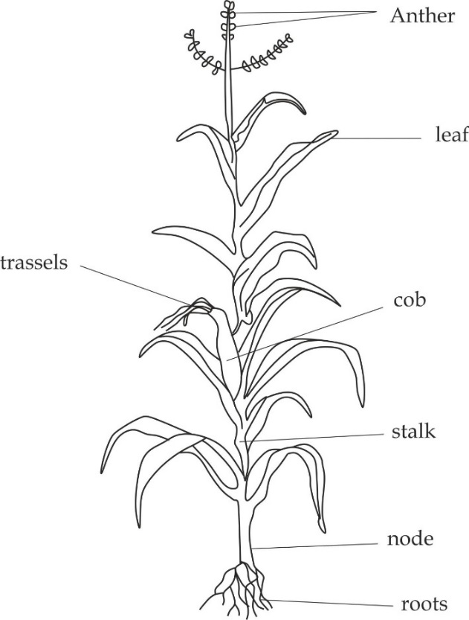

*Structure of a maize plant*

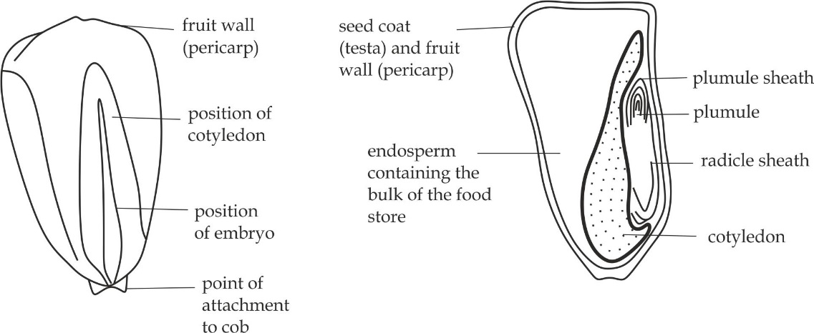

*An endosperm maize fruit Maize fruit in section (LS)*

**Reasons of maize being fruits and not seeds:**

1. They have two scars.
2. They develop from the ovary.
3. They have endosperms.

**Class dicotyledoneae**

**Common organism:** Bean plant

**Scientific name:** Vicia paba

**Habitat:** Terrestrial

**Distinctive characteristics of class monocotyledoneae**

The following main features are possessed by the members of the class *dicotyledoneae* which differentiate them from those of class *monocotyledoneae:*

1. They have broad and net leaf venation.
2. They have ring forms vascular bundles.
3. Embryo have two cotyledons.
4. Their flower parts are in five or multiple of five.
5. They have tap type of root system.
6. They exhibit epigeal type of seed germination.

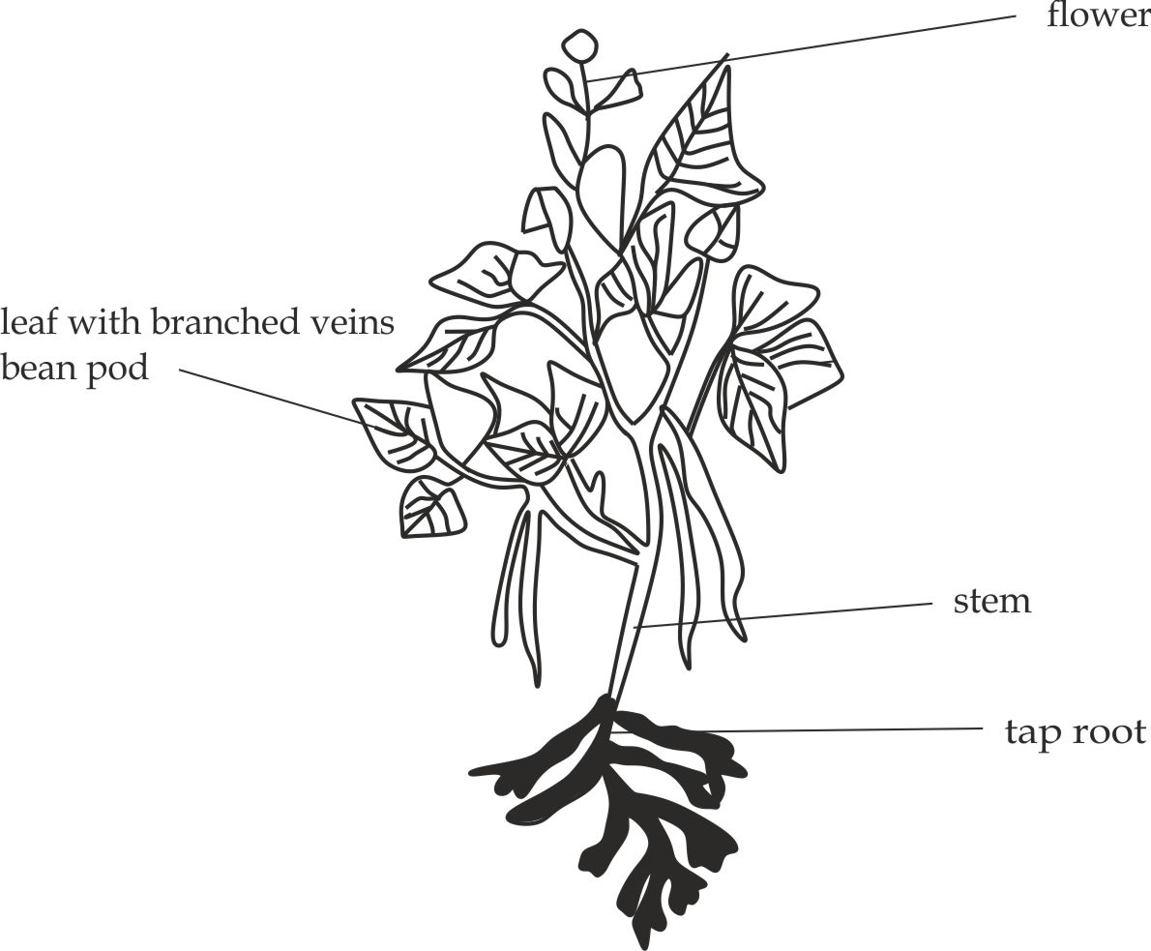

*Structure of a bean plant*

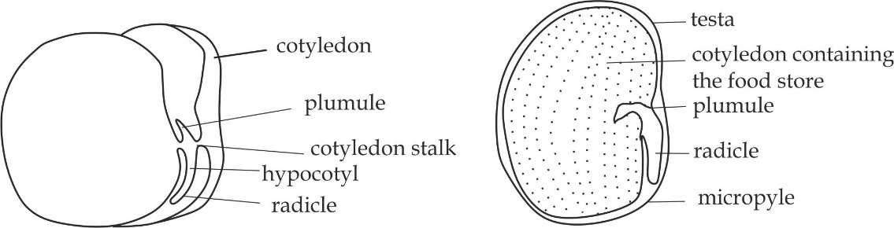

*Bean seed bean seed in section (LS)*

**Reasons of bean being seeds and not fruits:**

1. They have one scar.
2. They develop from the ovule.
3. Absent of endosperm.

**Adaptations of Angiospermophytes to its terrestrial life:**

Angiosperms are the most recently evolved plants and are relatively the most adapted plants to terrestrial/ land environment; several factors have contributed to their survival, hence success on land, such factors include:

1. They have cuticle on their leaves to prevent excess water loss.
2. They have stomata pores for maximum gaseous exchange.
3. They have extensive root system for anchorage and absorption.
4. They have advanced vascular system for translocation.
5. Shedding their leaves during the dry seasons to prevent excess water loss.
6. They have ability to reproduce sexual without the need of water.

**Economic importance of angiosperms**

Since angiosperms are predominant group of plants, this is the same as economic importance of kingdom Plantae:

**Advantages:**

1. They are primary producers in the ecosystem**.**
2. They prevent soil erosion and conserving the environment.
3. They are source of fuel such as charcoal and woods.
4. They produce oxygen gas for aerobic respiration.
5. They serve as habitat to other animals.
6. They reduce carbondioxide concentration in the atmosphere which may lead to global warming.
7. Some are source of food.
8. Some are source of medicines.
9. They are source of rainfall.
10. They are source of timber for buildings.
11. Some are the ornaments for decoration.

**Disadvantages:**

1. Some plants are poison to human beings.
2. Some plants can cause allergic reactions to humans.
3. Some plants cause threat in ecosystem such as water lilies grow very fast in lakes hence cause eutrophication and destroy the habitat for fish and other organisms.

**Selected family in class dicotyledoneae**

**Family cactaceae**

This is very important family in *class dicotyledoneae*, members of this family occur in a wide range of shapes and sizes, and they show many adaptations to conserve water.

**Common name:** Cactus/ xerophyte

**Habitat:** Semi – arid areas.

**Class**: Dicotyledoneae

**Distinctive characteristics of cactus plant (Xerophyte)**

1. They possess needle leaves on the stem.
2. They have swollen stem with a lot of stored food.
3. They have deeper tap root system.
4. They have thick cuticle.

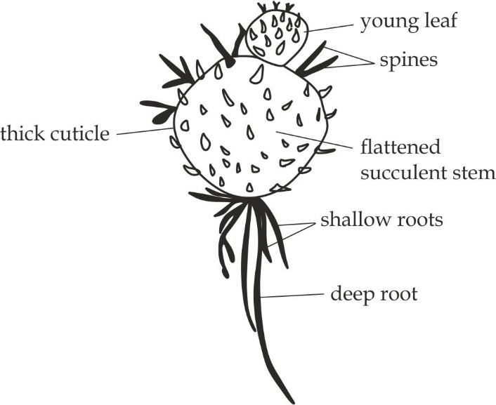

*Structure of a cactus plant*

**Adaptations of xerophytes/ cactus plants to semi – desert life:**

1. They have spiny leaves for reducing transpiration process and for defense purpose against animals that potentially eat them.
2. They have thick and fleshy stem for storage of water.
3. They have sunken stomata which minimizes excess water loss by the transpiration process.
4. They have deeper tap root for absorption of water and anchorage of cactus.
5. They have many root hairs growing on fibrous roots for collecting even smallest droplets of water.
6. They have thick cuticle to prevent excess water loss by transpiration.

**Economic importance of water**

1. They are used to make drugs.
2. They are used in scientific investigation.
3. They prevent soil erosion.
4. They provide oxygen to the atmosphere which is used by animals.
5. They provide shallow water to small animals.
6. Decorate environment (ornaments).
7. They protect the ground.
8. **KINGDOM ANIMALIA**

Kingdom Animalia is large and composed of the wide variety of animals, which are multicellular eukaryotic organisms.

**General characteristics of kingdom Animalia**

1. They show heterotrophic mode of nutrition.
2. They store carbohydrates in form of glycogen.
3. They undergo locomotion.
4. They have limited growth.
5. They have skeletal system.
6. They have well developed nervous system due to the presence of sense organs.

**Phyla of kingdom Animalia**

Kingdom Animalia is divided into about twenty eight phyla, but this book will deal with five (5) selected phyla:

* Phylum platyhelminthesis
* Phylum Nematoda
* Phylum Annelida
* Phylum chordata
* Phylum Arthropoda

**Phylum Platyhelminthesis**

This is a group of all flatworms. The worms can be free living or parasites.

**General characteristics of phylum platyhelminthesis**

1. They are dorsal ventrally flattened.
2. They have no body cavity, eg. Acoelomates.
3. They are triploblastic, eg. Arise from three embryonic layers.
4. They are bilateral symmetrical.
5. They are hermaphrodites, eg. Male and female organs are found in the same organism.
6. They have flame cells for excretion.

**Classes of phylum Platyhelminthesis**

There are three classes of phylum Platyhelminthesis, these are:

* **Class cestoda**, consist of endoparasites animals such as the tape worm.
* **Class trematoda**, consist of the flukes; fasciola hepatica (liver fluke) and blood flukes such as schistosoma hematobium and schistosoma mansoni.
* **Class turbellaria**, consists of free living worms such as planaria.

**Common class in practical work**: Class cestoda

**Common organism:** Tape worm

**Scientific name:** Taenia sagnata (*pork tape worm*)

Taenia solium (*beef tape* *worm).*

**Habitat**: Endoparasites of animals mainly found in the intestine.

**Mode of nutrition:** Endoparasitism

**Mode of reproduction:** sexually

**Distinctive characteristics of the tape worms:**

1. They are dorsal ventrally thin and flattened
2. They body consist of segments (proglottids) containing reproductive organs.
3. They have anterior head called scolex with hooks and suckers.
4. They lack body cavity, i.e. acoelomate.
5. They have tough outer cuticle layer.
6. They have no mouth or gut.

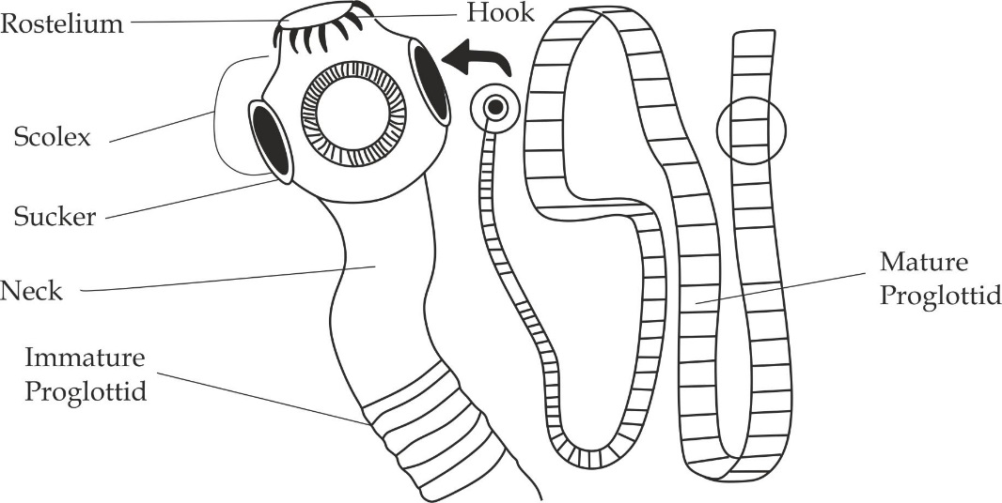

*Structure of a tape worm*

**Adaptations of tape worm (taenia) to its mode of life**

1. It has hooks and sucker on its head for attachment to the host.
2. It has thick cuticle which prevents it from being digested by the host enzymes.
3. It has larger surface area to volume ratio for maximum absorption of nutrients by simple diffusion.
4. It is able to respire anaerobically to ensure its survival chances in the absence of oxygen gas.
5. It secretes digestive enzymes to aid penetration into host.
6. It has alternative hosts to ensure its survival.
7. It produces larger number of eggs, over 70, 000 million per year which increase survival chances.
8. It contains hermaphrodite reproductive organs which ensure that fertilization or cross fertilization will occur.

**Economic importance of tape worm**

**Advantages:**

1. They are used in biological studies and research such as taenia solium.
2. They feed on dead bodies of the larger organisms, therefore; they decompose organic matter in the soil.

**Disadvantages:**

1. They cause blockage of intestine in human.
2. They suck most of the nutrients from human and domestic animals.
3. Their cyst can settle in the liver, eye, brain and other organs, whereby they can impair such organs.

**Phylum Nematoda**

This is a group of round worms. They are the most numerous multicellular animals on earth, and inhabit a wide range of environment.

**General characteristics of phylum Nematoda**

1. They are round worms.
2. They are pseudo coelomates.
3. They are triploblastic.
4. They are bilateral symmetrical.
5. They have separate sexes, eg. Males are smaller than females.

**Common organism:** Ascaris

**Scientific name:** Ascaris lumbricoides

**Habitat:** Free living species inhabit marine and fresh water.

**Distinctive characteristics of the Ascaris**

1. They are cylindrical and unsegmented body with tapering ends.
2. They have longitudinal muscles and no circular muscles.
3. They have mouth and anus.

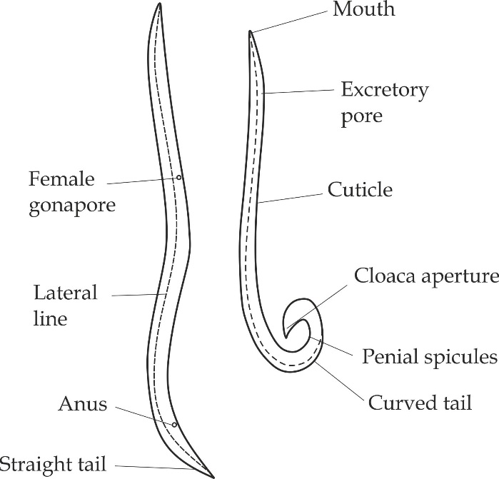

*Structure of a male and female Ascaris*

**Adaptations of Ascaris to its mode of life**

1. They have sucker on its mouth for attachment in the host body.
2. They have cuticle which prevents it from being digested by the host enzymes.
3. They have alimentary canal which opens at the mouth and anus, this enables the parasite to take food from the host digestive system.
4. They have sensory papillae around their mouth for detecting food present in the alimentary canal of the host.
5. The pharynx have valves, which prevent regurgitation of the ingested food.
6. They are able to respire anaerobically in the absence of oxygen gas.
7. They have two alternative hosts to ensure its survival.
8. They produce large number of eggs over 70, 000 million per year to increase survival chances.

**Differences between flatworm and roundworm**

|  |  |
| --- | --- |
| **Flatworm** | **Roundworm** |
| Dorsal ventrally flattened | Round and tapper at both ends |
| Suckers and hooks are present | Only suckers are present, no hooks |
| Incomplete digestive system | Complete digestive system |
| Hermaphrodite | Separate sexes |
| Circular and longitudinal muscles are present | Only the longitudinal muscles are present |

**Economic importance of nematodes**

**Advantages:**

1. Nematodes are used in biological studies in different ways; for instance, in laboratory practical studies.
2. Nematodes are used in biological control agents for pest insects.
3. Nematodes increase soil fertility.

**Disadvantages:**

1. They cause diseases to humans that may lead to obstruction in the gut and anemia.

**Phylum Annelida**

Members of this phylum are known as ringed or segmented worms.

**General characteristics of phylum Annelida**

1. They are segmented worms.
2. They are coelomates.
3. They are triploblastic.
4. They are bilateral symmetrical.

**Classes of phylum Annelida**

There are three classes of phylum Annelida, these are:

* **Class oligochaeta**, this class usually comprises earthworm.
* **Class Hirudinea**, this class usually comprises leeches.
* **Class polychaeta**, this class comprises rag worms.

**Common class in practical work**: Class oligochaeta

**Common organism:** Earthworm

**Scientific name:** Lumbricus terrestis

**Habitat**: Damp soil (Along water bodies such as river, pond and lake)

**Distinctive characteristics of class oligochaeta**

1. They have few chaetae.
2. They have clitellum (larger segment between bodies)
3. They do not have distinct head.
4. They live in fresh water or soil.

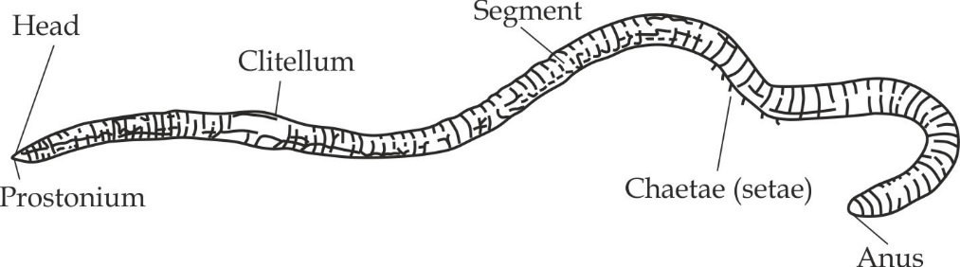

*Structure of earthworm*

**Adaptations of earthworm to its mode of life**

1. They have hydrostatic exoskeleton for support and locomotion.
2. They have chaetae for locomotion and also assist in holding two earthworms during copulation.
3. They have pointed ends for burrowing.
4. They have similar color with environment for camouflage.
5. They are able to respire anaerobic in the absence of oxygen.
6. They have both male and female reproductive organs ensure that fertilization or cross fertilization will occur.
7. They form cocoon which ensures efficient protection of the offspring during fertilization.

**Economic importance of earthworms**

**Advantages**

1. They are used in biological studies and research.
2. They are used as a fish bait.
3. They increase soil fertility.
4. They improve soil aeration, drainage channels and increase depth of the top soil through burrowing and mixing of soil layers.
5. They are ecological decomposers, hence they contribute to nutrients circulation.
6. Their excretory wastes in form of casts increase cementing effects of soil particles.
7. They are used for removing soil pollutants from the soil and clean the environment by transforming organic wastes during feeding as a way of waste management.

**Disadvantages**

1. They increase soil porosity, aeration, which is detrimental to paddy field (rice plant fields).
2. They damage young roots of the growing plants.
3. They destroy human crops during their feeding processes.

**Phylum Chordata**

This is the third largest phylum in the kingdom Animalia. The phylum comprises of all animals that at some point during their lives, possess a hollow nerve cord and notochord.

**General characteristics of phylum chordata**

1. They have a notochord at some stages of their development. *Notochord* is a stiff, flexible rod located dorsal to the gut and ventral to the nerve cord. In most chordates the *notochord* is replaced by a ventral backbone during adulthood.
2. They have pharyngeal clefts in embryonic stage.
3. They have post anal tail in embryonic stage.
4. They have endoskeleton made up of bones and cartilages.
5. They have dorsal hollow nerve cord.
6. They are usually triploblastic coelomates animals.
7. They have ventrally positioned heart with closed circulatory system.
8. They are bilateral symmetrical.
9. They have two pairs of pentadactyl limbs or fins.

**Classes of phylum chordata**

Phylum chordata is divided into six (6) classes, these are:

* Class Chondrichthyes (*not appeared in practical work*)
* Class Osteichthyes
* Class Amphibia
* Class Reptilia
* Class Aves
* Class Mammalia

**Class Osteichthyes**

Osteichthyes includes all bony fishes such as tilapia, tuna, and chipper.

**Common organism:** Tilapia

**Distinctive characteristics of class Osteichthyes**

1. They have a skeleton made up of bones.
2. They have terminal mouth
3. They possess thin, round and cycloid scales.
4. They have gills covered with operculum.
5. They have symmetrical tail fins.
6. They have swim bladder for maintaining buoyancy.
7. They usually undergo external fertilization.
8. They excrete ammonia as nitrogenous wastes.

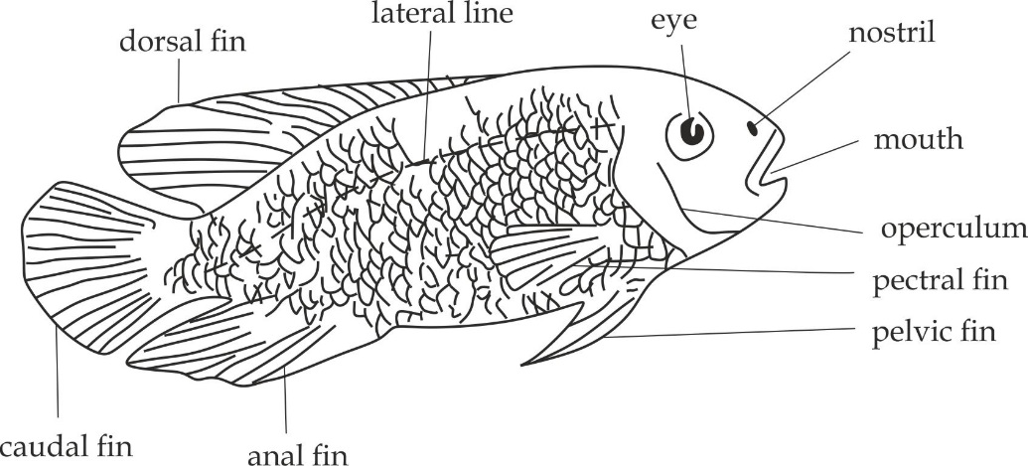

*Structure of a tilapia*

**Adaptation of tilapia to its mode of life**

1. They possess fins for locomotion by steering.
2. They have gills for maximum gaseous exchange.
3. They have swim bladder for buoyance.
4. They have streamline body and scales pointing backward to reduce water resistance.
5. They have lateral line to detect difference in pressure and water current.
6. They produce large number of eggs to ensure its survival.

**Class Amphibia**

The word amphibian refers to “*double life* “or life in water and on land. This class includes amphibians such as frogs, toads, caecilians and salamanders.

**Common organisms:** Toad and frog

**Distinctive characteristics of class Amphibia**

1. They dwell both in water and on land, i.e. they have double life.
2. They are cold blooded animals.
3. They have three heart chambers.
4. They have moist glandular skin.
5. They can undergo external fertilization.
6. The eggs have a soft covering
7. They undergo metamorphosis for development from larval to adult stage in their life cycle.
8. They have gills for respiration in water and lungs on land.

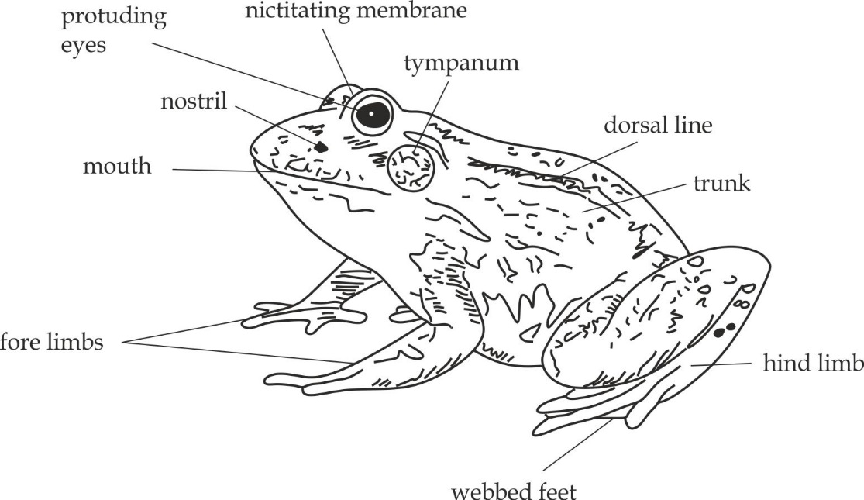

*Structure of a frog/ toad*

**Adaptations of frog to it mode of life**

1. They have protruding eyes assisting to have wide range of vision.
2. They have sticky tongue for capturing prey.
3. They have soft moist skin for maximum gaseous exchange.
4. They have webbed feet to support swimming.
5. They have small front legs for steering.
6. They have long and muscular hind limbs for jumping.
7. Their buccal cavity contains blood capillary for gaseous exchange.

|  |  |  |
| --- | --- | --- |
| **Criteria** | **Frog** | **Toad** |
| **Habitat** | Moist places near ponds | under stones or grasses |
| **Skin** | Smooth and moist | Dry and rough |
| **Glands** | Mucous glands | Many poisonous glands |
| **Teeth** | Present on upper jaw | Absent |

**Class Reptilia**

The class comprises a group of animals including snakes, lizards, tortoises, crocodiles, alligators and chameleons.

**Common organism:** Lizard

**Distinctive characteristics of class Reptilia**

1. They are cold blooded animals.
2. They have dry scaly skin which prevents water loss.
3. They have lungs for gaseous exchange.
4. They excrete uric acid as nitrogenous wastes.
5. They produce eggs covering with lathery shells.

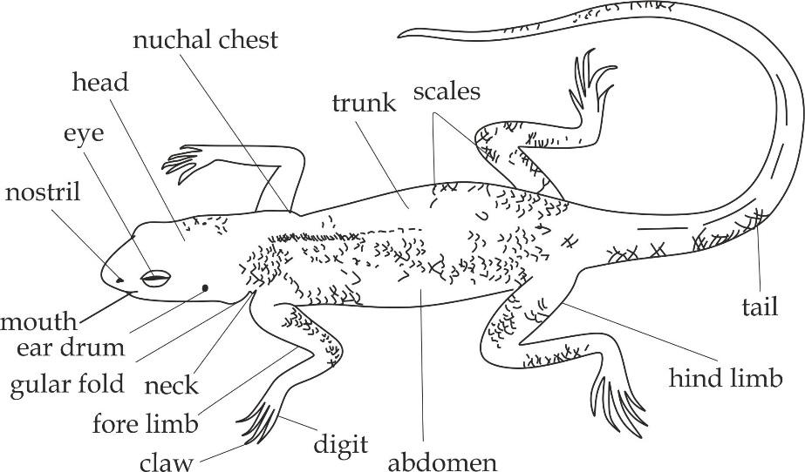

*Structure of a lizard*

**Adaptations of Reptilia to its mode of life**

1. They have dry scaly skin which prevents water loss.
2. They have lungs for maximum gaseous exchange.
3. They have toes with claws to dig and climb.
4. They produce leathery shelled eggs which are impermeable to water loss.
5. They excrete uric acid whose elimination required little amount of water.
6. They have streamline body enable easy penetration in water.
7. They have large protruding eyes gives the wider field of vision.
8. They hibernate to survive through adverse environmental conditions.

**Economic importance of lizard**

1. Source of food to other organisms.
2. Eat insects like housefly and mosquitoes which are harmful to human.
3. Some are poisonous when biting human beings.

**Differences between Amphibia and Reptilia**

|  |  |
| --- | --- |
| **Amphibia** | **Reptilia** |
| Need water to lay eggs | Do not need water to lay eggs |
| Fertilization is external | Fertilization is internal |
| Use skin and lungs for respiration | Use lungs only for respiration |
| Skin is moist and glandular | Skin is dry scaly and non-glandular |
| Digits lack claws | Digits have claws |
| Their eggs have soft covering | Their eggs have leathery covering |

**Class Aves**

The class aves include all birds. It is an extremely distinctive and successful class. Examples of birds are pigeon, parrot, owl, eagle, chicken, flamingo and ostrich.

**Common organism:** Pigeon

**Distinctive characteristics of class Aves**

1. Their skin bodies are covered with feathers.
2. They have hollow and light bones.
3. They have modified mouthparts into different types of beaks.
4. They have lungs for gaseous exchange.
5. They show the parental care.
6. The forelimbs are modified into wings.
7. They excrete uric acid as waste products.
8. They have amniotes eggs with calcium carbonate shell.

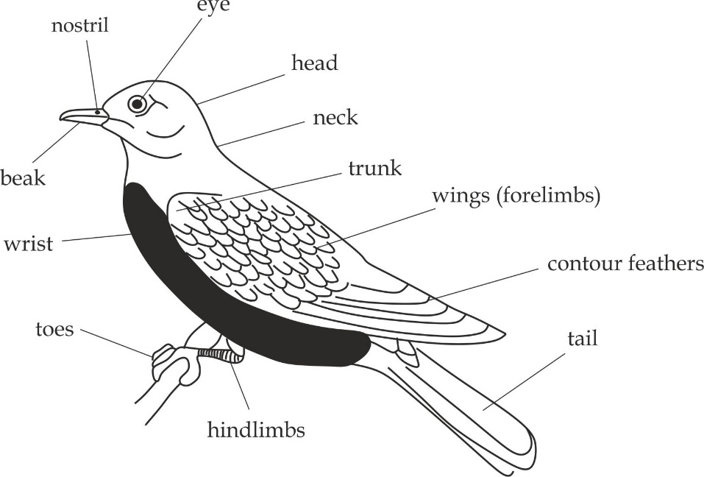

*Structure of a pigeon*

**Adaptations of Aves to its mode of life**

1. They have hollow and light bones, thus reducing the weight of the birds for efficient flight.
2. They have streamline body reduce air resistance while flying.
3. The forelimbs are modified into wings for flight.
4. The sternum is supplied with powerful muscles aid in flying.
5. They have high rate of oxygen consumption which generate required ATP for flight.
6. Their bodies are covered by feathers for insulation against heat loss.
7. They excrete uric acid to conserve water for the development of shell.

**Class Mammalia**

The class Mammalia consists of all animals with mammary glands. It is an extremely diverse and very advanced group in the kingdom Animalia. Members of the class Mammalia include; human, rat, rabbit, cow, whale and donkey**.**

**Common organism:** Rat

**Distinctive characteristics of class Mammalia**

1. They have mammary glands, which produce milk for their newborn.
2. They have fur or hair that covers their skin to insulate heat loss.
3. They have external ear called pinna for collecting sound waves,
4. They have muscular diaphragm which separate the thorax from the abdominal cavity.
5. They have heterodent teeth for variety purpose such as cutting and chewing.
6. They have sweat glands for temperature regulation.
7. They are warm blooded animals.
8. They are viviparous (give birth to young ones).
9. They have well developed nervous system and hormonal coordination system.

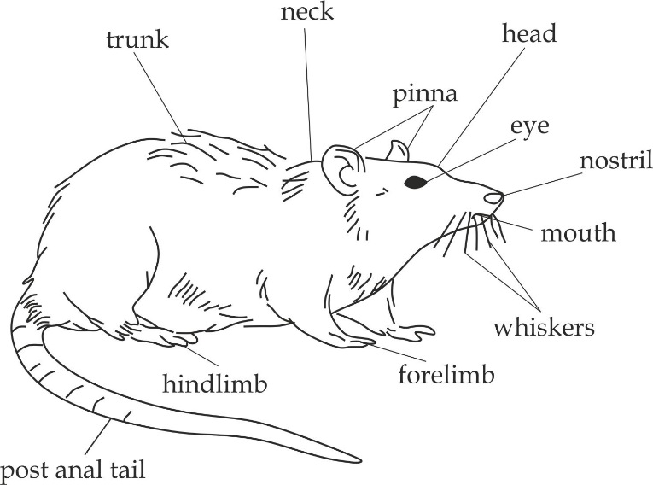

*Structure of a rat*

**Adaptations of rat to its mode of life**

1. Presence of pinna which aid in hearing.
2. Presence of hair which aid in maintaining body temperature.
3. Presence of mammary glands which produce milk for feeding offspring.
4. Presence of sweat glands for temperature regulation.
5. Presence of lungs for maximum gaseous exchange.
6. Presence of well-developed nervous system and hormonal system for coordination of the body.
7. Presence of well-developed blood circulatory system for the efficient transportation of materials within the body.

**Economic importance of rat**

1. It is used in biological studies as a specimen.
2. It is used in biological research for laboratory investigation of PTB.
3. It is used as the source of food by other organisms such as cat.
4. It spreads diseases such as plaque.
5. It destroy properties such as clothes.

**Phylum Arthropoda**

This is the largest and most successful group in the kingdom Animalia, with high species diversity. Arthropoda represent about three quarters of all known living organisms. Arthropoda comes from the Greek word “*arthro “*that means joint and “*podos “that* means foot, therefore; all arthropoda have jointed appendages.

**General characteristics of phylum arthropoda**

1. They possess a chitinous and sometimes calcareous exoskeleton which may be rigid, stiff and flexible.
2. They have jointed, paired appendages such as legs and antennae.
3. They have segmented bodies, which are arranged into head, thorax and abdomen, the head of some arthropods such as arachnids and crustaceans is fused with the thorax to form a structure called cephalothorax.
4. They possess a blood filled cavity called haemocoel.
5. They have dorsal heart with open blood circulatory system.
6. They are triploblastic coelomate animals.
7. Their bodies plan is bilateral symmetrical.
8. They have a ventral nervous system.

**Classes of phylum arthropoda**

Arthropoda are classified into **five** classes namely:

1. Class Diplopoda
2. Class Chilopoda
3. Class Crustacea
4. Class Arachnida
5. Class insecta

**Class Diplopoda**

The class diplopoda consists of members with many legs; usually two pairs of legs per body segment.

**Common organism:** Millipede

**Scientific name**: Lulus terestris

**Habitat**: They are found in dark and moist places.

**Distinctive characteristics of class diplopoda**

Diplopoda have the following unique features, which differentiate them from other arthropods.

1. They have cylindrical segmented body.
2. They have two pairs of legs per segment.

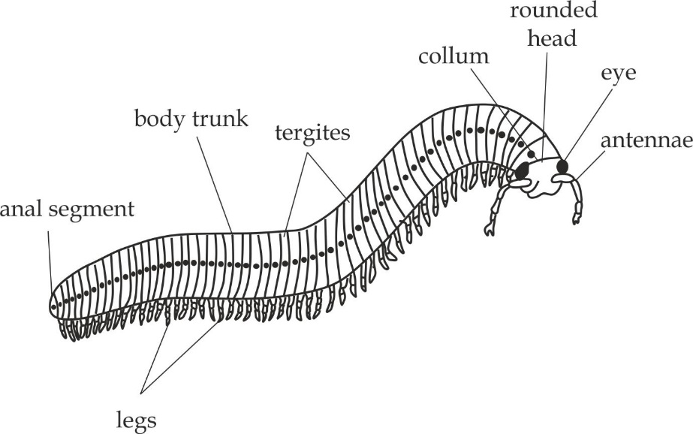

*Structure of a millipede*

**Adaptations of a millipede to its mode of life**

1. They have many, short and strong legs that enable them to burrow into the soil.
2. They have exoskeleton which protects them against serious desiccation.
3. They have mandible for feeding.
4. They live in shady and rich soil and they are reddish/ brownish in colour that gives them camouflage.
5. They are herbivores feeding on living and decaying matter which increase survival chances.
6. They can roll around to form a ball when touched and secrete an offensively odorous fluid called **repugnatorial fluid** when provoked; this acts as a defense against predators.

**Class Chilopoda**

This class Chilopoda consists of member with also many legs; usually one pair of leg per body segment.

**Common organism**: Centipede

**Scientific name:** Lithobius froficatus

**Habitat:** Sand soil and beneath stones

**Distinctive characteristics of class Chilopoda**

1. They have flattened segmented body.
2. They have one pair of leg in each segment.
3. They have a pair of poisonous claw known as maxilliped.

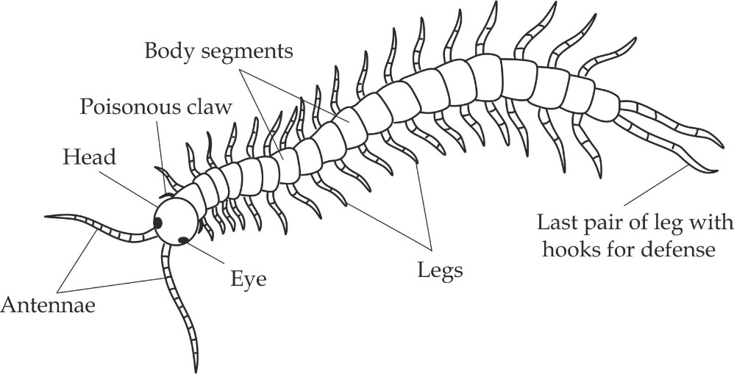

*Structure of a centipede*

**Adaptations of centipede to its mode of life**

1. They have many legs for locomotion.
2. They have exoskeleton which protect them against water loss.
3. They have flexible segmented body for penetration through narrow opening.
4. They are fast moving animals; this help them to catch their prey.
5. They have poisonous claw which protect themselves from predators and to paralyze their food before eating.

**Differences between millipede and centipede**

|  |  |
| --- | --- |
| **Millipede** | **Centipede** |
| It has two (2) pairs of appendages legs per each segment | It has one (1) pairs of appendages legs per each segment |
| The legs are vertical placed | The legs are horizontally placed |
| It is herbivores | It is carnivores |
| It has no poisonous claw | It has poisonous claw |
| It is usually harmless and can coil when disturbed | It bites with poisonous claw |
| It has cylindrical body | It has flattened body |

**Class Crustacea**

Crustaceans form a large group of aquatic arthropoda such as hermit crabs, lobsters, prawns, shrimps, benarcles and crayfish.

**Common organism**: crab

**Distinctive characteristics of class Crustacea**

1. They have two body divisions; which are cephalothorax (the head fused with thorax) and abdomen.
2. They have compound eyes raised on stalk.
3. They have carapace or an exoskeleton hardened with calcium salts which act as protective shell.
4. They have two pairs of antennae.
5. They have four pairs of walking legs and fourth pair modified into paddle like structure for swimming.
6. They have three pairs of mouth parts.
7. They have gills for gaseous exchange, which are the outgrowth of the body wall or limbs.

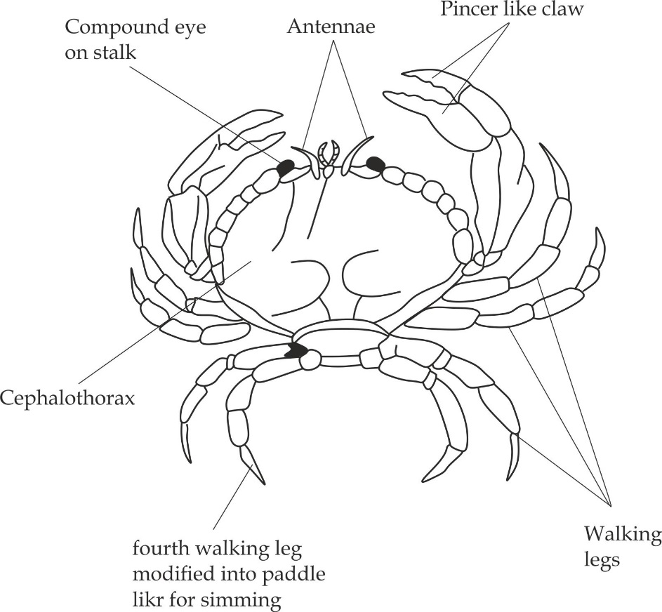

*Structure of a crab*

**Adaptations of crab to its mode of life**

1. They have body covered with exoskeleton impregnated with calcium carbonate for protection.
2. They have modified legs called **paddle** for swimming.
3. They have pincer like claws used for collecting and catching prey.
4. They have gills for maximum gaseous exchange in water.
5. They have versatile antennae that enable quick escape from danger.

**Class Arachnida**

The arachnids represent the second group of terrestrial arthropods after the insects. Most of them are carnivorous, except the *mites* which are herbivores. Members of this class include spiders, mites, ticks and scorpions.

**Common organism:** Spider

**Distinctive characteristics of class Arachnida**

1. They have four pairs of walking legs.
2. They have no antennae.
3. They have two body divisions, cephalothorax and abdomen.
4. They have lung book for maximum gaseous exchange.
5. They have simple eyes.
6. Some members has sting apparatus or poisonous claws.

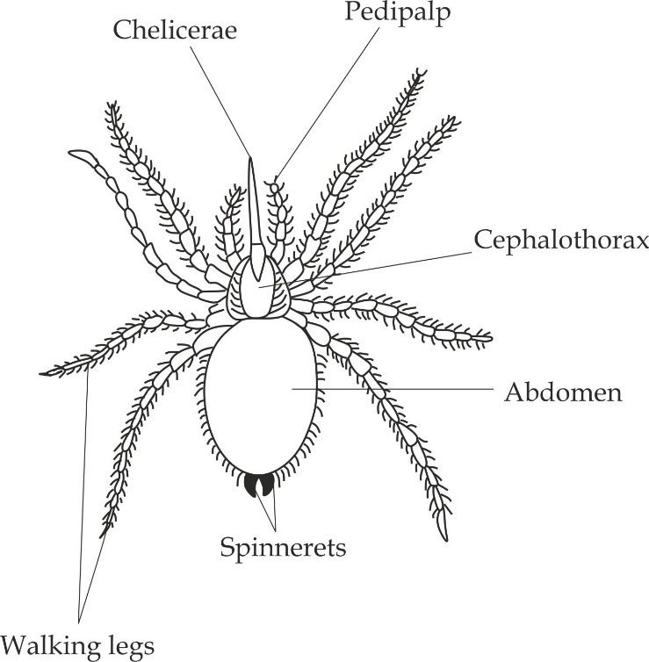

*Structure of a spider*

**Adaptations of spider to its mode of life**

1. They have a pair of pedipalp for holding a prey and sensation.
2. They have chelicerae with poisonous gland for protection against predators.
3. They have spinnerets (silk gland) which produces silk to trap some insects for food.
4. They have lung book for maximum gaseous exchange.
5. They have eight legs for locomotion.
6. They have high reproductive rate that ensure survival chances.

**Class insecta**

The class contains all insects and is the most diverse group of organisms on earth. Members of this class are found in all environment, but very few are found in marine habitats. Example of insects include grasshopper, butterfly, housefly, beetles, bees, ant, wasp and termite.

**Distinctive characteristics of class insecta**

1. They have three body parts; head, thorax and abdomen.
2. They have one pair of antennae.
3. They have three pairs of walking legs.
4. They have one or two pairs of wings.
5. They have tracheal system of maximum gaseous exchange.
6. They have three pairs of mouth parts, which are maxillae, mandible and labrum.
7. They undergo metamorphosis during their development through the molting process.

**Common organisms of class insecta**

Common organisms of class insecta are categorized according to their orders. The main nine (9) orders to be discussed include the following:

* Order Orthoptera
* Order Diptera
* Order Coleoptera
* Order Hemiptera
* Order Lepidoptera
* Order Isoptera
* Order Dicytoptera
* Order Odonata
* Order Hymenoptera

**REMEMBER:**

**This is the most frequently asked class in classification section**

1. **Order Orthoptera - Grasshopper**

**Distinctive characteristics:**

1. Two hind limbs are larger than the rest.
2. Long tapering antennae.
3. Chewing mouth parts.

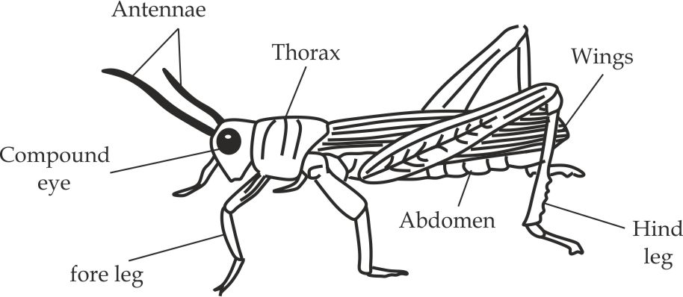

*Structure of a grasshopper*

1. **Order Diptera – Housefly and mosquito**

**Distinctive characteristics:**

1. Has one pair of wing (two wings).
2. Has short antennae.
3. Has sucking (proboscis) mouth part.

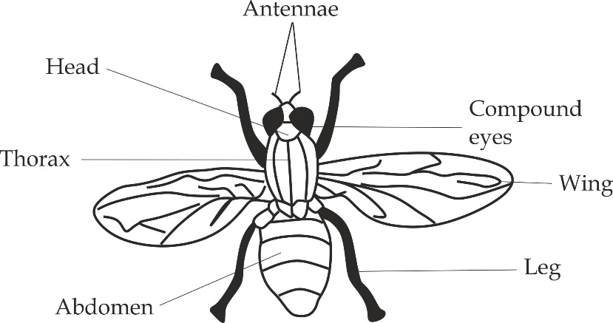

*Structure of housefly*

1. **Order Coleoptera - beetle**

**Distinctive characteristics:**

1. Outer wings are harder than soft inner ones.
2. Has biting mouth parts.

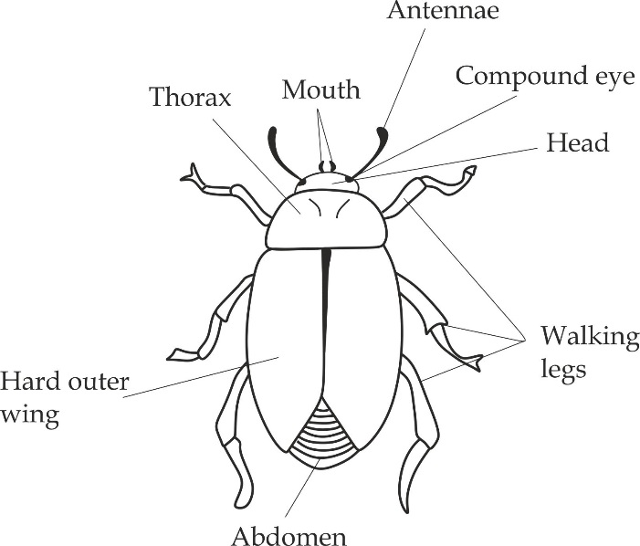

*Structure of a beetle*

1. **Class Hemiptera – ( true bugs) - kunguni**

**Distinctive characteristics:**

1. Has sucking mouth (This order is not asked in practical section).
2. **Order Lepidoptera – Butterfly and moths (nondo)**

**Distinctive characteristics**

1. Has scales wings.
2. Has long knobbed/clubbed antennae.
3. Has short maxillary pulp.

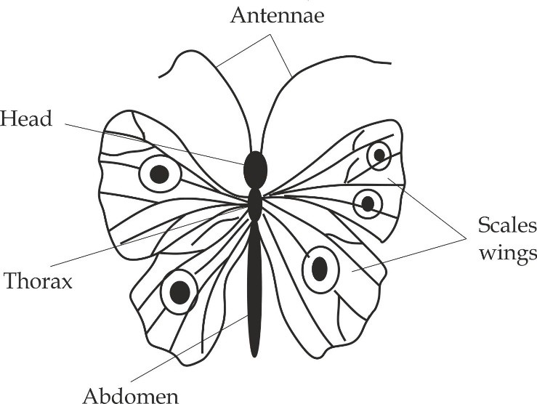

*Structure of a butterfly*

1. **Order Isoptera – termites (mchwa)**

**Distinctive characteristics:**

1. Has biting mouth (This order is not asked in practical section).
2. **Order Dicytoptera – Cockroach and Praying mantis(vunja jungu)**

**Distinctive characteristics:**

1. Has long and thin antennae.
2. Doral ventral flattened.
3. Has biting mouth parts.

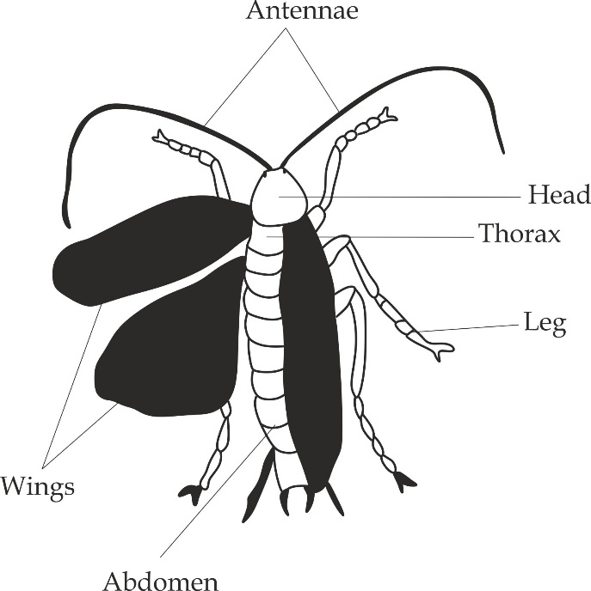

*Structure of a cockroach*

1. **Order Odonata - Dragonflies**

**Distinctive characteristics:**

1. Long and slender abdomen.
2. Thin legs and short antennae.
3. Has chewing mouth parts.

**REMEMBER:**

**This order is rarely asked in practical section**

1. **Order Hymenoptera - honeybee, wasp and ants**

**Distinctive characteristics:**

1. Has bodies are covered with hair.
2. Has chewing and mouth parts.

**Adaptations of class insecta to its mode of life:**

Insecta are the most abundant and diverse of organisms on earth. They possess the following adaptive features which help them to be successful diverse group:

1. They have exoskeleton for support and protection.
2. They have jointed legs for feeding and locomotion.
3. They have compound eyes enable them to have a wide range of vision.
4. They have antennae for detecting various stimuli.
5. They have wings used to escape from predators and move from one place to another to search for food and shelter.
6. They have trachea for maximum gaseous exchange.
7. Their small and flattened body shapes enable them to hide into small cracks and crevices where they live.
8. They undergo *moulting* process during development by removing their hard covers and become soft to facilitate growth.

**Economic importance of class insecta**

Insects play an important role in the world. However, not all insects are useful. Some are harmful to other living organisms:

**Advantages of insects:**

1. Insects such as bees and butterflies aid in pollination.
2. Insects such as honeybees are used in industries for production of honey and wax materials.
3. Insects are used in biological control of pests, for example; lady beetles are used to kill aphids.
4. Insecta are used in research and biological studies.
5. Many insects are used as food; they are good source of proteins for humans and other animals, for example; grasshopper and locust.
6. They are used for tourism as source of income; for example butterflies are valued for their beauty.
7. They are used in nutrients circulation, for example beetles.
8. Insects are used as indicators of the quality of environment.

**Disadvantages:**

1. Some insects are vectors of animal and plant diseases, for example; mosquitoes carry plasmodium.
2. Some insects such as *honey bees* bite human beings release their poison causing severe pain.
3. Some insects destroy crop plants, for example locust.
4. Some insects are parasitic to mammals, good example of such insect is bedbugs which grip themselves on human skin and such blood.

***Worked example -01***

***TAHOSSA – DAR 2014 /3A***

1. You are provided with specimen R1, R2 and R3. Observe the specimen carefully then answer the questions that follow:
2. Give the common names for the specimens R1, R2 and R3.
3. Classify specimens R1 and R2 from kingdom to class level with reasons.
4. Classify specimen R3 from kingdom to phylum.
5. State the economic importance for the specimen R1 and R3.

**Answer:**

1. **Common names for the specimens R1,R2 and R3**

|  |  |
| --- | --- |
| **Specimen** | **Common name** |
| R1 | Earthworm |
| R2 | Moss plant |
| R3 | Mushroom |

1. **Classification of specimen R1 and R2**

|  |  |  |  |
| --- | --- | --- | --- |
| **Specimen** | **Kingdom** | **Phylum** | **Class** |
| R1 | Animalia | Annelida | Oligochaeta |
| R2 | Plantae | Bryophyta | Musci |

**Reasons for R1 to be placed in:**

*Phylum Annelida*

* They are segmented body.

*Phylum Oligochaeta*

* They consist of one pair of chaeta per segment.

**Reasons for R2 to be placed in:**

*Divison Brophyta*

* They do not have true roots, stem or leaves.

*Class Musci*

* Leaves have spirally arranged.

1. **Kingdom and phylum of specimen R3**

|  |  |  |
| --- | --- | --- |
| **Specimen** | **Kingdom** | **Phylum** |
| R3 | Fungi | Basidiomycota |

1. **Economic importance of R1 and R3**

|  |  |
| --- | --- |
| **Specimen R1** | **Specimen R3** |
| Add soil fertility | Source of food |
| Used as a fish bait | Some are poisonous |

**Worked example – 02**

***MOCK COAST REGION/ 2016 3A***

You have been provided with *specimen D1, D1* and *D3*.Observe the specimen carefully and then answer the questions that follow:

1. Give the common names for the specimens D1, D2 and D3.
2. Name the phylum for each of the specimens D1, D2 and D3 belong.
3. Name the habitats for each specimen D1, D2 and D3.
4. Give the adaptive features for specimen D1 which are used to reduce the rate of transpiration.

**Answer:**

1. The common names for the specimens D1, D2 and D3.

|  |  |
| --- | --- |
| **Specimen** | **Common name** |
| D1 | Fern plant |
| D2 | Cactus plant |
| D3 | Hibiscus plant |

1. The phylum for the specimen D1, D2 and D3

|  |  |
| --- | --- |
| **Specimen** | **Habitat** |
| D1 | Terrestrial |
| D2 | Terrestrial |
| D3 | Terrestrial |

1. Adaptive features for D1:
2. It has very thick cuticle.
3. It has reduced leaves.
4. It has leaves dropping position to avoid sunrays.
5. Features which are used to place specimen D1, D2 and D3 in the same kingdom:
6. Having chlorophyll.
7. They are eukaryotic autotrophic.
8. Having cellulose cell wall.
9. They store food in form of starch.
10. They have localized growth.
11. They are non-motile.

***Worked example – 03***

***DAR MOCK 2014/ 3A***

You have been provided with the specimen P1, P2, P3 and P4. Observe the specimen very carefully then answer the questions that follows:

1. Give the common names for the specimen P1, P2, P3 and P4.
2. Name the kingdom for each specimen P1, P2, P3 and P4 belong and give the reasons.
3. State the economic importance of specimen P2 and P3.
4. State the differences between the specimen P2 and P4.
5. Mention the adaptations of specimen P3.

**Answer:**

1. The common names for specimen P1, P2, P3 and P4.

|  |  |
| --- | --- |
| **Specimen** | **Common name** |
| P1 | Lizard |
| P2 | Rat |
| P3 | Cockroach |
| P4 | Frog |

1. Kingdom and reasons for specimen P1, P2, P3 and P4.

Kingdom Animalia

Reasons:

1. They have locomotive structures.
2. They have skeletal system.
3. They store food in form of glycogen.
4. They have heterotrophic mode of nutrition.
5. Economic importance of specimen P2.
6. Source of food to other organisms.
7. Used in biological research.
8. They destroy human properties.

Economic importance of specimen P4

1. Source of food to other organisms.
2. Used in biological research.
3. Differences between P2 and P4

|  |  |
| --- | --- |
| **Specimen P2** | **Specimen P4** |
| Hairy body | Smoothly body |
| Has a tail | Tailless |
| Has pinna | Has no pinna |
| Unwebbed feet | Webbed feet |

1. Adaptations of specimen P3
2. Presence of exoskeleton for protection.
3. Presence of antennae for sensitivity.
4. Presence of wings for flight towards the requirements.
5. Presence of appendages legs for feeding and locomotion.

***Worked example – 04***

***DAR MOCK 2018, 3A***

1. Study the specimen H.
2. State the common name of the specimen H.
3. Give any four adaptations of specimen H in its habitat.
4. Make a large labeled diagram of specimen H.
5. Name the kingdom and division to which the specimen H belongs.
6. Give two distinctive features of the division in which the specimen H belong.
7. You have been provided with specimen P, Q, R and S, which are plants and animals from different habitats.
8. To which classes do specimens P, Q, R and S belong?
9. Give one reason for placing specimens b (i) above to their respective classes.
10. Identify each of the specimen P, Q, R and S by their common names.
11. Give any one reason to show why specimen Q can live succefully in its habitat.

**Answer:**

1. **i.** Specimen H is Conifer or Pinus.
2. Adaptations of specimen H in its habitat.

* They have needle shaped leaves to prevent excess water loss.
* They have vascular tissues for conducting materials.
* They have seeds that are resistant to dry season.
* They have winged seeds to facilitate dispersal.

1. The diagram of specimen H.

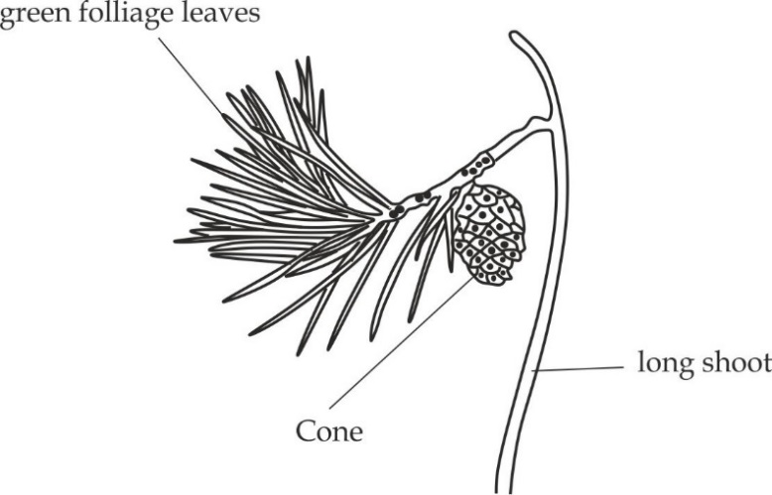

1. Kingdom – Plantae

Division – Coniferophyta

1. Distinctive features of specimen H to its division:

* Produce naked seeds.
* Reproduce by male and female cones.
* Leaves are reduced to needle shaped.
* They do not produce fruits.
* They have well developed vascular system.

1. Answer to qn b. i, ii and iii respectively.

|  |  |  |  |
| --- | --- | --- | --- |
| **Specimen** | **Class** | **Name** | **Reason** |
| P | Reptilia | Lizard | Have dry skin |
| Q | Amphibia | Frog | Have smooth skin |
| R | Insecta | Bee | Have 3 pairs of legs |
| S | Dicotyledoneae | Bean seed | Seeds have 2 cotyledons |

1. Specimen Q can live succefully in its habitat due to the fact that; it has both gills and lungs for breathing which can be able to live in both; terrestrial as well as aquatic environment. Eg, in dry land uses lungs and in water uses gills.

***Worked example – 05***

***DAR MOCK 2019, 3A***

1. You have been provided with specimen B4, B5, B6 and B7. Observe the specimens carefully and then answer the questions that follow:
2. Give the common names for the specimens B4, B5, B6 and B7.
3. Classify the specimen B4 and B7 from Kingdom to phylum level.
4. Differentiate between specimen B5 and B6.
5. Name the habitat for each specimen B4 and B7.
6. Give the adaptive features for specimen B4.

**Answer:**

1. **i.** The common names for specimen B4, B5, B6 and B7.

|  |  |
| --- | --- |
| **Specimen** | **Common name** |
| B4 | Spirogyra |
| B5 | Maize seedling |
| B6 | Bean seedling |
| B7 | Fern |

1. Kingdom and division of specimen B4 and B7.

|  |  |  |
| --- | --- | --- |
| **Specimen** | **Kingdom** | **Phylum** |
| B4 | Protoctista | Chlorophyta |
| B5 | Plantae | Filicinophyta |

1. Differences between specimen B5 and B6

|  |  |
| --- | --- |
| **Specimen B5** | **Specimen B6** |
| Has long narrow leaves | Has short broad leaves |
| Leaves have parallel venation | Leaves have network venation |
| Has fibrous root system | Has tap root system |
| Has one cotyledon | Has two cotyledons |

1. Habitat for B4 – Aquatic environment

Habitat for B7 – Terrestrial environment

1. Adaptations of specimen B4
2. It has chlorophyll to enable photosynthesis.
3. It has filamentous constriction which assist it to float on water.
4. It has ability to undergo dormancy period in order to withstand unfavorable conditions in the environment.

***Worked example - 06***

***DAR MOCK 2018 – 3B***

You are provided with specimen B3, B4, B5, B6 and B7. Observe the specimens carefully and then answer the questions which follow:

1. Give the common names of specimen B3, B4, B5, B6 and B7.
2. Classify the specimen B3, B4, B5, B6 and B7 to phylum/ division level.
3. Mention any two diseases transmitted by the specimen B5.
4. Draw a well labeled diagram of specimen B3.
5. Give the adaptive features of specimen B4 to its habitat.

Answer:

1. The common names of specimen B3, B4, B5, B6 and B7.

|  |  |
| --- | --- |
| **Specimen** | **Common name** |
| B3 | Fern plant |
| B4 | Tilapia fish |
| B5 | Housefly |
| B6 | Millipede |
| B7 | Bread mould |

1. Classify the specimen B3, B4, B5, B6 and B7 to phylum/ division level.

|  |  |  |
| --- | --- | --- |
| Specimen | **Kingdom** | Phylum/ division |
| B3 | Plantae | Filicinophyta |
| B4 | Animalia | Chordata |
| B5 | Animalia | Arthropoda |
| B6 | Animalia | Arthropoda |
| B7 | Fungi | Zygomycota |

1. Diseases transmitted by specimen B5 are cholera, typhoid and trachoma.
2. Diagram of specimen B3



1. Adaptive features of specimen B4 to its habitat:
2. Presence of gills for maximum gaseous exchange.
3. Presence of swim bladder filled with air to regulate buoyance.
4. Presence of fins for swimming by steering.
5. Presence of lateral line for sensitivity.
6. They undergo external fertilization to increase its survival chances.

***Worked example – 07***

***DAR MOCK 2018, 3B***

You are provided with specimen L1, L2 and L3. Observe the specimen very carefully and then answer the questions that follow:

1. Give the common name of specimen L1, L2 and L3.
2. Classify the specimen L1 and L2 to class level with reasons.
3. Classify the specimen L3 to phylum level.
4. Mention the economic importance of specimen L1 and L3.

**Answer:**

1. The common names of specimens L1, L2 and L3**.**

|  |  |
| --- | --- |
| **Specimen** | **Common name** |
| L1 | Tapeworm |
| L2 | Spider |
| L3 | Bread mould |

1. Classification of specimen L1 and L2 to class level

|  |  |  |  |
| --- | --- | --- | --- |
| **Specimen** | **Kingdom** | **Phylum** | **Class** |
| L1 | Animalia | Platyhelminthesis | cestoda |
| L2 | Animalia | Arthropoda | Arachnida |

Reasons of L1 to phylum platyhelminthesis:

1. It is dorsal ventral flattened.
2. It is acoelomate.
3. It is hermaphrodite.
4. It has flame cells for excretion.

Reasons of L1 to class cestoda:

1. It has hooks and suckers for attachment to the host intestine.
2. It has body segments called proglottids each contain reproductive organs.
3. It has tough outer cuticle that prevents from being digested by the host enzymes.
4. It has no mouth or gut, digested food is absorbed over the body by diffusion.

Reasons of L2 to phylum Arthropoda

1. It has segmented body.
2. It has jointed legs.
3. Its body is covered with a thick chitinous exoskeleton.
4. It consists of head, thorax and abdomen; sometimes head and thorax may be fused to form cephalothorax.

Reasons of L2 to class Arachnida

1. It has four pairs of walking legs.
2. It has no antennae.
3. Its body is divided into two parts; cephalothorax and abdomen.
4. It has no wings.
5. Classification of L3 to phylum level

|  |  |  |
| --- | --- | --- |
| **Specimen** | **Kingdom** | **Phylum** |
| L3 | Fungi | Zygomycota |

1. Economic importance of L1 and L3:

Specimen L1:

1. It sucks most of nutrients from human and domestic animals.
2. Its cyst can settle in the brain, eyes, liver and elsewhere in the body, where it can lead to impairment of such organ.
3. It is used in biological research.

Specimen L3:

1. It causes food spoilage.
2. It acts as decomposer in the soil.
3. It can be used in biological studies.

***Worked example – 08***

***JECAS 2017, 3A***

You are provided with specimen H, I, J, K and L. observe the specimens carefully and then answer the questions that follow:

1. Give the common names of specimen H, I, J, K and L.
2. Mention the observable differences between specimen H and I.
3. Write the distinguish features of specimen J, K and L.
4. Mention the adaptive features of specimen J.

**Answer:**

1. The common names of specimens H, I, J, K and L.

H – Moss K - Tapeworm

I – Fern L - Earthworm

J – Ascaris

1. Differences between specimen H and I

|  |  |
| --- | --- |
| **Moss plant** | **Fern plant** |
| Plant body is either leafy. | Plant body is differentiated into roots, stem and leaves. |
| Leaves are very small in size and called simple leaves. | Leaves are relatively large divided into many leaflets, they are called fronds. |
| Has capsule for the formation of spores. | Has sori for the spore’s formation. |
| No vascular bundles | Has vascular bundles. |

1. Distinctive features of:

Specimen H

1. It is small plant lacking vascular tissues.
2. It has no true roots, leaves or stem.
3. It has roots like structures called rhizoids.
4. It has alternation of generation in which sporophyte is dominant.

Specimen I

1. Its leaves are relatively larger are called fronds.
2. It has underground stem called rhizoids.
3. It has true vascular bundles.
4. It has alternation in generation in which sporophyte is dominant.

Specimen J

1. It has unsegmented stem called rhizoids.
2. It is pseudocoelomate.
3. It is tapered at both ends.

Specimen K

1. It is dorsal ventrally flattened.
2. It is acoelomate.
3. It is hermaphrodite.
4. It has flame cells for excretion.

Specimen L

1. It has external chaetae for locomotion.
2. It is coelomate.
3. It has segmented body.
4. Adaptations of specimen J to its habitat
5. It has suckers on its mouth for attachment to the host.
6. It has cuticle which prevent it from being digested by the enzymes.
7. It respires anaerobic in the absence of oxygen.
8. It has high rate of reproduction to ensure its survival chances.
9. It has well developed chemotactic response that enables it to detect suitable place in the host.

***Worked example – 09***

***MOROGORO MOCK 2019, 3A***

You are provided with the specimens S3, S4, S5, S6, S7 and S8.Observe the specimens carefully and then answer the questions that follow:

1. Identify the specimen S3, S4, S5, S6, S7 and S8 by using their common names.
2. Classify the specimen S3, S4, S5 and S6 to the class level.
3. Outline the features of each class to which specimen S4 and S6 belongs.
4. Give reasons why specimen S7 is a seed and specimen S8 is a fruit.

**Answer:**

1. The common names of specimen S3, S4, S5, S6, S7 and S8.

|  |  |
| --- | --- |
| **Specimen** | **Common name** |
| S3 | Yeast |
| S4 | Spider |
| S5 | Bee |
| S6 | Lizard |
| S7 | Bean seed |
| S8 | Maize grain |

1. Classification of specimen S3, S4, S5 and S6 to class level.

|  |  |  |  |
| --- | --- | --- | --- |
| **Specimen** | **Kingdom** | **Phylum** | **Class** |
| S3 | Fungi | Ascomycota | Hemiascomycete |
| S4 | Animalia | Arthropoda | Arachnida |
| S5 | Animalia | Arthropoda | Insecta |
| S6 | Animalia | Chordata | Reptilia |

1. Features of each class to which specimen S4 and S6 belongs:

Distinguish features of S4 – Class Arachnida

1. They have no antennae.
2. They possess four pairs of legs.
3. They have two body parts; cephalothorax and abdomen.
4. They have simple eyes (no compound eyes).
5. They have lung book for gaseous exchange.

Distinguish features of S6 – class Reptilia

1. They have dry skin with horny scales.
2. They have lungs for gaseous exchange.
3. They are cold blooded animals.
4. Reasons why specimen S7 is a seed and S8 is a fruit

|  |  |
| --- | --- |
| **S7 is a seed** | **S8 is a fruit** |
| Have no scar | Have two scars |
| Develop from the ovule | Develop from the ovary |
| Absent of endosperms | Presence of endosperms |

**Worked example – 10**

**MOCK MTWARA AND LINDI 2022, 3B**

You are provided with specimen K2, K3, K4, K5 and K6. Observe them carefully and then answer the questions which follow:

1. Identify the specimen K2, K3, K4, K5 and K6 with their common names.
2. Classify specimen K3, K4 and K5 to class level.
3. Give three adaptations of specimen K2 to its mode of life.
4. State two morphological differences between specimen K4 and K5.

**Answer:**

1. The common names of specimen K1, K2, K3, K4, K5 and K6.

|  |  |
| --- | --- |
| **Specimen** | **Common name** |
| K2 | Spider |
| K3 | Earthworm |
| K4 | Lizard |
| K5 | Tilapia |
| K6 | Hibiscus flower |

1. Classify specimen K3, K4 and K5 to class level.

|  |  |  |  |
| --- | --- | --- | --- |
| **Specimen** | **Kingdom** | **Phylum** | **Class** |
| K3 | Animalia | Annelida | Oligochaeta |
| K4 | Animalia | Chordata | Reptilia |
| K5 | Animalia | Chordata | Osteichthyes |

1. Adaptations of specimen K2 to its mode of life
2. They have a pair of pedipalp for holding a prey and sensation.
3. They have chelicerae with poisonous gland for protection against predators.
4. They have spinnerets (silk gland) which produces silk to trap some insects for food.
5. They have lung book for maximum gaseous exchange.
6. They have eight legs for locomotion.
7. They have high reproductive rate that ensure survival chances.
8. State two morphological differences between K4 and K5

|  |  |
| --- | --- |
| **Specimen K4 (Lizard)** | **Specimen K5(Tilapia)** |
| Have legs for walking | Have fins for swimming |
| Have nostril for gaseous exchange | Have gills for gaseous exchange |